Google Ads API v20 Shopping Campaign UI Mapping
This document maps the user interface (UI) input fields required for setting up a Google Ads Shopping Campaign to the corresponding Google Ads API v20 Python SDK fields (`google-ads==28.0.0`), entities, and ENUMs. It strictly follows the order presented in the provided Google Doc.

1. Merchant Center account
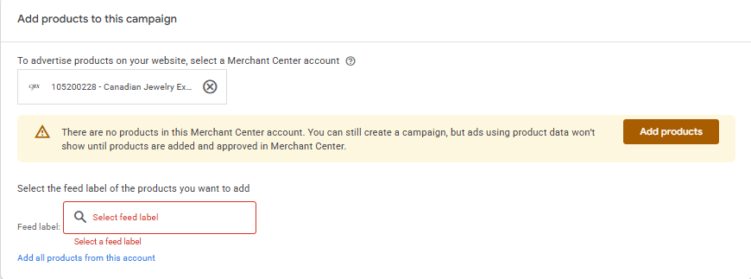
- UI Field: Merchant Center account selection.
- API Mapping: `Campaign.shopping_setting.merchant_id`
- Entity: `client.get_type("CampaignOperation").create.shopping_setting`
- Data Type: `int64`
- Hierarchy: Campaign-level setting.

2. Choose Shopping/Performance Max
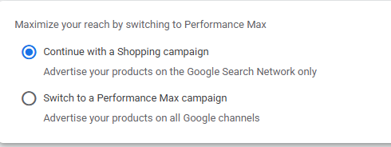
- UI Field: Select between Shopping and Performance Max.
- **API Mapping**:
- For standard Shopping: `Campaign.advertising_channel_type = client.enums.AdvertisingChannelTypeEnum.SHOPPING`
- For Performance Max: `Campaign.advertising_channel_type = client.enums.AdvertisingChannelTypeEnum.PERFORMANCE_MAX`
- Hierarchy: Campaign-level setting.

3. Campaign Name
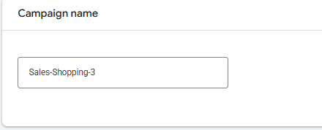
- UI Field: Campaign Name.
- API Mapping: `Campaign.name`
- Entity: `client.get_type("CampaignOperation").create`
- Data Type: `string`
- Hierarchy: Campaign-level setting.

4. Budget and Bidding Optimization

Budget
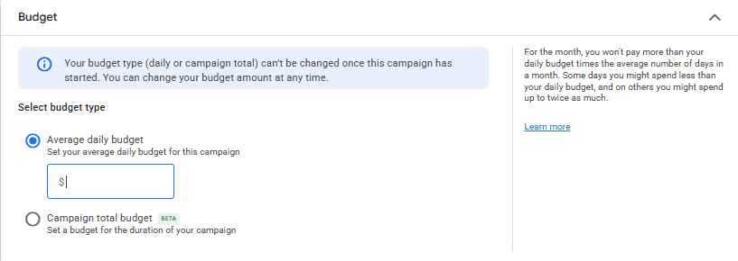
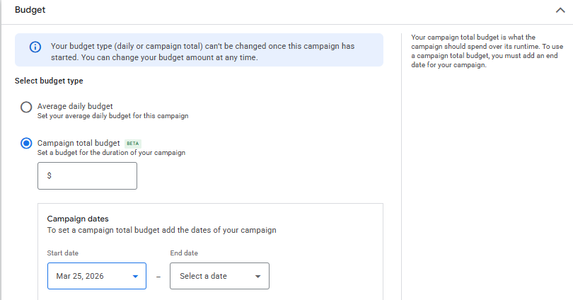
- UI Field: Budget amount and delivery method (Standard).
- **API Mapping**:
- Create a `CampaignBudget` entity: `client.get_type("CampaignBudgetOperation").create`
- Amount: `CampaignBudget.amount_micros` (in micros, 1,000,000 micros = $1)
- Delivery Method: `CampaignBudget.delivery_method` (`client.enums.BudgetDeliveryMethodEnum.STANDARD`)
- Hierarchy: Campaign Budget is a separate entity linked to the Campaign via `Campaign.campaign_budget`.

Bidding
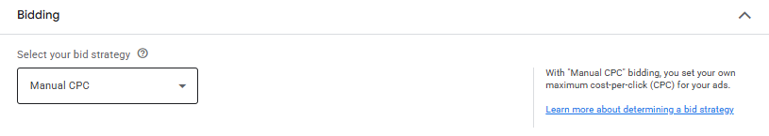
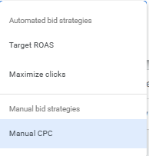
- UI Field: Bidding strategy (e.g., Target ROAS, Maximize Clicks, Manual CPC).
- **API Mapping**:
- `Campaign.bidding_strategy_type` ENUMs mapping:
- Target ROAS: `client.enums.BiddingStrategyTypeEnum.TARGET_ROAS` (configure via `Campaign.target_roas`)
- Maximize Clicks: `client.enums.BiddingStrategyTypeEnum.TARGET_SPEND` (configure via `Campaign.target_spend`)
- Manual CPC: `client.enums.BiddingStrategyTypeEnum.MANUAL_CPC` (configure via `Campaign.manual_cpc`)
- Hierarchy: Campaign-level setting (Standard Bidding) or shared Bidding Strategy entity.

Customer Acquisition
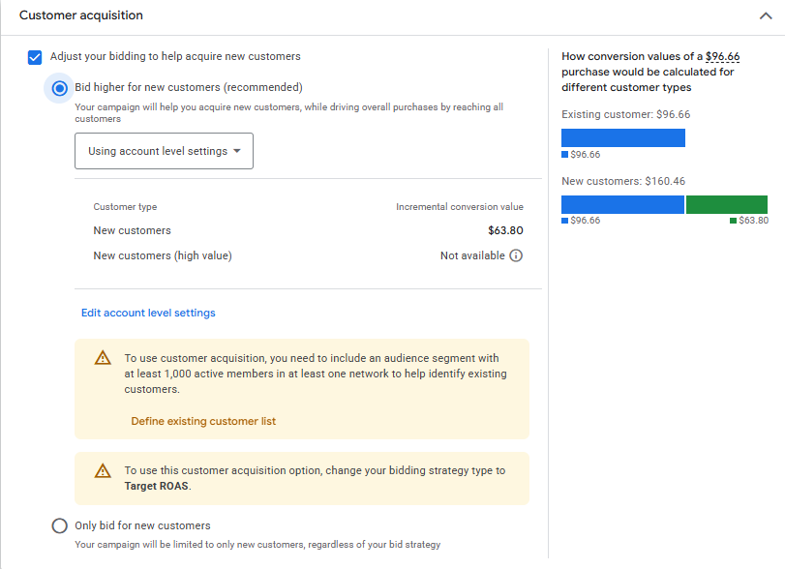
- UI Field: Customer acquisition settings (e.g., bid higher for new customers).
- API Mapping: Customer Acquisition is managed at the campaign level via a specific objective mapping or shared set. *Note*: In API v20, there is a `CustomerAcquisitionGoalSettings` entity (`optimization_mode`, `value_settings`), but it usually requires linking via a Customer Acquisition goal or conversion tracking setup rather than a simple campaign flag for standard Shopping campaigns.

Campaign Priority
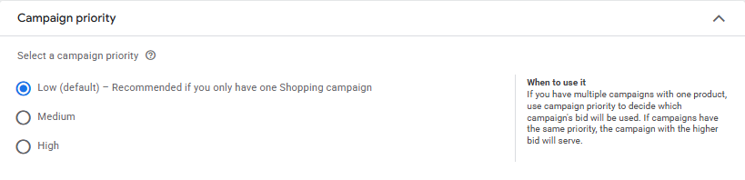
- UI Field: Campaign priority (Low, Medium, High).
- API Mapping: `Campaign.shopping_setting.campaign_priority`
- Data Type: `int32` (0 = Low, 1 = Medium, 2 = High)
- Hierarchy: Campaign-level setting.

5. Campaign Settings

Locations
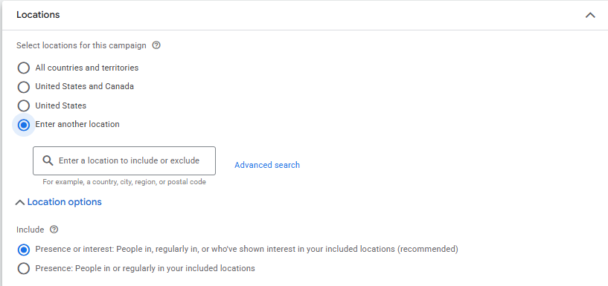
- UI Field: Location targeting.
- **API Mapping**:
- Create a `CampaignCriterion` entity: `client.get_type("CampaignCriterionOperation").create`
- Set `CampaignCriterion.location.geo_target_constant`
- Hierarchy: Campaign Criterion (separate entity linked to Campaign).

Local Products
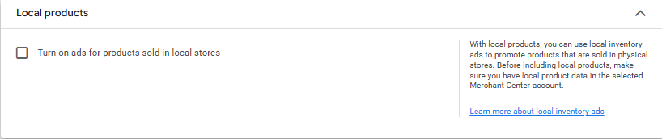
- UI Field: Enable local inventory ads.
- API Mapping: `Campaign.shopping_setting.enable_local`
- Data Type: `bool`
- Hierarchy: Campaign-level setting.

EU Political Ads
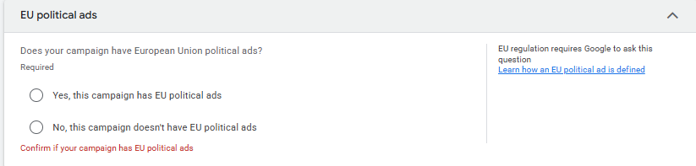
- UI Field: EU political ads declaration.
- API Mapping: `Campaign.contains_eu_political_advertising` (Note: Often automatically determined or requires specific account-level compliance settings, field availability depends on policy exceptions).
- Data Type: `bool`
- Hierarchy: Campaign-level setting.

Start and End Dates
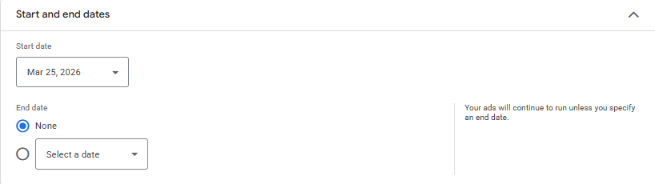
- UI Field: Start and end dates for the campaign.
- **API Mapping**:
- `Campaign.start_date` (format: YYYY-MM-DD)
- `Campaign.end_date` (format: YYYY-MM-DD)
- Hierarchy: Campaign-level setting.

Campaign URL Options
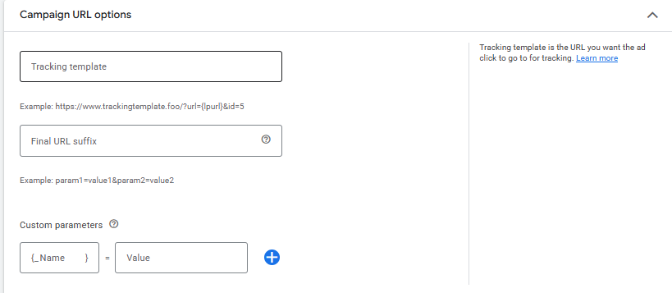
- UI Field: Tracking templates and custom parameters.
- **API Mapping**:
- Tracking Template: `Campaign.tracking_url_template`
- Final URL Suffix: `Campaign.final_url_suffix`
- Custom Parameters: `Campaign.url_custom_parameters`
- Hierarchy: Campaign-level setting.

Networks
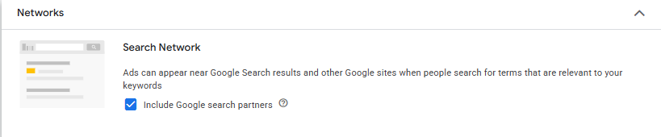
- UI Field: Search Network, Search Partners, etc.
- API Mapping: `Campaign.network_settings`
- `network_settings.target_google_search` (`bool`)
- `network_settings.target_search_network` (`bool`)
- `network_settings.target_content_network` (`bool`)
- `network_settings.target_partner_search_network` (`bool`)
- Hierarchy: Campaign-level setting.

6. Ad Group Configuration

Ad Group Name
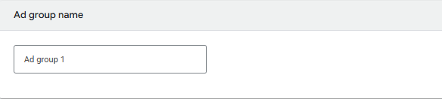
- UI Field: Name of the Ad Group.
- API Mapping: `AdGroup.name`
- Entity: `client.get_type("AdGroupOperation").create`
- Data Type: `string`
- Hierarchy: Ad Group-level setting linked to Campaign.

Ad Group Bid
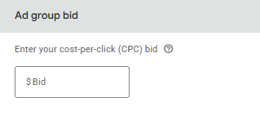
- UI Field: Default max CPC bid for the Ad Group.
- API Mapping: `AdGroup.cpc_bid_micros`
- Data Type: `int64` (in micros)
- Hierarchy: Ad Group-level setting.

Product Groups
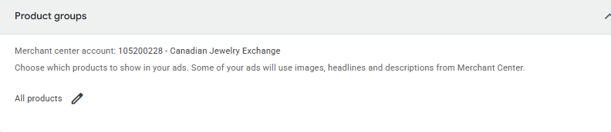
- UI Field: Product group subdivision (e.g., "All products").
- **API Mapping**:
- Create an `AdGroupCriterion` entity: `client.get_type("AdGroupCriterionOperation").create`
- Configure `AdGroupCriterion.listing_group`
- Entity `ListingGroupInfo` (`type_` = SUBDIVISION or UNIT, `case_value`, `parent_ad_group_criterion`)
- Set specific bids using `AdGroupCriterion.cpc_bid_micros` on the UNIT listing groups.
- Hierarchy: Ad Group Criterion (separate entity linked to Ad Group).

Anomaly Data & API Nuances

Anomaly Data & API Nuances
Feature / Setting | API Limitations & Notes
Customer Acquisition | Setting up "Bid higher for new customers" in standard shopping requires complex conversion goal tracking. API handles this mostly in Performance Max or via `CustomerAcquisitionGoalSettings`. Not a simple boolean toggle on standard Shopping Campaigns.
EU Political Ads | The field `contains_eu_political_advertising` exists but modifying it might be restricted depending on your account's verification status for political advertising. Often a read-only or policy-driven field in standard execution.
Campaign Priority | Stored as integer (0, 1, 2) rather than explicit ENUM strings like LOW, MEDIUM, HIGH.
Budget Delivery Method | `ACCELERATED` delivery method is deprecated in Google Ads API. All new budgets default to standard delivery optimization.
Smart Shopping (Deprecated) | Smart Shopping campaigns have been deprecated and auto-upgraded to Performance Max (`AdvertisingChannelTypeEnum.PERFORMANCE_MAX`). Standard Shopping remains supported.

