Superstore Sales Dashboard
Improving Retail Decision-Making Through Data Visualisation

This project explores how data visualisation can improve retail decision-making by transforming 9,994 raw sales transactions from the Sample Superstore dataset (Kaggle, 2023) into a single Power BI dashboard — giving sales, finance, marketing, and operations teams the insights they need to act quickly and confidently.
Data Visualisation • Business Analysis • Stakeholder Analysis • Data-Driven Decision-Making
Minhajur Rahman
MSc Student, The University of Law
2026

Contents

Introduction 3
Business Problem 3
Target Business 4
Primary Stakeholders 4
Secondary and External Stakeholders 5
Main Section 5
Data Source 5
Target Business, Stakeholders and Audience 6
Stage of Visualisaition 6
Dashboard Visuals and Commentary 7
Business Evidence Based Decisions 10
Finding 11
References 12

Introduction

This part represents Portfolio 4 activity, which is based on a data source, a business dashboard, and a data driven decision based on visualisation. The dashboard is for Superstore Sales Dataset (Kaggle, 2023), including 9,994 sales related data in United States retain from 2014 to 2017. The dashboard was created through Microsoft Power BI (Microsoft, 2024). Knaflic (2015) assert that data visualisation provides crucial information clearly, which allows quick and more accurate decision making. Tufte (2001, p. 13) also highlights that high quality visualisations show large data into a one display, which helps large datasets meaningful. This report critically analyses business circumstances, stakeholder framework, data visualisation process, finding and data driven suggestion.

Business Problem

Nowadays, retail sector produces a huge amount of sales data regularly; therefore, without analysing data properly, the data might not fully utilised and fail to provide decision making (Few, 2012). The business problem is that limitation of making data driven decision quickly find out business trends, geographical differences and profit limitation from the huge amount of raw data. The superstore dataset represents a medium sized US retailer, which sales furniture, technology products, and office products in four regions. Wexler et al. (2017). Explain that a dashboard is a data display of the key information, which needs to meet goals and can be represented in one screen. The dashboard illustrates the issue by combining essential information into engaging display. Davenport and Harris (2007) argue that businesses operating on data analytics through use data to create high-quality decision, and Cairo (2016) assert that visualisation tools provide methods for both analysis and communication.

Target Business
The target business is a medium to large retail companies running in several US states, supplying consumer, B2B business and office products, which might helpful for single sales analytics dashboard which combines regional, temporary, and product related performance data.

Primary Stakeholders
The main stakeholders are those who engage directly with the dashboard to build day to day-based decision and implementation decisions.
Sales Managers- Track product category and regional outcomes to manage resources and set objective.
Financial Teams – monitor profit margins, discount effects, and financial planning.
Marketing Teams – analyse sales peaks and top performing products for marketing planning.
Operations Teams – apply reginal data and product grouping data to manage stock and logistics decisions.

Secondary and External Stakeholders
Indirect stakeholders which include top level management applying summary findings for long-term planning. External stakeholders such as investors with financial stake in earning trends and partners influenced by sales demand behavior. Eckerson (2010) highlights that high-quality dashboard design must consider for these different data requirements throughout users.

Main Section

Data Source

The Sample Superstore dataset (Kaggle, 2023) has 9,994 rows and 31 columns in US retail orders from January 2014 to December 2017. Important variables are Order data, Category, Sub-Category, Sales, Profit, Discount, Region, State, and Segment. The dataset was loaded into Power BI. The Order date column was transformed from text to a information format in Power Query Editor, which allows the Year, Quarter and Month in a structure levels. Sharda el al. (2020) highlights that preparing the data is an important stage in business analytics, and poor data causes misinformation in the visualisation and decision making.

Target Business, Stakeholders and Audience

The dashboard provides a retail company functioning across several US regions and product segments. Sales executives need segments and regional based analysis, financial teams need to do profit and discount analysis, marketing teams will get benefit from seasonal time-series data and operations teams apply sub-category data from inventory decisions. The dashboard focusses on clarity and user engagement, Few (2012) highlights that dashboard should provide most crucial information in one dashboard. Kirk (2016) also argues that impactful visualisation must be understandable for the decision maker.

Stage of Visualisaition

Stage 1 – Data collection: The Superstore CSV was taken from Kaggle (2023) and downloaded. Stege 2 – Preparing Data: Power Query Editor was implemented to analyse the data and transformed the Order Date to Data type, and build Year, Quarter and Month structured. Provost and Fawcett (2013) highlights that it is important that understanding the data before analysis to prevent misinformation. Stage 3 – Visualisation creation: - Seven visualisaition were created, those are KPI cards, bar chart, line chart, map, tree map, scatter chart, and donut chart, with two slicers one is Category and another is Regional. Stage 4- Analysis – Each visualisaiton was reviewed for relationship, long term changes and irregularities. Step 5- Reporting – Screenshot was taken and added into this report with data-driven discussion.

Dashboard Visuals and Commentary

Figure 1 represent the dashboard which created in Power BI Desktop, that has seven visuals.
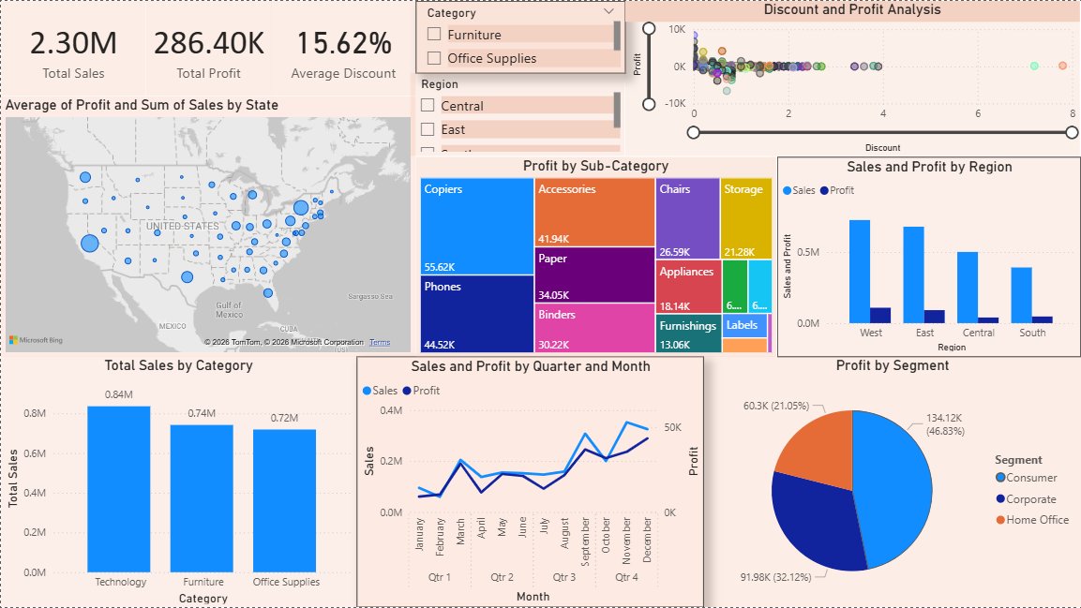Figure 1: Superstore Sales Dashboard

Visual 1 – Kpl Cards: The cards illustrate Total Sales of $2.30M, Total Profit of 286.40K, and Average Discount of 15.62%. Few (2012) highlights that KPI cards allows decision-makers to analyse business performance quickly, while Eckerson (2010) argue that the most common used in dashboard features for quick performance level display.

Visual 2- Sales by Category (Bar Chart)- Technology products records with $0.84, while Furniture and office supplies generated $0.74$ million and $0.72 million respectively. Furniture shows low profit compared with sales revenue, which highlights pricing and cost structure problem. Tufte (2001) highlights that bar charts are the most understandable visuals for analysing individual segment.

Visual 3- Line Chart (Sales and Profit by Quarter and Month): The final quarter sales and high profit is noticeable annually due to seasonal consumer demand. Q1 is regularly the weakest performing period. Wexler et al. (2017) find that time based line charts are the most effective method to understand patters of change and seasonal trends from business data.
Visual 4 – Sales by State (Map): The Bubble map demonstrates California, New York, and Texas as the successful state, while the Central area demonstrates significantly lower value size, which shows weaker performance. Cairo (2016) highlights that map based visuals specifically illustrate geographic patters hidden in data table, which makes map crucial in retail dashboards.

Visual 5 – Profit by Sub-Category (Treemap): Copiers, Phone, and Accessories are the largest segment as well as the highest profitable. Table and Bookcases seem limited profit.

Visual 6 – Sales and Profit by Region (Bar Chart): The West region rank first in both Sales and Profit; the Central region shows the poorest performance. The East region demonstrates high sales; however, a lower in profit, which indicates higher expenses or discount in that region. Davenport and Harris (2007) highlight that regional performance evaluation is the extremely usable for visualisation in retail sector.

Visual 7 – Discount and Profit Analysis (Scatter Chart): A negative relationship is noticeable because around 20% discounts regularly generate losses. This finding offers data driven proof that present discounts strategies are generating significant financial losses. Provost and Fawcett (2013) highlight that Scatter plots are essential for showing relationships between numerical business variables, that makes them essential for price analysis.

Visual 8 – Profit by Segment (Donut Chart): Consumer shows for 46.83% ($134.12k) of total profit, and Corporate demonstrates 32.12% ($91.98k), and Home office is at 21.05% ($60.3k). Sharda et al. (2020) argues that donut charts are perfect when shoeing a small amount of numbers are separated shares in which share distributions are the main analytical goal.

Business Evidence Based Decisions

Decision 1 – Prioritise in technology and evaluate furniture pricing strategy because technology generate highest return, and Furniture delivers unusually low returns. Therefore, fixing pricing strategy is required.

Decision 2 - Planning for Q4 marketing is essential as time series chart demonstrates in peak in Q4. The business must allocate funds for focused marketing campaigns for Octobers to December and develop stock capacity.

Decision 3 – improvement needs in Central region as both the map and regional bar chart prove that Central ranks the lowest. So a focused development plain based on the west region method should be implemented.

Decision 4- Limit in discount at 20% is needed since the scatter chart shows clear proof that discount more than 20% creates losses. A discount policy must be no more then 20%.

Decision 5 – Focus on consumer retention as consumer contributes for 46.83% of profit. Devenport and Harris (2007) argues that loyalty programs and target marketing should be focused.

Finding

The Superstore Sales Dashboard delivered five critical insights. First, Technology is the highest profitability segment while Furniture shows a financial risk. Secondly, a regular Q4 season is the highest sales period. Third, the West region ranks highest; however, the Central region ranks lowest. Forth, discount more than 20% creates negative profit, and it proves that discounts should be limited. Fifth, the consumer segment generates 46.83% from overall profit and requires top priority for customer retention. These findings show importance of data visualisation as data analysis tool. Knaflic (2015) argues that well structured visuals allow business to identify and understand data that support improved decisions. The idea of this dashboard clearly demonstrates and converts 9,994 raw data into actionable business findling.

References

Cairo, A. (2016). The truthful art: Data, charts, and maps for communication. New Riders.
Davenport, T. H., & Harris, J. G. (2007). Competing on analytics: The new science of winning. Harvard Business School Press.
Eckerson, W. W. (2010). Performance dashboards: Measuring, monitoring, and managing your business (2nd ed.). John Wiley and Sons.
Few, S. (2012). Show me the numbers: Designing tables and graphs to enlighten (2nd ed.). Analytics Press.
Kaggle. (2023). Sample superstore dataset. https://www.kaggle.com/datasets/vivek468/superstore-dataset-final
Kirk, A. (2016). Data visualisation: A handbook for data driven design. SAGE Publications.
Knaflic, C. N. (2015). Storytelling with data: A data visualisation guide for business professionals. John Wiley and Sons.
Microsoft. (2024). Power BI documentation. Microsoft Corporation. https://docs.microsoft.com/en-us/power-bi/
Provost, F., & Fawcett, T. (2013). Data science for business: What you need to know about data mining and data-analytic thinking. O'Reilly Media.
Sharda, R., Delen, D., & Turban, E. (2020). Analytics, data science, and artificial intelligence: Systems for decision support (11th ed.). Pearson.
Tufte, E. R. (2001). The visual display of quantitative information (2nd ed.). Graphics Press.
Wexler, S., Shaffer, J., & Cotgreave, A. (2017). The big book of dashboards: Visualizing your data using real-world business scenarios. John Wiley and Sons.

