**Sk. Abdul Kader Arafin**

***Skak_arafin@daffodilvarsity.edu.bd***

**Associate Professor (Physics)**

**Department of Natural Sciences**

**Daffodil International University (DIU)**

**Friction and frictional force:**

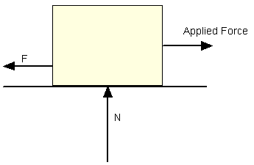When surfaces of two bodies are in contact whether they are at rest or in relative motion with respect to one another, they developed a force at plane of their contact which opposes their relative motion. This opposition is known as friction and the force which produced at the plane of contact between surfaces due to the relative motion of their surface called frictional force.

Frictional force can be expressed as

Ff = μ N        (1)

Where,

Ff = frictional force (N, lb)

μ = static (μs) or kinetic (μk) frictional coefficient

N = normal force (N, lb)

Frictional force mainly depends on

1. Nature of the surface
2. Degree of their smoothness
3. Presence of foreign materials (Air, oil, water etc.)
4. Temperature.

**Types of frictional force:**

### I. Kinetic friction:

If force **F** is greater than friction **Fr** (written as **F >Fr**), then the object will slide or move. The friction is considered kinetic friction, which means moving friction.

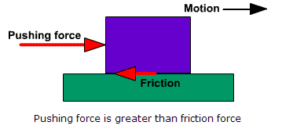

### II. Static friction:

### If the pushing force F is less than the resistive force of friction Fr (written as F <Fr), there is no motion and the objects remain static with respect to each other. In this case, the friction is considered static friction, which means it is not moving.

## III. Rolling friction:

When a wheel of ball is in contact with a solid surface, and a force is applied to the wheel, static friction will prevent the wheel from sliding. Instead, the wheel will start to roll. Once the wheel is rolling, another type of friction takes over. Rolling friction is the resistive force that slows the wheel's motion on the other solid surface. It is different than static or kinetic friction. Much of rolling friction is caused by adhesion between the surfaces.

## IV. Fluid friction

When a solid object is in contact with a fluid, such as a liquid or gas, and a force is applied to either the object or to the fluid, there is a friction force that resists the motion. Examples where fluid friction occurs are water flowing through a hose, an airplane flying through the atmosphere and oil lubricating moving parts.

**Coefficient of static and kinetic friction:**

The ratio of the magnitude of the maximum force of static friction to the magnitude of the normal force is called the coefficient of static friction for the surface involved. If fsrepresent the magnitude of the force of static friction, we can write

**Fs<**

Where, is the coefficient of static friction an N is the magnitude of the normal force. The equality sign holds only when fshas its maximum value.

The ratio of the magnitude of the force of kinetic friction to the magnitude of the normal force is called the coefficient of the kinetic friction, then

**fk =**

Where, $μ_{k}$ is the coefficient of kinetic friction.

Both $μ_{k} and μ_{s}$ is dimensionless constants, each being the ratio of (magnitudes of) two forces. Usually, for a given pair of surfaces, $μ_{s>}μ_{k}$

**Problem:**

1. An 80 kg box is pushed by 600 N forces with an angle of 30o along to the horizontal line. The box gained velocity 6 m/s starting from rest at 4 seconds. Find the friction coefficient of the box.
2. A 60 kg box is pushed by 600 N forces with an angle of 45o along to the horizontal line. If the sliding friction coefficient of the box is 0.4, find the acceleration of the box.

**Momentum/ Linear momentum:**

The momentum P of a body is defined as the product of its mass and its velocity:

**p = mv**

As the product of a vector and a scalar, momentum must also be a vector. From the above equation we can say that, the direction of P is the same as direction of p is the same direction of v. Because, p depends on v.

**Angular momentum:**

The moment of the liner momentum of a point or an axis is known as angular momentum. It is defined as the vector product of momentum and relative position vector.

Angular momentum, L = r x p

= rp sin $θ$

If the angle between r and p is 900.

Then, L = rp

**Moment of Inertia:**

The tendency of a body to resist angular acceleration, expressed as the sum of the products of the mass of each particle in the body and the square of its perpendicular distance from the axis of rotation is known as moment of inertia. For a point mass the moment of inertia is just the mass times from the axis squired. Mathematically, it can be written as,



**Theorem of moment of inertia:**

**a) Perpendicular Axis Theorem:**

The perpendicular axis theorem for planer objects can be demonstrated by looking at the contribution to the three axis momentums of inertia from an arbitrary mass element. From the point mass moment, the contributions to each of the axis moments of inertia are

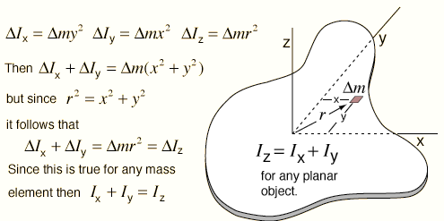

**b) Parallel Axis Theorem:**

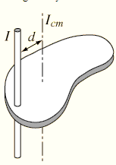The moment of inertia about a parallel axis is the center of mass moment plus the moment of inertia of the entire object treated as a point mass at the center of mass.



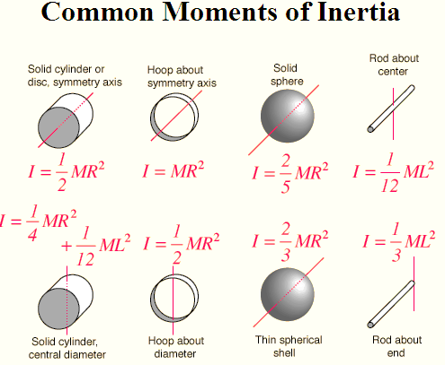

**Calculate the Moment of Inertia of a uniform bar about an axis passing through the midpoint and normal to the length of the bar:**

**Solution:** Let us consider *L* is the length and M is the mass of a bar. So, we can write the mass per unit length, **m = $\frac{M}{L}$**

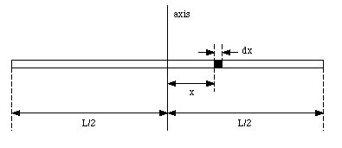

The mass dm of an element of the rod with length dx is **dm = $\frac{M }{L}dx$**

The contribution of this mass to the total moment of inertia of the rod is

dI = x2 dm =

The total moment of inertia of the rod can be determined by integrating over all parts of the rod: **dI = $\int_{\frac{-L}{2}}^{\frac{L}{2}}{\frac{M}{L}}x^{2} dx$**

**I = $\frac{M}{L }{\left[\frac{x^{3}}{3 }\right]}_{\frac{-L}{2}}^{\frac{L}{2}}$**

**I = $\frac{1}{3}\frac{M}{L} (\frac{L^{3}}{8}+ \frac{L^{3}}{8})$**

**I = $\frac{M L^{2}}{12}$**

**Find the moment of inertia of a thin circular disc about an axis passing through the center and normal to its plane.**

Consider a uniform circular plate of mass M and radius R as shown below in the figure

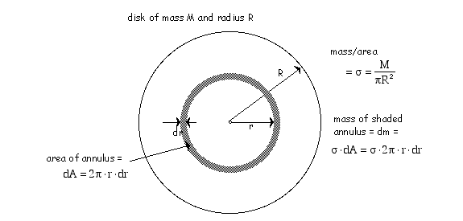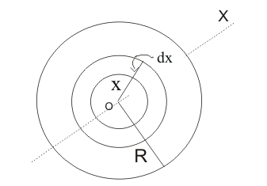

**O**

***Fig: Uniform circular disk with radius R and mass M.***

Let O be the center of the disk and OX is the axis perpendicular to the plane of the paper. To find the moment of inertia of the disk about the axis OX, we can consider a ring of thickness dr at a distance r from the center.

Area of this ring is equal to its circumference multiplied by its width i.e.  
Area of the ring, dA =2πrdr

Mass per unit area of the ring would be, $σ= \frac{M}{πR^{2}}$

So, the mass of the shaded portion, dm = $σ. 2πrdr$  
 = $\frac{M}{πR^{2}}. 2πrdr$

= $\frac{2 Mrdr}{R^{2}}$

 Moment of inertia of this ring about axis OX would be

MI of the ring = $\frac{2M rdr}{R^{2}}r^{2}$**= $\frac{2 Mr^{3}dr}{R^{2}}$**   
  
 Since whole disc can be supposed to be made up of such like concentric rings of radii ranging from O to R ,we can find moment of inertia I of the disc by integrating moment of inertia of the ring for the limits x=0 and x=R 

MI = $\int_{0}^{R }{\frac{2 Mr^{3}dr}{R^{2}}}$

= $\frac{2M}{R^{2 }}{[ \frac{r^{4}}{4} ]}_{0}^{R}$

**= $\frac{2M}{R^{2 }}\frac{R^{4}}{4}$**

MI **= $\frac{MR^{2}}{2}$**

**Work:**

The work is done whether a body is moved by applied force and is measured by the product of magnitudes of the force and the displacement or the component of the displacement along the force.

The unit of work or energy is the **Newton meter or Joule.**

1J is the quantity of work done when a force of 1N moves 1m, along its own line of action.

If the direction of the displacement is *not the same* as the direction of the force, we use the component of the force which is parallel to the displacement. For example, when a body is caused to accelerate down an inclined plane by the force of gravity:

|  |
| --- |
| DISPLACEMENT |

Therefore, the more general equation to calculate work done is

|  |
| --- |
| EQUATION |

The dot product of vector quantities is always scalar which means it is has only magnitude and no direction, that is why work is a scalar quantity.

Work can be either positive or negative: if the force has a component in the same direction as the displacement of the object experiencing the force, the force is doing positive work, but if the force has a component in the direction opposite to the displacement, the force does negative work. If you pick a book off the floor and put it on a table, for example, you're doing positive work on the book, because you supplied an upward force and the book went up. If you pick the book up and place it gently back on the floor again, though, you're doing negative work, because the book is going down but you're exerting an upward force, acting against gravity.

**Energy:**

The energy of a system or a body is the property of the system or the body enables it to do work. Work shifts energy from one system to another.

Energy is a scalar quantity. The unit of work is the unit of energy, the joule (J). 1 J = 1 N m. Energy can exist in many different forms. All forms of energy are either kinetic or potential energy.

### Kinetic energy: An object has kinetic energy if it has mass and if it is moving. It is energy associated with a moving object, in other words. For an object traveling at a speed v and with a mass m, the kinetic energy is given by:

K.E = $\frac{1}{2} m v^{2}$

**Potential energy: The energy associated with position is called potential energy and it is divided into two categories.**

**I) Gravitational Potential energy:**

Gravitational potential energy is a function of the position of the object in a gravitational field, force of gravity at that point and mass of the object. The formula is as follows:

Gravitational potential energy, P.E. = mgh

Where m is the mass, g is the acceleration due to gravity (9.8 ms-2) and h is the height above the Earth surface.

II) **Elastic potential energy**:

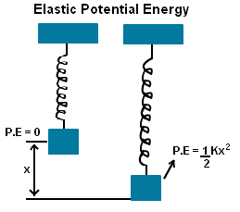Elastic potential energy is the potential energy observed due to stretching or compression by an external force to a given elastic object.The **Elastic Potential Energy Formula** for the stretched spring is given by

**P.E. = $\frac{1}{2} k x^{2}$**

Where k is the spring constant, x is the displacement.

**Work- Energy Theorem:**

**The work-energy theorem is a generalized description of motion that states that the work done by the sum of all forces acting on an object is equal to the change in that object's kinetic energy.** Mathematically,

$$∆K=K_{f}- K_{i}=W$$

### Derivation of Work-Energy Theorem using a Constant Net Force:

Let us consider a particle of mass m is moving a velocity Vo along +X- axis. A constant force F is applied on the particle and produces acceleration along X- axis. From, Newton’s second law of motion,

F = ma

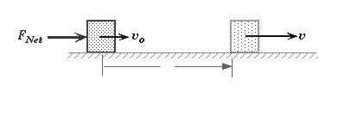

**x**

The work done by the force for its time of action

W = F.x = ma. x ( where, x is the displacement at time ,t)

Since, a and x are acting along the same line, so

$$θ=0 , cosθ=1$$

**W = max …… (1)**

Again, if a particle moves with uniform acceleration Vo and V initial and final velocities respectively. Then, the relation can be written as,

**V2 = Vo2 + 2ax**

**2ax = V2 – Vo2**

**ax = ½ (V2 – Vo2)** ………….(2)

Using this value, in equation (1), we obtain,

**W = m (V2 – Vo2)**

=  **m V 2 - m Vo2**

But m Vo2 is the initial kinetic energy and m V 2 is the final kinetic energy. Thus for accelerated motion, the work done by a constant force is equal to the increasing kinetic energy.

**Problem**: A block of mass m = 11.7kg is to be pushed a distance of s = 4.65 m along an incline sot that it is raised a distance of h = 2.86 m in the process (fig -1). As summing frictionless surfaces, calculate how much work you would do on the block if you applied a force parallel to the incline to push the block up at constant speed.

**Torque:**

The quantity in rotational dynamics that takes into account both the magnitude of the force and the direction and location at which it is applied is called torque. In a word, torque is a twist or turn that tends to produce rotation. Applications are found in many common tools around the home or industry where it is necessary to turn, tighten or loosen devices.

**Or**. A torque is an action that causes objects to rotate. A torque is required to rotate an object, just as a force is required to move an object in a line.

The torque (τ) created by a force is equal to the lever arm (r) times the magnitude of the force (F).

$$τ=r x F$$

The units of torque are force times distance, or newton-meters.

When an object is in rotational equilibrium,the net torque applied to it is zero. For example, if an object such as a see-saw is not rotating, you know the torque on each side is balanced.

**Problem** : A boy and his cat sit on a seesaw. The cat has a mass of 4 kg and sits 2 m from the center of rotation. If the boy has a mass of 50 kg, where should he sit so that the see-saw will balance?

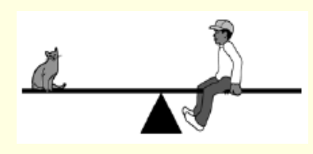

**The banking on curved road:**

The system of a rising the outer edge of curved road above its inner edge is called banking of a curved road. The angle that track makes with the horizontal is called the banking.

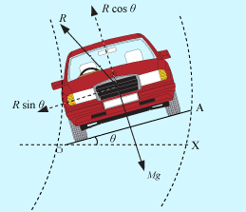

Consider a vehicle of weight Mg moving round a curved path of radius r, with a speed v, on a road banked through angle $θ.$

The vehicle is under the action of the following forces:

The weight Mg, acting vertically downwards

The reaction R of the ground to the vehicle, acting along the normal to the banked road OA in the upward direction.

The vertical component R cos $θ$ of the normal reaction R will balance the weight of the vehicle and the horizontal component R sin $θ$ will provide the necessary centripetal force to the vehicle. Thus

R cos $θ=Mg$…………. (1)

R sin $θ$ = $\frac{M v^{2}}{r}$……… (2)

Now dividing equation (2) by equation (1), we get

$$\frac{R sin θ}{R cosθ}= \frac{\frac{M v^{2}}{r}}{Mg}$$

tan $θ$ = $\frac{v^{2}}{rg}$

**Problem**: A banked circular highway curve is designed for traffic moving at 20 km/h. The radius of the curve is 19000 cm. Find the banking angle? (Take g= 9.8 m/s2)

Reference book:)

1. Fundamental of Physics, 9th edition (Halliday, Resnick and krane)

2. Physics for game developers (David M. Bourg and Bryan Bywalec)