ANSWER 4.1







ANSWER 4.2









ANSWER 4.3

A) The arrangement of optical cable types used in practice in increasing order according to their size:

The size of optical cables is typically categorized by the diameter of the core (the central part that carries the light). Here is a general arrangement from smallest to largest:

1. **Single-Mode Fiber (SMF):**
   * Single-mode fiber has a small core size, usually around 9 microns in diameter. It allows only one mode of light to propagate, providing high bandwidth and long-distance transmission.
2. **Multimode Fiber (MMF):**
   * Multimode fiber has a larger core size compared to single-mode fiber, typically around 50 to 62.5 microns in diameter. It allows multiple modes of light to propagate, providing shorter-distance transmission but with a higher bandwidth than single-mode fiber.
3. **Plastic Optical Fiber (POF):**
   * Plastic optical fiber has a larger core size compared to glass fibers. The core size can vary but is generally in the range of 200 to 1000 microns. POF is often used for shorter-distance applications.

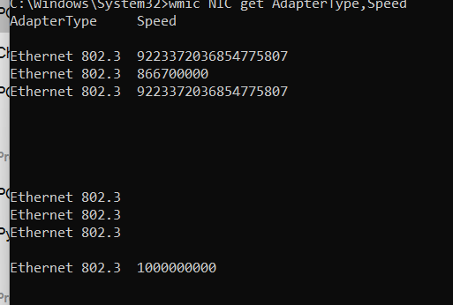

ANSWER 4.4

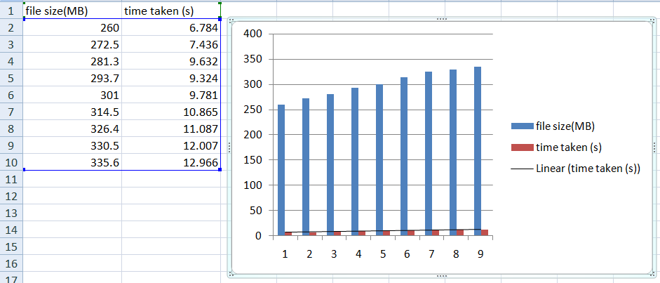

ANSWER 4.5

