4.1 A**) Characteristics of coaxial cable**:

- Diameter: Thin coaxial cable is around 5mm, while thick coaxial cable is around 10mm.

- Connector types: BNC connectors are commonly used, with options like T-connectors, barrel connectors, and terminators.

- Length from connector to NIC: Varies depending on network setup, ranging from a few centimeters to several meters, with couplers adding a few more centimeters.  
  
  
4.1 B) **Characteristics of twisted-pair cable**:

- Diameter: Varies depending on the specific type and category of twisted-pair cable being used.

- Connector components: Utilizes RJ-45 connectors, which consist of plastic housing and metal pins.

- Length from plug to NIC: Differs based on network setup and requirements, typically ranging from a few centimeters to several meters.  
  
  
4.1 C) **Characteristics of optical fiber cable:**

- Diameter of outer plastic jacket: Varies depending on the specific cable, but typically ranges from 2mm to 10mm.

- Cable types according to length in increasing order: Single-mode fiber and multimode fiber.

- Diameter of plug submodule: Differs based on the connector type, commonly around 2.5mm to 3mm.

4.2 A) To calculate the corresponding decibel values for the given power ratios (x), we can use the formula:

dB = 10 * log 10(x)

- For x = 12 , the decibel value is approximately 10.79 dB.

- For x = 14 , the decibel value is approximately 11.46 dB.

- For x = 16 , the decibel value is approximately 12.04 dB.

4.2 B) The corresponding values of power ratio (x) for the given decibel values are approximately as follows:

- For 13 dBs, x approx 19.95

- For -68 dBs, x approx 1.58 * 10^-7

- For -70 dBs, x approx 1.00 * 10^-7

4.3 A) **The properties of the Oracle VM VirtualBox**

- version number : 7.0.10 r158379 (Qt5.15.2)



- number of possible VM types : 5

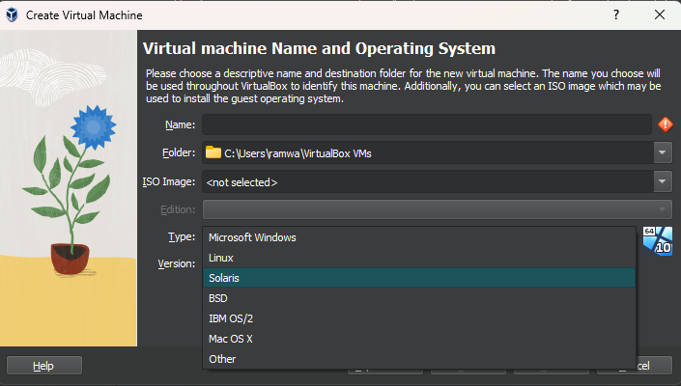

- possible types of VM network interfaces:

- NAT (Network Address Translation)

- Bridged Adapter

- Internal Network

- Host-only Adapter

- Generic Driver

- Cloud Network(Experimental)

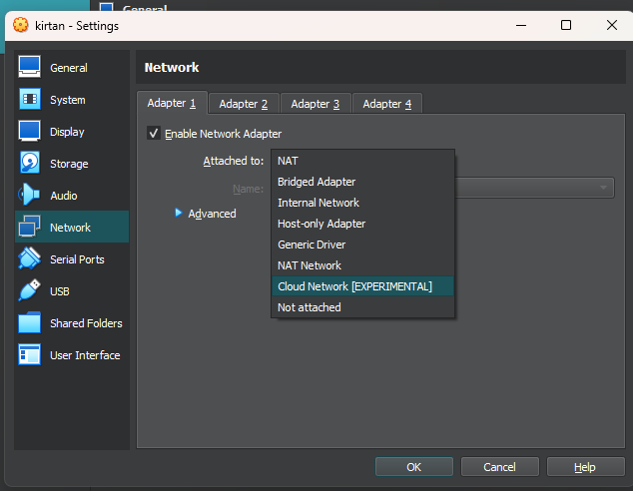

- possible number of VM network interfaces:

7

4.3 B) Configuration : C:\Users\ramwa\VirtualBox VMs\kirtan

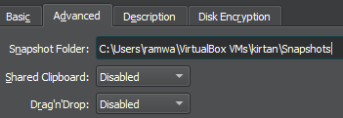

HardDisk :

