Lab04

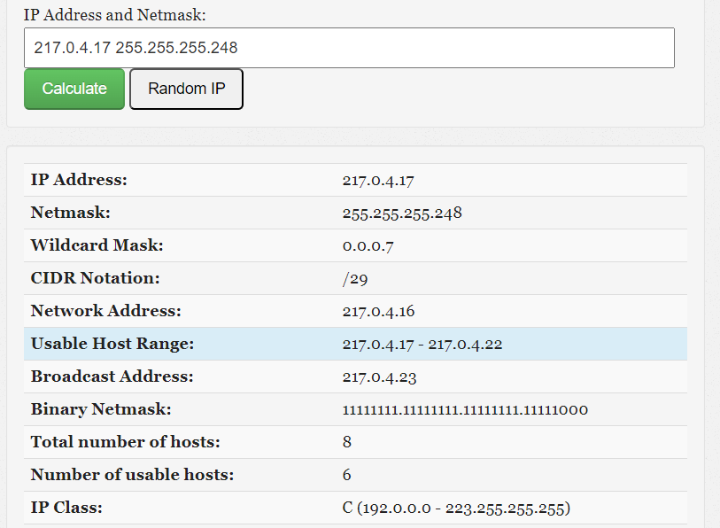

4.1.

A) Network address/Netid: 217.0.4.16

B) Host address/Hostid:(217.0.4.17-217.0.4.22)

C) IP address class: C

D) Netmask related to the address / (in slash notation) and in dotted decimal form:/29 and 255.255.255.248

4.2.

A) What IP addresses did the virtual machines receive in the network?

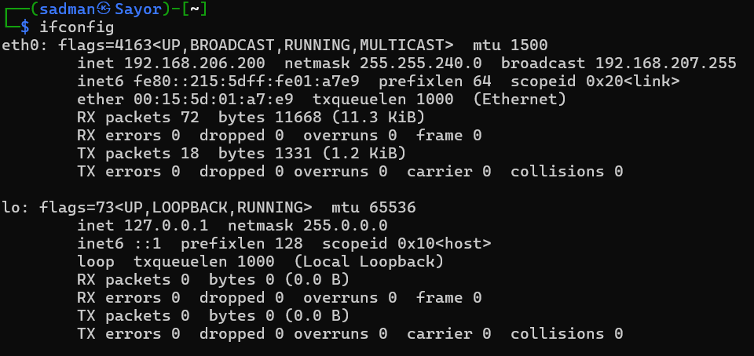

B) How would be possible to change the IP address of the 1st machine for the IP address used in the previous exercise?

sudo nano /etc/network/interfaces

sudo /etc/init.d/networking restart

4.3.

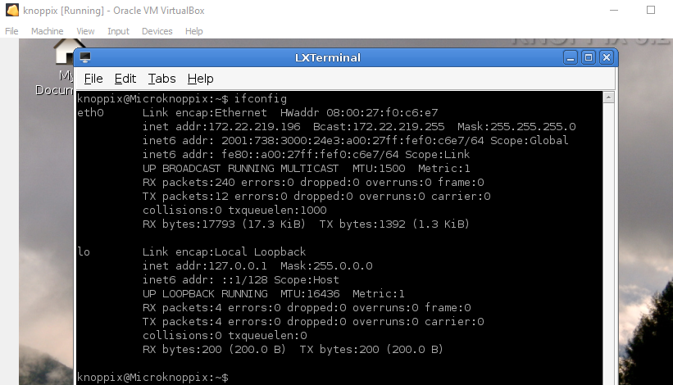

A) What is the physical address of the 1st machine? How can you display this information (by using only linux terminal)?

08:00:27:f0:c6:e7

ifconfig

B) What is the name of the manufacturing company assigned to this physical address?

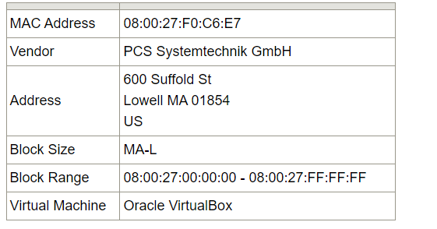

C) What does happen with the ARP table after shutting down the connection and after reconnection?

* After shutting down the connection and reconnecting, the ARP table on the 1st machine will be cleared.
* Upon reconnection, the 1st machine will send ARP requests to re-establish connections with other devices, and the ARP table will be repopulated with the MAC addresses of the devices it communicates with.

D) Which command did you use precisely to insert a new entry to the arp table?

sudo arp -s [IP_address] [MAC_address]

E) Which command did you use precisely to delete a static entry from the arp table?

sudo arp -d [IP_address]

4.4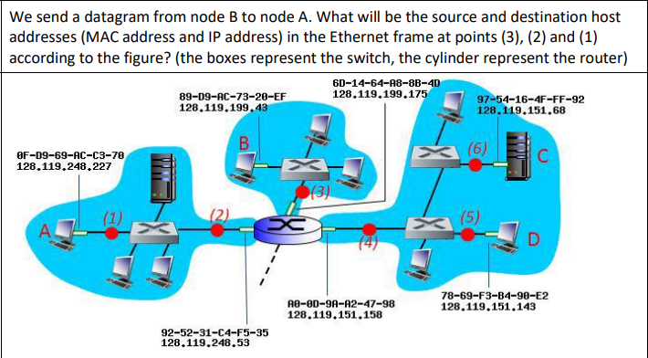

A) Fill in the following table:

3.IP(source):128.119.199.43

MAC(source):6D-14-64-A8-8B-4D

IP(destination):128.119.248.227

MAC(destination):92-52-31-C4-F5-35

2.IP(source): 128.119.199.43

MAC(source): 6D-14-64-A8-8B-4D

IP(destination): 128.119.248.227

MAC(destination): 89-D9-AC-73-20-EF

1.IP(source): 128.119.199.43

MAC(source):6D-14-64-A8-8B-4D

IP(destination): 128.119.248.227

MAC(destination):89-D9-AC-73-20-EF

B) Explain what is the role of the physical address and that of the IP address in the network communication. Which type of address can be used in what cases (when)?

