Lab05

S M Sadman Sakib Sayor

figure 3.1

Internet

|

Router 1

| | | |

Hub 1 Hub 2 Sw1 Sw2

| | | |

PC1 PC2 PC3 PC4

4.1.

A) How many collision domains and broadcast domains did you find?

In the given network topology:

* **Collision Domains**: There are 6 collision domains. Each port on a switch represents a separate collision domain, so we have 2 from the switches (Sw1 and Sw2). Each hub also represents a single collision domain, so we have 2 from the hubs (Hub1 and Hub2). Finally, each interface on the router also represents a separate collision domain, so we have 2 from the router (Router1).
* **Broadcast Domains**: If we consider the router, then we have 3 broadcast domains. Each interface on the router is a separate broadcast domain. So, the network connected to each interface of the router forms a separate broadcast domain.

B) How would the domains change if you used L1 connection devices instead of all L2 connection devices on your figure?

If we replaced all L2 devices (the switches) with L1 devices (hubs):

* **Collision Domains**: The number of collision domains would decrease. This is because hubs do not separate collision domains. Each hub represents a single collision domain, regardless of the number of devices connected to it. So, in this case, we would have 4 collision domains - 2 from the new hubs replacing the switches, and 2 from the existing hubs.
* **Broadcast Domains**: The number of broadcast domains would remain the same. This is because both switches and hubs forward broadcast traffic. So replacing a switch with a hub does not change the number of broadcast domains. We would still have 3 broadcast domains, one for each interface on the router

. 4.2.

a)After the configuration of the IP address (using ifconfig command) the routing table will be empty or not?

After configuring the IP address using the ifconfig command, the routing table will not be empty. It will have at least one entry, which is the network that the IP address belongs to. This is because when you assign an IP address to an interface, the system automatically creates a route for the network that this IP address belongs to.

B) Why is it not enough to configure the routing table only on one node?

Configuring the routing table on only one node is not enough because routing is a two-way process. For communication to happen between two nodes, both nodes need to know how to reach each other. If only one node knows the route to the other, it can send packets to the other node, but the other node won’t be able to send packets back. Therefore, for effective communication, routing tables need to be configured on all nodes involved.

C) Can we configure a node as a default gateway with a network address/ prefix length 10.0.4.25/24? Why?

Yes, you can configure a node as a default gateway with a network address/prefix length of 10.0.4.25/24. However, the IP address 10.0.4.25 should be assigned to one of the interfaces of the node that you want to configure as the default gateway. The default gateway is the node that the network uses to send packets to other networks. In this case, any packet with a destination outside the 10.0.4.0/24 network would be sent to the default gateway for further routing. Please note that the default gateway itself needs to know how to route these packets to their destination, which is typically achieved by configuring static routes or running a routing protocol.

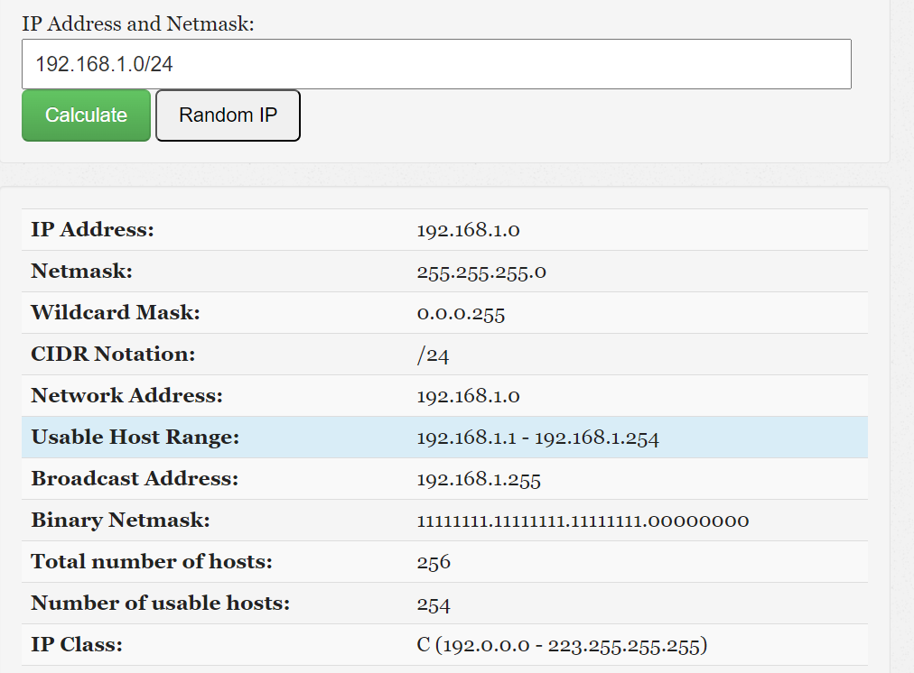

4.3.

A)Determine the obtained subnets together with their netmask.

Here are the obtained subnets along with their netmasks:

1. Subnet 1: 192.168.1.0/27 with a netmask of 255.255.255.224
2. Subnet 2: 192.168.1.32/27 with a netmask of 255.255.255.224
3. Subnet 3: 192.168.1.64/27 with a netmask of 255.255.255.224
4. Subnet 4: 192.168.1.96/27 with a netmask of 255.255.255.224
5. Subnet 5: 192.168.1.128/27 with a netmask of 255.255.255.224
6. Subnet 6: 192.168.1.160/27 with a netmask of 255.255.255.224

B) Is it possible to refer somehow to the first 4 subnets all together from the obtained subnets? If it is possible, how can we do it?

Yes, it is possible to refer to the first 4 subnets all together. You can do this by using a larger subnet that encompasses all 4 subnets. In this case, you can use the 192.168.1.0/26 subnet, which includes all addresses from 192.168.1.0 to 192.168.1.63, thus covering the first 4 subnets. Please note that this is for reference purposes only and doesn’t change the actual configuration of the individual subnets.

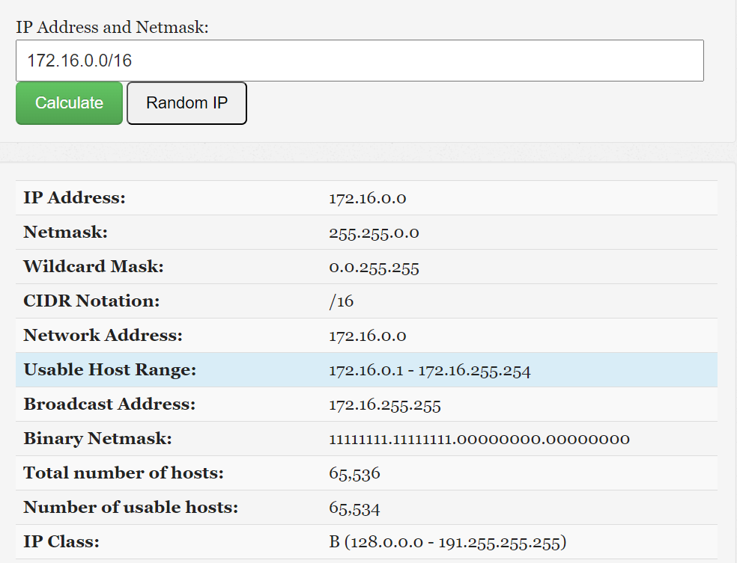

4.4.

A) Determine the obtained subnets together with their netmask.

Here are the obtained subnets along with their netmasks:

1. Subnet 1: 172.16.0.0/19 with a netmask of 255.255.224.0
2. Subnet 2: 172.16.32.0/21 with a netmask of 255.255.248.0
3. Subnet 3: 172.16.40.0/20 with a netmask of 255.255.240.0
4. Subnet 4: 172.16.56.0/21 with a netmask of 255.255.248.0

B) What happens if the requirements arrive with a bigger difference in time, i.e. subnetting has to be performed in the order of entering routes in the routing table?/

 If the requirements arrive with a bigger difference in time, i.e., if the subnets are not all known at the start, then the subnetting would need to be performed in the order of the requirements. This could potentially lead to inefficient use of the IP address space, as you might end up with a situation where you cannot satisfy a later requirement because the address space has been used up by earlier subnets.

C) How many nodes approximately left from the initial network with a thousand precision which can be used?

The initial network with a prefix length of /16 has 2^(32-16) = 65,536 addresses. After subtracting the addresses used by the four subnets (8192 for subnet 1, 2048 for subnet 2, 4096 for subnet 3, and 2048 for subnet 4), and considering that each subnet uses 2 addresses for the network and broadcast addresses, we have approximately 65,536 - (8192 + 2048 + 4096 + 2048) - 4*2 = 48,128 addresses left. So, approximately 48,000 addresses are left with a thousand precision.

D) What is the size of the biggest subnet/network which can be used from the remaining host addresses?

The size of the biggest subnet/network that can be used from the remaining host addresses would be a /17 subnet, which provides 2^(32-17) = 32,768 addresses (32,766 usable). This is because 32,768 is the largest power of 2 that is less than the number of remaining addresses (48,128).