**LAB-06**

4.1.

A) What modes do we have to configure on each network adapter?

Su

Root priviledge or super user mode

B) What command the IP addresses can be configured with?

sudo ifconfig eth0 <ip addr> netmask <netmask>

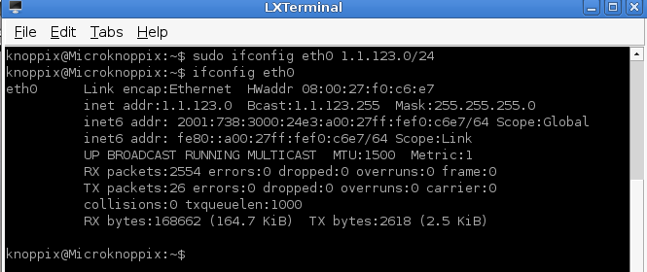

4.2.

A) What is the meaning of the routing table?

A routing table serves as a **database** that tracks paths, similar to a map. It helps determine the optimal way to forward network traffic.

B) What command the access of a direct network can be configured with?

route add –net <ip addr> eth0

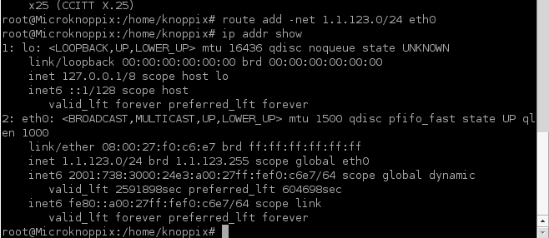

C) What command the access of a remote network can be configured with?

route add –net <ip addr> gw

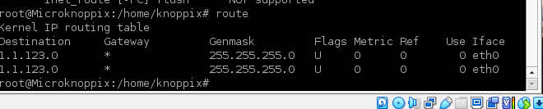

4.3.

A) How can we find the number of routers between two nodes? Determine the command.

Traceroute

Ping –c 4 unideb.hu

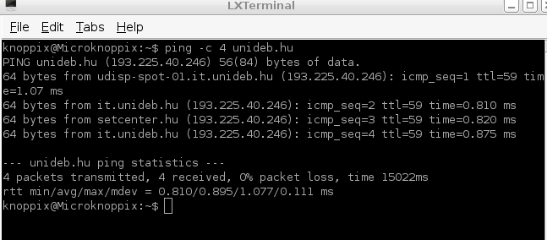

Common default ttl value in linux is 64

Number of router is (64 – ttl value) = 64 -59 = 5

B) What does RTT (Round-Trip Time) value prove?

Round Trip Time (RTT) - the total time it takes for a packet of data to be sent from a source to a destination and then back to the source and often used as an indicator of network latency, which is the time it takes for data to travel from one point to another in a network.