**EXPERIMENT NO. 3**

**Aim**: To understand the Kubernetes Cluster Architecture, install and Spin Up a Kubernetes Cluster on Linux Machines/Cloud.

**Procedure:**

1. **Creation Of Instance**

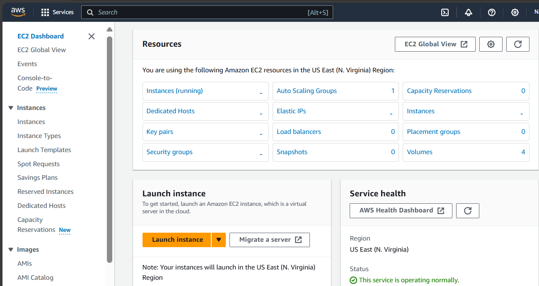

Search EC-2 instance. Then create three EC-2 instances and choose Amazon Linux as OS and also allow ssh traffic from anywhere.

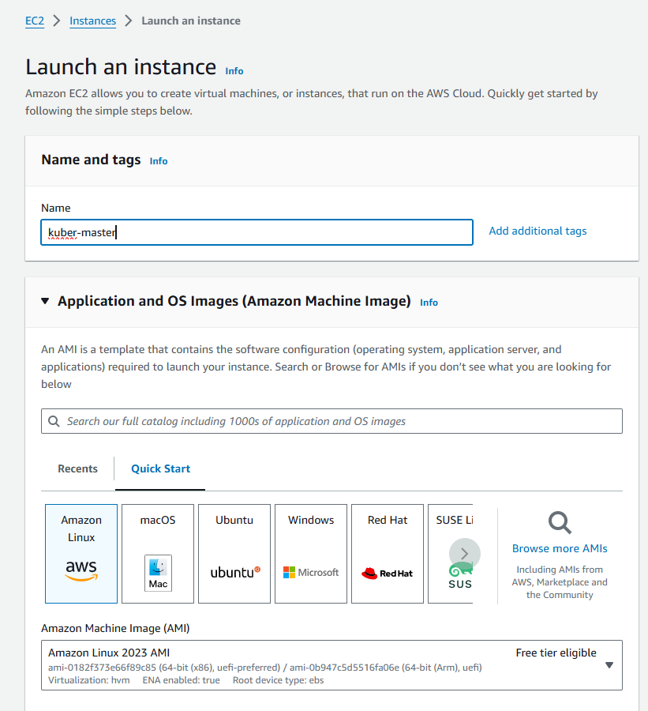

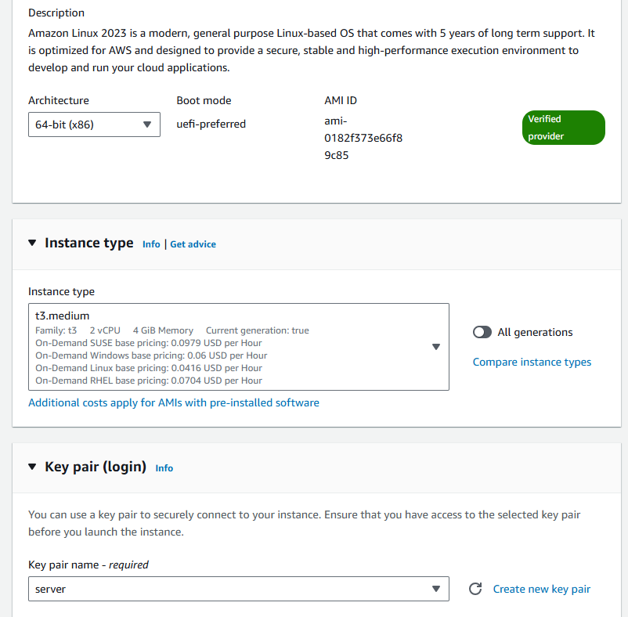

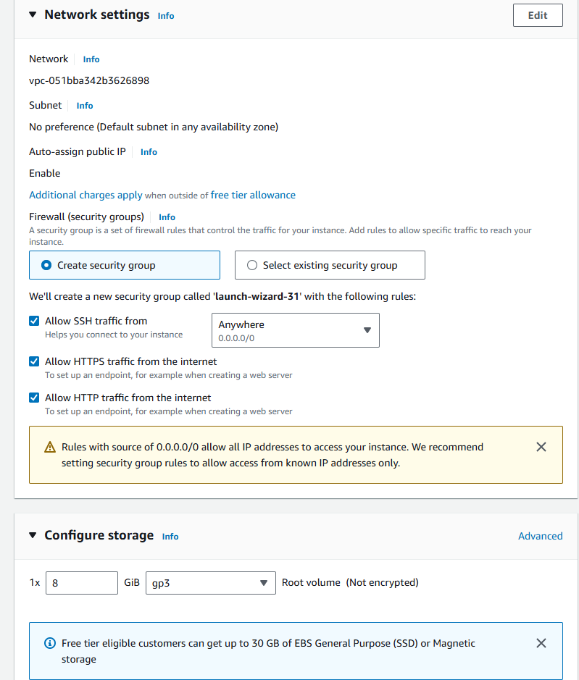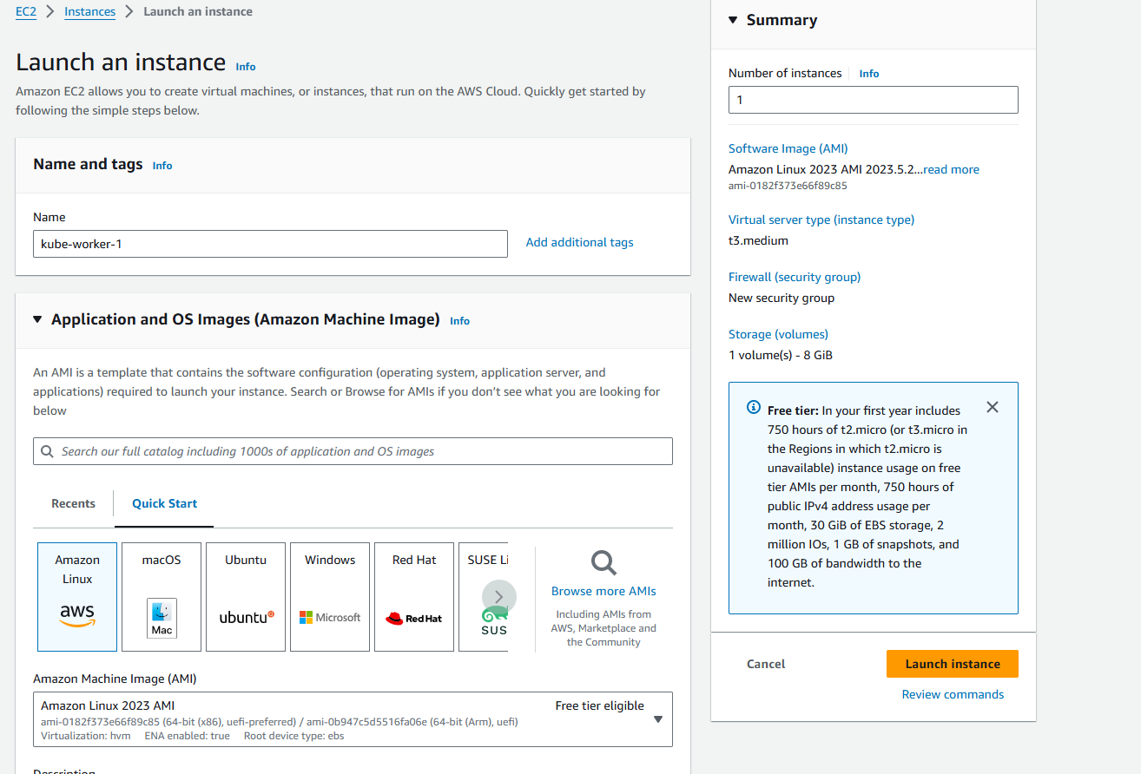

To efficiently run kubernetes cluster select instance type of at least t3.medium as kubernetes recommends at least 2 vCPU to run smoothly on it.

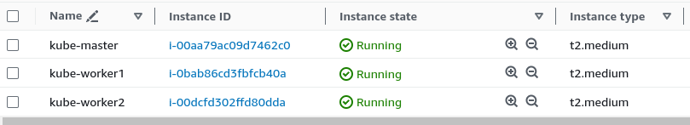

* Then for making connection through SSH into all 3 machines each in separate terminal

Use this following command:

ssh -i <keyname>.pem ubuntu@<public_ip_address> where keyname is name of the key you created here i created key server.pem and use public IP address.(I have entered this command on git bash where i entered in downloads where server.pem is stored then as the key is not accessible hence we need to change its mode using chmod 400 “key name.pem”. Then use the given command for making connections).

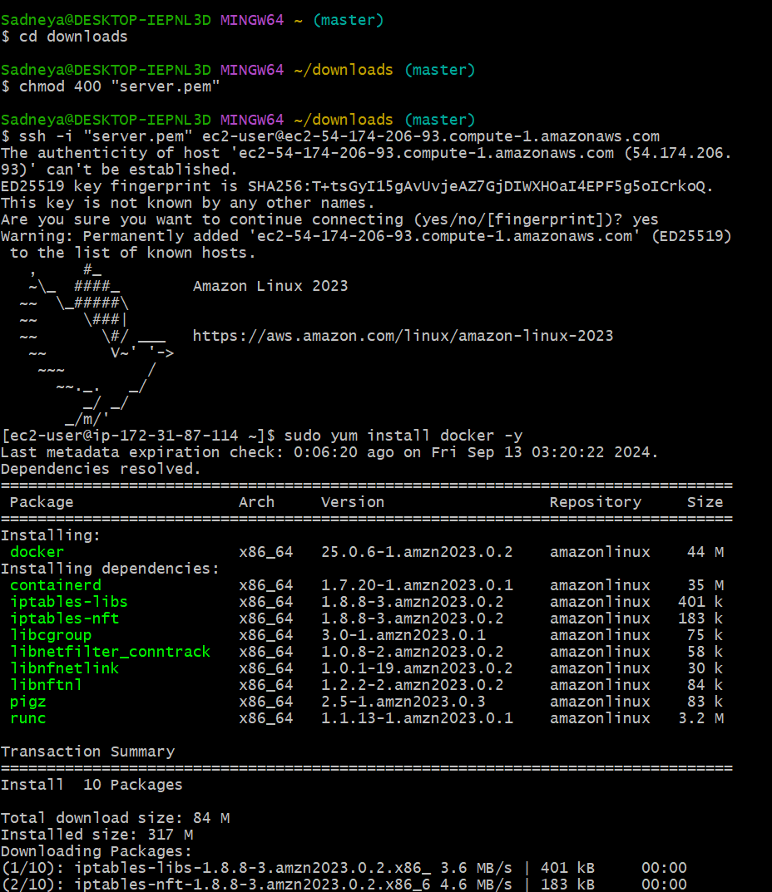

1. **Installation Of Docker on three machines**

* For installation of Docker into all three machines run the following command:

sudo yum install docker -y



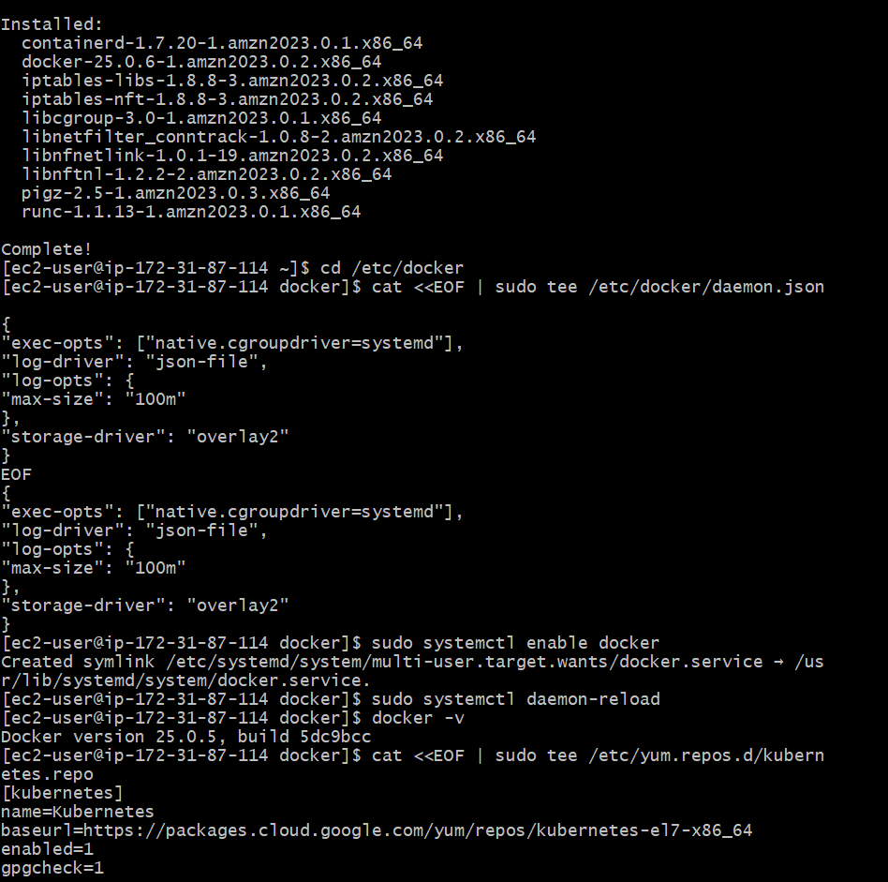

* Then, configure cgroup in a daemon.json file by using following commands

cd /etc/docker

cat <<EOF | sudo tee /etc/docker/daemon.json

{

"exec-opts": ["native.cgroupdriver=systemd"],

"log-driver": "json-file",

"log-opts": {

"max-size": "100m"

},

"storage-driver": "overlay2"

}

EOF



* Then after this run the following command to enable and start docker and also to load the daemon.json file.

sudo systemctl enable docker

sudo systemctl daemon-reload

sudo systemctl restart docker



* Then check the version of docker installed.

docker -v



1. **Installation Of Kubernetes on three machines**

* SELinux needs to be disable before configuring kubelet thus run the following command

sudo setenforce 0

sudo sed -i 's/^SELINUX=enforcing$/SELINUX=permissive/' /etc/selinux/config



* Here We are adding kubernetes using the repository whose command is given below.

cat <<EOF | sudo tee /etc/yum.repos.d/kubernetes.repo

[kubernetes]

name=Kubernetes

baseurl=https://pkgs.k8s.io/core:/stable:/v1.30/rpm/

enabled=1

gpgcheck=1

gpgkey=https://pkgs.k8s.io/core:/stable:/v1.30/rpm/repodata/repomd.xml.key

exclude=kubelet kubeadm kubectl cri-tools kubernetes-cni

EOF

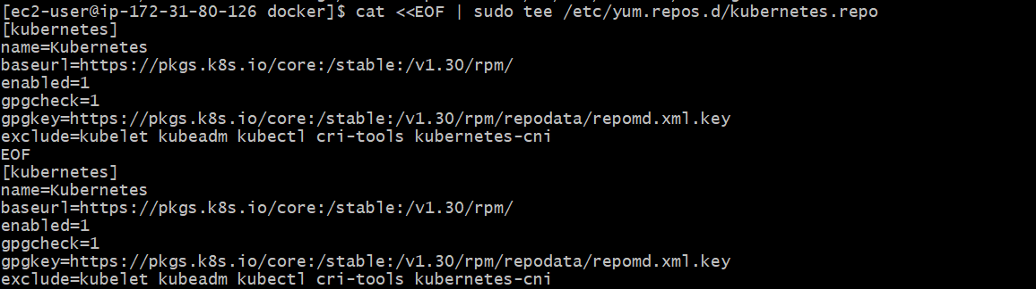

* After that Run following command to make the updation and also to install kubelet ,kubeadm, kubectl: sudo yum update

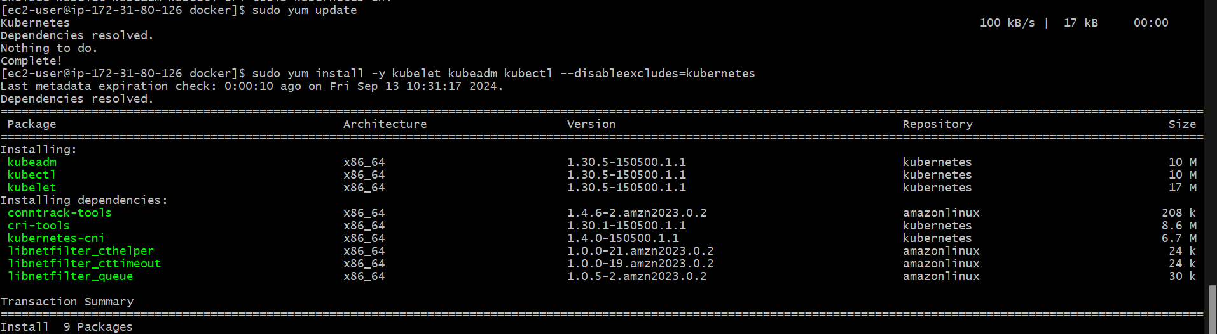

sudo yum install -y kubelet kubeadm kubectl --disableexcludes=kubernetes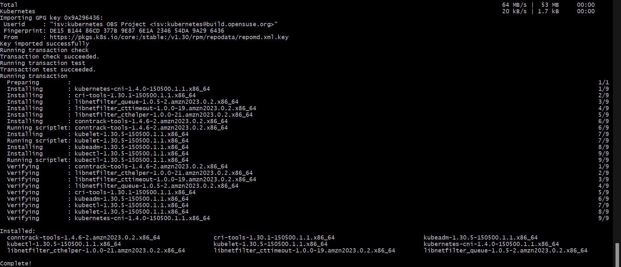

* After installing Kubernetes, we need to configure internet options to allow bridging.

1. sudo swapoff -a
2. echo "net.bridge.bridge-nf-call-iptables=1" | sudo tee -a /etc/sysctl.conf
3. sudo sysctl -p

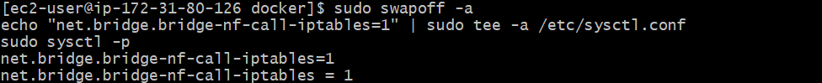

1. **Perform this ONLY on the Master machine**

* Initialize kubernetes by typing below command

sudo kubeadm init --pod-network-cidr=10.244.0.0/16 --ignore-preflight-errors=all

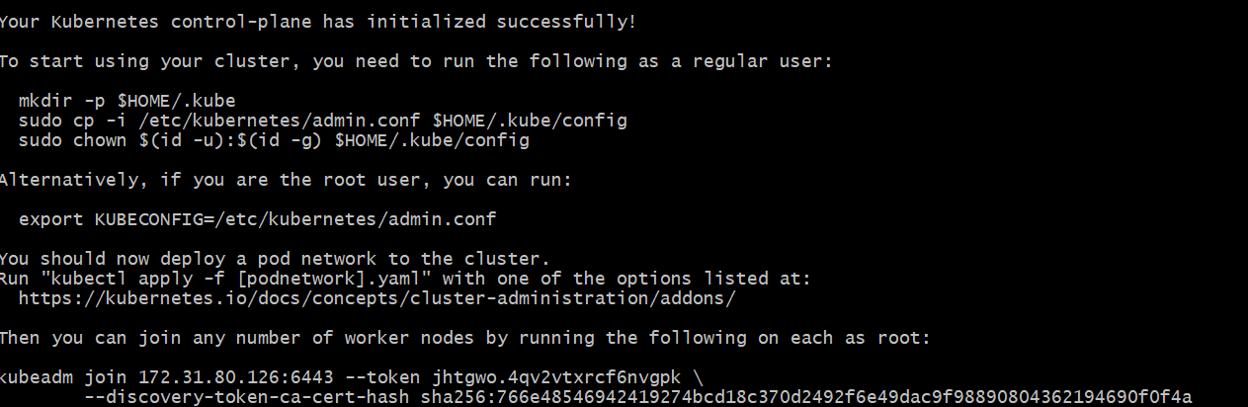

* So after initialization you will get token at the end for joining master and worker. Like here I got this :(save this token as it is required later.Then you can join any number of worker nodes by running the following on each as root.)

kubeadm join 172.31.80.126:6443 --token jhtgwo.4qv2vtxrcf6nvgpk\ --discovery-token-ca-cert-hash sha256:766e48546942419274bcd18c370d2492f6e49dac9f98890804362194690f0f4a

* Also,Copy the mkdir and chown commands from the top and execute them

mkdir -p $HOME/.kube

sudo cp -i /etc/kubernetes/admin.conf $HOME/.kube/config

sudo chown $(id -u):$(id -g) $HOME/.kube/config

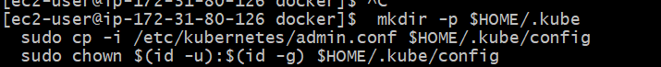

* Then, add a common networking plugin called flammel file as mentioned in the code.

kubectl apply -f <https://raw.githubusercontent.com/coreos/flannel/master/Documentation/kube-flannel.yml>



* Now to Check the created pod use this command

kubectl get pods

1. **Perform this ONLY on the worker machines**

Paste the below command on all 2 worker machines

* sudo yum install iproute-tc -y
* sudo systemctl enable kubelet
* sudo systemctl restart kubelet

Now use this

kubeadm join 172.31.80.126:6443 --token jhtgwo.4qv2vtxrcf6nvgpk\ --discovery-token-ca-cert-hash sha256:766e48546942419274bcd18c370d2492f6e49dac9f98890804362194690f0f4a

(Optional To check the status of pods executed these commands:

Kubectl get pods -n kube-system :gives status of all pods

Kubectl get daemonstat -n kube-system: gives status of pod named daemonstat 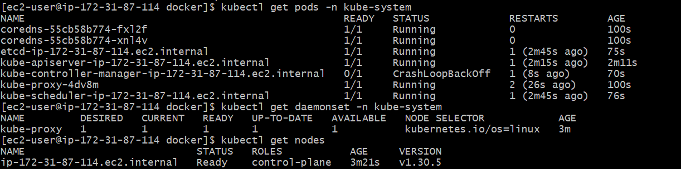)

Now to see whether master and workers get connected successfully or not run **kubectl get nodes** command on master machine



**Conclusion:** In these EC-2 instance created successfully on AWS Linux. Then I installed docker ,kuberneted and then kubelet ,kubeadm, kubectl.Then on Master machine ,I initailized the kubernetes which given me the token which will be used for connection of master and workers.then on slave I installed iproute and enabled and restarted kubelet then i enter the token which i got from master but there was an issue in joint.that is why on output i just got of only one

pc mater on performing command kubectl get nodes.