Experiment No. 9

**Aim**: To implement Service worker events like fetch, sync and push for E-commerce PWA.

# Theory:

* **Service Worker**

Service Worker is a script that works on browser background without user interaction independently. Also, It resembles a proxy that works on the user side. With this script, you can track network trafﬁc of the page, manage push notiﬁcations and develop “ofﬂine ﬁrst” web applications with Cache API.

Things to note about Service Worker:

1. A service worker is a programmable network proxy that lets you control how network requests from your page are handled.
2. Service workers only run over HTTPS. Because service workers can intercept network requests and modify responses, "man-in-the-middle" attacks could be very bad.
3. The service worker becomes idle when not in use and restarts when it's next needed. You cannot rely on a global state persisting between events. If there is information that you need to persist and reuse across restarts, you can use IndexedDB databases.
4. Service workers make extensive use of promises, so if you're new to promises, then you should stop reading this and check out Promises, an introduction.

# Fetch Event

You can track and manage page network trafﬁc with this event. You can check existing cache, manage “cache ﬁrst” and “network ﬁrst” requests and return a response that you want.

Of course, you can use many different methods but you can ﬁnd in the following example a “cache ﬁrst” and “network ﬁrst” approach. In this example, if the request’s and current location’s origin are the same (Static content is requested.), this is called “cacheFirst” but if you request a targeted external URL, this is called “networkFirst”.

1. **CacheFirst** - In this function, if the received request has cached before, the cached response is returned to the page. But if not, a new response requested from the network.
2. **NetworkFirst** - In this function, ﬁrstly we can try getting an updated response from the network, if this process completed successfully, the new response will be cached and returned. But if this process fails, we check whether the request has been cached before or not. If a cache exists, it is returned to the page, but if not, this is up to you. You can return dummy content or information messages to the page.

# Sync Event

Background Sync is a Web API that is used to delay a process until the Internet connection is stable. We can adapt this deﬁnition to the real world; there is an e-mail client application that works on the browser and we want to send an email with this tool. Internet connection is broken while we are writing e-mail content and we didn’t realize it. When completing the writing, we click the send button.

Here is a job for the Background Sync.

The following view shows the classical process of sending email to us. If the Internet Connection is broken, we can’t send any content to Mail Server.

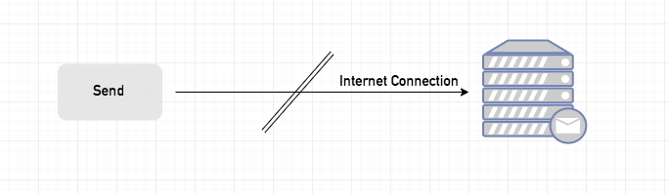

Here, you can create any scenario for yourself. A sample is in the following for this case.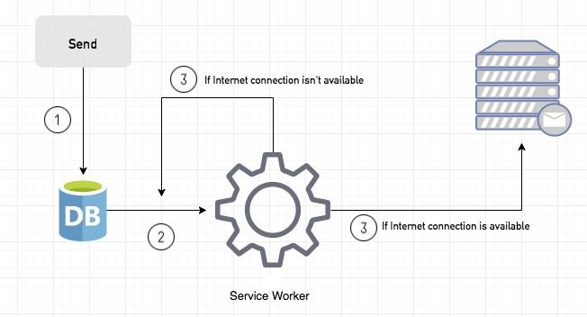

1. When we click the “send” button, email content will be saved to IndexedDB.
2. Background Sync registration.
3. **If the Internet connection is available**, all email content will be read and sent to Mail Server.

**If the Internet connection is unavailable**, the service worker waits until the connection is available even though the window is closed. When it is available, email content will be sent to Mail Server.

You can see the working process within the following code block.

# Push Event

This is the event that handles push notiﬁcations that are received from the server. You can apply any method with received data.

We can check in the following example.

“Notiﬁcation.requestPermission();” is the necessary line to show notiﬁcation to the user. If you don’t want to show any notiﬁcation, you don’t need this line.

In the following code block is in sw.js ﬁle. You can handle push notiﬁcations with this event. In this example, I kept it simple. We send an object that has “method” and “message” properties. If the method value is “pushMessage”, we open the information notiﬁcation with the “message” property.

You can use Application Tab from Chrome Developer Tools for testing push notiﬁcation.

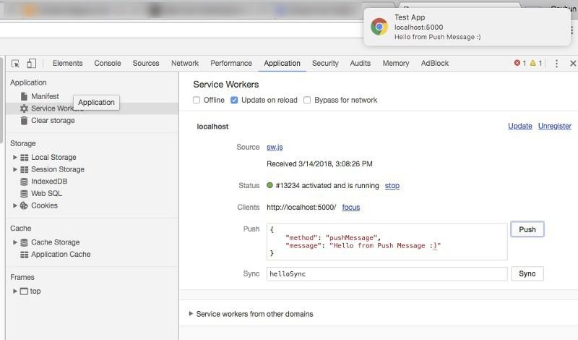

* **Github Link:** [**https://github.com/sadneya145/acti_web.git**](https://github.com/sadneya145/acti_web.git)
* **Output:** so here it shows test push message from Devtools so we can push notifications here.

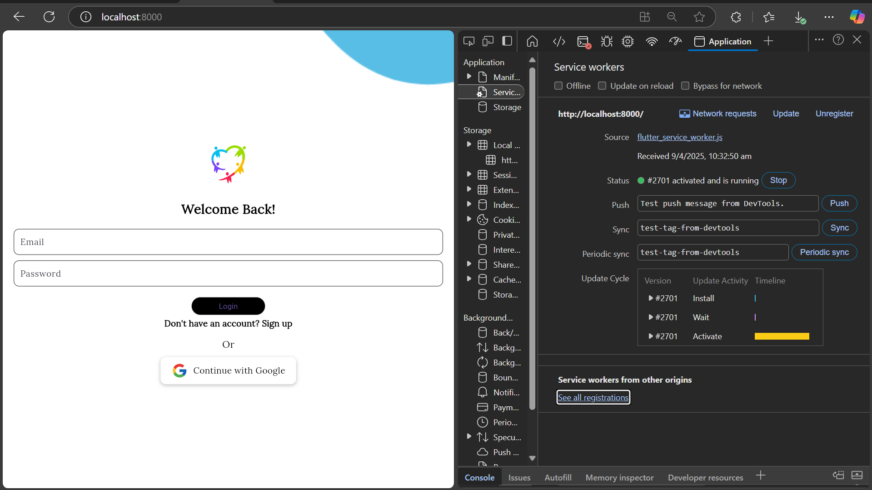

## Conclusion: We successfully implemented Service Worker events for our E-commerce PWA, significantly improving its reliability and user experience. The fetch event implementation enables faster page loads and offline browsing. The sync event ensures that user actions like placing orders complete successfully even during connectivity issues. The push event implementation allows the application to receive timely updates and notifications from the server, enhancing user engagement.