**EXPERIMENT NO:6**

**Aim**: **-** To write meta data of your Ecommerce PWA in a Web app manifest file to enable “add to homescreen feature”.

**Github Link:** [**https://github.com/sadneya145/Activibe.git**](https://github.com/sadneya145/Activibe.git)

**Description:**

In this app, user authentication is handled using Firebase Authentication and user data is

stored in MongoDB.

**Login Functionality:**

1. Users enter their email and password to log in.
2. Firebase Authentication verifies credentials.
3. If successful, the app retrieves the user's data from MongoDB and redirects them to the home page.

**Signup Functionality:**

1. Users register with an email, password, and optionally other details.
2. Firebase Authentication creates the new user.
3. The user's details are then stored in MongoDB for future reference.
4. Once signed up, the user is redirected to the main page.

**Output:**

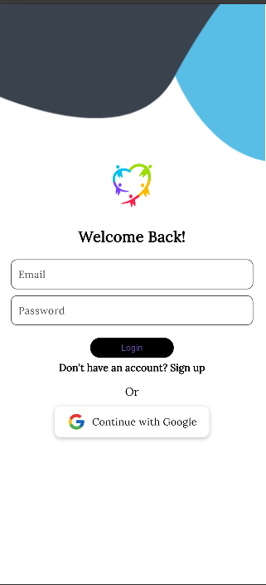 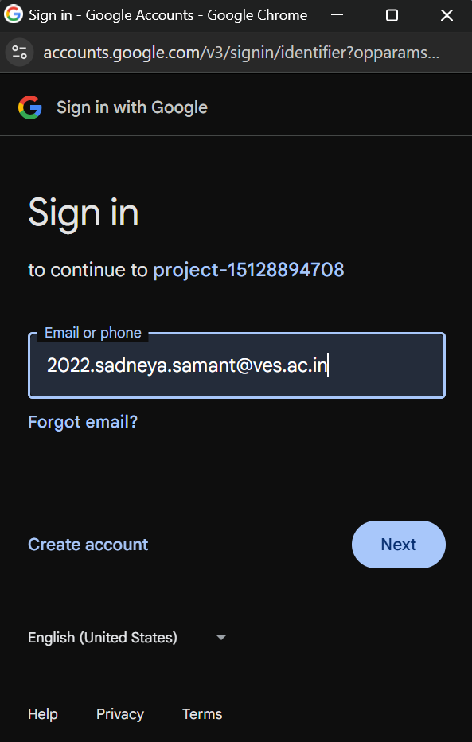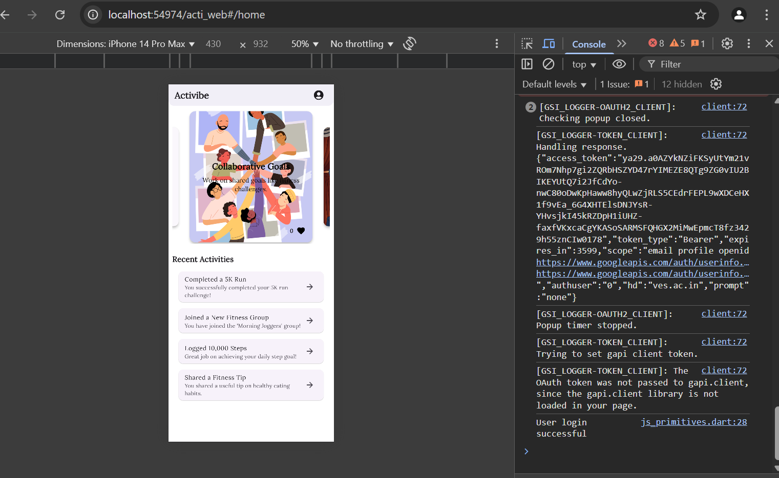

**Conclusion:** This experiment successfully demonstrated how to connect a Flutter UI to a Firebase database for real-time data management. By integrating Firebase Authentication and Firestore, user authentication and data storage were implemented efficiently. The experiment also covered CRUD operations, ensuring smooth interaction with the database. Proper authentication and security measures were applied to protect user data. Overall, this experiment highlights the seamless integration of Flutter with Firebase, enabling the development of dynamic and secure applications.