Google Cloud Deployments:

What is Cloud Computing?
Cloud computing is defined as the services offered through remote servers on the internet. These services might include database storage, applications, compute power and other IT resources over the pay-as-you-go pricing approach. The remote server allows users to save, modify, or process data on the internet or cloud-based platform instead of storing it on a local server or their devices.
Cloud computing is evolving due to fast performance, better manageability, and less maintenance. It helps organizations to minimize the number of resources and overall infrastructure costs. Additionally, it helps IT teams better focus on the important applications, services, and processes and achieve the company's goals.
Typically, the cloud-computing providers offer their services according to the following three standard models:
- Platform as a Service (PaaS)
- Software as a Service (SaaS)
- Infrastructure as a Service (IaaS)

What is Google Cloud Platform?
Google Cloud Platform (GCP) is a suite of cloud computing services provided by Google. It is a public cloud computing platform consisting of a variety of services like compute, storage, networking, application development, Big Data, and more, which run on the same cloud infrastructure that Google uses internally for its end-user products, such as Google Search, Photos, Gmail and YouTube, etc.
The services of GCP can be accessed by software developers, cloud administrators and IT professionals over the Internet or through a dedicated network connection.

Why Google Cloud Platform?
Google Cloud Platform is known as one of the leading cloud providers in the IT field. The services and features can be easily accessed and used by the software developers and users with little technical knowledge. Google has been on top amongst its competitors, offering the highly scalable and most reliable platform for building, testing and deploying the applications in the real-time environment.
Apart from this, GCP was announced as the leading cloud platform in the Gartner's IaaS Magic Quadrant in 2018. Gartner is one of the leading research and advisory company. Gartner organized a campaign where Google Cloud Platform was compared with other cloud providers, and GCP was selected as one of the top three providers in the market.
Most companies use data centers because of the availability of cost forecasting, hardware certainty, and advanced control. However, they lack the necessary features to run and maintain resources in the data center. GCP, on the other side, is a fully-featured cloud platform that includes:
- Capacity: Sufficient resources for easy scaling whenever required. Also, effective management of those resources for optimum performance.
- Security: Multi-level security options to protect resources, such as assets, network and OS -components.
- Network Infrastructure: Number of physical, logistical, and human-resource-related components, such as wiring, routers, switches, firewalls, load balancers, etc.
- Support: Skilled professionals for installation, maintenance, and support.
- Bandwidth: Suitable amount of bandwidth for peak load.
- Facilities: Other infrastructure components, including physical equipment and power resources.
Therefore, Google Cloud Platform is a viable option for businesses, especially when the businesses require an extensive catalog of services with global recognition.

Benefits of Google Cloud Platform
Some of the main benefits of Google Cloud Platform are explained below:
Best Pricing: Google enables users to get Google Cloud hosting at the cheapest rates. The hosting plans are not only cheaper than other hosting platforms but also offer better features than others. GCP provides a pay-as-you-go option to the users where users can pay separately only for the services and resources they want to use.
Work from Anywhere: Once the account is configured on GCP, it can be accessed from anywhere. That means that the user can use GCP across different devices from different places. It is possible because Google provides web-based applications that allow users to have complete access to GCP.
Private Network: Google has its own network that enables users to have more control over GCP functions. Due to this, users achieve smooth performance and increased efficiency over the network.
Scalable: Users are getting a more scalable platform over the private network. Because Google uses fiber-optic cables to extend its network range, it is likely to have more scalability. Google is always working to scale its network because there can be any amount of traffic at any time.
Security: There is a high number of security professionals working at Google. They always keep trying to secure the network and protect the data stored on servers. Additionally, Google uses an algorithm that encrypts all the data on the Cloud platform. This gives assurance to the users that their data is completely safe and secure from unauthorized sources.
Redundant Backup: Google always keeps backup of user's data with built-in redundant backup integration. In case a user has lost the stored data, it's not a big problem. Google always has a copy of the users' data unless the data is deleted forcefully. This adds data integrity, reliability and durability with GCP.

Key Features of Google Cloud Platform
The following are some key features of Google Cloud Platform:
- On-demand services: Automated environment with web-based tools. Therefore, no human intervention is required to access the resources.
- Broad network access: The resources and the information can be accessed from anywhere.
- Resource pooling: On-demand availability of a shared pool of computing resources to the users.
- Rapid elasticity: The availability of more resources whenever required.
- Measured service: Easy-to-pay feature enables users to pay only for consumed services.
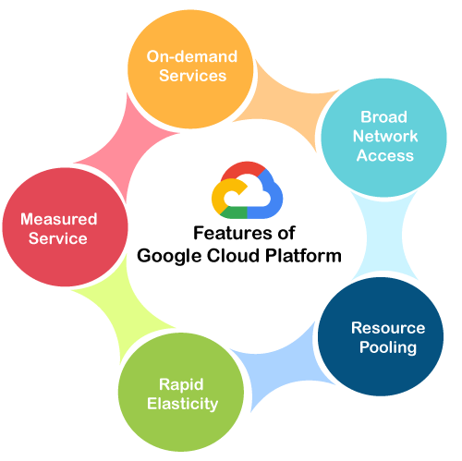

Working of Google Cloud Platform
When a file is uploaded on the Google cloud, the unique metadata is inserted into a file. It helps identify the different files and track the changes made across all the copies of any particular file. All the changes made by individuals get synchronized automatically to the main file, also called a master file. GCP further updates all the downloaded files using metadata to maintain the correct records.
Let's understand the working of GCP with a general example:
Suppose that MS Office is implemented on Cloud to enable several people to work together. The primary aim of using cloud technology is to work on the same project at the same time. We can create and save a file on the cloud once we install a plugin for the MS Office suite. This will allow several people to edit a document at the same time. The owner can assign access to specific people to allow them to download and start editing the document in MS Office.
Once users are assigned as an editor, they can use and edit the document's cloud copy as desired. The combined, edited copy is generated that is known as the master document. GCP helps to assign a unique URL to each specific copy of the existing document given to different users. However, any of the authorized users' changes will be visible on all the copies of documents shared over the cloud. In case multiple changes are made to the same document, then GCP allows the owner to select the appropriate changes to keep.

Google Cloud Platform Services
Google provides a considerable number of services with several unique features. That is the reason why Google Cloud Platform is continually expanding across the globe. Some of the significant services of GCP are:
- Compute Services
- Networking
- Storage Services
- Big Data
- Security and Identity Management
- Management Tools
- Cloud AI
- IoT (Internet of Things)
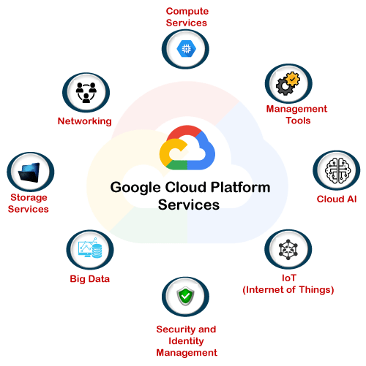
Let's understand each of these services in details:

Compute Services
GCP offers a scalable range of computing services, such as:
- Google App Engine: It is a cloud computing platform that follows the concept of Platform-as-a-Service to deploy PHP, Java and other software. It is also used to develop and deploy web-based software in Google-managed data centers. The most significant advantage of Google App Engine is its automatic scaling capability. This means that the App Engine automatically allocates more resources for the application when there is an increase in requests.
- Compute Engine: It is a cloud computing platform that follows the concept of Infrastructure-as-a-Service to run Windows and Linux based virtual machines. It is an essential component of GCP. It is designed on the same infrastructure used by Google search engine, YouTube and other Google services.
- Kubernetes Engines: This computing service is responsible for offering a platform for automatic deployment, scaling, and other operations of application containers across clusters of hosts. The engine supports several container tools like a docker, etc.

Networking
GCP includes the following network services:
- VPC: VPC stands for Virtual Private Network. The primary function of VPC is to offer a private network with routing, IP allocation, and network firewall policies. This will help to create a secure environment for the application deployments.
- Cloud Load Balancing: As its name states, Cloud balancing is used to distribute workload across different computing resources to balance the entire system performance. This also results in cost-reduction. The process also helps in minimizing the availability and maximizing the capability of the resources.
- Content Delivery Network: CDN is a geographically distributed network of proxy servers and their data centers. The primary aim of using CDN is to provide maximum performance to the users. Additionally, it also helps deliver high availability of resources by equally distributing the related services to the end-users.

Storage Services
GCP has the following storage services:
- Google Cloud Storage: It is an online data storage web service that Google provides to its users to store and access data from anywhere. The service also includes a wide range of features like maximum performance, scalability, security and sharing.
- Cloud SQL: It is a web-service that enables users to create, manage, and use relational databases stored on Google Cloud servers. The service itself maintains and protects the databases, which helps users focus on their applications and other operations.
- Cloud Bigtable: It is known for its fast performance and highly manageable feature. It is a highly scalable NoSQL database service that allows collecting and retaining data from as low as 1 TB to hundreds of PB.

Big Data
GCP provides a variety of services related to big data; they are:
- BigQuery: It is a fully managed data analysis service by Google. The primary aim of Google BigQuery service is to helps businesses to analyze Big Data. It offers a highly scalable data management option. This means BigQuery allows users to perform ad-hoc queries and share data insights across the web.
- Google Cloud Datastore: Google Cloud Datastore is a kind of datastore service that is fully managed, schema-less, and non-relational. This service enables businesses to perform automatic transactions and a rich set of queries. The main advantage of Google Cloud Datastore is the capability of automatic scaling. This means that the service can itself scale up and down, depending on the requirement of resources.
- Google Cloud Dataproc: It is a very fast and easy to use big data service offered by Google. It mainly helps in managing Hadoop and Spark services for distributed data processing. The service allows users to create Hadoop or Spark clusters sized according to the overall workload and can be accessed whenever users want them.

Security and Identity Management
GCP includes the following services related to Security and Identity management:
- Cloud Data Loss Prevention API: It is mainly designed to manage sensitive data. It helps users manage sensitive data elements like credit card details, debit card details, passport numbers, etc. It offers fast and scalable classification for sensitive data.
- Cloud IAM: It stands for Cloud Identity and Access Management. It is a framework that contains rules and policies and validates the authentication of the users for accessing the technology resources. That is why it is also known as Identity Management (IdM).

Management Tools
GCP includes the following services related to management tools:
- Google Stackdriver: Google Stackdriver service is primarily responsible for displaying the overall performance and diagnostics information. This may include insights of data monitoring, tracing, logging, error reporting, etc. The service also prompts an alert notification to the public cloud users.
- Google Cloud Console App: It is a native mobile application powered by Google. The primary aim of this service is to enable users to manage the core features of Google Cloud services directly from their mobile devices anytime, anywhere. The primary functions of this service are alerting, monitoring, and performing critical actions on resources.

Cloud AI
When it comes to Cloud AI, GCP offers these services:
- Cloud Machine Learning Engine: It is another fully managed service that allows users to create Machine Learning models. The service is mainly used for those ML models, which are based on mainstream frameworks.
- Cloud AutoML: It is the type of service that is based on Machine Learning. It helps users to enter their data sets and gain access to quality trained pre-designed ML models. The service works by following Google's transfer learning and Neural Architecture Search method.

IoT (Internet of Things)
GCP contains the following IoT services:
Cloud IoT Core: It is one of the fully managed core services. It allows users to connect, control, and ingest data from various devices that are securely connected to the Internet. This allows other Google cloud services to analyze, process, collect and visualize IoT data in real-time.
Cloud IoT Edge: The Edge computing service brings memory and other computing-power resources near to the location where it is required.

Advantages of Google Cloud Platform
There are several advantages of using Google Cloud Platform, such as:
- Google Cloud Offers Quick and Easy Collaboration: Multiple users can access the data and simultaneously contribute their information. This is possible because the data is stored on the cloud servers, not on the user's personal computers.
- Higher Productivity with Continuous Development: Google is always working on adding new features and functionalities to provide higher productivity to the customers. Therefore, Google delivers frequent updates to its products and services.
- Less Disruption with Adopting New Features: Instead of pushing huge disruptive updates of changes, Google provides small updates weekly. This helps users to understand and adopt new features easily.
- Least or Minimal Data is stored on Vulnerable Devices: Google does not store data on local devices unless a user explicitly tries to do it. This is because the data stored on local devices may get compromised compared to the cloud's data.
- Users can access Google Cloud from Anywhere: The best thing is that a user can easily access the information stored on Google cloud from anywhere because it is operated through web-based applications.
- Google provides Maximum Security with its Robust Structure: Google hires leading security professionals to protect user's data. Users get process-based and physical security features made by Google.
- Users have Full Control over their Data: Users gain full control over services and the data stored in Google Cloud. If a user does not want to use Google services any longer and wants to delete the cloud data, it can be easily performed.
- Google provides Higher Uptime and Reliability: Google uses several resources to provide higher and reliable up-time servers. If a data center is not working for technical issues, the system will automatically communicate with the secondary center without interruption visible to users.

Creating a Free Tier Account on GCP
To start using Google Cloud Platform, we are first required to create an account GCP. Here, we will create a free tier account for explaining the upcoming topic of this tutorial. The best thing about free account is that Google provides $300 worth credit to spend over the next 90 days after the date of account creation. Google offers all the core services of GCP with a free account for the next 90 days.
However, users must have a credit card to start a free tier account. Google asks for the credit card details to make sure that it is a genuine human request. Google does not charge automatically even after the 90 days or when we have exhausted the $300 free credit. The amount will only be charged when we will be upgrading our free account to a paid account manually.
Let's start with the steps of creating a free tier account on Google Cloud Platform:
Step 1: First, we are required to navigate to the following link: https://cloud.google.com/gcp/
Step 2: On the next screen, we need to click on 'Get started for free', as shown below:
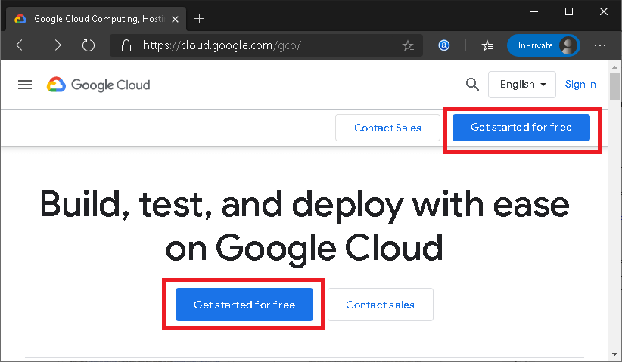
Step 3: Next, we are required to login to the Google Account. We can use the 'create an account' button if we don't have an existing Google account.
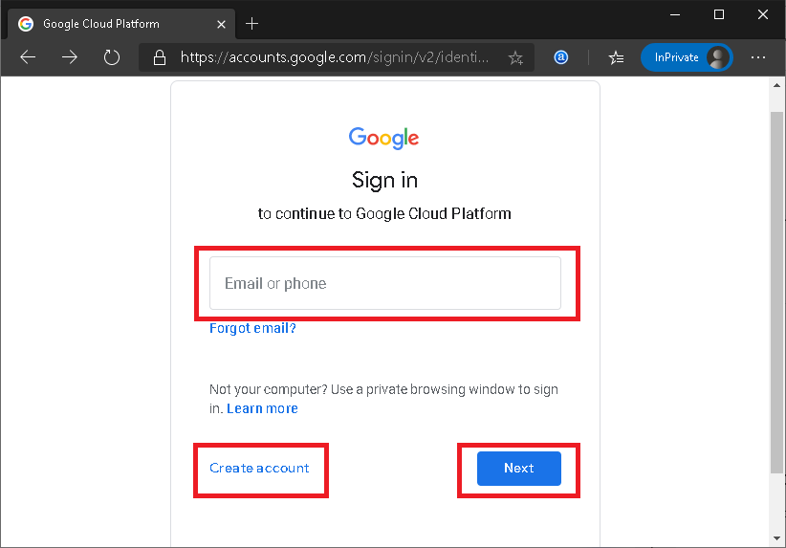
Step 4: Once we have logged in, we will get to the following screen:
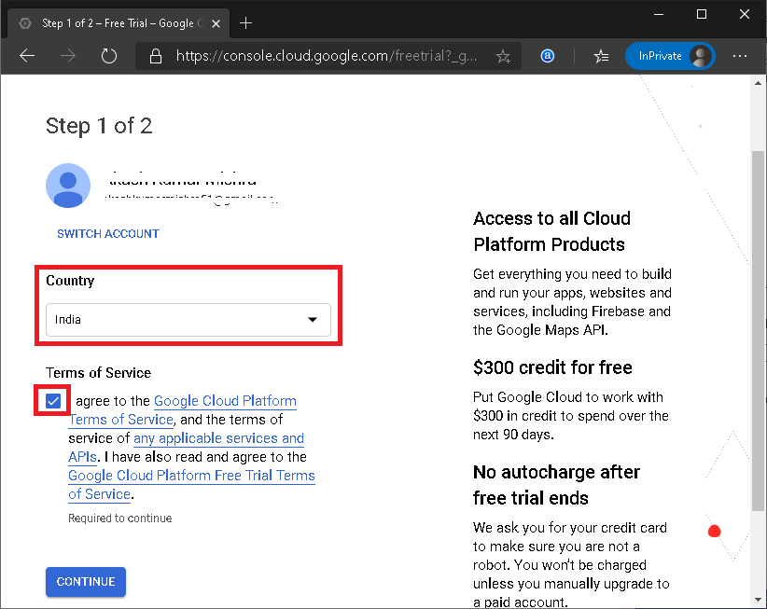
Here, we must select the Country, agree to the Terms of Service, and then click on the 'CONTINUE' button.
Step 5: On the next screen, we have to enter some necessary details such as name and address details. Also, we have to enter payment details like the method of payments and credit card details. After filling all the details, we need to click on the button 'START MY FREE TRIAL' from the bottom of the page:
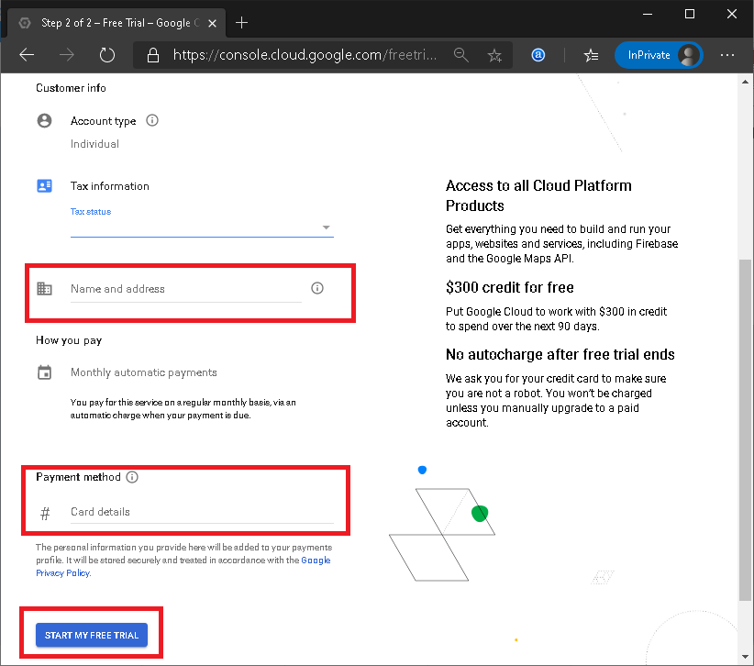
Step 6: Google asks for the confirmation to use the credit card for the small deduction to ensure that the card information is correct. However, the amount is refunded back to the same account. Here, we need to click on the 'CONTINUE' button:
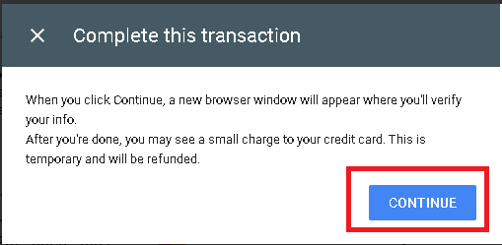
Step 7: On the next screen, we must click on the 'GO TO CONSOLE' button:
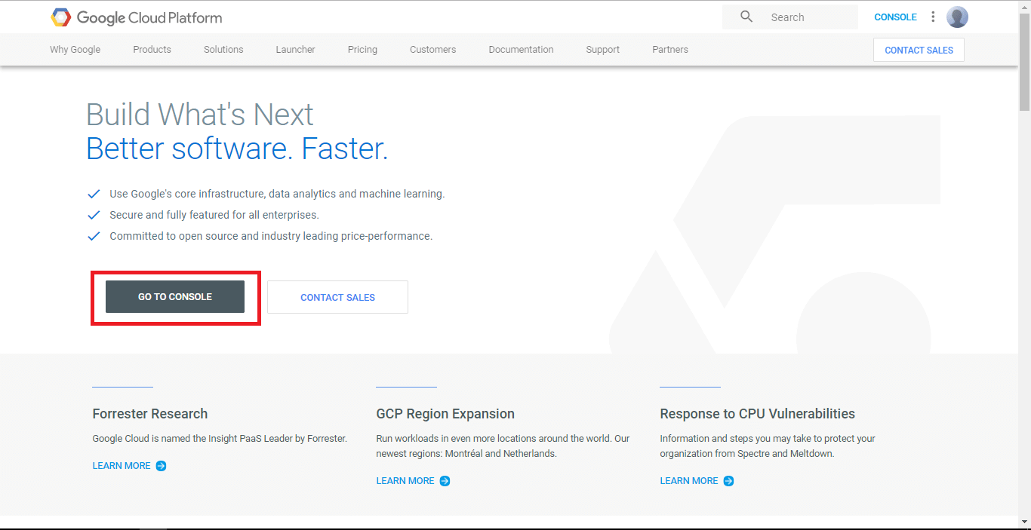
After clicking on the 'GO TO CONSOLE' button, we will be redirected to the Dashboard that includes a summary of GCP services along with projects and other insights. It looks like this:
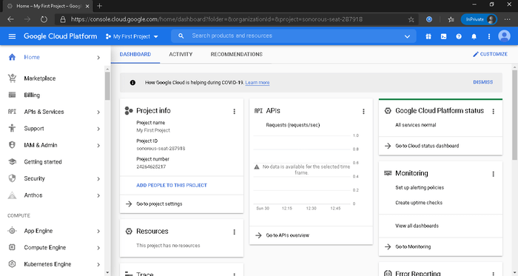
To be specific, a Dashboards of GCP displays the summarized view of the followings:
- Project Info: contains project details such as project name, ID, and number.
- Resources: contains a list of resources being used in the related project.
- APIs: contains various API requests running with the project (in request/sec form).
- Google Cloud Platform Status: displays an overall summary of services that are part of GCP.
- Monitoring: displays alerts, performance stats, Uptime, etc. to ensure that systems are running reliably.
- Error Reporting: displays errors occurring in the projects, but it needs to be configured first.
- Trace: displays latency data of existing applications across a distributed tracing system.
- Compute Engine: displays the insights of CPU usage in percentage (%).
- Tutorials: contains Getting Started guides (basic guides) to explain how the GCP features work.
- News: displays news and other important updates regarding Google Cloud Platform.
- Documentation: contains in-depth guides to teach more about Compute Engine, Cloud Storage, and App Engine.

Google Cloud Platform Pricing
When it comes to pricing, Google Cloud Platform is the cheapest solution in the market. GCP is not only low on price but also offers more features and services than other providers.
When comparing GCP with other leading competitors, it has more benefits over them. Google provides its users a massive 60% savings, including:
- 15% rightsizing recommendation
- 21% list price differences
- 24% of sustained usage discounts
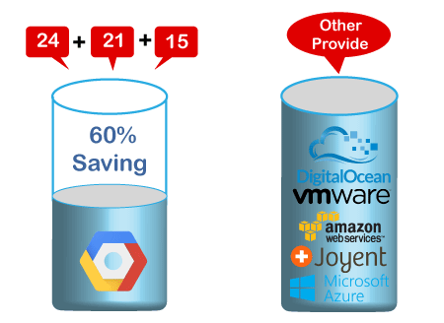
Some of the main benefits of GCP pricing are:
No Hidden Charges: There are no hidden charges behind the GCP pricing. Google's pricing structure is straightforward and can be easily understood.
Pay-as-you-go: Google offers its customer 'use now, pay later' option. So, users will have to pay only for those services which they want to use or already using.
No Termination Fee: Users are free to stop using Google services whenever they want, and there will not have to pay any termination fee. That means the moment users stop using Google services; they stop paying for it.

Difference between Google Cloud Platform, AWS and Azure
Like Google cloud platform, AWS and Azure are the other popular cloud-based platforms. However, there are differences amongst them. Some of the main differences between GCP, AWS and Azure are tabulated below:
Google Cloud | AWS | Azure
It uses GCE (Google Compute Engine) for computing purposes. | AWS EC2 offers core compute services. | It uses virtual machines for computation purposes.
It uses Google Cloud Storage for storage purposes. | It uses Amazon S3 for storing the data. | It uses a storage block bob that comprises blocks for storing the data.
It offers the lowest price to the customers to beat other cloud providers. | AWS pricing is generally keen to have inscrutable. The overall structure of granular pricing is a bit complex. | Like AWS, Azure pricing structure is also difficult to understand unless you have considerable experience.
It uses Cloud Test labs for App Testing purposes. | It uses a device farm for App Testing purposes. | It uses DevTest labs for App Testing purposes.
It uses Subnet as a virtual network. | It uses VPC as a virtual network. | It uses VNet as a virtual Network.
It follows the Cloud Load Balancing configuration. | It follows the Elastic Load Balancing configuration. | It follows the Load-Balancer Application Gateway configuration.

All Products
🔗-Product page 📄-Documentation

Compute
- Cloud Functions: Event-driven serverless functions 🔗 📄
- App Engine: Managed app platform 🔗 📄
- Cloud Run: Serverless for containerized applications 🔗 📄
- Google Kubernetes Engine (GKE): Managed Kubernetes/containers 🔗 📄
- Compute Engine: VMs, GPUs, TPUs, Disks 🔗 📄
- Bare Metal Solution: Hardware for specialized workloads 🔗
- Preemptible VMs: Short-lived compute instances 🔗 📄
- Shielded VMs: Hardened VMs 🔗 📄
- Sole-tenant Nodes: Dedicated physical servers 🔗 📄
- VMware Engine: VMware as a service 🔗 📄

Storage
- Cloud Filestore: Managed NFS server 🔗 📄
- Cloud Storage: Multi-class multi-region object storage🔗 📄
- Persistent Disk: Block storage for VMs 🔗 📄
- Local SSD: VM locally attached SSDs 🔗 📄

Database
- Cloud Bigtable: Petabyte-scale, low-latency, non-relational 🔗 📄
- Cloud Firestore: Serverless NoSQL document database 🔗 📄
- Cloud Memorystore: Managed Redis and Memcached 🔗 📄
- Cloud Spanner: Horizontally scalable relational database 🔗 📄
- Cloud SQL: Managed MySQL, PostgreSQL, SQL Server 🔗 📄
- Database Migration Service: Migrate to Cloud SQL 🔗 📄
- Cloud SQL Insights: SQL Inspector 🔗 📄

Data Analytics
- BigQuery: Data warehouse and analytics 🔗 📄
- BigQuery BI Engine: In-memory analytics engine 📄
- BigQuery ML: BigQuery model training/serving 📄
- BigQuery GIS: BigQuery geospatial functions/support 📄
- BigQuery Data Transfer Service: Automated data ingestion service 📄
- Connected Sheets: Spreadsheet interface for (big)data 📄
- Cloud Composer: Managed workflow orchestration service 🔗 📄
- Cloud Data Fusion: Graphically manage data pipelines 🔗 📄
- Dataflow: Stream/batch data processing 🔗 📄
- Dataprep by Trifacta: Visual data wrangling 🔗 📄
- Dataproc: Managed Spark and Hadoop 🔗 📄
- Datastream: Change data capture/replication service 🔗 📄
- Pub/Sub: Global real-time messaging 🔗 📄
- Data Catalog: Metadata management service 🔗 📄
- Google Data Studio: Collaborative data exploration/dashboarding 🔗 📄
- Looker: Enterprise BI and analytics 🔗
- Public Datasets: Hosted data in BigQuery📄

Hybrid and multi-cloud
- Anthos: Enterprise hybrid/multi-cloud platform 🔗 📄
- Anthos clusters: Hybrid/on-premises GKE 🔗 📄
- Anthos Config Management:Policy and security automation 🔗 📄
- Anthos Service Mesh: Managed service mesh (Istio) 🔗 📄
- Cloud Run for Anthos: Serverless development for Anthos 🔗 📄
- Google Cloud Marketplace for Anthos: Pre-configured containerized apps 🔗 📄
- Migrate for Anthos and GKE: Migrate VMs to GKE 🔗 📄
- Google Cloud's operations suite: Monitoring, logging, troubleshooting 🔗 📄
- Traffic Director: Service mesh traffic management 🔗 📄
- Apigee API Management: API management, development, security 🔗

AI and ML
- Vertex AI: Managed platform for ML 🔗
- AutoML: Custom low-code models 📄
- Vertex AI Data Labeling: Data labeling by humans 📄
- Deep Learning VM Images: Preconfigured VMs for deep learning 🔗 📄
- Vertex AI Workbench:Jupyter-based environment for Data Science 🔗 📄
- Deep Learning Containers: Preconfigured containers for deep learning 🔗 📄
- Vertex AI Matching Engine: Vector similarity searches 🔗📄
- Vertex AI Pipelines: Hosted ML workflows🔗
- Vertex AI Predictions: Autoscaled model serving 📄
- Vertex AI Training: Distributed AI training 📄
- Vertex AI Edge Manager: Deploy monitor edge inferences 📄
- Vertex Explainable AI: Understand ML model predictions 🔗 📄
- Vertex AI Feature Store: Managed ML feature repository 🔗 📄
- Vertex ML Metadata: Artifact, lineage, and execution tracking 🔗 📄
- Vertex AI Model Monitoring: Monitor models for skew/drift 🔗 📄
- Vertex AI Tensorboard: Managed TensorBoard for ML-experiment Visualization 🔗 📄
- Vertex AI Vizier: black-box hyperparameter tuning 🔗 📄
- Speech-To-Text: Convert audio to text 🔗 📄
- Talent Solutions: Job search with ML 🔗 📄
- Text-To-Speech: Convert text to audio 🔗 📄
- Cloud TPU: Hardware acceleration for ML 🔗 📄
- Cloud Translation: Language detection and translation 🔗 📄
- Cloud Video Intelligence API: Scene-level video annotation 🔗 📄
- Cloud Vision: Image recognition and classification 🔗 📄
- Contact Center AI: AI in your contact center🔗 📄
- Dialogflow: Create conversational interfaces 🔗 📄
- Document AI: Analyze, classify, search documents 🔗 📄
- Recommendations AI: Create custom recommendations 🔗 📄
- Vision Product Search: Visual search for products 📄

Networking
- Carrier Peering: Peer through a carrier 📄
- Direct Peering: Peer with Google Cloud 📄
- Dedicated Interconnect: Dedicated private network connection 📄
- Partner Interconnect: Connect on-prem network to VPC 📄
- Google Cloud Armor: DDoS protection and WAF 🔗 📄
- Cloud CDN: Content delivery network 🔗 📄
- Cloud DNS: Programmable DNS serving 🔗 📄
- Cloud Load Balancing: Multi-region load distribution/balancing 🔗 📄
- Cloud NAT: Network address translation service 📄
- Cloud Router: VPC/on-prem network route exchange (BGP) 📄
- Cloud VPN: Virtual private network connection📄
- Network Service Tiers: Price versus performance tiering 🔗 📄
- Network Telemetry: Network telemetry service 🔗 📄
- Traffic Director: Service mesh traffic management 🔗 📄
- Anthos Service Mesh: Service-aware network management 🔗 📄
- Virtual Private Cloud: Software defined networking 🔗 📄
- Cloud Domains: Register, transfer, manager domains 🔗 📄
- VPC Service Controls: Security perimeters for API-based services 🔗 📄
- Network Intelligence Center: Network monitoring and topology 🔗 📄
- Service Directory: Centrally publish/discover/connect services 🔗 📄
- Private Service Connect: Privately connect services across VPCs 🔗 📄
- Network Connectivity Center: Connect VPC & On-prem 🔗 📄
- Packet Mirroring: Monitor/analyze instance traffic 📄
- Cloud IDS: Detects network based threats 🔗 📄

Identity and Security
- Access Transparency: Audit cloud provider access 🔗 📄
- Assured Workloads: Workload compliance controls 🔗 📄
- Binary Authorization: Kubernetes deploy-time security 🔗 📄
- Certificate Authority Service: Managed private CAs 🔗 📄
- Cloud Asset Inventory: All assets, one place 🔗 📄
- Cloud Audit Logs: Audit trails for Google Cloud 🔗 📄
- Cloud Data Loss Prevention (DLP): Classify and redact sensitive data 🔗 📄
- Cloud HSM: Hardware security module service 🔗 📄
- Cloud External Key Manager (EKM): External keys you control 🔗 📄
- Cloud IAM: Resource access control 🔗 📄
- Cloud Identity: Manage users, devices & apps 🔗 📄
- Cloud Identity-Aware Proxy: Identity-based app access 🔗 📄
- Cloud Key Management Service: Hosted key management service 🔗 📄
- Resource Manager: Cloud project metadata management 🔗 📄
- Security Command Center: Security management and data risk platform 🔗 📄
- Web Security Scanner: App engine security scanner 🔗 📄
- Confidential Computing: Encrypt data in-use 🔗 📄
- Access Context Manager: End-user attribute-based access control 🔗 📄
- Event Threat Detection: Scans for suspicious activity 🔗
- Managed Service for Microsoft Active Directory: Managed Microsoft Active Directory 🔗 📄
- Secret Manager: Store and manage secrets 🔗 📄
- Security Key Enforcement: Two-step key verification 🔗
- Shielded VMs: Hardened VMs 🔗 📄
- Titan Security Key: Two-factor authentication (2FA) device 🔗
- VPC Service Controls: VPC data constraints 🔗 📄
- Chronicle: Find threats from security telemetry 🔗
- VirusTotal: Research/hunt for malware 🔗
- Risk Manager: Evaluate organization’s security posture 🔗
- reCAPTCHA Enterprise: Protection against bot/spam/abuse 🔗 📄
- BeyondCorp Enterprise: Zero trust secure access 🔗 📄
- Access Context Manager: Fine-grained, attribute based access-control 📄
- Web Security Scanner: Identifies web-app security vulnerabilities 📄

Operations & Monitoring
- Cloud Debugger: Live production debugging 🔗 📄
- Error Reporting: App error reporting 🔗 📄
- Cloud Logging: Centralized logging 🔗 📄
- Cloud Monitoring: Infrastructure and application monitoring 🔗 📄
- Cloud Profiler: CPU and heap profiling 🔗 📄
- Cloud Trace: App latency insights 🔗 📄
###DevOps CI/CD
- Cloud Build: Continuous integration/delivery platform 🔗 📄
- Cloud Deploy: Deployment pipeline for GKE 🔗 📄
- Artifact Registry: Universal package manager 🔗 📄
- Cloud Source Repositories: Hosted private git repos 🔗 📄
- Container Registry: Private container registry/storage 🔗 📄

Application Integration
- Eventarc: Event-driven Cloud Run services 🔗 📄
- Cloud Scheduler: Managed cron job service 🔗 📄
- Cloud Tasks: Asynchronous task execution 🔗 📄
- Workflows: HTTP services orchestration 🔗 📄
- Pub/Sub: Global real-time messaging 🔗 📄

API Platform and Ecosystems
- API Analytics: API metrics 🔗
- API Monetization: Monetize APIs 🔗
- Apigee API Platform: Develop, secure, monitor APIs 🔗
- API Gateway: Fully managed API Gateway 🔗
- Apigee Hybrid: Manage hybrid/multi-cloud API environments 🔗📄
- Apigee Sense: API protection from attacks 🔗
- Cloud Endpoints: Cloud API gateway 🔗
- Developer Portal: API management portal 🔗
- Marketplace: Partner & open source marketplace 🔗
- AppSheet: No-code App creation 🔗

Internet of Things (IoT)
- Cloud IoT Core: Manage devices, ingest data 🔗 📄

Gaming
- Google Cloud Game Servers: Orchestrate Agones clusters 🔗

Healthcare
- Cloud Healthcare API: Healthcare system Google Cloud interoperability 🔗
- Apigee Healthcare APIx: Healthcare system Google Cloud interoperability 🔗
- Healthcare Natural Language AI: Real-time insights from media-text 🔗
- Cloud Life Sciences*: Manage, process, transform biomedical-data 🔗📄

Retail
- Vision Product Search: Visual search for products 📄
- Recommendations AI: Create custom recommendations 🔗 📄
- Visual Inspection AI: Train/deploy models to detect defects 🔗

Management Tools
- VM Manager: Manage OS VM Fleets 📄
- Cloud APIs: APIs for cloud services 🔗 📄
- Cloud Billing API: Programmatically manage Google Cloud billing 📄
- Cloud Billing: Billing and cost management tools 🔗 📄
- Cloud Console: Web-based management console 🔗
- Cloud Deployment Manager: Templated infrastructure deployment 🔗 📄
- Cloud Mobile App: iOS/Android Google Cloud manager app 🔗
- Private Catalog: Internal Solutions Catalog 🔗 📄
- Carbon Footprint: Report and reduce carbon emissions 🔗 📄

Developer Tools
- Cloud Code for IntelliJ: IntelliJ Google Cloud tools 🔗
- Cloud Code for VS Code: VS Code Google Cloud tools 🔗
- Cloud Code: Cloud native IDE extensions 🔗 📄
- Cloud Tools for Eclipse: Eclipse Google Cloud tools 🔗
- Cloud Tools for Visual Studio: Visual Studio Google Cloud tools 🔗
- App Engine Plugins: Gradle/Maven App Engine plugin 🔗
- Cloud SDK: CLI for Google Cloud 🔗 📄
- Cloud Shell: Browser-based terminal/CLI 🔗 📄

Migration to Google Cloud
- BigQuery Data Transfer Service: Bulk import analytics data 🔗 📄
- Cloud Data Transfer: Data migration tools/CLI 🔗
- Google Transfer Appliance: Rentable data transport box 🔗 📄
- Storage Transfer Service: Online/on-premises data transfer 📄
- Migrate for Anthos and GKE: Migrate VMs to GKE 🔗 📄
- Migrate for Compute Engine: Compute Engine migration tools 🔗 📄
- Migrate from Amazon Redshift: Migrate from Redshift to BigQuery 🔗
- Migrate from Teradata: Migrate from Teradata to BigQuery 🔗
- Cloud Foundation Toolkit: Infrastructure as Code templates 🔗
- KF: Cloud Foundry to Kubernetes 🔗

Google Maps Platform
- Directions API: Get directions between locations 🔗
- Distance Matrix API: Multi-origin/destination travel times 🔗
- Geocoding API: Convert address to/from coordinates 🔗
- Geolocation API: Derive location without GPS 🔗
- Maps Embed API: Display iframe embedded maps 🔗
- Maps JavaScript API: Dynamic web maps 🔗
- Maps SDK for Android: Maps for Android apps 🔗
- Maps SDK for iOS: Maps for iOS apps 🔗
- Maps Static API: Display static map images 🔗
- Maps SDK for Unity: Unity SDK for games 🔗
- Maps URLs: URL scheme for maps 🔗
- Places API: Rest-based Places features 🔗
- Places Library, Maps JS API: Places features for web 🔗
- Places SDK for Android: Places features for Android 🔗
- Places SDK for iOS: Places feature for iOS 🔗
- Roads API: Convert coordinates to roads 🔗
- Street View Static API: Static street view images 🔗
- Street View Service: Street view for JavaScript 🔗
- Time Zone API: Convert coordinates to timezone 🔗

Workspace Platform
- Admin SDK: Manage Google Workspace resources 🔗
- AMP for Email: Dynamic interactive email 🔗
- Apps Script: Extend and automate everything 🔗
- Calendar API: Create and manage calendars 🔗
- Classroom API: Provision and manage classrooms 🔗
- Cloud Search: Unified search for enterprise 🔗
- Docs API: Create and edit documents 🔗
- Drive Activity API: Retrieve Google Drive activity 🔗
- Drive API: Read and write files 🔗
- Drive Picker: Drive file selection widget 🔗
- Email Markup: Interactive email using schema.org 🔗
- Google Workspace Add-ons: Extend Google Workspace apps 🔗
- Google Workspace Marketplace: Storefront for integrated applications 🔗
- Gmail API: Enhance Gmail 🔗
- Google Chats API: Conversational bots in chat 🔗
- People API: Manage user's Contacts 🔗
- Sheets API: Read and write spreadsheets 🔗
- Slides API: Create and edit presentations 🔗
- Task API: Search, read & update Tasks 🔗
- Vault API: Manage your organization's eDiscovery 🔗

Mobile (Firebase)
- Cloud Firestore: Document store and sync 🔗
- Cloud Functions for Firebase: Event-driven serverless applications 🔗
- Cloud Storage for Firebase: Object storage and serving 🔗
- Crashlytics: Crash reporting and analytics 🔗
- Firebase A/B Testing: Create A/B test experiments 🔗
- Firebase App Distribution: Trusted tester early access 🔗
- Firebase Authentication: Drop-in authentication 🔗
- Firebase Cloud Messaging: Send device notifications 🔗
- Firebase Dynamic Links: Link to app content 🔗
- Firebase Extensions: Pre-packaged development solutions 🔗
- Firebase Hosting: Web hosting with CDN/SSL 🔗
- Firebase In-App Messaging: Send in-app contextual messages 🔗
- Firebase Performance Monitoring: App/web performance monitoring 🔗
- Firebase Predictions: Predict user targeting 🔗
- Firebase Realtime Database: Real-time data synchronization 🔗
- Firebase Remote Config: Remotely configure installed apps 🔗
- Firebase Test Lab: Mobile testing device farm 🔗
- Google Analytics for Firebase: Mobile app analytics 🔗
- ML Kit for Firebase: ML APIs for mobile 🔗

Additional Resources
- Google Cloud Home Page: 🔗
- Google Cloud Blog: 🔗
- Google Cloud Platform Podcast: [🔗](https://Google Cloudpodcast.com/)
- Kubernetes Podcast from Google: 🔗
- Google Cloud Reader: 🔗
- Google Cloud Open Source: 🔗
- Google Cloud Medium Publication: 🔗
- Apigee Blog: 🔗
- Firebase Blog: 🔗
- Google Workspace Developers Blog: 🔗
- Google Workspace GitHub: 🔗
- Google Workspace Twitter: 🔗
- Google Cloud Certifications: 🔗
- Google Cloud System Status: 🔗
- Google Cloud Training: 🔗
- Google Developers Blog: 🔗
- Google Maps Platform Blog: 🔗
- Google Open Source Blog: 🔗
- Google Security Blog: 🔗
- Kaggle Home Page: 🔗
- Kubernetes Blog: 🔗
- Regions and Network Map: 🔗
- DORA - Software & Delivery Research: 🔗
- Cloud Security Podcast: 🔗
- Google Cloud Sketchnote: [🔗](https://goo.gle/Google Cloudsketchnote)

Everything below is not included in the PDFs/PNGs due to space limitations

Additional Resources
- Source for this document: 🔗
- Google Cloud Solutions Library: 🔗
- Google Workspace Solutions Gallery: 🔗
- Google Cloud Support Hub: 🔗
- Google Cloud Pricing: 🔗
- Google Cloud Pricing Calculator: 🔗
- Qwiklabs Home Page: 🔗
- Codelabs Home Page: 🔗
- YouTube Channels:
  - Google Cloud: 🔗
  - Google Cloud Technical: 🔗
  - Google Workspace: 🔗
  - Google Developer's: 🔗
  - Firebase: 🔗
- Reddit:
  - /r/googlecloud: 🔗
  - /r/AppEngine: 🔗
  - /r/bigquery: 🔗
  - /r/dataflow: 🔗
  - /r/firebase: 🔗
  - /r/GoogleAppsScript: 🔗
- Big Data / Data Analytics Product Comparisons: 🔗
- Compute Product Comparisons: 🔗
- Database Product Comparisons: 🔗
- Networking Product Comparisons: 🔗
- Storage Product Comparisons: 🔗

Google Cloud Foundational Open Source Projects
- Apache Beam: Batch/streaming data processing 🔗
- Go: High Concurrency Programming Language 🔗
- gRPC: RPC framework 🔗
- gVisor: Secure container runtime 🔗
- Istio: Connect and secure services 🔗
- Knative: Serverless framework for Kubernetes 🔗
- Kubeflow: ML toolkit for Kubernetes 🔗
- Kubernetes: Management of containerized applications 🔗
- OpenCensus: Cloud native observability framework 🔗
- TensorFlow: ML framework 🔗

Platform Comparisons
- Google Cloud Platform for AWS Professionals: 📄
- Google Cloud Platform for Azure Professionals: 📄
- Google Cloud Platform for Data Center Professionals: 📄
- Google Cloud Platform for OpenStack Users: 📄

Language Specific Documentation
- Apps Script: 📄
- Java: 📄
- Node.js: 📄
- Python: 📄
- Go: 📄
- Ruby: 📄
- PHP: 📄
- .NET/C#: 📄

