**Chapter 1 – Fundamentals of Computer Programming with C#**



Studenti: Prof.Dr:

Sadri Gjuli Muzafer Shala

Asistenti: Laberion Zebica

Prishtinë 2021

Exercises and choices

1. Install and make yourself familiar with Microsoft Visual Studio and

Microsoft Developer Network (MSDN) Library Documentation.

2. Find the description of the System.Console class in the standard .NET

API documentation (MSDN Library).

3. Find the description of the System.Console.WriteLine() method and its

different possible parameters in the MSDN Library.

4. Compile and execute the sample program from this chapter using the

command prompt (the console) and Visual Studio.

5. Modify the sample program to print a different greeting, for example

"Good Day!".

6. Write a console application that prints your first and last name on the

console.

6.

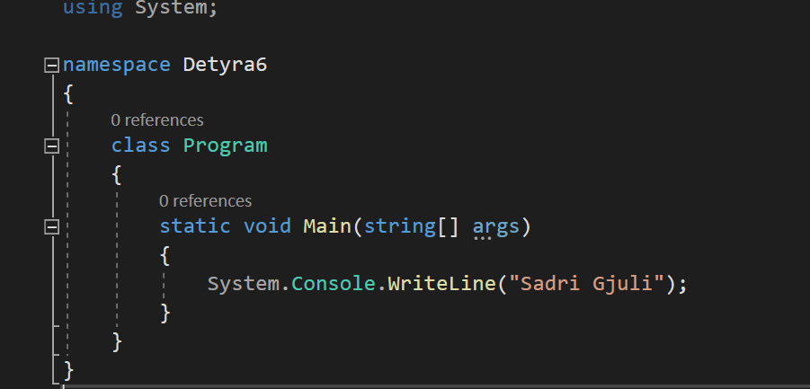

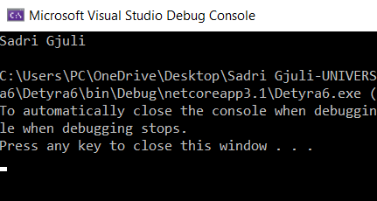

7. Write a program that prints the following numbers on the console 1,

101, 1001, each on a new line.

7.

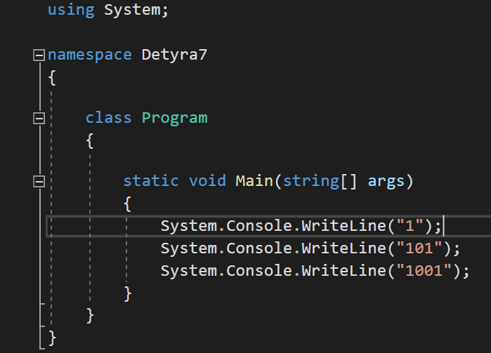

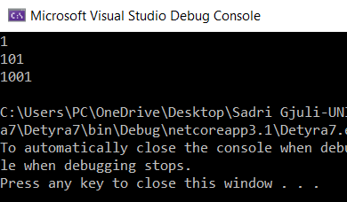

8. Write a program that prints on the console the current date and time.

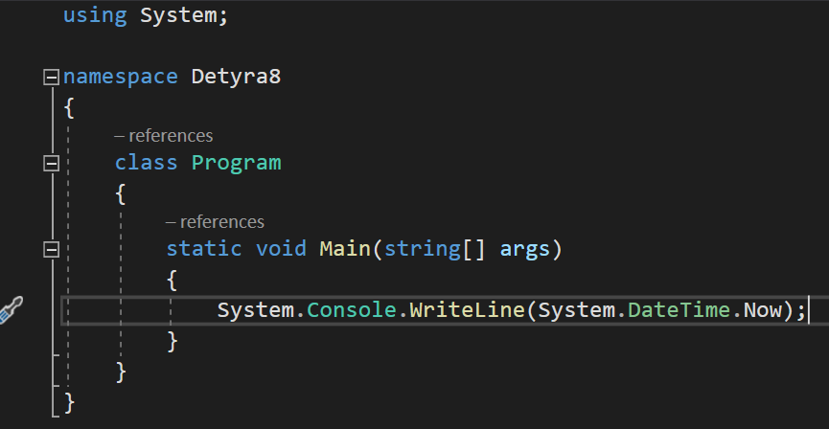

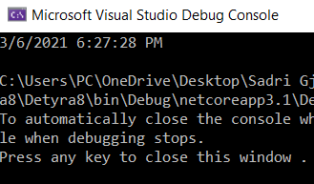

9. Write a program that prints the square root of 12345.

9.

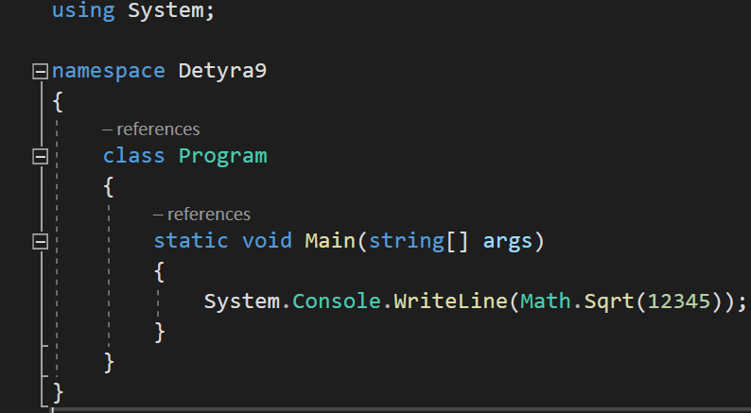

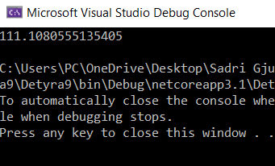

10. Write a program that prints the first 100 members of the sequence 2, -

3, 4, -5, 6, -7, 8.

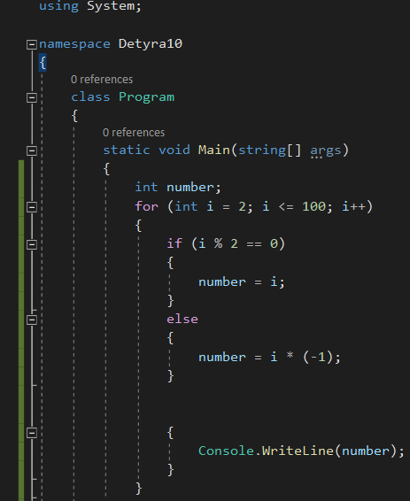

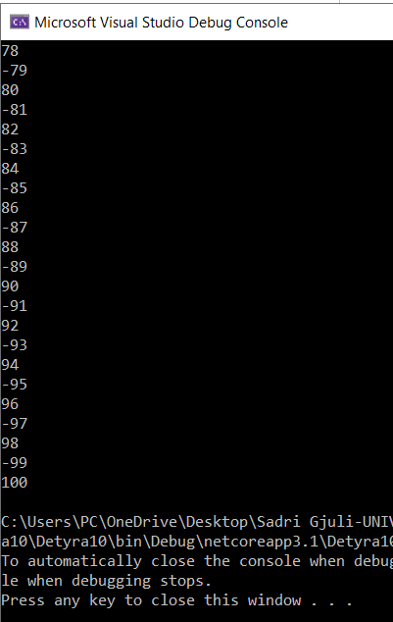

11. Write a program that reads your age from the console and prints your

age after 10 years.

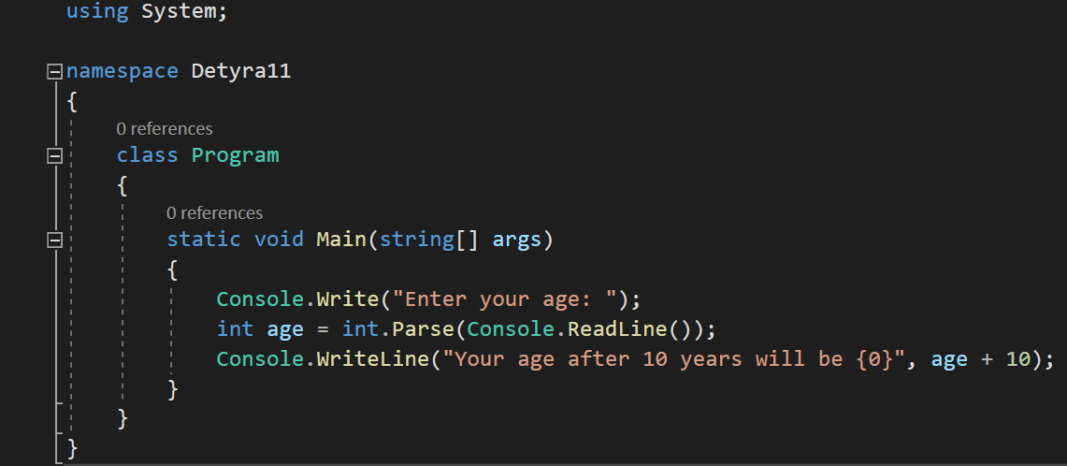

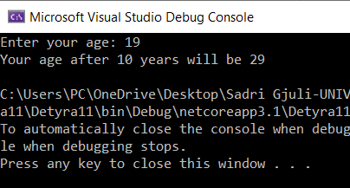

12. Describe the difference between C# and the .NET Framework.

12. In simple terms, C# is a programming language, whereas .NET is the framework on which the language is built. Microsoft created .NET (Network Enabled Technology), and .NET developers will use programming languages such as C#. In fact, .NET supports many programming languages, and defines the rules and associated libraries those languages will use.

13. Make a list of the most popular programming languages. How are they

different from C#?

13. Here are the 10 most popular programming languages:

1. Java

2. Python

3. C

4. Ruby

5. JavaScript

6. C#

7. PHP

8. Objective-C

9. SQL

10. C

C# is a general-purpose, multi-paradigm programming language encompassing static typing, strong typing, lexically scoped, imperative, declarative, functional, generic, object-oriented, and component-oriented programming disciplines.

14. Decompile the example program from exercise 5.

