**Chapter 2 – Fundamentals of Computer Programming with C#**



Studenti: Prof.Dr:

Sadri Gjuli Muzafer Shala

Asistenti: Laberion Zebica

Prishtinë 2021

1. Declare several variables by selecting for each one of them the most

appropriate of the types sbyte, byte, short, ushort, int, uint, long

and ulong in order to assign them the following values: 52,130; -115;

4825932; 97; -10000; 20000; 224; 970,700,000; 112; -44; -1,000,000;

1990; 123456789123456789.

1.

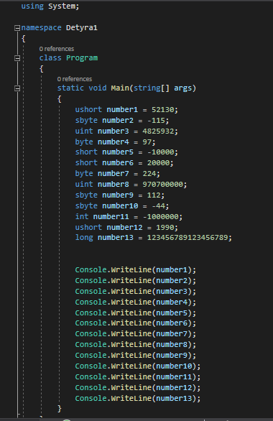 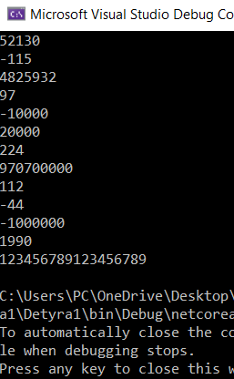

2. Which of the following values can be assigned to variables of type float,

double and decimal: 5, -5.01, 34.567839023; 12.345; 8923.1234857;

3456.091124875956542151256683467?

2.

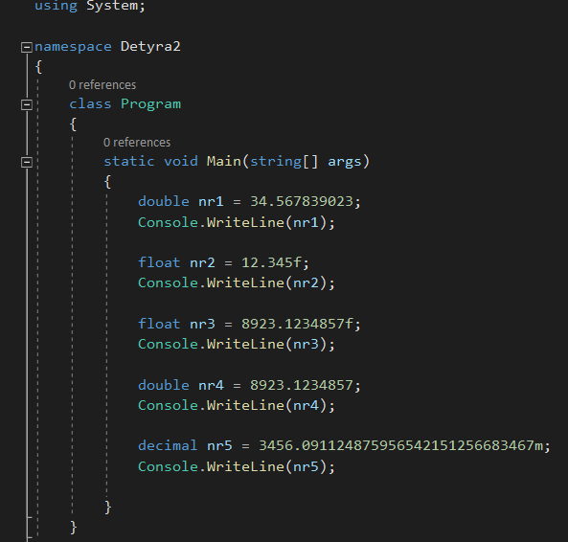

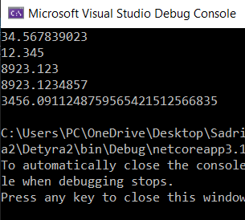

3. Write a program, which compares correctly two real numbers with

accuracy at least 0.000001.

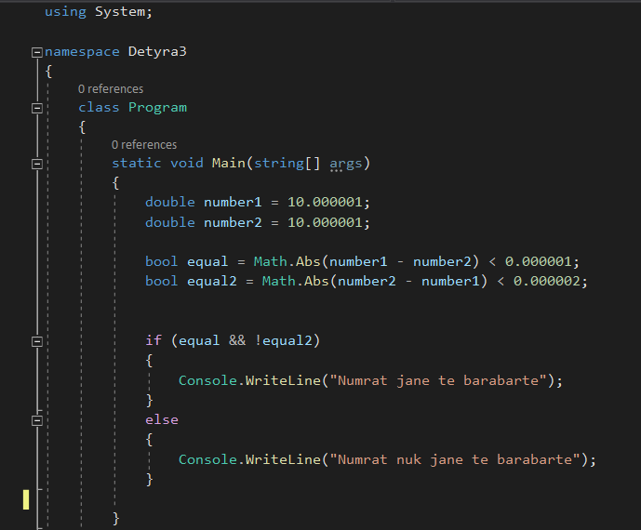

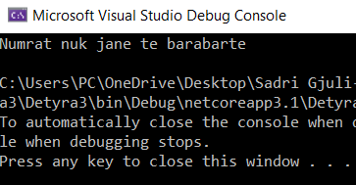

4. Initialize a variable of type int with a value of 256 in

hexadecimal format (256 is 100 in a numeral system with base 16).

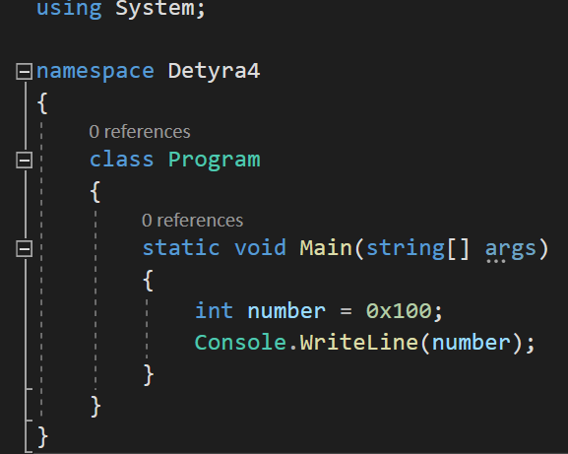

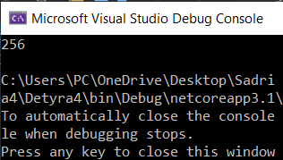

5. Declare a variable of type char and assign it as a value the character,

which has Unicode code, 72 (use the Windows calculator in order to find

hexadecimal representation of 72).

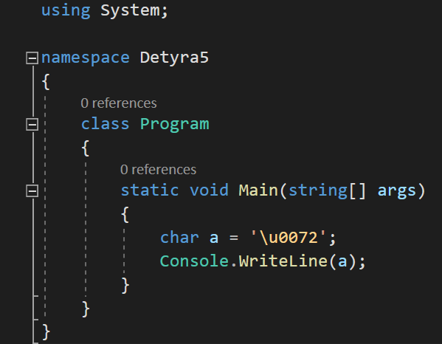

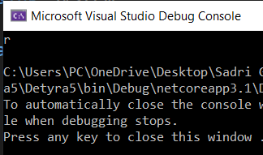

6. Declare a variable isMale of type bool and assign a value to it depending

on your gender.

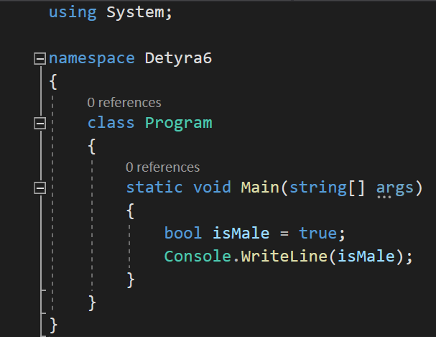

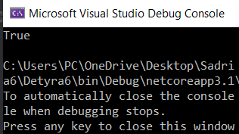

7. Declare two variables of type string with values "Hello" and "World".

Declare a variable of type object. Assign the value obtained of

concatenation of the two string variables (add space if necessary) to this

variable. Print the variable of type object.

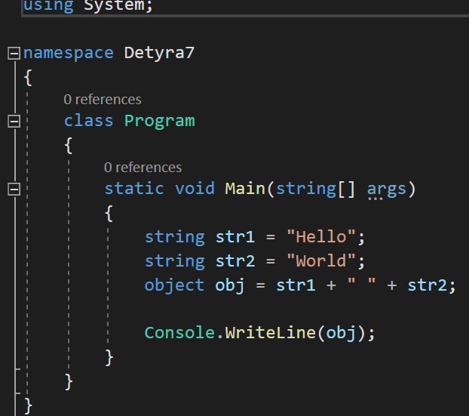

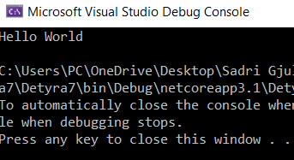

8. Declare two variables of type string and give them values "Hello" and

"World". Assign the value obtained by the concatenation of the two

variables of type string (do not miss the space in the middle) to a

variable of type object. Declare a third variable of type string and

initialize it with the value of the variable of type object (you should use

type casting).

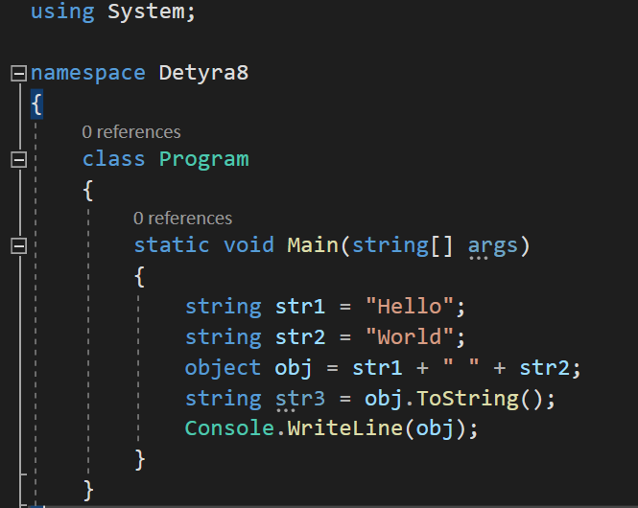

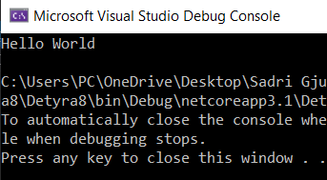

9. Declare two variables of type string and assign them a value “The

"use" of quotations causes difficulties.” (without the outer quotes).

In one of the variables use quoted string and in the other do not use it.

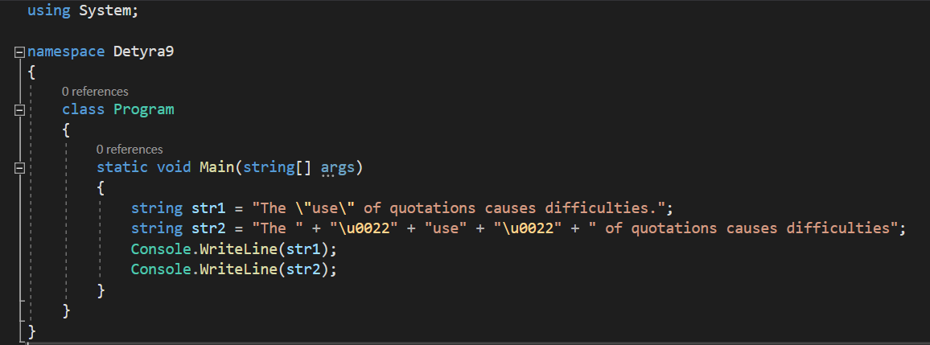

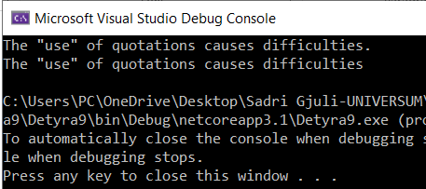

10. Write a program to print a figure in the shape of a heart by the sign "o".

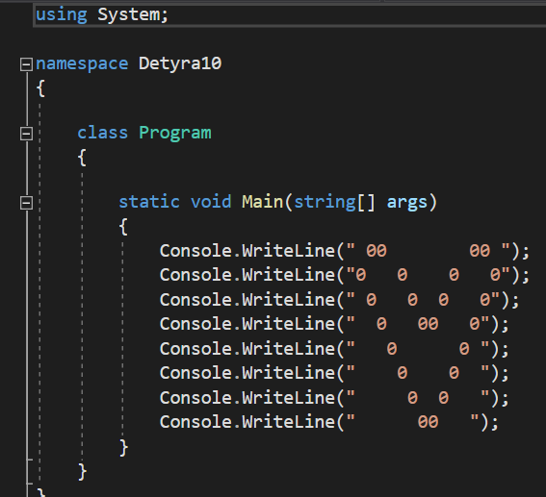

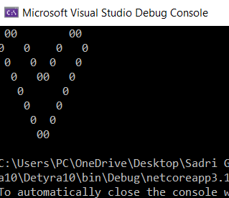

11. Write a program that prints on the console isosceles triangle which

sides consist of the copyright character "©".

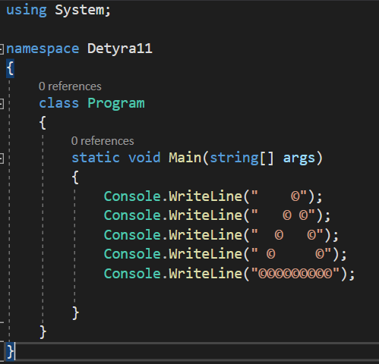

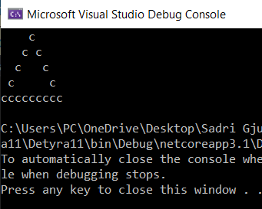

12. A company dealing with marketing wants to keep a data record of its

employees. Each record should have the following characteristic – first

name, last name, age, gender (‘m’ or ‘f’) and unique employee number

(27560000 to 27569999). Declare appropriate variables needed to

maintain the information for an employee by using the appropriate data

types and attribute names.

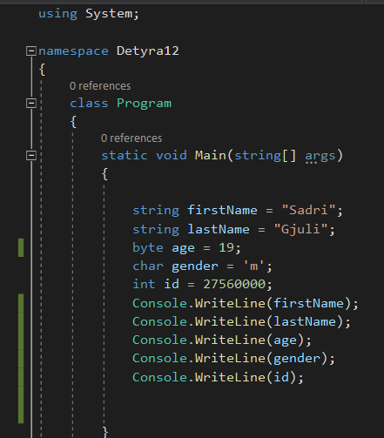

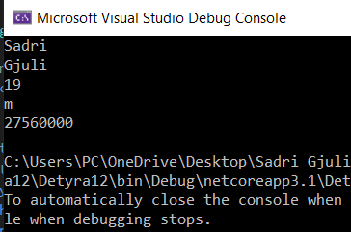

13. Declare two variables of type int. Assign to them values 5 and 10

respectively. Exchange (swap) their values and print them.

