How can enable Two-factor authentication in Pgadmin4 web

Two-factor authentication is a great feature of Pgadmin-4.11. I will show you how to enable it from the web version which is set up in the ubuntu server.

**Pre-requisite:**

1. Smart Phone of android or iOS
2. Microsoft Authenticator App
3. Pgadmin4 configured in Linux/ubuntu server

**How Can install authenticator app in smart phone:**

1. Go play store from your smart phone & search “Microsoft Authenticator”. You will see an window like below picture. Install it as I already installed that’s why it shows Open otherwise it will show install button.

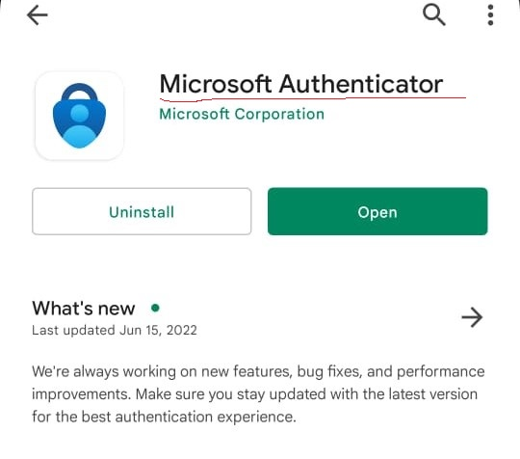

1. After installation you will get it in the app list like below picture.

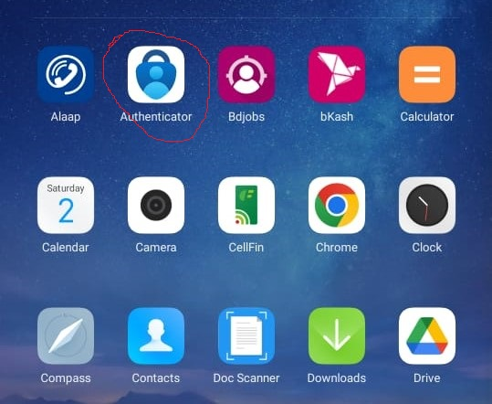

1. Open the app, initially you will do not see any account. I have used it for 4 accounts as authenticator.

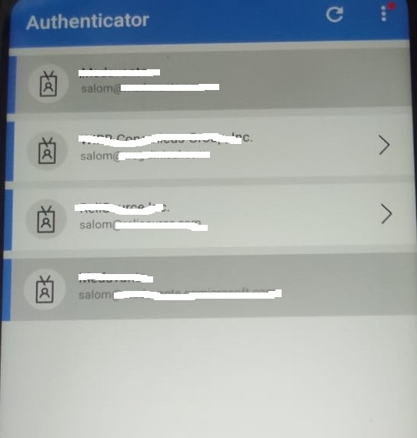

**Enable two-factor authentication in pgadmin4 steps:**

* Visit [here](https://github.com/sadrulemail/PostgresqlScripts/blob/main/PgAdmin4_Installation_LinuxSRV.txt) to know the installation process of pgadmin4 in ubuntu server.
* This is my VMware ubuntu server 22.04 workstation where I already installed pgadmin4

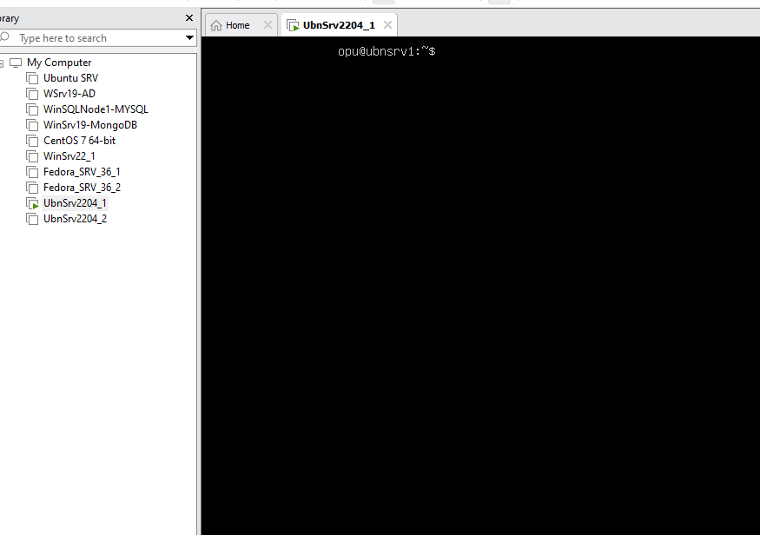

* After set up pgadmin4, visit url from chrome browser. In my case it’s <http://192.168.37.139/pgadmin4> & will appear below window.

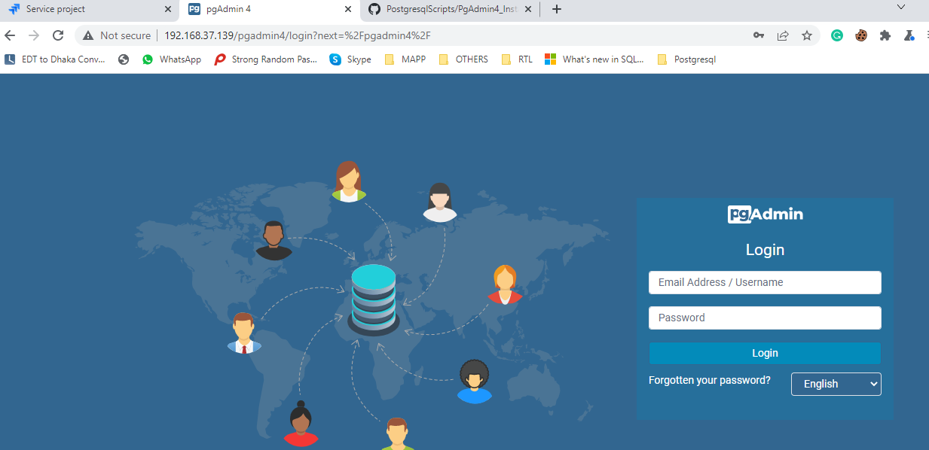

* Type your email address & password in required field. Hit on “Login” button

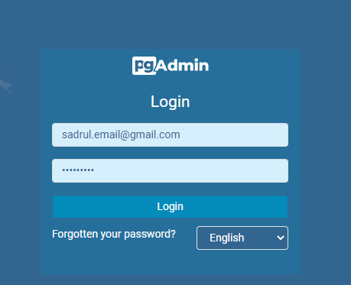

* After successful login, below window will be appeared. In my case, it shows DB server info in left side which I already linked earlier.

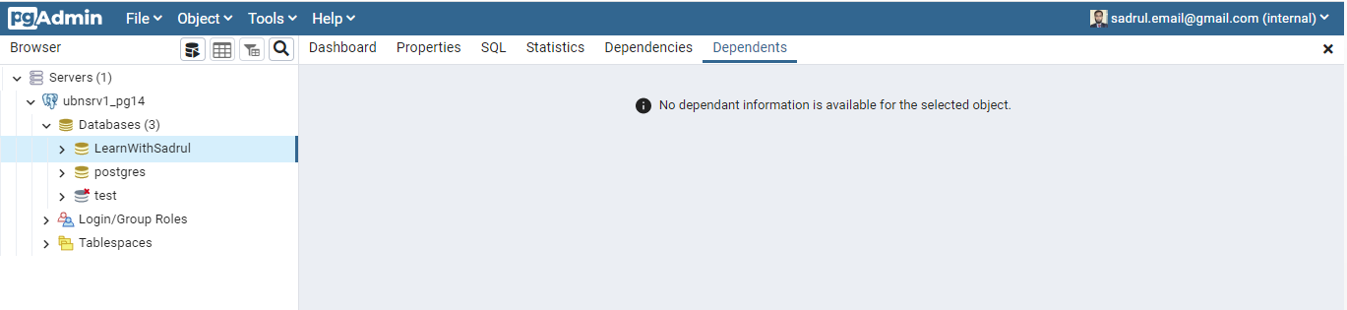

* In the upper right side, click on the drop-down icon, this will show below window.

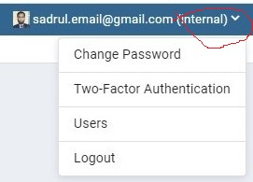

* Click on “Two-Factor Authentication” to set up it, below pop-up window will appear soon. **We will show the process through authenticator App.**



* Click on Setup button which is inline with authenticator App. Below window will be appeared.

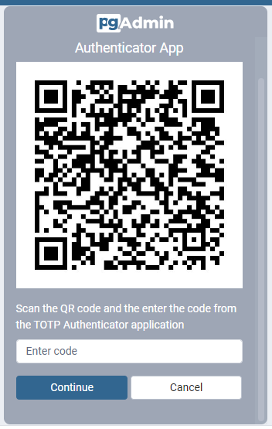

* Scan *by default scanner* or from authenticator app click on *add account* & scan the QR code which will add your pdadmin4 account in Microsoft authenticator App like below picture.

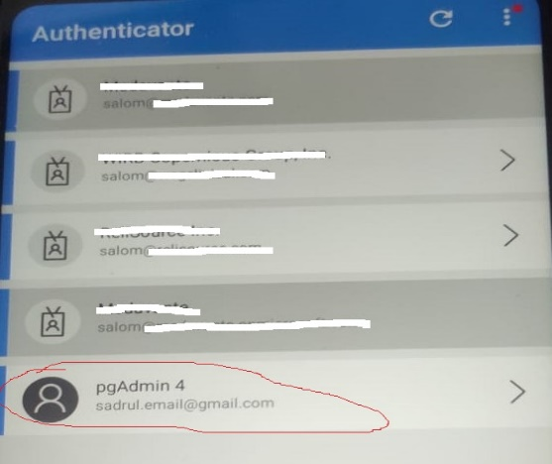

* Click on pgAdmin4 from Microsoft authenticator app & will show the code/OTP. This is the security code which work as second authentication code.

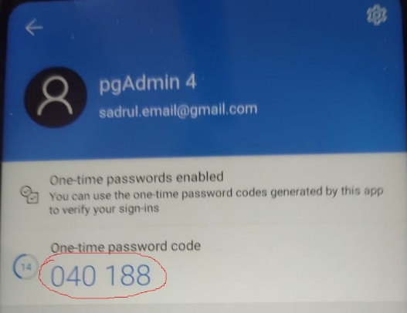

* Type above code on below window & press on “Continue” button to complete the setup of Two-factor authentication process.

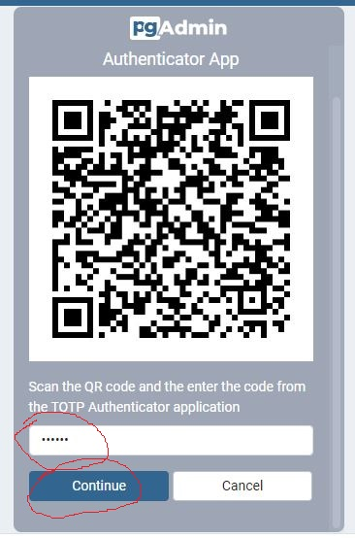

* After press “Continue” button, it will show below window which means setup process has been done.

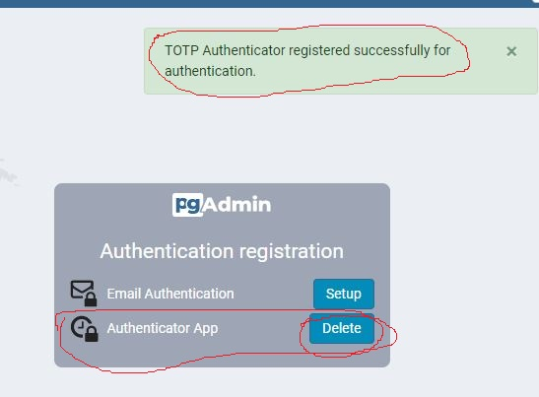

* Now time to check it. Log out from pgadmin4, type email address and password, finally hit on Login button. Below window you will see soon.

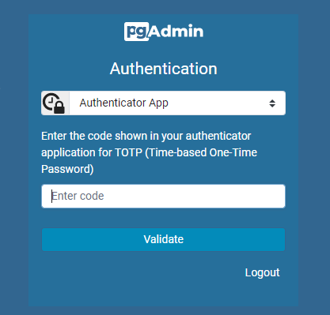

* Go to pgadmin4 account from authenticator App and type the security code or OTP & press on validate button. This code validation period is 30 seconds, after every 30 secs it will be refresh automatically from authentication app. If code is validated successfully then you will see default successful window. If you type wrong code then invalid code message will be appeared.

