Radius: AI Assisted Hyperlocal Marketplace
Final Project Report
Team: [Team Name]
Members: [Names and IDs]
Course: [Course Code]
Instructor: [Instructor Name]
Date: [Submission Date]

Abstract
Radius is a full-stack hyperlocal secondhand marketplace that helps users buy and sell products near their location. The system supports guest, registered user, and admin roles. Registered users can create listings, upload images, chat, report suspicious listings, complete trades, and review users after completed trades. Admins can moderate reports, manage users, review suspicious listings, and inspect AI/ML prediction logs.
The intelligent feature is an explainable trust and fraud detection engine. It analyzes product image similarity, price anomaly, seller history, listing text, brand consistency, reused descriptions, and off-platform contact signals. The system returns a score, decision, signal list, explanations, component scores, model version, and feature snapshot hash. The ML service also includes price suggestion with Random Forest regression and candidate fraud training with TF-IDF and Naive Bayes.

1. Introduction
Secondhand marketplaces are useful, but they often suffer from fake listings, copied photos, suspicious prices, and sellers who push buyers to pay outside the platform. Radius addresses this by combining nearby product discovery with explainable trust screening.


2. Objectives
- Build a role-based marketplace system with guest, registered user, and admin roles.
- Support product selling, browsing, searching, chat, reporting, trade, and review workflows.
- Use geofenced browsing so users can discover nearby products.
- Add an AI/ML based trust and fraud detection feature.
- Provide admin moderation and ML prediction audit logs.
- Create a polished portfolio-quality project with tests and documentation.

3. Requirement Mapping
Requirement | Implemented in Radius
Different user roles | Guest, registered user, admin
Product selling system | Listing create/manage, image upload, search, detail page
AI/ML feature | Trust scoring, duplicate image detection, price anomaly, price suggestion, candidate fraud training
Dataset | Market price CSV, manual label CSV, admin/report labels
Python ML | FastAPI, scikit-learn, pandas, Pillow, imagehash
Frameworks | React, Express, Supabase, FastAPI, Socket.io

4. Literature Review
Fraud detection literature shows that marketplace fraud can be detected using seller behavior, listing behavior, image similarity, and transaction signals. The project follows research guidance by storing features, labels, predictions, and evaluation metrics rather than using accuracy alone.
- Mutemi and Bacao (2023) show marketplace fraud can be detected using machine learning features from digital marketplaces.
- Ali et al. (2022) explain fraud detection metrics such as precision, recall, F1, and false positive rate.
- Chatrath, Batra, and Chaba (2022) motivate image-based checking for secondhand product trust.
- Amazon Science Fraud Dataset Benchmark motivates standardized datasets, splits, and evaluation practices.

5. System Architecture
Radius has three main layers: React frontend, Express backend API, and Python FastAPI ML service. Supabase Postgres stores persistent data and PostGIS supports location search.
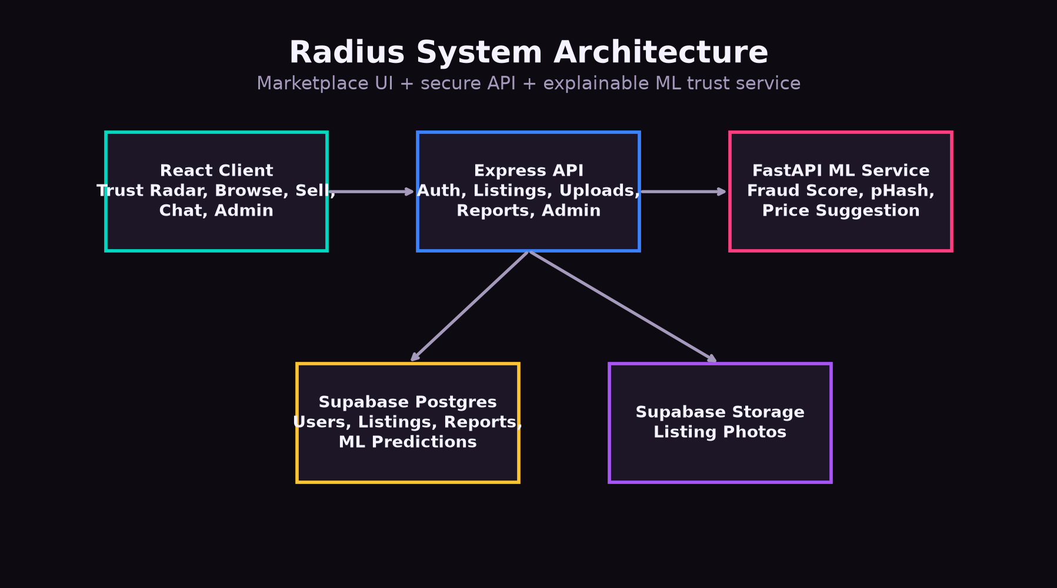

6. User Roles
- Guest: browse, search, filter, and view listing details.
- Registered user: create listings, upload photos, chat, report suspicious listings, manage own listings, and review after completed trades.
- Admin: view analytics, review fraud queue, resolve reports, manage users, and inspect ML prediction logs.

7. Main Features

7.1 Trust Radar
Trust Radar is an interactive product discovery view. The center represents user location, and nearby products appear as image nodes with trust colors.

7.2 Listing and Sell Flow
Registered users can submit product information and photos. The listing is scored by the ML service before being stored.
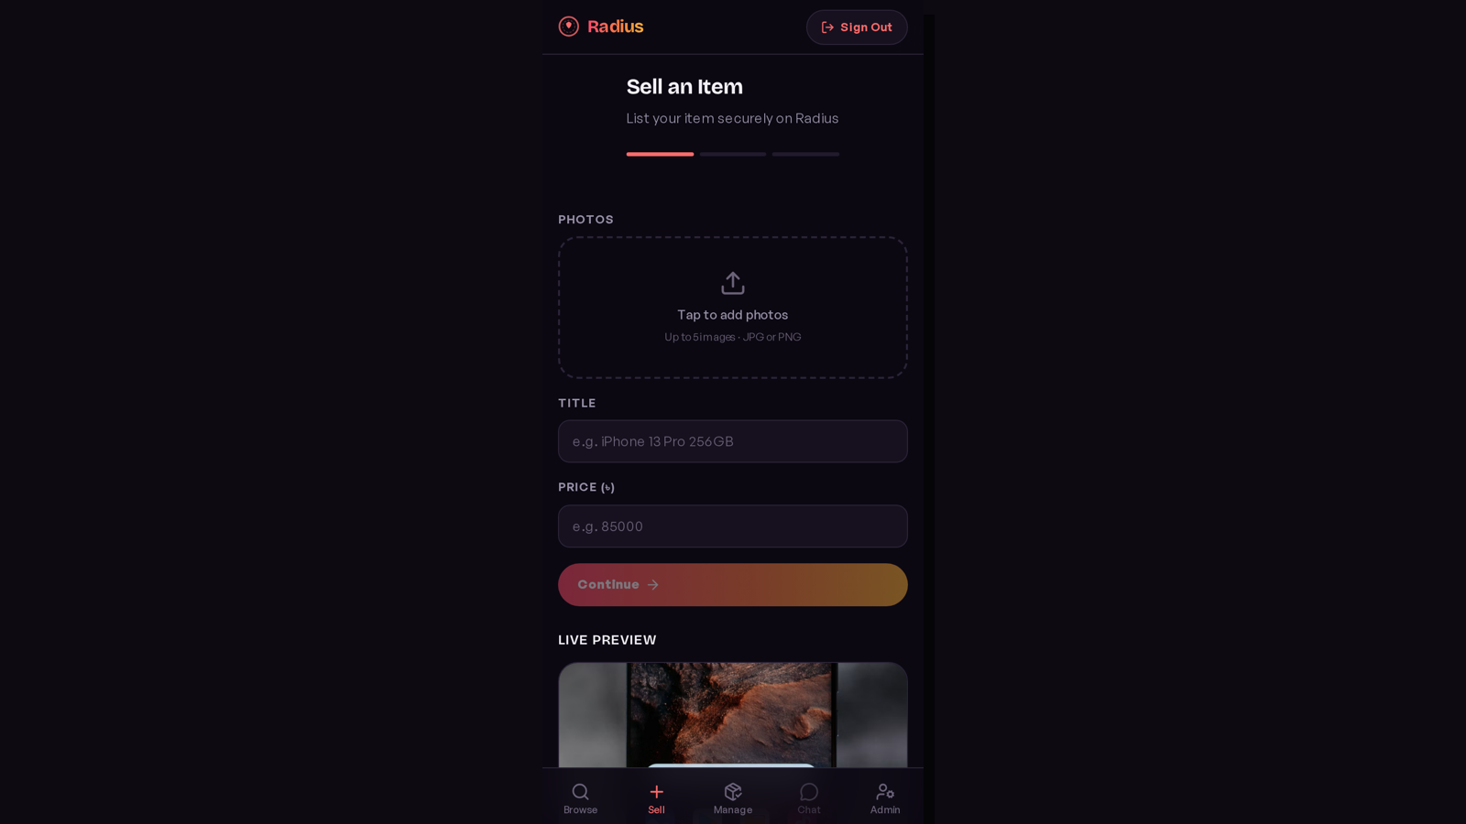

7.3 Listing Detail
The listing detail page shows product information, seller information, trust score, price comparison, report action, and chat action.
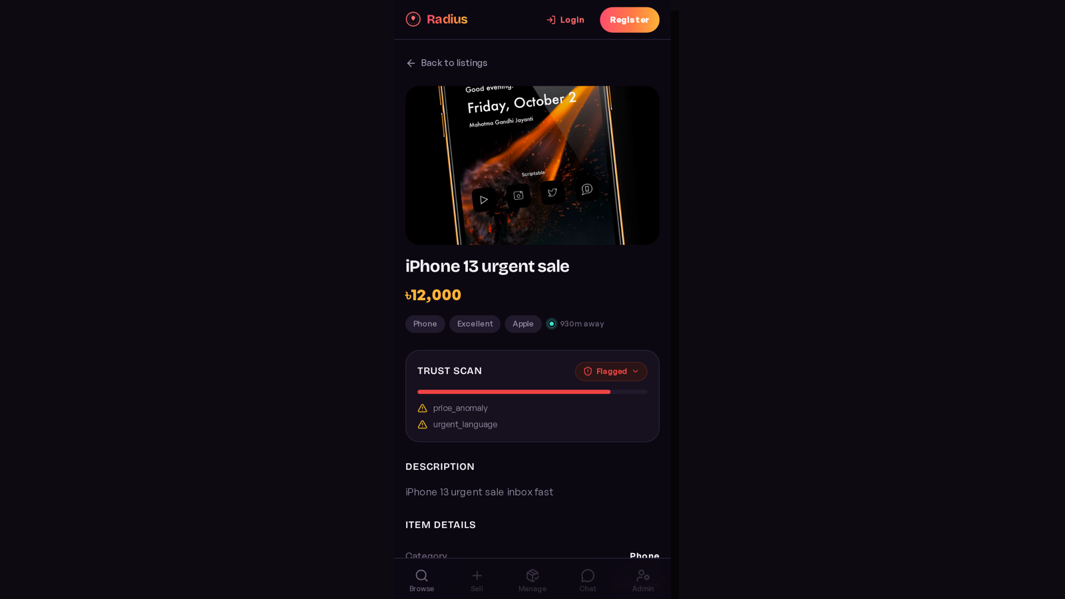

7.4 Chat, Trade, and Review
Socket.io powers real-time chat. Reviews are allowed only after completed trades, which reduces fake reputation.


7.5 Admin Dashboard
Admin can review fraud queue, resolve reports, manage users, and inspect ML prediction logs.
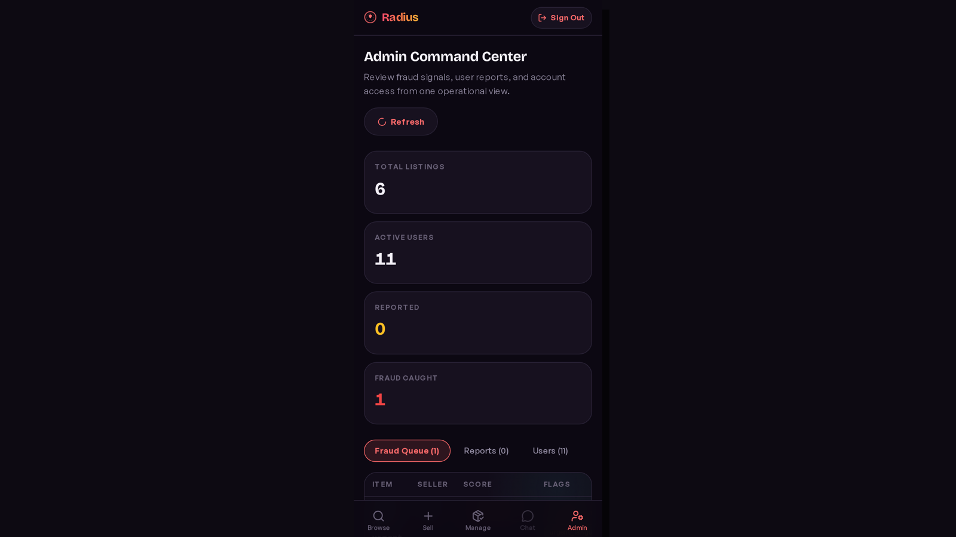

8. AI/ML Feature
The fraud engine uses explainable signals. Each risky signal adds points and trusted seller history can reduce points. The final score is clamped from 0 to 100.
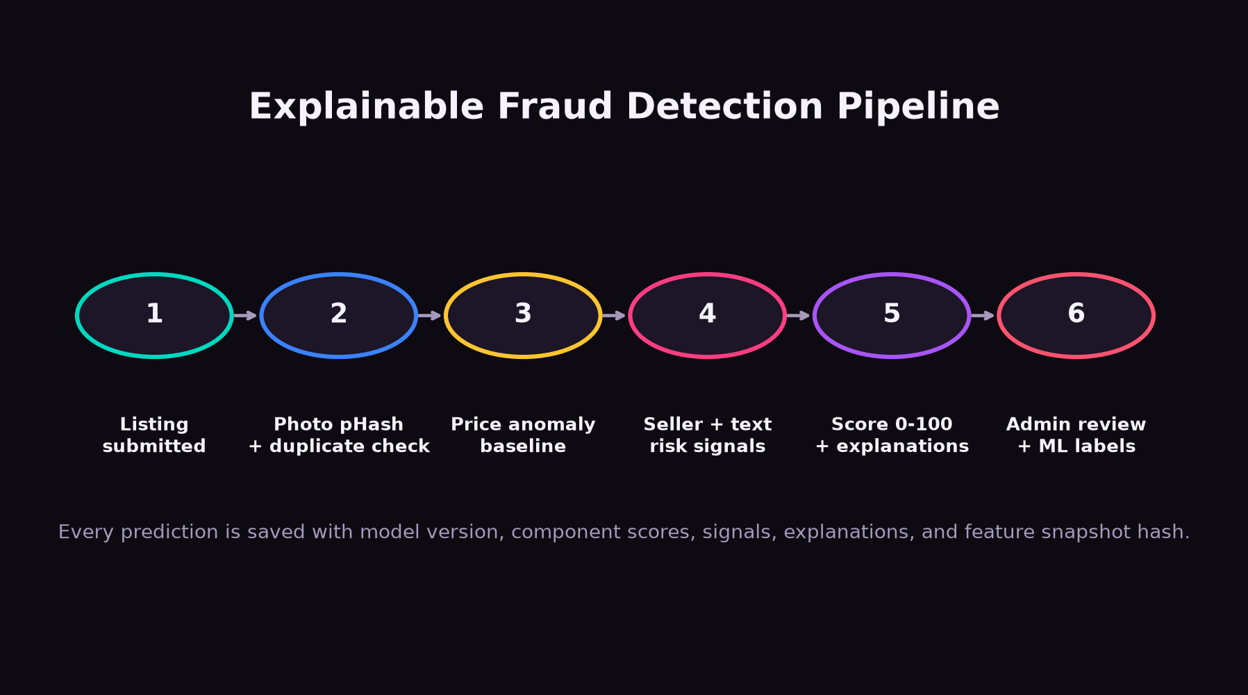
- Duplicate or visually similar image using pHash and Hamming distance.
- Price anomaly using category-condition baseline.
- New seller high-value listing and seller prior flags.
- Urgent language, payment pressure, off-platform contact, and prohibited item words.
- Brand/title mismatch and reused title-description.
- Feature snapshot, component scores, model version, and explanations saved for audit.

9. Dataset and Evaluation
The current dataset includes market price rows across product categories. Admin decisions, reports, and manual CSV imports can produce fraud labels for future training.
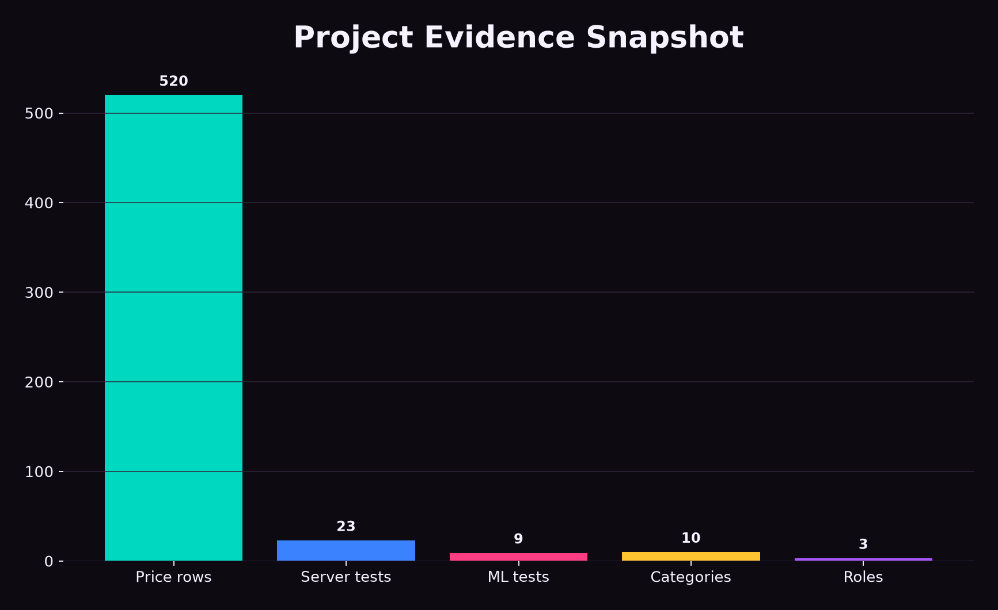
- Price suggestion uses Random Forest regression.
- Candidate fraud model uses TF-IDF and Multinomial Naive Bayes.
- Evaluation metrics include precision, recall, F1, and false positive rate.
- The online decision is explainable and human-reviewed rather than fully automatic removal.

10. Security
- Passwords are hashed with bcrypt.
- JWT is used for authentication.
- Admin routes require admin role.
- Listing mutation checks owner or admin permission.
- Supabase service role key stays server-side only.
- Express uses validation, CORS, rate limiting, and Helmet.

11. Testing and Results
- ML service tests: 9 passed.
- Server tests: 23 passed.
- Client production build: passed.

12. Limitations
- The dataset is demonstration-sized and should be expanded before production.
- The online fraud engine is an explainable hybrid scoring system, not a large production-trained deep learning model.
- Payment gateway and identity verification are not included in the academic scope.

13. Future Work
- Collect larger labeled marketplace datasets ethically.
- Train and deploy a stronger supervised fraud classifier.
- Add graph-based fraud detection for seller-buyer networks.
- Add escrow payment, identity verification, and mobile app support.

14. Conclusion
Radius satisfies the project requirements by implementing role-based access, a product selling system, a Python AI/ML service, dataset support, admin moderation, and a polished user interface. Its main contribution is combining nearby product discovery with explainable fraud detection.

References
- Mutemi, A., and Bacao, F. (2023). A numeric-based machine learning design for detecting organized retail fraud in digital marketplaces. Scientific Reports. https://doi.org/10.1038/s41598-023-38304-5
- Ali, A. et al. (2022). Financial Fraud Detection Based on Machine Learning: A Systematic Literature Review. Applied Sciences. https://doi.org/10.3390/app12199637
- Chatrath, S. K., Batra, G. S., and Chaba, Y. (2022). Handling consumer vulnerability in e-commerce product images using machine learning. Heliyon. https://doi.org/10.1016/j.heliyon.2022.e10743
- Amazon Science. Fraud Dataset Benchmark. https://github.com/amazon-science/fraud-dataset-benchmark

