LABORATORY REPORT #13
GEORGESCU Mihai-Antonio, 1242EA
Bioinformatics, 4th year 1st semester, 2025-2026
lab13_1.py
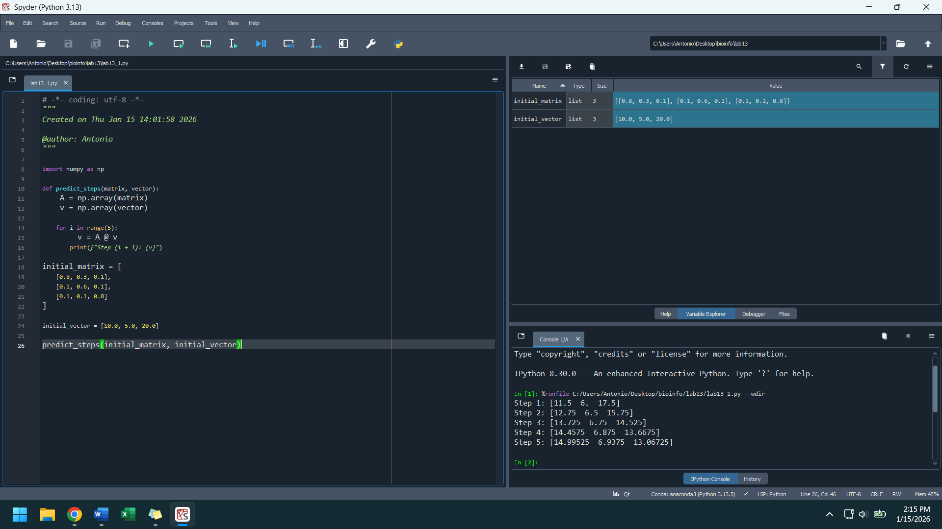
lab13_2.py
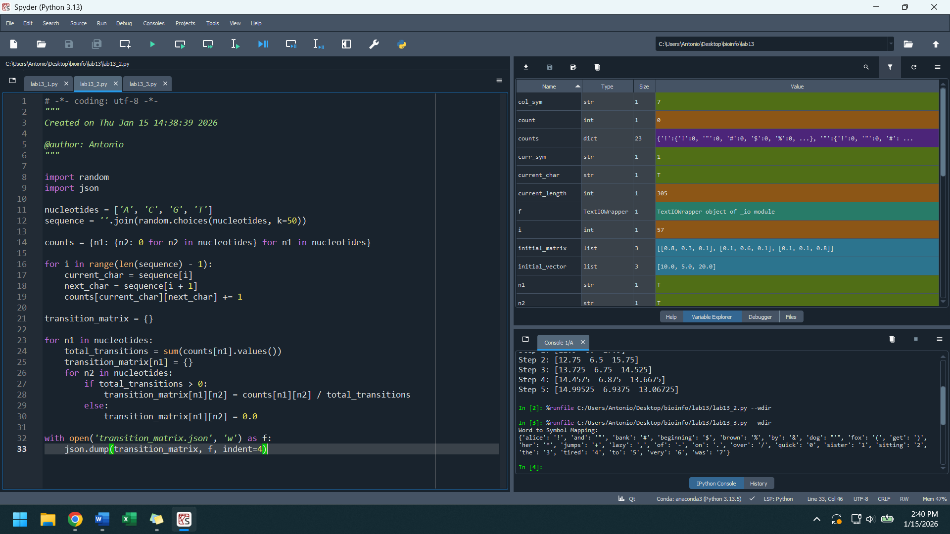
lab13_3.py
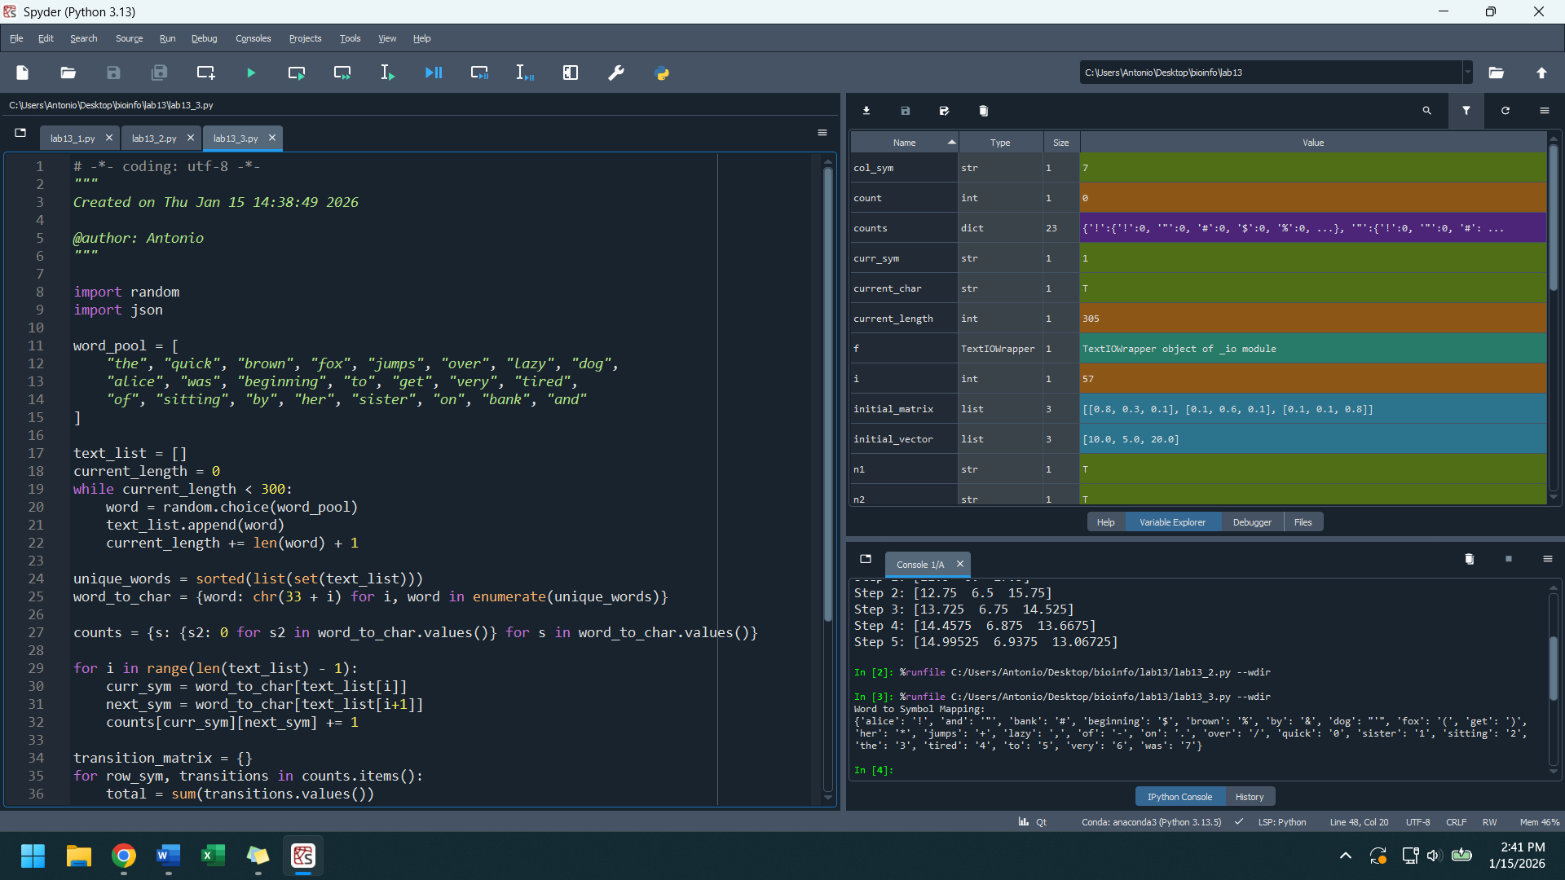
lab13_4.py
