# Order Management System

Below steps have been followed to develop the required REST API in ASP.NET MVC project.

1. Created required tables & stored procedures. In order to perform the API operations some sample data has been inserted into the tables.
2. Created a MVC Web API project. The project has 3 controllers – Admin, Buyer, Order.

Admin – Will be able to retrieve all the orders available.

Buyer – Will be able to retrieve the associated order details.

Order- Allows to add, edit, update and delete the existing orders.

1. In the project I have used Entity framework 6.1.3 and Database first approach.  
   (i) Added the ADO.NET Entity model  
   (ii) Configured the model with already defined database.  
   (iii) Used the Entities to access the data from the model.
2. If you observe the approach in the Order Controller, I have used the stored procedures to perform the GET operations and data model to perform rest of the operations such as POST, PUT & DELETE.
3. Three stored procedures are used in project.  
   (i) sp_getallOrders – retrieves the details related to all the orders.

(ii) sp_getordersforBuyer – retrieves information related to buyer related orders.

(iii) sp_Orders_CRUD – allows to perform Insert, Update, Delete operations on the tables.

1. As I wanted my result to be in JSON format only, necessary steps have been followed to configure the same in WebApiConfig.cs

Please find the SQL related queries below.



Please find the screenshots of Web API results below.

1. GET

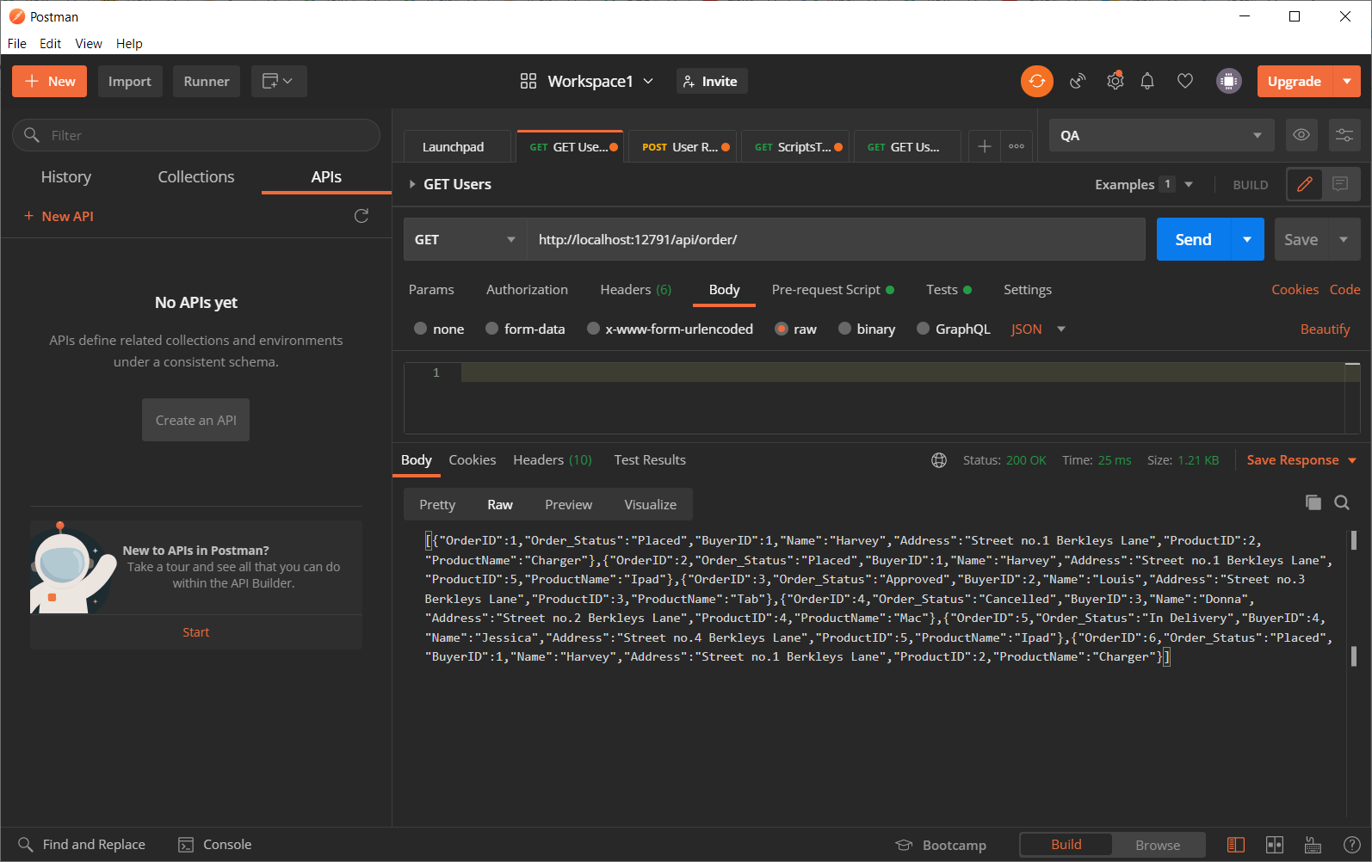

1. GET with ID

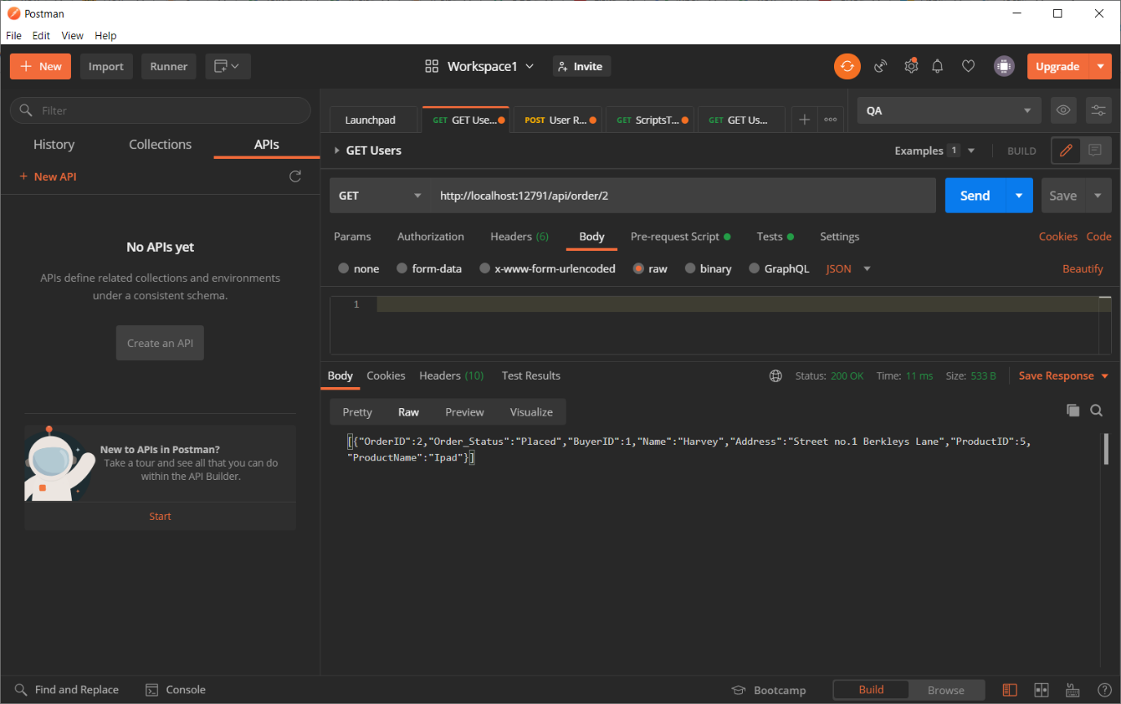

1. POST – API takes the values from Body as below.

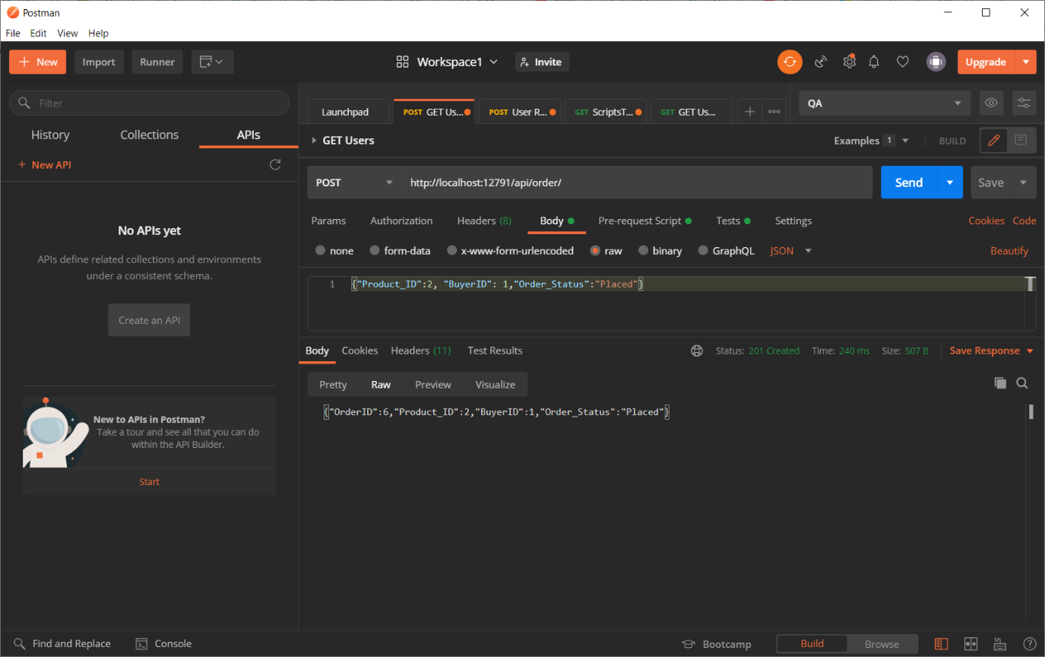

1. PUT – The details to be updated will be taken from the body and id to which we perform the update will be referred from the URI.

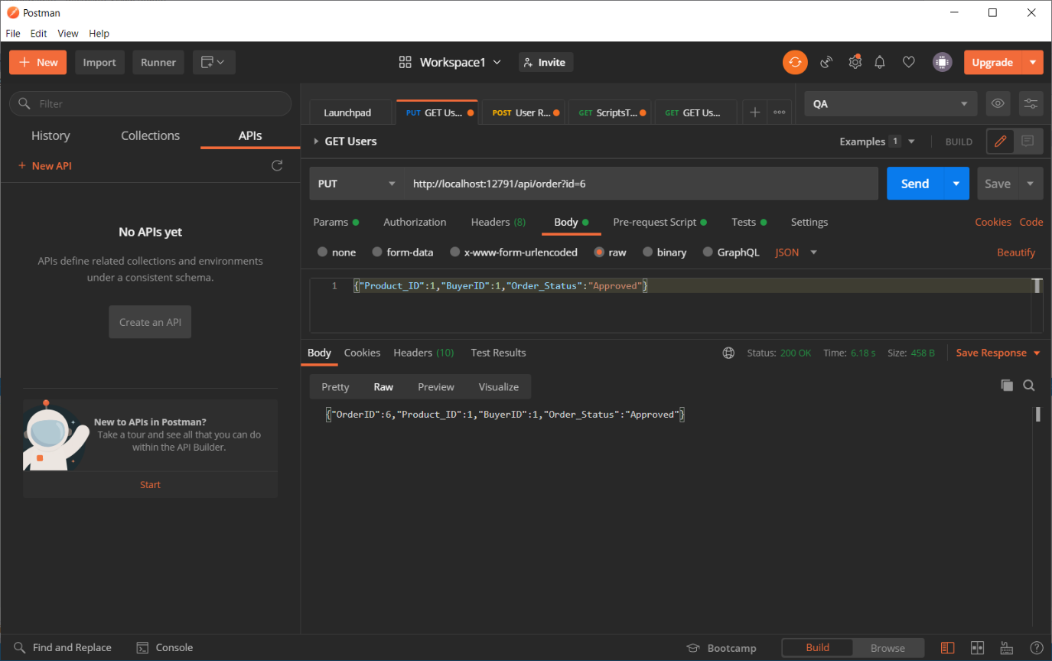

1. DELETE – The order ID which is used to delete the record is included in the URI.

