Findings:

**Airport Information:**

There are some airports in the USA which are active during certain periods of the year:

To name a few:

Quincy, IL - active only in DEC

Spokane, WA- active Jun-Dec with few flights every month

Cap Girardeau, Mo - active only in Dec

FairBanks, AK- active only in Jun, Jul and Dec

Eagle, Co- active from Dec to Apr

**A day of the week:**

1. Comparatively, there are more landings all days then takeoffs
2. There were continous takeoffs of flights from 6am to 2259am on all days
3. The months that were busy with take offs during the days of the week:

Mon: July

Tues: June

Wed: July

Thrus: June

Fri: July

Sat: July

Sun: July

1. The months that were busy with landings during the days of the week:

Mon: July

Tues: June

Wed: July

Thrus: June

Fri: July

Sat: Dec

Sun: July

1. The above points conclude that June and July are always the busiest months out of the year and throughout all days of the week.

The is mostly because of the summer vacations in US

1. The plot also shows some usual delays that took place:

Similarly to the one showing below, which was in Nov on one Thrusday

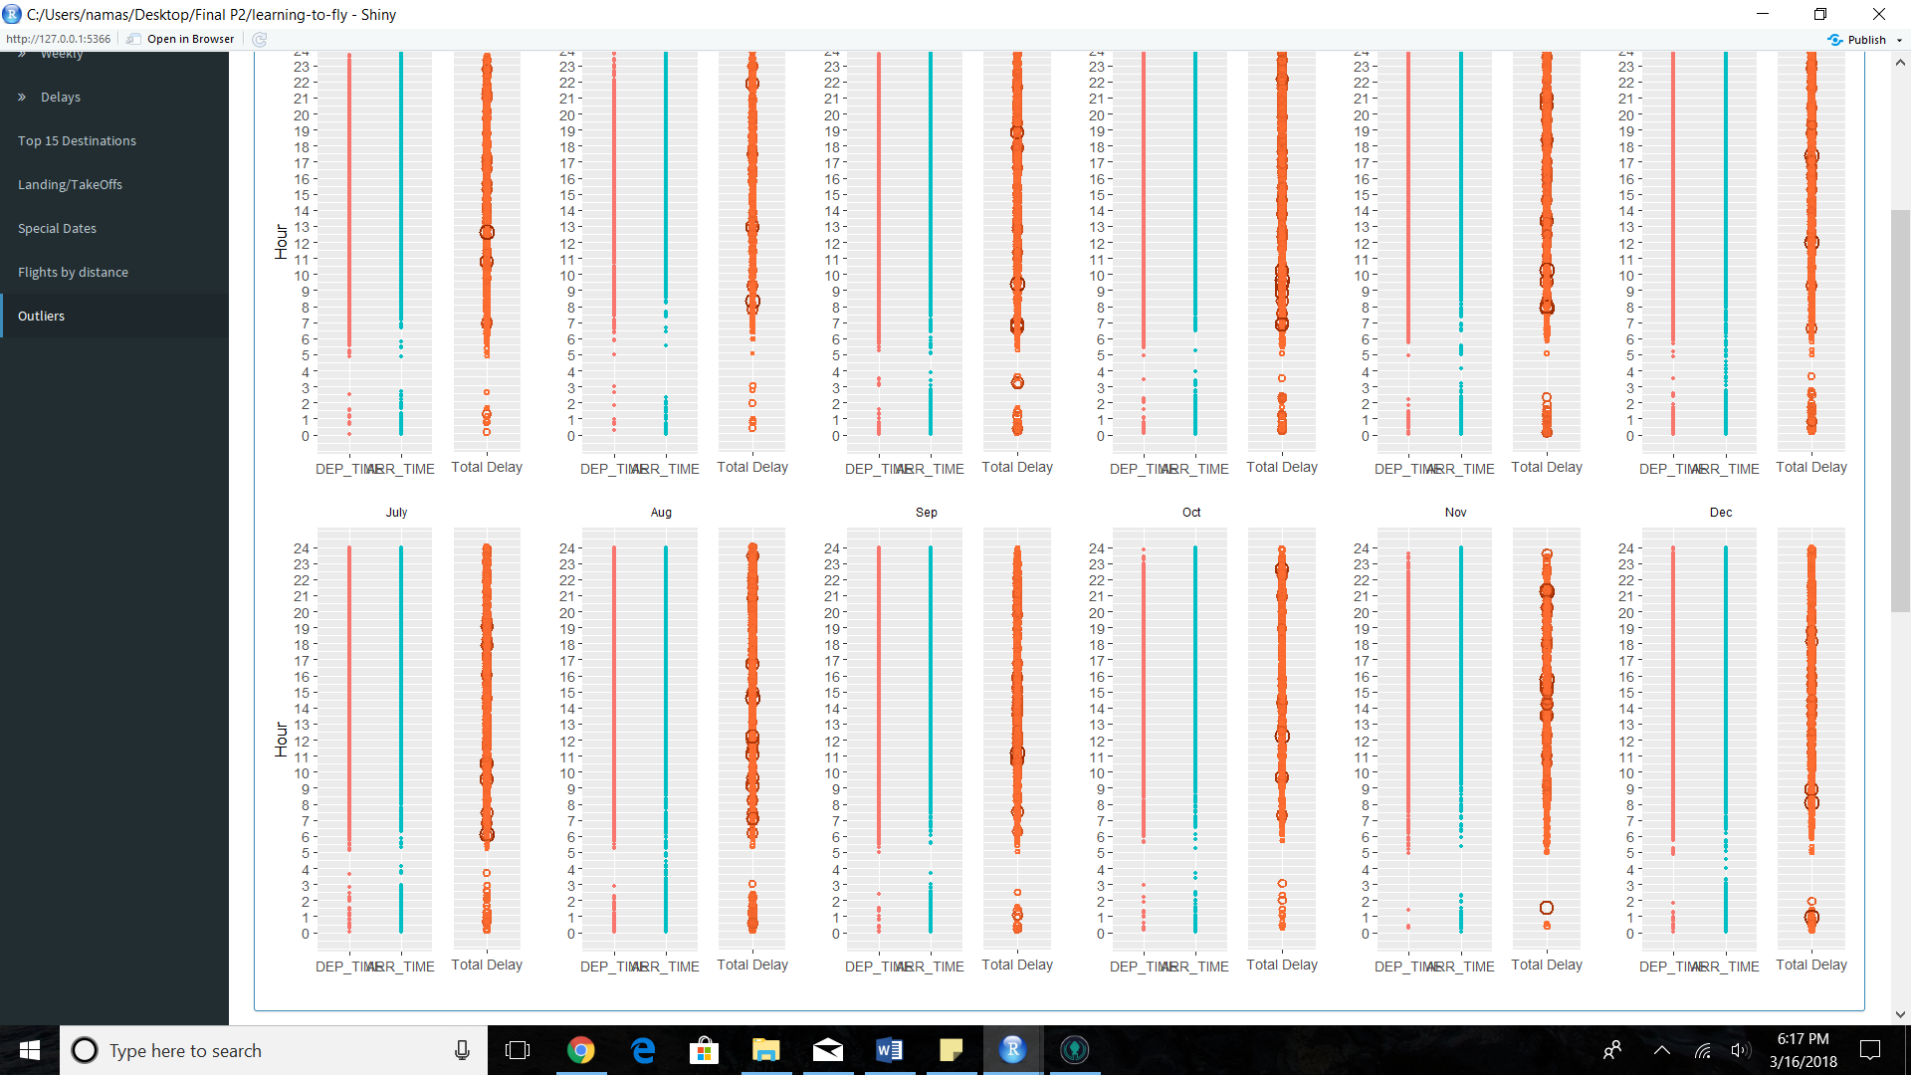

1. Similarly, higher delays:

Mon:July

Tues: Oct

Wed: June

Thrus:

Fri:

Sat:

Sun: