EXOS Functional Test Plan
Extreme Fabric Attach - Zero Touch

Release Information
Release | EXOS 31.3
Feature Number | EXOS-067
CR Number
Author | Alexander J

General Information
Note
This specification is preliminary and subject to change. This document is Extreme Networks company confidential and not intended for external distribution.

Overview:
This is the functional test plan for fabric attach – zero touch client provisioning. When FA-proxy or server detected FA client, it will assign pre-configured VLAN/NSI mapping to that device.
So all the devices discovered of that same type will have same VLAN/NSI mapping configurations.

Feature Highlights:
Zero Touch Client adds addition functionality that enhances Fabric Attach by allowing static mappings for client types. Normally NSI/VLAN mappings are received from the Client through LLDP or are configured statically on a port. ZTC provides a method to configure a mapping for a specific client ty , so that all devices discovered of that type will have the same mapping. For example, all LLDP neighbors defined as Fabric Attach Client Phones could be configured to be added to VLAN phoneVlan. All phones would be treated the same without the Client requiring knowledge of this. ZTC NSI/VLAN mappings are added to the vlan as the untagged vlan for the port. ZTC may only configure one mapping per client type since there can only be one untagged port vlan. ZTC provides a method to configure port priority. If no priority is provided, the statically configured dot1p priority will be used.

Contents

General Information 1
Overview: 1
Feature Highlights: 1
Contents 2
Introduction 5
1.1 Overview 5
1.2 Use Cases 5
1.3 Limitations 5
1.4 Terminology and Acronyms 5
2 Topology 5
3 Set up and Configurations 7
4 Tools 9
5 Test Cases 9
5.1 Conformance to Industry Standard 9
5.2 Feature Adherence to Functional Spec 9
5.2.1 Standalone/Stack 9
5.2.1.1 Verify zero touch client behavior on standalone switch with default port priority 9
5.2.1.2 Verify zero touch client behavior on standalone switch with user configured port priority 10
5.2.1.3 Verify zero touch client behavior on stack switch where FA client is connected on backup node with default port priority 10
5.2.1.4 Verify zero touch client behavior on stack switch where FA client is connected on standby node with default port priority 11
5.2.1.5 Configure VLAN/NSI mapping for zero touch client and add the port client port to that VLAN manually. 11
5.2.1.6 Delete the client port from ZTC VLAN manually 11
5.2.1.7 Verify zero touch client behavior by connecting multiple FA clients of same device type on FA proxy 12
5.2.1.8 Disconnect one FA client from FA proxy and verify zero touch client behavior 12
5.2.1.9 Disconnect all FA clients from FA proxy and verify zero touch client behavior 12
5.2.1.10 Verify zero touch client behavior by stop advertising LLDP packet from FA-client 13
5.2.1.11 Verify zero touch client behavior by sending VLAN/NSI mapping from FA-client in LLDP advertisement 13
5.2.1.12 Verify zero touch client behavior by sending VLAN/NSI mapping from RADIUS server 14
5.2.1.13 Verify zero touch client behavior by configuring static VLAN/NSI mapping over the VLAN 14
5.2.1.14 Verify zero touch client behavior with standalone FA-proxy configuration 15
5.2.1.15 Disable zero touch client and check whether VLAN/NSI mapping is removed after timeout 15
5.2.1.16 Enable zero touch client and verify VLAN/NSI mapping are advertised to FA server 16
5.2.1.17 Assign same VLAN/NSI mapping for multiple FA clients of same device type through the LLDP, RADIUS and ZTC methods 16
5.2.1.18 Verify zero touch client behavior after removing the FA-server from the network 17
5.2.1.19 Verify zero touch client behavior on netlogin and one policy enabled ports 17
5.2.1.20 Configure VLAN/NSI mapping for zero touch client and send different VLAN/NSI mapping from FA client in LLDP packet 18
5.2.1.21 Configure VLAN/NSI mapping for zero touch client and send different VLAN/NSI mapping for FA client from RADIUS server 18
5.2.1.22 Configure VLAN/NSI mapping for zero touch client and create different VLAN/NSI mapping through static configuration 18
5.2.2 MLAG 19
5.2.2.1 Connect FA client on MLAG ports and validate zero touch client behavior 19
5.2.2.2 Verify zero touch client behavior by disabling MLAG port on MLAG master node 19
5.2.2.3 Verify zero touch client behavior by enabling MLAG port on MLAG master node 20
5.2.2.4 Reboot MLAG non-authenticator switch with zero touch client configuration enabled 21
5.2.2.5 Reboot MLAG authenticator switch with zero touch client configuration enabled 21
5.2.2.6 Disable ISC ports and check zero touch client behavior 21
5.2.2.7 Enable ISC ports and check zero touch client behavior 22
5.2.2.8 Verify zero touch client behavior with standalone MLAG-FA-proxy configuration 22
5.2.2.9 configure VxLAN tenant VLAN as zero touch client VLAN and check VNI/NSI mappings are check pointed to the peer switch 22
5.2.3 W-MLAG 23
5.2.3.1 Check VLAN/NSI mapping is checkpointed to all FA proxies when LLDP packet is received on MLAG port and Non-MLAG in W-MLAG setup 23
5.2.3.2 Reboot Middle MLAG peer in W-MLAG setup. 24
5.2.4 Single homed FA over MLAG 24
5.2.4.1 Verify zero touch client functionality in single homed fabric attach over MLAG setup 24
5.2.4.2 Verify zero touch client functionality in single homed fabric attach over MLAG-standalone proxy setup. 25
5.3 Feature Adherence to PRD/MRD 25
5.4 Feature Configuration - CLI & Network Mgmt Tool 25
5.5 SNMP MIB Verification 25
5.6 Redundancy/Resiliency/Failover 25
5.6.1.1 Save and reboot FA servers peers/FA Proxy Peers 25
5.6.1.2 Restart port all 25
5.6.1.3 Restart process LLDP 26
5.6.1.4 Restart process VSM 26
5.6.1.5 Run Failover 26
5.6.1.6 Disable port all 26
5.6.1.7 Enable port all 27
5.7 Feature Scaling & Feature Limit Testing 27
5.8 Feature Performance 27
5.9 Integrated Feature Scaling & Limit Testing 27
5.10 Integrated Feature Performance 27
5.11 Interoperability - Extreme & 3rd Party 27
5.12 Diagnostic & Debug Testing 27
5.13 Usability Testing 27
5.14 Negative Testing 27
5.15 System Resource & Stress testing 28
6 Appendix A: References 28
7 Appendix B: Minutes of Test Plan Review Meeting 29
8 Review Meeting Action Items 30

Introduction

Overview

Zero Touch Client adds addition functionality that enhances Fabric Attach by allowing static mappings for client types. Normally NSI/VLAN mappings are received from the Client through LLDP or are configured statically on a port. ZTC provides a method to configure a mapping for a specific client type, so that all devices discovered of that type will have the same mapping. For example, all LLDP neighbors defined as Fabric Attach Client Phones could be configured to be added to VLAN phoneVlan. All phones would be treated the same without the Client requiring knowledge of this. ZTC NSI/VLAN mappings are added to the vlan as the untagged vlan for the port. ZTC may only configure one mapping per client type since there can only be one untagged port vlan. ZTC provides a method to configure port priority. If no priority is provided, the statically configured dot1p priority will be used.
By default, all clients are configured to disabled state without a mapping. When enabled and a mapping is configured, all clients of the type will use the mapping. Static mappings can still overrule ZTC, if configured to be.

Use Cases
- Useful for non-VLAN aware devices which simply need an untagged connection.
- Same type of devices will be grouped under same VLAN/NSI mapping.

Limitations

Terminology and Acronyms

FA – Fabric Attach
NSI - Network Service Identifier
ISID - Individual Service Identifier
ZTC – Zero Touch Client
LLDP – Link Layer Discovery Protocol
VxLAN – Virtual extensible Local Area Network
LAG – Link Aggregation
DUT – Device Under Test

Topology

Topology:1(Standalone setup)
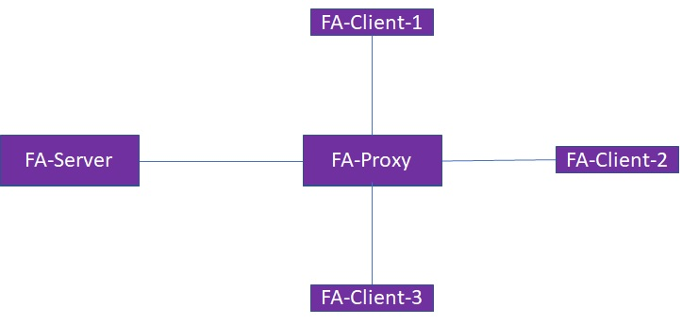

Topology:2(MLAG setup)

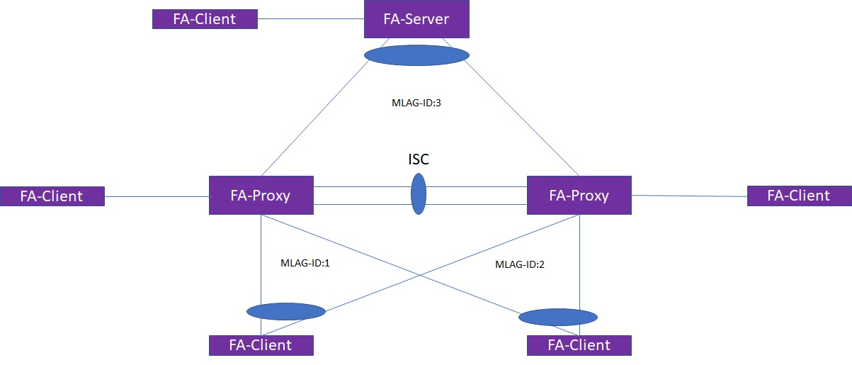

Topology:3(W-MLAG setup)
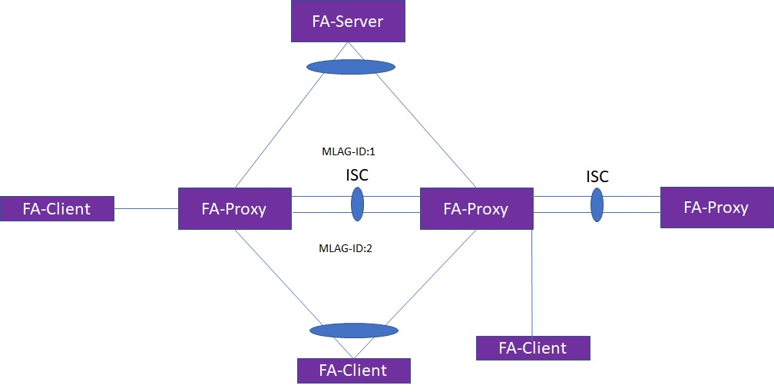

Topology:4(Two-Tier MLAG setup)

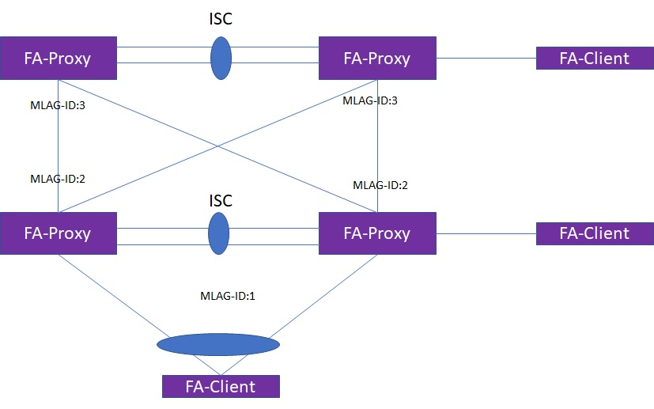

Set up and Configurations

Following Steps are needed to configure extreme fabric attach zero touch client and validate VLAN/NSI mapping:

- Configure vlan/NSI mapping to the FA Clients types.
- When an LLDP packet is received with a Fabric Attach TLV with the same Client type information, the CLI configured VLAN/NSI is added to the list of mappings found in the Fabric Attach TLV and pushed into the FA database to be used.
- Port will be added to the VLAN as untagged.
- In MLAG, VLAN and NSI will be checkpointed to the peer switch.

ZTC Configurations:

Create vlan v600 tag 600
configure fabric attach zero-touch-client phone enable
configure fabric attach zero-touch-client phone vlan 600 nsi 60001

MLAG PEER1:
ISC configuration :
enable sharing 9 grouping 9-10 algorithm address-based L2 lacp
enable sharing 17 grouping 17-18 algorithm address-based L2 lacp

create vlan "isc_vlan1"
configure vlan isc_vlan1 tag 100
configure vlan isc_vlan1 add ports 17 tagged
configure vlan isc_vlan1 ipaddress 10.1.1.1 255.255.255.0

MLAG Configuration

create mlag peer "peer1"
configure mlag peer "peer1" ipaddress 10.1.1.2 vr VR-Default
enable mlag port 9 peer "peer1" id 100

OTM Configuration

configure virtual-network local-endpoint ipaddress 2.2.2.20 vr "VR-Default"
create virtual-network "five000" flooding standard
configure virtual-network "five000" vxlan vni 100500
configure virtual-network "five000" add vlan five000

MLAG PEER2
ISC configuration :

enable sharing 11 grouping 11-12 algorithm address-based L2 lacp

enable sharing 17 grouping 17-18 algorithm address-based L2 lacp

create vlan "isc_vlan2"
configure vlan isc_vlan2 tag 100

configure vlan isc_vlan2 add ports 17 tagged
configure vlan isc_vlan1 ipaddress 10.1.1.2 255.255.255.0

MLAG Configuration

create mlag peer "peer2"
configure mlag peer "peer2" ipaddress 10.1.1.1 vr VR-Default
enable mlag port 11 peer "peer2" id 100

FA Proxy – static Configuration

configure vlan 600 add nsi 600001

Netlogin configurations:

enable netlogin mac
configure netlogin authentication protocol-order dot1x mac web-based
enable netlogin ports 10 mac
configure netlogin add mac-list ff:ff:ff:ff:ff:ff 48

Tools

IXIA
RADIUS
LLDP-Packetgenerator.py (To simulate FA clients)

Test Cases

Conformance to Industry Standard

Feature Adherence to Functional Spec

Standalone/Stack

Verify zero touch client behavior on standalone switch with default port priority

Topology used: Topology 1
Methodology:
  - Create auto-peering and create virtual networks in DUT1.
  - Configure LTEP IPaddress in DUT1.
  - FA elements should be detected on FA proxy
  - Create vlan v101 and configure static zero touch client VLAN/NSI mapping on FAProxy.
  - Send LLDP packet with FA-TLV from FA-client to FA-proxy.

  - VLAN/NSI mapping will be sent to FA server for authentication.
  - Send traffic from FA Client device and check pass criteria
Pass Criteria:
- After auto-peering and LTEP configuration, DUT1 will transition from FA-client to FA-server.
- FA-Client connected to port will be added to the ZTC VLAN as untagged.
- FA proxy approves the mapping after getting approval from FA server
- Ensure that traffic is received on FA server and mapped to correct NSI.
- Default dot1p priority will be set to the FA-client traffic.

Sanity (Yes/No):

Verify zero touch client behavior on standalone switch with user configured port priority

Topology used: Topology 1
Methodology:
- Create auto-peering and create virtual networks in DUT1.
- Configure LTEP IPaddress in DUT1.
- FA elements should be detected on FA proxy
- Create vlan v101 and configure static zero touch client VLAN/NSI mapping on FAProxy with user priority.
- Send LLDP packet with FA-TLV from FA-client to FA-proxy.

- VLAN/NSI mapping will be sent to FA server for authentication.
- Send traffic from FA Client device and check pass criteria
Pass Criteria:
- After auto-peering and LTEP configuration, DUT1 will transition from FA-client to FA-server.
- FA-Client connected to port will be added to the ZTC VLAN as untagged.
- FA proxy approves the mapping after getting approval from FA server
- Ensure that traffic is received on FA server and mapped to correct NSI.
- User configured port priority will be set to the FA-client traffic.

Sanity (Yes/No):

Verify zero touch client behavior on stack switch where FA client is connected on backup node with default port priority
Topology used: Topology 1
Methodology:
Configure as in 5.2.1.1
Connect FA-client in stack backup node.
Pass Criteria:
As in 5.2.1.1
Sanity (Yes/No):

Verify zero touch client behavior on stack switch where FA client is connected on standby node with default port priority

Topology used: Topology 1
Methodology:
Configure as in 5.2.1.1
Connect FA-client in stack standby node.
Pass Criteria:
As in 5.2.1.1
Sanity (Yes/No):

Configure VLAN/NSI mapping for zero touch client and add the port client port to that VLAN manually.

Topology used: Topology 1
Methodology:
- Create auto-peering and create virtual networks in DUT1.
- Configure LTEP IPaddress in DUT1.
- FA elements should be detected on FA proxy
- Create vlan v101 and configure static zero touch client VLAN/NSI mapping on FAProxy with user priority.
- Add FA client connected port to the vlan v101 manually.
- Send LLDP packet with FA-TLV from FA-client to FA-proxy.

- VLAN/NSI mapping will be sent to FA server for authentication.
Send traffic from FA Client device and check pass criteria
Pass Criteria:
- After auto-peering and LTEP configuration, DUT1 will transition from FA-client to FA-server.
- No error should be observed. FA client should be detected as element in FA database.
- FA proxy approves the mapping after getting approval from FA server
- Ensure that traffic is received on FA server and mapped to correct NSI.
- Default dot1p priority will be set to the FA-client traffic
Sanity (Yes/No):

Delete the client port from ZTC VLAN manually

Topology used: Topology 1
Methodology:
Configure as in 5.2.1.1
Delete FA client port from ZTC VLAN.
Pass Criteria:

Error message should be printed . CLI should not allow the user to delete dynamically added ports from VLAN.
Sanity (Yes/No):

Verify zero touch client behavior by connecting multiple FA clients of same device type on FA proxy

Topology used: Topology 1
Methodology:
Configure as in 5.2.1.1
Connect multiple FA clients of same device type to the FA-Proxy.
Pass Criteria:
As in 5.2.1.1
All the FA client ports will be added to the ZTC VLAN.
Sanity (Yes/No):

Disconnect one FA client from FA proxy and verify zero touch client behavior
Topology used: Topology 1
Methodology:
Configure as in 5.2.1.7.
Disable one of the FA client port in FA-proxy.
Pass Criteria:
When one of FA client is disconnected from FA-proxy, uplink port should not be removed from ZTC VLAN.
Sanity (Yes/No):

Disconnect all FA clients from FA proxy and verify zero touch client behavior
Topology used: Topology 1
Methodology:
Configure as in 5.2.1.7.
Disable all FA clients port in FA-Proxy.
Pass Criteria:
All client ports should be removed from ZTC VLAN.
Uplink port should be removed from ZTC VLAN.

Sanity (Yes/No):

Verify zero touch client behavior by stop advertising LLDP packet from FA-client

Topology used: Topology 1
Methodology:
- Create auto-peering and create virtual networks in DUT1.
- Configure LTEP IPaddress in DUT1.
- FA elements should be detected on FA proxy
- Create vlan v101 and configure static zero touch client VLAN/NSI mapping on FAProxy.
- Send LLDP packet with FA-TLV from FA-client to FA-proxy.

- VLAN/NSI mapping will be sent to FA server for authentication.
- Send traffic from FA Client device and check pass criteria
- Stop sending LLDP packet from FA client.
Pass Criteria:
- After auto-peering and LTEP configuration, DUT1 will transition from FA-client to FA-server.
- FA-Client connected to port will be added to the ZTC VLAN as untagged.
- FA proxy approves the mapping after getting approval from FA server
- Ensure that traffic is received on FA server and mapped to correct NSI.
- Default dot1p priority will be set to the FA-client traffic
- After LLDP timeout, Client port and uplink port will be removed from ZTC VLAN.
Sanity (Yes/No):

Verify zero touch client behavior by sending VLAN/NSI mapping from FA-client in LLDP advertisement
Topology used: Topology 1
Methodology:
- Create auto-peering and create virtual networks in DUT1.
- Configure LTEP IPaddress in DUT1.
- FA elements should be detected on FA proxy
- Create vlan v101 and configure static zero touch client VLAN/NSI mapping on FAProxy.
- Send LLDP packet with VLAN/NSI mapping from FA-client to FA-proxy.
- VLAN/NSI mapping will be sent to FA server for authentication.
- Send traffic from FA Client device and check pass criteria
Pass Criteria:
- After auto-peering and LTEP configuration, DUT1 will transition from FA-client to FA-server.
- FA-Client connected to port will be added to the VLAN which is advertised in LLDP packet.
- FA proxy approves the mapping after getting approval from FA server
- Ensure that traffic is received on FA server and mapped to correct NSI.
- Default dot1p priority will be set to the FA-client traffic.

Sanity (Yes/No):

Verify zero touch client behavior by sending VLAN/NSI mapping from RADIUS server
Topology used: Topology 1
Methodology:
- Create auto-peering and create virtual networks in DUT1.
- Configure LTEP IPaddress in DUT1.
- FA elements should be detected on FA proxy
- Create vlan v101 and configure static zero touch client VLAN/NSI mapping on FAProxy.
- Send LLDP packet with FA-TLV from FA-client to FA-proxy.
- VLAN/NSI mapping will be sent to FA server for authentication.
- Send traffic from FA Client device and check pass criteria

Pass Criteria:
- After auto-peering and LTEP configuration, DUT1 will transition from FA-client to FA-server.
- FA-Client connected to port will be added to the VLAN which returned from RADIUS server.
- FA proxy approves the mapping after getting approval from FA server
- Ensure that traffic is received on FA server and mapped to correct NSI.
- Default dot1p priority will be set to the FA-client traffic.

Sanity (Yes/No):

Verify zero touch client behavior by configuring static VLAN/NSI mapping over the VLAN
Topology used: Topology 1
Methodology:
Configure as in 5.2.1.1
Add static VLAN and NSI entry in FA proxy.
Pass Criteria:
Static VLAN/NSI mapping will get higher priority over ZTC configuration.
Sanity (Yes/No):

Verify zero touch client behavior with standalone FA-proxy configuration
Topology used: Topology 1
Methodology:
- Create auto-peering and create virtual networks in DUT1.
- Configure LTEP IPaddress in DUT1.
- FA elements should be detected on FA proxy
- Create vlan v101 and configure static zero touch client VLAN/NSI mapping on FAProxy.
- Configure fabric attach uplink port on FA-proxy.
- Send LLDP packet with FA-TLV from FA-client to FA-proxy.
- Send traffic from FA Client device and check pass criteria

Pass Criteria:
- After auto-peering and LTEP configuration, DUT1 will transition from FA-client to FA-server.
- FA-Client connected to port and uplink port will be added to the VLAN .
- Default dot1p priority will be set to the FA-client traffic.

Sanity (Yes/No):

Disable zero touch client and check whether VLAN/NSI mapping is removed after timeout
Topology used: Topology 1
Methodology:
- Create auto-peering and create virtual networks in DUT1.
- Configure LTEP IPaddress in DUT1.
- FA elements should be detected on FA proxy
- Create vlan v101 and configure static zero touch client VLAN/NSI mapping on FAProxy.
- Send LLDP packet with VLAN/NSI mapping from FA-client to FA-proxy.
- VLAN/NSI mapping will be sent to FA server for authentication.
- Send traffic from FA Client device and check pass criteria
- Disable zero touch client for all device type.
Pass Criteria:
- After auto-peering and LTEP configuration, DUT1 will transition from FA-client to FA-server.
- FA-Client connected to port will be added to the VLAN which is advertised in LLDP packet.
- FA proxy approves the mapping after getting approval from FA server
- Ensure that traffic is received on FA server and mapped to correct NSI.
- Default dot1p priority will be set to the FA-client traffic
- Step 8, FA client port and uplink will be removed from ZTC VLAN after LLDP timeout.
Sanity (Yes/No):

Enable zero touch client and verify VLAN/NSI mapping are advertised to FA server
Topology used: Topology 1
Methodology:
- Create auto-peering and create virtual networks in DUT1.
- Configure LTEP IPaddress in DUT1.
- FA elements should be detected on FA proxy
- Create vlan v101 and configure static zero touch client VLAN/NSI mapping on FAProxy.
- Send LLDP packet with VLAN/NSI mapping from FA-client to FA-proxy.
- VLAN/NSI mapping will be sent to FA server for authentication.
- Send traffic from FA Client device and check pass criteria
- Disable zero touch client for all device type.
- Re-enable zero touch client on FA proxy.

Pass Criteria:
- After auto-peering and LTEP configuration, DUT1 will transition from FA-client to FA-server.
- FA-Client connected to port will be added to the VLAN which is advertised in LLDP packet.
- FA proxy approves the mapping after getting approval from FA server
- Ensure that traffic is received on FA server and mapped to correct NSI.
- Default dot1p priority will be set to the FA-client traffic
- Step 8, FA client port and uplink will be removed from ZTC VLAN after LLDP timeout.
- Step 9, FA proxy will send VLAN/NSI mapping to FA server for approval.
- FA-Client connected to port will be added to the VLAN which is advertised in LLDP packet.
- FA proxy approves the mapping after getting approval from FA server

Sanity (Yes/No):

Assign same VLAN/NSI mapping for multiple FA clients of same device type through the LLDP, RADIUS and ZTC methods
Topology used: Topology 1
Methodology:
- Create auto-peering and create virtual networks in DUT1.
- Configure LTEP IPaddress in DUT1.
- FA elements should be detected on FA proxy
- Create vlan v101 and configure static zero touch client VLAN/NSI mapping on FA Proxy.
- Send LLDP packet with VLAN/NSI mapping from FA-client-1 to FA-proxy.
- Send LLDP packet without VLAN/NSI mapping from FA-client-2 to FA-proxy.
- Enable Netlogin on FA-client-3 connected port and after successful authentication
Send VLAN/NSI mapping from RADIUS server.
- VLAN/NSI mapping will be sent to FA server for authentication.
- Send traffic from FA Client device and check pass criteria

Pass Criteria:
- After auto-peering and LTEP configuration, DUT1 will transition from FA-client to FA-server.
- All the FA-Clients connected to ports will be added to the VLAN.
- FA proxy approves the mapping after getting approval from FA server
- Ensure that traffic is received on FA server and mapped to correct NSI.
- Default dot1p priority will be set to the FA-client traffic.

Sanity (Yes/No):

Verify zero touch client behavior after removing the FA-server from the network
Topology used: Topology 1
Methodology:
- Configure as in 5.2.1.1
- Delete auto-peering and remove LTEP IPaddress on FA-server.

Pass Criteria:
- As in 5.2.1.1
- After removing LTEP ipaddress and delete auto-peering, FA-server will transition to default FA-client.
- FA-Server element will be removed from FA-proxy and FA-proxy will transition to FA-Server.
Sanity (Yes/No):

Verify zero touch client behavior on netlogin and one policy enabled ports
Topology used: Topology 1
Methodology:
- Create auto-peering and create virtual networks in DUT1.
- Configure LTEP IPaddress in DUT1.
- FA elements should be detected on FA proxy
- Create vlan v101 and configure VLAN/NSI mapping for FA client on FAProxy.
- Enable Netlogin on FA-client connected ports.
- Authenticate FA-clients through RADIUS Server.
- Send LLDP packet with FA-TLV from FA-client-1 to FA-proxy.

Pass Criteria:
- FA client will be authenticated successfully. VNI/NSI sent from RADIUS server will be applied on FA-proxy.

Sanity (Yes/No):

Configure VLAN/NSI mapping for zero touch client and send different VLAN/NSI mapping from FA client in LLDP packet
Topology used: Topology 1
Methodology:
- Create auto-peering and create virtual networks in DUT1.
- Configure LTEP IPaddress in DUT1.
- FA elements should be detected on FA proxy
- Create vlan v101 and configure static zero touch client VLAN/NSI mapping on FAProxy.
- Send LLDP packet with different VLAN/NSI mapping from FA-client to FA-proxy.
- VLAN/NSI mapping will be sent to FA server for authentication.
- Send traffic from FA Client device and check pass criteria
Pass Criteria:
- VLAN/NSI mapping sent from FA-Client in LLDP packet will get higher priority.
- FA proxy approves the mapping after getting approval from FA server
- Ensure that traffic is received on FA server and mapped to correct NSI.

Sanity (Yes/No):

Configure VLAN/NSI mapping for zero touch client and send different VLAN/NSI mapping for FA client from RADIUS server
Topology used: Topology 1
Methodology:
- Create auto-peering and create virtual networks in DUT1.
- Configure LTEP IPaddress in DUT1.
- FA elements should be detected on FA proxy
- Create vlan v101 and configure static zero touch client VLAN/NSI mapping on FAProxy.
- Enable Netlogin on FA client connected port and authenticate FA client through RADIUS server.
- Send LLDP packet with FA-TLV from FA-client to FA-proxy.
- VLAN/NSI mapping will be sent to FA server for authentication.
- Send traffic from FA Client device and check pass criteria
Pass Criteria:
- VLAN/NSI mapping sent from RADIUS server will get higher priority.
- FA proxy approves the mapping after getting approval from FA server
- Ensure that traffic is received on FA server and mapped to correct NSI.
Sanity (Yes/No):

Configure VLAN/NSI mapping for zero touch client and create different VLAN/NSI mapping through static configuration

Topology used: Topology 1
Methodology:
- Create auto-peering and create virtual networks in DUT1.
- Configure LTEP IPaddress in DUT1.
- FA elements should be detected on FA proxy
- Create vlan v101 and configure static zero touch client VLAN/NSI mapping on FAProxy.
- Add static VLAN and NSI entry in FA proxy.
- Send LLDP packet with FA-TLV from FA-client to FA-proxy.
- VLAN/NSI mapping will be sent to FA server for authentication.
- Send traffic from FA Client device and check pass criteria
Pass Criteria:
- VLAN/NSI mapping configured through CLI will get higher priority.
- FA proxy approves the mapping after getting approval from FA server
- Ensure that traffic is received on FA server and mapped to correct NSI.
Sanity (Yes/No):

MLAG

Connect FA client on MLAG ports and validate zero touch client behavior
Topology used: Topology 2
Methodology:
- Configure MLAG Peer1 and Peer2 as mentioned in configuration section.
- MLAG is enabled on FA Client connected ports on both peer.
- FA-Proxy will receive an LLDP packet from the FA client and add MLAG local port and ISC port to the ZTC VLAN.
- Peer MLAG FA proxy will receive VLAN/NSI mappings over ISC and will add client port, ISC and approve FA assignments.
- VLAN/NSI mapping will be sent to FA server for authentication.

Pass Criteria:
- Verify MLAG peer status . Peer should be UP
- Check show vlan fabric attach assignments- VLAN and NSI mapping should be created and dynamic.
- Check show lldp neighbors detailed- Extreme Fabric Attach NSI(I-SID)/VLAN map should be populated with Status,VID and NSI-ID on port.
- Check show fdb - Verify FDB is learnt over MLAG port and checkpointed to MLAG peer
- Ensure that traffic is received on FA server and mapped to correct NSI
Sanity (Yes/No):

Verify zero touch client behavior by disabling MLAG port on MLAG master node
Topology used: Topology 2
Methodology:
- Configure MLAG Peer1 and Peer2 as mentioned in configuration section.
- MLAG is enabled on FA Client connected ports on both peer.
- FA-Proxy will receive an LLDP packet from the FA client and add MLAG local port and ISC port to the ZTC VLAN.
- Peer MLAG FA proxy will receive VLAN/NSI mappings over ISC and will add client port, ISC and approve FA assignments.
- VLAN/NSI mapping will be sent to FA server for authentication.
- Disable master MLAG switch(highest ISC ipaddress) client connected MLAG port.

Pass Criteria:
- Verify MLAG peer status . Peer should be UP
- Check show vlan fabric attach assignments- VLAN and NSI mapping should be created and dynamic.
- Check show lldp neighbors detailed- Extreme Fabric Attach NSI(I-SID)/VLAN map should be populated with Status,VID and NSI-ID on port.
- Check show fdb - Verify FDB is learnt over MLAG port and checkpointed to MLAG peer
- Ensure that traffic is received on FA server and mapped to correct NSI.
- After LLDP timeout, VLAN/NSI mapping is removed from MLAG ports.
- FA client entry will be removed from FA element list.

Sanity (Yes/No):

Verify zero touch client behavior by enabling MLAG port on MLAG master node
Topology used: Topology 2
Methodology:
- Configure MLAG Peer1 and Peer2 as mentioned in configuration section.
- MLAG is enabled on FA Client connected ports on both peer.
- FA-Proxy will receive an LLDP packet from the FA client and add MLAG local port and ISC port to the ZTC VLAN.
- Peer MLAG FA proxy will receive VLAN/NSI mappings over ISC and will add client port, ISC and approve FA assignments.
- VLAN/NSI mapping will be sent to FA server for authentication.
- Disable master MLAG switch(highest ISC ipaddress) client connected MLAG port.
- Re-enable MLAG port.

Pass Criteria:
- Verify MLAG peer status . Peer should be UP
- Check show vlan fabric attach assignments- VLAN and NSI mapping should be created and dynamic.
- Check show lldp neighbors detailed- Extreme Fabric Attach NSI(I-SID)/VLAN map should be populated with Status,VID and NSI-ID on port.
- Check show fdb - Verify FDB is learnt over MLAG port and checkpointed to MLAG peer
- Ensure that traffic is received on FA server and mapped to correct NSI.
- After LLDP timeout, VLAN/NSI mapping is removed from MLAG ports.

- FA client entry will be removed from FA element list.
- FA client will be detected when LLDP packet is received on MLAG port.

Sanity (Yes/No):

Reboot MLAG non-authenticator switch with zero touch client configuration enabled
Topology used: Topology 2
Methodology:
- Configure as in 5.2.2.1
- Reboot non-master MLAG switch(lowest ISC ipaddress).
- Once FA proxy peers comes up they should approve mappings ‘show fabric attach assignments’ . mappings should move to Active and both peers should be in sync

Pass Criteria:
- Verify MLAG peer status . Peer should be UP.
- VLAN/NSI mappings should be in sync on both fabric attach proxy peers.

Sanity (Yes/No):

Reboot MLAG authenticator switch with zero touch client configuration enabled
Topology used: Topology 2
Methodology:
- Configure as in 5.2.2.1
- Reboot master MLAG switch(highest ISC ipaddress).
- Once FA proxy peers comes up they should approve mappings ‘show fabric attach assignments’ . mappings should move to Active and both peers should be in sync

Pass Criteria:
- Verify MLAG peer status . Peer should be UP.
- VLAN/NSI mappings should be in sync on both fabric attach proxy peers.

Sanity (Yes/No):

Disable ISC ports and check zero touch client behavior
Topology used: Topology 2
Methodology:
- Configure as in 5.2.2.1
- Disable ISC in one of the MLAG switch.
Pass Criteria:
- VLAN/NSI mappings should be in sync on both fabric attach proxy peers.
- Verify MLAG peer status . Peer will go down after ISC ports are disabled.
- Verify ZTC behavior after ISC goes down.
Sanity (Yes/No):

Enable ISC ports and check zero touch client behavior
Topology used: Topology 2
Methodology:
- Configure as in 5.2.2.1
- Disable ISC in one of the MLAG switch.
- Re-enable ISC ports.
Pass Criteria:
- VLAN/NSI mappings should be in sync on both fabric attach proxy peers.
- Verify MLAG peer status . Peer will go down after ISC ports are disabled.
- Verify ZTC behavior after ISC goes down.
- Verify MLAG peer status. Peer should be UP.
- VLAN/NSI mappings should be in sync on both fabric attach proxy peers.

Sanity (Yes/No):

Verify zero touch client behavior with standalone MLAG-FA-proxy configuration
Topology used: Topology 4
Methodology:
- Configure MLAG Peer1 and Peer2 as mentioned in configuration section.
- MLAG is enabled on FA Client connected ports on both peer.
- MLAG is enabled on FA Proxy connected ports on both peer.
- Configure fabric attach uplink ports on FA proxy.
- FA-Proxy will receive an LLDP packet from the FA client and add MLAG local port and ISC port to the ZTC VLAN.
- Peer MLAG FA proxy will receive VLAN/NSI mappings over ISC and will add client port, ISC and approve FA assignments.
- FA proxy will approve VLAN/NSI mapping by own.
Pass Criteria:
- Verify MLAG peer status . Peer should be UP
- Check show vlan fabric attach assignments- VLAN and NSI mapping should be created and dynamic.
- FA proxy will transition to standalone Fa proxy after uplink port configuration.
- Check show lldp neighbors detailed- Extreme Fabric Attach NSI(I-SID)/VLAN map should be populated with Status,VID and NSI-ID on port.
- Check show fdb - Verify FDB is learnt over MLAG port and checkpointed to MLAG peer
- Ensure that traffic is received on FA server and mapped to correct NSI

configure VxLAN tenant VLAN as zero touch client VLAN and check VNI/NSI mappings are check pointed to the peer switch

Topology used: Topology 4
Methodology:
- Configure MLAG Peer1 and Peer2 as mentioned in configuration section.
- MLAG is enabled on FA proxy connected ports on both peer.
- Connect FA client directly to the FA server.
- FA-Server will receive an LLDP packet from the FA client and add Client port and ISC port to the ZTC VLAN.
- Peer MLAG FA Server will receive VLAN/NSI mappings over ISC and will add ISC and approve FA assignments.

Pass Criteria:
- Verify MLAG peer status . Peer should be UP
- Check show vlan fabric attach assignments- VLAN and NSI mapping should be created and dynamic.
- Check show lldp neighbors detailed- Extreme Fabric Attach NSI(I-SID)/VLAN map should be populated with Status,VID and NSI-ID on port.
- Check show fdb - Verify FDB is learnt over MLAG port and checkpointed to MLAG peer
Sanity (Yes/No):

W-MLAG

Check VLAN/NSI mapping is checkpointed to all FA proxies when LLDP packet is received on MLAG port and Non-MLAG in W-MLAG setup
Topology used: Topology 3
Methodology:
- Configure MLAG peer1, peer2 and peer3 as mentioned in configuration section.
- Create auto-peering and create virtual networks in DUT1.
- Configure LTEP IPaddress in DUT1.
- FA elements should be detected on FA proxy
- Create vlan v101 and configure static zero touch client VLAN/NSI mapping on FAProxy.
- Send LLDP packet with FA-TLV from FA-client to FA-proxy.
- When W-MLAG peers are in proxy mode and VLAN/NSI mappings can now be received on MLAG local port and also non mlag port.
- VLAN/NSI mapping will be sent to FA server for authentication.
- Send traffic from FA Client device and check pass criteria

Pass Criteria:
- Verify MLAG peer status . Peer should be UP
- After step 6, Client port, ISC port and uplink will be added to the ZTC VLAN.
- check FA server approving mappings for mappings from both single homed fa client and dual homed fa client.

Sanity (Yes/No):

Reboot Middle MLAG peer in W-MLAG setup.
Topology used: Topology 3
Methodology:
- Configure as in 5.2.3.1
- Reboot middle MLAG peer.
Pass Criteria:
- Verify MLAG peer status. Peer should be up.
- After rebooting middle MLAG switch, left peer and right peer MLAG status will be down.
- Once FA proxy peers comes up they should approve mappings ‘show fabric attach assignments’ . mappings should move to Active and both peers should be in sync

Sanity (Yes/No):

Single homed FA over MLAG

Verify zero touch client functionality in single homed fabric attach over MLAG setup
Topology used: Topology 3
Methodology:
- Configure MLAG peer1, peer2 as mentioned in configuration section.
- Configure MLAG peer3, peer4 as mentioned in configuration section
- Create auto-peering and create virtual networks in MLAG peer1 and peer2.
- Configure LTEP IPaddress in MLAG peer1 and peer2.
- FA elements should be detected on FA proxy
- Create vlan v101 and configure static zero touch client VLAN/NSI mapping on FAProxy
- Connect FA clients on FA-server and FA-server non-MLAG ports.
- Send LLDP packet with FA-TLV from FA-client to FA-proxy and FA-server.
- VLAN/NSI mapping will be sent to FA server for authentication.
- Send traffic from FA Client device and check pass criteria

Pass Criteria:
- Verify MLAG peer status. Peer should be up.
- After receiving an LLDP packet from FA client, local MLAG switch will add the client port to the ZTC VLAN.
- Peer switch will receive an update and add the ISC port to the ZTC VLAN.
- Check show vlan fabric attach assignments- VLAN and NSI mapping should be created and dynamic.
- Check show lldp neighbors detailed- Extreme Fabric Attach NSI(I-SID)/VLAN map should be populated with Status,VID and NSI-ID on port
- VLAN/NSI mappings should be in sync on both fabric attach proxy peers

Sanity (Yes/No):

Verify zero touch client functionality in single homed fabric attach over MLAG-standalone proxy setup.

Topology used: Topology 3
Methodology:
- Configure MLAG peer1, peer2 as mentioned in configuration section.
- Configure MLAG peer3, peer4 as mentioned in configuration section
- Create vlan v101 and configure static zero touch client VLAN/NSI mapping on FA Proxy
- Configure FA uplink ports on both MLAG FA proxy switches.
- Connect FA client on FA-proxy non-MLAG port.
- Send LLDP packet with FA-TLV from FA-client to FA-proxy .
- Send traffic from FA Client device and check pass criteria
Pass Criteria:
- Verify MLAG peer status. Peer should be up.
- After receiving an LLDP packet from FA client, local MLAG switch will add the client port to the ZTC VLAN.

Sanity (Yes/No):

Feature Adherence to PRD/MRD

Feature Configuration - CLI & Network Mgmt Tool

SNMP MIB Verification

Redundancy/Resiliency/Failover

Save and reboot FA servers peers/FA Proxy Peers

Restart port all
Topology used: Topology 4
Methodology:
- Configure MLAG Peer1 and Peer2 as mentioned in configuration section.
- Restart port all in FA Server MLAG PEERs and verify FA Db
- Restart port all in FA proxy MLAG PEERs and verify FA Db
Pass Criteria:
- MLAG and ISC config should be successful. Verify with show config.
- Convergence should be proper and the port role/state of both the mlag ports should be in sync.
- Fdb should be flushed and check pointing should happen

Restart process LLDP
Topology used: Topology 4
Methodology:
- Configure MLAG Peer1 and Peer2 as mentioned in configuration section.
- Restart LLDP process in peer 1 and peer 2.
Pass Criteria:
- MLAG and ISC config should be successful. Verify with show config.
- After the process restart, there should not be any impact in lldp proces

Sanity (Yes/No):

Restart process VSM
Topology used: Topology 4
Methodology:
- Configure MLAG Peer1 and Peer2 as mentioned in configuration section.
- Restart VSM process in peer 1 and peer 2.
Pass Criteria:
- MLAG and ISC config should be successful. Verify with show config.
- After the process restart, there should not be any impact in vsm proces

Sanity (Yes/No):

Run Failover
Topology used: Topology 1
Methodology:
- Configure as in 5.2.1.3
- Do run failover.
Pass Criteria:
- No error should be observed. FA client should be detected as element in FA database.
- FA proxy approves the mapping after getting approval from FA server
- Ensure that traffic is received on FA server and mapped to correct NSI.
Sanity (Yes/No):

Disable port all
Topology used: Topology 4
Methodology:
- Configure as in 5.2.2.1
- Disable port all in MLAG peer 1.
Pass Criteria:
- VLAN/NSI mappings should be in sync on both fabric attach proxy peers.
- Verify MLAG peer status . Peer will go down after disable port all.
- Verify ZTC behavior after MLAG peer goes down.

Sanity (Yes/No):

Enable port all
Topology used: Topology 4
Methodology:
- Configure as in 5.2.2.1
- Disable port all in MLAG peer 1.
- Enable port all in MLAG peer 1.
Pass Criteria:
- VLAN/NSI mappings should be in sync on both fabric attach proxy peers.
- Verify MLAG peer status . Peer will go down after disable port all.
- Verify ZTC behavior after MLAG peer goes down.
- Once FA proxy peers comes up they should approve mappings ‘show fabric attach assignments’ . mappings should move to Active and both peers should be in sync

Sanity (Yes/No):

Feature Scaling & Feature Limit Testing

Feature Performance

Integrated Feature Scaling & Limit Testing

Integrated Feature Performance

Interoperability - Extreme & 3rd Party

Diagnostic & Debug Testing

Usability Testing

Negative Testing

Identify negative test cases:

System Resource & Stress testing

Appendix A: References

Appendix B: Minutes of Test Plan Review Meeting

Date and Location

Attendees

Software Development

SQA

Customer Advocacy

Original Feature Requestor

PLM

Comments

Review Meeting Action Items

Item No. | Task Description | Owner | Start Date | Due Date | Status | Actual Closed Date | Comments / Progress

