## 理解 binder

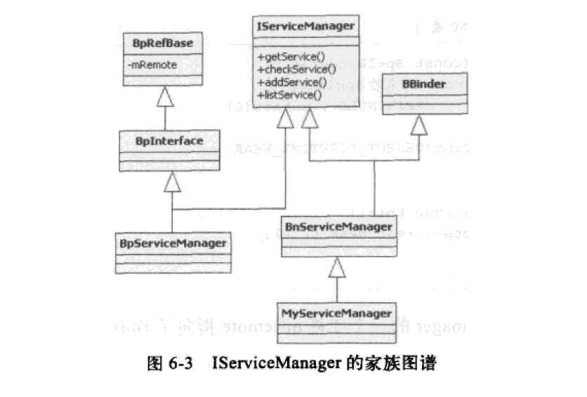

源码路径:

RefBash.h system/core/include/RefBase.h   
  
RefBash.cpp system/core/libutils/RefBash.cpp

System/core/include/utils/StrongPoniter.h //包含 sp<T> 模板函数 .

system/core/include/RefBase.h //包含了 wp<T> 模板函数的定义.和实现.