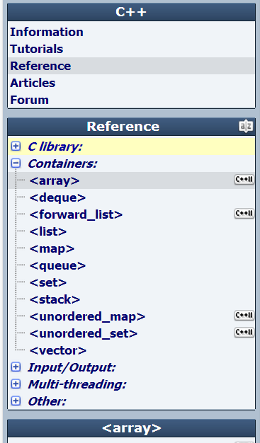

library

**Containers**

**Standard Containers**

A container is a holder object that stores a collection of other objects (its elements). They are implemented as class templates, which allows a great flexibility in the types supported as elements.  
  
The container manages the storage space for its elements and provides member functions to access them, either directly or through iterators (reference objects with similar properties to pointers).  
  
Containers replicate structures very commonly used in programming: dynamic arrays ([vector](http://www.cplusplus.com/vector)), queues ([queue](http://www.cplusplus.com/queue)), stacks ([stack](http://www.cplusplus.com/stack)), heaps ([priority_queue](http://www.cplusplus.com/priority_queue)), linked lists ([list](http://www.cplusplus.com/list)), trees ([set](http://www.cplusplus.com/set)), associative arrays ([map](http://www.cplusplus.com/map))...  
  
Many containers have several member functions in common, and share functionalities. The decision of which type of container to use for a specific need does not generally depend only on the functionality offered by the container, but also on the efficiency of some of its members (complexity). This is especially true for sequence containers, which offer different trade-offs in complexity between inserting/removing elements and accessing them.  
  
[stack](http://www.cplusplus.com/stack), [queue](http://www.cplusplus.com/queue) and [priority_queue](http://www.cplusplus.com/priority_queue) are implemented as *container adaptors*. Container adaptors are not full container classes, but classes that provide a specific interface relying on an object of one of the container classes (such as [deque](http://www.cplusplus.com/deque)or [list](http://www.cplusplus.com/list)) to handle the elements. The underlying container is encapsulated in such a way that its elements are accessed by the members of the *container adaptor* independently of the underlying *container* class used.

**Container class templates**

**Sequence containers**:

[**array**](http://www.cplusplus.com/reference/array/array/)

Array class (class template )

[**vector**](http://www.cplusplus.com/reference/vector/vector/)

Vector (class template )

[**deque**](http://www.cplusplus.com/reference/deque/deque/)

Double ended queue (class template )

[**forward_list**](http://www.cplusplus.com/reference/forward_list/forward_list/)

Forward list (class template )

[**list**](http://www.cplusplus.com/reference/list/list/)

List (class template )

**Container adaptors**:

[**stack**](http://www.cplusplus.com/reference/stack/stack/)

LIFO stack (class template )

[**queue**](http://www.cplusplus.com/reference/queue/queue/)

FIFO queue (class template )

[**priority_queue**](http://www.cplusplus.com/reference/queue/priority_queue/)

Priority queue (class template )

**Associative containers**:

[**set**](http://www.cplusplus.com/reference/set/set/)

Set (class template )

[**multiset**](http://www.cplusplus.com/reference/set/multiset/)

Multiple-key set (class template )

[**map**](http://www.cplusplus.com/reference/map/map/)

Map (class template )

[**multimap**](http://www.cplusplus.com/reference/map/multimap/)

Multiple-key map (class template )

**Unordered associative containers**:

[**unordered_set**](http://www.cplusplus.com/reference/unordered_set/unordered_set/)

Unordered Set (class template )

[**unordered_multiset**](http://www.cplusplus.com/reference/unordered_set/unordered_multiset/)

Unordered Multiset (class template )

[**unordered_map**](http://www.cplusplus.com/reference/unordered_map/unordered_map/)

Unordered Map (class template )

[**unordered_multimap**](http://www.cplusplus.com/reference/unordered_map/unordered_multimap/)

Unordered Multimap (class template )

**Other**:  
Two class templates share certain properties with containers, and are sometimes classified with them: [bitset](http://www.cplusplus.com/bitset) and[valarray](http://www.cplusplus.com/valarray).

**Member map**

This is a comparison chart with the different member functions present on each of the different containers:  
  
**Legend**:

|  |  |
| --- | --- |
| **C++98** | Available since C++98 |
| **C++11** | New in C++11 |

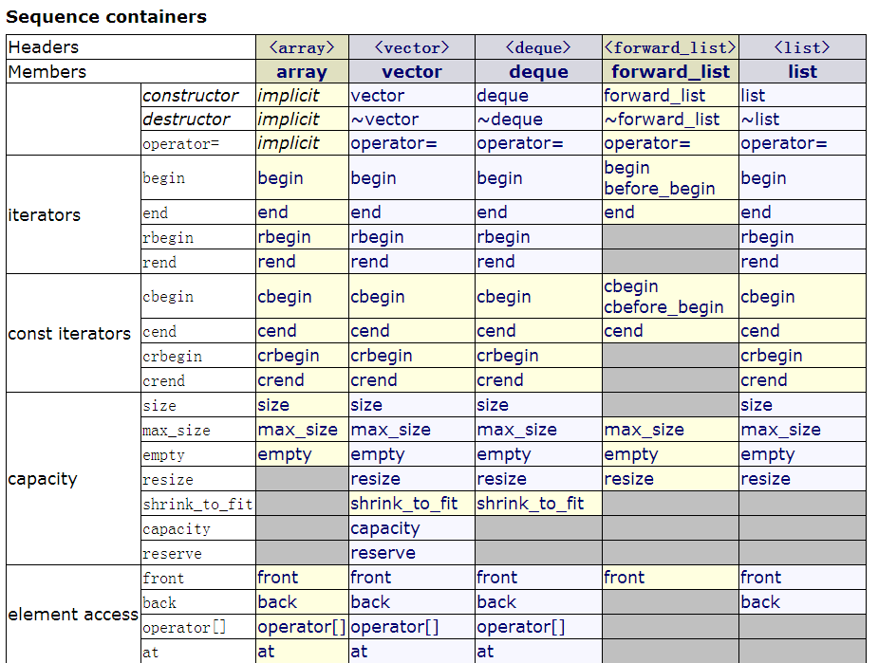

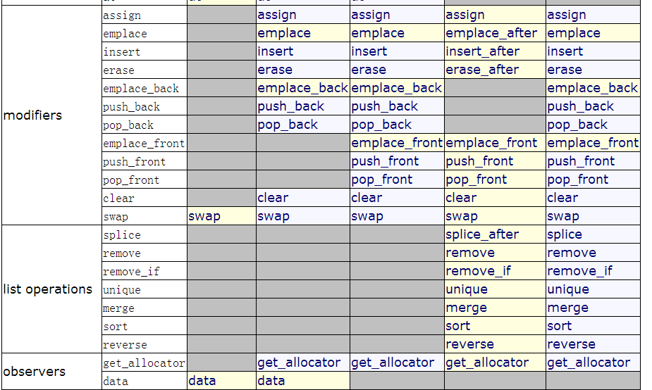  
  
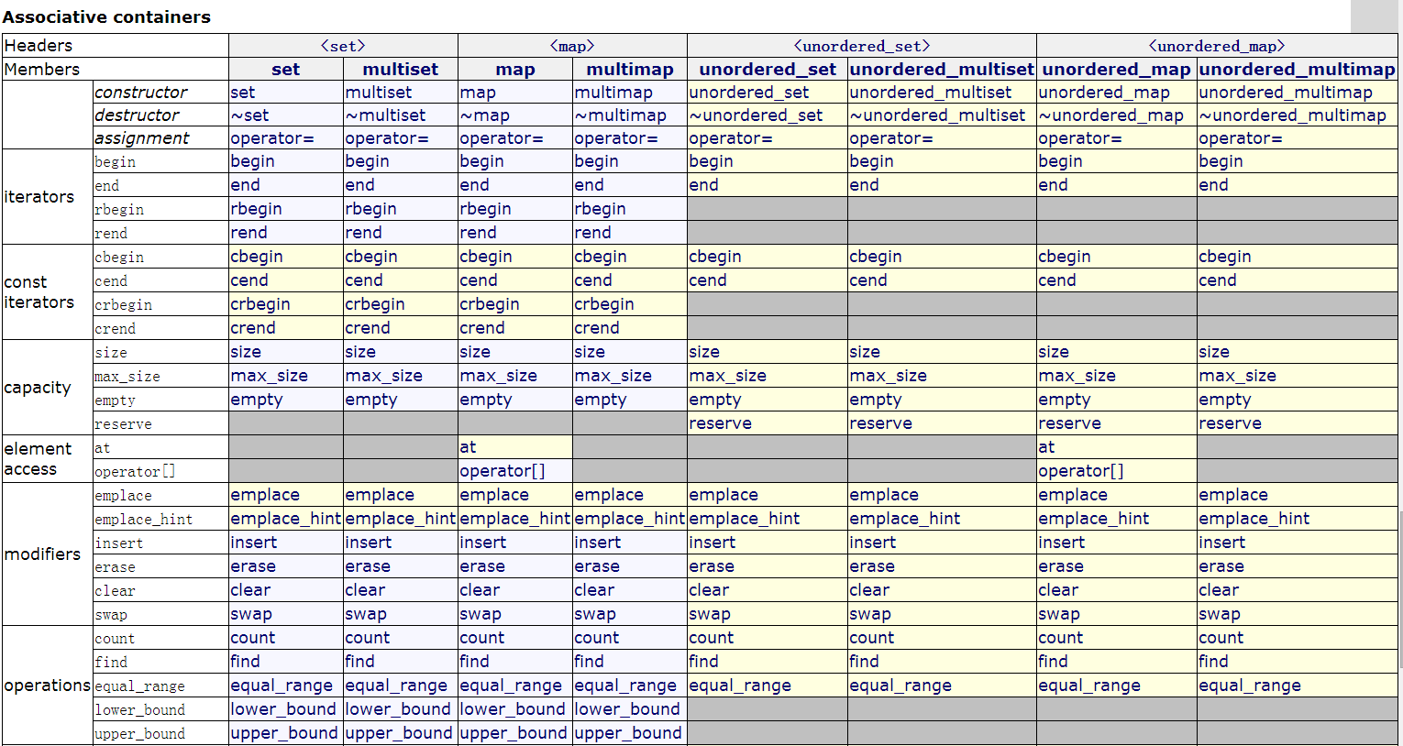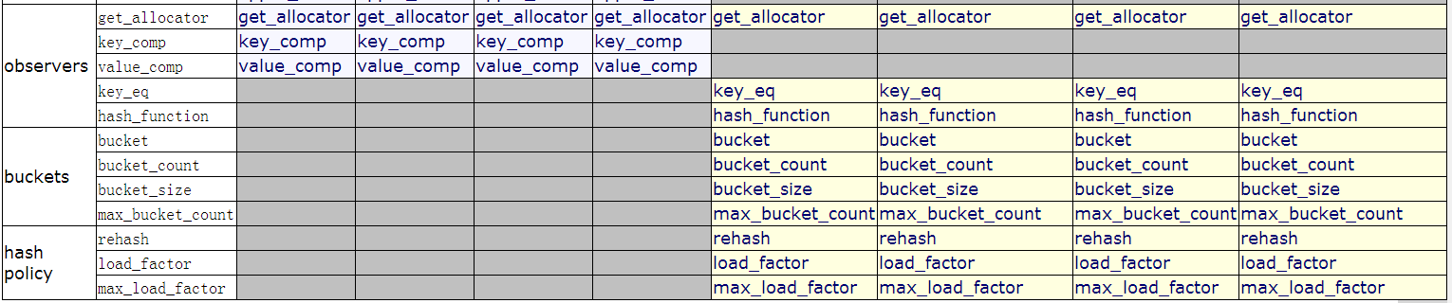

header

**<array>**

**Array header**

Header that defines the fixed-size [array](http://www.cplusplus.com/array) container class:

**Classes**

[**array**](http://www.cplusplus.com/reference/array/array/)

Array class (class template )

**Functions**

[**begin**](http://www.cplusplus.com/reference/iterator/begin/)

Iterator to beginning (function template )

[**end**](http://www.cplusplus.com/reference/iterator/end/)

Iterator to end (function template )

header

**<deque>**

**Deque header**

Header that defines the [deque](http://www.cplusplus.com/deque) container class:

**Classes**

[**deque**](http://www.cplusplus.com/reference/deque/deque/)

Double ended queue (class template )

**Functions**

[**begin**](http://www.cplusplus.com/reference/iterator/begin/)

Iterator to beginning (function template )

[**end**](http://www.cplusplus.com/reference/iterator/end/)

Iterator to end (function template )

header

**<forward_list>**

**Forward list**

Header that defines the [forward_list](http://www.cplusplus.com/forward_list) container class:

**Classes**

[**forward_list**](http://www.cplusplus.com/reference/forward_list/forward_list/)

Forward list (class template )

**Functions**

[**begin**](http://www.cplusplus.com/reference/iterator/begin/)

Iterator to beginning (function template )

[**end**](http://www.cplusplus.com/reference/iterator/end/)

Iterator to end (function template )

header

**<list>**

**List header**

Header that defines the [list](http://www.cplusplus.com/list) container class:

**Classes**

[**list**](http://www.cplusplus.com/reference/list/list/)

List (class template )

**Functions**

[**begin**](http://www.cplusplus.com/reference/iterator/begin/)

Iterator to beginning (function template )

[**end**](http://www.cplusplus.com/reference/iterator/end/)

Iterator to end (function template )

header

**<map>**

**Map header**

Header that defines the [map](http://www.cplusplus.com/map) and [multimap](http://www.cplusplus.com/multimap) container classes:

**Classes**

[**map**](http://www.cplusplus.com/reference/map/map/)

Map (class template )

[**multimap**](http://www.cplusplus.com/reference/map/multimap/)

Multiple-key map (class template )

**Functions**

[**begin**](http://www.cplusplus.com/reference/iterator/begin/)

Iterator to beginning (function template )

[**end**](http://www.cplusplus.com/reference/iterator/end/)

Iterator to end (function template )

header

**<queue>**

**Queue header**

Header that defines the [queue](http://www.cplusplus.com/queue) and [priority_queue](http://www.cplusplus.com/priority_queue) container adaptor classes:

**Classes**

[**queue**](http://www.cplusplus.com/reference/queue/queue/)

FIFO queue (class template )

[**priority_queue**](http://www.cplusplus.com/reference/queue/priority_queue/)

Priority queue (class template )

eader

**<set>**

**Set header**

Header that defines the [set](http://www.cplusplus.com/set) and [multiset](http://www.cplusplus.com/multiset) container classes:

**Classes**

[**set**](http://www.cplusplus.com/reference/set/set/)

Set (class template )

[**multiset**](http://www.cplusplus.com/reference/set/multiset/)

Multiple-key set (class template )

**Functions**

[**begin**](http://www.cplusplus.com/reference/iterator/begin/)

Iterator to beginning (function template )

[**end**](http://www.cplusplus.com/reference/iterator/end/)

Iterator to end (function template )

header

**<stack>**

**Stack header**

Header that defines the [stack](http://www.cplusplus.com/stack) container class:

**Classes**

[**stack**](http://www.cplusplus.com/reference/stack/stack/)

LIFO stack (class template )

header

**<unordered_map>**

**Unordered map header**

Header that defines the [unordered_map](http://www.cplusplus.com/unordered_map) and [unordered_multimap](http://www.cplusplus.com/unordered_multimap) container classes:

**Classes**

[**unordered_map**](http://www.cplusplus.com/reference/unordered_map/unordered_map/)

Unordered Map (class template )

[**unordered_multimap**](http://www.cplusplus.com/reference/unordered_map/unordered_multimap/)

Unordered Multimap (class template )

**Functions**

[**begin**](http://www.cplusplus.com/reference/iterator/begin/)

Iterator to beginning (function template )

[**end**](http://www.cplusplus.com/reference/iterator/end/)

Iterator to end (function template )

header

**<unordered_set>**

**Unordered set header**

Header that defines the [unordered_set](http://www.cplusplus.com/unordered_set) and [unordered_multiset](http://www.cplusplus.com/unordered_multiset) container classes:

**Classes**

[**unordered_set**](http://www.cplusplus.com/reference/unordered_set/unordered_set/)

Unordered Set (class template )

[**unordered_multiset**](http://www.cplusplus.com/reference/unordered_set/unordered_multiset/)

Unordered Multiset (class template )

**Functions**

[**begin**](http://www.cplusplus.com/reference/iterator/begin/)

Iterator to beginning (function template )

[**end**](http://www.cplusplus.com/reference/iterator/end/)

Iterator to end (function template )

header

**<vector>**

**Vector header**

Header that defines the [vector](http://www.cplusplus.com/vector) container class:

**Classes**

[**vector**](http://www.cplusplus.com/reference/vector/vector/)

Vector (class template )

[**vector<bool>**](http://www.cplusplus.com/reference/vector/vector-bool/)

Vector of bool (class template specialization )

**Functions**

[**begin**](http://www.cplusplus.com/reference/iterator/begin/)

Iterator to beginning (function template )

[**end**](http://www.cplusplus.com/reference/iterator/end/)

Iterator to end (function template )