library

**Input/Output**

**Input/Output library**

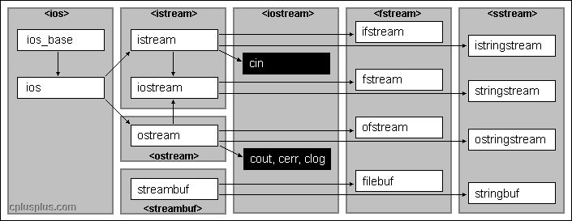   
  
The iostream library is an object-oriented library that provides input and output functionality using streams.  
  
A stream is an abstraction that represents a device on which input and ouput operations are performed. A stream can basically be represented as a source or destination of characters of indefinite length.  
  
Streams are generally associated to a physical source or destination of characters, like a disk file, the keyboard, or the console, so the characters gotten or written to/from our abstraction called stream are physically input/output to the physical device. For example, file streams are C++ objects to manipulate and interact with files; Once a file stream is used to open a file, any input or output operation performed on that stream is physically reflected in the file.  
  
To operate with streams, C++ provides the standard iostream library, which contains the following elements:

Basic class templates

The base of the iostream library is the hierarchy of class templates. The class templates provide most of the functionality of the library in a type-independent fashion.  
  
This is a set of class templates, each one having two template parameters: the *char type* (charT) parameter, that determines the type of elements that are going to be manipulated and the *traits* parameter, that provides additional characteristics specific for a particular type of elements.  
  
The class templates in this class hierarchy have the same name as their char-type instantiations but with the prefix basic_. For example, the class template which istream is instantiated from is called basic_istream, the one from which fstream is is called basic_fstream, and so on... The only exception is ios_base, which is by itself type-independent, and therefore is not based on a template, but is a regular class.

Class template instantiations

The library incorporates two standard sets of instantiations of the entire iostream class template hierarchy: one is narrow-oriented, to manipulate elements of type char and another one, wide-oriented, to manipulate elements of type wchar_t.  
  
The narrow-oriented (char type) instantiation is probably the better known part of the iostream library. Classes like ios, istream and ofstream are narrow-oriented. The diagram on top of this page shows the names and relationships of narrow-oriented classes.  
  
The classes of the wide-oriented (wchar_t) instatiation follow the same naming conventions as the narrow-oriented instantiation but with the name of each class and object prefixed with a w character, forming wios, wistream andwofstream, as an example.

Standard objects

As part of the iostream library, the header file <iostream> declares certain objects that are used to perform input and output operations on the standard input and output.  
  
They are divided in two sets: narrow-oriented objects, which are the popular cin, cout, cerr and clog and their wide-oriented counterparts, declared as wcin, wcout, wcerr and wclog.

Types

The iostream classes barely use fundamental types on their member's prototypes. They generally use defined types that depend on the traits used in their instantiation. For the default char and wchar_t instantiations, typesstreampos, streamoff and streamsize are used to represent positions, offsets and sizes, respectively.

Manipulators

Manipulators are global functions designed to be used together with insertion (<<) and extraction (>>) operators performed on iostream stream objects. They generally modify properties and formatting settings of the streams.endl, hex and scientific are some examples of manipulators.

**Organization**

The library and its hierarchy of classes is split in different files:

* <ios>, <istream>, <ostream>, <streambuf> and <iosfwd> aren't usually included directly in most C++ programs. They describe the base classes of the hierarchy and are automatically included by other header files of the library that contain derived classes.
* <iostream> declares the objects used to communicate through the standard input and output (including cin andcout).
* <fstream> defines the file stream classes (like the template basic_ifstream or the class ofstream) as well as the internal buffer objects used with these (basic_filebuf). These classes are used to manipulate files using streams.
* <sstream>: The classes defined in this file are used to manipulate [string](http://www.cplusplus.com/string) objects as if they were streams.
* <iomanip> declares some standard manipulators with parameters to be used with extraction and insertion operators to modify internal flags and formatting options.

**Compatibility notes**

The names, prototypes and examples included in this reference for the iostream classes mostly describe and use thechar instantiations of the class templates instead of the templates themselves, even though these classes are only one of their possible instantiations. We believe this provides a better readability and is arguably as easy to obtain the names and prototypes of the basic template from the char instantiation as the opposite.

**Elements of the iostream library (char instantitation)**

**Classes**:

[**ios_base**](http://www.cplusplus.com/reference/ios/ios_base/)

Base class for streams (class )

[**ios**](http://www.cplusplus.com/reference/ios/ios/)

Base class for streams (type-dependent components) (class )

[**istream**](http://www.cplusplus.com/reference/istream/istream/)

Input stream (class )

[**ostream**](http://www.cplusplus.com/reference/ostream/ostream/)

Output Stream (class )

[**iostream**](http://www.cplusplus.com/reference/istream/iostream/)

Input/output stream (class )

[**ifstream**](http://www.cplusplus.com/reference/fstream/ifstream/)

Input file stream class (class )

[**ofstream**](http://www.cplusplus.com/reference/fstream/ofstream/)

Output file stream (class )

[**fstream**](http://www.cplusplus.com/reference/fstream/fstream/)

Input/output file stream class (class )

[**istringstream**](http://www.cplusplus.com/reference/sstream/istringstream/)

Input string stream (class )

[**ostringstream**](http://www.cplusplus.com/reference/sstream/ostringstream/)

Output string stream (class )

[**stringstream**](http://www.cplusplus.com/reference/sstream/stringstream/)

Input/output string stream (class )

[**streambuf**](http://www.cplusplus.com/reference/streambuf/streambuf/)

Base buffer class for streams (class )

[**filebuf**](http://www.cplusplus.com/reference/fstream/filebuf/)

File stream buffer (class )

[**stringbuf**](http://www.cplusplus.com/reference/sstream/stringbuf/)

String stream buffer (class )

**Objects**:

[**cin**](http://www.cplusplus.com/reference/iostream/cin/)

Standard input stream (object )

[**cout**](http://www.cplusplus.com/reference/iostream/cout/)

Standard output stream (object )

[**cerr**](http://www.cplusplus.com/reference/iostream/cerr/)

Standard output stream for errors (object )

[**clog**](http://www.cplusplus.com/reference/iostream/clog/)

Standard output stream for logging (object )

**Types**:

[**fpos**](http://www.cplusplus.com/reference/ios/fpos/)

Stream position class template (class template )

[**streamoff**](http://www.cplusplus.com/reference/ios/streamoff/)

Stream offset type (type )

[**streampos**](http://www.cplusplus.com/reference/ios/streampos/)

Stream position type (type )

[**streamsize**](http://www.cplusplus.com/reference/ios/streamsize/)

Stream size type (type )

**Manipulators**:

[**boolalpha**](http://www.cplusplus.com/reference/ios/boolalpha/)

Alphanumerical bool values (function )

[**dec**](http://www.cplusplus.com/reference/ios/dec/)

Use decimal base (function )

[**endl**](http://www.cplusplus.com/reference/ostream/endl/)

Insert newline and flush (function )

[**ends**](http://www.cplusplus.com/reference/ostream/ends/)

Insert null character (function )

[**fixed**](http://www.cplusplus.com/reference/ios/fixed/)

Use fixed floating-point notation (function )

[**flush**](http://www.cplusplus.com/reference/ostream/flush-free/)

Flush stream buffer (function )

[**hex**](http://www.cplusplus.com/reference/ios/hex/)

Use hexadecimal base (function )

[**internal**](http://www.cplusplus.com/reference/ios/internal/)

Adjust field by inserting characters at an internal position (function )

[**left**](http://www.cplusplus.com/reference/ios/left/)

Adjust output to the left (function )

[**noboolalpha**](http://www.cplusplus.com/reference/ios/noboolalpha/)

No alphanumerical bool values (function )

[**noshowbase**](http://www.cplusplus.com/reference/ios/noshowbase/)

Do not show numerical base prefixes (function )

[**noshowpoint**](http://www.cplusplus.com/reference/ios/noshowpoint/)

Do not show decimal point (function )

[**noshowpos**](http://www.cplusplus.com/reference/ios/noshowpos/)

Do not show positive signs (function )

[**noskipws**](http://www.cplusplus.com/reference/ios/noskipws/)

Do not skip whitespaces (function )

[**nounitbuf**](http://www.cplusplus.com/reference/ios/nounitbuf/)

Do not force flushes after insertions (function )

[**nouppercase**](http://www.cplusplus.com/reference/ios/nouppercase/)

Do not generate upper case letters (function )

[**oct**](http://www.cplusplus.com/reference/ios/oct/)

Use octal base (function )

[**resetiosflags**](http://www.cplusplus.com/reference/iomanip/resetiosflags/)

Reset format flags (function )

[**right**](http://www.cplusplus.com/reference/ios/right/)

Adjust output to the right (function )

[**scientific**](http://www.cplusplus.com/reference/ios/scientific/)

Use scientific floating-point notation (function )

[**setbase**](http://www.cplusplus.com/reference/iomanip/setbase/)

Set basefield flag (function )

[**setfill**](http://www.cplusplus.com/reference/iomanip/setfill/)

Set fill character (function )

[**setiosflags**](http://www.cplusplus.com/reference/iomanip/setiosflags/)

Set format flags (function )

[**setprecision**](http://www.cplusplus.com/reference/iomanip/setprecision/)

Set decimal precision (function )

[**setw**](http://www.cplusplus.com/reference/iomanip/setw/)

Set field width (function )

[**showbase**](http://www.cplusplus.com/reference/ios/showbase/)

Show numerical base prefixes (function )

[**showpoint**](http://www.cplusplus.com/reference/ios/showpoint/)

Show decimal point (function )

[**showpos**](http://www.cplusplus.com/reference/ios/showpos/)

Show positive signs (function )

[**skipws**](http://www.cplusplus.com/reference/ios/skipws/)

Skip whitespaces (function )

[**unitbuf**](http://www.cplusplus.com/reference/ios/unitbuf/)

Flush buffer after insertions (function )

[**uppercase**](http://www.cplusplus.com/reference/ios/uppercase/)

Generate upper-case letters (function )

[**ws**](http://www.cplusplus.com/reference/istream/ws/)

Extract whitespaces (function )

header

# <fstream>

**File streams**

Header providing file stream classes:

### Class templates

[**basic_ifstream**](http://www.cplusplus.com/reference/fstream/basic_ifstream/)

Input file stream (class template )

[**basic_ofstream**](http://www.cplusplus.com/reference/fstream/basic_ofstream/)

Output file stream (class template )

[**basic_fstream**](http://www.cplusplus.com/reference/fstream/basic_fstream/)

File stream (class template )

[**basic_filebuf**](http://www.cplusplus.com/reference/fstream/basic_filebuf/)

File stream buffer (class template )

### Classes

#### Narrow characters (char)

[**ifstream**](http://www.cplusplus.com/reference/fstream/ifstream/)

Input file stream class (class )

[**ofstream**](http://www.cplusplus.com/reference/fstream/ofstream/)

Output file stream (class )

[**fstream**](http://www.cplusplus.com/reference/fstream/fstream/)

Input/output file stream class (class )

[**filebuf**](http://www.cplusplus.com/reference/fstream/filebuf/)

File stream buffer (class )

#### Wide characters (wchar_t)

[**wifstream**](http://www.cplusplus.com/reference/fstream/wifstream/)

Input file stream (wide) (class )

[**wofstream**](http://www.cplusplus.com/reference/fstream/wofstream/)

Output file stream (wide) (class )

[**wfstream**](http://www.cplusplus.com/reference/fstream/wfstream/)

File stream (wide) (class )

[**wfilebuf**](http://www.cplusplus.com/reference/fstream/wfilebuf/)

File stream buffer (wide) (class )

header

# <iomanip>

**IO Manipulators**

Header providing parametric manipulators:

### Parametric manipulators

[**setiosflags**](http://www.cplusplus.com/reference/iomanip/setiosflags/)

Set format flags (function )

[**resetiosflags**](http://www.cplusplus.com/reference/iomanip/resetiosflags/)

Reset format flags (function )

[**setbase**](http://www.cplusplus.com/reference/iomanip/setbase/)

Set basefield flag (function )

[**setfill**](http://www.cplusplus.com/reference/iomanip/setfill/)

Set fill character (function )

[**setprecision**](http://www.cplusplus.com/reference/iomanip/setprecision/)

Set decimal precision (function )

[**setw**](http://www.cplusplus.com/reference/iomanip/setw/)

Set field width (function )

[**get_money**](http://www.cplusplus.com/reference/iomanip/get_money/)

Get monetary value (function )

[**put_money**](http://www.cplusplus.com/reference/iomanip/put_money/)

Put monetary value (function )

[**get_time**](http://www.cplusplus.com/reference/iomanip/get_time/)

Get date and time (function )

[**put_time**](http://www.cplusplus.com/reference/iomanip/put_time/)

Put date and time (function )

Notice that non-parametric manipulators are declared directly in [<ios>](http://www.cplusplus.com/%3Cios%3E).

header

# <ios>

**Input-Output base classes**

Header providing base classes and types for the IOStream hierarchy of classes:  
  


### Types

#### Class templates

[**basic_ios**](http://www.cplusplus.com/reference/ios/basic_ios/)

Base class for streams (type-dependent components) (class template )

[**fpos**](http://www.cplusplus.com/reference/ios/fpos/)

Stream position class template (class template )

#### Classes

[**ios**](http://www.cplusplus.com/reference/ios/ios/)

Base class for streams (type-dependent components) (class )

[**ios_base**](http://www.cplusplus.com/reference/ios/ios_base/)

Base class for streams (class )

[**wios**](http://www.cplusplus.com/reference/ios/wios/)

Base class for wide character streams (class )

#### Other types

[**io_errc**](http://www.cplusplus.com/reference/ios/io_errc/)

Input/output error conditions (enum class )

[**streamoff**](http://www.cplusplus.com/reference/ios/streamoff/)

Stream offset type (type )

[**streampos**](http://www.cplusplus.com/reference/ios/streampos/)

Stream position type (type )

[**streamsize**](http://www.cplusplus.com/reference/ios/streamsize/)

Stream size type (type )

[**wstreampos**](http://www.cplusplus.com/reference/ios/wstreampos/)

Wide stream position type (type )

### Format flag manipulators (functions)

**Independent flags (switch on)**:

[**boolalpha**](http://www.cplusplus.com/reference/ios/boolalpha/)

Alphanumerical bool values (function )

[**showbase**](http://www.cplusplus.com/reference/ios/showbase/)

Show numerical base prefixes (function )

[**showpoint**](http://www.cplusplus.com/reference/ios/showpoint/)

Show decimal point (function )

[**showpos**](http://www.cplusplus.com/reference/ios/showpos/)

Show positive signs (function )

[**skipws**](http://www.cplusplus.com/reference/ios/skipws/)

Skip whitespaces (function )

[**unitbuf**](http://www.cplusplus.com/reference/ios/unitbuf/)

Flush buffer after insertions (function )

[**uppercase**](http://www.cplusplus.com/reference/ios/uppercase/)

Generate upper-case letters (function )

**Independent flags (switch off)**:

[**noboolalpha**](http://www.cplusplus.com/reference/ios/noboolalpha/)

No alphanumerical bool values (function )

[**noshowbase**](http://www.cplusplus.com/reference/ios/noshowbase/)

Do not show numerical base prefixes (function )

[**noshowpoint**](http://www.cplusplus.com/reference/ios/noshowpoint/)

Do not show decimal point (function )

[**noshowpos**](http://www.cplusplus.com/reference/ios/noshowpos/)

Do not show positive signs (function )

[**noskipws**](http://www.cplusplus.com/reference/ios/noskipws/)

Do not skip whitespaces (function )

[**nounitbuf**](http://www.cplusplus.com/reference/ios/nounitbuf/)

Do not force flushes after insertions (function )

[**nouppercase**](http://www.cplusplus.com/reference/ios/nouppercase/)

Do not generate upper case letters (function )

**Numerical base format flags ("basefield" flags)**:

[**dec**](http://www.cplusplus.com/reference/ios/dec/)

Use decimal base (function )

[**hex**](http://www.cplusplus.com/reference/ios/hex/)

Use hexadecimal base (function )

[**oct**](http://www.cplusplus.com/reference/ios/oct/)

Use octal base (function )

**Floating-point format flags ("floatfield" flags)**:

[**fixed**](http://www.cplusplus.com/reference/ios/fixed/)

Use fixed floating-point notation (function )

[**scientific**](http://www.cplusplus.com/reference/ios/scientific/)

Use scientific floating-point notation (function )

**Adustment format flags ("adjustfield" flags)**:

[**internal**](http://www.cplusplus.com/reference/ios/internal/)

Adjust field by inserting characters at an internal position (function )

[**left**](http://www.cplusplus.com/reference/ios/left/)

Adjust output to the left (function )

[**right**](http://www.cplusplus.com/reference/ios/right/)

Adjust output to the right (function )

### Other functions

[**iostream_category**](http://www.cplusplus.com/reference/ios/iostream_category/)

Return iostream category (function )

Notice that not all standard manipulators are defined in this header. Input streams also support [ws](http://www.cplusplus.com/ws), and output streams[endl](http://www.cplusplus.com/endl), [ends](http://www.cplusplus.com/ends) and [flush](http://www.cplusplus.com/flush). Streams also support an additional set of manipulators, which are parametric and defined apart in header [<iomanip>](http://www.cplusplus.com/iomanip). These are: [setiosflags](http://www.cplusplus.com/setiosflags), [resetiosflags](http://www.cplusplus.com/resetiosflags), [setbase](http://www.cplusplus.com/setbase), [setfill](http://www.cplusplus.com/setfill), [setprecision](http://www.cplusplus.com/setprecision), [setw](http://www.cplusplus.com/setw)

header

# <iosfwd>

**Input-Output forward declarations**

This header provides forward declarations for the types of the standard input/output library.  
  
Note that the file does not contain the template definitions, and thus shall only be included in other headers to provide forward declarations of these types.

### <iosfwd>

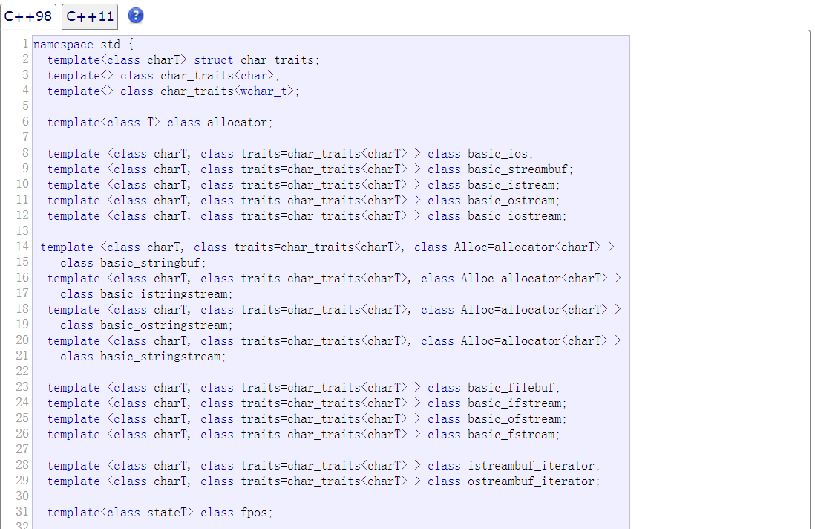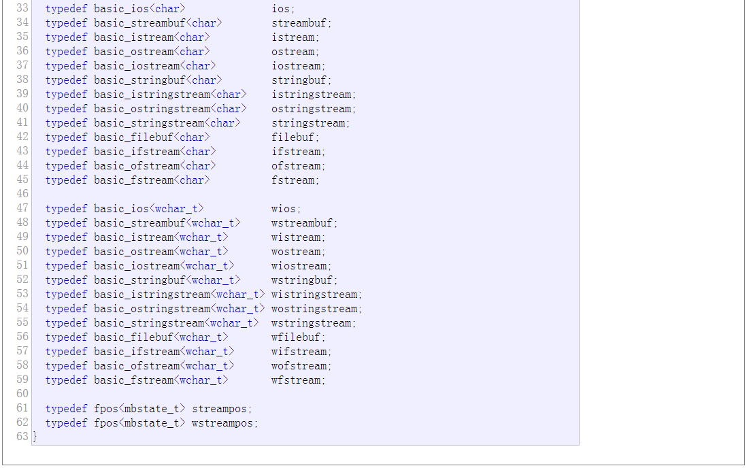

header

# <iostream>

**Standard Input / Output Streams Library**

Header that defines the standard input/output stream objects:

* [C++98](javascript:switch1.select(1))
* [C++11](javascript:switch1.select(2))

Including this header may automatically include other headers, such as [<ios>](http://www.cplusplus.com/%3Cios%3E), [<streambuf>](http://www.cplusplus.com/%3Cstreambuf%3E), [<istream>](http://www.cplusplus.com/%3Cistream%3E), [<ostream>](http://www.cplusplus.com/%3Costream%3E) and/or[<iosfwd>](http://www.cplusplus.com/%3Ciosfwd%3E).

Note that the [iostream](http://www.cplusplus.com/iostream) class is mainly declared in header [<istream>](http://www.cplusplus.com/%3Cistream%3E).

### Objects

#### Narrow characters (char)

[**cin**](http://www.cplusplus.com/reference/iostream/cin/)

Standard input stream (object )

[**cout**](http://www.cplusplus.com/reference/iostream/cout/)

Standard output stream (object )

[**cerr**](http://www.cplusplus.com/reference/iostream/cerr/)

Standard output stream for errors (object )

[**clog**](http://www.cplusplus.com/reference/iostream/clog/)

Standard output stream for logging (object )

#### Wide characters (wchar_t)

[**wcin**](http://www.cplusplus.com/reference/iostream/wcin/)

Standard input stream (wide) (object )

[**wcout**](http://www.cplusplus.com/reference/iostream/wcout/)

Standard output stream (wide) (object )

[**wcerr**](http://www.cplusplus.com/reference/iostream/wcerr/)

Standard output stream for errors (wide-oriented) (object )

[**wclog**](http://www.cplusplus.com/reference/iostream/wclog/)

Standard output stream for logging (wide) (object )

header

# <istream>

**Input stream**

Header providing the standard input and combined input/output stream classes:

### Class templates

[**basic_istream**](http://www.cplusplus.com/reference/istream/basic_istream/)

Input stream (class template )

[**basic_iostream**](http://www.cplusplus.com/reference/istream/basic_iostream/)

Input/output stream (class template )

### Classes

[**istream**](http://www.cplusplus.com/reference/istream/istream/)

Input stream (class )

[**iostream**](http://www.cplusplus.com/reference/istream/iostream/)

Input/output stream (class )

[**wistream**](http://www.cplusplus.com/reference/istream/wistream/)

Input stream (wide) (class )

[**wiostream**](http://www.cplusplus.com/reference/istream/wiostream/)

Input/output stream (wide) (class )

### Input manipulators (functions)

[**ws**](http://www.cplusplus.com/reference/istream/ws/)

Extract whitespaces (function )

header

# <ostream>

**Output stream**

Header providing the standard output stream class:

### Class templates

[**basic_ostream**](http://www.cplusplus.com/reference/ostream/basic_ostream/)

Output stream (class )

### Classes

[**ostream**](http://www.cplusplus.com/reference/ostream/ostream/)

Output Stream (class )

[**wostream**](http://www.cplusplus.com/reference/ostream/wostream/)

Output stream (wide) (class )

### Input manipulators (functions)

[**endl**](http://www.cplusplus.com/reference/ostream/endl/)

Insert newline and flush (function )

[**ends**](http://www.cplusplus.com/reference/ostream/ends/)

Insert null character (function )

[**flush**](http://www.cplusplus.com/reference/ostream/flush-free/)

Flush stream buffer (function )

header

# <sstream>

**String streams**

Header providing string stream classes:

### Class templates

[**basic_istringstream**](http://www.cplusplus.com/reference/sstream/basic_istringstream/)

Input string stream (class template )

[**basic_ostringstream**](http://www.cplusplus.com/reference/sstream/basic_ostringstream/)

Output string stream (class template )

[**basic_stringstream**](http://www.cplusplus.com/reference/sstream/basic_stringstream/)

String stream (class template )

[**basic_stringbuf**](http://www.cplusplus.com/reference/sstream/basic_stringbuf/)

String stream buffer (class template )

### Classes

#### Narrow characters (char)

[**istringstream**](http://www.cplusplus.com/reference/sstream/istringstream/)

Input string stream (class )

[**ostringstream**](http://www.cplusplus.com/reference/sstream/ostringstream/)

Output string stream (class )

[**stringstream**](http://www.cplusplus.com/reference/sstream/stringstream/)

Input/output string stream (class )

[**stringbuf**](http://www.cplusplus.com/reference/sstream/stringbuf/)

String stream buffer (class )

#### Wide characters (wchar_t)

[**wistringstream**](http://www.cplusplus.com/reference/sstream/wistringstream/)

Input string stream (wide) (class )

[**wostringstream**](http://www.cplusplus.com/reference/sstream/wostringstream/)

Output string stream (wide) (class )

[**wstringstream**](http://www.cplusplus.com/reference/sstream/wstringstream/)

Input/output string stream (wide) (class )

[**wstringbuf**](http://www.cplusplus.com/reference/sstream/wstringbuf/)

String stream buffer (wide) (class )

header

# <streambuf>

**Stream buffer**

Header providing the [streambuf](http://www.cplusplus.com/streambuf) buffer class, to be used in combination with input/output streams:

### Class templates

[**basic_streambuf**](http://www.cplusplus.com/reference/streambuf/basic_streambuf/)

Base buffer class for streams (class template )

### Classes

[**streambuf**](http://www.cplusplus.com/reference/streambuf/streambuf/)

Base buffer class for streams (class )

[**wstreambuf**](http://www.cplusplus.com/reference/streambuf/wstreambuf/)

Base buffer class for streams (wide) (class )