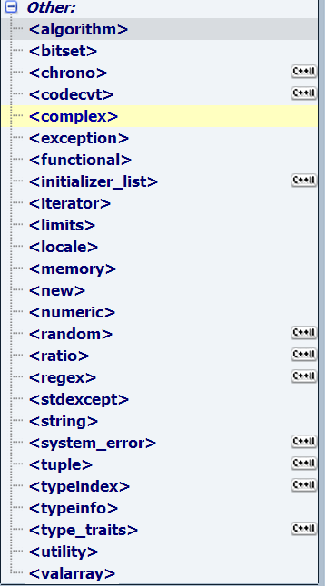  
  
library

**Other**

**Standard Library - Miscellaneous headers**

Other headers part of the C++ standard library:

* [C++98](javascript:switch1.select(1))
* [C++11](javascript:switch1.select(2))

[**<complex>**](http://www.cplusplus.com/reference/complex/)

Complex numbers library (header)

[**<exception>**](http://www.cplusplus.com/reference/exception/)

Standard exceptions (header)

[**<functional>**](http://www.cplusplus.com/reference/functional/)

Function objects (header)

[**<iterator>**](http://www.cplusplus.com/reference/iterator/)

Iterator definitions (header)

[**<limits>**](http://www.cplusplus.com/reference/limits/)

Numeric limits (header)

[**<locale>**](http://www.cplusplus.com/reference/locale/)

Localization library (header)

[**<memory>**](http://www.cplusplus.com/reference/memory/)

Memory elements (header)

[**<new>**](http://www.cplusplus.com/reference/new/)

Dynamic memory (header)

[**<numeric>**](http://www.cplusplus.com/reference/numeric/)

Generalized numeric operations (header)

[**<stdexcept>**](http://www.cplusplus.com/reference/stdexcept/)

Exception classes (header)

[**<string>**](http://www.cplusplus.com/reference/string/)

Strings (header)

[**<typeinfo>**](http://www.cplusplus.com/reference/typeinfo/)

Type information (header)

[**<utility>**](http://www.cplusplus.com/reference/utility/)

Utility components (header)

[**<valarray>**](http://www.cplusplus.com/reference/valarray/)

Library for arrays of numeric values (header)