NIP Project — Submission Template
Pega Platform project · This document is your complete submission

Section 1 — Your Details
Full Name | Vadla Sadvik Kumar
Email ID (registered on NIP) | vadlasadvik99@gmail.com
Phone Number | +91 8919597568
College Name | Ellenki College of Engineering and Technology
Course (e.g. IT, CS) | CSE AIML
State | Telangana
Project Chosen (Vehicle Service OR Movie Ticket Booking) | Vehicle Service Management
Pega Application Name (e.g. NIP-VehicleService-YourName) | NIP-VehicleServiceManagement-SadvikKumarVadla
Case Type Name (exact) | Vehicle Service Request
Pega Instance URL | Pega App Studio
Operator Name (created in Pega with your full name) | SadvikKumarVadla@VSM

Section 2A — Vehicle Service Management Application
Complete this section only if you selected this project. Delete the other project section before submitting.

US-001 — Submit Vehicle Service Request
What is expected:
Case created, customer submits Vehicle ID, Vehicle Model, Issue Description. Validation applied.
Screenshot — paste your screenshot below this line:
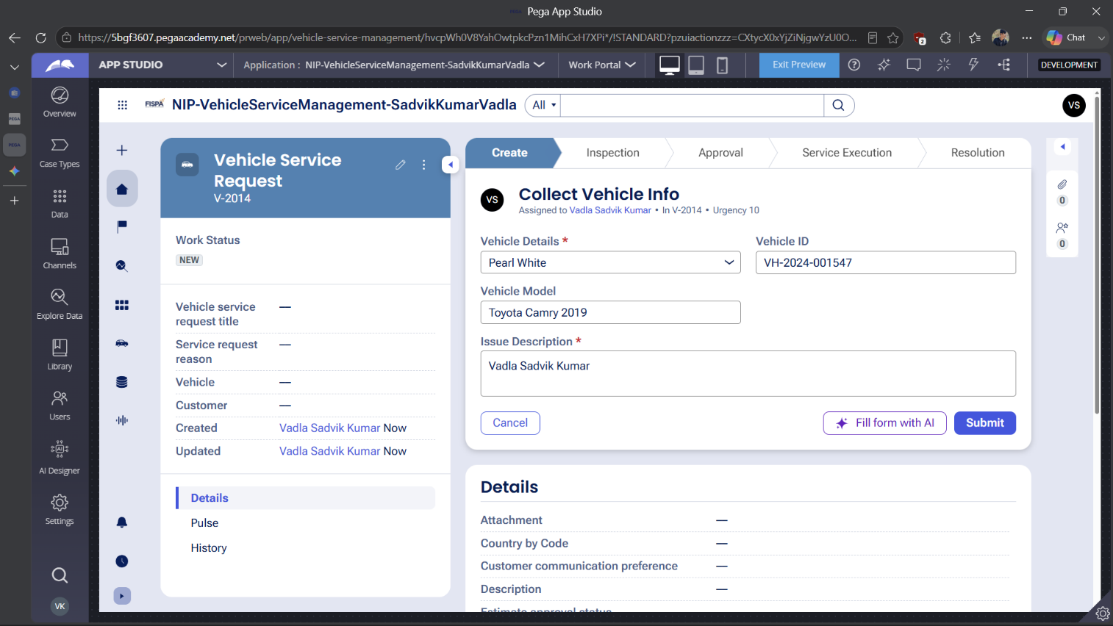
[

What I built for this (1–2 lines in your own words):
Configured the initial Create stage to capture the customer's Vehicle ID, Vehicle Model, and Issue Description to generate the service request.

US-002 — Perform Vehicle Inspection
What is expected:
Inspection stage with Service Advisor step. Inspection Notes and Condition Rating captured.
Screenshot — paste your screenshot below this line:
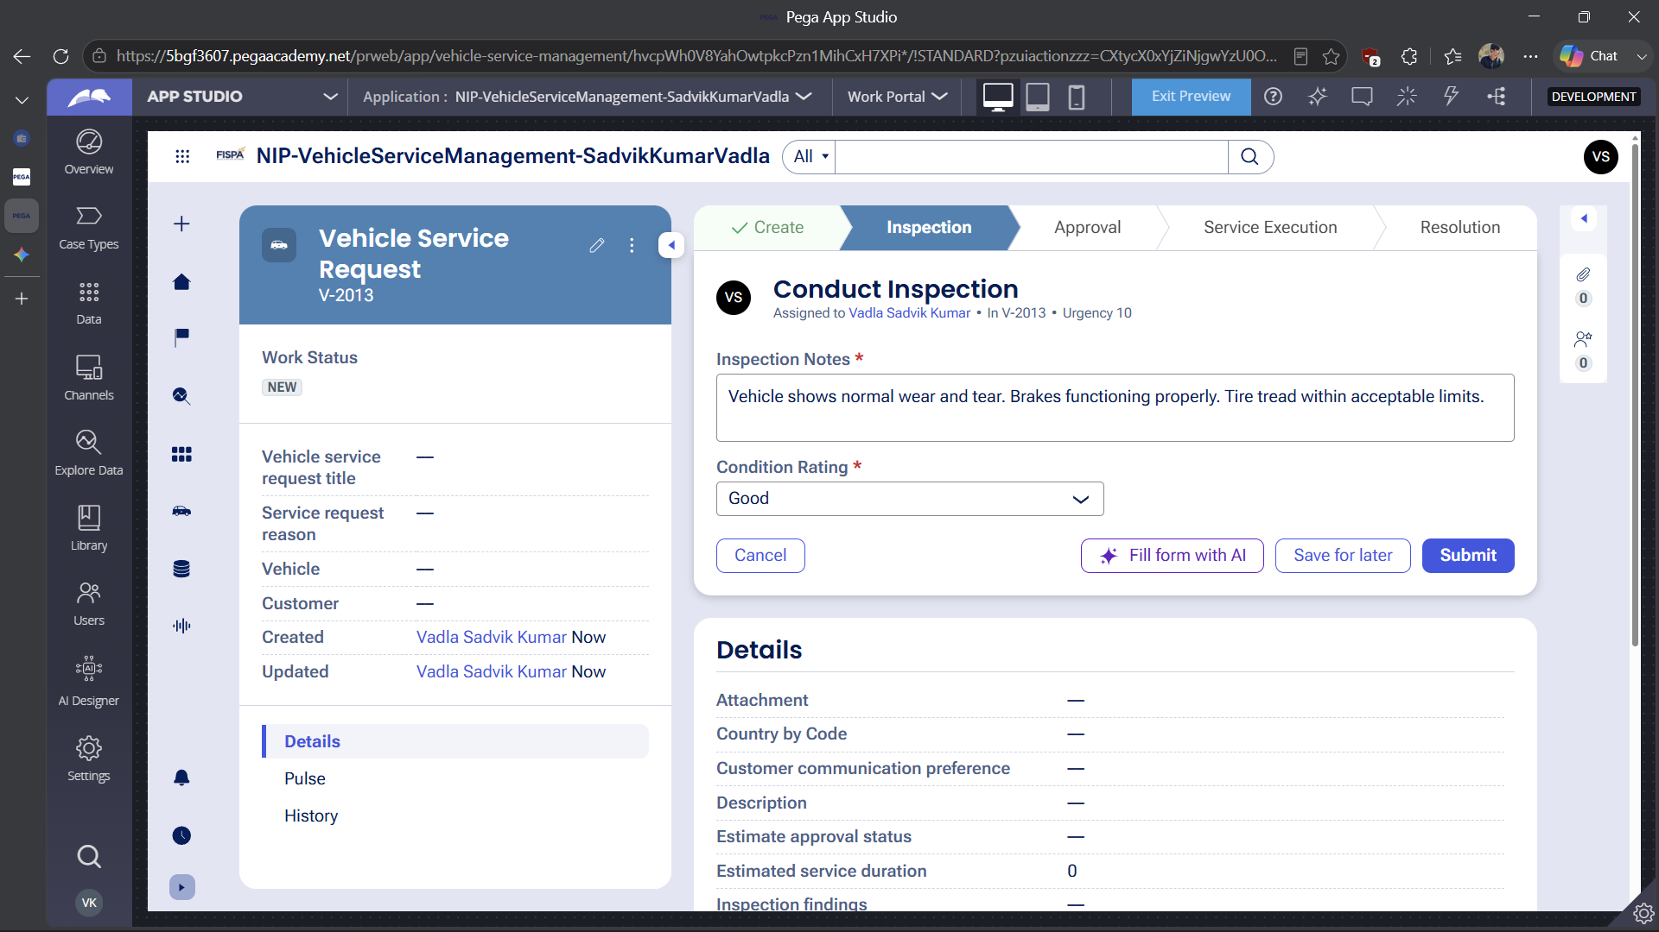

What I built for this (1–2 lines in your own words):
Configured the Inspection stage for the technician to evaluate the vehicle, record detailed inspection notes, and assign an overall condition rating based on their findings.

US-003 — Generate Service Estimate
What is expected:
Labor Cost and Parts Cost captured. Total Cost calculated automatically by declare expression.
Screenshot — paste your screenshot below this line:
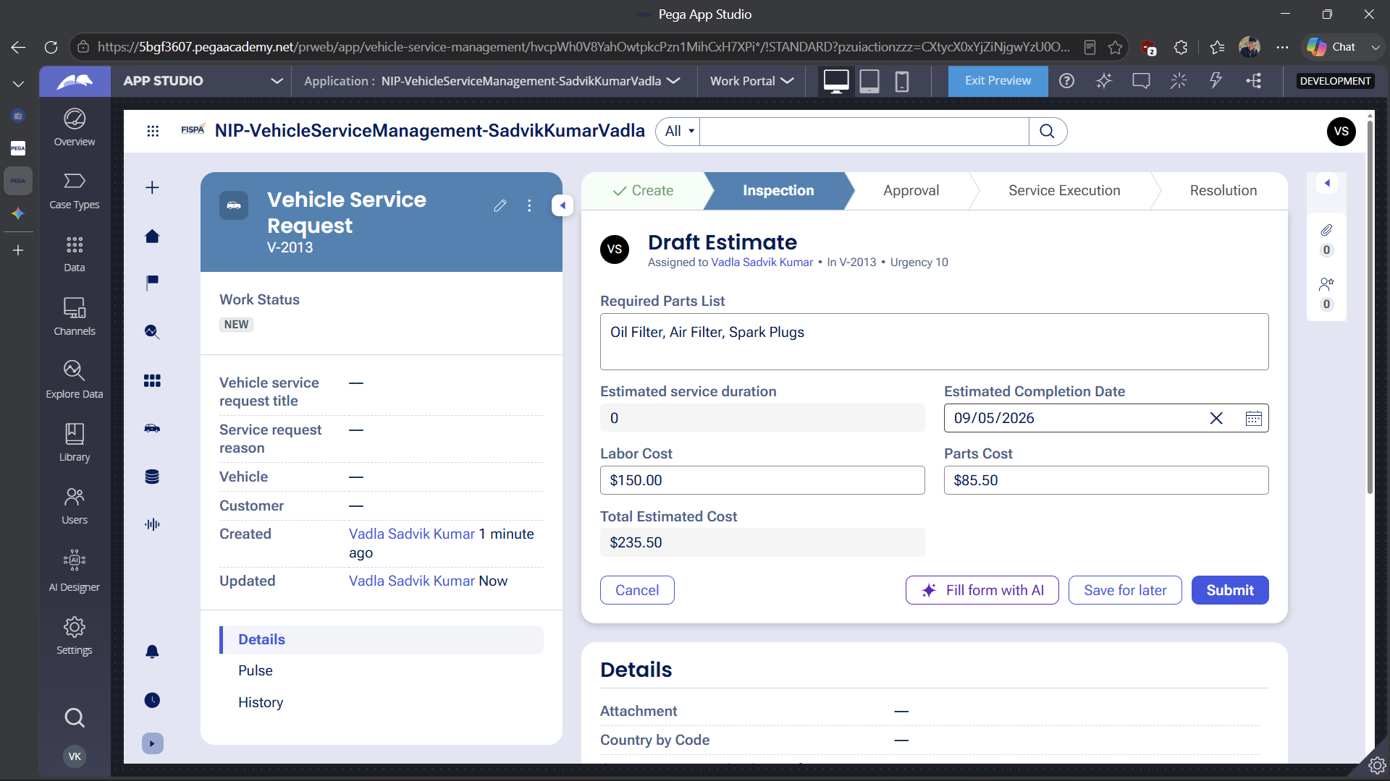

What I built for this (1–2 lines in your own words):
Configured the cost estimation step to capture required labor and parts expenses, allowing the system to determine the total service cost before requiring customer approval.

US-004 — Approve Service Estimate
What is expected:
Approval stage assigned to Customer. Approval Status captured. Flow branches on approve/reject.
Screenshot — paste your screenshot below this line:
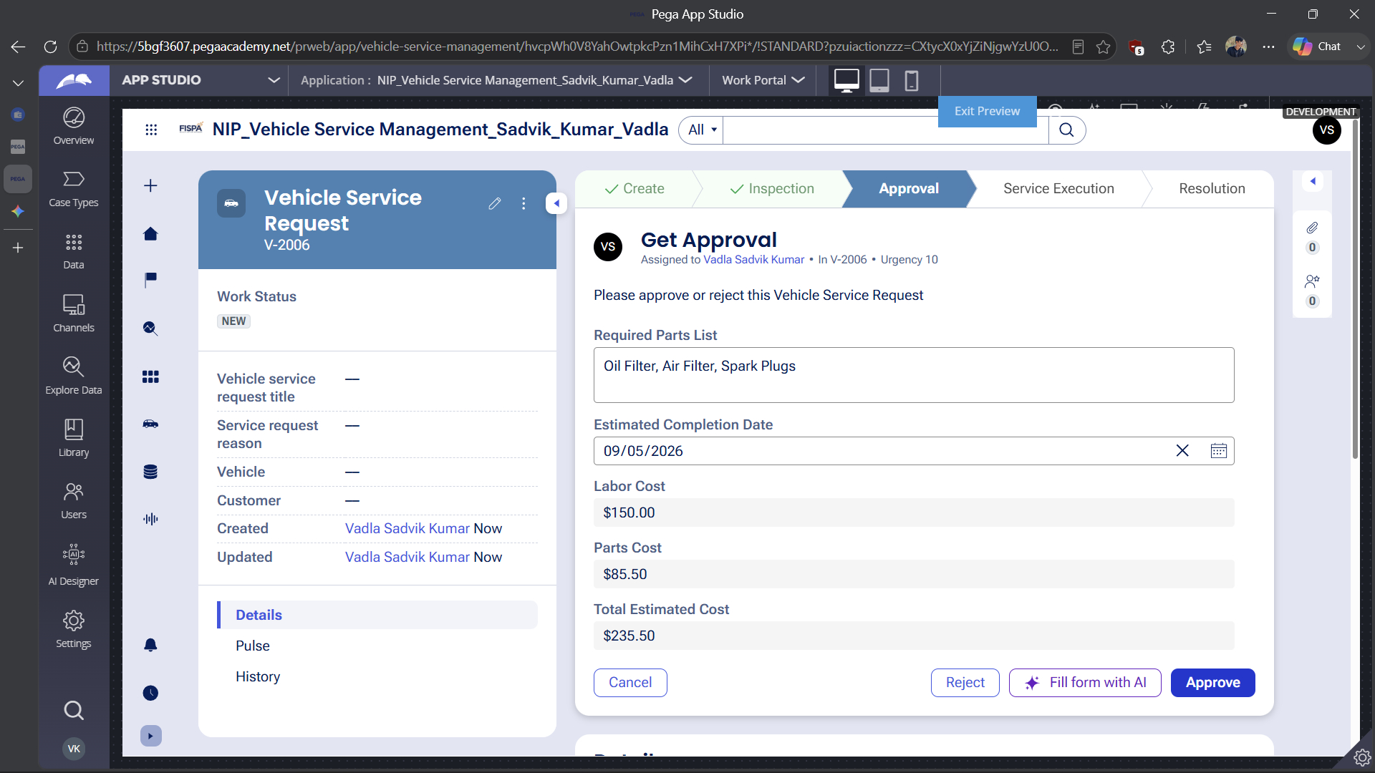

What I built for this (1–2 lines in your own words):
Configured an approval step to explicitly route the estimated service costs to the customer for review before any service work begins.

US-005 — Maintain Vehicle Data
What is expected:
Reusable Vehicle data object created with Vehicle ID, Model, Type — linked to case.
Screenshot — paste your screenshot below this line:
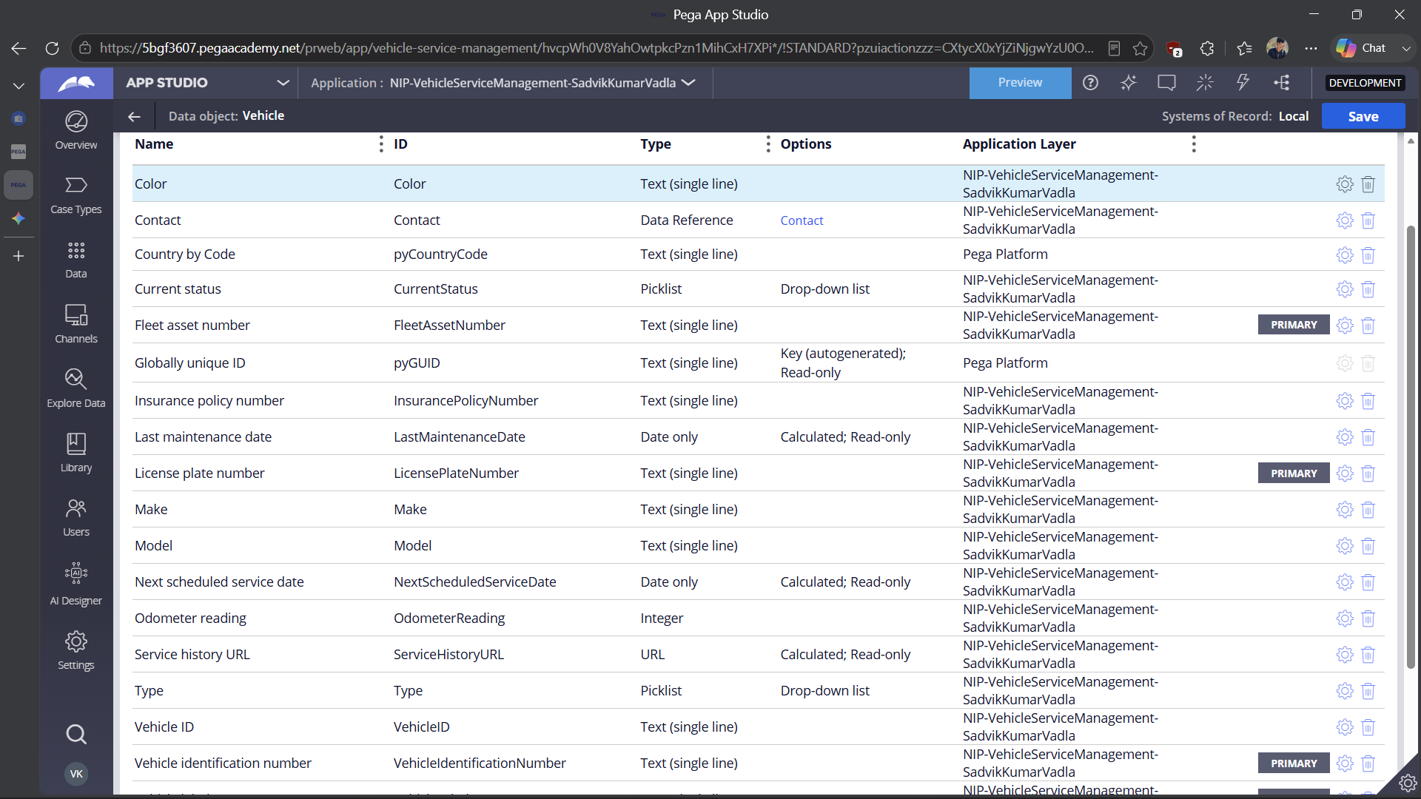

What I built for this (1–2 lines in your own words):
Created a dedicated Vehicle data object to structure and maintain essential properties including Vehicle ID, Model, and Type.

US-006 — Review Service Estimate
What is expected:
Approval screen shows Labor Cost, Parts Cost and Total Cost clearly to the Customer persona.
Screenshot — paste your screenshot below this line:


What I built for this (1–2 lines in your own words):
Implemented an approval interface allowing the customer to formally approve or reject the proposed service request and associated costs.

US-007 — Auto Assign Technician
What is expected:
Service Execution stage with routing to HeavyVehicleQueue or LightVehicleQueue. Assigned Technician and Service Status properties maintained.
Screenshot — paste your screenshot below this line:
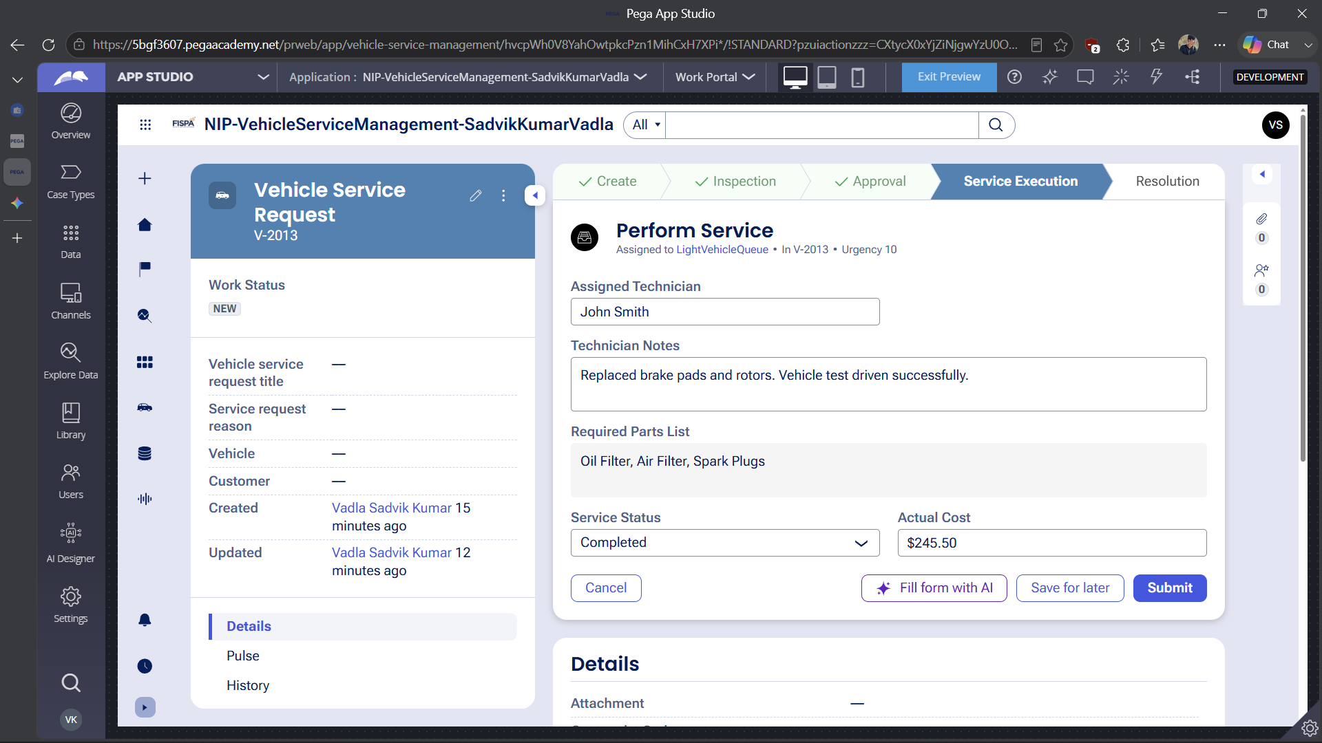

What I built for this (1–2 lines in your own words):
Configured the Service Execution step to route dynamically to the correct vehicle queue and capture the assigned technician and service status.

US-008 — Notify Service Completion
What is expected:
Correspondence rule created and triggered on case resolution. Email includes case and vehicle details.
Screenshot — paste your screenshot below this line:
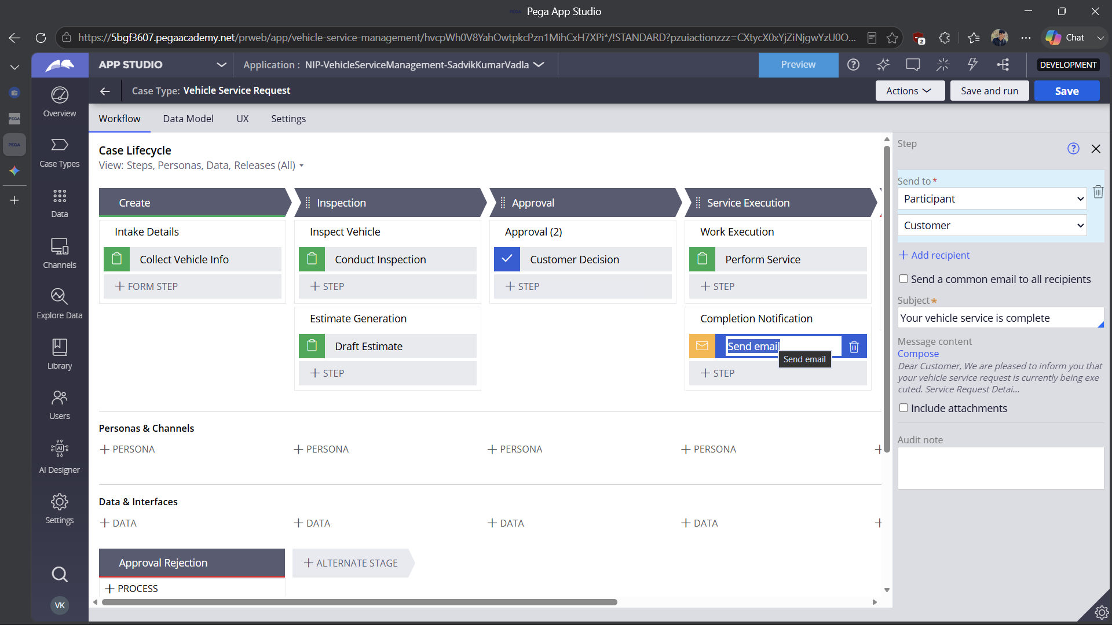

What I built for this (1–2 lines in your own words):
Configured an automated email notification to alert the customer as soon as their vehicle service has been completed.

US-009 — Define Service SLA
What is expected:
SLA configured on the case type. Goal: 2 days. Deadline: 3 days. Priority increases on breach.
Screenshot — paste your screenshot below this line:
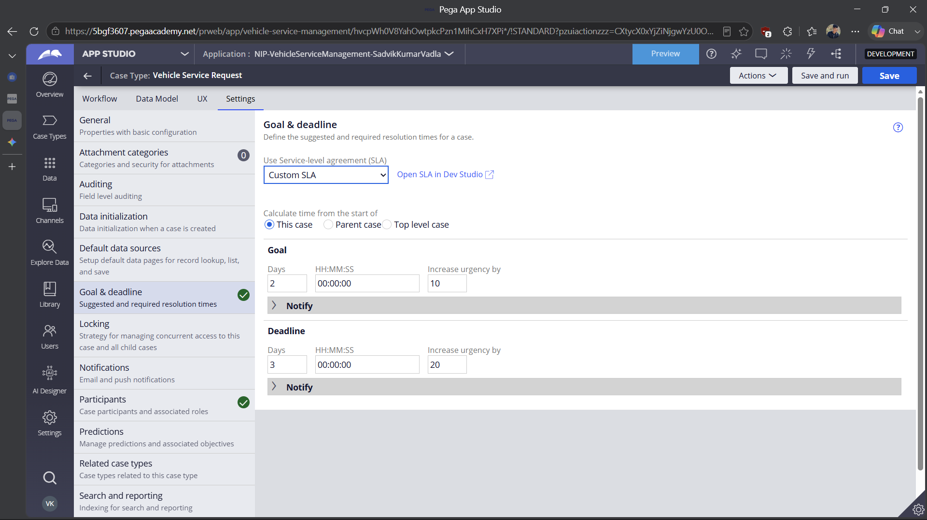

What I built for this (1–2 lines in your own words):
Established a case-level Service Level Agreement (SLA) with a target completion goal of 2 days and a mandatory deadline of 3 days.

US-010 — Route by Vehicle Type
What is expected:
Routing rule or Decision Table routes to HeavyVehicleQueue or LightVehicleQueue based on Vehicle Type property.
Screenshot — paste your screenshot below this line:
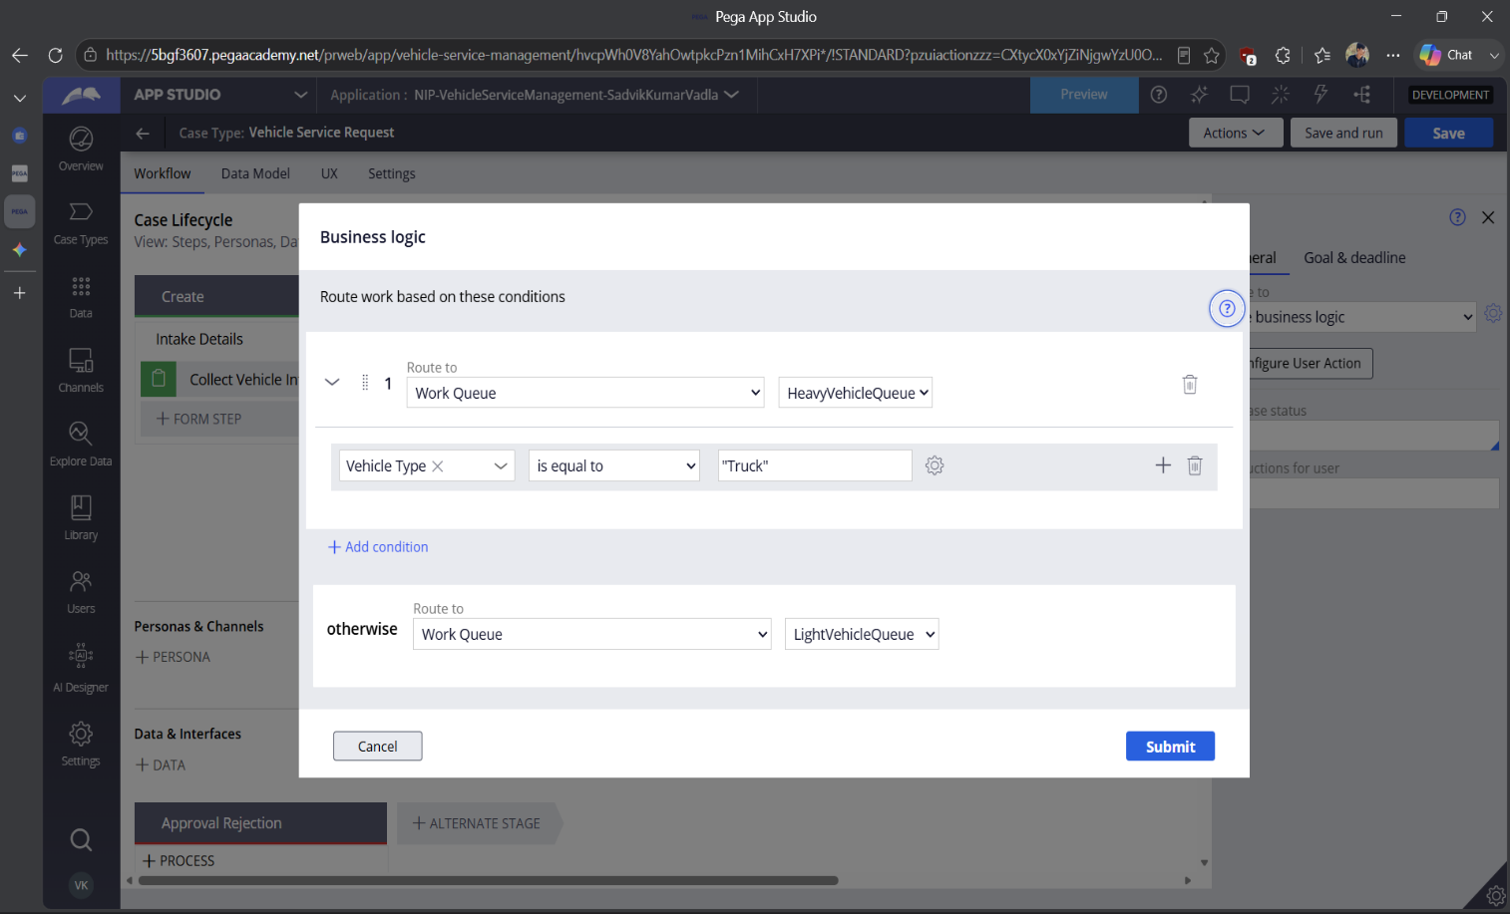

What I built for this (1–2 lines in your own words):
Implemented business logic routing to automatically distribute work to either the HeavyVehicleQueue or LightVehicleQueue based on the specified vehicle type.

Section 3 — About Your Application
These answers are checked against your screenshots. Write exactly what is in your application.

Q1. List your stages in the order they appear in your case lifecycle.
Stage names in order, separated by commas.
Create, Inspection, Approval, Service Execution, Resolution

Q2. Name the data object(s) you created and the properties inside them.
Data object name and its properties.
Data Object: Vehicle
Properties: Vehicle ID, Vehicle Model, Vehicle Type

Q3. What is the exact name and type of the rule you used to calculate Total Cost?
Provide:
• Rule Name
• Rule Type
• Properties used in the calculation
• Formula used
Rule Name: Total Cost
Rule Type: Calculated Field
Properties used in the calculation: Labor Cost, Parts Cost
Formula used: Labor Cost + Parts Cost

Section 4 — Your Understanding
Short, honest and specific answers score well.

Q4. What did Blueprint generate for you, and what did you add or change yourself afterwards?
Be specific about what was already there and what you built or modified on top.
Blueprint generated the basic case lifecycle stages (Create, Inspection, Approval, Service Execution, Resolution) and the initial data object framework. I manually added specific properties like Vehicle ID and Vehicle Model to the view in the Create stage, configured the custom formula for the Total Cost field, and built the specific business logic routing to direct cases to different work queues based on the vehicle type.

Q5. Was there anything Blueprint created that you had to correct or configure further? Describe one example.
A real example from your own work.
I had to correct the routing on the Perform Service step. Blueprint defaulted the routing to a specific operator or the current user. I had to open the business logic settings and manually change the routing dropdowns from "Operator" to "Work Queue" to ensure cases correctly dropped into either the HeavyVehicleQueue or LightVehicleQueue.

Q6. Explain your case flow from creation to resolution, in order.
What happens first, who does what, when the case closes.
The case begins with the customer submitting their vehicle details and describing the issue. A technician then receives the case to perform an inspection and enter labor and parts costs to generate an estimate. The case then routes back to the customer, who must approve or reject the total cost. If approved, the case goes to a specific technician queue (heavy or light) for service execution. Once the mechanic completes the work and updates the status, the case resolves and an automated email notifies the customer.

Q7. Pick two design choices you made in your application and explain why you made them.
For each design choice, provide:
• What you implemented
• Why you chose that approach
• What benefit it provides to the application
Design Choice 1: Automated Cost Calculation
- What you implemented: A calculated field that automatically adds Labor Cost and Parts Cost together to output the Total Cost.
- Why you chose that approach: It removes the need for technicians to manually calculate math on the spot.
- What benefit it provides: It reduces human error and ensures the customer always receives a perfectly accurate estimate for approval.

Design Choice 2: Skill-based Routing by Vehicle Type
- What you implemented: Business logic that checks if the Vehicle Type is "Truck" and routes to a heavy queue; otherwise, it routes to a light queue.
- Why you chose that approach: Different vehicle sizes require different mechanic skill sets and garage bay equipment.
- What benefit it provides: It ensures service requests are instantly assigned to the right team, preventing delays caused by manual assignment transfers.

Q8. What was the hardest part, and how exactly did you fix it?
Specific and honest. A real challenge scores much better than a generic answer.
The most challenging part was satisfying the routing requirements for the Service Execution stage while ensuring the queue name appeared correctly on the screen. Initially, the system kept assigning the case to my operator name instead of the queue. I fixed this by opening the Business Logic window, deleting the default operator condition, adding a specific condition to evaluate Vehicle Type is equal to Truck, and strictly setting both the condition and the "otherwise" path to route to Work Queues instead of Operators.

Q9. If the approval step was only needed when Total Cost is above a certain amount, what would you change in your application?
Explain what you would change and where. You do not need to build this.
I would open the case lifecycle, click on the Approval step, and look for the routing or step execution conditions in the right-hand properties panel. I would change the step to start conditionally (using custom logic) rather than always starting. I would then set the condition to evaluate if Total Cost is greater than the target amount, which would automatically bypass the approval screen for cheaper services.

Q10. List three exact rule names from your application that you personally created or modified.
Include the rule name and rule type for each one (for example: CalculateTotalCost - Declare Expression).
Vehicle (Data Object)
Total Cost (Calculated Field)
LightVehicleQueue (Work Queue)
Q11. List all personas used in your application.
List the persona names exactly as they appear in your application.
Customer, Technician
Q12. List all work queues used in your application and explain when each one is used.
For each work queue, provide its exact name and the condition or type of work routed to it.
HeavyVehicleQueue: Cases are routed here during the Service Execution stage if the customer's selected Vehicle Type is equal to "Truck".
LightVehicleQueue: Cases are routed here during the Service Execution stage for all other cases (acting as the "otherwise" condition if the vehicle is not a truck).

