TABLE OF CONTENTS

Chapter No | Contents | Page No
 | Executive Summary | I
 | LIST OF FIGURES | II
 | LIST OF TABLES | III
 | LIST OF ACRONYMS | IV
1 | Introduction | 1
1.1 | Background | 1
1.2 | Problem Statement | 1
1.3 | Importance | 2
1.4 | Organization of Report | 2-3
1.5 | Key Elements | 3
2 | Overview and Planning | 4
2.1 | Proposed System Overview | 4
2.2 | Challenges | 4
2.3 | Assumptions | 5
2.4 | Architecture Specifications | 5
2.5 | Hardware Requirements | 5-6
2.6 | Software Requirements | 6
2.7 | Gantt Chart | 6-7
2.8 | Work Breakdown Structure | 7-8
3 | Literature Survey and Review | 9
3.1 | Literature Survey | 9-10
3.3.1 | Overview | 10
3.3.2 | Introduction to BI Project | 10
3.3.3 | Comparison of BI Projects | 10
3.3.4 | Dashboard Design Issues | 10
3.2 | Literature Summary | 11
4 | System Design | 11
4.1 | High-Level Design | 11-12
4.2 | Low-Level Design | 12-13
4.3 | Constraints and Tradeoffs | 13
4.4 | Test Cases Generation | 13
5 | System Implementation | 14
5.1 | Code | 14-19
5.2 | Unit Testing | 19
5.3 | Integration Testing | 20
5.4 | Test Results | 20
6 | Results and Discussion | 21
6.1 | Output/Results | 21
6.2 | Results Analysis | 25
6.3 | Discussion | 25
7 | Conclusion and Future Work | 26
7.1 | Conclusion | 26
7.2 | Scope of Future Work | 27
8 | References | 28

1. INTRODUCTION
The software design document is a document to provide documentation which will be used to aid in software development by providing the details for how the software should be built. Within the software design document are narrative and graphical documentation of the software design for the project including use case models, sequence diagrams, collaboration models, object behavior models, and other supporting requirement information will be provided.

1.1 Background
This project is being developed for all business activities, companies having their data to visualize and for making conclusion (analytics). Here we use an umbrella term that refers to a variety of software applications used to analyze an organization’s raw data. It also combines tools, database, and applications. We Intended to provide key to thriving in a competitive marketplace is staying ahead of competition in business.

1.2 Problem Statement
This mainly concerned about the art of extracting information, and turning that information into knowledge upon which actions can be taken. The project is primarily concerned with these Fig 1.
This project intended to provide a replacement strategy for business is as follows.
- What happened? (reporting)
- Why did it happen? (analyzing)
- Why will it happen? (predicting)

What is happening? (monitoring)Making it happen. [decision making support]
EXTRACT
TRANSFER
LOAD

Fig 1.2.1: ETL (methodology)
1.3 Importance
The project preliminary aims to make decision quickly based on terminology (etl).To Make staff easily understood by providing analysis and reporting interface. Our title reveals the proposed system of how to approach the process:
Business intelligence leads us to make business decision quickly and data visualization helps us to visualize the raw data. Data analytics helps us to make interaction with raw data and for predicting outcomes of system.
- Here we used visualization tool for data visualization is tableau.
- And for data analytics we used the qlikview, as to discover data & distribute.
Advantages:
- Cost reduction
- More reliable
Faster and better decision making. These shares expert information, knowledge useful in management for organization and individual business, in this sense, Business Intelligence (BI): Data visualization and Data analytics is a broad category of applications and technologies for gathering, providing access to, distribute and analyzing data. The scope thus for helping enterprise users make better business decisions quickly.

1.4 Organization of Report
The main body of the report is preceded by detailed contents including lists of figures, tables, and annexes followed by units used in the report. This is followed by executive summary giving briefly the scope and objectives of the study, importance of the topic, methodology, limitations, major observations / findings, and recommendations & action plan.
Chapter 1: Explains the importance of the topic, scope, methodology of data collection and analysis.
Chapter 2: Discusses the properties of potential is presented.
Chapter 3, In chapter 4. The utilization potential in business sector, of which decision- making is a sub-set, is the focus.
Chapter 5 discusses the technologies used in these projects.
Chapter 6 the specific case studies / projects related to business sector components where plays vital role.
Chapter 7. Chapter 8 gives the conclusions, recommendations & action plan.

The format of this document is consisting as follows. Bold face, Bold + Italic and Regular is used on general topics and or specific points of interest. The remainder of the document will be written using the standard font, Times New Roman.
This document is intended to be read by the Data Scientist. This is a technical document and the terms should be understood by the customer.

1.5 Key Elements

Business Intelligence: Business intelligence (BI) is a data-driven DSS that combines
data gathering, data storage, and knowledge management with analysis to
provide input to the decision process.
Dashboard: A dashboard is a single screen user interface consists of a static
structure which makes information available.
Data Visualization: A special aspect of user interfaces the means for communicating
structures and processes, which may be shown in abstract or representational
forms.
User Interface: A computer program is the part that handles the output to the display and the input from the person using the program.
Information: Significant patterns of organized data.

2. Overview and Planning
2.1 Proposed System Overview
The proposed system typically associated with these project include the following are mentioned below.
- Target decisions: identify the key business decisions for which bi is needed.
- Extract, transform and load source data: analyze the source data to determine requirements for extracting, transforming and transferring data for subsequent analytics in real time.
- Decision support modeling: develop the logic, models and display formats by which the source data can be analyzed, mapped, displayed and reported.
- Analysis and reporting: develop the reports, queries, graphs, dashboards, to be used analyze and display or report the data.

REQUIREMENTS
ANALYSIS
BUILD INTERFACE
DISTRIBUTE

Fig 2.1.1: Proposed System

2.2 Challenges
The primary importance of these project which involves phases like as follows.
- Expert view: these expert treats user interface platform for decision making support in business organization. They need to be make sure for making decision by visualizing the raw data and make conclusions with the data.
- Approaches: the main key to success of project is consolidating data from the enterprise operational systems into an enterprise data warehouse. Identifying the relationship between data and do classification.
- Analysis of right information: the dataset contains data should be relevant and
classify the correct data.
2.3 Assumptions
Information is often regarded as the second most important resource a company has (a company's most valuable assets are its people). So when a company can make decisions based on timely and accurate information, the company can improve its performance.

2.4 Architecture Specifications
These project architecture includes the following criteria where certain rules to be followed to achieve the reports. Which helps business organization for making business decision-making quickly.

Steps | Specifications
Prediction model | Predict value for specific data
Relevance | Collect similar data items
Link analysis | Identify relations between attributes
Classification | Determine to which class a data item belong
Pattern analysis | Sequential order to be followed
Etl,olap | Helps to analyze users in different dimensions of data
Models | Easily understood by representing in bars, graphs ,pivot and others
User interface | To make strong assumptions for business organization

TABLE 2.4.1: Specification

2.5 Hardware Requirements:
These project completely based on memory speed which technically called as compatibility. This projects able to create user interface which helps us to visualize and analysis. It may distribute the user interface web-based and it will be hosted by Qlikview server, tableau server. This user interface can be viewed by web browser, securely. It supports all web browsers.
- Hardware :INTEL I5 QUAD CORE CHIP (OR HIGHER)
- Hard Disk :30 GB
- RAM : 2GB (OR) HIGHER.

2.6 Software Requirements:
- Operating system : Windows 8 (OR) HIGHER, UBUNTU 12
- Software’s : Qlikview , R-STUDIO,TABLEAU.

2.7 Project Schedule (gantt chart)

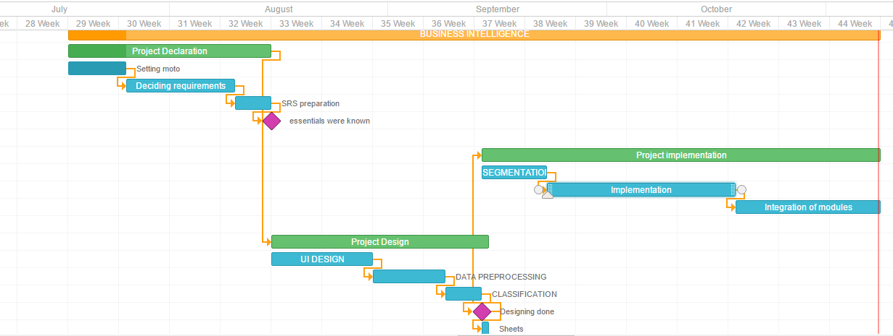
Fig 2.7.1 : Gantt chart

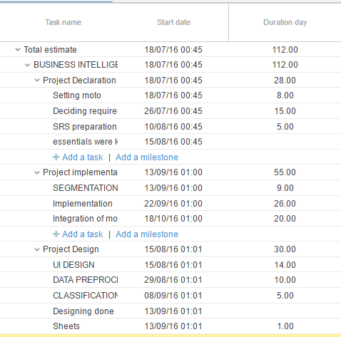

Table 2.7.2: Schedule

2.8 Work Breakdown Structure
A detailed description of each component contained within the process is presented.

Dashboards
These dashboards can provide a customized snapshot of daily operations, and assist the user in identifying the problems and the source of those problems, as well as providing valuable, up-to-date information- all in one place.

kpi (key performance indicators)
These module helps to enable clear, concise definition and tracking of performance indicators for a period, and measures. Users can further analyse performance with easy-to- use features like drill down, drag and drop etc.

Graphical list
These module makes us easy for your staff to find, filter and analyse data, going beyond numbers, users to make visualize the information with stunning displays, and valuable types.

Forecasting
Our analysis used to historical product sales, pricing, forecasts the measures with numerous time series options to improve your planning process.

Reports
Reports are web-based in the organization within hours! Its easy to use, and able tocreate a report to summarize your performance, users can only access the reports.
This is the brief description of project work flow (may be work done by us ).
These project work breakdown structure looks work done by us.

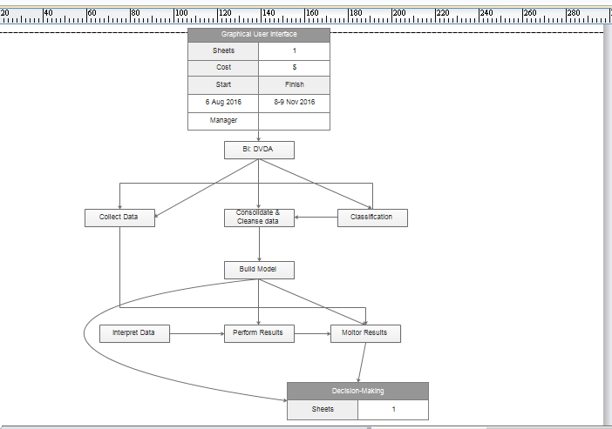
Fig 2.8.1: wbs

3. Literature survey and review
3.1 Literature survey
1)Few, S. (2006). Information Dashboard Design. The effective visual communication of data, Sebastopol.
2)Ford, R. C., & Richardson, W. D. (1994). Ethical decision making: A review of the empirical literature. Journal of Business Ethics, 13(3), 205-221. doi:10.1007/BF02074820.
3)Gable, G. G. (1994). Integrating case study and survey research methods: an example in Information Technology. Journal Article, Retrieved April 24, 2009, from HTTP://EPRINTS.QUT.EDU.AU/5853/.
4)Hall, O. P. (2003). Using Dashboard Based Business Intelligence Systems: An
approach to improve business performance. Journal of Contemporary Business Practice, 6.
3.1.1 Overview
This project provides an overview of business intelligence (bi). The first section our project provides a brief overview of the business. The later part of this project discusses the importance of decision making.

3.1.2 Introduction to BI Projects
The main goal of the company was to make data available in an integrated and consolidated manner to the users, processes and applications.
- Improved problem solving
- Better customer experience
- Improved reporting and analytics capability
- Optimized business function

3.1.3 Comparison of BI Projects
A bi dashboard allows business users to have complete control over how they manage the data while it can be more involved with technology integration, maintenance and support.
Representing performance information in a graphical format allowing users to
- Rapidly recognize performance issues.
- Analyzing performance information in a structured manner within the context.
- Goals and objectives.
- Helping to facilitate better decision making and reducing the costs incurred.
- Manual information gathering.
- Assisting with reducing costs related to administrative or manual work.

3.1.4 Dashboard Design Issues in BI Project
A dashboard should be able to filter, sort and analyze the data.
            - A dashboard should have the drag-and-drop functionality available.
      - It should provide drillable charts and graphs.
      - It should be multilingual.
      - It should be able to create alternative solution.

3.2 Literature Summary
The research described in the prior sections has contributed towards the BI
dashboard literature. The literature helps in understanding the BI systems, difference between BI systems used for the decision making process and provides knowledge about design issues that affect the decision making process. The following section will describe the methods used for measuring the effect of BI systems.

4. System Design

4.1 High-Level Design
In this Business Intelligence: Data Visualization Data analytics, we have used Tableau, Qlikview and R Studio has been used for all the functionalities that are carried out in the whole system. In order to remove the complexity of converting raw data into meaningful data, we have considered three different modules. In the very first module we will take the raw data and will be converted into meaningful data which helps in understanding the raw data very easily, In case if data can be easily understood and still want to analyze more data and if this happens second module comes working here we can able to analyze the whole data how we are taken the data how we are going to analyze where one data is linked to the other data has come under the second module And the third module is here we are going to predict the data what is going to happen in the future what is the outcome of the data by taking the previous data and will predict the future by using algorithms. So, it’s clear that the raw data can be taken and will be going to represent in an understandable manner to each individual and can able to analytics the data. If the data cannot be understood by code they can able to understand it by seeing the charts which are of pie charts, bar charts, bubble charts, etc. This is how the system works more efficiently. In order to have a best system we have separated the whole system into three different modules so even though if from one module the data cannot be understood pretty sure that another module the data can be understood. For creating and making functionalities we have used the r programming and qlikview programming this how the system is programmed and maintained.

MODULE-1
MODULE-2
BI:DVDA

MODULE-3
Fig 4.1.1: Design

Module-1:
The data can be easily understood by just pointing the cursor where you want and easily understand the raw data.
Module-2:
The raw data which in the form of xml or from the data base are from any source has been taken and converted the meaningful data where a normal person can able to find the data easily.
Module-3:
Not only converting the raw data into meaningful data we can able to the previous data and can able to predict the future outcomes which helps us to take the necessary steps for the bright outcomes.
All the modules are implemented in Tableau, Qlikview and R studio. R studio is used because we can able to do the work more easier way.

4.2 Low-Level Design
As explained in the earlier high level design Tableau Qlikview has been used for data visualization and analytics and to predict the data R programming and Qlikview programming is used, upon the need of the module.

Components explanations:
- Software:
- Tableau:
- Qlikview:
- R Programming:
- Programming Language:
- R programming is a set of language extension for the R Programming language. This language uses most of the syntax and semantics of standard R. Qlikview coding is also in Qlikview for its functionalities.

4.3 Constraints and Tradeoffs
Business Intelligence: Data Visualization Data Analytics system it delivers a rich set of benefits that drive significant and tangible return on investment. It will help in understanding the raw data into meaningful data where the data can be easily understood by the pictorial way like using the charts pie charts, bar charts, line chart etc. We are also using the representation of data in different modules where if u cannot able to understand in one module then you can able to understand it in different module not only it but also we are going to collect the previous the data where we analyze the data and will predict the future outcomes which helps to take the necessary data.
This document addresses the general purposes for our system. Any detail requirements can be verified with the user or the customer.

4.4 Test Cases Generation

Test Case 1:
Input : Data Set in Tableau tool
Expected Output : Visualization
Actual Output : Data visualization
Test Result : PASS

Test Case 2:
Input : Data Set in R Studio
Expected Output : Decision Tree(Graph)
Actual Output : Decision Tree(Graph)
Test Result : PASS
Test Case 3:
Input: : Data Set in Qlikview
Expected Output : look-and-feel
Actual Output : look-and-feel
Test Result : PASS

5. System Implementation

5.1 Code
Decision.R
library(party)
df<-read.csv("Superstore.csv")
data<-data.frame(df)
str(data)
pd=sample(2,nrow(data),replace=TRUE,prob=c(0.9,0.1))
train=data[pd==1,]
test=data[pd==2,]
dctree <- ctree((Profit ~ Category+Discount) , data=train)
pre=predict(dctree,test)
pre
t=pre==test$Profit
table(t)
print(dctree)
plot(dctree)
plot(pre)
table(pre)
mean(pre!=test$Profit)
table(pre,test$Profit)

QlikView Commands:
Sales_Data:
LOAD [Actual Delivery Date],
CustKey as [Customer Number],
DateKey,
[Discount Amount],
[Invoice Date],
Year ( [Invoice Date]) as Year,
Month ([Invoice Date]) as Month,
[Invoice Number],
[Item Class],
[Item Number],
Item,
[Line Number],
[List Price],
[Order Number],
[Promised Delivery Date],
[Sales Amount],
[Sales Amount Based on List Price],
[Sales Cost Amount],
[Sales Margin Amount],
[Sales Price],
[Sales Quantity],
[Sales Rep],
[U/M]
FROM
[C:\Users\Kishan\Desktop\vstr\QlikView Activity Files\M2_SalesData.xls]
(biff, embedded labels, table is SalesData$);

Customer:
LOAD [Address Number],
[Business Family],
[Business Unit],
Customer,
[Customer Number],
[Customer Type],
Division,
[Line of Business],
Phone,
[Region Code],
[Regional Sales Mgr],
[Search Type]
FROM
[C:\Users\Kishan\Desktop\vstr\QlikView Activity Files\M2_Customers.xls]
(biff, embedded labels, table is CUSTOMERS$) where Exists ([Customer Number]);

Division:
LOAD Division,
[Division Name]
FROM
[C:\Users\Kishan\Desktop\vstr\QlikView Activity Files\M2_Division.xls]
(biff, embedded labels, table is DIVISION$);

Region:
LOAD [Region Code],
[Region Name]
FROM
[C:\Users\Kishan\Desktop\vstr\QlikView Activity Files\M2_Region.xls]
(biff, embedded labels, table is REGION$);

Cust_Address:
LOAD [Address Number],
City,
Country,
[Customer Address 1],
[Customer Address 2],
[Customer Address 3],
[Customer Address 4],
State,
[Zip Code]
FROM
[C:\Users\Kishan\Desktop\vstr\QlikView Activity Files\M2_CustomerAddress.xls]
(biff, embedded labels, table is CUSTOMERADDRESS$);

Camera_Details:
LOAD CameraID,
Location,
Status
FROM
[C:\Users\Kishan\Desktop\vstr\QlikView Activity Files\M2_CameraCapture.xlsx]
(ooxml, embedded labels, table is CameraDetails) WHERE (Status = 'Active');

Capture_Details:
LOAD CameraID,
LicensePlate as [License Plate],
CaptureTime,
CaptureDay,
CapturedColour
FROM
[C:\Users\Kishan\Desktop\vstr\QlikView Activity Files\Capture_Details.xlsx]
(ooxml, embedded labels, table is Sheet1);

Car_Details:
LOAD [License Plate],
RegisteredColour,
YearRegistered
FROM
[C:\Users\Kishan\Desktop\vstr\QlikView Activity Files\M2_CarDetails.xlsx]
(ooxml, embedded labels, header is 1 lines, table is CarDetails);

Weekdays:
LOAD * INLINE
[
CaptureDay, Sort Order,
Monday, 1
Tuesday, 2
Wednesday, 3
Thursday, 4
Friday, 5
Saturday, 6
Sunday, 7
];

FinanceData:
LOAD Date,
Year,
Month,
[Month of Year],
Category,
Description,
[Money in],
[Money Out],
Balance
FROM
[C:\Users\Kishan\Desktop\vstr\QlikView Activity Files\M4_FinanceData.xlsx]
(ooxml, embedded labels, table is [Statements09013331649888 (1)]);

5.2 Unit Testing
Unit testing involves the design of test cases that validate that the internal program logic is functioning properly, and that program inputs produce valid outputs. All decision branches and internal code flow should be validated. It is the testing of individual software units of the application .it is done after the completion of an individual unit before integration. This is a structural testing, that relies on knowledge of its construction and is invasive. Unit tests perform basic tests at component level and test a specific business process, application, and/or system configuration. Unit tests ensure that each unique path of a business process performs accurately to the documented specifications and contains clearly defined inputs and expected results.
Unit testing is usually conducted as part of a combined code and unit test phase of the software lifecycle, although it is not uncommon for coding and unit testing to be conducted as two distinct phases.

Test strategy and approach
Field testing will be performed manually and functional tests will be written in detail.
Test objectives
- All fields such as attributes, dimensions, measures must work properly.
- The entry screen, messages and responses must not be delayed.
Features to be tested
- Verify that the attributes, dimensions, measures are of the correct format.
- All links should take the user to the correct page.

5.3 Integration Testing
Integration tests are designed to test integrated software components to determine if they actually run as one program. Testing is event driven and is more concerned with the basic outcome of screens or fields. Integration tests demonstrate that although the components were individually satisfaction, as shown by successfully unit testing, the combination of components is correct and consistent. Integration testing is specifically aimed at exposing the problems that arise from the combination of components.
Software integration testing is the incremental integration testing of two or more integrated software components on a single platform to produce failures caused by interface defects.
The task of the integration test is to check that components or software applications, e.g. components in a software system or – one step up – software applications at the company level – interact without error.

5.4 Test Results
All the test cases mentioned above passed successfully. No defects encountered. The testing is done among the team members and by the end users. It satisfies the specified requirements and finally we obtained the results as expected.
The existence of a large amount of legacy data: The current BI tools are not adequate for accessing and using legacy data for future BI applications. BI is underutilized: There are significant opportunities to increase the use of BI technology to support critical decision making but these opportunities are underutilized.

6. Results and Discussion
6.1 Output/Results
In these Project Data visualization done with by creating the user interface in Tableau, and classification in qlikview. To know whether the organization is having maturity level. The sheets can also be shared across the globe but it can be done in confidently.

Store Profit Rate-Output: Accuracy[1]
Fig 6.1.1: Decision tree
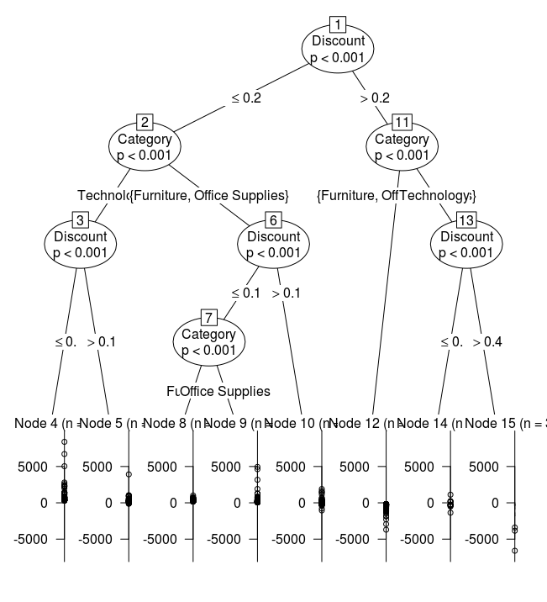

Qlikview Interface: Look-and-Feel
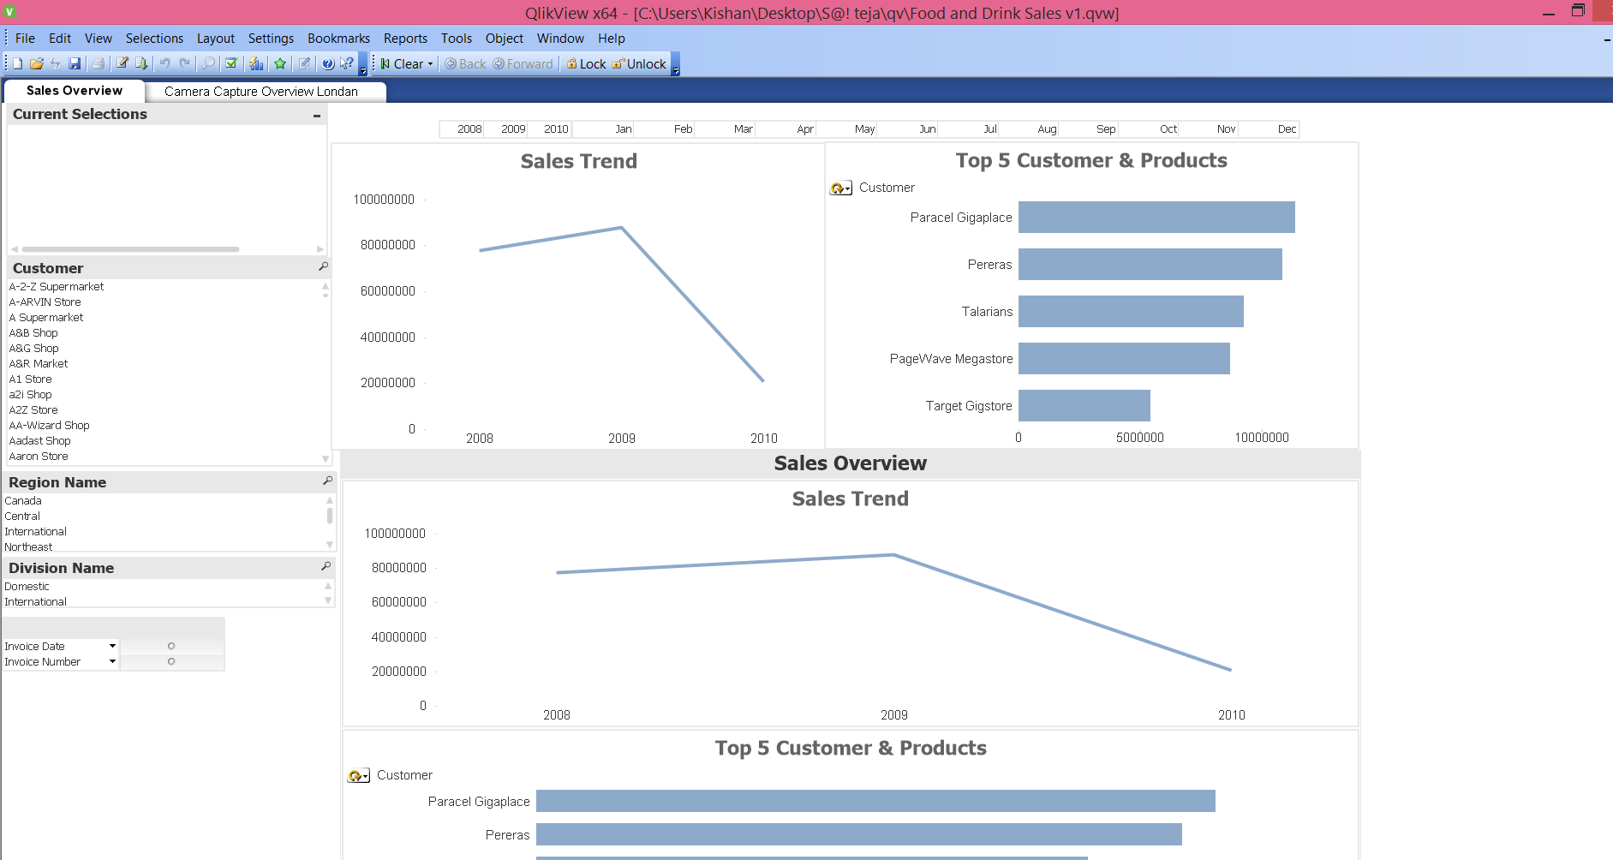 Fig 6.1.2: Look-and-feel

Finance Data:

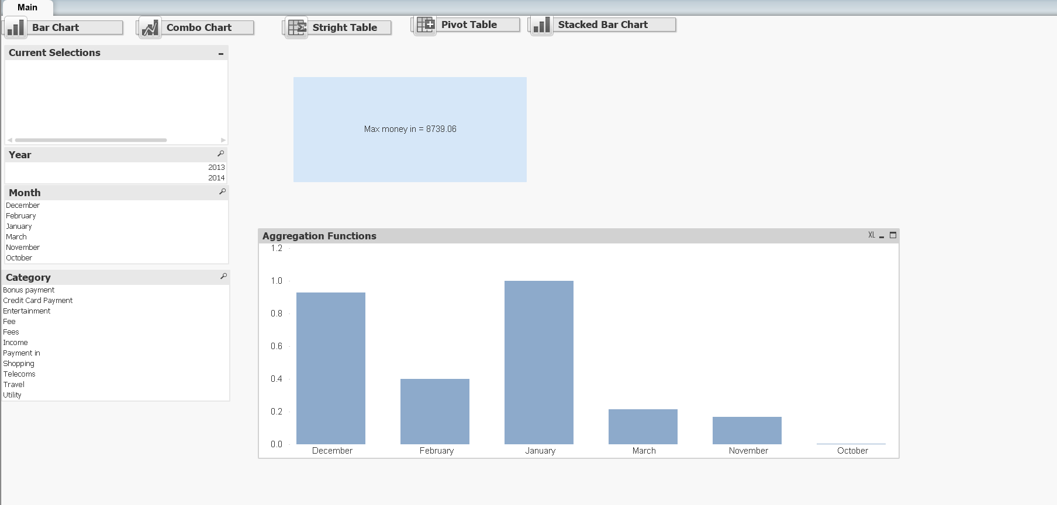
Fig 6.1.3:Finance

QlikView Classification:

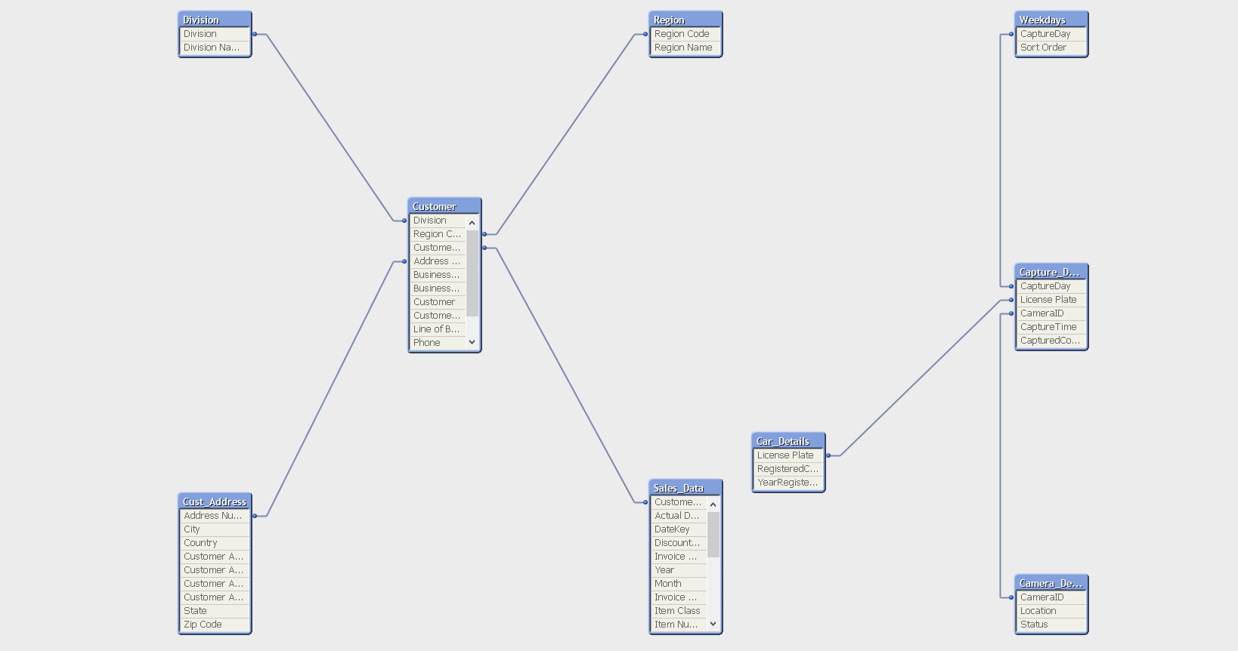
Fig 6.1.4: Classification
Captured Overview:

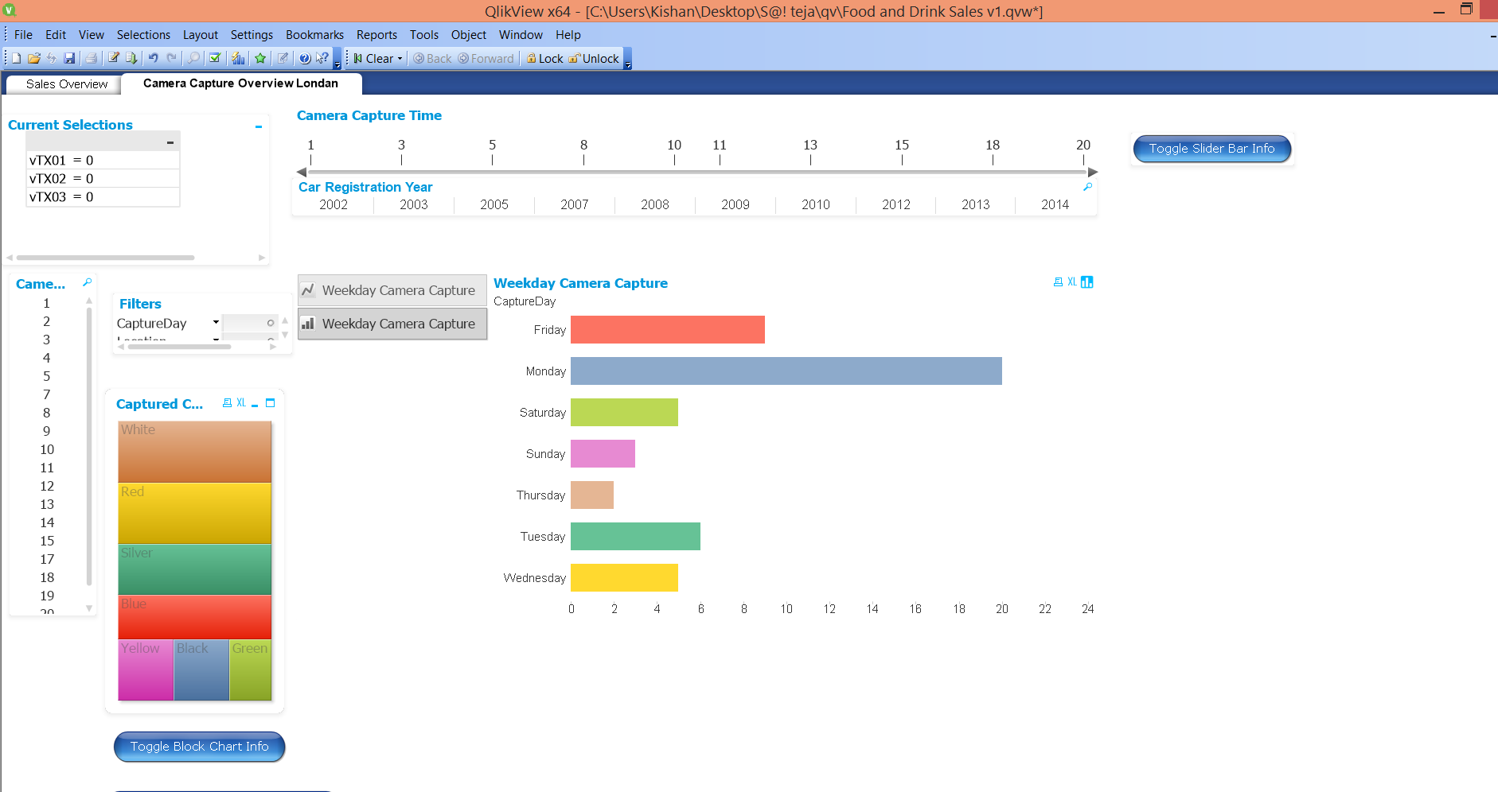
Fig 6.1.5: Sheet Details

QlikView Sheets Across Globe:[Create-Publish-Deploy]
In These Project we have done with qlik sense cloud that will generate a link to access an app which was created by us. This sheets cannot be edit under any circumstances.

App name: VSTR

Link: https://www.qlikcloud.com/view/582066966a909900016b3dbc

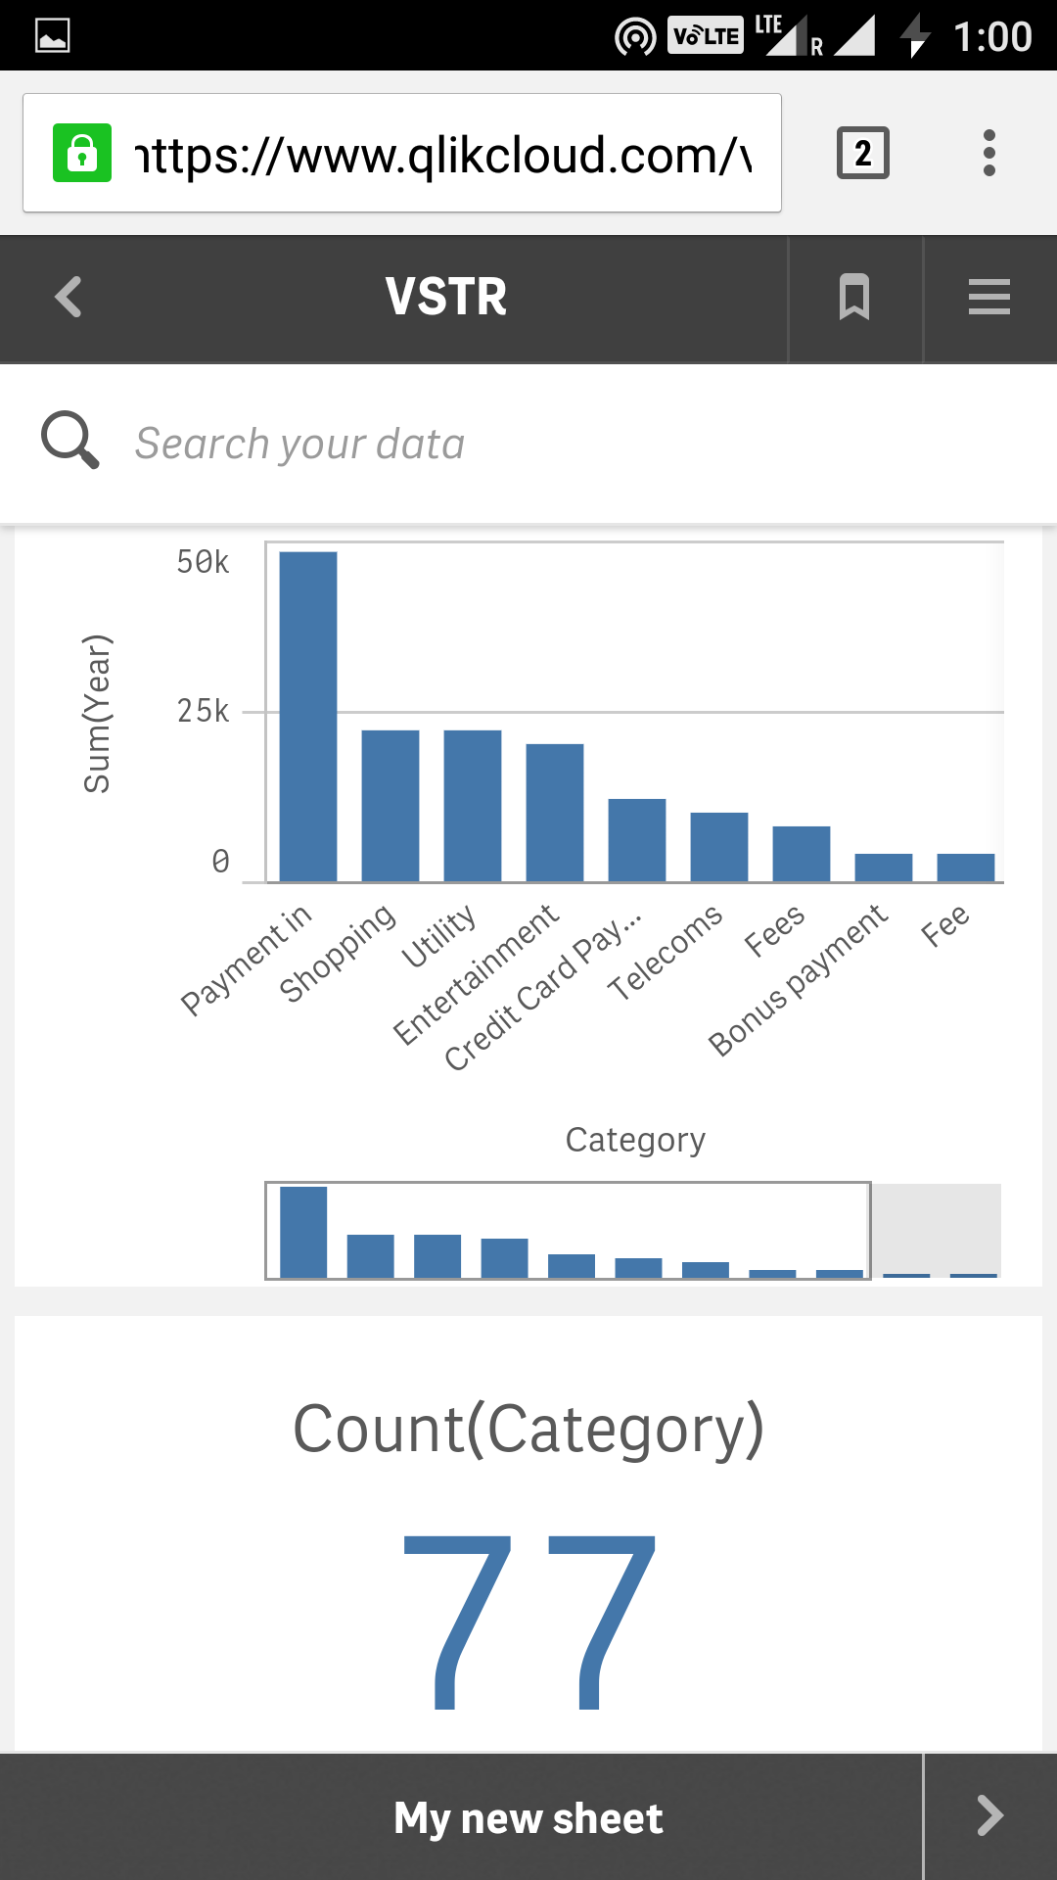
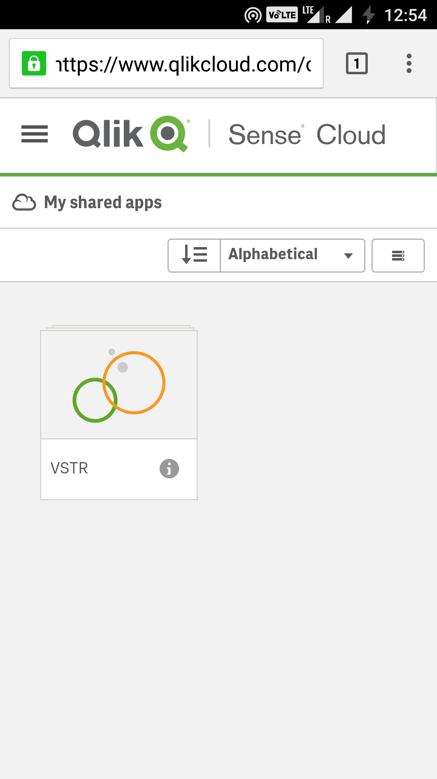

Fig 6.1.6: App Fig 6.1.7: Sheet1

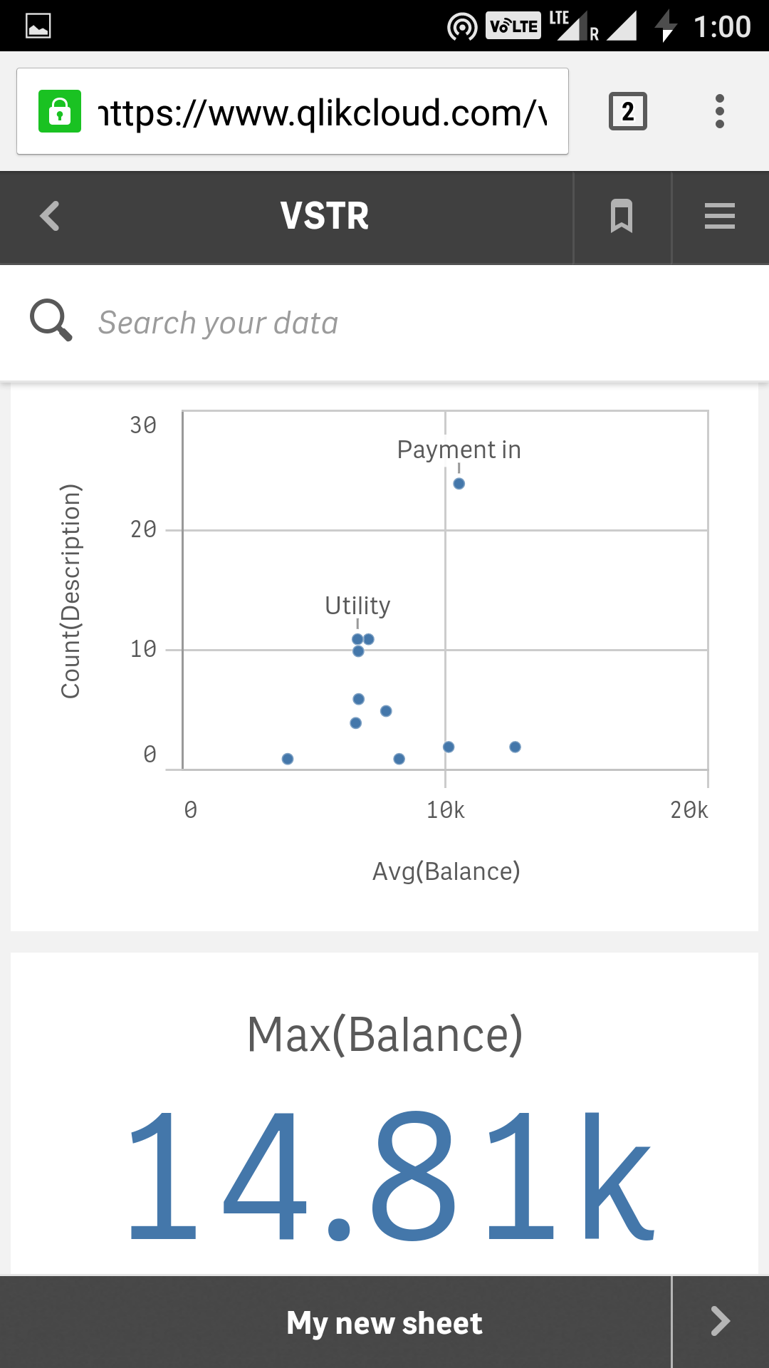
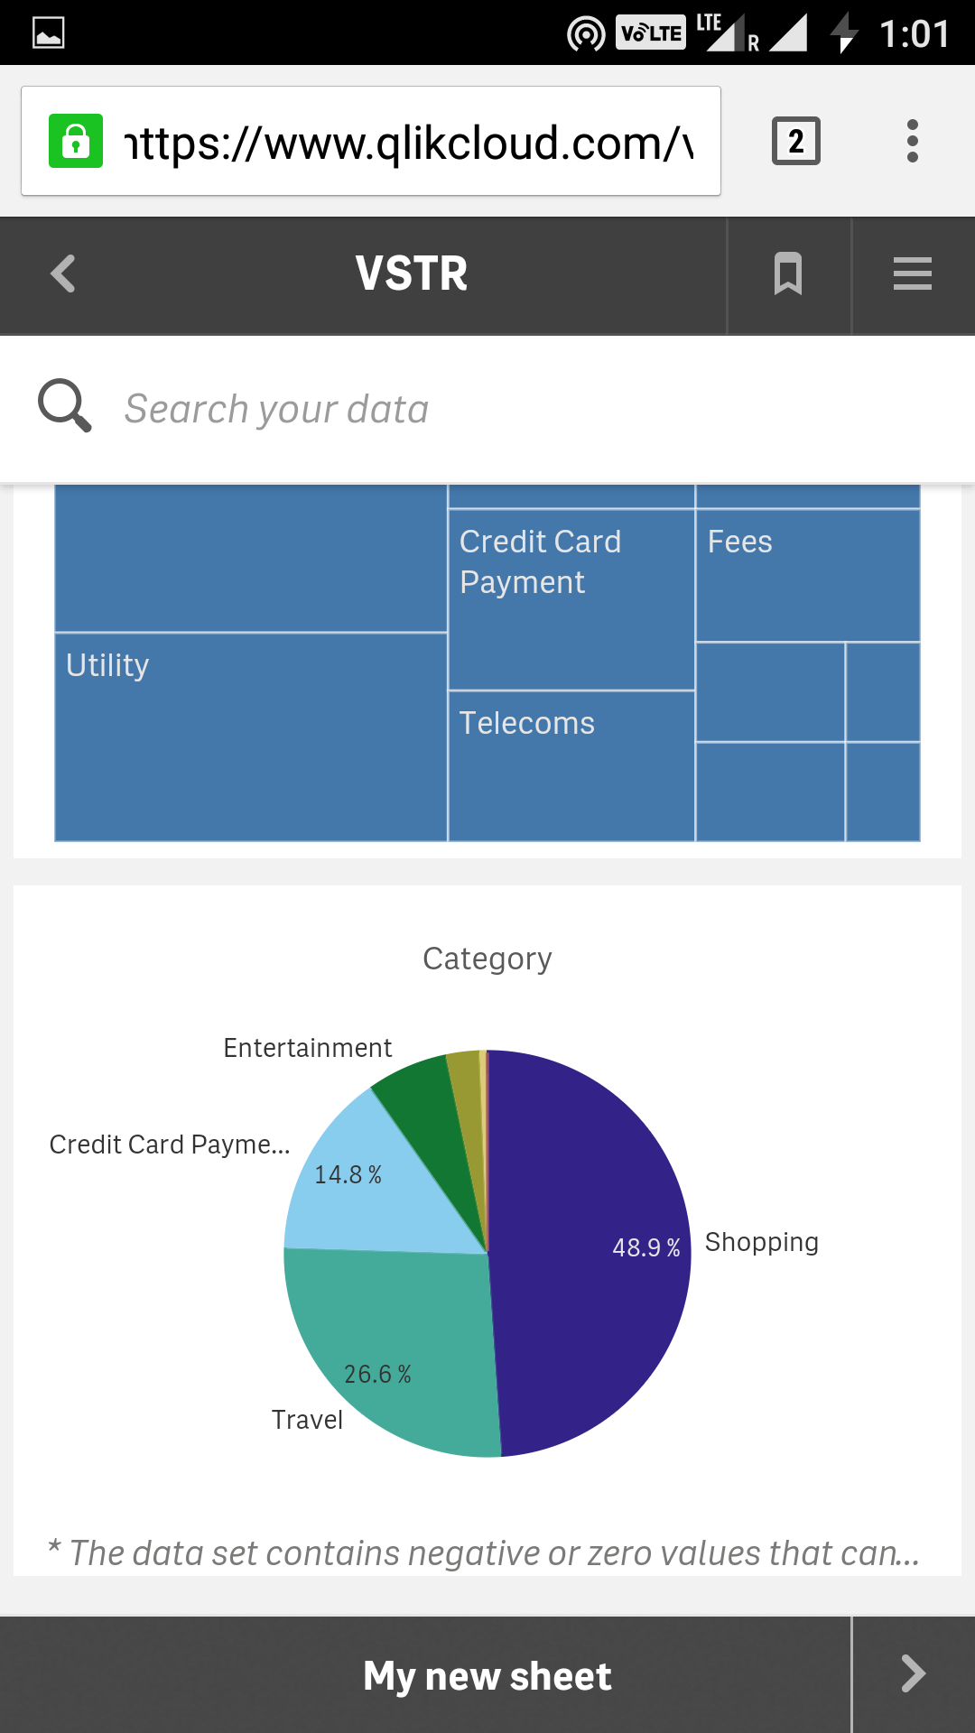

Fig 6.1.8: Sheet2 Fig 6.1.9: Sheet3

6.2 Results Analysis
These Results helps business organization to gain maturity level by making business Decision.
These also helps to provide graphical interface to analysis the business flow. The main objective of the project is to convert the raw data into meaningful business decisions making by presenting the whole data in the pictorial/graphical format for better understanding ,insight and better business decisions which in turn call as visualization and also we are going to use the data , making statistical analysis , exploratory and predictive models to gain insights and act on complex issues which of data analytics.
The purpose of the Software Design Document is to provide a description of the design of a system fully enough to allow for software development to proceed with an understanding of what is to be built and how it is expected to build. The Software Design Document provides information necessary to provide description of the details for the software and system to be built.

6.3 Discussion
The ultimate purpose of this project is to make the user interface effective and simple manner, which provides more intelligent way of identifying the probability of getting profit based on the data provided. It will explain the purpose and features of the system, the interface of the system, what the system will do, the constraints under which it must operate and how the system will react.
There are lot of systems and techniques we can perform by using systems in business field, but vary few of them are effective, even though they are not able to justify for all kind of people. There is always a gap between users and the system, This project can help the people in an easy and efficient manner to make data visualization and data analytics in an business intelligence for an organization.
This study focused on evaluating the possible effectiveness of a dashboard in the
decision making process across three different departments. It further drew a
comparative analysis between the commonly used functionalities offered in a
dashboard among the three groups. This study was limited due to the fact that data
was collected from a small population. Most of the subjects interviewed and surveyed were Senior Analysts, Project Managers or Managers.

7. Conclusion and future work

7.1 conclusion
Data collection:
Collecting the relevant data is important and plays vital role in achieving the process. We here uses excel format of store data. The dataset regarding the attributes which suites the attributes containing in it project must be analyzed such that the entire results depend on the dataset collected.

Dataset analysis:
Here, we need to identify the relationship between the data and to make visualizing the data it need a huge interface screen which is impossible. So making analysis of data we need to specify which is to be used for specific purpose.

Data visualization:
The next module in the project will be the visualization of the classified data. The visualization helps in better understanding of the classified data. The Visualization is the process where the prediction of the data takes place by various resources available.
The tool used for the Visualization of the data is “Tableau”. The visualization can be done for various kind of data.

Data analytics:
This is a module where project involves in predicting data over cleaning, slice and dice for making prediction over data easier. This involves writing Scripts where we need to fetch data accordingly. It’s like interacting with data. The tool used by our project concerned with raw data make them to interact is “Qlikview”.

Creating interface:
User interfaces are really necessary to understand the raw data and for doing prediction over data. Allow other individuals to visualize the interface which we are created it can be provided by reports, dashboards also. But it need the HOST to be registered in Tableau server, Qlikview Server.

7.2 scope of future work
These project provides many benefits to companies. It can eliminate a lot of the guesswork within organization, and enables companies to respond quickly.
- Reports, user interface helps firm identify their most profitable customers as well as identify future customers.
- Analyze the potential growth of customer profitability and make future predictions.
- Ability to quickly visualize and analysis the dataset easily.
The Scope of project is ultimate and we can do data scientist work in and organization for making business decision quickly in an effective manner.

8 References
1)Ballou, D. P., & Tayi, G. K. (1999). Enhancing data quality in data warehouse
environments. Communication of the ACM, 42(1), 73-78. doi:10.1145/291469.291471.
2)Bellomo, C. (1999). Unleashing The Power of ERP. DM Review Magazine.
Chaudhuri, S., & Dayal, U. (1997). An overview of data warehousing and OLAP
technology. SIGMOD Record, 26(1), 65-74. doi: 10.1145/248603.248616.
3)Clark, R. C., Lyons, C., & Hoover, L. (2004). Graphics for learning: Proven
guidelines for planning, designing, and evaluating visuals in training materials.
Performance Improvement, 43(10).
4)Loshin, D. (2003). Business intelligence: the savvy manager's guide, getting
onboard with emerging IT. Morgan Kaufmann. (p. 270) Malik, S. Enterprise dashboards design and best practices for, Wiley, August 12, 2005, ISBN-10: 0471738069.
5)Marcus, A. (2006). Dashboards in your future. interactions, 13(1), 48-60. doi:
10.1145/1109069.1109103.
6)Myers, B. A. (1995). User interface software tools. ACM Transactions on Computer.-
Human Interaction., 2(1), 64-103. doi: 10.1145/200968.200971
7)Resnick, M. L., & Miami, F. L. (2003). Situation awareness applications to executive
dashboard design. In Proceedings of the Human Factors and Ergonomics Society 47th Annual Conference.
8)Shen-Hsieh, A., & Schindl, M. (2002). Data visualization for strategic decision
making. In Case studies of the CHI2002|AIGA Experience Design FORUM (pp. 1-17).
9)Olszak, C. M., & Ziemba, E. (2006). Business Intelligence Systems in the Holistic
Infrastructure Development Supporting Decision-Making in Organisations. Interdisciplinary Journal of Information, Knowledge, and Management, 1, 57-68.
Price, D. A. (2006). The Dawn of a New Era:Wliat's Next in Business Intelligence?.DM Review.
10)Vedder, R.G., Vanecek, M.T., Guynes, C.S., & Cappel, J.J. (1999).CEO and CIO
perspectives on competitive intelligence. Communications of the ACM, 42(8), 108 –116.
11)Wixom, B. H., & Watson, H. J. (2001). An empirical investigation of the factors
affecting data warehousing success. MIS quarterly, 25(1), 17–41.

