1. Updating zs based on bed tilting is deactivated

|  |
| --- |
| *Edited part*  *flow_timestep.F90*   Metronome simulation        if (par%metro_period > 0.d0) then           par%metro_dzb=(-par%metro_omega*par%metro_amp1*sin(par%metro_omega*par%t-par%metro_phase1) &              -par%metro_omega2*par%metro_amp2*sin(par%metro_omega2*par%t-par%metro_phase2)) *par%dt  s%zb=s%zb+par%metro_dzb*(0.5d0*par%metro_basinlength-(s%xz-s%xz(1,1)))/(0.5d0*par%metro_basinlength)           ! !s%zs(2:s%nx,:)=s%zs(2:s%nx,:)+par%metro_dzb*(0.5d0*par%metro_basinlength-(s%xz(2:s%nx,:)-s%xz(1,1)))/(0.5d0*par%metro_basinlength)        endif |

1. ‘metro_omega2’ is considered in defining the function of bed tilting

Tiding function is

$$z_{b}=a_{1}\cos\left(\frac{2πt}{T}-φ_{1}\right)+ a_{2}\cos\left(\frac{2πft}{T}-φ_{2}\right)$$

metro_period = $T$

metro_amp1 = $a_{1}$

metro_amp2 = $a_{2}$

metro_phase1 = $φ_{1}$

metro_phase2 = $φ_{2}$

metro_basinlength = *l*

metro_period2 = $f$

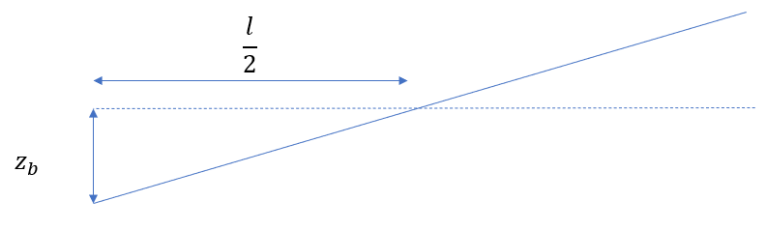

|  |
| --- |
| *Edited part*  *flow_timestep.F90*   par%metro_dzb=(-par%metro_omega*par%metro_amp1*sin(par%metro_omega*par%t-par%metro_phase1) &              -par%metro_omega2*par%metro_amp2*sin(par%metro_omega2*par%t-par%metro_phase2)) *par%dt |

1. ‘num_boundary_layer_water_level’ is used to imposed the boundary conditions (water level) directly on defined layers of cells near sea and river boundaries.

|  |
| --- |
| *Edited part*  *flow_timestep.F90*   s%zs(1:par%num_boundary_layer_water_level,1:s%ny+1) = s%zs01                           !*****----> Saeb        s%zs(s%nx-par%num_boundary_layer_water_level+1:s%nx+1,1:s%ny+1) = s%zs02 !s%zs0(1:2,:)            !*****----> Saeb |

1. ‘relaxtaion_parameter’ is added to consider relaxation for velocity

|  |
| --- |
| *Edited part*  *flow_timestep.F90*  do j=1,s%ny+1           do i=1,s%nx+1              !s%uu(i,j) = ((relaxtaion_parameter)*s%uu(i,j)) + ((1-relaxtaion_parameter)*uu_old(i,j)) !***** Saeb              s%uu(i,j) = ((par%relaxtaion_parameter)*s%uu(i,j)) + ((1-par%relaxtaion_parameter)*uu_previous_time_step(i,j)) !***** Saeb           end do        end do |

1. ‘dtset’ is added to limit maximum of time step

∆t=min(dtset, [](https://eu-prod.asyncgw.teams.microsoft.com/v1/objects/0-weu-d6-969dd2b4b6659229c8873541e569caaf/views/imgo)

|  |
| --- |
| *Edited part*  *timesteps.F90*  par%dt = min(par%dt, par%dtset)       !--->**** Saeb |

1. ‘reduced_velocity_activation’ and ‘reduced_velocity_activation’ are considered to reduce the velocity near sea and river boundaries virtually.

if (par%reduced_velocity_activation  == 1) then

      s%uu(1:par%num_boundary_layer_water_level,1:s%ny+1) =par%reduced_velocity_parameter_boundary_sea_river* s%uu(1:par%num_boundary_layer_water_level,1:s%ny+1)                !*****----> Saeb

      s%uu(s%nx-par%num_boundary_layer_water_level+1:s%nx+1,1:s%ny+1) = par%reduced_velocity_parameter_boundary_sea_river * s%uu(s%nx-par%num_boundary_layer_water_level+1:s%nx+1,1:s%ny+1)    !*****----> Saeb

      endif

1. required variables are defined

*params.def*

1. updating continuity equation by considering bed movement

regarding the XBeach document

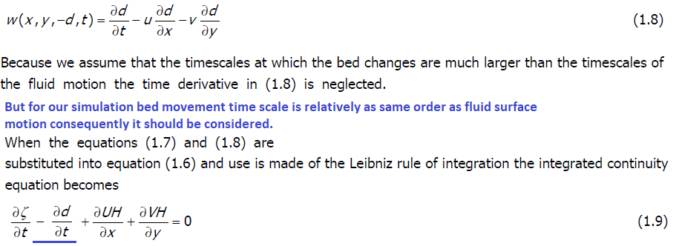

! Update water level using continuity eq.

!

metro_dzb_continuty=(par%metro_omega*par%metro_amp1*sin(par%metro_omega*par%t-par%metro_phase1) &

-par%metro_omega2*par%metro_amp2*sin(par%metro_omega2*par%t-par%metro_phase2))

 if (s%ny>0) then

   do j=jmin_zs,jmax_zs

     do i=imin_zs,imax_zs

      s%dzsdt(i,j) = (-1.d0)*( s%qx(i,j)*s%dnu(i,j)-s%qx(i1,j)*s%dnu(i-1,j)  &

                  + s%qy(i,j)*s%dsv(i,j)-s%qy(i,j-1)*s%dsv(i,j-1) )*s%dsdnzi(i,j) &

                  - s%infil(i,j) + s%rainfallrate(i,j)

d_zb_dt(i,j)=metro_dzb_continuty*(0.5d0*par%metro_basinlength-(s%xz(i,j)-s%xz(1,1)))/(0.5d0*par%metro_basinlength)     !*****----> Saeb

            end do

         end do

         s%zs(imin_zs:imax_zs,jmin_zs:jmax_zs) = s%zs(imin_zs:imax_zs,jmin_zs:jmax_zs) &

            + (s%dzsdt(imin_zs:imax_zs,jmin_zs:jmax_zs)*par%dt) - (d_zb_dt(imin_zs:imax_zs,jmin_zs:jmax_zs)*par%dt)

      else

         j=1

         do i=imin_zs,imax_zs

            s%dzsdt(i,j) = (-1.d0)*( s%qx(i,j)*s%dnu(i,j)-s%qx(i-1,j)*s%dnu(i-1,j) )*s%dsdnzi(i,j) &

               - s%infil(i,j) + s%rainfallrate(i,j)

            d_zb_dt(i,j)=metro_dzb_continuty*(0.5d0*par%metro_basinlength-(s%xz(i,j)-s%xz(1,1)))/(0.5d0*par%metro_basinlength)     !*****----> Saeb

         end do

         s%zs(imin_zs:imax_zs,1) = s%zs(imin_zs:imax_zs,1)+(s%dzsdt(imin_zs:imax_zs,1)*par%dt) - (d_zb_dt(imin_zs:imax_zs,1)*par%dt)

      endif !s%ny>0

**User adjustments**

By using the following keywords in *params.txt* file, we could activate or deactivate the corresponding modification

* *num_boundary_layer_water_level*, range 0 to 99

It defines the number of cell layers in sea and river side boundaries to impose water level directly.

If it sets 0, this option is deactivated.

* *reduced_velocity_parameter_boundary_sea_river*, range 0 to 1

$$u_{x sea/river}= reduced_velocity_parameter_boundary_sea_river *u_{x sea/river}$$

virtually reduces the velocity at sea and river sides. It is an option to consider reservoir effect.

The keyword for activating this option is *reduced_velocity_activation*. *reduced_velocity_activation* =0 deactivate and *reduced_velocity_activation* =1 activate this option.

* *relaxation_parameter,* range 0 to 1

It relaxes the velocity all over the geometry

$u_{x}^{n+1}= (1-relaxation_parameter ) {* u}_{x}^{n}$ + $(relaxation_parameter ) {* u}_{x}^{n+1}$

$u_{x}^{n+1}$ is current time step velocity and ${ u}_{x}^{n}$ is the previous time step velocity

* *reduced_velocity_activation*, range (0 or 1)

activate or deactivate *reduced_velocity_parameter_boundary_sea_river*

*reduced_velocity_activation* =0 deactivate and *reduced_velocity_activation* =1 activate this option.

* *zs_updating_with_zb_activation*, range (0 or 1)

it activates or deactivates water level updating with bed level moving.

*zs_updating_with_zb_activation* = 1 consider updating water surface by bed movement (Dano approach), *zs_updating_with_zb_activation* = 0 ignore the mentioned updating.

* *vy_zero_boundary_sea_river_activation*, range (0 or 1)

*vy_zero_boundary_sea_river_activation* =1, y velocity direction zero at *num_boundary_layer_water_level*-th cells of sea and river side boundaries.

* *countinuty_with_Dzb_activation*, range (0 or 1)

*countinuty_with_Dzb_activation* =1 consider bed motion derivatives in time in continuity equation as

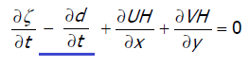

*countinuty_with_Dzb_activation* =0 ignore bed motion derivatives in time in continuity equation

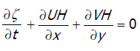

* *zero_gradient_u_activation,*

*zero_gradient_u_activation* =1 set zero gradient for velocity in x direction at sea and river boundaries. *zero_gradient_u_activation* = 0 deactivates this option.

$$u_{x }(last_row_of_cells,:)= u_{x }(last_row_of_cells-1,:)$$

$$u_{x }(first_row_of_cells,:)= u_{x }(lfirst_row_of_cells+1,:)$$

* *impicit_iteration_threshold* range (0,1,2,3,…)

number of iterations for correction-solution continuity and momentum equations inside each time step. It implements implicit simulation based on Gauss-Seidel method.

if *impicit_iteration_threshold* = 0 it converts to explicit approach.

* *Dirichlet_water_level_activation* range (0 or 1)

*Dirichlet_water_level_activation =1,* activate imposing the water level time series boundary conditions

* *water_level_loc_file* defines the location of boundary to impose water level boundary condition. It works as same as *disch_loc_file*
* *water_level_timeseries_file* defines time series of water level at boundaries. It works as same as *disch_timeseries_file.*
* *num_boundary_layer_water_level = 1.* Number of layers of mesh to impose water level boundary conditions. It should be set 1 at least to involve imposed boundary conditions in solving continuity and momentum equation.