**SimpleWebService**

* **Summary**

A simple web Service that uses RESTful API to manage a DB of Customers, Factories and Groups

The service is built with the following technologies:

WebAPI in ASP.NET 6.0,

Entity Framework Core 7.0.1

LINQ

Swagger UI

* **Software requirements:**
  + SQL Server.
  + DOT NET 6.0,
  + **For Debugging:**

Visual Studio 2022 is required.

When installing VS 2022, make sure you include the workloads in the installation (as in the screenshot below – the marked one):

* + - ASP.NET and web development

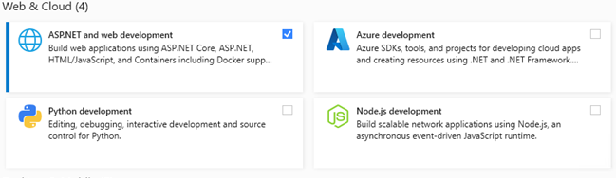

* **Configuration**
  + DB Connection string:

Found in **appsettings.json** file under the solution’s project folder.

Here: “MyDBConnection”, as in the screenshot:

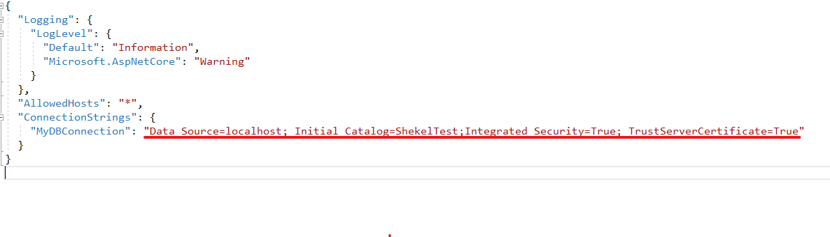

* **DB initialization**

Run “DBInit.sql” under the solution folder to initialize an empty DB for the service to work

* **API Methods:**

Currently, the following API Entities are supported (in the screenshot below), under each one listed its supported methods

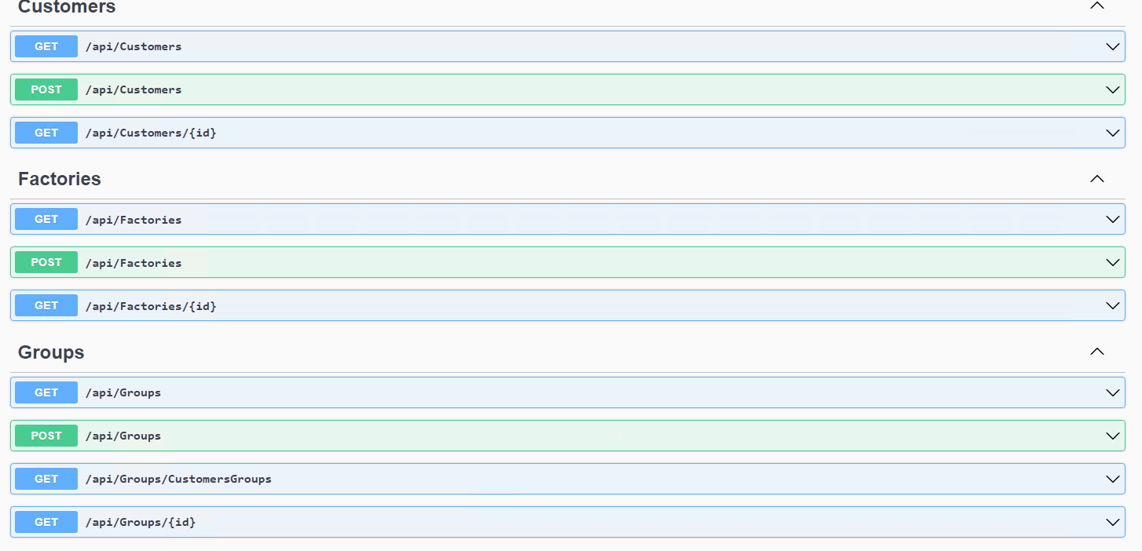

All operations above are standard operations, **except for the following:**

* + POST /api/Customers:
    - In addition to the customer object, the operation requires group code and customer code (how to obtain an example for each API call is described in the **Testing with VS Debugger** section)
  + GET /api/Groups/CustomersGroups
    - Returns a list of all groups, under each group also returned are its associated customers
* **Testing with VS 2022 Debugger:**

Since the app uses Swagger UI, it’s intuitive to use,

Simply start the app from VS, wait until the web browser opens and the main page loads, click on any API operation desired, such as:



The bar expands to something like this:

It shows an example request body and a “Try it out button”, click the button, this appears:

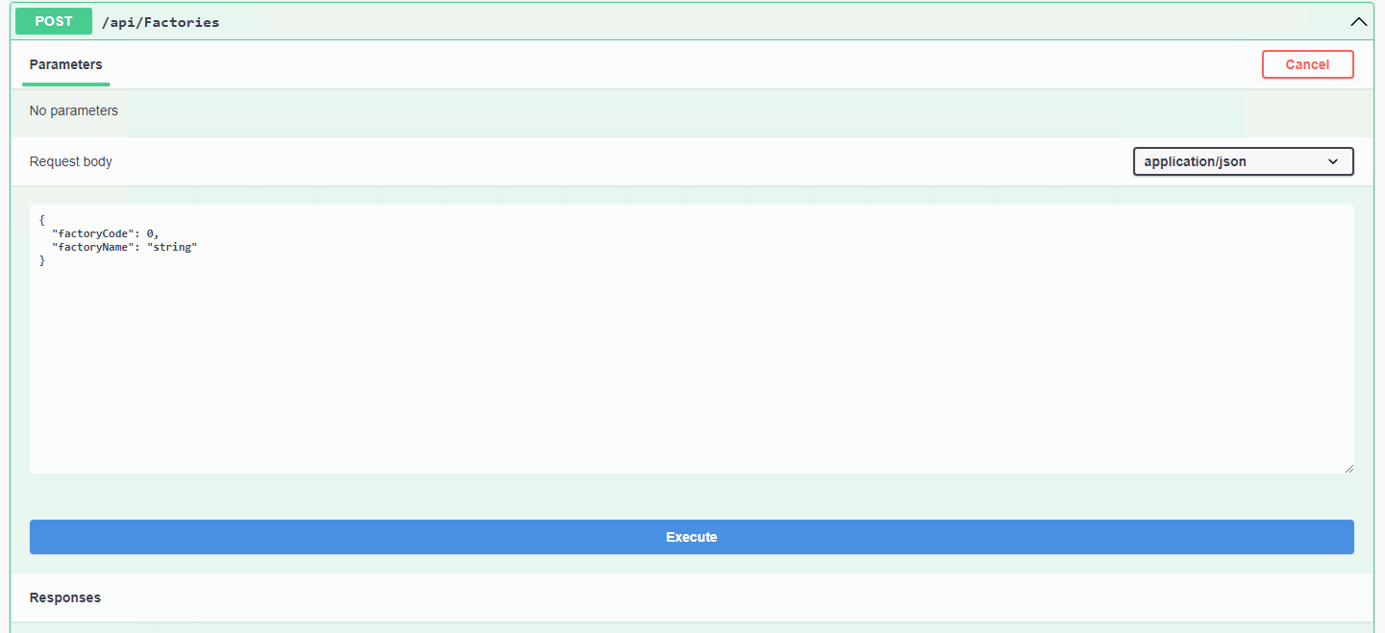

edit the request body by following the example body, then click **Execute**

the response shows underneath the “Responses” section.