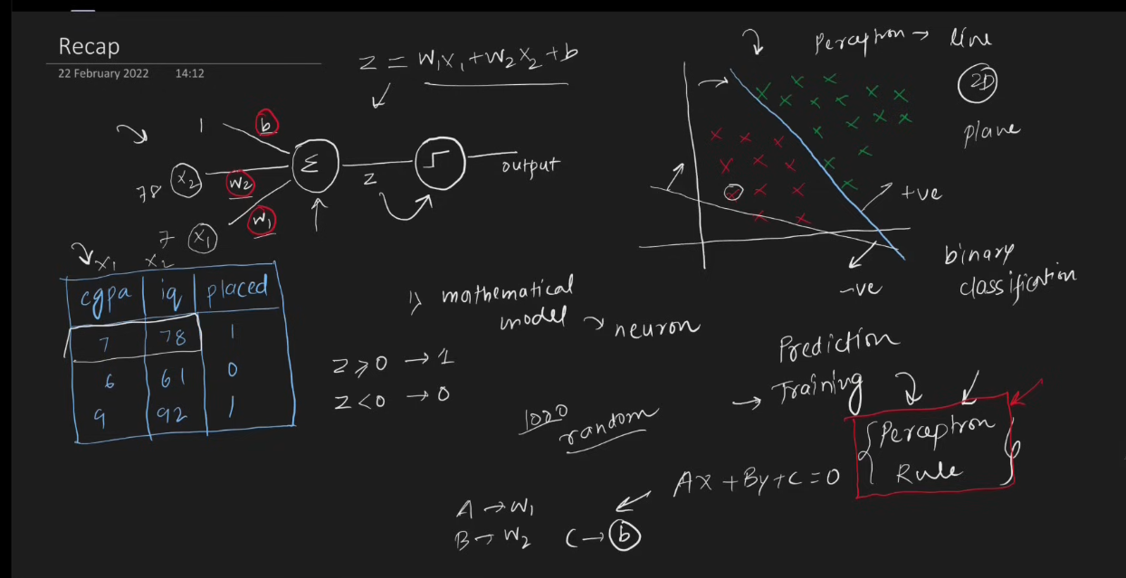
Perceptron loss function :

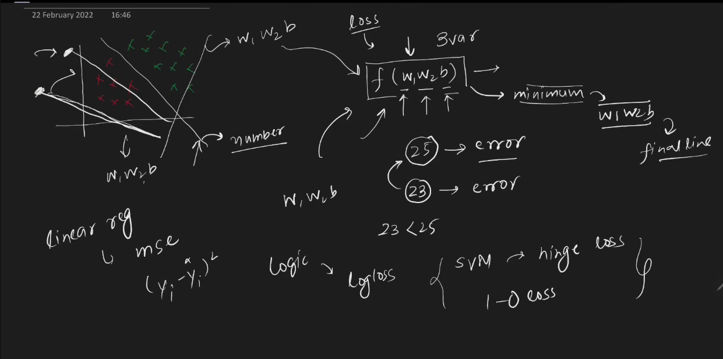

Core Optimization Framework
The central diagram illustrates how machine learning algorithms find the best decision boundary.
- Parameters: The model takes weights and bias (\(w_1, w_2, b\)) as inputs (3 variables).
- Objective: These parameters feed into a loss function \(f(w_1, w_2, b)\) to compute an error value (e.g., comparing an error of \(25\) vs. \(23\)).
- Optimization: The goal is to minimize this loss function (\(23 < 25\)).
- Output: Finding the absolute minimum loss yields the optimal parameters (\(w_1, w_2, b\)), defining the final line (decision boundary).
📈 Geometric Classification
The plot in the top-left visualizes a binary classification problem in a 2D space.
- Data Points: Green plus signs (\(+\)) represent one class, and red cross signs (\(\times \)) represent the other class.
- Candidate Lines: Multiple straight lines governed by \(w_1, w_2, b\) are drawn across the data.
- Evaluation: Each line outputs a specific number (loss/error score) indicating how poorly or accurately it separates the two classes.
🧮 Loss Functions by Algorithm
The bottom section categorizes different machine learning algorithms by their respective loss functions:
- Linear Regression
  - Uses Mean Squared Error (mse).
  - Formula written: \((y_i - \hat{y}_i)^2\).
- Logistic Regression (Logic)
  - Uses Cross-Entropy Loss (logloss).
- Support Vector Machines (SVM)
  - Uses hinge loss.
  - Also associated with 1-0 loss (misclassification error).

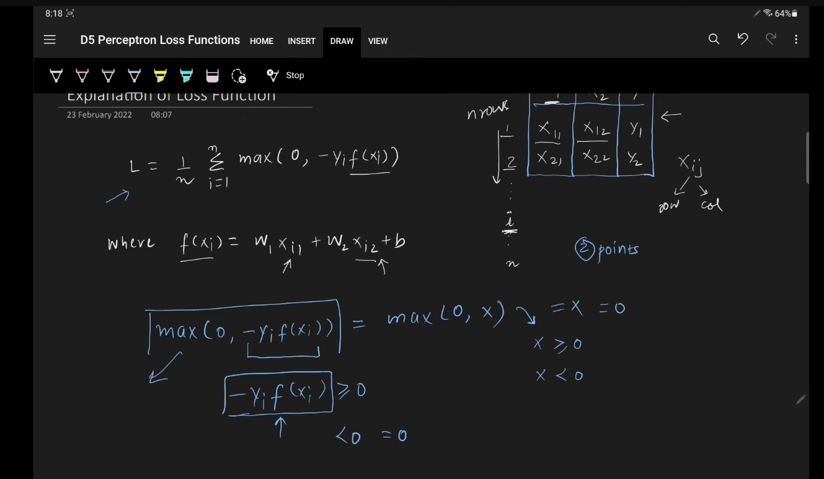
Perceptron Loss Function Overview
The image explains the Perceptron Loss Function, which measures the error of a Perceptron model across a dataset of \(n\) samples.

Key Formulas
- Total Loss (\(L\)):
\(L=\frac{1}{n}\sum _{i=1}^{n}\max (0,-y_{i}f(x_{i}))\)
This calculates the average loss across all \(n\) data points.
- Model Prediction (\(f(x_i)\)):
\(f(x_{i})=w_{1}x_{i1}+w_{2}x_{i2}+b\)
  - \(x_{i1}, x_{i2}\): Features of the \(i\)-th data point (row \(i\) in the matrix).
  - \(w_1, w_2\): Weights assigned to features.
  - \(b\): Bias term.

How the Hinge-like Loss Works
The term \(\max(0, -y_i f(x_i))\) determines the penalty for a single data point based on the sign of \(-y_i f(x_i)\):
- Correct Classification:
  - \(y_{i}\) and \(f(x_i)\) have the same sign (both positive or both negative).
  - Their product \(y_i f(x_i)\) is positive, making \(-y_i f(x_i)\) negative (\(<0\)).
  - \(\max(0, \text{negative}) = 0\).
  - Result: Zero loss for correct predictions.
- Incorrect Classification:
  - \(y_{i}\) and \(f(x_i)\) have opposite signs.
  - Their product \(y_i f(x_i)\) is negative, making \(-y_i f(x_i)\) positive (\(\ge 0\)).
  - \(\max(0, \text{positive}) = -y_i f(x_i)\).
  - Result: A positive loss value proportional to how wrong the prediction is.

