# **Key: Chris, ZOE, HOLIDAY, RYAN, MOE**

# **3. EVALUATION**

This section of the document details the tests designed to ensure the success of GAS’s subsystems. In addition, results for each of the tests are reported. Table 3 lists the technical design constraints that govern each of the tests.

**Table 3. Technical Design Constraints**

|  |  |
| --- | --- |
| **Name** | **Description** |
| Battery Life | GAS has a battery life that lasts a minimum of one hour. |
| Waist Size/Ankle Size | The belt portion of GAS is adjustable and 91.0 to 111 centimeters long, while the ankle bracelets are adjustable and 19.7 to 24.0 centimeters long apiece. |
| Measurement Frequency | GAS achieves a measurement frequency of at least 115 measurements per minute. |
| Measurement Accuracy | Displayed data values on the app are within ±5 % of the actual values. |
| Memory Storage | The belt’s memory storage holds at least an hour’s worth of data. |

To comply with the above constraints listed in Table 3, each component of the subsystems is tested individually to guarantee success once each subsystem is integrated into the overall design. Since the course objective is to achieve functionality at the subsystem level, the overall hardware construction was temporarily modified for testing purposes. For this evaluation, each subsystem includes an Arduino and battery connection.

**3.1 Test Certification – General Sensor Testing**

It is critical that both the PIR and ultrasonic sensors record accurate data. To ensure the proper functionality of both types of sensors, general testing was performed on each. The general testing of each sensor involves determining how each sensor works indoors and in direct sunlight upon contact of clothing and skin. It is also important to note that each sensor must work within the labelled angle values listed on its data sheet. A pre-determined set of range values is used for each test to make sure that both types of sensors can operate under the necessary conditions in order to be viable for use in GAS.

**3.1.1 Test Certification – PIR Sensor Testing**

Table 3.1 outlines the tests performed to determine how well the SEN-13968 PIR sensor functions. This PIR sensor returns a digital output, meaning that a ‘1’ will be returned if an object is detected. On the other hand, if the PIR sensor is unable to detect an object, it will return a ‘0.’ The functionality of the PIR sensor is verified by ensuring that the variable in the Arduino code that represents the PIR’s status, pirStat, is the proper output during experimentation. This condition was verified through Arduino’s Serial Monitor. Tests have been performed in different environments (indoors and direct sunlight) and have included results for different clothing that the user may wear during walking sessions.

**Table 3.1 PIR Sensor Tests**

|  |  |  |  |  |  |
| --- | --- | --- | --- | --- | --- |
| **Test Type** | **Angle from Normal Direction of Sensor (°)** | **Requirements** | **Distance from Sensor (cm)** | **Results**  **(pirStat)** | **Pass/Fail** |
| Sunlight/ Clothing | 0, 60 | Must be able to detect clothing in direct sunlight (pirStat ==1) | 1 | 1, 1 | Pass |
| 10 | 1, 1 | Pass |
| 50 | 1, 1 | Pass |
| 100 | 1, 1 | Pass |
| 500 | 0, 0 | Fail |
| Sunlight/ Bare Skin | 0, 60 | Must be able to detect bare skin in direct sunlight (pirStat ==1) | 1 | 1, 1 | Pass |
| 10 | 1, 1 | Pass |
| 50 | 1, 1 | Pass |
| 100 | 1, 1 | Pass |
| 500 | 0, 0 | Fail |
| Indoors/ Clothing | 0, 60 | Must be able to detect clothing indoors (pirStat ==1) | 1 | 1, 1 | Pass |
| 10 | 1, 1 | Pass |
| 50 | 1, 1 | Pass |
| 100 | 1, 0 | Pass, Fail |
| 500 | 0, 0 | Fail, Fail |
| Indoors/Bare Skin | 0, 60 | Must be able to detect bare skin indoors (pirStat ==1) | 1 | 1, 1 | Pass |
| 10 | 1, 1 | Pass |
| 50 | 1, 1 | Pass |
| 100 | 1, 0 | Pass, Fail |
| 500 | 0, 0 | Fail, Fail |

Four separate tests of five different distances were conducted for the normal and edge cases of the PIR sensor. The normal case for the PIR sensor is that the sensor detects movement perpendicular to the direction that it is facing, while the edge case for the PIR sensor is that the sensor detects movement on the outer bound of the measuring angle (60**°** from the normal angle) [1]. The four tests involved studying how the PIR sensor detects clothing in sunlight, bare skin in sunlight, clothing indoors, and bare skin indoors. Each test was conducted for the following measurements: 1 cm, 10 cm, 50 cm, 100 cm, and 500 cm. The 1 cm, 10 cm, and 50 cm values were tested since they encompass the average step width as well as uncommonly narrow and wide step widths [2]. The 100 cm and 500 cm values were tested since they are in the range of possible distant objects from the user. From Table 3.1, the PIR sensor seems to not be significantly impacted by its environment. Overall, the PIR sensor works slightly better in sunlight than indoors. In sunlight, the 500 cm distance is the only test that the PIR sensor fails. On the other hand, the PIR sensors failed the indoor 500 cm distance and the edge case for the 100 cm tests. However, it is important to note that these test failures are not significant since the PIR sensor works as intended for relatively short distances. This means that the PIR sensor does not have trouble detecting the user’s arm and leg motions. At the same time, the outer PIR sensors on each ankle bracelet can still detect motion near the user that could possibly interfere with the device. Also, it is necessary to mention that PIR sensors detect clothing and bare skin in the same fashion, which helps confirm that GAS is usable with different types of clothing. Finally, not included in Table 3.1 are the upper limit values for the PIR sensor. The PIR sensor can detect small movements (hand waving, arm swings, leg swings, etc.) up to 163 cm away indoors and 261 cm away in sunlight and large movements (entire person moving, large object moving, etc.) up to 272 cm indoors and 587 cm in sunlight. It is imperative that the PIR sensors work as intended. Figure 3.1 shows an oscilloscope output of the voltage and current across a single PIR sensor.

*Insert image here*

**Figure 3.1 PIR Oscilloscope Output**

Figure 3.1 discussion.

**3.1.2 Test Certification – Ultrasonic Sensor Testing**

Table 3.2 outlines the tests performed on the HC-SR04 ultrasonic sensor. The ultrasonic sensor returns an analog value to the Arduino of the distance it measured. The range of the HC-SR04 is 2 cm to 400 cm; therefore, the sensor should not report an output for any value less than 2 cm or greater than 400 cm. Since the average step width is 7.7 to 10 cm [2], this range constraint is not an issue. Since it is impossible for any individual to have a step width of over 400 cm, any time when an error is thrown, there is no feedback, or there is a relatively large value means that the user’s step width is less than 2 cm. The functionality of the ultrasonic sensor was tested by using Arduino’s Serial Monitor and using measuring tape to confirm the output.

**Table 3.2 Ultrasonic Sensor Tests**

|  |  |  |  |  |
| --- | --- | --- | --- | --- |
| **Actual Distance (cm)** | **Requirements (cm)** | **Returned Distance (cm)** | **Percent Error** | **Pass/Fail** |
| 1 | Throw Error/No Feedback/ Large Value | 1190 | N/A | Pass |
| 2 | 2 | 2.06 | 3.00% | Pass |
| 7.7 | 7.7 | 7.91 | 2.73% | Pass |
| 10 | 10 | 10.10 | 1.00% | Pass |
| 20 | 20 | 19.62 | 1.90% | Pass |
| 100 | 100 | 98.60 | 1.40% | Pass |
| 400 | 400 | 1190 | 198% | Fail |

From Table 3.2, it is apparent that all the tests passed except for the 400 cm test. This test failure is insignificant since no user can have a step width of 400 cm. The ultrasonic sensor passed for every other test due to the fact that there was less than 5 % error for each measurement. For the 1 cm test, the ultrasonic sensor returned a value of 1190 cm, which appears to be the largest value that the ultrasonic sensor can output. If, for some reason, the user has a step width of less than 2 cm, then the Arduino software will make a note of the large returned value and record a value of 1 cm instead. Figure 3.2 shows an oscilloscope output of the voltage and current across the ultrasonic sensor to further confirm that the ultrasonic sensor works as intended.

*Insert image here*

**Figure 3.2 PIR Oscilloscope Output**

Figure 3.2 discussion.

## **3.2 Test Certification – Belt Subsystem**

GAS incorporates a belt to record important measurements involving the user’s arm-swinging patterns. For the purposes of this subsection of the evaluation, the prototype belt subsystem only includes an Arduino and two PIR sensors. The first test conducted is a measurement accuracy test that shows that the PIR sensors are accurately reading the arm swings. The goal for these measurement accuracy tests is to guarantee that the device works within the intended accuracy range of ±5 %. In addition, the sensors should output exactly which arm is swinging at a given time, along with the total time for each set of movements. This total time contains important information, as it is useful for determining the length of the patient’s walking session. Finally, the last test ensures that the belt size is adjustable. Figure 3.3 shows a rough prototype of the belt subsystem.

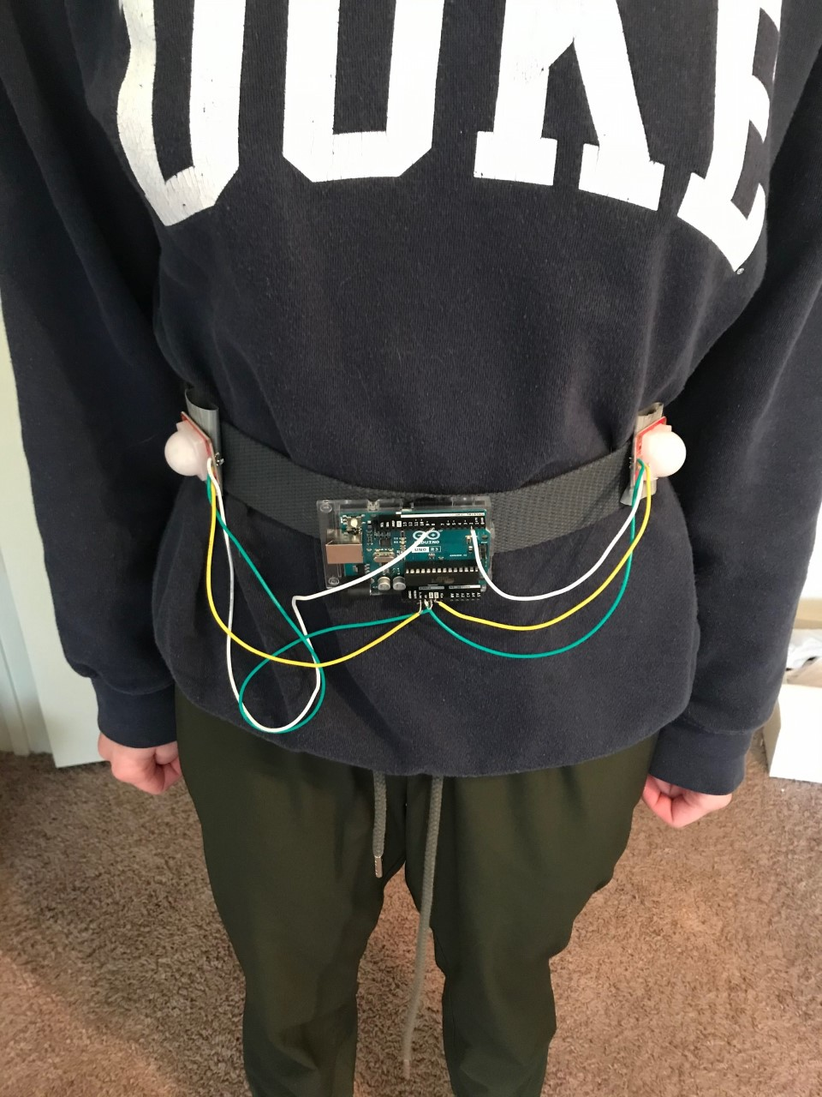

**Figure 3.3 Belt Subsystem Rough Prototype**

PIR sensors are attached near the hips, as shown by Figure 3.3. These sensors, based on their location, capture all arm-swinging patterns.

**3.2.1 Test Certification – Measurement Frequency and Accuracy Tests**

The PIR sensors on the belt must be able to accurately output the number of arm swings that the user completes with each arm as well as the time elapsed for each set of measurements. Table 3.3 details the measurements taken to confirm that the belt’s PIR sensors met this standard.

**Table 3.3 Belt Measurement Tests**

|  |  |  |  |  |  |  |  |
| --- | --- | --- | --- | --- | --- | --- | --- |
| **Type of Test** | **Actual Number of Arm Swings** | **Actual Total Time (sec)** | **Measured Number of Arm Swings** | **Measured Total Time (sec)** | **Percent Error for Time per Arm Swing** | **Percent Error for Number of Arm Swings** | **Pass/Fail** |
| Right Arm | 5 | 9.340 | 5 | 9.359 | 0.203% | 0.00% | Pass |
| 10 | 12.480 | 10 | 12.592 | 0.897% | 0.00% | Pass |
| 15 | 19.590 | 15 | 20.303 | 3.64% | 0.00% | Pass |
| Left Arm | 5 | 5.970 | 5 | 6.178 | 3.48% | 0.00% | Pass |
| 10 | 12.260 | 10 | 12.841 | 4.74% | 0.00% | Pass |
| 15 | 18.960 | 15 | 19.470 | 2.69% | 0.00% | Pass |
| Right, Left Arms | 5, 5 | 11.05, 9.87 | 5, 5 | 11.527, 10.198 | 4.32%, 3.32% | 0.00%, 0.00% | Pass |
| 10, 10 | 23.460, 25.90 | 10, 10 | 24.236, 26.227 | 3.31%, 1.26% | 0.00%, 0.00% | Pass |
| 15, 15 | 39.910, 39.300 | 15, 15 | 41.574, 40.073 | 4.17%, 1.97% | 0.00%, 0.00% | Pass |

For Table 3.3, three types of tests were conducted for three different arm swing values. The three types of tests were the right arm test, the left arm test, and the right and left arm test (alternating which arm is swinging). Each of these tests were conducted for 5, 10, and 15 arm swings. A stopwatch app was used to provide the actual total time for each test, while the actual number of arm swings was counted manually. The Arduino code provided an output for when each arm swing was detected, the elapsed time for each set of arm swings, and how many arm swings had been detected in total. All measurements captured by the code were displayed in Arduino’s Serial Monitor. The actual total time recorded by the stopwatch was compared to the total time measured by the Arduino built-in timer (millis()) in order to calculate the percent error for the time per arm swing. The actual number of arm swings was compared to the number of arm swings measured by the subsystem in order to calculate the percent error for the number of arm swings. In conclusion, the subsystem measured the total number of arm swings with 0.00% error and the time per arm swing with less than 5.00% error. Due to these percent error values, every test passed, demonstrating that the belt subsystem maintained a high accuracy.

**3.2.2 Test Certification – Adjustability**

According to the technical design constraints, it is necessary that the belt is adjustable and is at least 91.0 to 111 centimeters long. The belt that is used in GAS’s prototype belt subsystem is 46 inches long (117 centimeters) and adjustable. Therefore, GAS’s belt subsystem can accommodate a variety of waist sizes.

## **3.3 Test Certification – Left Ankle Bracelet Subsystem**

GAS uses two ankle bracelets to take measurements while the user is walking. This section details the tests and results for the left ankle bracelet subsystem, which includes an Arduino, battery pack, and two PIR sensors. The tests found in this section include a measurement frequency and accuracy test for both the inner and outer PIR sensors as well as an adjustability test. Figure 3.4 demonstrates a rough prototype for the left ankle bracelet.

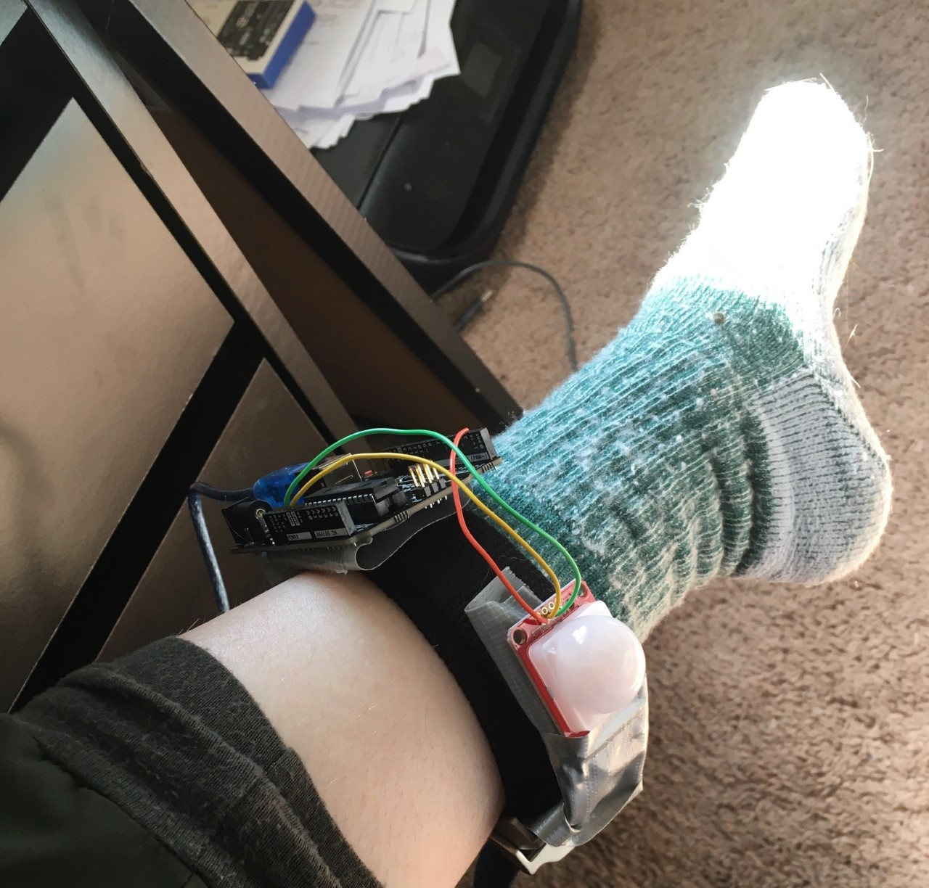

**Figure 3.4 Left Ankle Rough Prototype**

For prototyping purposes, the PIR sensors were attached to the fabric of the left ankle bracelet using duct tape as seen in Figure 3.4; however, the final prototype will consist of the PIR sensors with a Velcro backs and several pieces of Velcro where the PIR sensors can be attached, thus allowing the ankle bracelet to adapt to users’ different ankle sizes.

**3.3.1 Test Certification – Inner PIR Sensor**

The first set of tests involves a measurement frequency test to determine whether GAS can accommodate a walking pace of 115 steps per minute at a minimum [3]. The inner PIR sensor is responsible for conducting these measurements. Table 3.4 documents the measurements taken to confirm that the inner PIR sensor met this standard. Each test was conducted by measuring the number steps over the course of a minute, using a metronome app to pace the steps accordingly.

**Table 3.4 Inner PIR Sensor Tests**

|  |  |  |  |
| --- | --- | --- | --- |
| **Actual Step Speed (Steps/Minute)** | **Measured Step Speed (Steps/Minute)** | **Percent Error** | **Pass/Fail** |
| 60 | N/A | N/A | N/A |
| 75 | N/A | N/A | N/A |
| 90 | N/A | N/A | N/A |
| 110 | N/A | N/A | N/A |
| 115 | N/A | N/A | N/A |
| 120 | N/A | N/A | N/A |

*TBD: Discussion about Table 3.4*

**3.3.2. Test Certification – Outer PIR Sensor**

The outer PIR sensor of the left ankle bracelet is meant to detect other people, animals, or objects to the left of the user. If the outer PIR sensor detects any of these things, then it should raise a flag that tells the device to not record data. Table 3.5 details the measurements taken to confirm whether certain objects were detected at specified ranges.

**Table 3.5 Outer PIR Sensor Tests**

|  |  |  |  |
| --- | --- | --- | --- |
| **Object** | **Range (cm)** | **Flag Raised (Yes/No)** | **Pass/Fail** |
| Person | 1 | Yes | Pass |
| 10 | Yes | Pass |
| 50 | Yes | Pass |
| 100 | Yes | Pass |
| Cat | 1 | Yes | Pass |
| 10 | Yes | Pass |
| 50 | Yes | Pass |
| 100 | Yes | Pass |
| Car | 30 | Yes | Pass |
| 60 | Yes | Pass |
| 100 | Yes | Pass |
| 200 | Yes | Pass |

For safety purposes, the car tests were conducted with the car in a stationary position. Table 3.5 demonstrates that the outer PIR sensor can account for different nearby objects and raises a flag for each. This is important because encountering different objects, such as a nearby person, can cause the PIR sensors to record data for these objects, thus invalidating the acquired data.

**3.3.3 Test Certification – Adjustability**

According to the technical design constraints, it is necessary that the left ankle bracelet is adjustable and is at least 19.7 centimeters to 24.0 centimeters long. An adjustable belt that is 32 inches long (81 centimeters) is used in GAS’s prototype left ankle bracelet subsystem.

**3.4 Test Certification – Right Ankle Bracelet Subsystem**

The right ankle bracelet subsystem is similar to the left ankle bracelet; however, this subsystem includes only one outer PIR sensor and an inner ultrasonic sensor. The tests in this section also cover a measurement frequency and accuracy test as well as an adjustability test.

**3.4.1 Test Certification – Inner Ultrasonic Sensor**

The inner ultrasonic sensor must take a measurement only when the user’s legs are in a parallel position. Furthermore, for each measurement, the ultrasonic sensor must have an accuracy range of ±5 %. Table 3.6 documents tests for the ultrasonic sensor that determine whether the sensor takes only 1 measurement whenever the user’s legs are in parallel.

**Table 3.6 Inner Ultrasonic Sensor**

|  |  |  |  |  |  |
| --- | --- | --- | --- | --- | --- |
| **Actual Distance (cm)** | **Expected Number of Measurements** | **Measured Distance (cm)** | **Actual Number of Measurements** | **Percent Error for Distance** | **Pass/Fail** |
| 4 | 1 | 3.91 | 1 | 2.25% | Pass |
| 8 | 1 | 8.21 | 1 | 2.63% | Pass |
| 12 | 1 | 11.95 | 1 | 0.417% | Pass |

Table 3.6 confirms that the ultrasonic sensor can interact with the PIR sensor by taking only one measurement when motion is detected. It is important to only take one distance measurement per step in order to maintain overall accuracy.

**3.4.2. Test Certification – Outer PIR Sensor**

The outer PIR sensor of the right ankle bracelet is meant to detect other people, animals, or objects to the right of the user. If the outer PIR sensor detects any of these things, then it should raise a flag that tells the device to not record data. Since the outer PIR sensors on both ankle bracelets perform the same function and run the same code, it is unnecessary to repeat the same set of tests. Information regarding the outer PIR sensors’ performance is in Table 3.5.

**3.4.3 Test Certification – Adjustability**

According to the technical design constraints, it is necessary that the right ankle bracelet is adjustable and is at least 19.7 centimeters to 24.0 centimeters long. An adjustable belt that is 32 inches long (81 centimeters) is used in GAS’s prototype right ankle bracelet subsystem.

**3.5 Test Certification – Portability Test**

In order to satisfy the physical design constraint of GAS weighing no more than 2.3 kilograms, a portability test is necessary to determine the sum of the weights of each subsystem. In Table 3.7, each subsystem has been broken down into its wearable components of non-negligible weight so that the total weight of GAS can be calculated.

**Table 3.7 Component Weight**

|  |  |  |  |
| --- | --- | --- | --- |
| **Component** | **Component Weight (g)** | **Number of Components** | **Total Weight (g)** |
| PIR sensor | 5 | 5 | 25 |
| Ultrasonic sensor | 8 | 1 | 8 |
| Ankle bracelet | 121 | 2 | 242 |
| Belt | 94 | 1 | 94 |
| Arduino | 39 | 1 | 39 |
| Battery | 46 | 1 | 46 |
| Memory Chip | 9 | 1 | 9 |
| **Total** |  |  | **463** |

The weight values listed in Table 3.7 were measured by placing each component on a scale and recording the displayed value. Overall, the device weighs 463 grams or 0.463 kilograms. This total weight is less than the 2.3-kilogram requirement; therefore, the device passes the portability test.

**3.6 Test Certification – Battery Life Test**

According to the technical design constraints, GAS’s battery life must last at least for 1 hour. From the Approach section of this document, the expected battery life of GAS with the 6LR61 battery is approximately 4 hours and 22 minutes. While it is not necessary for the battery life to last 4 hours and 22 minutes, this time limit provides an expected battery life value. The test recorded in Table 3.8 ensures that GAS meets the 1-hour standard set by the technical design constraints.

**Table 3.8 Battery Life**

|  |  |  |  |
| --- | --- | --- | --- |
| **Requirement** | **Expected Value** | **Actual Value** | **Pass/Fail** |
| 1 hour | 4 hours 22 minutes | N/A | N/A |

*TBD: Table 3.8 discussion*

**3.6 Test Certification – LED Protocol Test**

To notify the user about GAS’s operation and state, the belt harbors two LEDs. The first LED designates the technical condition of the entire system and illuminates red if the battery is low, memory is full, and/or the sensors are inoperable. The second LED showcases the system’s operating condition and is green for the following conditions: GAS is recording, GAS is initializing, GAS is uploading data, or GAS is connecting to a USB. The following table describes the state of the LEDs within their respective conditions.

**Table 3.9 LED Protocols**

|  |  |  |  |  |
| --- | --- | --- | --- | --- |
| **LED Type** | **Color** | **Protocol** | **Behavior** | **Satisfactory** |
| Technical | Red | Low battery | Blink twice every two seconds | N/A |
| Technical | Red | Full memory | Blink five times every two seconds | N/A |
| Technical | Red | Sensors inoperable | Blink slowly continuously | N/A |
| Operational | Green | Sensors recording | On continuously | Yes |
| Operational | Green | Sensors not recording | Off continuously | Yes |
| Operational | Green | Uploading data | Blink LED Quickly | N/A |
| Operational | Green | USB connected | Blink LED slowly | N/A |

*TBD: Table 3.9 discussion*

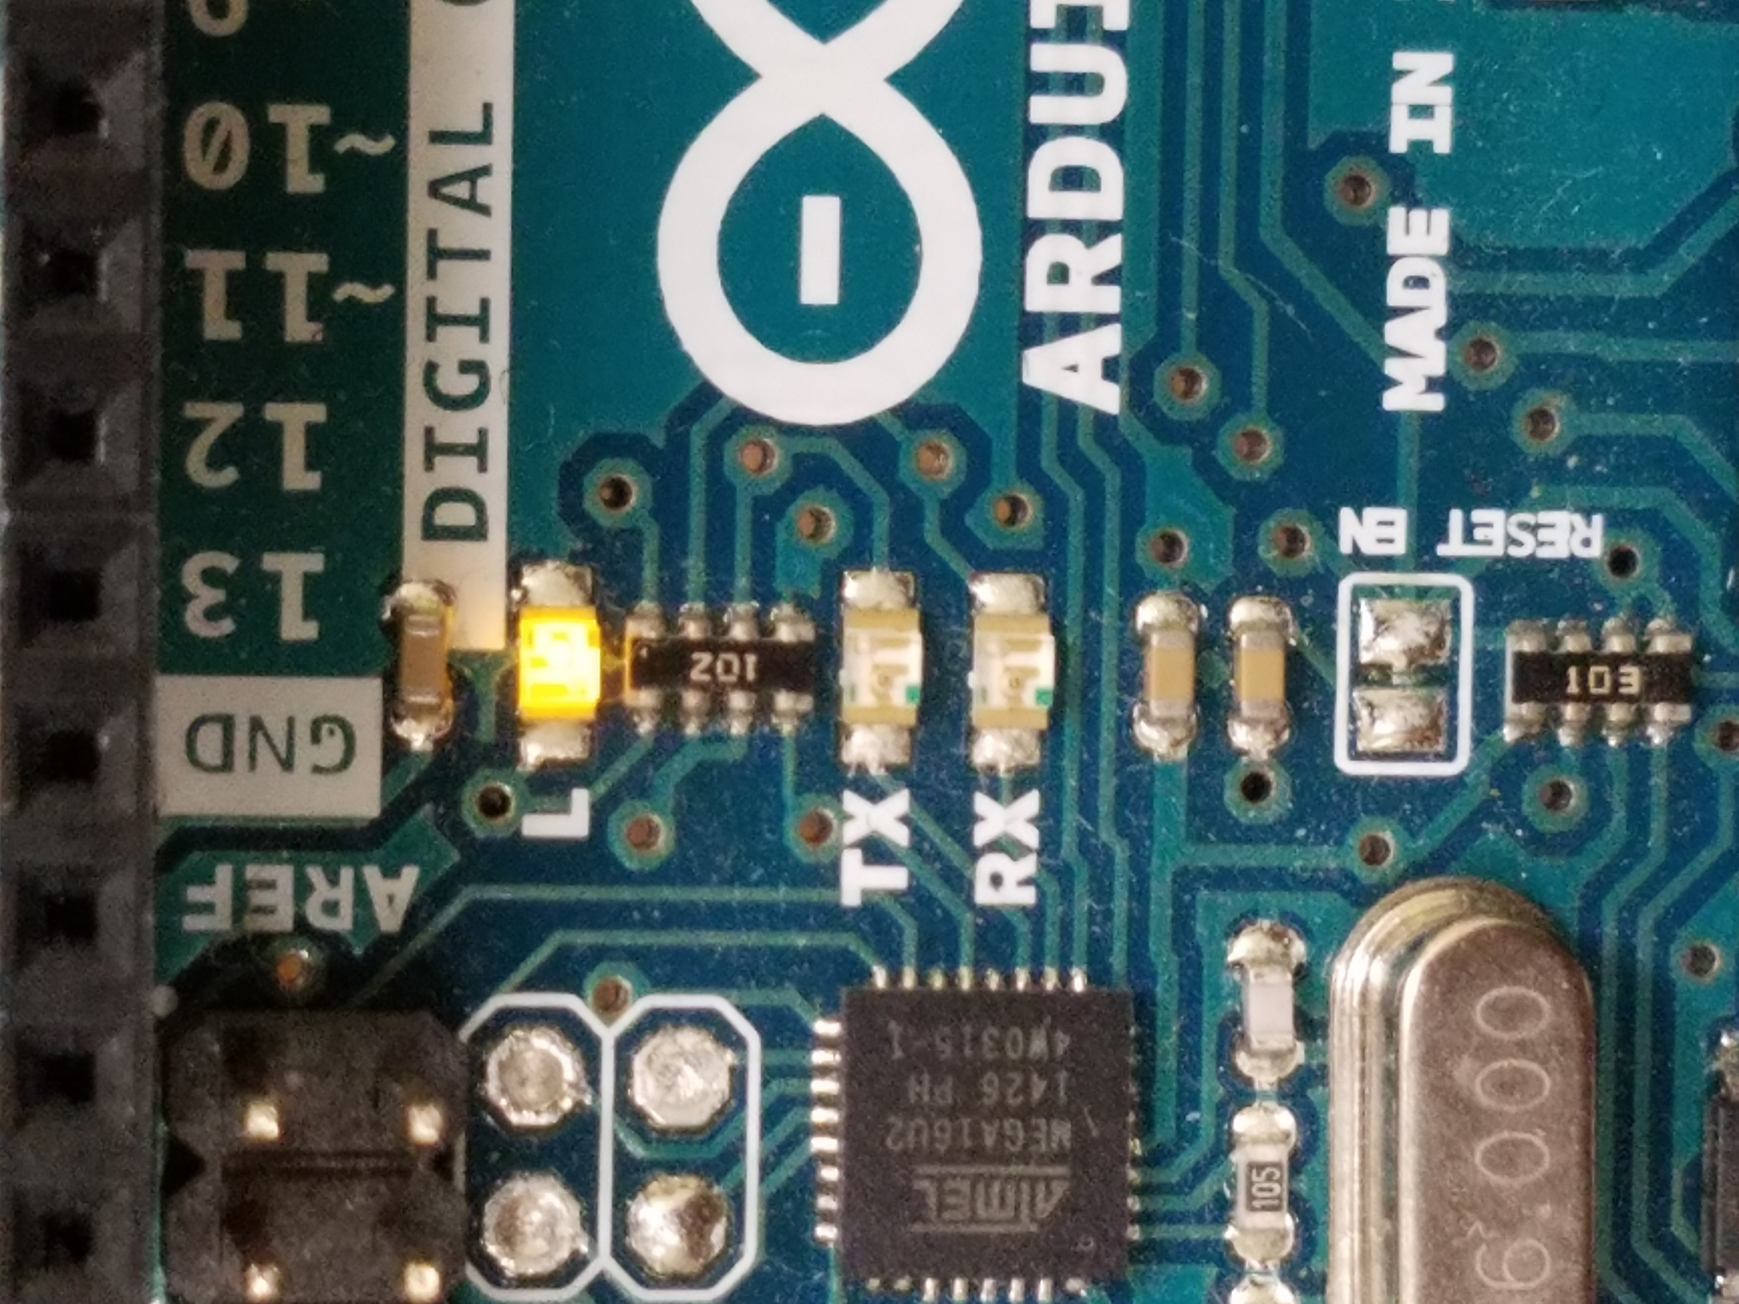

**Figure 3.5 - LED ON Continuously**

*TBD: More LED discussion. Above image will be replaced with the actual LEDs intended for the design!*

## **3.7 Test Certification – User Interface**

This section shows the user interface design that physical therapists interact with to upload and monitor their patients’ data. As the application is designed to be flexible and easy to use, it also provides users with attractive diagrams as analysis for the sessions’ data.

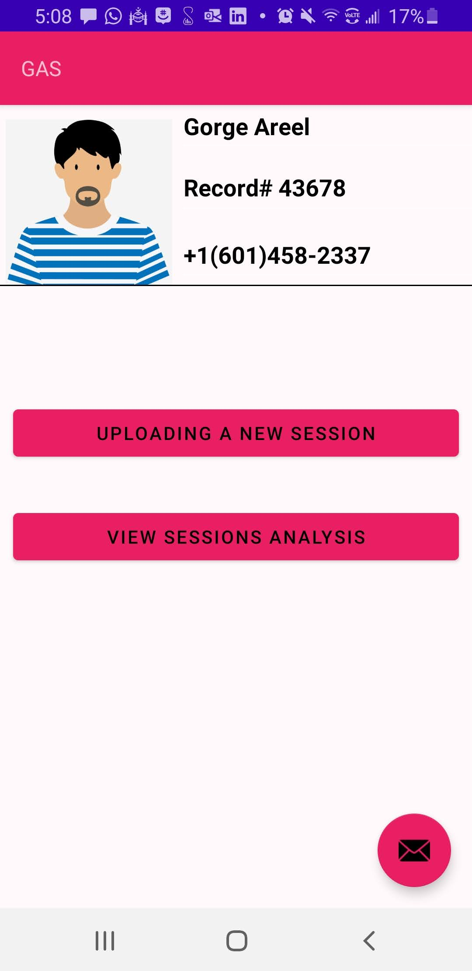 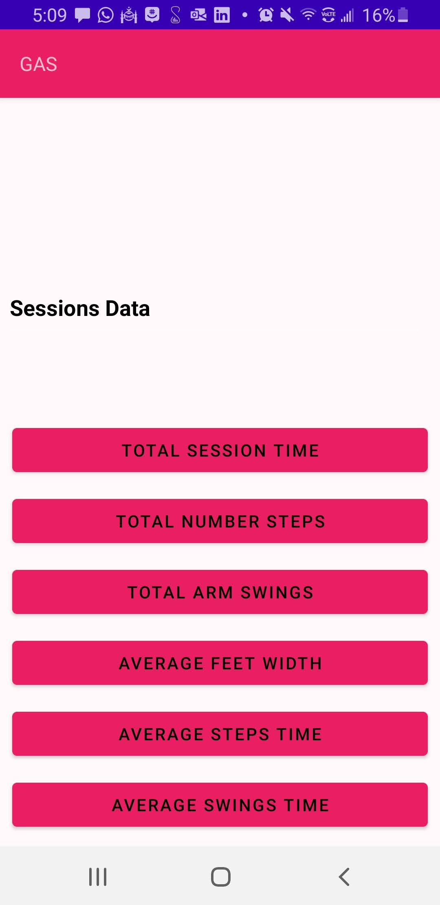

**Figure 3.6 UI Main Menu** **Figure 3.7 UI Sessions Data**

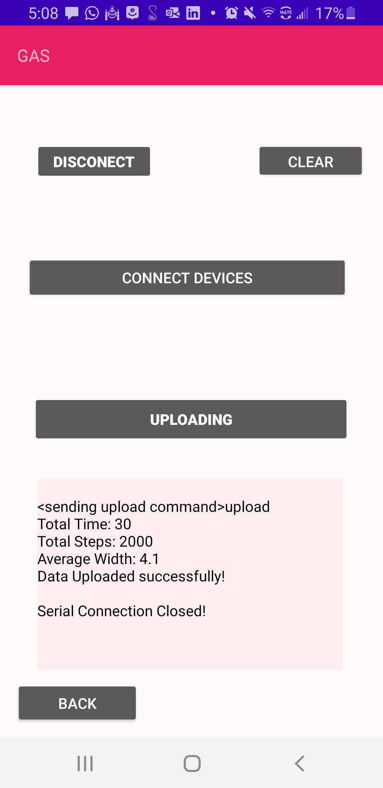 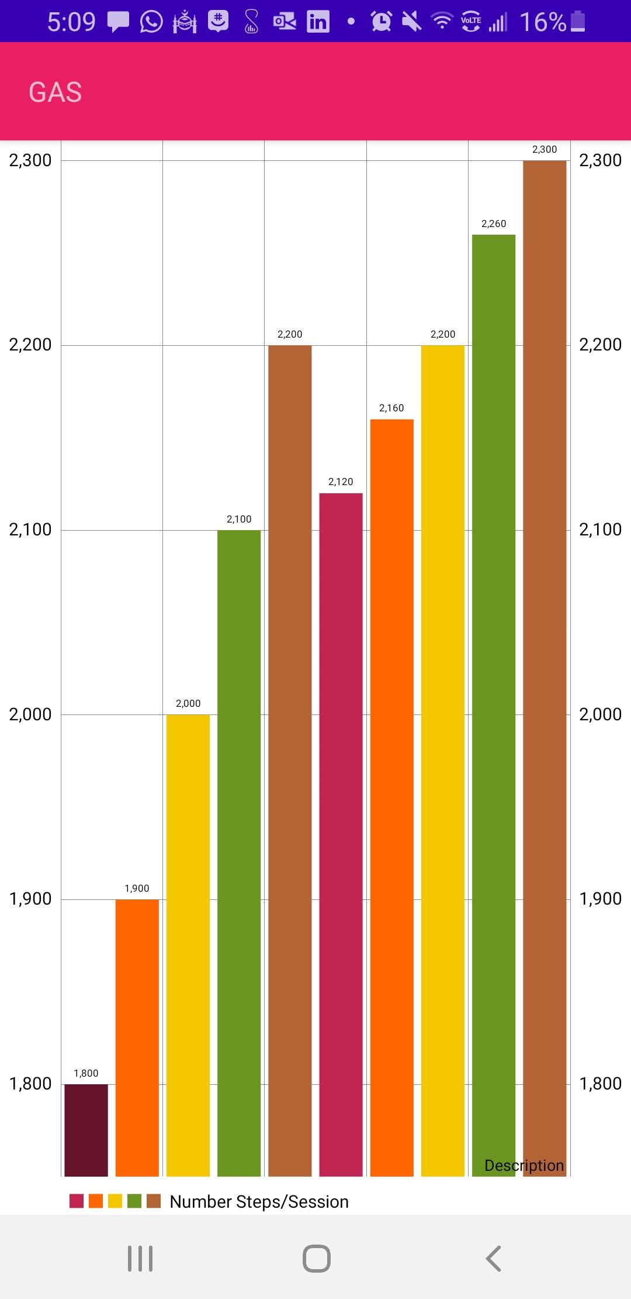

**Figure 3.8 UI Uploading Data** **Figure 3.9 UI Total Steps**

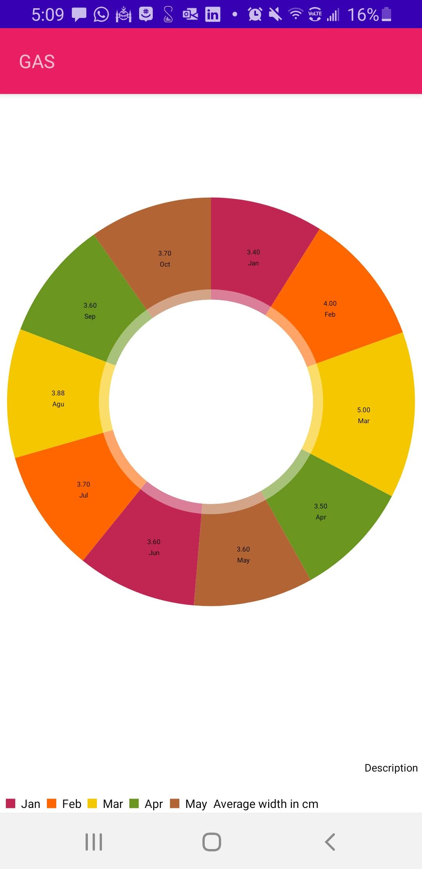

**Figure 4.0 UI Sessions Average Widths**

The application has a main menu for the users with two primary choices either uploading or viewing data of the sessions as shown in Figure 3.5. To upload the data, first, the user needs to click on the connecting devices button and then on the upload button if the devices got connected as shown in Figure 3.7. The message box is to give the user feedback about the status of the uploaded data. It displays a success message along with two values for the uploaded data such as the total time of the uploaded session and the average width between the user's feet. However, if the devices could not connect or something went wrong, an error message would show up on the feedback box to warn the user. To view the data of a patient’s session, the physical therapist can choose one of the six analysis variables on the list, which are shown in Figure 3.6. The six variables of the last uploaded session are displayed on different charts along with the values of the previous sessions as a comparison. Figure 3.8 is an example of the bar chart of the total steps for each session organized based on the date of the sessions. The physical therapist can identify the number of steps of the last uploaded session and compare it to the previous sessions to measure progress. The number of the steps of the last uploaded sessions are 2,300, and there are 10 sessions. Figure 3.9 is another chart example of the average widths between the user’s feet for all sessions. The physical therapist can view up to 10 sessions on the application and interact with data flexibly.

**References:**

[1] “SparkFun OpenPIR,” *Sparkfun Electronics.* [Online]. Available: https://media.digikey.com/pdf/Data%20Sheets/Sparkfun%20PDFs/SEN%E2%80%9013968_Web.pdf [Accessed 17-Sept-2020].

[2] Blackstock, T., “Step Width,” September 2020.

[3] Blackstock, T., “Step Speed,” September 2020.