**EXECUTIVE SUMMARY**

Analyzing how an individual walks can allow physical therapists to assess whether an individual, particularly an elderly patient, is at risk of falling. This process, known as gait analysis, is a key component in improving a patient’s ability to walk correctly and thus is critical in preventing future falls. However, while a physical therapist is able to assess and correct a patient’s walking patterns during therapy sessions, there exists no method to monitor the patient outside of these sessions. Patients are often prescribed walking sessions to complete between therapy sessions, but patients may perform poorly during these sessions since the physical therapist is not present to correct and coach them.

Gait Analysis System (GAS) provides physical therapists with patients’ walking data outside therapy sessions by creating a wearable device that captures key gait-related data, as shown in Figure 1. GAS’s design includes a belt and two ankle bracelets that record the user’s walking data, such as the arm swing speed, step speed, and step width. After the user goes for a walk, the physical therapist can connect the device to an Android smartphone via USB to upload the recorded data to the GAS smartphone application (app). The app then presents the data in the form of charts and graphs, making it easy for the physical therapist to comprehend the recorded information.

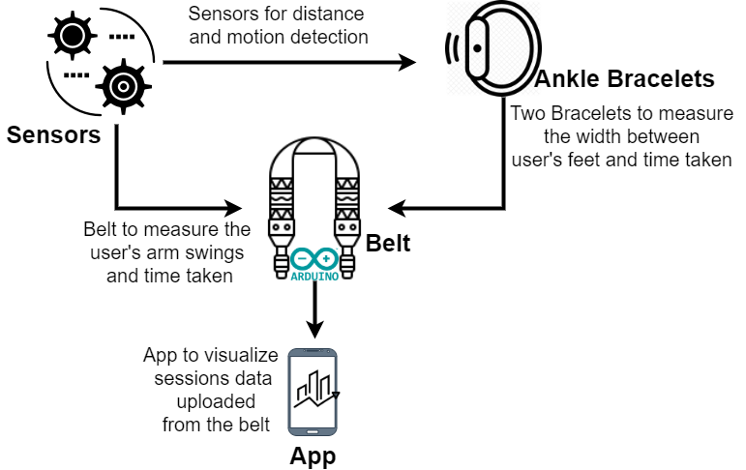

**Figure 1. GAS Flowchart**

The belt captures arm-swinging measurements, while the two ankle bracelets handle the step-speed and step-width measurements. The belt subsystem is comprised of a microcontroller, two PIR sensors, two LEDs, and a memory chip. The two PIR sensors on the belt count and time each of the user’s arm swings. The left ankle bracelet includes an inner-ankle PIR sensor that measures the user’s step speed, while the right ankle bracelet includes an inner-ankle PIR sensor that measures the user’s step width. Both ankle bracelets also include an outer-ankle PIR sensor that temporarily halts measurements whenever they detect a nearby object. The microcontroller then handles all the processing and sends all the recorded data to the memory chip when the walking session is over.

GAS provides a novel approach to recording a patient’s walking information and has the ability to revolutionize outpatient therapy. GAS provides physical therapists an accurate measurement of a patient’s improvement over time and allows them to address walking ailments effectively. In the future, the design team would like to collaborate with therapists in outpatient therapy to test the device on elderly patients.