CIP — Technical Specification
Data Automation · Coresight Research
October 14, 2026

Contents

Forsta ETL, data storage and operations for the Consumer Insight Portal. Version 1.0 · 13 October 2026 · Owner: Data Automation (Coresight Research)
Built from the section files in docs/technical/ (00–08); the data dictionary is generated from the live database.

0. Overview
Consumer Insight Portal (CIP) — Technical Specification. How survey data is retrieved from Forsta, transformed, loaded into cip_stg, verified and prepared for reporting. Version 1.0 · 13 October 2026.

0.1 Scope
In scope | Out of scope (for now)
Forsta API extraction, every survey the key can see | Reactivating hibernated surveys (manual in Forsta)
Transformation, loading, verification, derived tables | The new portal UI (designs only)
History from Qualtrics and SurveyMonkey (  dwh_sm*  ) | Azure Blob archive of raw payloads (deferred)
Scheduling, monitoring, reconciliation | Weighting (columns reserved; waves are unweighted)

0.2 Document map
Section | Content
1 | Connection and API: endpoints, authentication, responses, status codes, configuration
2 | Extract: discovery, due selection, fetching, wave identity, legacy sources
3 | Transform: question shapes, labels, bipolar grids, other-specify, flags, personal data, profiles, concepts
4 | Load and verify: write order, transactions, verification, visibility, idempotency, reconciliation
5 | Derived data, storage design, indexes, partitioning, performance
6 | Data dictionary: every table, view and column
7 | Survey patterns: cadence, rotation, modules, codes, how to apply
8 | Operations runbook: schedule, exit codes, commands, monitoring, incidents, security

0.3 Architecture
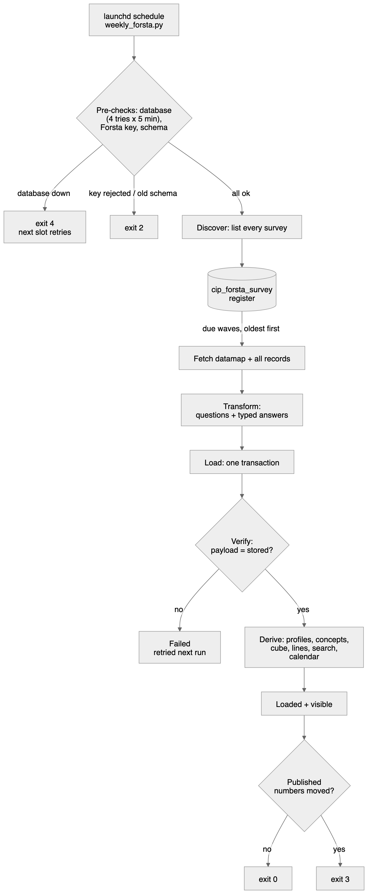
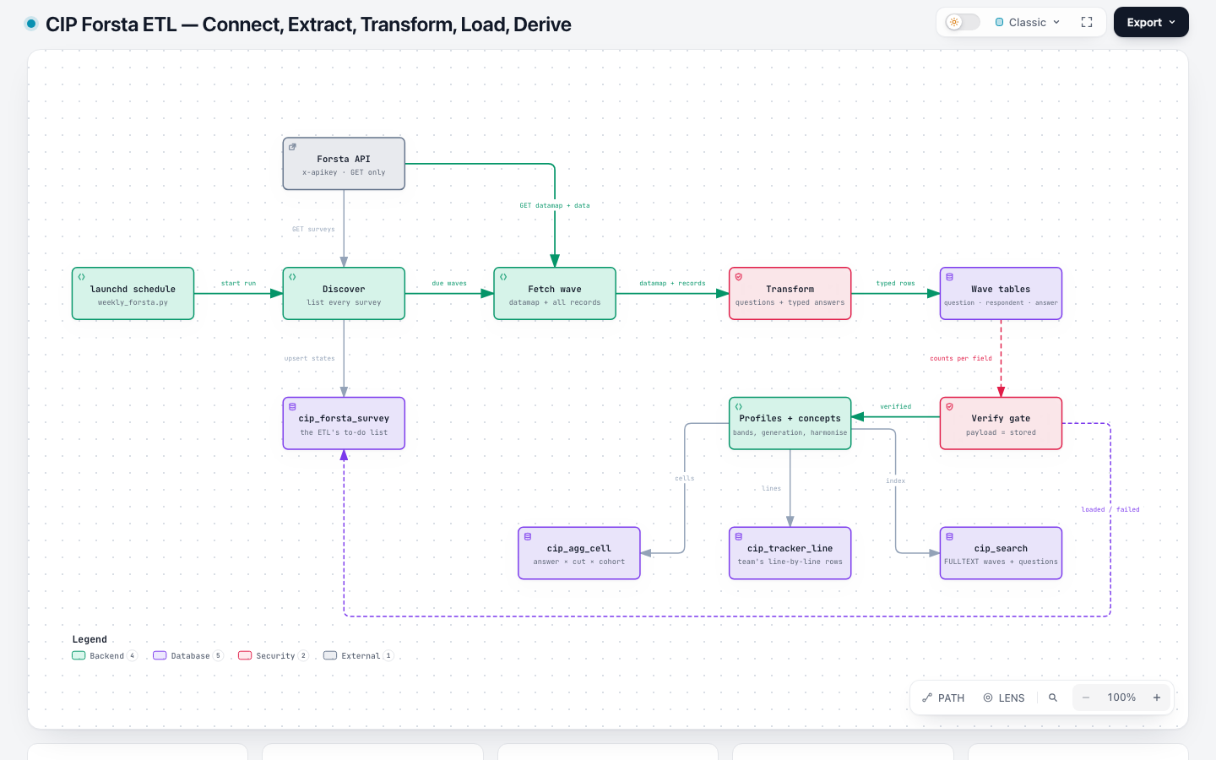
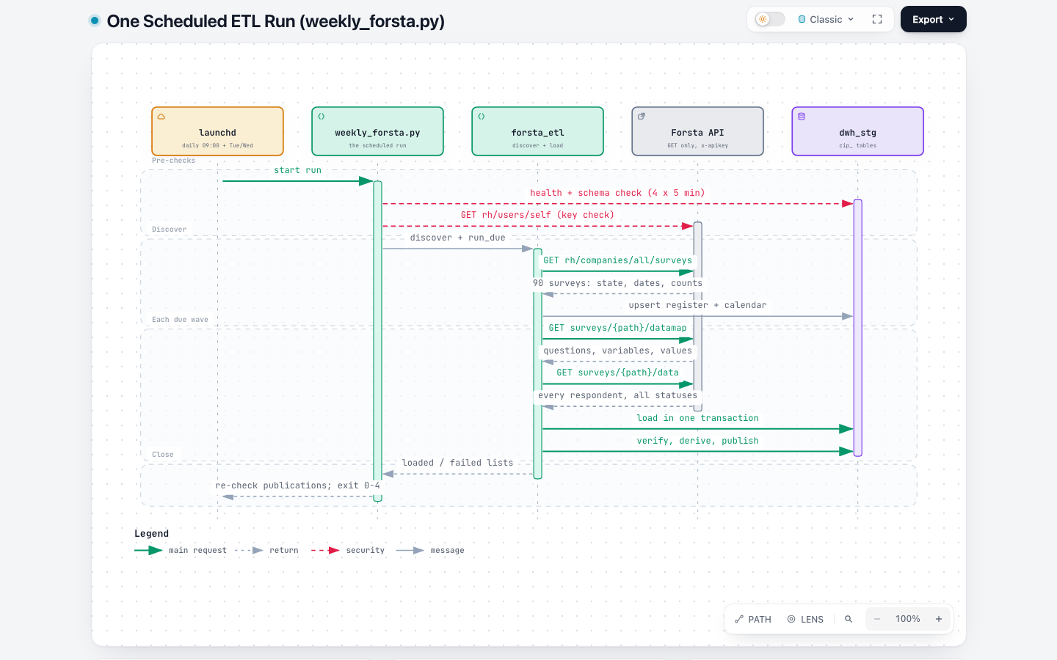
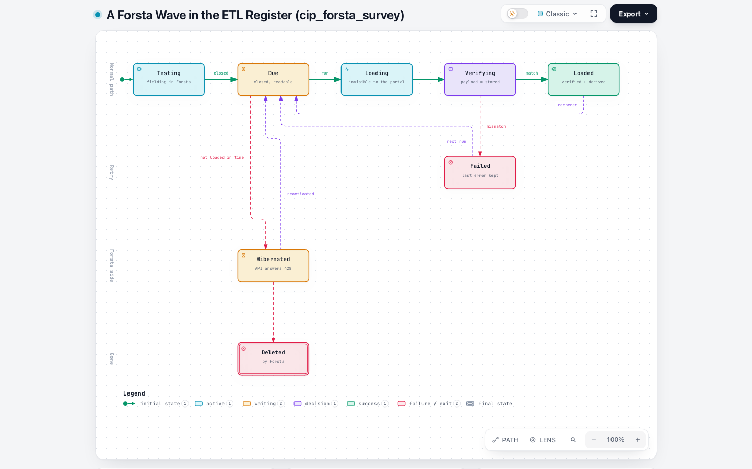
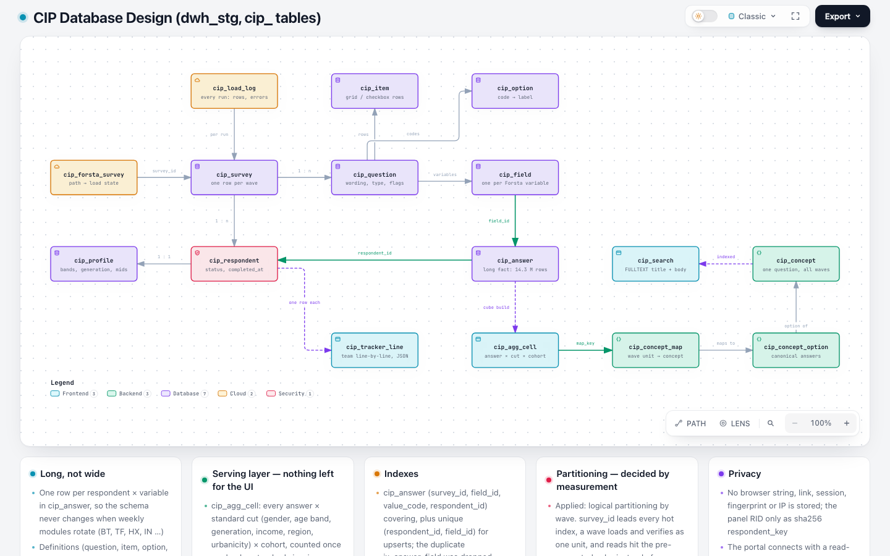

0.4 Components
Component | File | Responsibility
Scheduled run | scripts/weekly_forsta.py | health, key and schema checks; discover; load due; drift; exit code
Forsta client | etl/forsta_client.py | authenticated GET with retries
Datamap adapter | etl/forsta_api.py | Forsta JSON → questions (shapes, labels, bipolar, other-specify, flags, personal-field denylist)
Pipeline | etl/forsta_etl.py | register, load, verify, reconcile, reindex
Loaders | etl/loaders.py | survey and definition upserts, load log, search index
Shared loader steps | etl/run_pipeline.py | profiles, question bases, wave label
Demographics | etl/survey_map.py  +  config/survey_map.yml | topics, profile mapping, age/income bands, regions
Harmoniser | app/data/harmonise.py | concepts across waves and platforms
Cohorts and cube | app/data/cohorts.py  ,  app/data/cube.py | segment membership, pre-computed cells
Line-by-line | etl/tracker_line.py  +  config/tracker_line.yml | the data team’s weekly table
Survey calendar | etl/survey_calendar.py  +  config/survey_calendar.yml | cadence, modules, season wave numbers
History | etl/legacy_dwh.py  ,  etl/qualtrics_export.py | Qualtrics and SurveyMonkey
Schema | sql/001_schema.sql  ,  sql/002_views.sql  ,  app/core/schema_upgrade.py  ,  scripts/init_db.py | DDL, views, upgrades
Checks | scripts/reconcile.py  ,  scripts/perf_check.py  ,  tests/ | correctness, speed, 227 tests

1. Connection and API

1.1 Systems involved
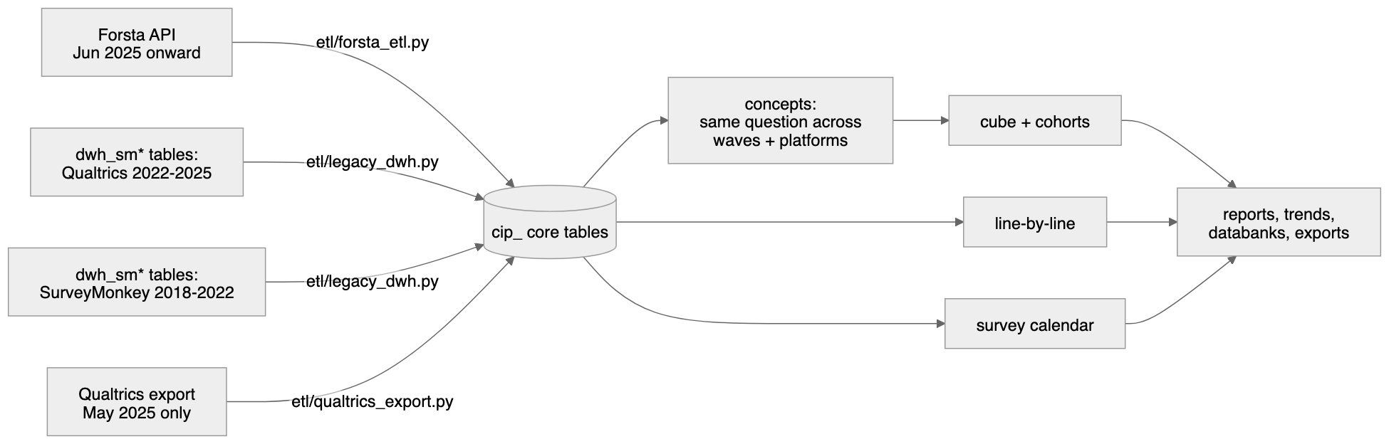
System | Role | Access
Forsta Surveys (Decipher)  se1.decipherinc.com | Live survey source | HTTPS REST API v1,  GET only
Azure Database for MySQL 8.0  csr-mysql8-flex-stg.mysql.database.azure.com  , schema  cip_stg  (all  cip_  tables and views) | Warehouse | TLS 1.2+, PyMySQL via SQLAlchemy 2
dwh_sm*  tables in  dwh_stg | Qualtrics + SurveyMonkey history (read) | same server; read through  dwh_sm*  views in  cip_stg
macOS launchd (  com.coresight.cip-forsta-etl  ) | Scheduler | user agent on the ETL host

1.2 Forsta API
Setting | Value
Base URL | https://se1.decipherinc.com/api/v1/
Authentication | header  x-apikey: <64-character key>  ; key in  .env  as  FORSTA_API_KEY  (never logged or printed)
Other headers | Accept: application/json  ,  User-Agent: coresight-cip/1.0
Account | user 879, company 86, directory “Coresight Research” (  58f  )
Timeout | 120 s per request (  FORSTA_TIMEOUT_SECONDS  )
Retries | up to 4 attempts, exponential back-off 2 → 60 s, on connection errors, timeouts,  429  and  5xx
Usage header | x-usage-today  logged at debug level
Client | etl/forsta_client.py  (  ForstaClient  )

Endpoints used (all GET)
Endpoint | Purpose | Called
rh/users/self | Proves the key works | Start of every scheduled run
rh/companies/all/surveys | Every survey the key can see:  path  ,  title  ,  state  ,  hibernated  ,  tags  ,  createdOn  ,  dateLaunched  ,  closedDate  ,  qualified  ,  total  ,  sampleSources | Once per run (discovery) and reused for the run’s loads
surveys/{path}/datamap?format=json | Questionnaire definition | Once per wave loaded
surveys/{path}/data?format=json | Every respondent record;  no cond filter  , so terminates, over-quota and partials are included | Once per wave loaded and per reconciliation

Nothing else is called. data/edit, reactivation, survey edits and datafeed acknowledgements are not used; the client has no POST/PUT/DELETE method.

Response shapes
Survey list item
{"path": "selfserve/58f/260908", "title": "Shopping and Spending - inc Home Furnishings + Holiday Tracker + GenAI", "state": "closed", "hibernated": false, "tags": ["Coresight Research", "Weekly consumer tracker"], "createdOn": "2026-09-22T15:57:00Z", "dateLaunched": "2026-10-05T12:22:25Z", "closedDate": "2026-10-06T14:19:55Z", "qualified": 401, "total": 823, "sampleSources": ["114"]}
Datamap — questions[], each with qlabel, qtitle, type (single / multiple / float / number / text), grouping (rows / cols), optional flags (t technical, v virtual), values[] (value, title) on the question or on each variable, and variables[] (label, row, rowTitle, colTitle, type, values).
Data — a JSON array, one object per respondent, every value a string: "status": "3", checkbox "0"/"1", single choice "1"…"n", numbers as text, verbatims as text, "date": "09/28/2026 10:56", plus record, uuid, RID, markers, userAgent, url, session, dcua.

Status codes and what the pipeline does
Code | Meaning | Handling
200 | OK | continue
401 | Key missing, wrong, revoked or user disabled | run stops, exit 2
403 | Key valid, no rights on the survey | wave fails, recorded
428 | Survey hibernated | never loaded; reconciliation skips it with a warning
429 / 5xx | Busy / server error | retried (4 attempts) then the wave fails and is retried next run

1.3 Warehouse connection
Setting | Value
Driver | mysql+pymysql  , SQLAlchemy 2 engine, pooled (  DB_POOL_SIZE  ,  DB_MAX_OVERFLOW  )
ETL account | STG_DB_USER  (  mohdsaeedafri  ) — ALL PRIVILEGES on  cip_stg  , SELECT on  dwh_stg
Portal account | read-only grants (  sql/004_grants.sql  , applied by the DBA)
TLS | required; CA bundle  STG_DB_SSL_CA  (DigiCert Global Root G2)
Latency | ≈250 ms round trip from the India office — every loader step is batched to a constant number of statements per wave
Health check | SELECT VERSION()  ; the scheduled run tries 4 times, 5 minutes apart, before exiting 4

1.4 Configuration (.env)
Variable | Use
APP_ENV | LOCAL  /  STAGING  /  PRODUCTION
STG_DB_HOST  ,  STG_DB_PORT  ,  STG_DB_NAME  ,  STG_DB_USER  ,  STG_DB_PASSWORD  ,  STG_DB_SSL_CA | Warehouse
FORSTA_HOST  (default  se1.decipherinc.com  ),  FORSTA_API_KEY | Forsta
FORSTA_TIMEOUT_SECONDS  (120),  FORSTA_MAX_RETRIES  (4) | Client
LOCAL_SQLITE_PATH | Offline SQLite copy for development

2. Extract
Code: etl/forsta_etl.py (discover, run_due, load_survey), etl/forsta_client.py.
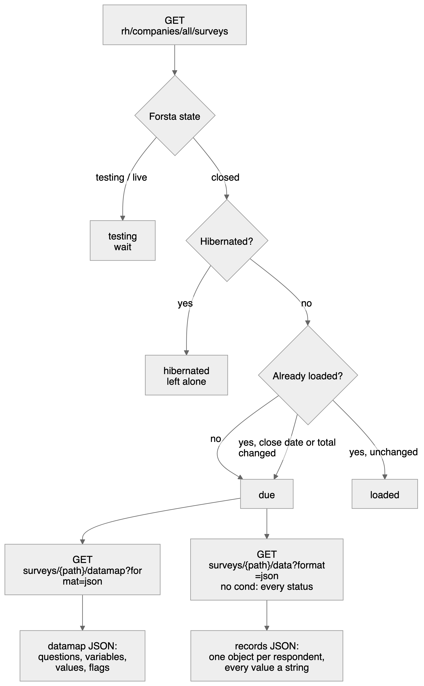

2.1 Discovery (every run)
discover(client) calls rh/companies/all/surveys once and upserts one row per survey into cip_forsta_survey (key forsta_path). The load state is decided as follows:
Condition (in order) | load_state
previously  loaded  and neither  closedDate  nor  total  changed | loaded
Forsta  state  ≠  closed  (testing, live) | testing
closed and  hibernated = true | hibernated
closed, readable, previously  failed | failed  (retried)
closed, readable, otherwise | due

A loaded survey whose close date or total respondents changed (reopened in Forsta) becomes due again. The same transaction rebuilds the survey calendar (cip_wave_module, section 5.6).
Columns written: title, state, hibernated, tags (comma list), study_type (tracker if tagged “Weekly consumer tracker” or titled “Shopping and spending…”, annual if tagged “annual tracker”, else adhoc), created_on, launched_at, closed_at, qualified_n, total_n, last_seen (UTC), load_state.

2.2 Choosing what to load
run_due(client) selects load_state IN ('due','failed') ordered by closed_at, forsta_path (oldest first) and loads them one at a time. The survey list from discovery is reused, so a run makes one list call however many waves it loads. A failure is recorded (load_state = failed, last_error) and the run continues with the next wave.

2.3 Fetching a wave
For each due survey:
- GET surveys/{path}/datamap?format=json — the questionnaire (≈0.5 MB).
- GET surveys/{path}/data?format=json — all records (≈2 MB for 500 respondents), withoutcond, so every status is present: 1 terminated · 2 over quota · 3 qualified · 4 partial.
- Records without a uuid are discarded (Forsta system rows).

2.4 Wave identity
Field | Rule
Forsta path | selfserve/58f/YYMMNN  — one survey = one wave
wave_label  /  wave_date | Monday of the earliest completion date among  qualified  records (all records if none qualified)
Reload | A survey already loaded by this pipeline (load log  source_ref = forsta:{path}  ) keeps its wave label and  survey_id  , even if its first date moves
Family | CSI-US  for the weekly tracker; for other studies the title without the year, upper-cased (  HOLIDAY_SHOPPING  )

2.5 Legacy extraction (history)
Source | Module | Notes
Qualtrics 2022–2025 in  dwh_sm* | python -m etl.legacy_dwh --all | 142 waves, completes only, matched to the original responses
SurveyMonkey 2018–2022 in  dwh_sm* | python -m etl.legacy_dwh --all --era surveymonkey | 145 waves; matrix questions as grids; SurveyMonkey Audience demographics fill profiles
Qualtrics Excel export, May 2025 | python -m etl.qualtrics_export --wave 2025-05-12 --file … | The only wave missing from  dwh_sm*

3. Transform
Code: etl/forsta_api.py (questions_from_datamap), etl/forsta_etl.py (_answer, _respondent), etl/records.py (ParsedQuestion, clean_text), etl/survey_map.py (profiles), etl/loaders.py (topics, short labels).
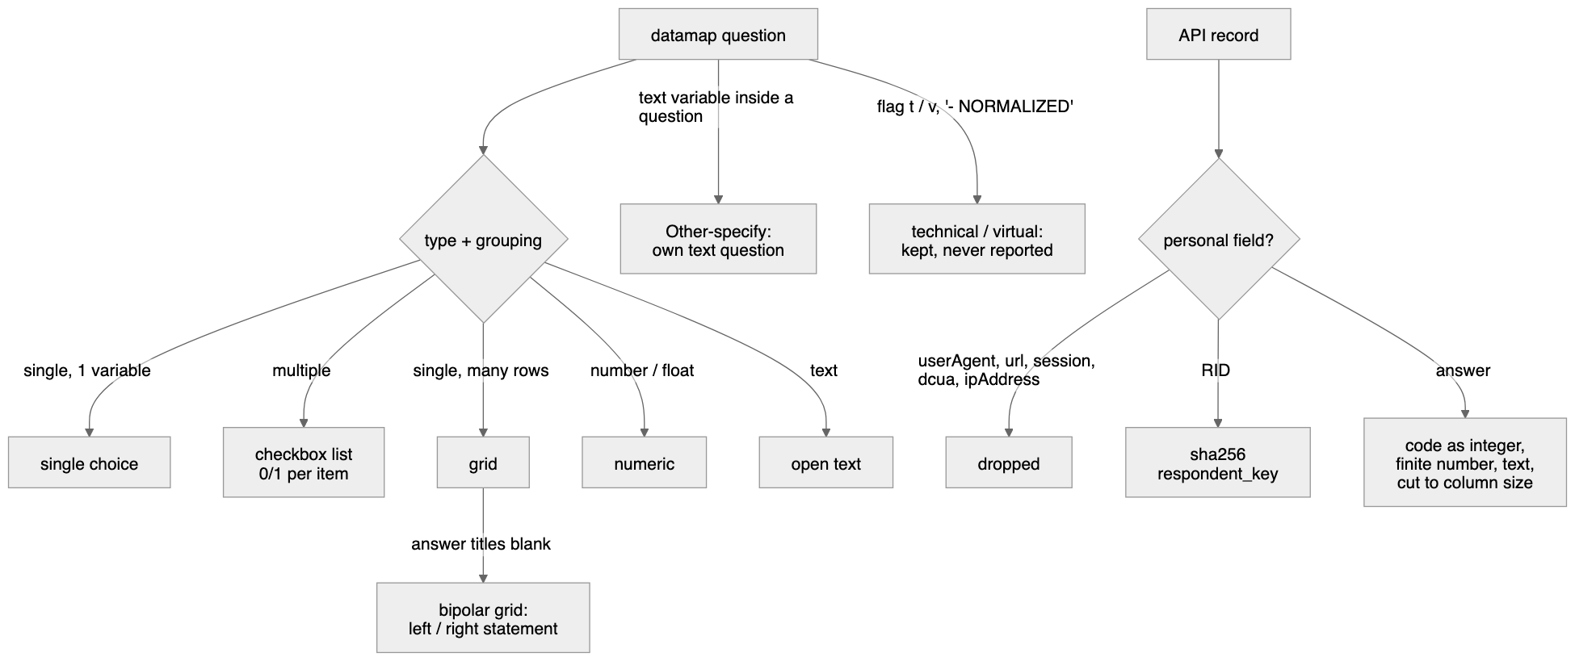

3.1 Datamap → questions (one ParsedQuestion per Forsta question)
Forsta shape | Measured frequency (1,416 questions) | Stored as  qtype | Fields created
single  , 1 variable | 693 | single | one field = the question code
multiple  , many variables | 491 | multi  (0/1 per item) | one field per item (  q1r1  ,  q1r2  …)
single  ,  rows  , many variables | 73 | grid_single | one field per row
single  ,  cols  , + a text variable | 53 | single  + separate  text  question for the “Other (specify)” variable
single  ,  rows  , 1 variable | 43 | single  (or  grid_single  when the variable is named apart)
float  /  number | 32 | numeric
text  /  textarea | 23 | text
date | — | datetime

Rules, in order:
- Text — titles are HTML-unescaped and whitespace-normalised (clean_text); qtext_short is a ≤ 80-character label.
- Answer labels — taken from the question’s values[]; when empty (about a third of datamaps) from the first variable that has values[]. Only integer codes are kept.
- Grid — a single-choice question whose variables are “named apart” (more than one row, or the one row’s code differs from the question code). Row label = rowTitle — colTitle.
- Bipolar grid — a grid whose answer titles are all blank (e.g. HX6): options become 1 = Left statement, 2 = Right statement; each row stores its left statement (its own title) and its right statement (the {question}_norm{row}_r variable of Forsta’s NORMALIZED copy) in cip_item.left_label / right_label.
- Other (specify) — a text variable inside a non-text question becomes its own text question, code = the variable label (vosr15oe, q1r2oe), wording “
- Flags — t → is_technical = 1 (conditions, qtime, start_date, status…); v → is_virtual = 1 (vlist, vos, vbrowser…); a title ending “- NORMALIZED” is virtual. Technical and virtual questions are stored but never reported, harmonised or cubed.
- Personal variables — RID, userAgent, url, session, dcua, ipAddress never become questions or fields, even if a datamap lists them.
- Topic — each question is placed in an editorial topic (cip_topic) from its code and wording (config/survey_map.yml); technical topics also set is_technical.
- Answer attributes — an option whose label contains “don’t know”, “not sure” or “prefer not to say” is is_nonresponse; an item starting “None of these” is is_exclusive; an item code ending oe is is_other.

3.2 Records → respondent rows
Column | Source | Rule
record_no | record | integer
forsta_uuid | uuid | ≤ 64 chars, the upsert key with  survey_id
status_code  /  status_label | status | 1 Terminated · 2 Overquota · 3 Qualified · 4 Partial
is_qualified |  | status = 3
completed_at | date | MM/DD/YYYY HH:MM  → datetime
interview_secs | qtime | integer seconds
markers | markers | ≤ 1,000 chars
device  ,  os  ,  browser  ,  dropout_qcode | vmobiledevice  ,  vos  ,  vbrowser  ,  vdropout | ≤ 50 chars
panel_source | vlist  /  list | ≤ 100 chars
respondent_key | RID | sha256 hex  — the panel id itself is never stored
sample_rid |  | always NULL

3.3 Records → answer rows
Each (record, field) with a non-empty value becomes one cip_answer row:
Field kind | Stored
code  (single, grid row, checkbox item) | value_code  integer (  "3"  ,  "3.0"  → 3);  value_label  = the option label (single/grid) or the item label (checkbox)
code  but not a whole number | value_label  = the raw text, no code invented
numeric | value_number  , only if finite and |x| < 10¹⁴ (column is DECIMAL(18,4)); otherwise not stored
text | value_text  verbatim

Empty strings and nulls are not stored, so “no answer” is the absence of a row. Checkbox 0is stored (item shown, not chosen), which gives every multi-select question its “answered” base.

3.4 Derived transformations (after load)
Output | Rule | Code
Profile per respondent (  cip_profile  ) | Demographic questions found per wave from  config/survey_map.yml  (CSI-US: D1 gender, D2 age, D3 relationship, D4 ethnicity, D5 income, D6 urbanicity, D7 political, D8 state, CS1/CS2 outlook) or by wording; mapping recorded in  cip_profile_map | run_pipeline._rebuild_profiles
Age band | 18-29 · 30-44 · 45-60 · Over 60 (from a single year, or a band that fits one band); “Under 18” unbanded | survey_map.classify_age
Generation | GenZ 18-28 · Millennial 29-44 · GenX 45-60 · Boomer 61+ | same
Age midpoint | the year itself; bands: the analysts’ midpoints (over 60 = 67) | same
Income midpoint ($000) | under $25k = 13 · $25-49.9k = 37.4995 · $50-99.9k = 74.9995 · $100-149.9k = 124.9995 · $150-199.9k = 174.9995 · $200k+ = 225 | survey_map.income_mid_k
Census region | State → Northeast / Midwest / South / West (SurveyMonkey: Census division → region) | survey_map.census_region
Question base | qualified respondents who reached the question | _rebuild_question_bases
Concepts | exact (same normalised wording and options) → confirmed; changed options → proposed; wording ≥ 0.85 similar → proposed; else new concept | app/data/harmonise.py
Line-by-line row | the data team’s format, see 5.4 | etl/tracker_line.py
Calendar | lead sector, topics, seasonal tracker, events; season wave numbers | etl/survey_calendar.py

4. Load and verify
Code: etl/forsta_etl.py (load_survey, _write, verify), etl/loaders.py (upsert_survey, load_definitions, start_run, finish_run).
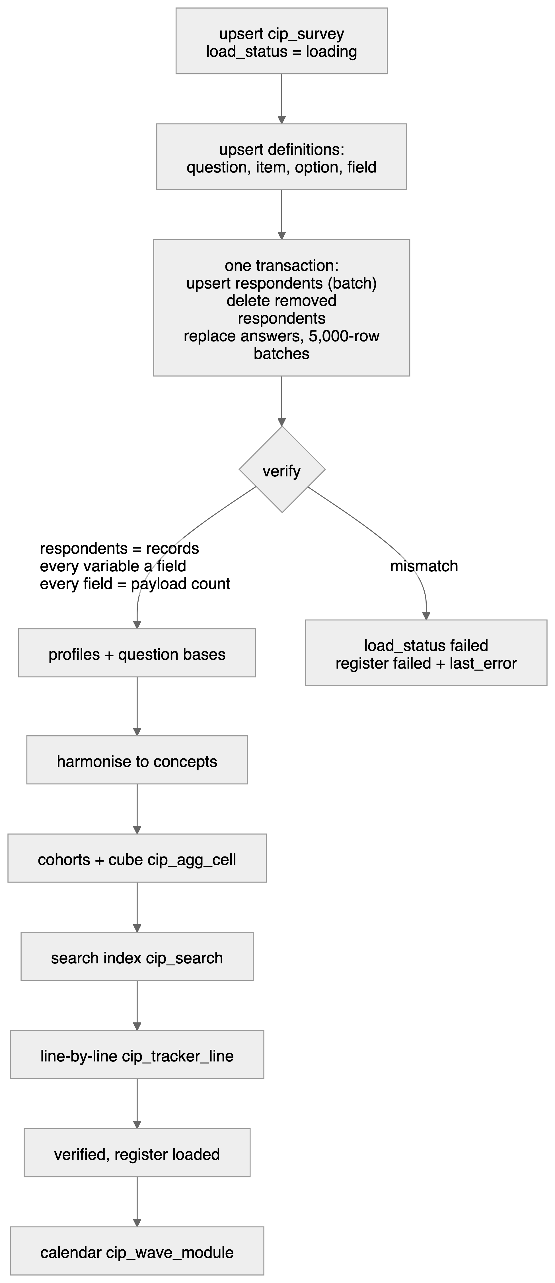

4.1 Order of writes
Step | Table(s) | Statement | Transaction
1 | cip_survey | INSERT … ON DUPLICATE KEY UPDATE  keyed  (platform, source_ref, wave_label)  ; then  load_status = 'loading'  ,  sample_source  ,  total_n  ,  tags  ,  field_start  ,  field_end | own
2 | cip_load_log | new run row:  source_type = api  ,  object_type = data  ,  source_ref = forsta:{path} | own
3 | cip_topic  ,  cip_question  ,  cip_option  ,  cip_item  ,  cip_field | batched upserts (one statement per table),  INSERT IGNORE  for fields | own
4 | cip_respondent | one batched upsert keyed  (survey_id, record_no) | A
4b | cip_answer  ,  cip_respondent_cohort  ,  cip_profile  ,  cip_respondent | respondents no longer in Forsta’s payload are deleted | A
4c | cip_answer | DELETE … WHERE survey_id  , then inserts in batches of 5,000 rows (all placeholders, so PyMySQL batches them) | A
5 | — | verify (reads only)
6 | cip_profile_map  ,  cip_profile | profiles rebuilt | own
7 | cip_question.base_n | question bases | own
8 | cip_concept*  ,  cip_concept_map | harmonise | own
9 | cip_respondent_cohort  ,  cip_agg_cell | cohorts derived, cube rebuilt (old cells removed first) | own
10 | cip_search | the wave’s survey + question rows; concept rows | own
11 | cip_tracker_line | the wave’s lines (tracker family only) | own
12 | cip_load_log | run finished: rows read / loaded, status | own
13 | cip_survey  ,  cip_forsta_survey | load_status = 'verified'  ; register  loaded  ,  survey_id  ,  loaded_at | own
14 | cip_wave_module | calendar rebuilt (questions now known) | own

Transaction A is all-or-nothing: if it fails, the previous answers are untouched.

4.2 Verification (before anything is visible)
verify(survey_id, datamap, records) must return no problems:
- Respondents — stored respondents for the wave = records sent.
- Fields — every datamap variable (except personal ones) has a cip_field.
- Answers — for every field, stored answer count = the number of records with a non-empty value.
Any mismatch raises "{path} does not match its payload", the wave is marked failed, and its error is kept in cip_load_log.error_text and cip_forsta_survey.last_error.

4.3 Visibility and status
cip_survey.load_status | Meaning | Visible in reports
loading | being written | no
verified | proven equal to Forsta and derived | yes
failed | did not match, or a later step failed | no

If a reload fails before transaction A commits, a previously verified wave keeps verified (its data did not change). If it fails after, the wave becomes failed and the next run retries it.

4.4 Idempotency
- Every write is an upsert or a replace keyed on Forsta’s own identifiers (forsta_path, uuid, record, variable label), so re-running a load never duplicates anything.
- A reload of the same Forsta survey reuses its survey_id and wave label — but only a wave that this pipeline loaded from the API (load log forsta:{path}); a wave loaded another way on the same path is never overwritten.

4.5 Reconciliation (independent check)
python scripts/reconcile.py (or python -m etl.forsta_etl --reconcile) re-reads every loaded wave from Forsta and compares every stored answer: codes exactly, numbers at the stored 4-decimal precision, texts exactly. Hibernated surveys are skipped with a warning. Last run (8 Oct 2026): 31 waves, 4,476,153 answers, 0 differences. Legacy waves are compared with their dwh_sm* source the same way.

5. Derived data, storage design and performance
Everything a report needs is computed in the warehouse when a wave loads, so the portal and exports only read pre-computed rows.
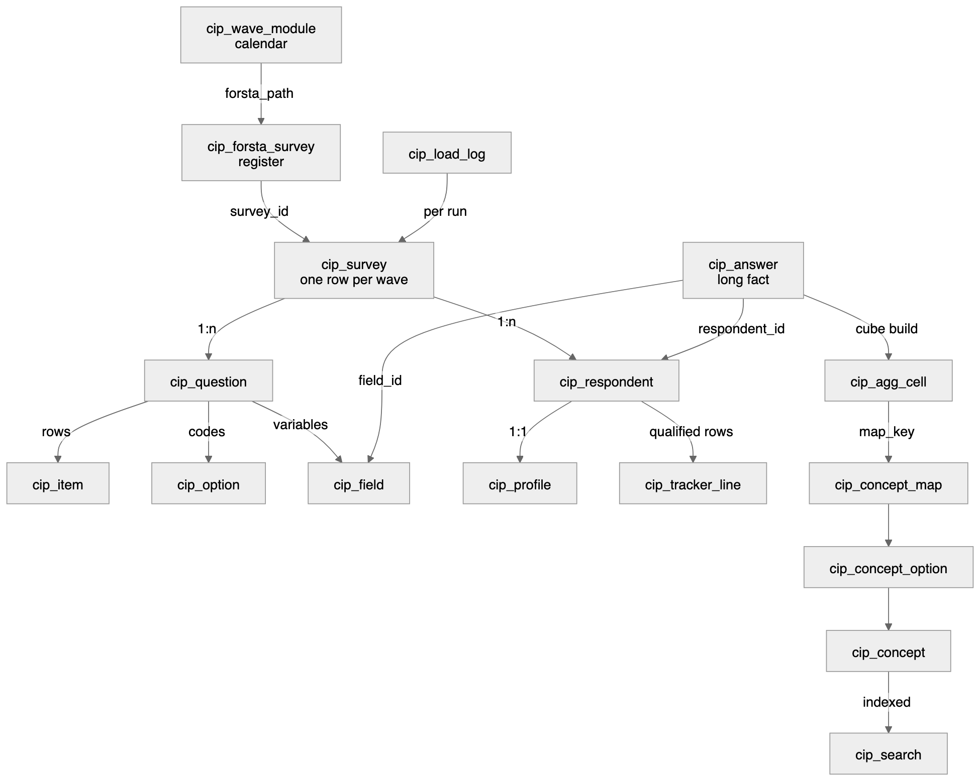

5.1 Design principles
- Long, not wide.cip_answer holds one row per respondent × variable, so the schema never changes when weekly modules rotate. (A wide table — one column per variable — would break every week.)
- Definitions per wave. Forsta codes are not stable (D2, BT14, DS1–DS7 changed meaning across waves), so questions are linked across waves by wording through concepts, never by code.
- Conformed dimensions. Concept + concept option are the shared “question” dimension across Forsta, Qualtrics and SurveyMonkey.
- Pre-aggregated cube.cip_agg_cell counts every answer once per standard cut and cohort.
- Prefix cip_ (views v_cip_) so nothing collides with other tables on the server (history in dwh_stg keeps its dwh_sm names).

5.2 Cube — cip_agg_cell
Aspect | Rule
Rows | every answer of every reportable question (single, grid row, checkbox item) × cut × cohort,  qualified respondents only
Cuts (  dim  ) | total, gender, age_band, generation, income_band, census_region, urbanicity
Cohorts | everyone (  cohort_id NULL  ) and each current cohort (  config/cohorts.yml  , e.g. Beauty shoppers)
Measures | n  ,  base_n  ,  sum_age_mid  ,  n_age_mid  ,  sum_income_mid_k  ,  n_income_mid  (averages without raw rows)
Bases | single/grid: who answered that row; checkbox: everyone who answered the question (“Total answering”)
Concept link | map_key = question:item:option  , joined to  cip_concept_map  at read time, so confirming a mapping needs no rebuild
Build | answers read once into a temporary table with every cut; each cut × cohort is an aggregate over it

5.3 Search — cip_search
One row per wave (title, family, tags, path), per non-technical question (wording, code) and per concept (name, code, number of waves). MySQL FULLTEXT on (title, body); queries use boolean mode with required, prefix-matched words, skipping InnoDB stop-words; LIKE fallback for words under 3 characters (e.g. “D5”). Only verified waves are returned.

5.4 Line-by-line — cip_tracker_line
The data team’s “Weekly Line-By-Line Survey Data” rebuilt per tracker wave (config/tracker_line.yml): one JSON row per qualified respondent, keys in the team’s column order.
Column(s) | Rule
Month | first day of the wave’s month
date | completion  MM/DD/YYYY HH:MM
Activities: … / Purchased In-store: … / Purchased Online: … / Food: … / Non-food: … | q1–q5, one column per item: the label when chosen, blank when not
Household Situation, Economic Situation | CS1, CS2
Gender, Age, Relationship Status, Ethnicity, Household Income, Primary Residence, State | D1–D6, D8 (Age a number when a single year)
start_date | survey start time
Age Range, Generation | profile bands in the team’s spelling (“over 60”, “Millenial”)

Not carried: D7 (the team omits it) and the panel session id (personal data). Check against the team’s file: python -m etl.tracker_line --compare "Weekly Line-By-Line Survey Data.xlsx".

5.5 Concepts — harmonisation
Decision | Condition | Status
exact | same normalised wording and type; every answer already a concept option | confirmed
changed | same wording, new answers | proposed
similar | wording ≥ 0.85 alike (the highest unrelated pair measured 0.796) | proposed
new | nothing close | new concept, confirmed

A grid is harmonised row by row. Proposals wait on the Mappings page; answers trend only once confirmed.

5.6 Survey calendar — cip_wave_module
Rebuilt after every discovery and load from config/survey_calendar.yml: each Forsta survey × module with kind (sector · topic · seasonal · event · annual · adhoc), is_lead, launched_on, season (July–June), series_wave_no, detected_by (title or questions). A seasonal tracker is detected from its own question (XM3 “current status of your holiday shopping”) once loaded. python -m etl.survey_calendar prints the calendar and the next 12 expected lead sectors.

5.7 Indexes
Index | Serves
cip_answer (survey_id, field_id, value_code, respondent_id)  covering | item incidence, cube build
cip_answer (respondent_id, field_id)  unique | upserts, cohort rules
cip_agg_cell (survey_id, map_key, cohort_id, dim)  ,  (survey_id, question_id, dim) | concept trends, standard views
cip_survey (load_status, study_type, wave_date) | wave pickers
cip_forsta_survey (load_state, closed_at) | the due list
cip_search  FULLTEXT  (title, body) | search
cip_wave_module (module_code, season, series_wave_no) | ”wave N vs last year’s wave N”
cip_tracker_line (wave_date, survey_id) | line-by-line exports

5.8 Partitioning decision
Measured 8 Oct 2026: cip_answer 14.3 M rows, 1.3 GB data + 2.9 GB index (≈23 M rows after the SurveyMonkey reload). It is not physically partitioned:
- InnoDB cannot partition a table that has foreign keys or a FULLTEXT index; cip_answer has both (referential integrity and verbatim search).
- Every hot read already starts with survey_id on a covering index; reports read the cube, not raw answers.
Applied instead: logical partitioning by wave — survey_id leads every hot index, a wave loads, verifies and is replaced as one unit, and reads go to the pre-computed cube and line tables. Trigger to revisit: cip_answer above 100 M rows → PARTITION BY HASH(survey_id) with integrity moved to the loader’s verify step and verbatim search to cip_search.

5.9 Measured performance (over the VPN, P95)
Read | P95
Search (FULLTEXT) | 0.26 s
Whole wave report (catalogue + cube + numbers + verbatims) | 1.05 s
Standard view (cube, one cut) | 0.25 s
Ad-hoc cohort, one wave | 0.76 s
Five-wave pooled concept | 0.27 s

Load time: 1.5–3 minutes per weekly wave (dominated by ~250 ms round trips; every step is batched).

6. Data dictionary — cip_ tables and views in cip_stg
Generated from the live database by scripts/data_dictionary.py; row counts are InnoDB estimates.
Object | Kind | Rows (approx.) | Purpose
cip_agg_cell | table | 2,081,530 | Pre-computed counts per wave x answer x cut x cohort.
cip_answer | table | 23,345,651 | Every answer, long format. ~151k rows per wave.
cip_auth_session | table | 2 | Sign-in audit and revocation.
cip_banner | table | 0 | Cross-tab column groups.
cip_cohort_def | table | 2 | Named, versioned respondent rules.
cip_concept | table | 1,769 | Canonical questions, stable across waves and platforms.
cip_concept_map | table | 66,766 | Wave question/item/option -> canonical concept, proposed or confirmed.
cip_concept_option | table | 11,670 | Canonical answers, with band midpoints.
cip_crosstab | table | 0 | Cross-tab cells: percentage, count, true base, significance.
cip_crosstab_run | table | 0 | One row per cross-tab export, with its base and filter settings.
cip_field | table | 56,452 | Export column -> question/item map.
cip_forsta_survey | table | 91 | Register of every Forsta survey the key can see, and what the ETL did with it.
cip_item | table | 50,335 | List items and grid rows.
cip_load_error | table | 0 | Rows that failed validation, kept for review.
cip_load_log | table | 408 | Audit trail. Nothing enters CSI without a row here.
cip_load_state | table | 0 | Watermarks so incremental pulls never re-read a whole survey.
cip_option | table | 28,967 | Answer codes and their labels.
cip_profile | table | 151,465 | Demographic cuts, one row per respondent.
cip_profile_map | table | 1,325 | Which question feeds each demographic cut, per wave. Auditable and editable.
cip_publication | table | 3 | A delivered chart or table, frozen at a version.
cip_publication_cell | table | 198 | The frozen numbers of a publication.
cip_question | table | 8,256 | Questions, with their own answering base.
cip_respondent | table | 176,470 | One row per interview.
cip_respondent_cohort | table | 6,517 | Materialised cohort membership.
cip_saved_view | table | 0 | Saved filter + question sets, re-run against current data.
cip_search | table | 9,829 | Search index: one row per wave, question and concept (FULLTEXT).
cip_segment | table | 0 | Cross-tab columns with their Forsta definitions.
cip_survey | table | 319 | Survey waves.
cip_topic | table | 16 | Editorial grouping of questions.
cip_tracker_line | table | 5,076 | The data team’s line-by-line rows: one per qualified tracker respondent, JSON in their column order.
cip_wave_module | table | 245 | Survey calendar: every Forsta survey x module (lead sector, topic, seasonal, event, annual, ad hoc).
cip_weight | table | 0 | One weight per respondent per scheme.
cip_weight_scheme | table | 0 | Named weighting schemes, per wave.
v_cip_answers | view |  | VIEW
v_cip_crosstab | view |  | VIEW
v_cip_grid | view |  | VIEW
v_cip_item_incidence | view |  | VIEW
v_cip_mapping_queue | view |  | VIEW
v_cip_question_base | view |  | VIEW
v_cip_single_distribution | view |  | VIEW
v_cip_survey_health | view |  | VIEW
v_cip_trend | view |  | VIEW

cip_agg_cell
Table — Pre-computed counts per wave x answer x cut x cohort.
Column | Type | Null | Key | Default | Meaning
cell_id | bigint unsigned | NO | PRI
survey_id | int unsigned | NO | MUL |  | → cip_survey.survey_id (cascade)
cell_key | varchar(200) | NO |  |  | question:item:option:cohort:scheme:dim:value
question_id | int unsigned | NO | MUL |  | → cip_question.question_id (cascade)
item_id | int unsigned | YES
option_id | int unsigned | YES
concept_option_id | int unsigned | YES | MUL
cohort_id | int unsigned | YES |  |  | NULL = all qualified respondents
scheme_id | int unsigned | YES |  |  | NULL = unweighted
dim | varchar(30) | NO |  |  | total, gender, age_band, …
dim_value | varchar(120) | NO
n | int | NO
base_n | int | NO
n_weighted | decimal(14,4) | YES
base_weighted | decimal(14,4) | YES
sum_age_mid | decimal(14,4) | YES
sum_income_mid_k | decimal(16,4) | YES
built_at | timestamp | NO |  | CURRENT_TIMESTAMP
map_key | varchar(40) | YES
n_age_mid | int | YES
n_income_mid | int | YES

Indexes: fk_agg_question (btree: question_id); ix_agg_concept (btree: concept_option_id, cohort_id, dim, survey_id); ix_agg_map (btree: survey_id, map_key, cohort_id, dim); ix_agg_question (btree: survey_id, question_id, dim); PRIMARY (btree: cell_id); uq_agg_cell (unique btree: survey_id, cell_key)

cip_answer
Table — Every answer, long format. ~151k rows per wave.
Column | Type | Null | Key | Default | Meaning
answer_id | bigint unsigned | NO | PRI
respondent_id | bigint unsigned | NO | MUL |  | → cip_respondent.respondent_id (cascade)
survey_id | int unsigned | NO | MUL |  | denormalised for filter speed
field_id | int unsigned | NO | MUL |  | → cip_field.field_id (cascade)
value_code | int | YES |  |  | 0/1, 1-5, 1-54
value_label | varchar(500) | YES |  |  | resolved label, denormalised for display
value_number | decimal(18,4) | YES |  |  | open numeric
value_text | text | YES | MUL |  | open-ended verbatim

Indexes: fk_answer_field (btree: field_id); ft_answer_text (fulltext: value_text); ix_answer_cover (btree: survey_id, field_id, value_code, respondent_id); ix_answer_respondent (btree: respondent_id); PRIMARY (btree: answer_id); uq_answer (unique btree: respondent_id, field_id)

cip_auth_session
Table — Sign-in audit and revocation.
Column | Type | Null | Key | Default | Meaning
session_id | varchar(64) | NO | PRI
user_email | varchar(200) | NO | MUL
user_name | varchar(200) | YES
provider | varchar(20) | NO |  | local
created_at | timestamp | NO |  | CURRENT_TIMESTAMP
expires_at | datetime | YES
revoked_at | datetime | YES
request_meta | varchar(500) | YES |  |  | host and user agent at sign-in

Indexes: ix_auth_user (btree: user_email, created_at); PRIMARY (btree: session_id)

cip_banner
Table — Cross-tab column groups.
Column | Type | Null | Key | Default | Meaning
banner_id | int unsigned | NO | PRI
survey_id | int unsigned | NO | MUL |  | → cip_survey.survey_id (cascade)
banner_code | varchar(50) | NO |  |  | AGE, GENDER, INCOME
banner_name | varchar(500) | NO |  |  | header text as printed
source_q | varchar(50) | YES |  |  | question the banner is built from
sort_order | smallint | NO |  | 0

Indexes: PRIMARY (btree: banner_id); uq_banner (unique btree: survey_id, banner_code)

cip_cohort_def
Table — Named, versioned respondent rules.
Column | Type | Null | Key | Default | Meaning
cohort_id | int unsigned | NO | PRI
cohort_code | varchar(60) | NO | MUL |  | BEAUTY_SHOPPER
version | smallint unsigned | NO |  | 1
cohort_name | varchar(200) | NO
rule_json | json | NO |  |  | any/all over concepts; see the spec §5.4
base_note | varchar(500) | YES
owner_email | varchar(200) | YES
is_current | tinyint(1) | NO |  | 1
created_at | timestamp | NO |  | CURRENT_TIMESTAMP

Indexes: PRIMARY (btree: cohort_id); uq_cohort_def (unique btree: cohort_code, version)

cip_concept
Table — Canonical questions, stable across waves and platforms.
Column | Type | Null | Key | Default | Meaning
concept_id | int unsigned | NO | PRI
concept_code | varchar(80) | NO | UNI |  | BEAUTY_RETAILER_3M
concept_name | varchar(255) | NO
concept_group | varchar(80) | YES | MUL |  | rows of one grid share a group
topic_id | smallint unsigned | YES | MUL |  | → cip_topic.topic_id (set null)
qtype | enum(‘single’,’multi’,’grid_single’,’grid_multi’,’numeric’,’text’,’datetime’) | NO
description | varchar(1000) | YES
created_at | timestamp | NO |  | CURRENT_TIMESTAMP
match_text | varchar(2000) | YES

Indexes: fk_concept_topic (btree: topic_id); ix_concept_group (btree: concept_group); PRIMARY (btree: concept_id); uq_concept (unique btree: concept_code)

cip_concept_map
Table — Wave question/item/option -> canonical concept, proposed or confirmed.
Column | Type | Null | Key | Default | Meaning
map_id | bigint unsigned | NO | PRI
survey_id | int unsigned | NO | MUL |  | → cip_survey.survey_id (cascade)
map_key | varchar(80) | NO |  |  | question_id:item_id:option_id, 0 when absent
question_id | int unsigned | NO | MUL |  | → cip_question.question_id (cascade)
item_id | int unsigned | YES | MUL |  | → cip_item.item_id (cascade)
option_id | int unsigned | YES | MUL |  | → cip_option.option_id (cascade)
concept_id | int unsigned | NO | MUL |  | → cip_concept.concept_id (cascade)
concept_option_id | int unsigned | YES | MUL |  | → cip_concept_option.concept_option_id (cascade)
status | enum(‘proposed’,’confirmed’,’rejected’) | NO | MUL | proposed
method | enum(‘exact_text’,’similar_text’,’manual’) | NO
confidence | decimal(5,4) | YES
evidence | varchar(1000) | YES |  |  | why the harmoniser proposed it
reviewed_by | varchar(200) | YES
reviewed_at | datetime | YES
created_at | timestamp | NO |  | CURRENT_TIMESTAMP

Indexes: fk_map_concept (btree: concept_id); fk_map_item (btree: item_id); fk_map_option (btree: option_id); fk_map_question (btree: question_id); ix_map_concept_option (btree: concept_option_id); ix_map_question (btree: survey_id, question_id); ix_map_status (btree: status); PRIMARY (btree: map_id); uq_concept_map (unique btree: survey_id, map_key)

cip_concept_option
Table — Canonical answers, with band midpoints.
Column | Type | Null | Key | Default | Meaning
concept_option_id | int unsigned | NO | PRI
concept_id | int unsigned | NO | MUL |  | → cip_concept.concept_id (cascade)
option_code | varchar(80) | NO |  |  | amazon
option_label | varchar(500) | NO |  |  | Amazon.com
sort_order | smallint | NO |  | 0
midpoint | decimal(12,4) | YES |  |  | numeric midpoint of a band: 23.5, 74.9995
net_group | varchar(50) | YES |  |  | TOP2, ANY_DRUGSTORE
is_nonresponse | tinyint(1) | NO |  | 0

Indexes: PRIMARY (btree: concept_option_id); uq_concept_option (unique btree: concept_id, option_code)

cip_crosstab
Table — Cross-tab cells: percentage, count, true base, significance.
Column | Type | Null | Key | Default | Meaning
crosstab_id | bigint unsigned | NO | PRI
run_id | int unsigned | NO | MUL |  | → cip_crosstab_run.run_id (cascade)
survey_id | int unsigned | NO | MUL
question_id | int unsigned | NO | MUL |  | → cip_question.question_id (cascade)
item_id | int unsigned | YES | MUL
option_id | int unsigned | YES
segment_id | int unsigned | NO | MUL |  | → cip_segment.segment_id (cascade)
item_label | varchar(500) | YES |  |  | grid sub-item, e.g. the retailer being rated in DP7
stub_label | varchar(1000) | NO |  |  | row label as printed
stub_key | varchar(600) | NO |  |  | item_label
stub_type | enum(‘item’,’net’,’mean’,’count’,’base’) | NO |  | item
pct | decimal(9,6) | YES |  |  | 0.527228 = 52.7%
count_n | int | YES
answer_base_n | int | YES |  |  | the true denominator: count_n / pct
sig_letters | varchar(40) | YES |  |  | segments this cell significantly beats

Indexes: fk_crosstab_question (btree: question_id); fk_crosstab_segment (btree: segment_id); ix_crosstab_item (btree: item_id); ix_crosstab_lookup (btree: survey_id, question_id, segment_id); PRIMARY (btree: crosstab_id); uq_crosstab (unique btree: run_id, question_id, stub_key, segment_id)

cip_crosstab_run
Table — One row per cross-tab export, with its base and filter settings.
Column | Type | Null | Key | Default | Meaning
run_id | int unsigned | NO | PRI
survey_id | int unsigned | NO | MUL |  | → cip_survey.survey_id (cascade)
run_label | varchar(255) | NO
respondent_base | varchar(100) | YES |  |  | ”Qualified Only”
extra_filter | varchar(500) | YES
table_set | varchar(100) | YES
pct_base | varchar(100) | YES |  |  | ”Total Answering” — see csi_crosstab.answer_base_n
stat_test | varchar(100) | YES
date_from | date | YES
date_to | date | YES
source_type | enum(‘api’,’excel’) | NO |  | excel
source_file | varchar(255) | YES
is_current | tinyint(1) | NO |  | 1
created_at | timestamp | NO |  | CURRENT_TIMESTAMP

Indexes: ix_run_survey (btree: survey_id, is_current); PRIMARY (btree: run_id)

cip_field
Table — Export column -> question/item map.
Column | Type | Null | Key | Default | Meaning
field_id | int unsigned | NO | PRI
survey_id | int unsigned | NO | MUL |  | → cip_survey.survey_id (cascade)
question_id | int unsigned | YES | MUL |  | → cip_question.question_id (cascade)
item_id | int unsigned | YES | MUL |  | set when the column is one row of a list/grid → cip_item.item_id (cascade)
field_name | varchar(100) | NO |  |  | exact export header: q1r1, D2, uuid
value_type | enum(‘code’,’numeric’,’text’,’datetime’) | NO
col_position | smallint | YES

Indexes: ix_field_item (btree: item_id); ix_field_question (btree: question_id); PRIMARY (btree: field_id); uq_field (unique btree: survey_id, field_name)

cip_forsta_survey
Table — Register of every Forsta survey the key can see, and what the ETL did with it.
Column | Type | Null | Key | Default | Meaning
forsta_path | varchar(255) | NO | PRI |  | selfserve/58f/260907
title | varchar(500) | NO
state | varchar(30) | NO |  |  | Forsta state: testing, live, closed
hibernated | tinyint(1) | NO |  | 0 | 1 = Forsta answers 428 until reactivated
tags | varchar(500) | YES
study_type | enum(‘tracker’,’annual’,’adhoc’) | NO |  | adhoc
created_on | datetime | YES
launched_at | datetime | YES
closed_at | datetime | YES
qualified_n | int | YES
total_n | int | YES
last_seen | datetime | NO
load_state | enum(‘new’,’due’,’loaded’,’failed’,’hibernated’,’testing’) | NO | MUL | new
survey_id | int unsigned | YES |  |  | cip_survey row once loaded
loaded_at | datetime | YES
last_error | varchar(1000) | YES

Indexes: ix_forsta_due (btree: load_state, closed_at); PRIMARY (btree: forsta_path)

cip_item
Table — List items and grid rows.
Column | Type | Null | Key | Default | Meaning
item_id | int unsigned | NO | PRI
question_id | int unsigned | NO | MUL |  | → cip_question.question_id (cascade)
item_code | varchar(50) | NO |  |  | q1r1, DP7r3
item_label | varchar(1000) | NO
item_short | varchar(255) | YES |  |  | trimmed for axis ticks
is_exclusive | tinyint(1) | NO |  | 0 | 1 = “None of these” — drop from rankings
is_other | tinyint(1) | NO |  | 0 | 1 = Other (please specify)
sort_order | smallint | NO |  | 0
left_label | varchar(500) | YES
right_label | varchar(500) | YES

Indexes: PRIMARY (btree: item_id); uq_item (unique btree: question_id, item_code)

cip_load_error
Table — Rows that failed validation, kept for review.
Column | Type | Null | Key | Default | Meaning
error_id | bigint unsigned | NO | PRI
load_id | bigint unsigned | NO | MUL |  | → cip_load_log.load_id (cascade)
record_ref | varchar(200) | YES |  |  | record number or sheet!cell
reason | varchar(500) | NO
payload | json | YES

Indexes: ix_error_load (btree: load_id); PRIMARY (btree: error_id)

cip_load_log
Table — Audit trail. Nothing enters CSI without a row here.
Column | Type | Null | Key | Default | Meaning
load_id | bigint unsigned | NO | PRI
survey_id | int unsigned | YES | MUL
source_type | enum(‘api’,’excel’,’manual’) | NO
object_type | enum(‘datamap’,’data’,’crosstab’,’profile’) | NO
source_ref | varchar(500) | YES |  |  | endpoint URL or file name
rows_read | int | NO |  | 0
rows_loaded | int | NO |  | 0
rows_bad | int | NO |  | 0
status | enum(‘running’,’success’,’partial’,’failed’) | NO |  | running
error_text | text | YES
started_at | datetime | NO |  | CURRENT_TIMESTAMP
finished_at | datetime | YES
archive_uri | varchar(1000) | YES
archive_sha256 | char(64) | YES

Indexes: ix_load_survey (btree: survey_id, object_type, started_at); PRIMARY (btree: load_id)

cip_load_state
Table — Watermarks so incremental pulls never re-read a whole survey.
Column | Type | Null | Key | Default | Meaning
feed_name | varchar(100) | NO | PRI
survey_id | int unsigned | YES
last_record | int unsigned | YES
last_completed | datetime | YES |  |  | watermark for incremental pulls
last_ack_at | datetime | YES
last_status | varchar(50) | YES
updated_at | timestamp | NO |  | CURRENT_TIMESTAMP

Indexes: PRIMARY (btree: feed_name)

cip_option
Table — Answer codes and their labels.
Column | Type | Null | Key | Default | Meaning
option_id | int unsigned | NO | PRI
question_id | int unsigned | NO | MUL |  | → cip_question.question_id (cascade)
value_code | int | NO
value_label | varchar(500) | NO
is_nonresponse | tinyint(1) | NO |  | 0 | Don’t know / Prefer not to say — excluded from Top-2-Box
net_group | varchar(50) | YES |  |  | TOP2 / BOT2 for net calculations
sort_order | smallint | NO |  | 0

Indexes: PRIMARY (btree: option_id); uq_option (unique btree: question_id, value_code)

cip_profile
Table — Demographic cuts, one row per respondent.
Column | Type | Null | Key | Default | Meaning
respondent_id | bigint unsigned | NO | PRI |  | → cip_respondent.respondent_id (cascade)
survey_id | int unsigned | NO | MUL |  | → cip_survey.survey_id (cascade)
gender | varchar(40) | YES |  |  | D1
age_years | smallint | YES |  |  | D2 resolved to a number
age_band | varchar(20) | YES |  |  | 18-29 / 30-44 / 45-60 / Over 60
generation | varchar(20) | YES |  |  | GenZ / Millennial / GenX / Boomer
relationship | varchar(60) | YES |  |  | D3
ethnicity | varchar(60) | YES |  |  | D4
income_band | varchar(40) | YES |  |  | D5
urbanicity | varchar(20) | YES |  |  | D6
political | varchar(120) | YES |  |  | D7
state_name | varchar(60) | YES |  |  | D8
census_region | varchar(20) | YES |  |  | derived from D8
outlook_income | varchar(40) | YES |  |  | CS1
outlook_economy | varchar(40) | YES |  |  | CS2
weight | decimal(10,6) | NO |  | 1.000000 | reserved; these waves are unweighted
age_mid | decimal(6,2) | YES
income_mid_k | decimal(10,4) | YES

Indexes: ix_profile_cuts (btree: survey_id, generation, gender, income_band); ix_profile_region (btree: survey_id, census_region); PRIMARY (btree: respondent_id)

cip_profile_map
Table — Which question feeds each demographic cut, per wave. Auditable and editable.
Column | Type | Null | Key | Default | Meaning
survey_id | int unsigned | NO | PRI |  | → cip_survey.survey_id (cascade)
dimension | varchar(40) | NO | PRI |  | gender, age, income_band, …
qcode | varchar(50) | NO |  |  | the question that supplies it
resolved_by | enum(‘config’,’detected’,’manual’) | NO |  | detected
updated_at | timestamp | NO |  | CURRENT_TIMESTAMP

Indexes: PRIMARY (btree: survey_id, dimension)

cip_publication
Table — A delivered chart or table, frozen at a version.
Column | Type | Null | Key | Default | Meaning
publication_id | int unsigned | NO | PRI
pub_code | varchar(80) | NO | MUL |  | BEAUTY_RETAILER_PROFILE
version | smallint unsigned | NO |  | 1
pub_name | varchar(255) | NO
owner_email | varchar(200) | YES
definition | json | NO |  |  | waves, concepts, cohort, break, scheme, min base
footnote | varchar(2000) | YES
destination | varchar(1000) | YES |  |  | where it was delivered, e.g. SharePoint URL
status | enum(‘draft’,’published’,’withdrawn’) | NO |  | draft
published_at | datetime | YES
created_at | timestamp | NO |  | CURRENT_TIMESTAMP

Indexes: PRIMARY (btree: publication_id); uq_publication (unique btree: pub_code, version)

cip_publication_cell
Table — The frozen numbers of a publication.
Column | Type | Null | Key | Default | Meaning
cell_id | bigint unsigned | NO | PRI
publication_id | int unsigned | NO | MUL |  | → cip_publication.publication_id (cascade)
row_key | varchar(250) | NO
col_key | varchar(250) | NO
n | int | YES
base_n | int | YES
value | decimal(18,6) | YES

Indexes: PRIMARY (btree: cell_id); uq_publication_cell (unique btree: publication_id, row_key, col_key)

cip_question
Table — Questions, with their own answering base.
Column | Type | Null | Key | Default | Meaning
question_id | int unsigned | NO | PRI
survey_id | int unsigned | NO | MUL |  | → cip_survey.survey_id (cascade)
topic_id | smallint unsigned | YES | MUL |  | → cip_topic.topic_id (set null)
qcode | varchar(50) | NO |  |  | q1, DP7, BN3
qtext | text | NO
qtext_short | varchar(255) | YES |  |  | chart title
qtype | enum(‘single’,’multi’,’grid_single’,’grid_multi’,’numeric’,’text’,’datetime’) | NO
value_min | int | YES
value_max | int | YES
is_technical | tinyint(1) | NO |  | 0
is_multi | tinyint(1) | NO |  | 0 | 1 = respondent may pick several
base_n | int | YES |  |  | respondents who reached this question
base_desc | varchar(255) | YES |  |  | e.g. “Bought from a department store in past 3 months”
asked_if | varchar(500) | YES |  |  | routing condition, when known
sort_order | smallint | NO |  | 0
is_virtual | tinyint(1) | NO |  | 0

Indexes: ix_question_topic (btree: topic_id); PRIMARY (btree: question_id); uq_question (unique btree: survey_id, qcode)

cip_respondent
Table — One row per interview.
Column | Type | Null | Key | Default | Meaning
respondent_id | bigint unsigned | NO | PRI
survey_id | int unsigned | NO | MUL |  | → cip_survey.survey_id (cascade)
record_no | int unsigned | NO |  |  | Forsta [record]
forsta_uuid | varchar(64) | YES
status_code | tinyint | YES |  |  | 1 Terminated 2 Overquota 3 Qualified 4 Partial
status_label | varchar(30) | YES
is_qualified | tinyint(1) | NO |  | 0 | default analysis base
started_at | datetime | YES
completed_at | datetime | YES
interview_secs | int | YES
panel_source | varchar(100) | YES
sample_rid | varchar(100) | YES
markers | varchar(1000) | YES |  |  | quota buckets as Forsta records them
device | varchar(50) | YES
os | varchar(100) | YES
browser | varchar(100) | YES
dropout_qcode | varchar(50) | YES
load_id | bigint unsigned | YES
loaded_at | timestamp | NO |  | CURRENT_TIMESTAMP
respondent_key | char(64) | YES
quality_flag | varchar(40) | YES

Indexes: ix_respondent_completed (btree: survey_id, completed_at); ix_respondent_key (btree: survey_id, respondent_key); ix_respondent_qualified (btree: survey_id, is_qualified); PRIMARY (btree: respondent_id); uq_respondent (unique btree: survey_id, record_no)

cip_respondent_cohort
Table — Materialised cohort membership.
Column | Type | Null | Key | Default | Meaning
cohort_id | int unsigned | NO | PRI |  | → cip_cohort_def.cohort_id (cascade)
respondent_id | bigint unsigned | NO | PRI |  | → cip_respondent.respondent_id (cascade)
survey_id | int unsigned | NO | MUL |  | → cip_survey.survey_id (cascade)

Indexes: fk_rcohort_survey (btree: survey_id); ix_rcohort_respondent (btree: respondent_id); ix_rcohort_survey (btree: cohort_id, survey_id); PRIMARY (btree: cohort_id, respondent_id)

cip_saved_view
Table — Saved filter + question sets, re-run against current data.
Column | Type | Null | Key | Default | Meaning
view_id | int unsigned | NO | PRI
survey_id | int unsigned | NO | MUL |  | → cip_survey.survey_id (cascade)
view_name | varchar(160) | NO
owner_email | varchar(200) | NO | MUL
is_shared | tinyint(1) | NO |  | 0 | 1 = visible to the whole team
definition | text | NO |  |  | JSON: criteria, question ids, break
description | varchar(500) | YES
created_at | timestamp | NO |  | CURRENT_TIMESTAMP
updated_at | timestamp | NO |  | CURRENT_TIMESTAMP

Indexes: ix_saved_view_survey (btree: survey_id, is_shared); PRIMARY (btree: view_id); uq_saved_view (unique btree: owner_email, view_name)

cip_search
Table — Search index: one row per wave, question and concept (FULLTEXT).
Column | Type | Null | Key | Default | Meaning
search_id | int unsigned | NO | PRI
kind | enum(‘survey’,’question’,’concept’) | NO | MUL
survey_id | int unsigned | YES
question_id | int unsigned | YES
concept_id | int unsigned | YES
wave_label | varchar(50) | YES
waves | int | YES |  |  | concept: waves it appears in
title | varchar(500) | NO | MUL
body | text | YES

Indexes: ft_search (fulltext: title, body); ix_search_kind (btree: kind, wave_label); PRIMARY (btree: search_id)

cip_segment
Table — Cross-tab columns with their Forsta definitions.
Column | Type | Null | Key | Default | Meaning
segment_id | int unsigned | NO | PRI
banner_id | int unsigned | NO | MUL |  | → cip_banner.banner_id (cascade)
survey_id | int unsigned | NO | MUL |  | → cip_survey.survey_id (cascade)
seg_letter | varchar(4) | YES |  |  | stat-test letter A..N1
seg_label | varchar(255) | NO |  |  | Male, GenZ, $50,000 - $99,999
seg_definition | varchar(2000) | YES |  |  | Forsta expression, kept verbatim so a wave is auditable
seg_base_n | int | YES |  |  | segment size — NOT the denominator of a routed question
is_total | tinyint(1) | NO |  | 0
low_base | enum(‘’,’*’,’**’) | NO |  |  | * caution, ** too small to report
sort_order | smallint | NO |  | 0

Indexes: ix_segment_survey (btree: survey_id); PRIMARY (btree: segment_id); uq_segment (unique btree: banner_id, seg_label)

cip_survey
Table — Survey waves.
Column | Type | Null | Key | Default | Meaning
survey_id | int unsigned | NO | PRI
forsta_host | varchar(100) | NO | MUL |  | se1.decipherinc.com
forsta_path | varchar(255) | NO |  |  | selfserve/58f/260908
title | varchar(500) | NO
survey_family | varchar(100) | YES | MUL |  | CSI-US — groups waves for trending
wave_label | varchar(50) | NO |  |  | fielding week, 2026-09-28
wave_date | date | YES
field_start | datetime | YES
field_end | datetime | YES
country | char(2) | YES |  | US
status | enum(‘draft’,’fielding’,’closed’,’archived’) | NO |  | closed
datamap_hash | char(64) | YES |  |  | sha256 of the datamap; detects questionnaire change
created_at | timestamp | NO |  | CURRENT_TIMESTAMP
updated_at | timestamp | NO |  | CURRENT_TIMESTAMP
platform | enum(‘forsta’,’qualtrics’,’surveymonkey’) | NO | MUL | forsta
source_ref | varchar(255) | NO
study_type | enum(‘tracker’,’annual’,’adhoc’) | NO |  | tracker
load_status | enum(‘loading’,’verified’,’failed’,’superseded’) | NO | MUL | verified
language | varchar(10) | NO |  | en
sample_source | varchar(50) | YES
total_n | int | YES
tags | varchar(500) | YES

Indexes: ix_survey_family (btree: survey_family, wave_date); ix_survey_pick (btree: load_status, study_type, wave_date); PRIMARY (btree: survey_id); uq_survey (unique btree: forsta_host, forsta_path, wave_label); uq_survey_source (unique btree: platform, source_ref, wave_label)

cip_topic
Table — Editorial grouping of questions.
Column | Type | Null | Key | Default | Meaning
topic_id | smallint unsigned | NO | PRI
topic_code | varchar(40) | NO | UNI |  | DEPT_STORES
topic_name | varchar(150) | NO |  |  | Department Stores
is_technical | tinyint(1) | NO |  | 0 | 1 = paradata/quota, hidden by default
sort_order | smallint | NO |  | 0

Indexes: PRIMARY (btree: topic_id); uq_topic (unique btree: topic_code)

cip_tracker_line
Table — The data team’s line-by-line rows: one per qualified tracker respondent, JSON in their column order.
Column | Type | Null | Key | Default | Meaning
respondent_id | bigint unsigned | NO | PRI
survey_id | int unsigned | NO
wave_date | date | NO | MUL
line | json | NO |  |  | header -> value, config/tracker_line.yml order

Indexes: ix_line_wave (btree: wave_date, survey_id); PRIMARY (btree: respondent_id)

cip_wave_module
Table — Survey calendar: every Forsta survey x module (lead sector, topic, seasonal, event, annual, ad hoc).
Column | Type | Null | Key | Default | Meaning
forsta_path | varchar(255) | NO | PRI
module_code | varchar(40) | NO | PRI
module_name | varchar(120) | NO
kind | enum(‘sector’,’topic’,’seasonal’,’event’,’annual’,’adhoc’) | NO
is_lead | tinyint(1) | NO |  | 0 | the tracker week’s lead sector
launched_on | date | YES | MUL
season | smallint | YES |  |  | seasonal / annual: Jul-Jun season year
series_wave_no | smallint | YES |  |  | nth wave of this module (in its season)
survey_id | int unsigned | YES |  |  | set once loaded
detected_by | enum(‘title’,’questions’) | NO |  | title

Indexes: ix_module_day (btree: launched_on); ix_module_series (btree: module_code, season, series_wave_no); PRIMARY (btree: forsta_path, module_code)

cip_weight
Table — One weight per respondent per scheme.
Column | Type | Null | Key | Default | Meaning
respondent_id | bigint unsigned | NO | PRI |  | → cip_respondent.respondent_id (cascade)
scheme_id | int unsigned | NO | PRI |  | → cip_weight_scheme.scheme_id (cascade)
weight | decimal(12,6) | NO

Indexes: ix_weight_scheme (btree: scheme_id); PRIMARY (btree: respondent_id, scheme_id)

cip_weight_scheme
Table — Named weighting schemes, per wave.
Column | Type | Null | Key | Default | Meaning
scheme_id | int unsigned | NO | PRI
survey_id | int unsigned | NO | MUL |  | → cip_survey.survey_id (cascade)
scheme_code | varchar(60) | NO |  |  | CENSUS_AGE_GENDER_REGION
method | varchar(100) | YES |  |  | raking, cell, …
targets | json | YES
description | varchar(500) | YES
created_at | timestamp | NO |  | CURRENT_TIMESTAMP

Indexes: PRIMARY (btree: scheme_id); uq_weight_scheme (unique btree: survey_id, scheme_code)

v_cip_answers
View — VIEW
Column | Type | Null | Key | Default | Meaning
survey_id | int unsigned | NO
survey_family | varchar(100) | YES |  |  | CSI-US — groups waves for trending
wave_label | varchar(50) | NO |  |  | fielding week, 2026-09-28
wave_date | date | YES
respondent_id | bigint unsigned | NO |  | 0
is_qualified | tinyint(1) | NO |  | 0 | default analysis base
gender | varchar(40) | YES |  |  | D1
age_band | varchar(20) | YES |  |  | 18-29 / 30-44 / 45-60 / Over 60
generation | varchar(20) | YES |  |  | GenZ / Millennial / GenX / Boomer
ethnicity | varchar(60) | YES |  |  | D4
income_band | varchar(40) | YES |  |  | D5
urbanicity | varchar(20) | YES |  |  | D6
census_region | varchar(20) | YES |  |  | derived from D8
political | varchar(120) | YES |  |  | D7
topic_name | varchar(150) | YES |  |  | Department Stores
qcode | varchar(50) | YES |  |  | q1, DP7, BN3
qtext | text | YES
qtext_short | varchar(255) | YES |  |  | chart title
qtype | enum(‘single’,’multi’,’grid_single’,’grid_multi’,’numeric’,’text’,’datetime’) | YES
question_base_n | int | YES |  |  | respondents who reached this question
item_code | varchar(50) | YES |  |  | q1r1, DP7r3
item_label | varchar(1000) | YES
field_name | varchar(100) | NO |  |  | exact export header: q1r1, D2, uuid
value_code | int | YES |  |  | 0/1, 1-5, 1-54
value_label | varchar(500) | YES |  |  | resolved label, denormalised for display
value_number | decimal(18,4) | YES |  |  | open numeric
weight | decimal(10,6) | YES |  | 1.000000 | reserved; these waves are unweighted

v_cip_crosstab
View — VIEW
Column | Type | Null | Key | Default | Meaning
survey_id | int unsigned | NO
wave_label | varchar(50) | NO |  |  | fielding week, 2026-09-28
qcode | varchar(50) | NO |  |  | q1, DP7, BN3
qtext | text | NO
item_label | varchar(500) | YES |  |  | grid sub-item, e.g. the retailer being rated in DP7
stub_label | varchar(1000) | NO |  |  | row label as printed
stub_type | enum(‘item’,’net’,’mean’,’count’,’base’) | NO |  | item
banner_name | varchar(500) | NO |  |  | header text as printed
seg_letter | varchar(4) | YES |  |  | stat-test letter A..N1
seg_label | varchar(255) | NO |  |  | Male, GenZ, $50,000 - $99,999
segment_size_n | int | YES |  |  | segment size — NOT the denominator of a routed question
denominator_n | int | YES |  |  | the true denominator: count_n / pct
low_base | enum(‘’,’*’,’**’) | NO |  |  | * caution, ** too small to report
pct | decimal(9,6) | YES |  |  | 0.527228 = 52.7%
count_n | int | YES
sig_letters | varchar(40) | YES |  |  | segments this cell significantly beats
pct_base | varchar(100) | YES |  |  | ”Total Answering” — see csi_crosstab.answer_base_n
respondent_base | varchar(100) | YES |  |  | ”Qualified Only”

v_cip_grid
View — VIEW
Column | Type | Null | Key | Default | Meaning
survey_id | int unsigned | NO
qcode | varchar(50) | NO |  |  | q1, DP7, BN3
qtext_short | varchar(255) | YES |  |  | chart title
item_label | varchar(1000) | NO
value_code | int | YES |  |  | 0/1, 1-5, 1-54
scale_label | varchar(500) | YES
scale_order | smallint | YES |  | 0
n | bigint | NO |  | 0
pct | decimal(26,5) | YES

v_cip_item_incidence
View — VIEW
Column | Type | Null | Key | Default | Meaning
survey_id | int unsigned | NO |  |  | denormalised for filter speed
question_id | int unsigned | NO |  | 0
qcode | varchar(50) | NO |  |  | q1, DP7, BN3
qtext_short | varchar(255) | YES |  |  | chart title
item_id | int unsigned | NO |  | 0
item_label | varchar(1000) | NO
is_exclusive | tinyint(1) | NO |  | 0 | 1 = “None of these” — drop from rankings
base_n | bigint | YES
selected_n | decimal(23,0) | YES
pct | decimal(29,5) | YES

v_cip_mapping_queue
View — VIEW
Column | Type | Null | Key | Default | Meaning
survey_id | int unsigned | NO
wave_label | varchar(50) | NO |  |  | fielding week, 2026-09-28
survey_title | varchar(500) | NO
question_id | int unsigned | NO
item_id | int unsigned | YES
qcode | varchar(50) | NO |  |  | q1, DP7, BN3
qtext | text | NO
qtype | enum(‘single’,’multi’,’grid_single’,’grid_multi’,’numeric’,’text’,’datetime’) | NO
item_label | varchar(1000) | YES
concept_id | int unsigned | NO
concept_code | varchar(80) | NO |  |  | BEAUTY_RETAILER_3M
concept_name | varchar(255) | NO
method | enum(‘exact_text’,’similar_text’,’manual’) | NO
confidence | decimal(5,4) | YES
evidence | varchar(1000) | YES |  |  | why the harmoniser proposed it
created_at | timestamp | NO |  | CURRENT_TIMESTAMP

v_cip_question_base
View — VIEW
Column | Type | Null | Key | Default | Meaning
survey_id | int unsigned | NO
topic_name | varchar(150) | YES |  |  | Department Stores
qcode | varchar(50) | NO |  |  | q1, DP7, BN3
qtext_short | varchar(255) | YES |  |  | chart title
qtype | enum(‘single’,’multi’,’grid_single’,’grid_multi’,’numeric’,’text’,’datetime’) | NO
is_multi | tinyint(1) | NO |  | 0 | 1 = respondent may pick several
base_n | int | YES |  |  | respondents who reached this question
base_desc | varchar(255) | YES |  |  | e.g. “Bought from a department store in past 3 months”
pct_of_wave | decimal(15,1) | YES

v_cip_single_distribution
View — VIEW
Column | Type | Null | Key | Default | Meaning
survey_id | int unsigned | NO
question_id | int unsigned | NO |  | 0
qcode | varchar(50) | NO |  |  | q1, DP7, BN3
qtext_short | varchar(255) | YES |  |  | chart title
value_code | int | YES |  |  | 0/1, 1-5, 1-54
answer_label | varchar(500) | YES
is_nonresponse | tinyint(1) | YES |  | 0 | Don’t know / Prefer not to say — excluded from Top-2-Box
net_group | varchar(50) | YES |  |  | TOP2 / BOT2 for net calculations
n | bigint | NO |  | 0
pct | decimal(26,5) | YES
base_n | decimal(42,0) | YES

v_cip_survey_health
View — VIEW
Column | Type | Null | Key | Default | Meaning
survey_id | int unsigned | NO |  | 0
title | varchar(500) | NO
wave_label | varchar(50) | NO |  |  | fielding week, 2026-09-28
total_records | bigint | NO |  | 0
qualified_n | decimal(25,0) | YES
terminated_n | decimal(23,0) | YES
overquota_n | decimal(23,0) | YES
partial_n | decimal(23,0) | YES
avg_loi_minutes | decimal(12,1) | YES
first_complete | datetime | YES
last_complete | datetime | YES

v_cip_trend
View — VIEW
Column | Type | Null | Key | Default | Meaning
survey_family | varchar(100) | YES |  |  | CSI-US — groups waves for trending
wave_label | varchar(50) | NO |  |  | fielding week, 2026-09-28
wave_date | date | YES
qcode | varchar(50) | NO |  |  | q1, DP7, BN3
item_label | varchar(1000) | NO
pct | decimal(29,5) | YES
base_n | bigint | YES

7. Survey patterns — measured, stored and applied
Source of every number below: the 90 surveys in cip_forsta_survey (Jul 2025 – Oct 2026) and the 23 loaded weekly waves. Rules live in config/survey_calendar.yml; results in cip_wave_module.

7.1 Cadence
Measure | Value
Tracker launches (UTC) | Monday 12–13 in 56 of 66 waves; Monday 14–16 in 7; Friday 2; Tuesday 1
Close (IST) | Monday 20:00 → Wednesday 23:00
Fielding time | median 13.1 h, 90th percentile 49 h, range 2.4 h – 6 days
Qualified | 400–414 per tracker wave (fixed quota ≈400)
Total started | 403 – 887
Gender quota | exactly balanced (7,000 / 7,000 in the team’s Feb–Sep file)
Hibernation | ≈3–4 months after close (  428  ); deletion 365 days after creation

7.2 Title grammar
Shopping and Spending - inc <part> + <part> + … — the first part is the lead sector; each further part is a recurring topic, a seasonal tracker, or a one-off event. Matching (case-insensitive regex, first part only for the lead):
Kind | Codes (config)
sector | DRUGSTORE, ECOMMERCE, LUXURY, DEPT_STORES, BEAUTY, HOME_FURNISHINGS, HOME_IMPROVEMENT, SOCIAL_COMMERCE, OFF_PRICE, APPAREL, MASS_WAREHOUSE, FOOTWEAR
topic | TARIFFS_INFLATION, GLP1, GENAI, FINANCIAL_HEALTH, MIDEAST_GAS
seasonal | HOLIDAY_TRACKER (title “holiday track…” or question “current status of your holiday shopping”)
event | any other part, slugged (PRIME_DAY, LABOR_DAY, BLACK_FRIDAY …)
annual | HOLIDAY_SHOPPING, AMAZON_APPAREL, ONLINE_GROCERY, BACK_TO_SCHOOL (not “inc” titles)
adhoc | everything else, slug of the title

7.3 Rotation evidence (weeks between appearances of each lead sector)
Sector | Gaps (weeks)
Drugstore | 12, 12, 12, 12, 12
eCommerce | 12, 12, 12, 12, 12
Luxury | 12, 12, 11, 12, 12
Department stores | 12, 12, 12, 12, 12
Beauty | 12, 12, 12, 12, 12
Home furnishings | 13, 11, 12, 12, 12
Home improvement | 13, 11, 12, 12
Social commerce | 24 (replaced by a Holiday week, Nov 3 2025), 12, 12
Off-price / dollar, Apparel, Mass / warehouse, Footwear | 12, 12, 12, 12

Prediction check: after Home furnishings (Oct 5 2026) the rotation gives Home improvement for Oct 12 — the Forsta survey 261000 is “Home Improvement/DIY + Holiday Tracker + …”.

7.4 Module question codes
Prefix | Module | Example
q1–q5, CS1–CS2, D1–D8 | Core (every wave) | see the business description, section 4.1
CS3+, D9+ , q6+ | Topical extensions of the core (tax filing, government shutdown, expenses) | CS3 “Have you filed your 2026 income tax return, yet?”
BT | Beauty | BT1 “Have you purchased any beauty products … in the past three months?”
XM | Holiday tracker | XM3 status · XM1 bought in last 7 days · XM1A categories · XM2 retailers
HX | Holiday outlook | HX1 spend vs last year · HX6 bipolar preferences
TF / T | Tariffs | TF1 “What impact, if any, do you think tariffs have on you personally?”
IN | Inflation | IN1 “Have you noticed any recent price changes in retail?”
GP | GLP-1 | GP1 “Are you currently using a GLP-1 drug like Ozempic?”
G, GU | GenAI | GU1 “Which, if any, of the following AI tools have you used …?”
F | Financial health | F1 “How long could you cover all of your bills … using just your personal savings?”
AP, DNM, R | Apparel, denim, returns
HF, HI | Home furnishings, home improvement
DP, LX, FW, EC, SC, O, DS, M | Dept stores, luxury, footwear, eCommerce, social commerce, off-price, dollar stores, mass
PB, BF, APR, PDR, BD, JP, SD | Holiday purchases, Black Friday, Prime Day, Big Deal Days, Singles Day
E, ID/IDR, FDR, LDR, HW, FWC/FWCR | Easter, July 4th, Father’s Day, Labor Day, Halloween, FIFA World Cup
EAT, CPG, SHRNK, BN, DJ, BST, EH, PF | Restaurants, packaged goods, shrink, BNPL, diamonds, store tech, experience, preferences

Codes are not stable across waves (the same code can carry different wording), which is why the harmoniser matches on wording.

7.5 Known scheme changes
Change | Effect | Handling
D2 age: bands (to Oct 2025) → single years (2026) | Age band / generation derivation differs | classify_age  derives bands from either
XM1 (bought in last 7 days): asked of everyone in 2025, only of those who started shopping in 2026 | Not comparable year on year | flagged in outputs
HX6 bipolar grid: blank answer titles | Excel route lost ~3,300 answers | API route stores left/right statements

7.6 Applying the patterns
- Expect the next wave — python -m etl.survey_calendar lists the next 12 lead sectors.
- Trend a sector — read waves where cip_wave_module.module_code = 'BEAUTY' AND is_lead = 1 (every 12 weeks).
- Year-on-year holiday — join this season’s HOLIDAY_TRACKER wave N to last season’s wave N on series_wave_no.
- New module or sector — add a line to config/survey_calendar.yml; the next run re-labels every survey.

8. Operations runbook

8.1 Schedule
Scheduler | launchd user agent  com.coresight.cip-forsta-etl  (plist in  scripts/launchd/  , installed in  ~/Library/LaunchAgents/  )
Command | .venv/bin/python scripts/weekly_forsta.py  in the repository
Times (IST) | daily  09:00  ; Tuesday and Wednesday  14:00  and  23:30
Why these times | waves launch Monday 12–13 UTC and close Monday 20:00 – Wednesday 23:00 IST; a missed slot runs when the Mac wakes
Log | logs/forsta-etl.log  (appended)
Server equivalent | cron  0 9 * * *  ,  0 14 * * 2,3  ,  30 23 * * 2,3  with  APP_ENV=staging

8.2 What one run does
- Database health check — 4 tries, 5 minutes apart.
- Forsta key check — GET rh/users/self.
- Schema check — cip_forsta_survey, cip_search, cip_tracker_line must exist.
- Discover → load every due wave → verify → derive (see sections 2–5).
- Re-check every frozen publication for drift.

8.3 Exit codes
Code | Meaning | Action
0 | Everything due loaded and verified (or nothing due) | none
1 | A wave failed to load or verify | read  cip_forsta_survey.last_error  ; the next run retries
2 | Forsta rejected the key, it is not configured, or the schema is behind the code | renew the key / run  python scripts/init_db.py
3 | Loaded, but a published number moved | review on the Publications page
4 | Database unreachable after 4 tries | check VPN / Azure firewall; the next slot retries

8.4 Commands
python scripts/test_connection.py # database + Forsta check (never prints the key) python scripts/init_db.py # create / upgrade the schema (refuses while a load runs) python scripts/weekly_forsta.py # the scheduled run, by hand python -m etl.forsta_etl --discover # refresh the register only python -m etl.forsta_etl --due # discover + load everything due python -m etl.forsta_etl --survey selfserve/58f/260908 # load or reload one wave python -m etl.forsta_etl --reconcile # every loaded Forsta wave vs Forsta python -m etl.forsta_etl --reindex # rebuild search for every verified wave python -m etl.tracker_line --rebuild # rebuild line-by-line rows python -m etl.tracker_line --compare "<team file>.xlsx" # compare with the data team's file (reads only) python -m etl.survey_calendar # calendar + next 12 lead sectors python -m etl.legacy_dwh --all [--era surveymonkey] # history from dwh_sm* python scripts/reconcile.py # every wave vs its source python scripts/perf_check.py # P95 timings python scripts/data_dictionary.py > docs/technical/06-data-dictionary.md

8.5 Monitoring queries
-- what the pipeline knows about Forsta SELECT load_state, COUNT(*) FROM cip_forsta_survey GROUP BY load_state; -- anything waiting or failed SELECT forsta_path, state, load_state, qualified_n, total_n, closed_at, last_error FROM cip_forsta_survey WHERE load_state IN ('due', 'failed'); -- last runs SELECT load_id, survey_id, source_type, status, rows_read, rows_loaded, started_at, finished_at, error_text FROM cip_load_log ORDER BY load_id DESC LIMIT 20; -- nothing should be stuck SELECT survey_id, wave_label, load_status FROM cip_survey WHERE load_status <> 'verified';

8.6 Common situations
Situation | Cause | Fix
Runs log “Loaded 0” for days | No survey has closed in Forsta | Expected; the wave loads at the first run after it is closed
Exit 4 / “Can’t connect to MySQL … timed out” | VPN down or office IP not allowed by the Azure firewall | Reconnect; the next slot retries
A wave  failed  with “does not match its payload” | Forsta changed data mid-load, or a load step broke | python -m etl.forsta_etl --survey <path>  ; investigate  last_error
Survey  hibernated  and history needed | Forsta hibernated it before it was loaded | A Forsta owner reactivates it; the next run loads it
Survey reopened and closed again | New respondents | Discovery marks it due; it is reloaded in place
Exit 2 “schema is behind the code” | New code deployed | python scripts/init_db.py

8.7 Change management
- Code: Python 3.13, SQLAlchemy 2, PyMySQL, tenacity, pandas; tests pytest (227 passing, SQLite).
- Schema: sql/001_schema.sql is the single source (MySQL DDL, converted to SQLite for tests); app/core/schema_upgrade.py adds new columns and indexes to an existing database.
- Rules without code changes: config/survey_map.yml (topics, demographics, bands), config/cohorts.yml, config/tracker_line.yml, config/survey_calendar.yml.

8.8 Security
- Forsta: GET only; no write method exists in the client. Key in .env, git-ignored, never printed.
- Warehouse: TLS; the portal uses a read-only account; only the ETL writes.
- Personal data: never stored (browser string, link, session, fingerprint, IP); panel id only as sha256.

