# **Medium severity issues**

* **Initial Token Distribution / Centralization**

In the constructor function, the deployer is minting tokens for his wallet address. All the initial supply are sent to the contract deployer when deploying the contract. This could be a centralization risk, the deployer can distribute those tokens without obtaining the consensus of the community.

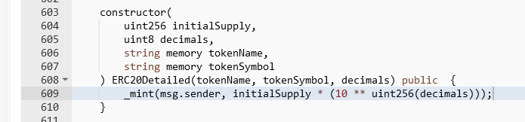

* **Recommendation**

We recommend the team to be transparent regarding the initial token distribution process, and the team shall make enough efforts to restrict the access of the private key, We also advise the client to adopt Multisig, Timelock, and/or DAO in the project to manage the specific account in this case.

* **Owner Role / Centralized Risk**

Only the owner role has authority over the functions shown below. Any compromise to the _owner account may allow the hacker to take advantage of this authority.

* lockByQuantity
* unlockByQuantity
* unlock
* **Recommendation**

The risk describes the current project design and potentially makes iterations to improve the security operation and level of decentralization, which in most cases cannot be resolved entirely at the present stage. We advise the client to carefully manage the privileged account's private key to avoid any potential risks of being hacked. In general, we strongly recommend centralized privileges or roles in the protocol be improved via a decentralized mechanism or smart-contract-based accounts with enhanced security practices, e.g., multi-signature wallets.

# **Low severity issues**

* **Improper Usage of public and external Type**

**public functions that are never called by the contract could be declared as external. external functions are more efficient than public functions.**

* lockByQuantity
* unlockByQuantity
* transferWithLock
* unlock
* **Recommendation**

**Consider using the external attribute for public functions that are never called within the contract.**

* **Unlocked Pragma Used**

Contracts should be deployed with the same compiler version and flags they have been tested with most. Locking the pragma helps ensure that contracts do not accidentally get deployed using, for example, the latest compiler which may have higher risks of undiscovered bugs. Contracts may also be deployed by others and the pragma indicates the compiler version intended by the original authors.

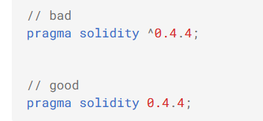

* **Recommendation**

Should lock pragmas to a specific compiler version.