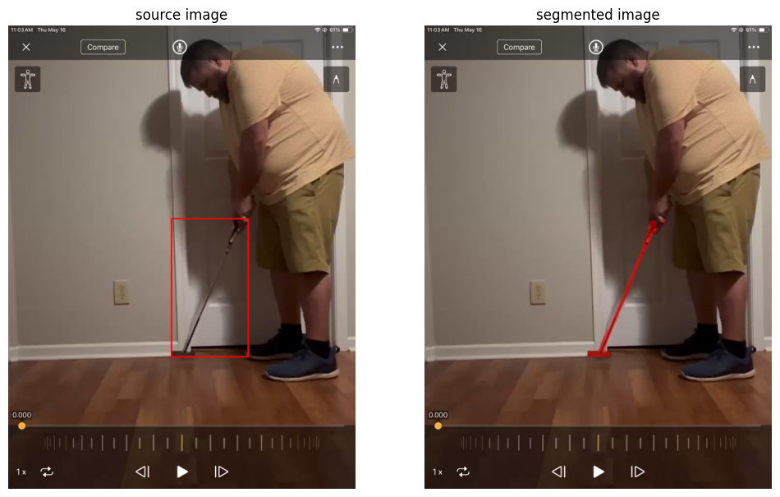
Movie 3
tilt angle using door segmentation mask: 0 degree
lie angle using golf segmentation mask: 66.713
corrected lie angle = 66.7
ground truth angle = 67 degree
difference b/w ground truth and predicted angle = 67-66.7= 0.3 degree


Movie 4:
tilt angle using door segmentation mask: -2.29 degree
lie angle using golf segmentation mask: 72.0234
corrected lie angle: 69.73 degree
ground truth angle: 70 degree
difference b/w ground truth and predicted angle = 70-69.73=0.27 degree

