Saeed Barcha

-:PostgreSQL:-

code#1
27/5/2022

switch to postgresql database from CMD
To start PostgreSQL
C:\Users\saeed>psql -U saeed -d postgres
Password for user saeed:
psql (14.2)
WARNING: Console code page (437) differs from Windows code page (1252)
8-bit characters might not work correctly. See psql reference
page "Notes for Windows users" for details.
Type "help" for help.

postgres=>

for help

postgres=> help
You are using psql, the command-line interface to PostgreSQL.
Type: \copyright for distribution terms
\h for help with SQL commands
\? for help with psql commands
\g or terminate with semicolon to execute query
\q to quit
postgres=>

postgres=> \help or postgres=> \?

Available help:
ABORT CREATE USER
ALTER AGGREGATE CREATE USER MAPPING
ALTER COLLATION CREATE VIEW
ALTER CONVERSION DEALLOCATE
ALTER DATABASE DECLARE
ALTER DEFAULT PRIVILEGES DELETE
ALTER DOMAIN DISCARD
ALTER EVENT TRIGGER DO
ALTER EXTENSION DROP ACCESS METHOD
ALTER FOREIGN DATA WRAPPER DROP AGGREGATE
ALTER FOREIGN TABLE DROP CAST
ALTER FUNCTION DROP COLLATION
ALTER GROUP DROP CONVERSION
ALTER INDEX DROP DATABASE
ALTER LANGUAGE DROP DOMAIN
ALTER LARGE OBJECT DROP EVENT TRIGGER
ALTER MATERIALIZED VIEW DROP EXTENSION
ALTER OPERATOR DROP FOREIGN DATA WRAPPER
ALTER OPERATOR CLASS DROP FOREIGN TABLE
ALTER OPERATOR FAMILY DROP FUNCTION
ALTER POLICY DROP GROUP
ALTER PROCEDURE DROP INDEX
ALTER PUBLICATION DROP LANGUAGE
ALTER ROLE DROP MATERIALIZED VIEW
ALTER ROUTINE DROP OPERATOR
ALTER RULE DROP OPERATOR CLASS
ALTER SCHEMA DROP OPERATOR FAMILY
ALTER SEQUENCE DROP OWNED
-- More --

To create user/role
postgres =>CREATE USER username WITH PASSWORD ‘password’ CREATEDB;

To show user/role list
postgres=> \du
Role name | Attributes | Member of
-----------+------------------------------------------------------------+-----------
postgres | Superuser, Create role, Create DB, Replication, Bypass RLS | {}
saeed | Create DB | {}

open PostgreSQL as saeed user
C:\Users\saeed>psql -U saeed -d postgres
Password for user saeed:1122
psql (14.2)
WARNING: Console code page (437) differs from Windows code page (1252)
8-bit characters might not work correctly. See psql reference
page "Notes for Windows users" for details.
Type "help" for help.

postgres=>

To create database
postgres=> CREATE DATABASE test;
CREATE DATABASE

To delete database
postgres=> DROP DATABASE test;
DROP DATABASE

To Show list of database
postgres=> \l
List of databases
Name | Owner | Encoding | Collate | Ctype | Access privileges
----------------+----------+----------+-----------------------+-----------------------+-----------------------
api | saeed | UTF8 | English_Pakistan.1252 | English_Pakistan.1252 |
generatebillty | saeed | UTF8 | English_Pakistan.1252 | English_Pakistan.1252 |
nodelogin | saeed | UTF8 | English_Pakistan.1252 | English_Pakistan.1252 |
postgres | postgres | UTF8 | English_Pakistan.1252 | English_Pakistan.1252 |
template0 | postgres | UTF8 | English_Pakistan.1252 | English_Pakistan.1252 | =c/postgres +
| | | | | postgres=CTc/postgres
template1 | postgres | UTF8 | English_Pakistan.1252 | English_Pakistan.1252 | =c/postgres +
| | | | | postgres=CTc/postgres
test | saeed | UTF8 | English_Pakistan.1252 | English_Pakistan.1252 |
users | postgres | UTF8 | English_Pakistan.1252 | English_Pakistan.1252 |
(8 rows)

postgres=>

To connect/ switch database
postgres=> \c test
You are now connected to database "test" as user "saeed".
test=>

To Quit
test=>\q

To clear cmd postgres screen
test=>\! cls

To clear cmd window screen
test=> cls

code#2
26/5/2022

Creating table👉

To Create table in the database test
test=> CREATE TABLE person(
test(> id INT,
test(> first_name VARCHAR(50),
test(> last_name VARCHAR(50),
test(> gender VARCHAR(7),
test(> date_of_birth DATE);
CREATE TABLE
test=>

To show the list of tables/relation in database
test=> \d
List of relations
Schema | Name | Type | Owner
--------+--------+-------+-------
public | person | table | saeed
(1 row)

test=>
To show the schema of the table/relation
test=> \d person;
Table "public.person"
Column | Type | Collation | Nullable | Default
---------------+-----------------------+-----------+----------+---------
id | integer | | |
first_name | character varying(50) | | |
last_name | character varying(50) | | |
gender | character varying(7) | | |
date_of_birth | date | | |

test=>

To delete a table
test=> DROP TABLE person;
DROP TABLE
test=>

improved person table by adding constraints
test=> DROP TABLE person;
DROP TABLE
test=> DROP TABLE person;
ERROR: table "person" does not exist
CREATE TABLE person(
id BIGSERIAL NOT NULL PRIMARY KEY,
first_name VARCHAR(50) NOT NULL,
last_name VARCHAR(50) NOT NULL,
gender VARCHAR(7) NOT NULL,
date_of_birth DATE NOT NULL,
email VARCHAR(150));
CREATE TABLE
test=>

test=> CREATE TABLE person(
test(> id BIGSERIAL NOT NULL PRIMARY KEY,
test(> first_name VARCHAR(50) NOT NULL,
test(> last_name VARCHAR(50) NOT NULL,
test(> gender VARCHAR(7) NOT NULL,
test(> date_of_birth DATE NOT NULL,
test(> email VARCHAR(150));
CREATE TABLE
test=>

To show the list of tables/relation in database
test=> \d
List of relations
Schema | Name | Type | Owner
--------+---------------+----------+-------
public | person | table | saeed
public | person_id_seq | sequence | saeed
(2 rows)

test=>
To show the schema of the table/relation
test=> \d person;
Table "public.person"
Column | Type | Collation | Nullable | Default
---------------+------------------------+-----------+----------+------------------------------------
id | bigint | | not null | nextval('person_id_seq'::regclass)
first_name | character varying(50) | | not null |
last_name | character varying(50) | | not null |
gender | character varying(7) | | not null |
date_of_birth | date | | not null |
email | character varying(150) | | |
Indexes:
"person_pkey" PRIMARY KEY, btree (id)

test=>

code#3
27/5/2022

Inserting values/records into the table👉

To insert data values in the table(person) in the database test don’t contains email
This row does not contain email that’s why we don’t include it.
test=> INSERT INTO person(
test(> first_name,
test(> last_name,
test(> gender,
tes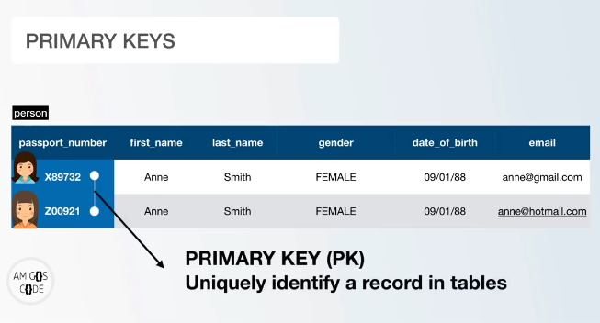t(> date_of_birth)
test-> VALUES ('saeed', 'barcha', 'male', date '1997-4-3');
INSERT 0 1
test=>

we can also add date without adding word date in before actual date value

To show records contains by this relation

Id column is auto increment able that’s why we don’t include it
test=> SELECT * FROM person;
id | first_name | last_name | gender | date_of_birth | email
----+------------+-----------+--------+---------------+-------
1 | saeed | barcha | male | 1997-04-03 |
(1 row)

test=>

To insert data values in all the columns of the table(person)
test=> INSERT INTO person(
test(> first_name,
test(> last_name,
test(> gender,
test(> date_of_birth,
test(> email)
test-> VALUES ('saeed', 'barcha', 'male', date '1997-4-3', 'saeed@gmail.com');
INSERT 0 1

To show records contains by this relation
test=> select * from person;
id | first_name | last_name | gender | date_of_birth | email
----+------------+-----------+--------+---------------+-----------------
1 | saeed | barcha | male | 1997-04-03 |
2 | saeed | barcha | male | 1997-04-03 |
3 | saeed | barcha | male | 1997-04-03 | saeed@gmail.com
(3 rows)

test=>

code#4
27/5/2022

Generate 1000 rows with Mockaroo 👉

Mockaroo is a web tool used to generate random data to any database

>open www.mobkaroo.com

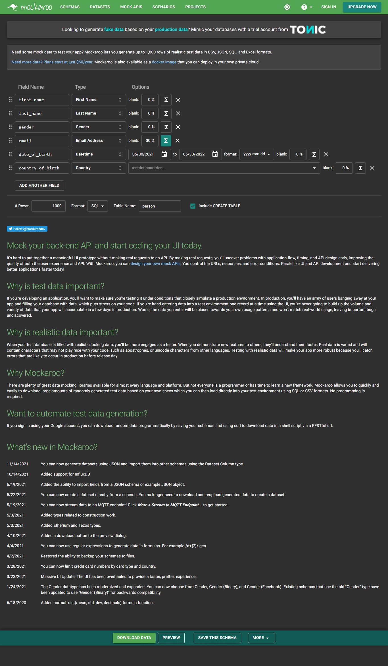

We can read data from file using \i command
File address
test=> \i C:/Users/saeed/Downloads/person.sql

File contains data
create table person (
id BIGSERIAL NOT NULL PRIMARY KEY,
first_name VARCHAR(50) NOT NULL,
last_name VARCHAR(50) NOT NULL,
gender VARCHAR(50) NOT NULL,
email VARCHAR(50),
date_of_birth DATE NOT NULL,
country_of_birth VARCHAR(150) NOT NULL
);
insert into person (first_name, last_name, gender, email, date_of_birth, country_of_birth) values ('Madelon', 'Longland', 'Female', null, '2022-05-05', 'Kazakhstan');
insert into person (first_name, last_name, gender, email, date_of_birth, country_of_birth) values ('Cicely', 'Dautry', 'Female', null, '2021-09-06', 'Iran');
insert into person (first_name, last_name, gender, email, date_of_birth, country_of_birth) values ('Ivett', 'Hugnet', 'Genderqueer', null, '2022-05-03', 'Sweden');
insert into person (first_name, last_name, gender, email, date_of_birth, country_of_birth) values ('Adey', 'Eidelman', 'Female', 'aeidelman3@toplist.cz', '2021-06-21', 'Nigeria');
insert into person (first_name, last_name, gender, email, date_of_birth, country_of_birth) values ('Trevor', 'Fenech', 'Male', 'tfenech4@xrea.com', '2021-11-10', 'Peru');
insert into person (first_name, last_name, gender, email, date_of_birth, country_of_birth) values ('Geralda', 'Leighton', 'Female', 'gleighton5@fda.gov', '2022-03-23', 'Philippines');

To show all the data from the table
test=> SELECT * FROM person;
id | first_name | last_name | gender | email | date_of_birth | country_of_birth
------+---------------+--------------------+-------------+----------------------------------------+---------------+--------------------------
1 | Madelon | Longland | Female | | 2022-05-05 | Kazakhstan
2 | Cicely | Dautry | Female | | 2021-09-06 | Iran
3 | Ivett | Hugnet | Genderqueer | | 2022-05-03 | Sweden
4 | Adey | Eidelman | Female | aeidelman3@toplist.cz | 2021-06-21 | Nigeria
5 | Trevor | Fenech | Male | tfenech4@xrea.com | 2021-11-10 | Peru
6 | Geralda | Leighton | Female | gleighton5@fda.gov | 2022-03-23 | Philippines

code#5
27/5/2022

SELECT FROM👉

To show all the data from the table person1
* is used to select all the columns from the table and show all the records

test=> select * from person1;
id | first_name | last_name | gender | date_of_birth | email
----+------------+-----------+--------+---------------+--------------------
1 | saeed | barcha | male | 1997-04-03 |
2 | saeed | barcha | male | 1997-04-03 | saeed@gamil.com
3 | noor | khan | male | 1977-04-03 | noorkhan@gamil.com
4 | alisha | khan | female | 2007-04-03 | alisha@gamil.com
5 | alisha | khan | female | 2007-04-03 |
(5 rows)

To show a single column(first_name) from the table person1
test=> select first_name from person1;
first_name
------------
saeed
saeed
noor
alisha
alisha
(5 rows)

test=>

To show only two column(first_name and last_name) from the table person1
test=> SELECT first_name, last_name from person1;
first_name | last_name
------------+-----------
saeed | barcha
saeed | barcha
noor | khan
alisha | khan
alisha | khan
(5 rows)

test=>

To show (email) named column from the table person1
test=> SELECT email FROM person1;
email
--------------------

saeed@gamil.com
noorkhan@gamil.com
alisha@gamil.com

(5 rows)

test=>
code#6
9/6/2022

Order by👉

To show all the data from the table person1 by Ordering
Order takes a column and its auth is to show the result on the ASCENDING OR DESCENDING order

WE can sort any table taking one or more than one column
>mostly have to take single column

Ordering last_name column ASENDING ASC
ACS is default value
1,2,3,4,5,…
a,b,c,d,e,…

default test=> SELECT * FROM person1 ORDER BY last_name ASC ;

test=> SELECT * FROM person1 ORDER BY last_name ;
id | first_name | last_name | gender | date_of_birth | email
----+------------+-----------+--------+---------------+--------------------
1 | saeed | barcha | male | 1997-04-03 |
2 | saeed | barcha | male | 1997-04-03 | saeed@gamil.com
3 | noor | khan | male | 1977-04-03 | noorkhan@gamil.com
4 | alisha | khan | female | 2007-04-03 | alisha@gamil.com
5 | alisha | khan | female | 2007-04-03 |
(5 rows)

Ordering last_name column DESCENDING DESC
test=> SELECT * FROM person1 ORDER BY last_name DESC;
id | first_name | last_name | gender | date_of_birth | email
----+------------+-----------+--------+---------------+--------------------
3 | noor | khan | male | 1977-04-03 | noorkhan@gamil.com
4 | alisha | khan | female | 2007-04-03 | alisha@gamil.com
5 | alisha | khan | female | 2007-04-03 |
1 | saeed | barcha | male | 1997-04-03 |
2 | saeed | barcha | male | 1997-04-03 | saeed@gamil.com
(5 rows)

test=>

Ordering table taking two columns id, email
test=> select * from person1 order by id,email ASC;
id | first_name | last_name | gender | date_of_birth | email
----+------------+-----------+--------+---------------+--------------------
1 | saeed | barcha | male | 1997-04-03 |
2 | saeed | barcha | male | 1997-04-03 | saeed@gamil.com
3 | noor | khan | male | 1977-04-03 | noorkhan@gamil.com
4 | alisha | khan | female | 2007-04-03 | alisha@gamil.com
5 | alisha | khan | female | 2007-04-03 |
(5 rows)

Ordering table taking two columns email, id
test=> select * from person1 order by email,id ASC;
id | first_name | last_name | gender | date_of_birth | email
----+------------+-----------+--------+---------------+--------------------
4 | alisha | khan | female | 2007-04-03 | alisha@gamil.com
3 | noor | khan | male | 1977-04-03 | noorkhan@gamil.com
2 | saeed | barcha | male | 1997-04-03 | saeed@gamil.com
1 | saeed | barcha | male | 1997-04-03 |
5 | alisha | khan | female | 2007-04-03 |
(5 rows)

code#7
9/6/2022

Distinct👉

To show single column data from table
test=> select gender from person1;
gender
--------
male
male
male
female
female
(5 rows)

show Distinct/ different values from any column
test=> SELECT DISTINCT gender FROM person1;
gender
--------
female
male
(2 rows)

Using Distinct and order by DESC
test=> SELECT DISTINCT gender FROM person1 ORDER BY gender DESC;
gender
--------
male
female
(2 rows)
Using Distinct and order by ASC
test=> SELECT DISTINCT gender FROM person1 ORDER BY gender DESC;
gender
--------
Female
male

(2 rows)

Show data from the table on the basis of two distinct values
This will consider only the first column and ignore columns
test=> SELECT DISTINCT first_name, email FROM person1;
first_name | email
------------+--------------------
saeed | saeed@gamil.com
alisha | alisha@gamil.com
saeed |
alisha |
noor | noorkhan@gamil.com
(5 rows)

test=> SELECT DISTINCT email, first_name FROM person1;
email | first_name
--------------------+------------
noorkhan@gamil.com | noor
| saeed
| alisha
saeed@gamil.com | saeed
alisha@gamil.com | alisha
(5 rows)

code#8
9/6/2022

WHERE CLAUSE and AND, OR👉

WHERE
To show data from the table by filtering it( where gender = male)
test=> SELECT * FROM person1 WHERE gender='male' ;
0 | barcha | male | 1997-04-03 | saeed@gamil.com
3 | noor | khan | male | 1977-04-03 | noorkhan@gamil.com
(3 rows)

To show data from the table by filtering it( where gender =’female’)
test=> SELECT * FROM person1 WHERE gender='female';
id | first_name | last_name | gender | date_of_birth | email
----+------------+-----------+--------+---------------+------------------
4 | alisha | khan | female | 2007-04-03 | alisha@gamil.com
5 | alisha | khan | female | 2007-04-03 |
(2 rows)

AND =:
To show data from the table by filtering it( where gender =’ male’ AND first_name=’saeed’)
test=> SELECT * FROM person1 WHERE gender='male' AND first_name='saeed';
id | first_name | last_name | gender | date_of_birth | email
----+------------+-----------+--------+---------------+-----------------
1 | saeed | barcha | male | 1997-04-03 |
2 | saeed | barcha | male | 1997-04-03 | saeed@gamil.com
(2 rows)

AND =:
To show data from the table by filtering it( where gender =’ female’ AND first_name=’saeed’)
test=> SELECT * FROM person1 WHERE gender='female' AND first_name='saeed';
id | first_name | last_name | gender | date_of_birth | email
----+------------+-----------+--------+---------------+-------
(0 rows)

OR
To show data from the table by filtering it( where gender =’ female’ AND ( first_name=’saeed’ OR last_name=’khan’)

test=> SELECT * FROM person1 WHERE gender='female' AND (first_name='saeed' OR last_name='khan');
id | first_name | last_name | gender | date_of_birth | email
----+------------+-----------+--------+---------------+------------------
4 | alisha | khan | female | 2007-04-03 | alisha@gamil.com
5 | alisha | khan | female | 2007-04-03 |
(2 rows)

test=>

AND AND
To show data from the table by filtering it( where gender =’ female’ AND first_name=’saeed’ AND last_name=’khan’;
test=> SELECT * FROM person1 WHERE gender='male' AND first_name='saeed' AND last_name='barcha';
id | first_name | last_name | gender | date_of_birth | email
----+------------+-----------+--------+---------------+-----------------
1 | saeed | barcha | male | 1997-04-03 |
2 | saeed | barcha | male | 1997-04-03 | saeed@gamil.com
(2 rows)

OR OR
To show data from the table by filtering it(gender='female' OR first_name='saeed' or last_name='barcha');

test=> SELECT * FROM person1 WHERE gender='female' OR first_name='saeed' or last_name='barcha';
id | first_name | last_name | gender | date_of_birth | email
----+------------+-----------+--------+---------------+------------------
1 | saeed | barcha | male | 1997-04-03 |
2 | saeed | barcha | male | 1997-04-03 | saeed@gamil.com
4 | alisha | khan | female | 2007-04-03 | alisha@gamil.com
5 | alisha | khan | female | 2007-04-03 |
(4 rows)

code#9
Comparison operators👉
9/6/2022

=
test=> SELECT 1 = 1;
?column?
----------
t
(1 row)

<
test=> SELECT 1 < 2;
?column?
----------
t
(1 row)

<=
test=> SELECT 1 <= 1;
?column?
----------
t
(1 row)

>
test=> SELECT 1 > 1;
?column?
----------
f
(1 row)

>=
test=> SELECT 1 >= 1;
?column?
----------
t
(1 row)

>=
test=> SELECT 1 >= 2;
?column?
----------
f
(1 row)

<> not equal to
test=> SELECT 1 <> 2;
?column?
----------
t
(1 row)

<> not equal to
test=> SELECT 1 <> 1;
?column?
----------
f
(1 row)

test=>

<=
test=> select 'saeed' <= 'saeed';
?column?
----------
t
(1 row)

code#10
9/6/2022

Limit Offset and Fetch👉

Limit
To show first 3 records from person table
test=> SELECT * FROM person1 LIMIT 3;
id | first_name | last_name | gender | date_of_birth | email
----+------------+-----------+--------+---------------+--------------------
1 | saeed | barcha | male | 1997-04-03 |
2 | saeed | barcha | male | 1997-04-03 | saeed@gamil.com
3 | noor | khan | male | 1977-04-03 | noorkhan@gamil.com
(3 rows)

Offset
To show records ignoring / skipping first 2 records
test=> SELECT * FROM person1 OFFSET 2;
id | first_name | last_name | gender | date_of_birth | email
----+------------+-----------+--------+---------------+--------------------
3 | noor | khan | male | 1977-04-03 | noorkhan@gamil.com
4 | alisha | khan | female | 2007-04-03 | alisha@gamil.com
5 | alisha | khan | female | 2007-04-03 |
(3 rows)

Limit and Offset
Show 2 records skipping first 2 records
test=> SELECT * FROM person1 OFFSET 2 LIMIT 2;
id | first_name | last_name | gender | date_of_birth | email
----+------------+-----------+--------+---------------+--------------------
3 | noor | khan | male | 1977-04-03 | noorkhan@gamil.com
4 | alisha | khan | female | 2007-04-03 | alisha@gamil.com
(2 rows)

FETCH
test=> SELECT * FROM person1 FETCH FIRST ROW ONLY;
id | first_name | last_name | gender | date_of_birth | email
----+------------+-----------+--------+---------------+-------
1 | saeed | barcha | male | 1997-04-03 |
(1 row)

Actually there is not any word in postgresql for limit
OFFSET and FETCH
Show 2 records skipping first 2 records (OFFSET 2 FETCH FIRST 2 ROW ONLY)

test=> SELECT * FROM person1 OFFSET 2 FETCH FIRST 2 ROW ONLY;
id | first_name | last_name | gender | date_of_birth | email
----+------------+-----------+--------+---------------+--------------------
3 | noor | khan | male | 1977-04-03 | noorkhan@gamil.com
4 | alisha | khan | female | 2007-04-03 | alisha@gamil.com
(2 rows)

Show 2 records skipping first 2 records (OFFSET 2 FETCH FIRST 5 ROW ONLY)

test=> SELECT * FROM person1 OFFSET 2 FETCH FIRST 5 ROW ONLY;
id | first_name | last_name | gender | date_of_birth | email
----+------------+-----------+--------+---------------+--------------------
3 | noor | khan | male | 1977-04-03 | noorkhan@gamil.com
4 | alisha | khan | female | 2007-04-03 | alisha@gamil.com
5 | alisha | khan | female | 2007-04-03 |
(3 rows)

code#11
IN Operater👉
9/6/2022

This operator work like OR operator but IN reduce code

OR
test=> SELECT * FROM person1 WHERE gender='male' OR gender='female';
id | first_name | last_name | gender | date_of_birth | email
----+------------+-----------+--------+---------------+--------------------
1 | saeed | barcha | male | 1997-04-03 |
2 | saeed | barcha | male | 1997-04-03 | saeed@gamil.com
3 | noor | khan | male | 1977-04-03 | noorkhan@gamil.com
4 | alisha | khan | female | 2007-04-03 | alisha@gamil.com
5 | alisha | khan | female | 2007-04-03 |
(5 rows)

IN both are same
test=> SELECT * FROM person1 WHERE gender IN ('female', 'male');
id | first_name | last_name | gender | date_of_birth | email
----+------------+-----------+--------+---------------+--------------------
1 | saeed | barcha | male | 1997-04-03 |
2 | saeed | barcha | male | 1997-04-03 | saeed@gamil.com
3 | noor | khan | male | 1977-04-03 | noorkhan@gamil.com
4 | alisha | khan | female | 2007-04-03 | alisha@gamil.com
5 | alisha | khan | female | 2007-04-03 |
(5 rows)

code#12
BETWEEN👉
10/6/2022

To Select data in between Range
USING BIGINT
est=> SELECT * FROM person1
test-> WHERE id
test-> BETWEEN BIGINT '2' AND '4';
id | first_name | last_name | gender | date_of_birth | email
----+------------+-----------+--------+---------------+--------------------
2 | saeed | barcha | male | 1997-04-03 | saeed@gamil.com
3 | noor | khan | male | 1977-04-03 | noorkhan@gamil.com
4 | alisha | khan | female | 2007-04-03 | alisha@gamil.com
(3 rows)

INT
test=> SELECT * FROM person1
test-> WHERE id
test-> BETWEEN INT '2' AND '3';
id | first_name | last_name | gender | date_of_birth | email
----+------------+-----------+--------+---------------+--------------------
2 | saeed | barcha | male | 1997-04-03 | saeed@gamil.com
3 | noor | khan | male | 1977-04-03 | noorkhan@gamil.com
(2 rows)

WITHOUT INT/BIGITN
test=> SELECT * FROM person1
test-> WHERE id
test-> BETWEEN '2' AND '3';
id | first_name | last_name | gender | date_of_birth | email
----+------------+-----------+--------+---------------+--------------------
2 | saeed | barcha | male | 1997-04-03 | saeed@gamil.com
3 | noor | khan | male | 1977-04-03 | noorkhan@gamil.com
(2 rows)

To Select data in between Range given date_of_birth

test=> SELECT * FROM person1
test-> WHERE date_of_birth
test-> BETWEEN DATE '1997-04-03' AND '2007-04-03';
id | first_name | last_name | gender | date_of_birth | email
----+------------+-----------+--------+---------------+------------------
1 | saeed | barcha | male | 1997-04-03 |
2 | saeed | barcha | male | 1997-04-03 | saeed@gamil.com
4 | alisha | khan | female | 2007-04-03 | alisha@gamil.com
5 | alisha | khan | female | 2007-04-03 |
(4 rows)

code#13
Like and ILike👉
10/6/2022

To select data from a column with the same pattern
Like
To select values from column email ends with (%.com)
test=> SELECT * FROM person1
test-> WHERE email LIKE '%.com';
id | first_name | last_name | gender | date_of_birth | email
----+------------+-----------+--------+---------------+--------------------
2 | saeed | barcha | male | 1997-04-03 | saeed@gamil.com
3 | noor | khan | male | 1977-04-03 | noorkhan@gamil.com
4 | alisha | khan | female | 2007-04-03 | alisha@gamil.com
(3 rows)

To select values from column email starts with (s%)
test=> SELECT * FROM person1
test-> WHERE email LIKE 's%';
id | first_name | last_name | gender | date_of_birth | email
----+------------+-----------+--------+---------------+-----------------
2 | saeed | barcha | male | 1997-04-03 | saeed@gamil.com
(1 row)

To select values from column email ends with (%@gmail.com)
test=> SELECT * FROM person1
test-> WHERE email LIKE '%@gamil.com';
id | first_name | last_name | gender | date_of_birth | email
----+------------+-----------+--------+---------------+--------------------
2 | saeed | barcha | male | 1997-04-03 | saeed@gamil.com
3 | noor | khan | male | 1977-04-03 | noorkhan@gamil.com
4 | alisha | khan | female | 2007-04-03 | alisha@gamil.com
(3 rows)

To select values from column email contains this pattern in between (%@gmail.%)
test=> SELECT * FROM person1
test-> WHERE email LIKE '%@gamil.%';
id | first_name | last_name | gender | date_of_birth | email
----+------------+-----------+--------+---------------+--------------------
2 | saeed | barcha | male | 1997-04-03 | saeed@gamil.com
3 | noor | khan | male | 1977-04-03 | noorkhan@gamil.com
4 | alisha | khan | female | 2007-04-03 | alisha@gamil.com
(3 rows)

To select values from column email which contains a specified number of characters before @(_____@%)
Underscore is equal to one character
test=> SELECT * FROM person1
test-> WHERE email LIKE '_____@%';
id | first_name | last_name | gender | date_of_birth | email
----+------------+-----------+--------+---------------+-----------------
2 | saeed | barcha | male | 1997-04-03 | saeed@gamil.com
(1 row)

To select values from column email which contains a specified number of characters after . (___.%)

test-> WHERE email LIKE '%.___';
id | first_name | last_name | gender | date_of_birth | email
----+------------+-----------+--------+---------------+--------------------
2 | saeed | barcha | male | 1997-04-03 | saeed@gamil.com
3 | noor | khan | male | 1977-04-03 | noorkhan@gamil.com
4 | alisha | khan | female | 2007-04-03 | alisha@gamil.com
(3 rows)

ILike :>same value for both
ILkie ignore the case sensitivity
To select values from column email which starts with small or capital s/S (S% / s%)

(s%)
test=> SELECT * FROM person1
test-> WHERE email ILIKE 's%';
id | first_name | last_name | gender | date_of_birth | email
----+------------+-----------+--------+---------------+-----------------
2 | saeed | barcha | male | 1997-04-03 | saeed@gamil.com
(1 row)

(S%)

test=> SELECT * FROM person1
test-> WHERE email ILIKE 'S%';
id | first_name | last_name | gender | date_of_birth | email
----+------------+-----------+--------+---------------+-----------------
2 | saeed | barcha | male | 1997-04-03 | saeed@gamil.com
(1 row)

code#14
Group By👉
10/6/2022

To show the number of people who are born in these countries

test=> SELECT country_of_birth FROM person ;
country_of_birth
--------------------------
Kazakhstan
Iran
Sweden
Nigeria
Peru
Philippines

To show the number of people who are born in these countries (COUNT(*) GROUP BY)
The count () function returns a column that contains the number of people born in these countries.
test=> SELECT country_of_birth, COUNT(*) FROM person GROUP BY country_of_birth;
country_of_birth | count
--------------------------+-------
Bangladesh | 4
Indonesia | 112
Venezuela | 7
Cameroon | 1
COUNT(*) , GROUP BY and ORDER BY .
To show the number of people who are born in these countries and ordering it (COUNT(*) GROUP BY)
test=> SELECT country_of_birth, COUNT(*) FROM person GROUP BY country_of_birth ORDER BY country_of_birth;
country_of_birth | count
--------------------------+-------
Afghanistan | 2
Albania | 7
Angola | 1
Antigua and Barbuda | 1
Argentina | 12
Armenia | 3

FETCH FIRST 5 ROWS ONLY
To show the number of people who are born in these countries and ordering it (COUNT(*) GROUP BY ORDER BY)
test=> SELECT country_of_birth, COUNT(*) FROM person GROUP BY country_of_birth ORDER BY country_of_birth FETCH FIRST 5 ROW ONLY;
country_of_birth | count
---------------------+-------
Afghanistan | 2
Albania | 7
Angola | 1
Antigua and Barbuda | 1
Argentina | 12
(5 rows)

test=>

code#15
10/6/2022

Group By Having COUNT(*) 👉

Having keyword works with GROUP BY keyword

To show the number of people who are born in these countries and greater than 100 in number only
test=> SELECT country_of_birth, COUNT (*) FROM person GROUP BY country_of_birth HAVING COUNT(*) > 100 ORDER BY country_of_birth;
country_of_birth | count
------------------+-------
China | 195
Indonesia | 112
(2 rows)

To show the number of people who are born in these countries and greater or equal to 40
test=> SELECT country_of_birth, COUNT(*) FROM person GROUP BY country_of_birth HAVING COUNT(*) >= 40 ORDER BY country_of_birth;
country_of_birth | count
------------------+-------
Brazil | 47
China | 195
Indonesia | 112
Philippines | 46
Russia | 65

code#16
10/6/2022

Aggergate functions 👉

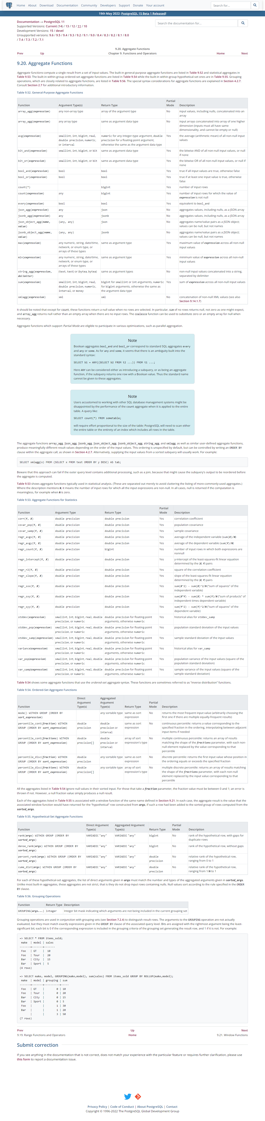
create table car (
id BIGSERIAL NOT NULL PRIMARY KEY,
make VARCHAR(50) NOT NULL,
model VARCHAR(50) NOT NULl,
price NUMERIC(19,2) NOT NULl
);
insert into car (id, make, model, price) values (1, 'Lexus', 'SC', 41288);
insert into car (id, make, model, price) values (2, 'Ford', 'Mustang', 13163);
insert into car (id, make, model, price) values (3, 'Scion', 'xB', 34718);
insert into car (id, make, model, price) values (4, 'Cadillac', 'CTS', 39490);
insert into car (id, make, model, price) values (5, 'Suzuki', 'Swift', 46830);

Calculating Min, Max and Average

Finding minimum value from the price column
test=> SELECT MIN(price) FROM car;
min
----------
10322.00
(1 row)

Finding maximum value from the price column
test=> SELECT MAX(price) FROM car;
max
----------
98482.00
(1 row)

Finding Average value of the price column
test=> SELECT AVG(price) FROM car;
avg
--------------------
52500.770000000000
(1 row)

Round (average value)
test=> SELECT ROUND(AVG(price)) FROM car;
round
-------
52501
(1 row)

GROUG BY on make and model of table car
We will make the groups of the car which have the same values in the make and model column and find the MIN value of the price
test=> SELECT make, model, MIN(price) FROM car GROUP BY make, model;
make | model | min
---------------+---------------------+----------
Toyota | Land Cruiser | 21866.00
Ford | ZX2 | 74914.00
Mercedes-Benz | S-Class | 42408.00
Mitsubishi | RVR | 30243.00
Ford | Courier | 50316.00
Chevrolet | 3500 | 11623.00
Mercury | Grand Marquis | 10322.00
Pontiac | LeMans | 48395.00

GROUG BY on make and model of table car
We will make the groups of the car which have the same values in the make and model column and find the MIN, MAX, and AVG values of the price
test=> SELECT make, model, MIN(price), MAX(price), AVG(price) FROM car GROUP BY make, model;
make | model | min | max | avg
---------------+---------------------+----------+----------+------------------------
Toyota | Land Cruiser | 21866.00 | 21866.00 | 21866.000000000000 Ford | ZX2 | 74914.00 | 74914.00 | 74914.000000000000 Mercedes-Benz | S-Class | 42408.00 | 42408.00 | 42408.000000000000 Mitsubishi | RVR | 30243.00 | 30243.00 | 30243.000000000000 Ford | Courier | 50316.00 | 50316.00 | 50316.000000000000 Chevrolet

GROUG BY on make and model of table car
We will make the groups of the car which have the same values in the make and model column and find the MIN, MAX, and ROUND(AVG) values of the price
^Ctest=> SELECT make, model, MIN(price), MAX(price), ROUND(AVG(price)) FROM car GROUP BY make, model;
make | model | min | max | round
---------------+---------------------+----------+----------+-------
Toyota | Land Cruiser | 21866.00 | 21866.00 | 21866
Ford | ZX2 | 74914.00 | 74914.00 | 74914
Mercedes-Benz | S-Class | 42408.00 | 42408.00 | 42408
Mitsubishi | RVR | 30243.00 | 30243.00 | 30243
Ford | Courier | 50316.00 | 50316.00 | 50316
Chevrolet | 3500 | 11623.00 | 11623.00 | 11623
Mercury | Grand Marquis | 10322.00 | 10322.00 | 10322

Finding SUM of the values present in the price column
test=> SELECT SUM(price) FROM car;
sum
------------
5250077.00
(1 row)

code#17
10/6/2022

Basics of Arthematics Operater👉

+
test=> SELECT 1+2;
?column?
----------
3
(1 row)

-
test=> SELECT 1-2;
?column?
----------
-1
(1 row)

/
test=> SELECT 1/2;
?column?
----------
0
(1 row)

%
test=> SELECT 1*2;
?column?
----------
2

%
test=> SELECT 1%2;
?column?
----------
1
(1 row)

test=> SELECT 4%2;
?column?
----------
0
(1 row)

test=> SELECT 6%2;
?column?
----------
0
(1 row)

test=> SELECT 5%2;
?column?
----------
1
(1 row)

Power(103)
test=> SELECT 10^3;
?column?
----------
1000
(1 row)

Factorial
test=> SELECT 10!;

code#18
11/6/2022

Arthematics Operater Round👉
Showing 10% of price of car
test=> SELECT id, make, model, price, price* .10 FROM car;
id | make | model | price | ?column?
-----+---------------+---------------------+----------+-----------
1 | Lexus | SC | 41288.00 | 4128.8000
2 | Ford | Mustang | 13163.00 | 1316.3000
3 | Scion | xB | 34718.00 | 3471.8000
4 | Cadillac | CTS | 39490.00 | 3949.0000
5 | Suzuki | Swift | 46830.00 | 4683.0000
6 | Ford | Econoline E150 | 53755.00 | 5375.5000
7 | Ford | Expedition | 80264.00 | 8026.4000
8 | Lexus | LX | 56685.00 | 5668.5000

TO show two numbers after decimal point
id | make | model | price | discount_10_per
-----+---------------+---------------------+----------+-----------------
1 | Lexus | SC | 41288.00 | 4128.80
2 | Ford | Mustang | 13163.00 | 1316.30
3 | Scion | xB | 34718.00 | 3471.80
4 | Cadillac | CTS | 39490.00 | 3949.00
5 | Suzuki | Swift | 46830.00 | 4683.00

Round up 10% of price of car
test=> SELECT id, make, model, price, ROUND (price * .10) FROM car;
id | make | model | price | round
-----+---------------+---------------------+----------+-------
1 | Lexus | SC | 41288.00 | 4129
2 | Ford | Mustang | 13163.00 | 1316
3 | Scion | xB | 34718.00 | 3472
4 | Cadillac | CTS | 39490.00 | 3949

Adding Column name to new added column
test=> SELECT id, make, model, price, ROUND (price * .10) discount_10_per FROM car;
id | make | model | price | discount_10_per
-----+---------------+---------------------+----------+-----------------
1 | Lexus | SC | 41288.00 | 4129
2 | Ford | Mustang | 13163.00 | 1316
3 | Scion | xB | 34718.00 | 3472

Renaming column name price to original price
id | make | model | original_price | discount_10_per
-----+---------------+---------------------+----------------+-----------------
1 | Lexus | SC | 41288.00 | 4129
2 | Ford | Mustang | 13163.00 | 1316
3 | Scion | xB | 34718.00 | 3472
4 | Cadillac | CTS | 39490.00 | 3949

To Show amount subtracting discounted value from original value

id | make | model | original_price | discount_10_per | price_after_less_10_per
-----+---------------+---------------------+----------------+-----------------+-------------------------
1 | Lexus | SC | 41288.00 | 4129 | 37159
2 | Ford | Mustang | 13163.00 | 1316 | 11847
3 | Scion | xB | 34718.00 | 3472 | 31246
4 | Cadillac | CTS | 39490.00 | 3949 |

code#19
11/6/2022

Coalesce👉
This key word is use to handle empty values in column. This works when there is not any default value present.

This function takes first parameter
test=> select COALESCE (1);
coalesce
----------
1
(1 row)

Adding column name
This function takes first parameter
test=> select COALESCE (1) AS number;
number
--------
1
(1 row)

Takes value that is not null from left to right
test=> select COALESCE (null, 3 , null, 1) AS number;
number
--------
3
(1 row)

Replacing empty values in column email with 'Email not Provided'
test=> SELECT id, first_name, COALESCE(email, 'Email not Provided') FROM person1;
id | first_name | coalesce
----+------------+--------------------
1 | saeed | Email not Provided
2 | saeed | saeed@gamil.com
3 | noor | noorkhan@gamil.com
4 | alisha | alisha@gamil.com
5 | alisha | Email not Provided

test=> SELECT COALESCE(email, 'Email not Provided') FROM person1;
coalesce
--------------------
Email not Provided
saeed@gamil.com
noorkhan@gamil.com
alisha@gamil.com
Email not Provided
(5 rows)
code#20
11/6/2022

NULLIF👉

- NULLIF function takes two arguments and returns the first argument if the second argument is not equal to the first argument
- If both are equal return null

Divide by 0 occurs an error to handle this we have NULLIF function
test=> SELECT 10/0;
ERROR: division by zero
test=>

fixed that error with NULLIF function
test=> SELECT COALESCE(10 / NULLIF(0,0), 0) ;
coalesce
----------
0
(1 row)

code#21
11/6/2022

Timestamps and Dates👉

NOW() function to print date of present day
test=> select NOW( );
now
-------------------------------
2022-06-11 16:35:17.386602+05
(1 row)

To Print only date
test=> select NOW( )::DATE;
now
------------
2022-06-11
(1 row)

To Print only time
test=> select NOW()::TIME;
now
-----------------
16:38:14.078921
(1 row)
code#22
11/6/2022

Adding and Subtracting with Dates👉
Day month years name is not case sensitive and writing or without s with these names will work perfectly

Subtracting
Subtracting 1 year from today’s date and time
test=> SELECT NOW() - INTERVAL '1 YEAR';
?column?
-------------------------------
2021-06-11 16:45:06.471763+05
(1 row)

Subtracting 7 month from todays date and time
test=> SELECT NOW() - INTERVAL '7 MONTH';
?column?
-------------------------------
2021-11-11 16:47:05.275156+05
(1 row)

For only date and time
test=> SELECT NOW()::DATE - INTERVAL '7 MONTH';
?column?
---------------------
2021-11-11 00:00:00
(1 row)

For only date
test=> SELECT (NOW() - INTERVAL '5 DAY'):: DATE;
date
------------
2022-06-06
(1 row)

Subtracting 3 Day from todays date and time
test=> SELECT NOW()::DATE - INTERVAL '3 DAY';
?column?
---------------------
2022-06-08 00:00:00
(1 row)

Adding
Adding 5 days
test=> SELECT (NOW() + INTERVAL '5 DAY'):: DATE;
date
------------
2022-06-16
(1 row)

Adding month
test=> SELECT (NOW() + INTERVAL '5 month'):: DATE;
date
------------
2022-11-11
(1 row)

Adding years
test=> SELECT (NOW() + INTERVAL '5 years'):: DATE;
date
------------
2027-06-11
(1 row)

code#23
11/6/2022

Extracting Fields from NOW( ) 👉

Extracting year from now( ) function
test=> SELECT EXTRACT(YEAR FROM NOW());
extract
---------
2022
(1 row)

Extracting MONTH from now ( ) function
test=> SELECT EXTRACT (MONTH FROM NOW ());
extract
---------
6
(1 row)

Extracting WEEK from now ( ) function
test=> SELECT EXTRACT (DOW FROM NOW ());
extract
---------
6
(1 row)

Extracting DAY from now ( ) function
test=> SELECT EXTRACT (DAY FROM NOW());
extract
---------
11
(1 row)

code#24
11/6/2022

AGE()👉
AGE function takes two parameters first one is the present date and the second one is an actual date we want to find the age

Finding the age of persons in person1 and person table
person1
test=> SELECT id, first_name, last_name, email, date_of_birth, AGE(NOW(), date_of_birth) FROM person1;
id | first_name | last_name | email | date_of_birth | age
----+------------+-----------+--------------------+---------------+----------------------------------------
1 | saeed | barcha | | 1997-04-03 | 25 years 2 mons 8 days 17:27:28.336108
2 | saeed | barcha | saeed@gamil.com | 1997-04-03 | 25 years 2 mons 8 days 17:27:28.336108
3 | noor | khan | noorkhan@gamil.com | 1977-04-03 | 45 years 2 mons 8 days 17:27:28.336108
4 | alisha | khan | alisha@gamil.com | 2007-04-03 | 15 years 2 mons 8 days 17:27:28.336108
5 | alisha | khan | | 2007-04-03 | 15 years 2 mons 8 days 17:27:28.336108
(5 rows)

person
test=> SELECT first_name, date_of_birth, AGE(NOW(), date_of_birth) FROM person;
first_name | date_of_birth | age
---------------+---------------+---------------------------------
Madelon | 2022-05-05 | 1 mon 6 days 17:31:25.586517
Cicely | 2021-09-06 | 9 mons 5 days 17:31:25.586517
Ivett | 2022-05-03 | 1 mon 8 days 17:31:25.586517
Adey | 2021-06-21 | 11 mons 20 days 17:31:25.586517
Trevor | 2021-11-10 | 7 mons 1 day 17:31:25.586517

ADDING age column name
test=> SELECT first_name, date_of_birth, AGE(NOW(), date_of_birth) AS actual_age FROM person;
first_name | date_of_birth | actual_age
---------------+---------------+--------------------------------
Madelon | 2022-05-05 | 1 mon 6 days 17:33:37.50799
Cicely | 2021-09-06 | 9 mons 5 days 17:33:37.50799
Ivett | 2022-05-03 | 1 mon 8 days 17:33:37.50799
Adey | 2021-06-21 | 11 mons 20 days 17:33:37.50799

code#25
11/6/2022
PRIMARY KEY👉

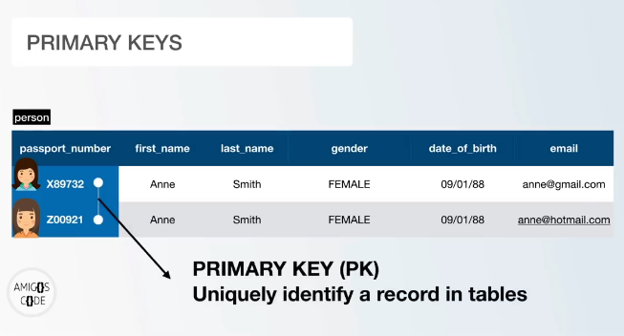

Adding primary while creating table
test=> CREATE TABLE students (
test(> id BIGSERIAL NOT NULL PRIMARY KEY,
test(> name VARCHAR(40) NOT NULL,
test(> f_name VARCHAR(40) NOT NULL,
test(> email VARCHAR(50) UNIQUE
test(>);
CREATE TABLE

test=> \d students;
Table "public.students"
Column | Type | Collation | Nullable | Default
--------+-----------------------+-----------+----------+--------------------------------------
id | bigint | | not null | nextval('students_id_seq'::regclass)
name | character varying(40) | | not null |
f_name | character varying(40) | | not null |
email | character varying(50) | | |
Indexes:
"students_pkey" PRIMARY KEY, btree (id)
"students_email_key" UNIQUE CONSTRAINT, btree (email)

ALTER TABLE
DELETING PRIMARY KEY
test=> ALTER TABLE students DROP CONSTRAINT students_pkey;
ALTER TABLE
test=> \d students;
Table "public.students"
Column | Type | Collation | Nullable | Default
--------+-----------------------+-----------+----------+--------------------------------------
id | bigint | | not null | nextval('students_id_seq'::regclass)
name | character varying(40) | | not null |
f_name | character varying(40) | | not null |
email | character varying(50) | | |
Indexes:
"students_email_key" UNIQUE CONSTRAINT, btree (email)

ALTER TABLE
Adding PRIMARY KEY
test=> ALTER TABLE students ADD PRIMARY KEY (id);
ALTER TABLE
test=> \d students;
Table "public. Students"
Column | Type | Collation | Nullable | Default
--------+-----------------------+-----------+----------+--------------------------------------
id | bigint | | not null | nextval('students_id_seq'::regclass)
name | character varying(40) | | not null |
f_name | character varying(40) | | not null |
email | character varying(50) | | |
Indexes:
"students_pkey" PRIMARY KEY, btree (id)
"students_email_key" UNIQUE CONSTRAINT, btree (email)

code#26
11/6/2022
Unique Constraints👉
Unique constraints allow us to have unique values for a given column
In this case, column email will take null but not similar values
test=> CREATE TABLE students (
test(> id BIGSERIAL NOT NULL PRIMARY KEY,
test(> name VARCHAR(40) NOT NULL,
test(> f_name VARCHAR(40) NOT NULL,
test(> email VARCHAR(50) UNIQUE
test(>);
CREATE TABLE

Adding constraints
Method 1 in this case we defines constraints name
test=> ALTER TABLE students ADD CONSTRAINT unique_f_name UNIQUE(f_name);
ALTER TABLE
test=> \d students
Table "public.students"
Column | Type | Collation | Nullable | Default
--------+-----------------------+-----------+----------+--------------------------------------
id | bigint | | not null | nextval('students_id_seq'::regclass)
name | character varying(40) | | not null |
f_name | character varying(40) | | not null |
email | character varying(50) | | |
Indexes:
"students_pkey" PRIMARY KEY, btree (id)
"students_email_key" UNIQUE CONSTRAINT, btree (email)
"unique_f_name" UNIQUE CONSTRAINT, btree (f_name)

Deleting constraint ^
test=> ALTER TABLE students DROP CONSTRAINT unique_f_name;
ALTER TABLE
test=> \d students;
Table "public.students"
Column | Type | Collation | Nullable | Default
--------+-----------------------+-----------+----------+--------------------------------------
id | bigint | | not null | nextval('students_id_seq'::regclass)
name | character varying(40) | | not null |
f_name | character varying(40) | | not null |
email | character varying(50) | | |
Indexes:
"students_pkey" PRIMARY KEY, btree (id)
"students_email_key" UNIQUE CONSTRAINT, btree (email)

- Method 2 in this case PostgreSQL defines constraints name
- Method to delete is same
test=> ALTER TABLE students ADD UNIQUE (email);
ALTER TABLE
test=> \d students;
Table "public.students"
Column | Type | Collation | Nullable | Default
--------+-----------------------+-----------+----------+--------------------------------------
id | bigint | | not null | nextval('students_id_seq'::regclass)
name | character varying(40) | | not null |
f_name | character varying(40) | | not null |
email | character varying(50) | | |
Indexes:
"students_pkey" PRIMARY KEY, btree (id)
"students_email_key" UNIQUE CONSTRAINT, btree (email)
"students_email_key1" UNIQUE CONSTRAINT, btree (email)

Deleting constraint
test=> ALTER TABLE students DROP CONSTRAINT students_email_key1;
ALTER TABLE
test=> \d students;
Table "public.students"
Column | Type | Collation | Nullable | Default
--------+-----------------------+-----------+----------+--------------------------------------
id | bigint | | not null | nextval('students_id_seq'::regclass)
name | character varying(40) | | not null |
f_name | character varying(40) | | not null |
email | character varying(50) | | |
Indexes:
"students_pkey" PRIMARY KEY, btree (id)
"students_email_key" UNIQUE CONSTRAINT, btree (email)

code#27
12/6/2022
Check Constraints👉
Check constraints allow us to add constraints based on a Boolean condition

Whenever we want to add only two types of values to a table we are using check constraints
In this table gender contains only value either male or female
test=> SELECT * FROM person1;
id | first_name | last_name | gender | date_of_birth | email
----+------------+-----------+--------+---------------+--------------------
1 | saeed | barcha | male | 1997-04-03 |
2 | saeed | barcha | male | 1997-04-03 | saeed@gamil.com
3 | noor | khan | male | 1977-04-03 | noorkhan@gamil.com
4 | alisha | khan | female | 2007-04-03 | alisha@gamil.com
5 | alisha | khan | female | 2007-04-03 |
(5 rows)
We can add another value then male and female
like she male which is not correct
test=> INSERT INTO person1(first_name,last_name,gender,date_of_birth,email)
test-> VALUES('noor', 'kareem', 's-male', '2000-4-4', 'kareem@gmail.com');
INSERT 0 1

test=> SELECT * FROM person1;
id | first_name | last_name | gender | date_of_birth | email
----+------------+-----------+--------+---------------+--------------------
1 | saeed | barcha | male | 1997-04-03 |
2 | saeed | barcha | male | 1997-04-03 | saeed@gamil.com
3 | noor | khan | male | 1977-04-03 | noorkhan@gamil.com
4 | alisha | khan | female | 2007-04-03 | alisha@gamil.com
5 | alisha | khan | female | 2007-04-03 |
6 | noor | kareem | s-male | 2000-04-04 | kareem@gmail.com
(6 rows)

To overcome this issue
Adding checks constraints on the table
test=> ALTER TABLE person1 ADD CONSTRAINT gender_constraint CHECK (gender='female' OR gender='male');
ALTER TABLE

In this column we can only add value that we have defined in the checks constraints while altering table
test=> INSERT INTO person1(first_name,last_name,gender,date_of_birth,email)
test-> VALUES('noor', 'kareem', 's-male', '2000-4-4', 'kareem@gmail.com');
ERROR: new row for relation "person1" violates check constraint "gender_constraint"
DETAIL: Failing row contains (7, noor, kareem, s-male, 2000-04-04, kareem@gmail.com).
test=>

we can add constraints according to our need
to add two constraints is not compulsory
adding check constraints=3
test=> ALTER TABLE person1 ADD CONSTRAINT gender_constraint CHECK (gender='Female' OR gender='Male' OR gender='smale');
ALTER TABLE

Viewing schema
test=> \d person1
Table "public.person1"
Column | Type | Collation | Nullable | Default
---------------+------------------------+-----------+----------+-------------------------------------
id | bigint | | not null | nextval('person1_id_seq'::regclass)
first_name | character varying(50) | | not null |
last_name | character varying(50) | | not null |
gender | character varying(7) | | not null |
date_of_birth | date | | not null |
email | character varying(150) | | |
Indexes:
"person1_pkey" PRIMARY KEY, btree (id)
Check constraints:
"gender_constraint" CHECK (gender::text = 'Female'::text OR gender::text = 'Male'::text OR gender::text = 'smale'::text)

Adding values
test=> INSERT INTO person1(first_name,last_name,gender,date_of_birth,email)
test-> VALUES('noor', 'kareem', 'Male', '2000-4-4', 'kareem@gmail.com');
INSERT 0 1
test=> INSERT INTO person1(first_name,last_name,gender,date_of_birth,email)
test-> VALUES('karima', 'kareem', 'Female', '2000-4-4', 'karima@gmail.com');
INSERT 0 1
test=> INSERT INTO person1(first_name,last_name,gender,date_of_birth,email)

error through because does not match constraints
test-> VALUES('khursheed', 'khan', 'patamale', '2000-4-4', 'kk@gmail.com');
ERROR: new row for relation "person1" violates check constraint "gender_constraint"
DETAIL: Failing row contains (5, khursheed, khan, s-male, 2000-04-04, kk@gmail.com).
test=> INSERT INTO person1(first_name,last_name,gender,date_of_birth,email)
test-> VALUES('khursheed', 'khan', 'smale', '2000-4-4', 'kk@gmail.com');
INSERT 0 1

Contains only 3 type of data in gender column
test=> select * from person1;
id | first_name | last_name | gender | date_of_birth | email
----+------------+-----------+--------+---------------+------------------
3 | noor | kareem | Male | 2000-04-04 | kareem@gmail.com
4 | karima | kareem | Female | 2000-04-04 | karima@gmail.com
6 | khursheed | khan | smale | 2000-04-04 | kk@gmail.com
7 | khursheed | khan | smale | 2000-04-04 | kk@gmail.com
(4 rows)
A Product amount should be bigger than 0 or anything

code#28
13/6/2022
Delete Records👉
To delete the whole table including all the records and schema
test=> DROP TABLE person1;
DROP TABLE
test=> SELECT * FROM person1;
ERROR: relation "person1" does not exist
LINE 1: SELECT * FROM person1;
To delete Multiple tables at a including all the records and schema
test=> DROP TABLE car, person;
DROP TABLE

To delete all the records from the table
test=> DELETE FROM person1;
DELETE 4
test=>
After deleting table records
test=> SELECT * FROM person1;
id | first_name | last_name | gender | date_of_birth | email
----+------------+-----------+--------+---------------+-------
(0 rows)

Again creating the table and inserting values
create table person1 (
id BIGSERIAL NOT NULL PRIMARY KEY,
first_name VARCHAR(50) NOT NULL,
last_name VARCHAR(50) NOT NULL,
gender VARCHAR(50) NOT NULL,
email VARCHAR(50) UNIQUE,
date_of_birth DATE NOT NULL,
country_of_birth VARCHAR(150) NOT NULL
);
CREATE TABLE

test=> insert into person1 (first_name, last_name, gender, email, date_of_birth, country_of_birth) values ('Madelon', 'Longland', 'Female', null, '2022-05-05', 'Kazakhstan');
INSERT 0 1
test=> insert into person1 (first_name, last_name, gender, email, date_of_birth, country_of_birth) values ('Cicely', 'Dautry', 'Female', null, '2021-09-06', 'Iran');
INSERT 0 1
test=> insert into person1 (first_name, last_name, gender, email, date_of_birth, country_of_birth) values ('Ivett', 'Hugnet', 'Genderqueer', null, '2022-05-03', 'Sweden');
INSERT 0 1
test=> insert into person1 (first_name, last_name, gender, email, date_of_birth, country_of_birth) values ('Adey', 'Eidelman', 'Female', 'aeidelman3@toplist.cz', '2021-06-21', 'Nigeria');
INSERT 0 1
test=> insert into person1 (first_name, last_name, gender, email, date_of_birth, country_of_birth) values ('Trevor', 'Fenech', 'Male', 'tfenech4@xrea.com', '2021-11-10', 'Peru');
INSERT 0 1
test=> insert into person1 (first_name, last_name, gender, email, date_of_birth, country_of_birth) values ('Geralda', 'Leighton', 'Female', 'gleighton5@fda.gov', '2022-03-23', 'Philippines');
INSERT 0 1

test=> select * from person1;
id | first_name | last_name | gender | email | date_of_birth | country_of_birth
----+------------+-----------+-------------+-----------------------+---------------+------------------
1 | Madelon | Longland | Female | | 2022-05-05 | Kazakhstan
2 | Cicely | Dautry | Female | | 2021-09-06 | Iran
3 | Ivett | Hugnet | Genderqueer | | 2022-05-03 | Sweden
4 | Adey | Eidelman | Female | aeidelman3@toplist.cz | 2021-06-21 | Nigeria
5 | Trevor | Fenech | Male | tfenech4@xrea.com | 2021-11-10 | Peru
6 | Geralda | Leighton | Female | gleighton5@fda.gov | 2022-03-23 | Philippines
(6 rows)

To single record from a table
Where id-2
test=> DELETE FROM person1
test-> WHERE id=2;
DELETE 1

Now record contains id=2 is deleted
test=> SELECT * FROM person1;
id | first_name | last_name | gender | email | date_of_birth | country_of_birth
----+------------+-----------+-------------+-----------------------+---------------+------------------
1 | Madelon | Longland | Female | | 2022-05-05 | Kazakhstan
3 | Ivett | Hugnet | Genderqueer | | 2022-05-03 | Sweden
4 | Adey | Eidelman | Female | aeidelman3@toplist.cz | 2021-06-21 | Nigeria
5 | Trevor | Fenech | Male | tfenech4@xrea.com | 2021-11-10 | Peru
6 | Geralda | Leighton | Female | gleighton5@fda.gov | 2022-03-23 | Philippines
(5 rows)

Deleting record from person1 on the base of 2 conditions using AND operater
test=> DELETE FROM person1
test-> WHERE gender='Female' AND first_name='Adey';
DELETE 1
test=>

Deleting record from person1 on the base of 2 conditions using OR operator
test=> DELETE FROM person1
test-> WHERE gender='Male' OR last_name='Hugnet';
DELETE 2
test=>

We can delete records from a table specifying more then 1 condition

code#29
13/6/2022
Update Records👉
Update a single Record in a table
test=> UPDATE person1 SET email='saeedbarcha77@gmail.com' WHERE id=1;
UPDATE 1
test=> SELECT * FROM person1;
id | first_name | last_name | gender | email | date_of_birth | country_of_birth
----+------------+-----------+--------+-------------------------+---------------+------------------
6 | Geralda | Leighton | Female | gleighton5@fda.gov | 2022-03-23 | Philippines
1 | Madelon | Longland | Female | saeedbarcha77@gmail.com | 2022-05-05 | Kazakhstan
(2 rows)

Again updating this row based on two conditions
test=> UPDATE person1 SET email='saeed77@gmail.com' WHERE id=6 OR last_name='Longland';
UPDATE 2
test=> SELECT * FROM person1;
id | first_name | last_name | gender | email | date_of_birth | country_of_birth
----+------------+-----------+--------+-------------------+---------------+------------------
6 | Geralda | Leighton | Female | saeed77@gmail.com | 2022-03-23 | Philippines
1 | Madelon | Longland | Female | saeed77@gmail.com | 2022-05-05 | Kazakhstan
(2 rows)

Updating two columns
test=> UPDATE person1 SET first_name='Saeed', last_name='Barcha', email='saeedlove54@gmail.com' WHERE id=1;
UPDATE 1
test=> SELECT * FROM person1;
id | first_name | last_name | gender | email | date_of_birth | country_of_birth
----+------------+-----------+--------+-----------------------+---------------+------------------
6 | Geralda | Leighton | Female | saeed77@gmail.com | 2022-03-23 | Philippines
1 | Saeed | Barcha | Female | saeedlove54@gmail.com | 2022-05-05 | Kazakhstan
(2 rows)

code#30
13/6/2022
On Conflict Do Nothing (error handelling)👉
When we want to insert a duplicate value in the primary key column, this will pass an error, to overcome that error we use (On Conflict Do Nothing

example
We have a record with id =1 we want to insert a row that contains the same id=1;
test=> SELECT * FROM person1;
id | first_name | last_name | gender | email | date_of_birth | country_of_birth
----+------------+-----------+--------+-----------------------+---------------+------------------
6 | Geralda | Leighton | Female | saeed77@gmail.com | 2022-03-23 | Philippines
1 | Saeed | Barcha | Female | saeedlove54@gmail.com | 2022-05-05 | Kazakhstan
(2 rows)

Inserting same value
test=> INSERT INTO person1(id, first_name, last_name, gender, email, date_of_birth,country_of_birth)
test-> VALUES(1, 'noor', 'khan', 'male', 'noor@gamil.com', '2000-4-4', 'pak');
Error
ERROR: duplicate key value violates unique constraint "person1_pkey"
DETAIL: Key (id)=(1) already exists.

Overcome this error/ we can only apply this on primary key or unique constraint column
test=> INSERT INTO person1(id, first_name, last_name, gender, email, date_of_birth,country_of_birth)
test-> VALUES(1, 'noor', 'khan', 'male', 'noor@gamil.com', '2000-4-4', 'pak')
test-> ON CONFLICT (id) DO NOTHING;
INSERT 0 0
test=>

work on column having unique constraint
test=> INSERT INTO person1(id, first_name, last_name, gender, email, date_of_birth,country_of_birth)
test-> VALUES(1, 'noor', 'khan', 'male', 'noor@gamil.com', '2000-4-4', 'pak')
test-> ON CONFLICT (email) DO NOTHING;
ERROR: duplicate key value violates unique constraint "person1_pkey"
DETAIL: Key (id)=(1) already exists.

this will not work if there is no unique or exclusion constraint matching the ON CONFLICT specification
test=> INSERT INTO person1(id, first_name, last_name, gender, email, date_of_birth,country_of_birth)
test-> VALUES(1, 'noor', 'khan', 'male', 'noor@gamil.com', '2000-4-4', 'pak')
test-> ON CONFLICT (first_name) DO NOTHING;
ERROR: there is no unique or exclusion constraint matching the ON CONFLICT specification

We can add conflict on more than one column as well

code#31
13/6/2022
Upsert👉
This method/ is used to update any column while inserting a new record into the table. which contains a primary key or unique constraint column already exist that value.

Update email at index 1
test=> INSERT INTO person1(id, first_name, last_name, gender, email, date_of_birth,country_of_birth)
test-> VALUES(1, 'noor', 'khan', 'male', 'barchabarcha@gamil.com', '2000-4-4', 'pak')
test-> ON CONFLICT (id) DO UPDATE SET email= EXCLUDED.email;
INSERT 0 1

test=> SELECT * FROM person1;
id | first_name | last_name | gender | email | date_of_birth | country_of_birth
----+------------+-----------+-------------+------------------------+---------------+------------------
2 | Cicely | Dautry | Female | | 2021-09-06 | Iran
3 | Ivett | Hugnet | Genderqueer | | 2022-05-03 | Sweden
4 | Adey | Eidelman | Female | aeidelman3@toplist.cz | 2021-06-21 | Nigeria
1 | Madelon | Longland | Female | barchabarcha@gamil.com | 2022-05-05 | Kazakhstan
(4 rows)

Updating first and last name in a row at index=1
test=> INSERT INTO person1(id, first_name, last_name, gender, email, date_of_birth,country_of_birth)
test-> VALUES(1, 'barcha', 'barcha', 'male', 'barchabarcha@gamil.com', '2000-4-4', 'pak')
test-> ON CONFLICT (id) DO UPDATE SET first_name=EXCLUDED.first_name, last_name=EXCLUDED.last_name;
INSERT 0 1
test=> SELECT * FROM person1;
id | first_name | last_name | gender | email | date_of_birth | country_of_birth
----+------------+-----------+-------------+------------------------+---------------+------------------
2 | Cicely | Dautry | Female | | 2021-09-06 | Iran
3 | Ivett | Hugnet | Genderqueer | | 2022-05-03 | Sweden
4 | Adey | Eidelman | Female | aeidelman3@toplist.cz | 2021-06-21 | Nigeria
1 | barcha | barcha | Female | barchabarcha@gamil.com | 2022-05-05 | Kazakhstan
code#31
13/6/2022
Foreign Keys, Joins & Relationships👉

What we want to able to do is, A query that returns a combination of those
persons and car details for a single person

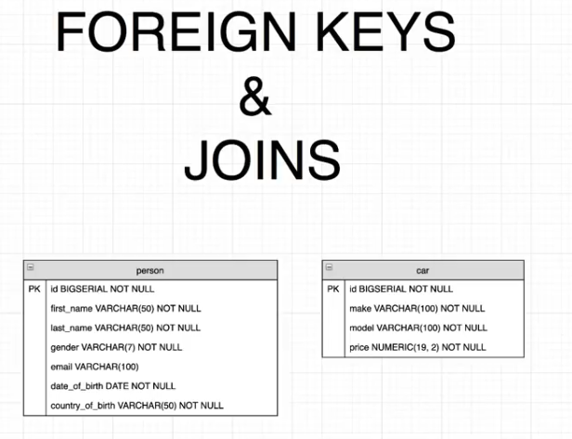

This is not good approach is due to, not everyone have car

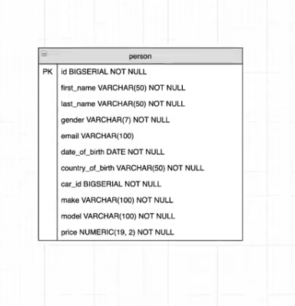

code#31
13/6/2022
Relationship👉
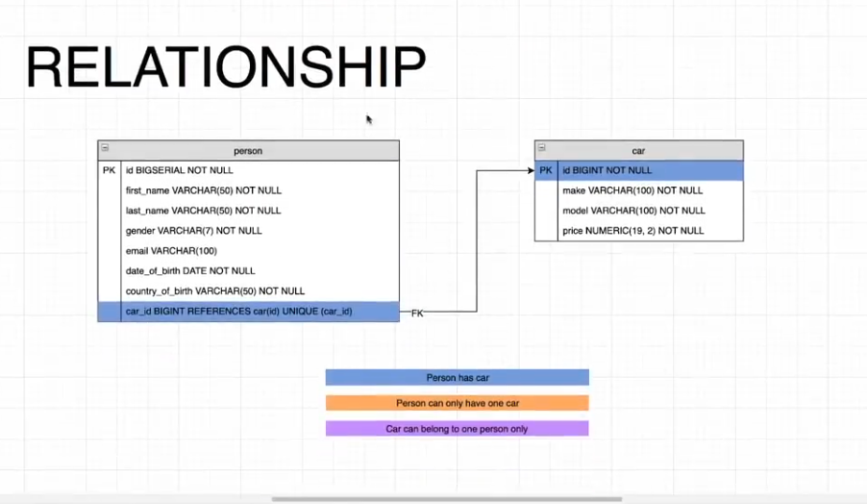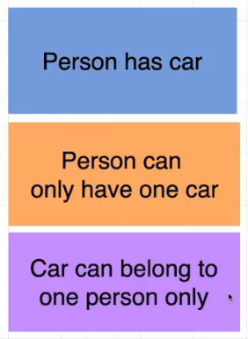

code#32
13/6/2022
Foreign key👉
A foreign key is a column references primary key in another key

Adding Relationships between table car and person


Table car
test=> SELECT * FROM car;
id | make | model | price
-----+---------------+---------------------+----------
1 | Lexus | SC | 41288.00
2 | Ford | Mustang | 13163.00
3 | Scion | xB | 34718.00
4 | Cadillac | CTS | 39490.00
5 | Suzuki | Swift | 46830.00

Table person
test=> SELECT * FROM person;
id | first_name | last_name | gender | email | date_of_birth | country_of_birth
------+---------------+--------------------+-------------+----------------------------------------+---------------+--------------------------
1 | Madelon | Longland | Female | | 2022-05-05 | Kazakhstan
2 | Cicely | Dautry | Female | | 2021-09-06 | Iran
3 | Ivett | Hugnet | Genderqueer | | 2022-05-03 | Sweden
4 | Adey | Eidelman | Female | aeidelman3@toplist.cz | 2021-06-21 | Nigeria
5 | Trevor | Fenech | Male | tfenech4@xrea.com | 2021-11-10 | Peru

Now we have to make relationships between them
Idea On the basis, one person can have one car, and one car can only belong to one person.

Creating foreign key
create table person (
id BIGSERIAL NOT NULL PRIMARY KEY,
first_name VARCHAR(50) NOT NULL,
last_name VARCHAR(50) NOT NULL,
gender VARCHAR(50) NOT NULL,
email VARCHAR(50),
date_of_birth DATE NOT NULL,
country_of_birth VARCHAR(150) NOT NULL,
car_id BIGINT REFERENCES car(id),
UNIQUE(car_id)
);

test=> \d person
Table "public.person"
Column | Type | Collation | Nullable | Default
------------------+------------------------+-----------+----------+------------------------------------
id | bigint | | not null | nextval('person_id_seq'::regclass)
first_name | character varying(50) | | not null |
last_name | character varying(50) | | not null |
gender | character varying(50) | | not null |
email | character varying(50) | | |
date_of_birth | date | | not null |
country_of_birth | character varying(150) | | not null |
car_id | bigint | | |
Indexes:
"person_pkey" PRIMARY KEY, btree (id)
"person_car_id_key" UNIQUE CONSTRAINT, btree (car_id)
Foreign-key constraints:
"person_car_id_fkey" FOREIGN KEY (car_id) REFERENCES car(id)

code#32
13/6/2022
Updating Foreign Key Columns👉

Table person
test=> SELECT * FROM person;
id | first_name | last_name | gender | email | date_of_birth | country_of_birth | car_id
----+------------+-----------+--------+-------+---------------+------------------+--------
1 | Saeed | Barcha | male | | 1997-04-03 | pakistan |
2 | Abid | Karim | male | | 1998-11-13 | pakistan |
3 | Alisha | Arman | Female | | 1999-07-23 | pakistan |
5 | Karishma | Baig | Female | | 2003-01-01 | pakistan |
4 | Zohaib | Ali | male | | 1987-12-13 |pakistan |
(5 rows)
Table car
test=> SELECT * FROM car;
id | make | model | price
----+--------+---------+----------
1 | Ford | Mustang | 13163.00
2 | Suzuki | Swift | 46830.00
3 | Honda | Civic | 53406.00
4 | Nissan | Sentra | 74876.00
5 | Toyota | Xtra | 27543.00
(5 rows)

Now we will update the car_id column in the person table
Assign car at id=2 to person at id=4
test=> UPDATE person SET country_of_birth='pakistan' WHERE id=4;
UPDATE 1
test=> SELECT * FROM person;
id | first_name | last_name | gender | email | date_of_birth | country_of_birth | car_id
----+------------+-----------+--------+-------+---------------+------------------+--------
1 | Saeed | Barcha | male | | 1997-04-03 | pakistan |
2 | Abid | Karim | male | | 1998-11-13 | pakistan |
3 | Alisha | Arman | Female | | 1999-07-23 | pakistan |
5 | Karishma | Baig | Female | | 2003-01-01 | pakistan |
4 | Zohaib | Ali | male | | 1987-12-13 | pakistan | 2
(5 rows)

Suppose I want to assign car at id=2 again to another person
test=> UPDATE person SET car_id=2 WHERE id=2;
ERROR: duplicate key value violates unique constraint "person_car_id_key"
DETAIL: Key (car_id)=(2) already exists.
test=>

assigning cars to persons
test=> SELECT * FROM person;
id | first_name | last_name | gender | email | date_of_birth | country_of_birth | car_id
----+------------+-----------+--------+-------+---------------+------------------+--------
3 | Alisha | Arman | Female | | 1999-07-23 | pakistan |
5 | Karishma | Baig | Female | | 2003-01-01 | pakistan |
4 | Zohaib | Ali | male | | 1987-12-13 | pakistan | 2
1 | Saeed | Barcha | male | | 1997-04-03 | pakistan | 3
2 | Abid | Karim | male | | 1998-11-13 | pakistan | 4
(5 rows)

We should have to only assign a value which is present in car table to person
otherwise error occur
There is not any record present in car table at index=10

test=> UPDATE person SET car_id=10 WHERE id=5;
ERROR: insert or update on table "person" violates foreign key constraint "person_car_id_fkey"
DETAIL: Key (car_id)=(10) is not present in table "car".
test=>

code#32
14/6/2022
Inner Joins👉
- We have foreign key constraints between the car and person table.
- Inner join is an effective way of combining two tables.
- We have two tables and we want to combine both tables,
Inner join takes whatever is common in both tables.
- Will only display rows having the same corresponding values.

Two tables
test=> SELECT * FROM person;
id | first_name | last_name | gender | email | date_of_birth | country_of_birth | car_id
----+------------+-----------+--------+-------+---------------+------------------+--------
3 | Alisha | Arman | Female | | 1999-07-23 | pakistan |
5 | Karishma | Baig | Female | | 2003-01-01 | pakistan |
4 | Zohaib | Ali | male | | 1987-12-13 | pakistan | 2
1 | Saeed | Barcha | male | | 1997-04-03 | pakistan | 3
2 | Abid | Karim | male | | 1998-11-13 | pakistan | 4
(5 rows)

test=> SELECT * FROM car;
id | make | model | price
----+--------+---------+----------
1 | Ford | Mustang | 13163.00
2 | Suzuki | Swift | 46830.00
3 | Honda | Civic | 53406.00
4 | Nissan | Sentra | 74876.00
5 | Toyota | Xtra | 27543.00
(5 rows)

Eg
If we have two tables A and B and both have records and have a foreign key. It takes the records of both tables and we call it as table C.
A + B = C

Applying join
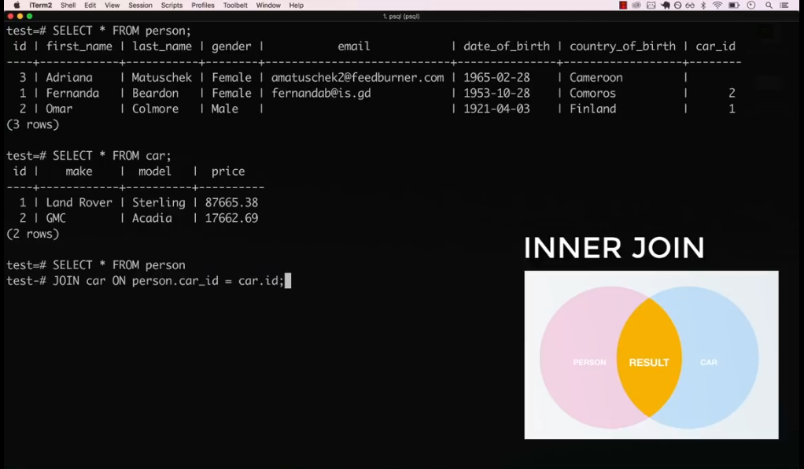

Only show those people who have car
Both is same
test=> SELECT * FROM person
test-> JOIN car ON person.car_id = car.id;

test=> SELECT * FROM person
test-> JOIN car ON car.id = person.car_id;

Result of join

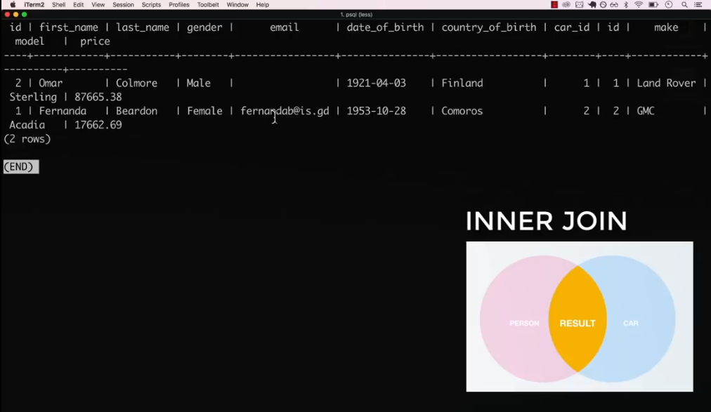

test=> SELECT * FROM person
test-> JOIN car ON person.car_id = car.id;
id | first_name | last_name | gender | email | date_of_birth | country_of_birth | car_id | id | make | model | price
----+------------+-----------+--------+-------+---------------+------------------+--------+----+--------+--------+----------
4 | Zohaib | Ali | male | | 1987-12-13 | pakistan | 2 | 2 | Suzuki | Swift | 46830.00
1 | Saeed | Barcha | male | | 1997-04-03 | pakistan | 3 | 3 | Honda | Civic | 53406.00
2 | Abid | Karim | male | | 1998-11-13 | pakistan | 4 | 4 | Nissan | Sentra | 74876.00
(3 rows)

Expanded display
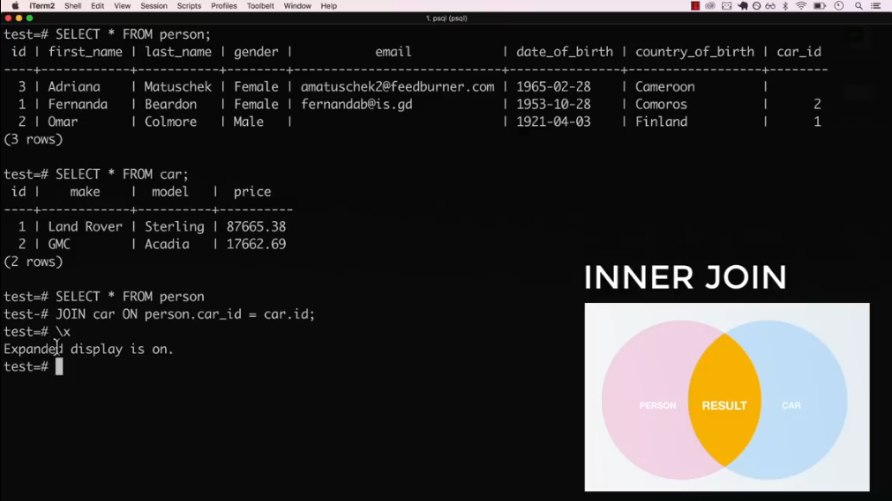

Expanded display result
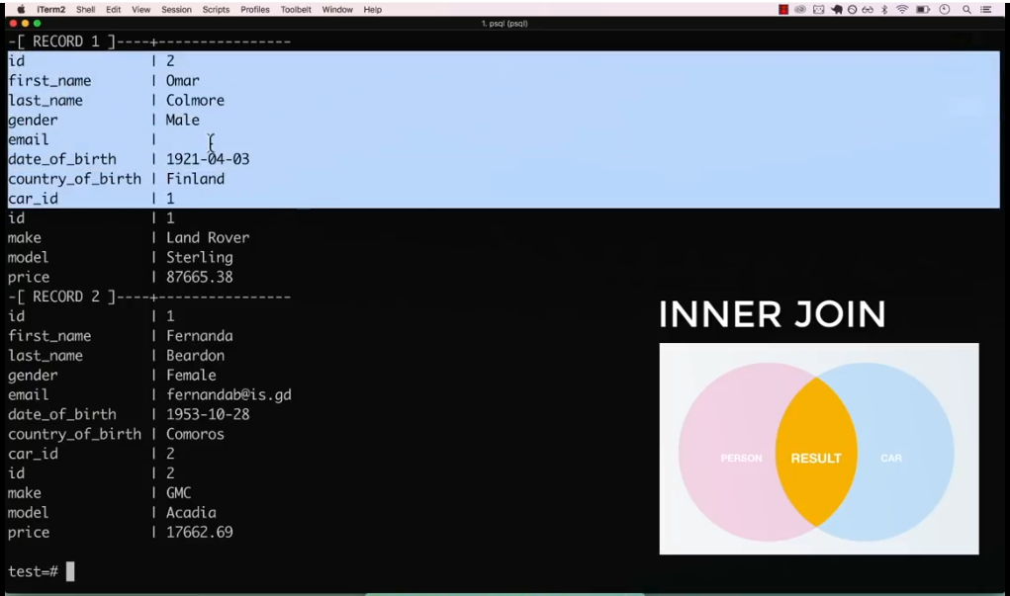

test-> JOIN car ON person.car_id = car.id;
-[ RECORD 1 ]----+-----------
id | 4
first_name | Zohaib
last_name | Ali
gender | male
email |
date_of_birth | 1987-12-13
country_of_birth | pakistan
car_id | 2
id | 2
make | Suzuki
model | Swift
price | 46830.00
-[ RECORD 2 ]----+-----------
id | 1
first_name | Saeed
last_name | Barcha
gender | male
email |
date_of_birth | 1997-04-03
country_of_birth | pakistan
car_id | 3
id | 3
make | Honda
model | Civic
price | 53406.00
-[ RECORD 3 ]----+-----------
id | 2
first_name | Abid
last_name | Karim
gender | male
email |
date_of_birth | 1998-11-13
country_of_birth | pakistan
car_id | 4
id | 4
make | Nissan
model | Sentra
price | 74876.00

Showing some field after joining them
test=> SELECT person.first_name, car.make, car.model, car.price
test-> FROM person
test-> JOIN car ON person.car_id=car_id;
-[ RECORD 1 ]--------
first_name | Zohaib
make | Ford
model | Mustang
price | 13163.00
-[ RECORD 2 ]--------
first_name | Saeed
make | Ford
model | Mustang
price | 13163.00
-[ RECORD 3 ]--------
first_name | Abid
make | Ford
model | Mustang
price | 13163.00
-[ RECORD 4 ]--------
first_name | Zohaib
make | Suzuki
model | Swift
price | 46830.00
-[ RECORD 5 ]--------
first_name | Saeed
make | Suzuki
model | Swift
price | 46830.00

code#33
14/6/2022
Left Joins👉
Left joins allow combining two tables like an inner join of table A and table B.
Left join includes all the rows from the Left table A as well as records from table that B have responding relationships and also the records that don’t have a responding relationship.

Left join will show those persons too who have not any car or whose person who have not foreign key relationships
test=> SELECT * FROM person
test-> LEFT JOIN car ON car_id = person.car_id;
id | first_name | last_name | gender | email | date_of_birth | country_of_birth | car_id | id | make | model | price
----+------------+-----------+--------+-------+---------------+------------------+--------+----+--------+---------+----------
3 | Alisha | Arman | Female | | 1999-07-23 | pakistan | | | | |
5 | Karishma | Baig | Female | | 2003-01-01 | pakistan | | | | |
4 | Zohaib | Ali | male | | 1987-12-13 | pakistan | 2 | 1 | Ford | Mustang | 13163.00
4 | Zohaib | Ali | male | | 1987-12-13 | pakistan | 2 | 2 | Suzuki | Swift | 46830.00
4 | Zohaib | Ali | male | | 1987-12-13 | pakistan | 2 | 3 | Honda | Civic | 53406.00
4 | Zohaib | Ali | male | | 1987-12-13 | pakistan | 2 | 4 | Nissan | Sentra | 74876.00

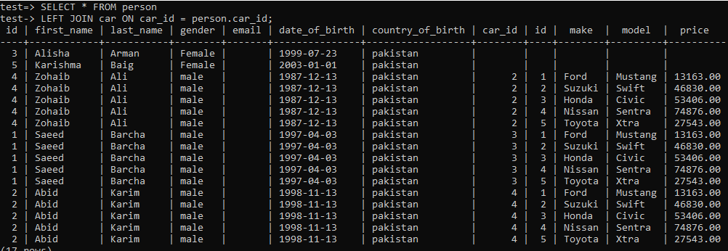

To show person haven’t car without using left join
Wrong method
test=> SELECT * FROM person
test-> WHERE car_id= NULL;
id | first_name | last_name | gender | email | date_of_birth | country_of_birth | car_id
----+------------+-----------+--------+-------+---------------+------------------+--------
(0 rows)

Right
test=> SELECT * FROM person
test-> WHERE car_id IS NULL;
id | first_name | last_name | gender | email | date_of_birth | country_of_birth | car_id
----+------------+-----------+--------+-------+---------------+------------------+--------
3 | Alisha | Arman | Female | | 1999-07-23 | pakistan |
5 | Karishma | Baig | Female | | 2003-01-01 | pakistan |
(2 rows)

To show person haven’t car using left join
car.* means all columns from the table
test=> SELECT * FROM person
test-> LEFT JOIN car ON car_id = person.car_id
test-> WHERE car.* IS NULL;
id | first_name | last_name | gender | email | date_of_birth | country_of_birth | car_id | id | make | model | price
----+------------+-----------+--------+-------+---------------+------------------+--------+----+------+-------+-------
3 | Alisha | Arman | Female | | 1999-07-23 | pakistan | | | | |
5 | Karishma | Baig | Female | | 2003-01-01 | pakistan | | | | |
(2 rows)
code#34
14/6/2022
Deleting Records with Forign Keys👉

We cannot delete any record from the table having a foreign key and its value is used in another table.

Table Person
test=> SELECT * FROM person;
id | first_name | last_name | gender | email | date_of_birth | country_of_birth | car_id
----+------------+-----------+--------+-------+---------------+------------------+--------
3 | Alisha | Arman | Female | | 1999-07-23 | pakistan |
5 | Karishma | Baig | Female | | 2003-01-01 | pakistan |
4 | Zohaib | Ali | male | | 1987-12-13 | pakistan | 2
1 | Saeed | Barcha | male | | 1997-04-03 | pakistan | 3
2 | Abid | Karim | male | | 1998-11-13 | pakistan | 4
(5 rows)

Table car
test=> SELECT * FROM car;
id | make | model | price
----+--------+---------+----------
1 | Ford | Mustang | 13163.00
2 | Suzuki | Swift | 46830.00
3 | Honda | Civic | 53406.00
4 | Nissan | Sentra | 74876.00
5 | Toyota | Xtra | 27543.00
(5 rows)

Left Join both tables
test=> SELECT * FROM person
test-> LEFT JOIN car ON car.id = person.car_id;
id | first_name | last_name | gender | email | date_of_birth | country_of_birth | car_id | id | make | model | price
----+------------+-----------+--------+-------+---------------+------------------+--------+----+--------+--------+----------
4 | Zohaib | Ali | male | | 1987-12-13 | pakistan | 2 | 2 | Suzuki | Swift | 46830.00
1 | Saeed | Barcha | male | | 1997-04-03 | pakistan | 3 | 3 | Honda | Civic | 53406.00
2 | Abid | Karim | male | | 1998-11-13 | pakistan | 4 | 4 | Nissan | Sentra | 74876.00
5 | Karishma | Baig | Female | | 2003-01-01 | pakistan | | | | |
3 | Alisha | Arman | Female | | 1999-07-23 | pakistan | | | | |
(5 rows)

We cannot delete record from car table having id=1
It is just because of it is use in the table person
test=> DELETE FROM car WHERE id=3;
ERROR: update or delete on table "car" violates foreign key constraint "person_car_id_fkey" on table "person"
DETAIL: Key (id)=(3) is still referenced from table "person".
test=>

to perform this, (to delete record from car table id =3)
we have to update the row in-person table where this value(car.id) is used or we have to delete the record from the person table first

update
test=> UPDATE person SET car_id=5 WHERE id=1;
UPDATE 1
test=> SELECT * FROM person;
id | first_name | last_name | gender | email | date_of_birth | country_of_birth | car_id
----+------------+-----------+--------+-------+---------------+------------------+--------
3 | Alisha | Arman | Female | | 1999-07-23 | pakistan |
5 | Karishma | Baig | Female | | 2003-01-01 | pakistan |
4 | Zohaib | Ali | male | | 1987-12-13 | pakistan | 2
2 | Abid | Karim | male | | 1998-11-13 | pakistan | 4
1 | Saeed | Barcha | male | | 1997-04-03 | pakistan | 5
(5 rows)

Now we can delete record from table car having id=3, it is just because of not in use
test=> SELECT * FROM car;
id | make | model | price
----+--------+--------+----------
2 | Suzuki | Swift | 46830.00
3 | Honda | Civic | 53406.00
4 | Nissan | Sentra | 74876.00
5 | Toyota | Xtra | 27543.00
(4 rows)

Deleting a record from car id=3
test=> DELETE FROM car WHERE id=3;
DELETE 1

Now this table did not have any record with id=3
test=> SELECT * FROM car;
id | make | model | price
----+--------+--------+----------
2 | Suzuki | Swift | 46830.00
4 | Nissan | Sentra | 74876.00
5 | Toyota | Xtra | 27543.00
(3 rows)

code#34
14/6/2022
Exporting Query Results to CSV👉

To export SQL query we ha \copy command in PostgreSQL
This will make a CSV file and the output of the query in it
test=> \copy (SELECT * FROM person) TO 'Downloads/expocsv.csv' DELIMITER','CSV HEADER;
COPY 5

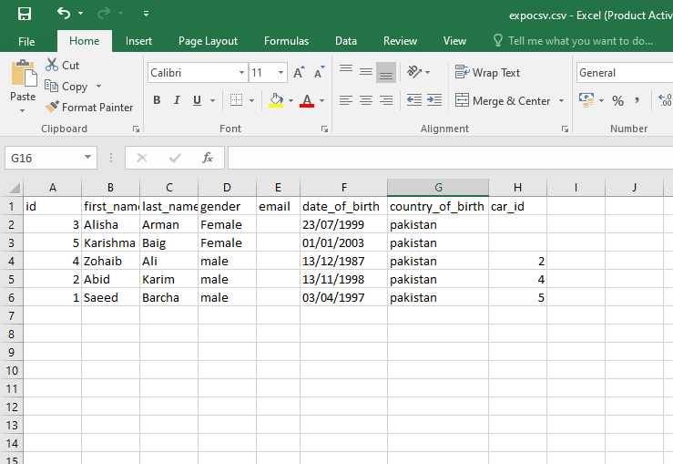
Second query
test=> \copy (SELECT * FROM person JOIN car ON car.id=person.car_id ) TO 'Downloads/exp.csv' DELIMITER','CSV HEADER;
Copy 3

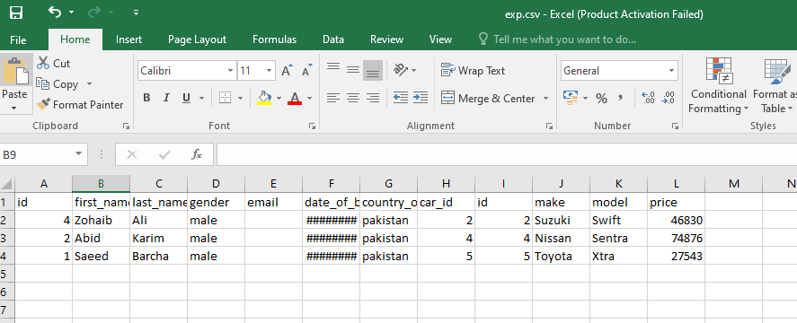

code#34
14/6/2022
Extensions👉

To view available extensions

test=> SELECT * FROM pg_available_extensions ;

name | default_version | installed_version | comment
---------------------+-----------------+-------------------+------------------------------------------------------------------------
adminpack | 2.1 | | administrative functions for PostgreSQL
amcheck | 1.3 | | functions for verifying relation integrity
autoinc | 1.0 | | functions for autoincrementing fields
bloom | 1.0 | | bloom access method - signature file based index
bool_plperl | 1.0 | | transform between bool and plperl
bool_plperlu | 1.0 | | transform between bool and plperlu
btree_gin | 1.3 | | support for indexing common datatypes in GIN
btree_gist | 1.6 | | support for indexing common datatypes in GiST
citext | 1.6 | | data type for case-insensitive character strings
cube | 1.5 | | data type for multidimensional cubes
dblink | 1.2 | | connect to other PostgreSQL databases from within a database
dict_int | 1.0 | | text search dictionary template for integers
dict_xsyn | 1.0 | | text search dictionary template for extended synonym processing
dummy_index_am | 1.0 | | dummy_index_am - index access method template
earthdistance | 1.1 | | calculate great-circle distances on the surface of the Earth
file_fdw | 1.0 | | foreign-data wrapper for flat file access
fuzzystrmatch | 1.1 | | determine similarities and distance between strings
hstore | 1.8 | | data type for storing sets of (key, value) pairs
hstore_plperl | 1.0 | | transform between hstore and plperl
hstore_plperlu | 1.0 | | transform between hstore and plperlu
hstore_plpython2u | 1.0 | | transform between hstore and plpython2u
hstore_plpython3u | 1.0 | | transform between hstore and plpython3u
hstore_plpythonu | 1.0 | | transform between hstore and plpythonu
insert_username | 1.0 | | functions for tracking who changed a table
intagg | 1.1 | | integer aggregator and enumerator (obsolete)
intarray | 1.5 | | functions, operators, and index support for 1-D arrays of integers
isn | 1.2 | | data types for international product numbering standards
jsonb_plperl | 1.0 | | transform between jsonb and plperl
jsonb_plperlu | 1.0 | | transform between jsonb and plperlu
jsonb_plpython2u | 1.0 | | transform between jsonb and plpython2u
jsonb_plpython3u | 1.0 | | transform between jsonb and plpython3u
jsonb_plpythonu | 1.0 | | transform between jsonb and plpythonu
lo | 1.1 | | Large Object maintenance
ltree | 1.2 | | data type for hierarchical tree-like structures
ltree_plpython2u | 1.0 | | transform between ltree and plpython2u
ltree_plpython3u | 1.0 | | transform between ltree and plpython3u
ltree_plpythonu | 1.0 | | transform between ltree and plpythonu
moddatetime | 1.0 | | functions for tracking last modification time
old_snapshot | 1.0 | | utilities in support of old_snapshot_threshold
pageinspect | 1.9 | | inspect the contents of database pages at a low level
pgcrypto | 1.3 | | cryptographic functions
pgrowlocks | 1.2 | | show row-level locking information
pgstattuple | 1.5 | | show tuple-level statistics
pg_buffercache | 1.3 | | examine the shared buffer cache
pg_freespacemap | 1.2 | | examine the free space map (FSM)
pg_prewarm | 1.2 | | prewarm relation data
pg_stat_statements | 1.9 | | track planning and execution statistics of all SQL statements executed
pg_surgery | 1.0 | | extension to perform surgery on a damaged relation
pg_trgm | 1.6 | | text similarity measurement and index searching based on trigrams
pg_visibility | 1.2 | | examine the visibility map (VM) and page-level visibility info
pldbgapi | 1.1 | | server-side support for debugging PL/pgSQL functions
plperl | 1.0 | | PL/Perl procedural language
plperlu | 1.0 | | PL/PerlU untrusted procedural language
plpgsql | 1.0 | 1.0 | PL/pgSQL procedural language
plpython2u | 1.0 | | PL/Python2U untrusted procedural language
plpython3u | 1.0 | | PL/Python3U untrusted procedural language
plpythonu | 1.0 | | PL/PythonU untrusted procedural language
plsample | 1.0 | | PL/Sample
pltcl | 1.0 | | PL/Tcl procedural language
pltclu | 1.0 | | PL/TclU untrusted procedural language
postgres_fdw | 1.1 | | foreign-data wrapper for remote PostgreSQL servers
refint | 1.0 | | functions for implementing referential integrity (obsolete)
seg | 1.4 | | data type for representing line segments or floating-point intervals
spgist_name_ops | 1.0 | | Test opclass for SP-GiST
sslinfo | 1.2 | | information about SSL certificates
system_stats | 1.0 | | EnterpriseDB system statistics for PostgreSQL
tablefunc | 1.0 | | functions that manipulate whole tables, including crosstab
tcn | 1.0 | | Triggered change notifications
test_bloomfilter | 1.0 | | Test code for Bloom filter library
test_ext1 | 1.0 | | Test extension 1
test_ext2 | 1.0 | | Test extension 2
test_ext3 | 1.0 | | Test extension 3
test_ext4 | 1.0 | | Test extension 4
test_ext5 | 1.0 | | Test extension 5
test_ext6 | 1.0 | | test_ext6
test_ext7 | 1.0 | | Test extension 7
test_ext8 | 1.0 | | Test extension 8
test_ext_cyclic1 | 1.0 | | Test extension cyclic 1
test_ext_cyclic2 | 1.0 | | Test extension cyclic 2
test_ext_evttrig | 1.0 | | Test extension - event trigger
test_ginpostinglist | 1.0 | | Test code for ginpostinglist.c
test_integerset | 1.0 | | Test code for integerset
test_pg_dump | 1.0 | | Test pg_dump with an extension
test_predtest | 1.0 | | Test code for optimizer/util/predtest.c
test_rbtree | 1.0 | | Test code for red-black tree library
test_regex | 1.0 | | Test code for backend/regex/
tsm_system_rows | 1.0 | | TABLESAMPLE method which accepts number of rows as a limit
tsm_system_time | 1.0 | | TABLESAMPLE method which accepts time in milliseconds as a limit
unaccent | 1.1 | | text search dictionary that removes accents
uuid-ossp | 1.1 | | generate universally unique identifiers (UUIDs)
xml2 | 1.1 | | XPath querying and XSLT
(91 rows)

Installing extensions
test=> CREATE EXTENSION IF NOT EXISTS "uuid-ossp";
CREATE EXTENSION
test=>
code#35
14/6/2022
Understanding UUID Data Type 👉

Before to use any Extension we have to install it first.

Installing extensions
test=> CREATE EXTENSION IF NOT EXISTS "uuid-ossp";
CREATE EXTENSION
test=>

Now uuid-ossp version 1.1 is installed
test=> SELECT * FROM pg_available_extensions ;
name | default_version | installed_version | comment
---------------------+-----------------+-------------------+------------------------------------------------------------------------
pldbgapi | 1.1 | | server-side support for debugging PL/pgSQL functions
plperl | 1.0 | | PL/Perl procedural language
plperlu | 1.0 | | PL/PerlU untrusted procedural language
plpgsql | 1.0 | 1.0 | PL/pgSQL procedural language
plpython2u | 1.0 | | PL/Python2U untrusted procedural language
plpython3u | 1.0 |
uuid-ossp | 1.1 | 1.1 | generate universally un

