In order to run the program, you need to install XAMPP which you can download from the following link:

<https://www.apachefriends.org/xampp-files/7.4.7/xampp-windows-x64-7.4.7-0-VC15-installer.exe>

After installing the XAMPP run it and start the Apache and MySQL server.

Please make sure that you choose the 80 port for Apache.

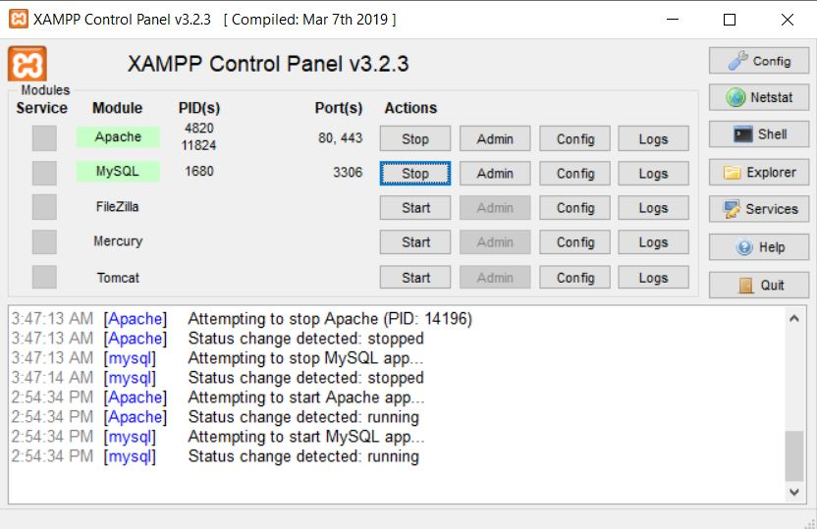

Then click on the Explorer button on the right side of the XAMPP window and go to the htdocs Folder

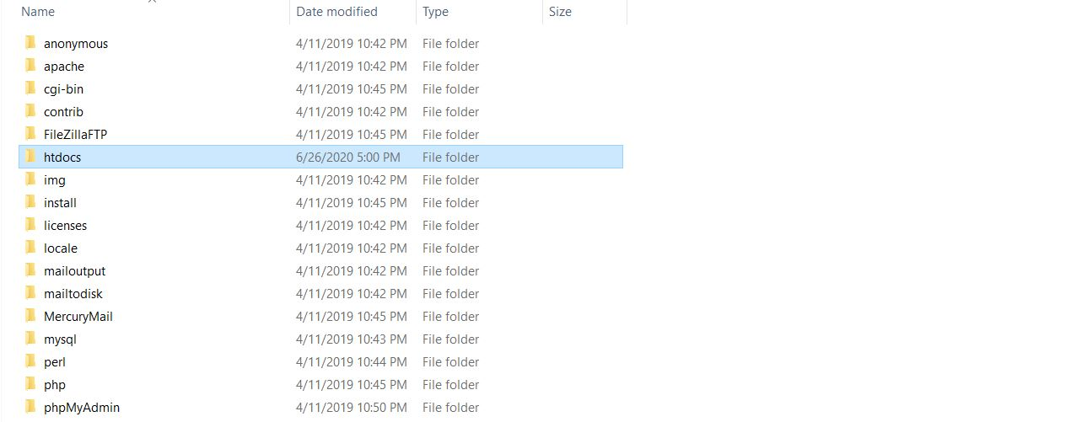

And copy all the folders of the project inside of htdocs exactly like the following picture.

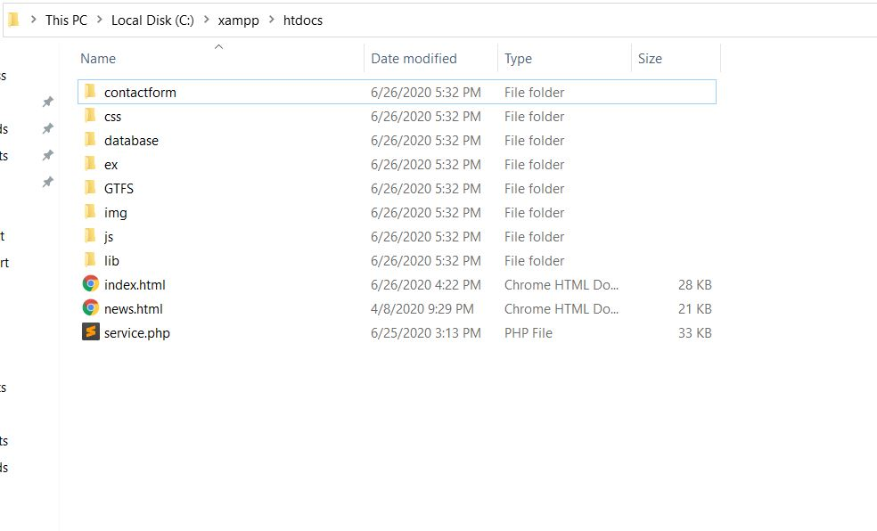

Then, open the browser and type the following address which put you in MySQL database administration which is the following picture.

<http://localhost/phpmyadmin>/

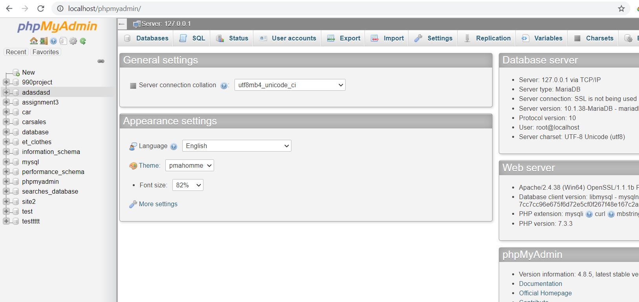

Then, create a New database and load the 990project.sql file into the new created database in order to load the designed tables into the database. The mentioned sql file is located at the following address in the project folder.

GTFS/990project.sql

Having all the above steps successfully you should be able to see the following result which shows all the designed tables.

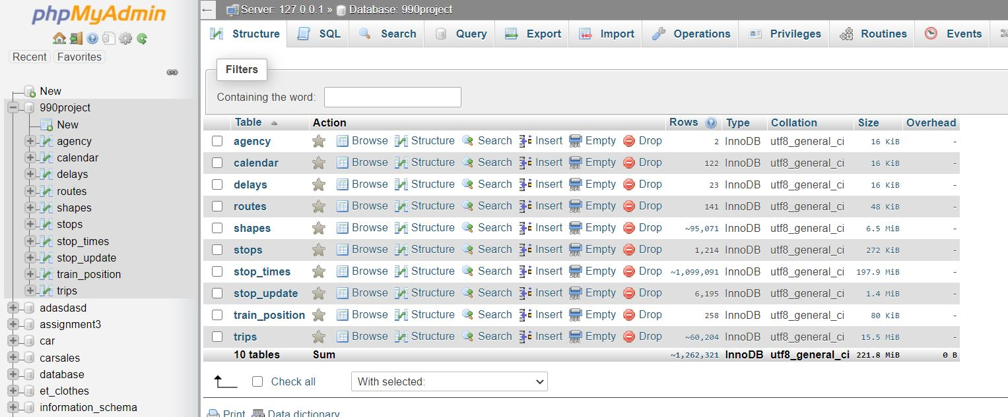

Next you have to install Node.js as well which is accessible by following link.

<https://nodejs.org/dist/v12.18.1/node-v12.18.1-x64.msi>

After Installing Node make sure you install and save the following libraries by command prompt.

For doing that you need the make sure that you are installing them exactly in the GTFS folder.

The command for installing libraries is as follows:

Npm install library_name –save

Libraries:

============================

gtfs-realtime-bindings

request

express

fs

unzip-stream

mysql

cors

node-schedule

============================

Having installed the above libraries, you are ready to run the application. Start by addressing the path to the GTFS/index.js file on the command prompt and run it by node js like the example below.

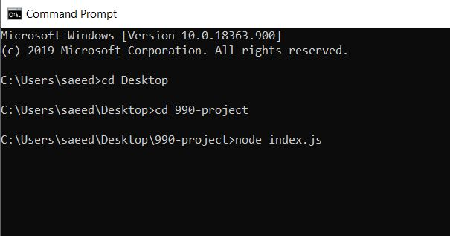

Then you will get the below result which shows that all the required data are OK and fetching to your PC and being loaded to the database.

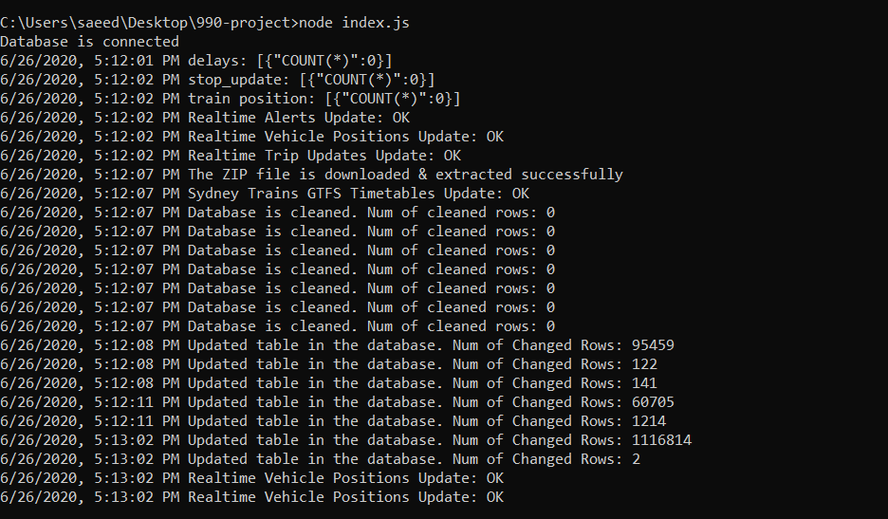

Having all the above steps successfully, the open the browser and type the following address.

<http://localhost/index.html>

then you will see the landing page as follows.



In order to see the service page, click on the Service section which puts you in services list section and then by clicking on any of the services listed there you should be able to see the following page which have all the designed functionalities.

