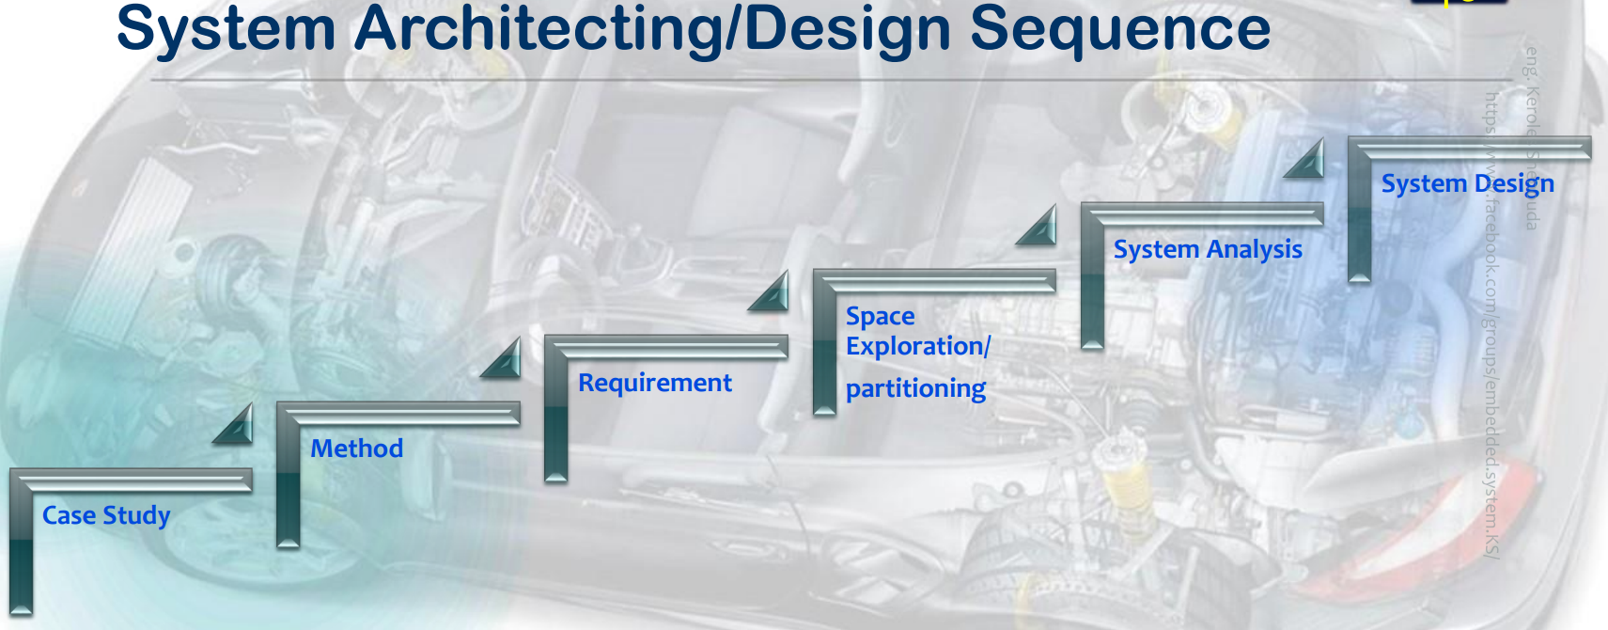

**Case study**

**Requirements**

* A pressure controller informs the crew of a cabin with an alarm when the pressure exceeds 20 bars in the cabin
* The alarm duration equals 60 seconds.
* keeps track of the measured values.

**Assumptions**

* The controller set up and shutdown procedures are not modeled
* The controller maintenance is not modeled
* The pressure sensor never fails
* The alarm never fails
* The controller never faces power cut

**Versioning**

The keep track of measured value option is not modelled in the first version of the design

**Method**

**Agile Scurm Methodology**

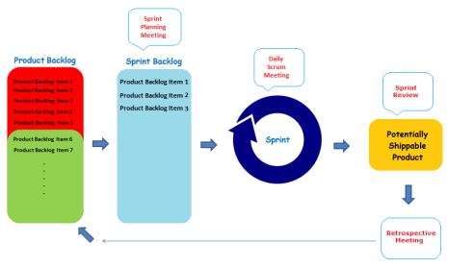

**Requirement**

**Requirement diagram**

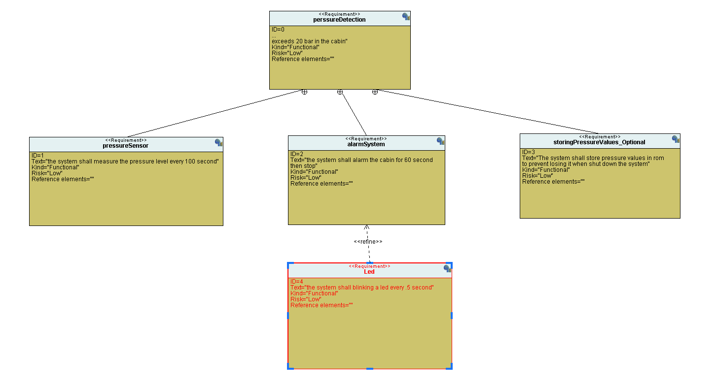

**Space Exploration/partitioning**

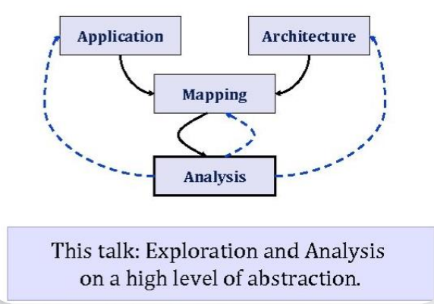

**System Analysis**

1. **Case Diagram**

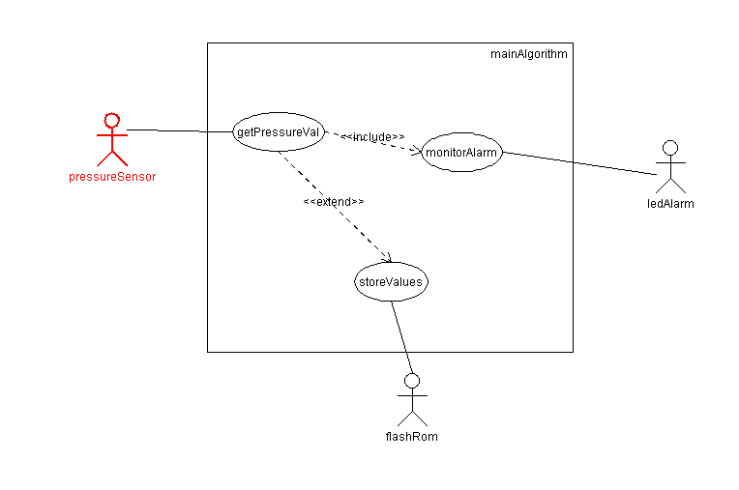

1. **Activity Diagram**

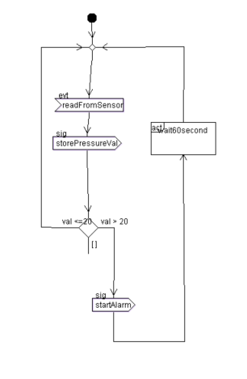

1. **Sequence Diagram**

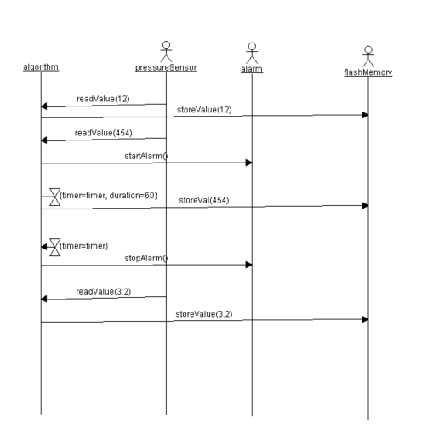

**System Design**

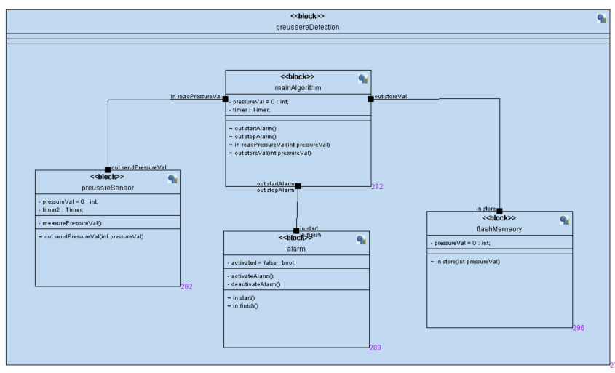

**Main algorithm**

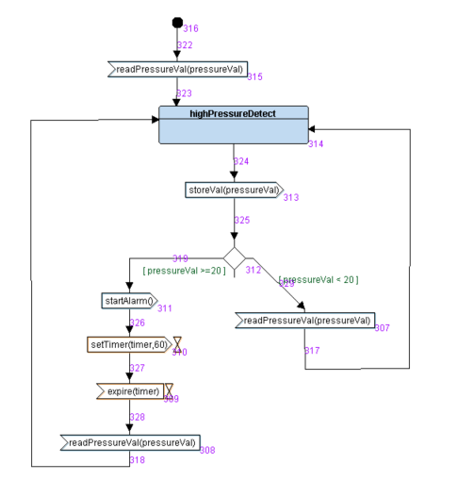

**Pressure sensor**

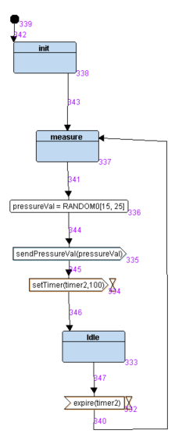

**Alarm system**

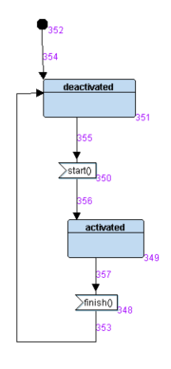

**Flash memory**

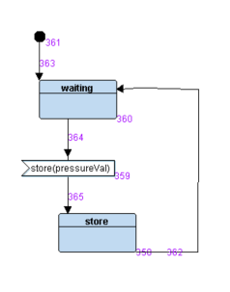

**Interactive simulation**

