Cairo University  
Faculty of Computers and Information



**CS251**

**Software Engineering I**

**Social Network**

Software Design

Abdelrahman Bahig Mahmoud 20170143

Saeed Mohamed Saeed 20170114

Shehap Ahmed Mohamed 20170129

Seif Mostafa Abobaker 20170123

December 2019

Contents

Team 3

Document Purpose and Audience 3

System Models 3

I. System Decomposition 4

II. Class diagrams 5

Important Algorithm 6

III. Sequence diagrams 7

Class - Sequence Usage Table 16

Traceability Matrix 17

Ownership Report 18

References 18

Authors 18

# Team

|  |  |  |  |
| --- | --- | --- | --- |
| **ID** | **Name** | **Email** | **Mobile** |
| 20170143 | Abdelrahman Bahig Mahmoud | abdelrahmanbahig04@gmail.com | 01115675674 |
| 20170114 | Saeed Mohamed Saeed | saidmsaid2011@gmail.com | 01116908081 |
| 20170129 | Shehap Ahmed Mohamed | Shihap.amara@gmail.com | 01005674525 |
| 20170123 | Seif Mostafa Abobaker | se.seifzzzz@gmail.com | 01550448069 |

# Document Purpose and Audience

The Purpose of document: explaining the Function of The System as System Decomposition , class Diagram , sequence Diagram The Audiences are: Project Manager, Customer, System Designer and System Analyst.

# System Models

## I. System Decomposition

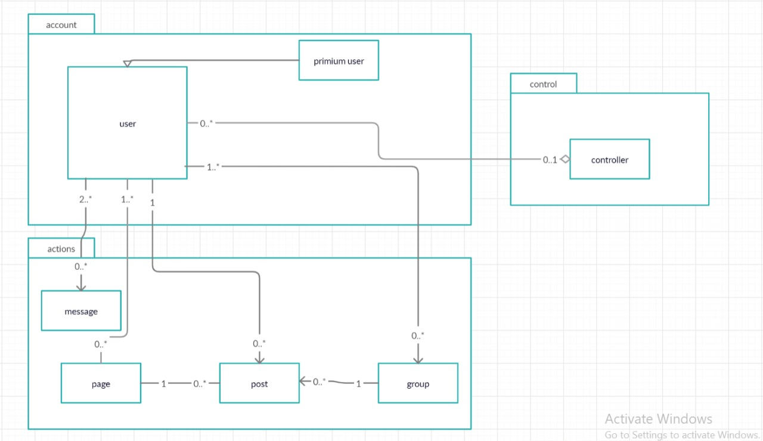

## II. Class diagrams

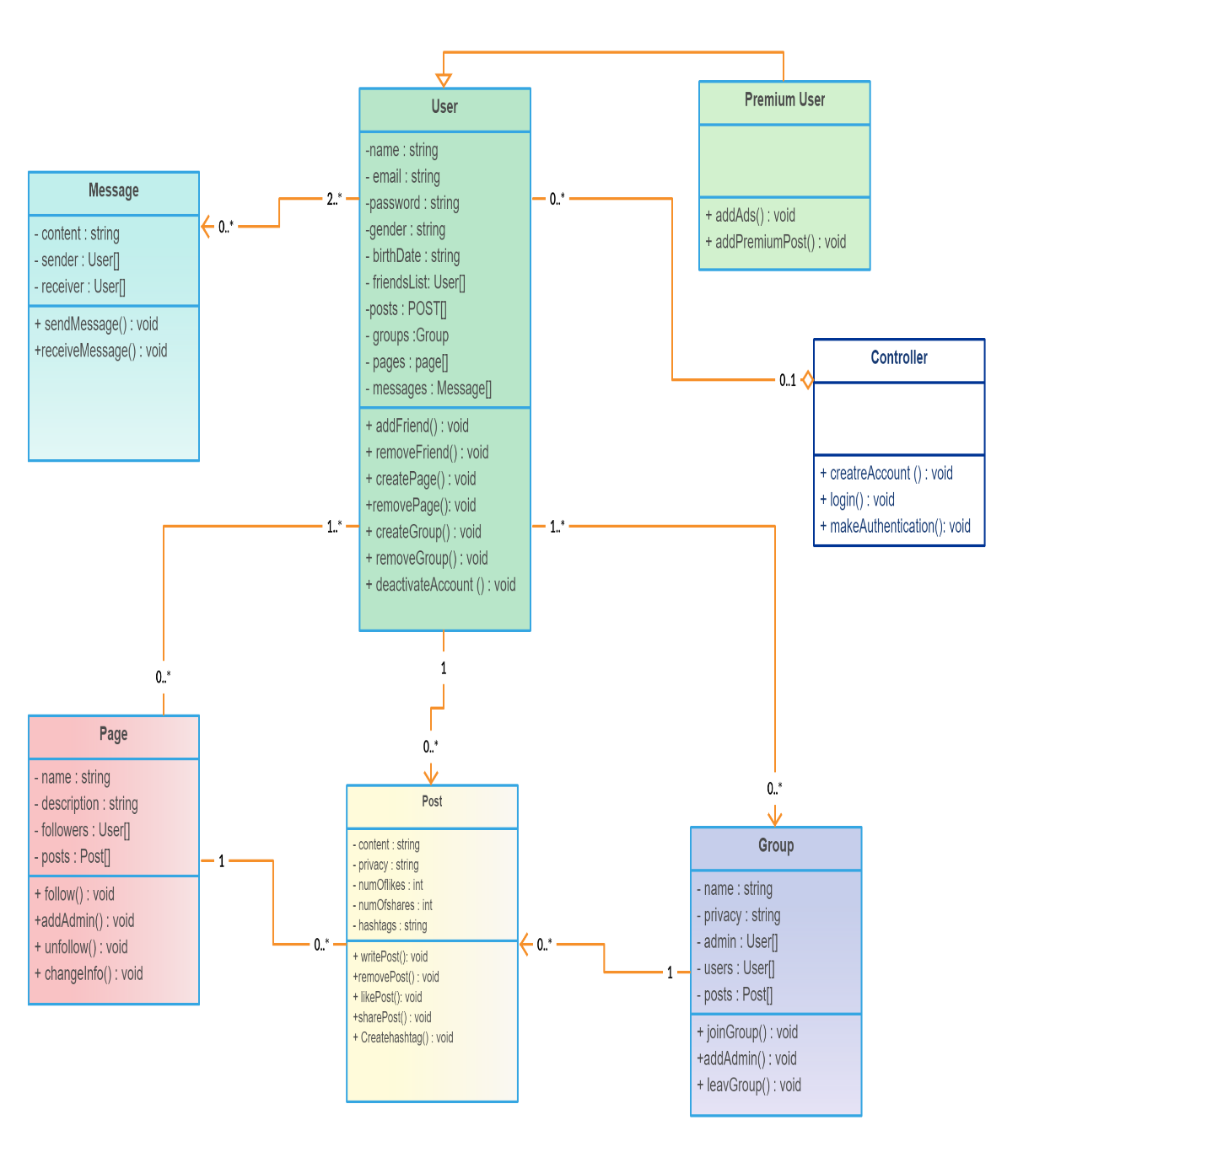

| **Class ID** | **Class Name** | **Subsystem ID** | **Description & Responsibility** |
| --- | --- | --- | --- |
| 1 | User | account | Save information of any user , |
| 2 | Premium User | account | Do special function from normal user such as add Advertisements |
| 3 | Page | Action | Save information of page and number of users who followed it and posts of this page |
| 4 | Post | action | Make functions related of post such as write , remove , like and share |
| 5 | Group | action | Save users numbers and posts of this Group Make functions related of Group such as create Group , leave Group , and join Group |
| 6 | Message | action | Send and receive Message between two users or many users like group chat |
| 7 | Controller | control | Make authentication of users who want to signup and login in this system |

### 

### Important Algorithm

## III. Sequence diagrams

## 1-Follow Page