

MSc Data Science Project
7PAM2002
Department of Physics, Astronomy and Mathematics

Data Science FINAL PROJECT REPORT
Project Title:
Deep Learning for Diabetic Retinopathy Detection
Using Retinal Fundus Images
Student Name and SRN:
Saeed Murrad 23081869

Supervisor: Vidas Regelskis
Date Submitted: 21/04/2026
Word Count: 3,454
DECLARATION STATEMENT

This report is submitted in partial fulfilment of the requirement for the degree of Master of Science in Data Science at the University of Hertfordshire.
I have read the detailed guidance to students on academic integrity, misconduct and plagiarism information at Assessment Offences and Academic Misconduct and understand the University process of dealing with suspected cases of academic misconduct and the possible penalties, which could include failing the project or course.
I certify that the work submitted is my own and that any material derived or quoted from published or unpublished work of other persons has been duly acknowledged. (Ref. UPR AS/C/6.1, section 7 and UPR AS/C/5, section 3.6)
I did not use human participants in my MSc Project.

I hereby give permission for the report to be made available on module websites provided the source is acknowledged.

Student Name printed: Saeed Murrad
Student Name signature
Student SRN number: 23081869

UNIVERSITY OF HERTFORDSHIRE
SCHOOL OF PHYSICS, ENGINEERING AND COMPUTER SCIENCE

Abstract
This study discusses how deep learning can be applied in the automatic detection of diabetic retinopathy in retinal fundus images. Diabetic retinopathy is one of the leading causes of preventable blindness and timely diagnosis is essential in ensuring that the level of blindness is reduced. The paper was meant to address the limitations of manual screening by implementing a transfer learning method on three convolutional neural network architectures that are pretrained and use MobileNetV2, EfficientNetB0, and ResNet50. The five-class data were reduced to a binary classification problem, in which the images were classified into no DR, and DR Present. Image preprocessing included image resizing, data normalization, data augmentation, stratified dataset split, and upsampling to reduce the imbalance of classes. The models were trained and evaluated by the accuracy, precision, recall, F1-score, and confusion matrix analysis. The results showed that the three models were performed averagely and equally. The models had a range of accuracy ranging between 0.68 and 0.69. ResNet50 got the best overall performance, and its highest accuracy was approximately 0.69, precision of 0.44, recall of 0.56, and F1-score of 0.49. The lowest performance was that of EfficientNetB0 and moderate performance followed by MobileNetV2. The confusion matrix analysis also indicated that the ResNet50 detected the highest number of cases of diabetic retinopathy yet, false positives and false negatives were still present in all the models. Overall, the findings suggest that the transfer learning technique can be utilized to identify diabetic retinopathy and that ResNet50 is the most effective among all the analyzed ones. However, the average results indicate that further optimization, increased scale training, and fine-tuning are required before these kinds of systems can be considered to be dependable in the real-life clinical practice.

Contents

- Chapter 1: Introduction 6
  - Problem Statement 6
  - Research Aim 7
  - Research Objectives 7
  - Research Questions 7
- Chapter 2: Literature Review 8
  - Related Work 8
- Chapter 3: Dataset Description & EDA 11
  - EDA 11
- Chapter 4: Ethical Implications 13
- Chapter 5: Methodology 14
  - Dataset Description 14
  - Data Preprocessing 15
  - Handling Class Imbalance 15
  - Model Architecture 15
  - Model Training 15
  - Model Evaluation 16
  - Comparative Analysis 16
- Chapter 6: Results 16
  - Accuracy Comparison 17
  - Precision Comparison 18
  - Recall Comparison 19
  - F1 Score Comparison 20
  - Confusion Matrix Analysis 21
    - MobilenetV2 21
    - EfficientNetV2 22
    - ResNet50 23
- Chapter 7: Discussion 25
  - Overall Model Performance 25
  - Impact of Data Preprocessing and Class Balancing 25
  - Comparison with Existing Literature 25
- Chapter 8: Conclusion and Future Work 26
- References 27

- Chapter 1: Introduction
Diabetic retinopathy (DR) is an eye disorder that occurs progressively as the retinal blood vessels are damaged as a result of chronic diabetes (Alyoubi et al., 2020). It is also among the major causes of avoidable blindness in the world especially among adults of working age. The World Health Organization has cited the rising cases of people at risk of developing diabetic retinopathy as due to the increasing prevalence of diabetes in the world today. Another significant aspect of preventing the loss of vision is the early diagnosis of the disease since the condition can be slowed down or even prevented by timely treatment (Tymchenko et al., 2020).
The diagnosis of DR occurs traditionally by manual examination of the images of the retinal fundus by ophthalmologists (Nguyen et al., 2020). Although this is effective, it is time consuming, resource intensive and inaccessible in low resource environments. The demand of screening has strained health care systems such that the necessity to possess an efficient and scalable diagnostic solution has been developed (Doshi et al., n.d.).
The current developments in Deep Learning created new opportunities in automated analysis of medical images (Mushtaq and Siddiqui, 2021). Deep learning algorithms are particularly convolutional neural networks (CNNs) capable of learning very complex visual patterns, and have demonstrated great performance on image classification tasks. These models can be trained to detect features that are associated with the disease in retinal fundus images with high accuracy regarding diabetic retinopathy (Bhaskar, 2022).
The concept of transfer learning has been applied in the research report wherein the pretrained CNN models, such as MobileNetV2, EfficientNetB0 and ResNet50, are used to develop an automated system to diagnose diabetic retinopathy. By simplifying the detection task based on the binary classification problem (presence vs. absence of DR) and maintaining the reliable performance, the study will make the problem easier to detect. Such systems are able to support clinicians, improve the efficiency of screening, and early diagnosis, especially in underserved regions (Sarki et al., 2020).

Problem Statement
The increasing number of diabetic patients has negatively affected the healthcare system despite the number of the screening methods, which are available. Diabetic retinopathy diagnosis is manually done, which is not only labor-intensive, but also prone to human error and inter-clinician variability. Moreover, in most areas, there is no sufficient number of skilled eye care specialists, and access to early diagnosis is restricted. This causes the postponement of treatment and the risk of irreparable blindness. Thus, the urgent need is the development of an efficient, accurate, and scalable solution that will help to detect diabetic retinopathy in its early stages.

Research Aim
The aim of this study is to develop and experiment an automated system to identify diabetic retinopathy using retinal fundus images using a deep learning approach. The research aims at applying transfer learning methods based on the use of ready-trained convolutional neural network structures such as MobileNetV2, EfficientNetB0, and ResNet50 to provide binary classification of diabetic retinopathy (present or absent). It seeks to study the performance of these models when they are trained with a balanced set of data with the use of preprocessing and augmentation techniques. In addition, the proposed study aims to compare the performance of the selected models by assessing them based on such evaluation metrics as accuracy, precision, recall, F1-score, and AUC to find out the best architecture to be employed when it comes to the detection of diabetic retinopathy and make a reliable and effective decision.

Research Objectives
- To preprocess retinal fundus images, including resizing, normalization, and data augmentation
- To convert the original dataset labels into a binary classification problem (DR vs No DR)
- To split the dataset into training, validation, and test sets with stratification
- To address class imbalance in the training data through upsampling techniques
- To implement transfer learning using pretrained models: MobileNetV2, EfficientNetB0, and ResNet50
- To train the models using a TensorFlow data pipeline and evaluate their performance
- To compare model performance using metrics such as accuracy, precision, recall, F1-score.

Research Questions
- How effectively can deep learning models detect diabetic retinopathy from retinal fundus images?
- Does converting the problem into binary classification improve model performance and simplicity?
- Which pretrained model (MobileNetV2, EfficientNetB0, or ResNet50) performs best for this task?
- How does class balancing (upsampling) affect model performance?
- What is the impact of data preprocessing and augmentation on model accuracy and generalization?
- Which evaluation metrics best reflect the reliability of the models in detecting diabetic retinopathy?

- Chapter 2: Literature Review
The most prevalent cause of blindness in the world is diabetic retinopathy and early and appropriate diagnosis is the most important factor in ensuring that the blindness is properly treated and prevented. The advancement of deep learning in the past few years has helped the enhanced automated retinal fundus image analysis that has been promising as the alternative to the traditional diagnostic techniques. The literature review looks at a number of studies that analyse the application of deep learning techniques, in particular, convolutional neural networks, to detect and categorize diabetic retinopathy. The methods that have been considered in the reviewed articles are transfer learning, ensemble modelling and better neural network architecture that have been shown to improve diagnostic accuracy. Another noteworthy issue that is discussed in the literature is the absence of annotated datasets, model generalisation, computational complexity and the need to integrate the model with clinics. On the whole, these works reveal the possibilities of artificial intelligence to increase the efficiency of screening and use less human error, as well as the necessity of more robust, interpretable, and realistic solutions.

Related Work
It has been suggested that (Simul Hasan Talukder and Author, n.d.) apply a more sophisticated deep learning model to detect diabetic retinopathy by introducing transfer learning and ensemble learning. The premise behind the experiment is that a group of pretrained convolutional neural networks, including ResNet50, DenseNet, MobileNet V2 and Inception models, will be pitted against each other and the one that scores the highest will be identified. This is done by means of data augmentation and regularisation to obtain more optimal results and reduce overfitting and maximize generalization. The authors also optimize the results of weighted and average ensemble combination of a large number of models. They have good results that are very accurate, precise and recall and F1-scores and their models are almost perfect in terms of classification. The usefulness of the implementation of the pretrained models and ensemble learning to increase the accuracy of the diagnostic is proven in this paper, yet the results would probably have to be verified on more heterogeneous data.
The algorithms of the deep learning were critically reviewed to identify the diabetic eye diseases with the fundus pictures in the article (Sarki et al., 2020). Major steps of the detection pipeline include the datasets, preprocessing, model architectures and assessment metrics which are referred in the paper. It proves that deep learning is better than traditional methods, particularly, in automated recognition and greater accuracy of classification. The other difficulties identified in the research are that there is deficiency of annotated data, computational demands and generalization of the model are high. Transfer learning is known to be a viable method of working on smaller datasets in a better manner. Also, the authors underline the clinical significance of early detection and the possibility of AI systems to decrease the workload of screening and human error.
It is a literature review on deep-learning techniques to identify and classify diabetic retinopathy, the entire data-processing, including data-collection and lesion-delimiting. (Tsiknakis et al., 2021) The article unveils the possibility of the convolutional neural networks to automatically extract features of images in a hierarchy, without the involvement of human factor. It also assesses publicly available datasets and underlines the importance of data quality and balance of classes in quality performances. Despite the recognition of the growing clinical application of deep learning in the paper, it also determines that such problems as data variability, standardization, and lower cross-population generalization exist. The authors report that future research must educate regarding the improvement in the model strength, interpretability and clinical integration.
The deep learning models, which are overviewed to the diabetic retinopathy diagnosis, and the convolutional neural network training are provided in (Abushawish et al., n.d.). In the research article, the comparison of the different approaches such as transfer learning, end-to-end learning, and hybrid models and also comparison of their performance on different datasets are introduced. The imbalance in classes, variability in data as well as the inability to interpret it are the largest issues mentioned. The other fact is that explainable AI, such as Grad-CAM can be implemented to increase the degree of transparency and build clinical trust. The article puts much emphasis on the fact that there should be strong models that can be generalised to a great number of datasets.
The study (Rakib Ul Islam Rahat et al., 2025) discusses the use of artificial intelligence in the diagnosis of diabetic retinopathy, especially in the aspect of clinical practice. The article sheds light on the growing disease burden in the global society and the necessity to possess large scale automated screening systems. Deep learning models have been demonstrated to be very diagnostic in detection of stages of diseases, and other related diseases like the macular oedema. The paper is also discussing the emerging technologies which are supportive of remote diagnosis such as portable imaging devices and telemedicine platforms. Some of the obstacles are however mentioned to be the regulatory barriers and system integration and the limitations on image quality. The authors conclude that even though AI has a good potential, more needs to be done to guarantee reliability and availability.
The study (Bhulakshmi and Rajput, 2024) is a review of the systematized literature on the deep learning-based diabetic retinopathy detection approach based on fundus images. The models of the neural networks that were discussed in the paper include convolutional, recurrent and generative adversarial. It throws into focus the ability of deep learning to automatically detect complex retinal structures such as microaneurysms and haemorrhages. The paper has also made a comparison of the methods founded on the premise of AI with the traditional diagnostic procedures and they have been identified to be more efficient and precise. Nevertheless, there are also such issues as massive datasets of annotations, computational complexity and generalization. The other critical point that the authors have brought up is the necessity to develop effective models which can be applied to the real world.
The study by (Nadeem et al., 2022) covers the use of deep learning in the analysis of diabetic retinopathy such as screening, segmentation, classification, and prediction. The article implies that deep learning may be implemented in the process of enhancing the quality of a diagnosis, and transform a manual analysis not so appealing. It is also applied to address such issues as data imbalance, small annotated data and computation price. Major challenges have been found to be model interpretability, population generalization and incorporation with clinical processes. According to the authors, the ways to create useful, explainable and clinical applicable models should be further researched.

- Chapter 3: Dataset Description & EDA
In the current study, the dataset will be obtained in Diabetic Retinopathy Unzipped Dataset, which is a cleaned and fixed version of the original dataset containing high-resolution retina fundus images. Images that are corrupted are removed in this version which ensures that there is quality and consistency of the data in the model training process. The data set consists of the retina images under varying conditions of imaging that offered variation in light, focus and orientation. The subjects have two pictures, indicating the right eye and the left eye, and a new subject ID (i.e., 1 right, 1 left). A clinician grades all the images on a scale of 0 to 4, 0 represents the absence of diabetic retinopathy, whereas 4 represents proliferative diabetic retinopathy. Multi-class classification of this study is converted into a binary classification problem where level 0 is regarded as No DR and level 1-4 is DR present. This eases the detection process whilst maintaining clinically significant information.

EDA

Figure 1 shows class imbalance, with significantly more “No DR” cases than “DR Present,” highlighting need for balancing techniques during training.

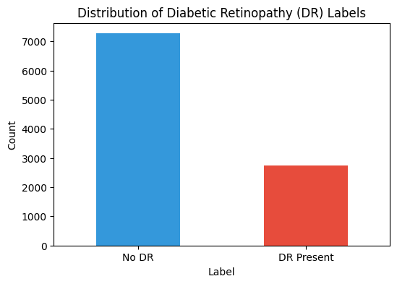
Figure 1 Distribution of Diabetic Retinopathy Labels
Figure 2 displayed retinal images are classified as “No DR,” showing consistent normal fundus patterns without visible signs of diabetic retinopathy.

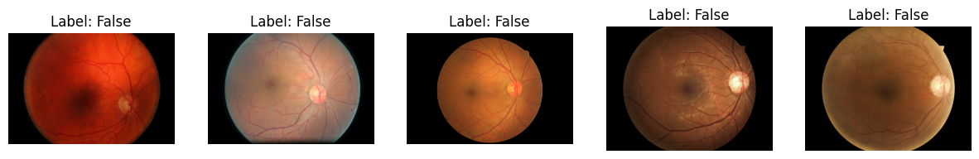
Figure 2 Labels

Figure 3 labelled “False,” indicating no diabetic retinopathy, with images showing normal retinal structures and absence of pathological features.

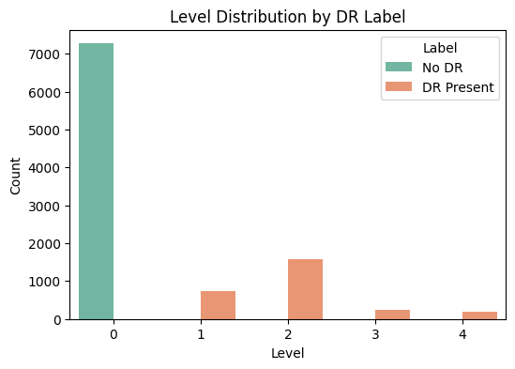
Figure 3 Level Distribution by DR Label

- Chapter 4: Ethical Implications
This study has been conducted in line with ethical requirements and processes of conducting research in the University of Hertfordshire. The publicly available anonymised data was employed in the current study and no data of the patients will be identified. In such a way, the study will not presuppose any direct contact with human subjects or personal information of sensitive character, which will minimize the possibilities of any ethical damage. However, some ethical issues might arise when it comes to medical imaging data and artificial intelligence application. One of the most significant issues is the problem of privacy and confidentiality of the data, and there is no other solution to this question than the utilisation of the anonymised information of the credible sources. In addition, the bias in the data may also affect the impartiality and the external validity of the developed models. Having a poorly prediction of the model on underrepresented populations may be a risk in case the dataset does not cover many types of populations. This is a weakness that is achieved and we make sure that we do not misinterpret the results in an irresponsible way. The other ethical issue is the problem of the misuse or excessive use of automated systems in clinical decision-making. The created model will be implemented as a decision-support tool instead of a substitute of the medical professionals. Assessment and professional control: It must undergo clinical validation and professional control before it is able to be put into use. Besides, AI systems should be trustworthy and the model predictions must be transparent and accountable. Overall, the study will contribute to the further development of the concept of responsible deep learning in the healthcare environment without violating the ethical considerations and institutional provisions.

- Chapter 5: Methodology
The chapter explains the strategy that has been used to develop a deep learning based system in order to detect diabetic retinopathy using the aid of retinal fundus images. It explains the data, which was used, data preprocessing, model development, training, and evaluation methodology. The methodology is premised on the concepts of transfer learning, involving the use of the already trained convolutional neural networks, which are able to extract features effectively and enhance classification. The systematic pipeline is founded on the analysis that includes preparing data, training and performance evaluation of a model.

Dataset Description
The dataset used in this study consists of retinal fundus images of a publicly available diabetic retinopathy dataset. The pictures are correlated with the labels that portray the severity of the disease. To meet the purpose of this study; the multi-class labels were converted to binary classification problem with the images already classified as either No Diabetic Retinopathy or Diabetic Retinopathy Present. This simplification allows the model to focus on finding the existence of the disease, but not the severity. The computational efficiency was also improved by using a smaller sample of the dataset to avoid spending excessive time to train the model with an equal representation of the two classes.

Data Preprocessing
Before the input data can be used, it is important to process the data to assure quality and consistency. All retinal images were rescaled to a standard size of 224 x 224 pixels to meet the requirements of the input of pre-trained convolutional neural networks. The pixel values were scaled between 0 and 1 in order to enhance model convergence. Also, the images whose file paths were missing or invalid were filtered because it would create errors in the course of processing. In order to improve model generalization and minimize overfitting, the training dataset was subjected to data augmentation (random flipping, rotation, zooming). These variations are modelled to represent variations in retinal images in the real world.

Handling Class Imbalance
Class imbalance is also characteristic of medical datasets, in which a type of data is well represented by the other. The imbalance was minimized in this study by using an upsampling method on the minority group in the training set. In so doing, the samples in the minority group are multiplied by expanding on the already existing samples, therefore the model is not biased to the majority group. It is important to note that balancing method was applied on the training set only to maintain the integrity of validation and test data.

Model Architecture
Three pretrained convolutional neural network models, including MobileNetV2, EfficientNetB0, and ResNet50, are applied in this paper to transfer learning. The reason why these models were chosen is because they are effective in image classification and also because they are able to extract high level features on images. The trained models were initialized using weights that were trained on ImageNet. These models were custom classified by having a global pooling layer followed by a dense layer with sigmoid activation function which was used in binary classification. The lower levels of the models were frozen to prevent the loss of characteristics previously learned as well as to reduce the amount of computation power.

Model Training
The models were trained using the TensorFlow and Keras models. The loss was a binary cross-entropy loss function as it can be applied in binary classification problems. Adam optimizer was used to update the model weights. The training was done over a fixed number of epochs with early stopping being used to avoid overfitting. Early stopping is used to check the loss of validation and terminates training when there is no improvement in a set number of epochs. The training also made use of the batch processing which included a TensorFlow data pipeline and enhanced the performance and efficiency.

Model Evaluation
In order to establish the performance of the trained models holistically, there were a number of measures of the performance. Such measures include accuracy, precision, recall, F1-score and Area Under the Curve (AUC). The accuracy of the model is used to measure the overall correctness of the model; the false positives and false negatives are understood by the recall and the precision respectively. Precision and recall are balanced in the F1-score and it is especially helpful with imbalanced data. Also, confusion matrices were built to visualize the performance of classifications and identify the misclassifications patterns. The test data was used to evaluate the program in order to have unbiased results.

Comparative Analysis
The performance of the three pretrained models was compared in order to analyze their performance. All the models were trained and tested in the same conditions to be fair. The results were compared with each other based on the evaluation metrics and the best model was identified. The comparison provides a clue of the efficiency of different architectures in detecting diabetic retinopathy and allows choosing the most suitable model to be utilized in the present task.

- Chapter 6: Results
The chapter shows the findings of the experimental analysis of three pretrained deep learning models, MobileNetV2, EfficientNetB0, and ResNet50, in detecting diabetic retinopathy. To offer a complete comparison, the key evaluation metrics such as accuracy, precision, recall, and F1-score are used to evaluate the performance of each model. Furthermore, the confusion matrix analysis is applied to analyse the classification behaviour more thoroughly and determine the patterns of misclassification. The findings are meant to bring out the advantages and shortcomings of each model in the identification of diabetic retinopathy using retinal images. This analysis gives some understanding on the effectiveness of the models and assists in deciding the most appropriate architecture that may be used in this classification task and which areas may be improved.

Accuracy Comparison
The findings of the three trained deep learning models, the MobileNet V2, EfficientNetB0, and ResNet50, to detect diabetic retinopathy are presented in figure 4. The results show that the three models are relatively the same in terms of their accuracy that falls between approximately 0.68 and 0.69. ResNet50 is the most accurate, and it is marginally ahead of EfficientNetB0 and MobileNetV2. The difference between EfficientNetB0 and MobileNetV2 is minimal, but it is not a major aspect, which could mean that all the models are similar in their performance in the given dataset. These two architectures show that transfer learning can be used to perform this classification task effectively, no matter which particular model is employed. However, the fact that ResNet50 has a deeper structure and is able to extract features in retinal pictures more explained the minor superiority. Although such outcomes, the comparatively low accuracy scores imply further improvement possibilities which may be achieved with the help of fine-tuning, increased training, or even improved preprocessing. Altogether, the comparison proves that all the models can be used, but ResNet50 seems to be the most appropriate one among the three to use in this task.

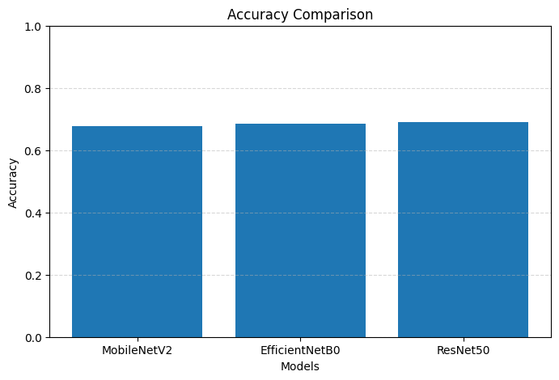
Figure 4 Accuracy Comparison

Precision Comparison
Figure 5 illustrates how three trained deep learning models MobileNetV2, EfficientNetB0 and ResNet50 are accurate in detecting positive cases of diabetic retinopathy. Precision is the number of cases of true positive prediction divided by the total number of cases that are predicted to be positive, of interest in medical diagnosis since the number of false positives needs to be minimized. The chart demonstrates that the highest accuracy (around 0.44) of ResNet50 is obtained, meaning that it is more reliable in identifying the symptoms of diabetic retinopathy. EfficientNetB0 is the next closest with a precision of about 0.42 and MobileNetV2 comes in the last with a much low precision of about 0.39. The fact that the difference between the models is quite minimal also indicates that all of the three architectures are similar in terms of their performance, with ResNet50 having a minor edge. This is due to the fact that it has a more detailed architecture, which resulted in more successful feature extraction. However, the total values of precision are also moderate, i.e., the models still provide a large number of false alarms. It shows that further development (refining or better preprocessing) is needed to make predictions more plausible.

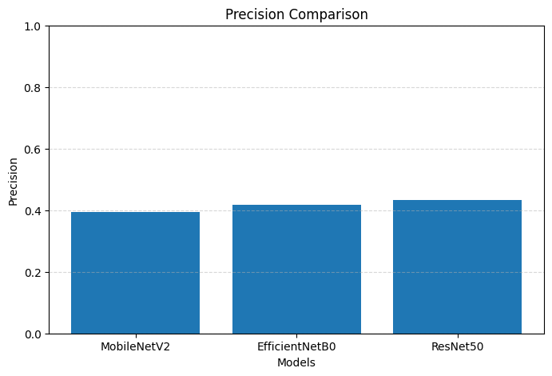
Figure 5 Precision Comparison

Recall Comparison
Figure 6 estimates the capability of three already trained deep learning models, that is, MobileNetV2, EfficientNetB0, and ResNet50, to recognize real instances of diabetic retinopathy. A significant parameter of medical diagnosis is the recollection because it defines the ability of a model to identify actual positive cases with a maximum number of false negatives. The chart shows that ResNet50 is the best one in terms of recall of about 0.56, i.e. it is more precise in recognizing the diabetic retinopathy patients. EfficientNetB0 comes next with the recall of approximately 0.49, and the lowest recall of approximately 0.42 is registered by MobileNetV2. The findings also indicate that ResNet50 is more effective on positive cases that should be used in a healthcare project where false diagnosis can be life threatening. The performance difference between the models implies that more efficient architectures such as ResNet50 are more effective to extract more complicated retinal features. The moderate values of the recalls, however, indicate that still cases of positive cases being missed occur. It demonstrates that further additions are still needed, such as models fine-tuning and better data augmentation, to increase the sensitivity of the detection.

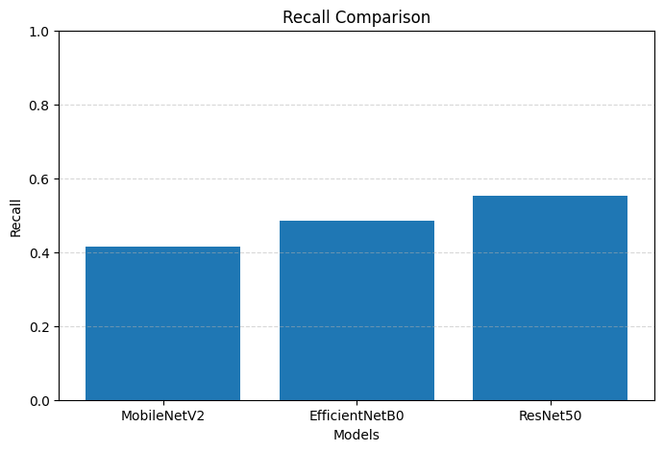
Figure 6 Recall Comparison

F1 Score Comparison
Figure 7 shows the total accuracy and the total recall of the three pretrained deep learning models of MobileNetV2, EfficientNetB0, and ResNet50 in detection of diabetic retinopathy. F1-score is a highly significant measure especially when the data is imbalanced as it is a value that measures both the precision and the recall in a single measure of the model performance. It is indicated in the chart that the F1-score of ResNet50 is the largest at 0.49, meaning that it represents the best tradeoff between the true prediction of positive cases and the false prediction. The next is EfficientNetB0 with a F1-score of around 0.45 and the final one is MobileNetV2 with a F1-score of around 0.41. The results show that ResNet50 performs best regarding the overall performance compared to the other two models, which is likely due to its more detailed architecture and the ability to extract more features. The fact that the MobileNetV2 is gradually becoming more similar to ResNet50 shows that the complexity of the model has a contribution to the performance in the classification. However, the average values of the F1-score imply that they can be raised. Further optimisation may also be carried out, both in refining the models or in better preprocessing of the data, to achieve better diabetic retinopathy detection.

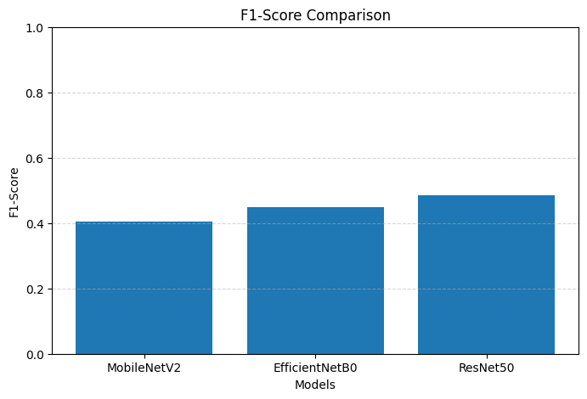
Figure 7 F1 Score Comparison

Confusion Matrix Analysis

MobilenetV2
Figure 8 presents the confusion matrix of the MobileNetV2 model and gives a general idea of the diagnosis power of this model in the diagnosis of diabetic retinopathy. The model is correct in acknowledging 340 of No DR and 66 cases of DR, which is an improved performance in the recognition of non-diseased images. However, it misclassifies 101 No DR cases as DR and, therefore, a relatively big number of false positives. Also there are 93 real cases of DR which are falsely identified as No DR indicating a weakness in the ability to identify positive cases. The implication of such findings is that, though MobileNetV2 can be used to perform with a fair degree of accuracy on healthy retinal images, it cannot be used to detect diabetic retinopathy. The presence of false positives and false negatives demonstrate the need to continue to improve the model, particularly on the sensitivity and the general balance of classification.

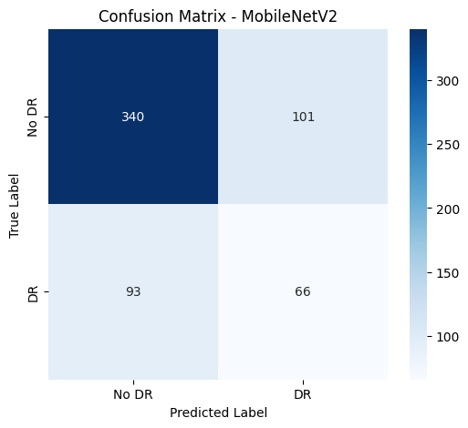
Figure 8 MobilenetV2 Confusion Matrix

EfficientNetV2
Figure 9 depicts the confusion matrix of the EfficientNetB0 model that demonstrates the performance of the model in the classification of diabetic retinopathy. The model recognizes 334 No DR and 77 DR cases and this fact means that the model is as successful in differentiating the two categories as MobileNetV2. It falsely positively classifies 107 cases of No DR as DR. In addition, it has 82 real instances of DR which have been inaccurately identified as No DR which is a little weak in sensitivity. EfficientNetB0, in comparison to MobileNetV2, shows a little more significant detection of positive cases, which is manifested in the increased number of true positives. In general, the model performs moderately, and there is a better balance between the classes, although, the model needs additional optimisation to decrease the misclassification and increase the diagnostic reliability.
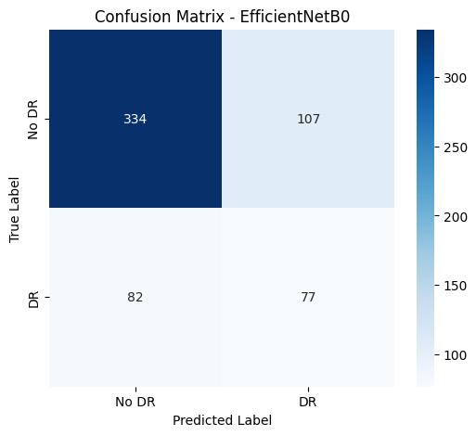
Figure 9 EfficientNetV2 Confusion Matrix

ResNet50
The confusion matrix of ResNet50 model which depicts the performance of this model in the classification of diabetic retinopathy is illustrated in figure 10. This model is right in the identification of 326 No DR cases, and 88 DR cases which means that this model identifies more positive cases than the other models. It incorrectly categorizes 115 cases which are No DR as DR though, creating more false positives. It also has 71 misclassified cases where prediction of 71 DR is 71 No DR which means that there are some false non-detections. However, ResNet50 has the best true positive that is more sensitive. In general, this model would be more even in performance, especially in the detection of diabetic retinopathy, but it would also need to be improved further in order to decrease false positive results and increase the overall accuracy.

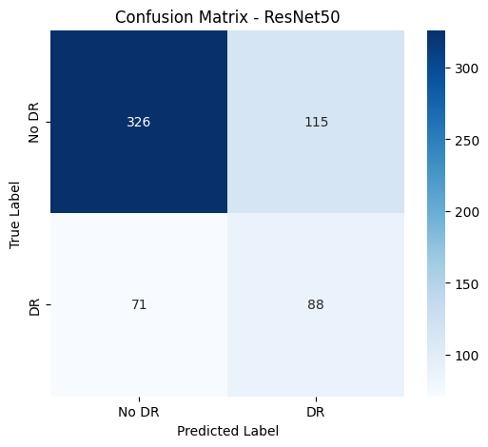
Figure 10 ResNet 50 Confusion Matrix

- Chapter 7: Discussion
This chapter discusses the findings of the study in relation to the research objectives and questions. The performance of the three pretrained deep learning models—MobileNetV2, EfficientNetB0, and ResNet50 is analysed based on the evaluation metrics and confusion matrices. The results are also interpreted in the context of existing literature to highlight similarities, differences, and key insights.

Overall Model Performance
The findings prove that the three models performed moderately similar in terms of evaluation measures, which proved that transfer learning is an effective method of diabetic retinopathy detection. Their accuracy rates were approximately 0.68 and 0.69 and this indicated that both models could acquire the required characteristics of retinal pictures. The levels of performance are however just average and this means that the models can be used, but they are not at a position to be implemented into the clinical environment until they are improved. ResNet50 model was superior in all metrics including accuracy, precision, recall, and F1-score as compared to the MobileNetV2 and EfficientNetB0 models. This implies that finer architectures would best represent finer retina fundus images. The findings of the present research are in line with those of the other sources that substantiate the advantages of the more advanced convolutional neural networks in the medical image classification.

Impact of Data Preprocessing and Class Balancing
The instances of preprocessing methods were resizing, normalisation and data augmentation, which were used to enhance the overall performance of the models in terms of better generalisation. Besides, the issue of imbalance of classes was also addressed with the help of upsampling that was employed to remove the bias towards the majority class. However, the dataset was still problematic, which was also evidenced by the intermediate evaluation scores. It implies that preprocessing and balancing are good but cannot be used independently to provide high-performance result. Other methods to optimize the models include class weighting or artificial data generation.

Comparison with Existing Literature
Its findings are in agreement with the previous research, which highlights the utility of the transfer learning to identify diabetic retinopathy. This study, as in those of Talukder et al. and Nadeem et al., indicates that pretrained models are capable of making reasonable performance with small amounts of data. However, the results obtained in this research are moderate compared to certain researches that have such large percentage of accuracy. This might be due to the disparity in the size of the dataset, the way of preprocessing or the evaluation strategies. It also highlights the point that realistic evaluation is critical and deep learning models are hard to apply on real world medical data.

- Chapter 8: Conclusion and Future Work
This study has developed and tested a deep learning-based approach to the automatic detection of diabetic retinopathy by analyzing retina fundus images. The research made the diagnostic intent simple by reducing the five-class grading issue into a binary classification issue such that the definition of whether or not diabetic retinopathy is present is established. Three models of the convolutional neural network, MobileNetV2, EfficientNetB0, and ResNet50, that have been trained were used on the dataset using the transfer learning and the accuracy, precision, recall, F1-score, and confusion matrices were used to assess the models. The findings revealed that all three of the models were able to learn significant retinal features and perform the task of classification with moderate success. Among them, ResNet50 performed the most, i.e., it was the most accurate, precise, recalled, and had the best F1-score, and it was more efficient in the detection of cases of diabetic retinopathy.
Another very evident point in the study was that the preprocessing methods including resizing, normalization, data augmentation, and class balancing showed a positive correlation with model training and generalisation. However, the results were moderate overall, and it implies that the developed models are yet to achieve the high diagnostic performance level. Namely, all the models also had false positives and false negatives, which shows deficits in the sensitivity and predictive accuracy. Therefore, despite the fact that the study has shown that transfer learning can be helpful in predicting diabetic retinopathy, it also suggests that optimization is yet to be done before such systems can be applied in practice into the real world.
The experiments in the future should be focused on improving the performance of the models by fine-tuning the backbones rather than making them frozen. It may also be enhanced by training on more data, more training epochs and more sophisticated augmentation techniques to render it robust. In addition, further research may also focus on the multi-class classification to establish the level of diabetic retinopathy severity as opposed to binary identification. The proposed system would be more useful and reliable with the help of ensemble learning, explainable AI, such as Grad-CAM, and external clinical validation of the system on different datasets.

- References
Abushawish, I. Y., Modak, S., Abdel-Raheem, E., Mahmoud, S. A., & Hussain, A. (n.d.). Date of publication xxxx 00, 0000, date of current version xxxx 00, 0000. Deep Learning in Automatic Diabetic Retinopathy Detection and Grading Systems: A Comprehensive Survey and Comparison of Methods. https://doi.org/10.1109/ACCESS.2017.DOI
Alyoubi, W. L., Shalash, W. M., & Abulkhair, M. F. (2020). Diabetic retinopathy detection through deep learning techniques: A review. Informatics in Medicine Unlocked, 20, 100377. https://doi.org/https://doi.org/10.1016/j.imu.2020.100377
Bhaskar, D. N. (2022). Diabetic Retinopathy Detection Using Deep Learning. Springer. https://doi.org/10.1007/978-981-19-1559-8_39
Bhulakshmi, D., & Rajput, D. S. (2024). A systematic review on diabetic retinopathy detection and classification based on deep learning techniques using fundus images. PeerJ Computer Science, 10. https://doi.org/10.7717/PEERJ-CS.1947
Doshi, D., Shenoy, A., Sidhpura, D., & Gharpure, P. (n.d.). Diabetic Retinopathy Detection using Deep Convolutional Neural Networks.
Mushtaq, G., & Siddiqui, F. (2021). Detection of diabetic retinopathy using deep learning methodology. IOP Conference Series: Materials Science and Engineering, 1070(1), 012049. https://doi.org/10.1088/1757-899x/1070/1/012049
Nadeem, M. W., Goh, H. G., Hussain, M., Liew, S. Y., Andonovic, I., & Khan, M. A. (2022). Deep Learning for Diabetic Retinopathy Analysis: A Review, Research Challenges, and Future Directions. In Sensors (Vol. 22, Number 18). MDPI. https://doi.org/10.3390/s22186780
Nguyen, Q. H., Muthuraman, R., Singh, L., Sen, G., Tran, A. C., Nguyen, B. P., & Chua, M. (2020). Diabetic retinopathy detection using deep learning. ACM International Conference Proceeding Series, 103–107. https://doi.org/10.1145/3380688.3380709
Rakib Ul Islam Rahat, S., Rahman, H., Arafat, Y., Rahaman, M., Minzamul Hasan, M., & Al Amin, M. (2025). British Journal of Nursing Studies Advancing Diabetic Retinopathy Detection with AI and Deep Learning: Opportunities, Limitations, and Clinical Barriers. https://doi.org/10.32996/bjns
Sarki, R., Ahmed, K., Wang, H., & Zhang, Y. (2020). Automatic Detection of Diabetic Eye Disease through Deep Learning Using Fundus Images: A Survey. In IEEE Access (Vol. 8, pp. 151133–151149). Institute of Electrical and Electronics Engineers Inc. https://doi.org/10.1109/ACCESS.2020.3015258
Simul Hasan Talukder, M., & Author, C. (n.d.). An Improved Model for Diabetic Retinopathy Detection by using Transfer Learning and Ensemble Learning.
Tsiknakis, N., Theodoropoulos, D., Manikis, G., Ktistakis, E., Boutsora, O., Berto, A., Scarpa, F., Scarpa, A., Fotiadis, D. I., & Marias, K. (2021). Deep learning for diabetic retinopathy detection and classification based on fundus images: A review. In Computers in Biology and Medicine (Vol. 135). Elsevier Ltd. https://doi.org/10.1016/j.compbiomed.2021.104599
Tymchenko, B., Marchenko, P., & Spodarets, D. (2020). Deep Learning Approach to Diabetic Retinopathy Detection. http://arxiv.org/abs/2003.02261

