# leveraging Pre-Trained Models

<https://youtu.be/E8yBgSKfCoo>

We covered three types of computer vision models in the video: **Classification, Detection, and Segmentation.**

There are other Pre-Trained models e.g. **Text recognition , pose estimation … etc.**

**Classification** determines a given “class” that an image, or an object in an image, belongs to, from a simple yes/no to thousands of classes. These usually have some sort of “probability” by class, so that the highest probability is the determined class, but you can also see the top 5 predictions as well.

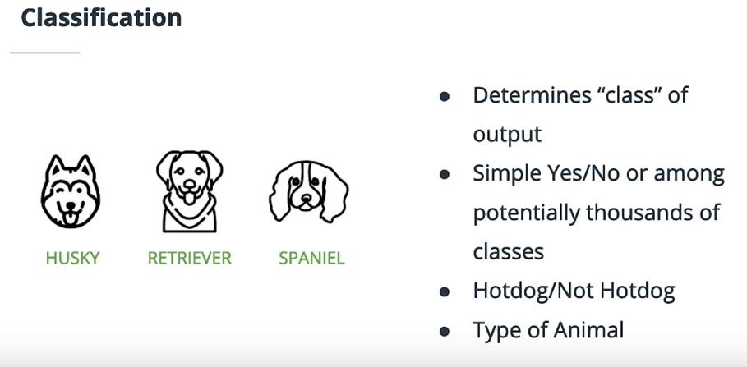

**Detection** gets into determining that objects appear at different places in an image, and oftentimes draws bounding boxes around the detected objects. It also usually has some form of classification that determines the class of an object in a given bounding box. The bounding boxes have a confidence threshold so you can throw out low-confidence detections.

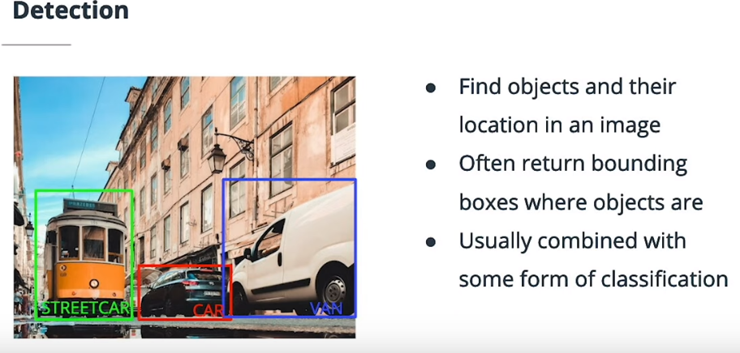

**Segmentation** classifies sections of an image by classifying each and every pixel. These networks are often post-processed in some way to avoid phantom classes here and there. Within segmentation are the subsets of **semantic segmentation** and **instance segmentation** - the first wherein all instances of a class are considered as one, while the second actually consider separates instances of a class as separate objects “e.g. two different bicycles.

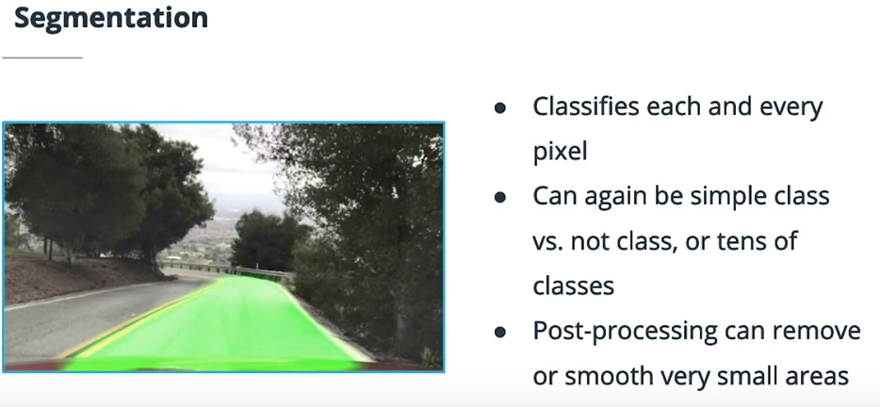

# Case Studies in Computer Vision

* <https://classroom.udacity.com/nanodegrees/nd132/parts/3eafdf71-b35c-4525-9b2c-d46f7dc300aa/modules/cc8ef708-33e0-472b-a8d6-ed66b8e6f678/lessons/ce84f711-c69f-4d6d-885d-0f18e061ca12/concepts/ee9f8ca0-8812-47e8-90a1-d05f81055e6a>
* <https://youtu.be/7mUaovlA4aQ>

this talk about various neural network architecture. They just talk about 3 different types and there are more to explore and new once.

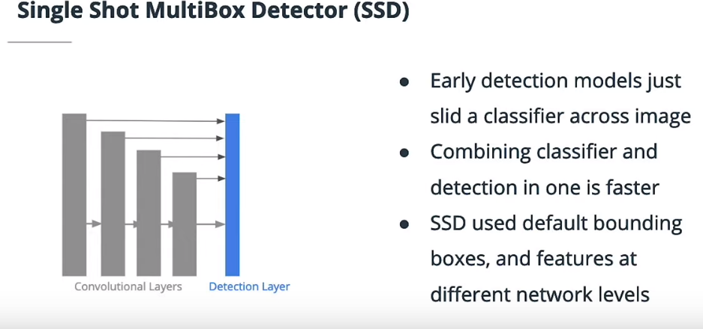

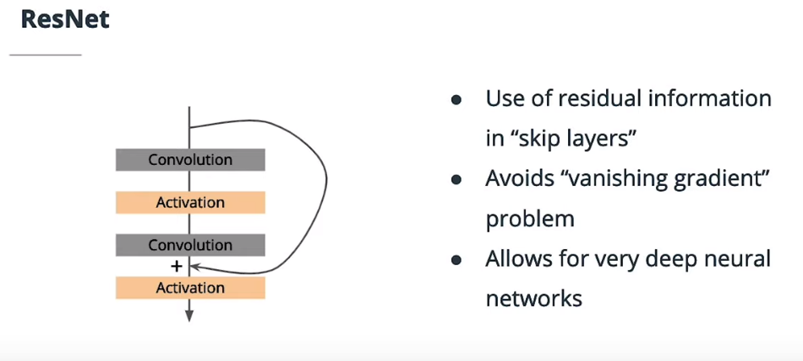

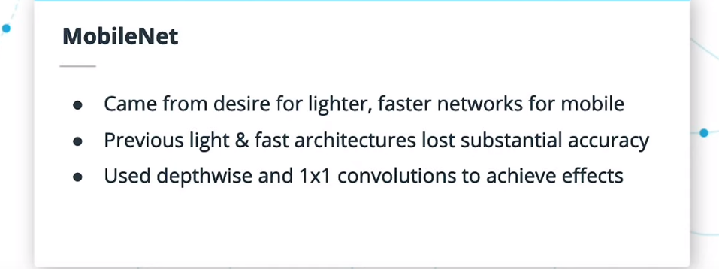

### Further Research

Getting used to reading research papers is a key skill to build when working with AI and Computer Vision. Below, you can find the original research papers on some of the networks we discussed in this section.

* [SSD](https://arxiv.org/abs/1512.02325)
* [YOLO](https://arxiv.org/abs/1506.02640)
* [Faster RCNN](https://arxiv.org/abs/1506.01497)
* [MobileNet](https://arxiv.org/abs/1704.04861)
* [ResNet](https://arxiv.org/abs/1512.03385)
* [Inception](https://arxiv.org/pdf/1409.4842.pdf)

# Available Pre-Trained Models in OpenVINO™