MSc Data Science Project
7PAM2002-0509-2024
Department of Physics, Astronomy and Mathematics

Data Science FINAL PROJECT REPORT

Project Title:
Glucose Level Forecasting: Advanced Data Analysis and Patient Profiling

Student Name and SRN:
Saher Saeed - 230950

Supervisor: William Cooper
Date Submitted: 28/08/2025
Word Count: Enter the word count excluding references and appendices

DECLARATION STATEMENT

This report is submitted in partial fulfilment of the requirement for the degree of Master of Science in Data Science at the University of Hertfordshire.
I have read the detailed guidance to students on academic integrity, misconduct and plagiarism information at Assessment Offences and Academic Misconduct and understand the University process of dealing with suspected cases of academic misconduct and the possible penalties, which could include failing the project or course.
I certify that the work submitted is my own and that any material derived or quoted from published or unpublished work of other persons has been duly acknowledged. (Ref. UPR AS/C/6.1, section 7 and UPR AS/C/5, section 3.6)
I did not use human participants in my MSc Project.

I hereby give permission for the report to be made available on module websites provided the source is acknowledged.

Student Name printed: Saher Saeed

Student Name: Saher Saeed

Student SRN number: 23095096

UNIVERSITY OF HERTFORDSHIRE
SCHOOL OF PHYSICS, ENGINEERING AND COMPUTER SCIENCE

Abstract
Accurate forecasting of insulin requirements is a crucial aspect of diabetes management, enabling more personalized treatment, reducing complications, and improving patient quality of life. This study explores the application of machine learning techniques to predict insulin usage using a rich dataset combining clinical and biometric data. By leveraging comprehensive feature engineering and in-depth exploratory data analysis, we develop and evaluate predictive models to forecast insulin demand on a patient-specific basis. The results provide actionable insights into key determinants of insulin requirements and highlight the potential of data-driven approaches to support clinical decision-making.
1. Introduction
Diabetes is a long-term condition that requires constant monitoring to avoid dangerous swings in blood glucose levels. Sudden rises (hyperglycemia) or drops (hypoglycemia) can have serious health consequences, making it important to predict these changes before they occur. Continuous Glucose Monitoring (CGM) devices now provide a stream of time-series data that opens the door for advanced forecasting methods to support better diabetes management.
This project focuses on applying deep learning models to forecast short-term glucose levels using CGM data. The key question addressed is: Which model—LSTM, GRU, or CNN—can provide the most accurate and reliable predictions? LSTM and GRU are popular recurrent models designed to capture sequential dependencies in data, while CNN, although commonly used in image recognition, has shown promise in handling time-series patterns.
By comparing these models on the same dataset, the study aims to provide a clear evaluation of their strengths and limitations. The ultimate goal is to explore how such predictive tools could support proactive diabetes care, enabling earlier interventions and reducing risks for patients.
2. Literature Review
Forecasting glucose levels has become an active research area with the growing availability of Continuous Glucose Monitoring (CGM) data. Early approaches often used traditional statistical models such as ARIMA, but these struggled with the complex, non-linear patterns present in biomedical signals (Jain and Tripathi, 2018).
The introduction of deep learning shifted the focus to recurrent neural networks (RNNs). Long Short-Term Memory (LSTM) networks are widely used for glucose prediction because of their ability to capture long-term dependencies in time-series data (Zhu et al., 2020). Gated Recurrent Units (GRUs) emerged as a simpler and faster alternative, often delivering comparable accuracy with fewer parameters (Li et al., 2019). Both have demonstrated strong performance in forecasting short-term glucose fluctuations.
More recently, Convolutional Neural Networks (CNNs) have been applied to sequential biomedical data. Although CNNs are traditionally associated with image recognition, they are highly effective at detecting local temporal patterns. Several studies found that CNN-based architectures can outperform recurrent models in accuracy and computational efficiency for glucose forecasting (Sun et al., 2021).
In summary, LSTM and GRU remain strong baselines in the literature, but CNNs are emerging as competitive alternatives. However, comparative evaluations are still limited, and outcomes often depend on dataset characteristics and preprocessing steps. This highlights the need for systematic studies, such as the one conducted in this project.
Despite encouraging results, challenges remain, including data sparsity, missing values, and the interpretability of black-box models. Clinical adoption requires models to be both accurate and transparent, providing interpretable recommendations that clinicians can trust. This study builds upon prior work by integrating comprehensive clinical and biometric features, performing robust feature engineering, and evaluating the practical implications of insulin forecasting models.
3. Data Description & Preprocessing

The dataset used in this project originates from a continuous glucose monitoring (CGM) study, consisting of 645,030 records across 41 variables. Each record represents an observation of a patient at a given point in time, identified by a unique id.
The key variable is gl, which captures the glucose level at the timestamp recorded in time. Alongside glucose data, the dataset includes a wide range of features:
- Demographic attributes such as gender, race, marital status, education level, and income (Gender, Race, EduLevel, AnnualInc).
- Lifestyle factors, including frequency of exercise and alcohol consumption (DaysWkEx, DaysWkDrinkAlc, DaysMonBingeAlc).
- Clinical history, including age at Type 1 diabetes diagnosis (T1DDiagAge), number of hospitalisations for diabetic ketoacidosis (NumHospDKA), and severe hypoglycemia (NumSHSinceT1DDiag).
- Comorbidities such as hypertension, depression, and kidney disease.
- Medication records for insulin, statins, vitamins, and other treatments.
This makes the dataset well-suited for investigating how glucose levels interact with both short-term behaviour and long-term health conditions.
Preprocessing Steps
To prepare the data for model training, several preprocessing steps were carried out:
- Data cleaning: Missing and inconsistent glucose readings were identified and removed.
- Time alignment: Glucose readings were sorted chronologically for each patient, and irregular intervals were resampled to a uniform time step.
- Scaling: Continuous variables such as glucose, insulin units, weight, and income were standardised using z-score scaling, ensuring comparability across patients.
- Sequence generation: Input features were transformed into overlapping windows of past glucose values (e.g., 12 steps), with the target being the glucose level at a future time point.
- Splitting: The dataset was divided chronologically into training, validation, and testing subsets to prevent data leakage.
This preprocessing ensured that the data was consistent, numerically stable, and suitable for training deep learning models such as LSTM, GRU, and CNN.
4. Exploratory Data Analysis (EDA)
4.1 Overview
This project examines how social context, lifestyle behaviors, clinical comorbidities, and medications relate to blood glucose in an adult diabetes cohort and prepares the ground for forecasting models.
4.2 Socio-demographic factors
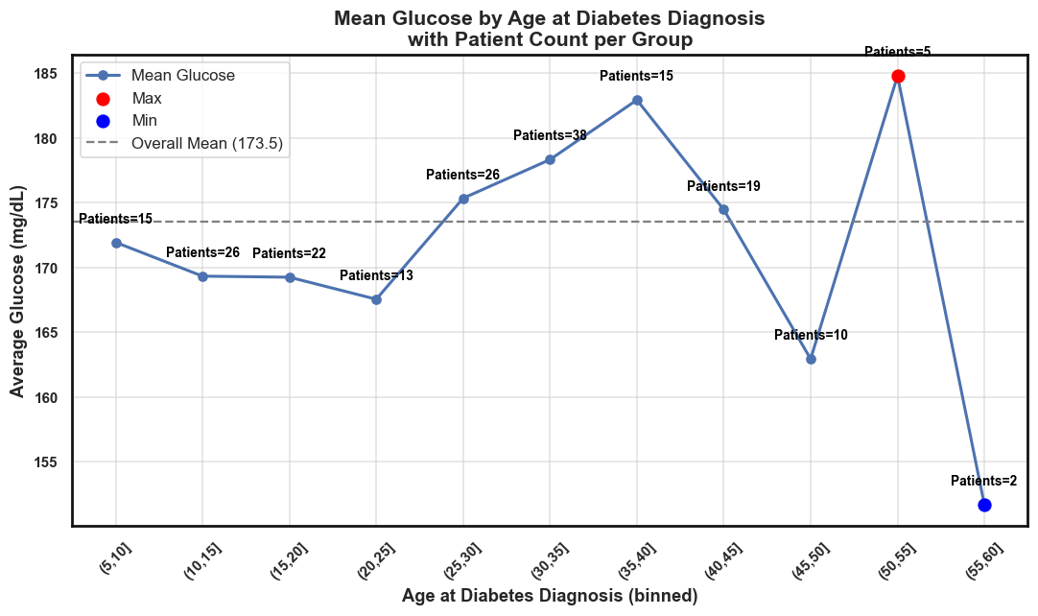
- Mean Glucose by Age at Diabetes Diagnosis with Patient Counts
People diagnosed at younger or middle ages show similar average glucose, while some older groups have slightly higher values. Each age group includes many patients, so the trend looks consistent overall.

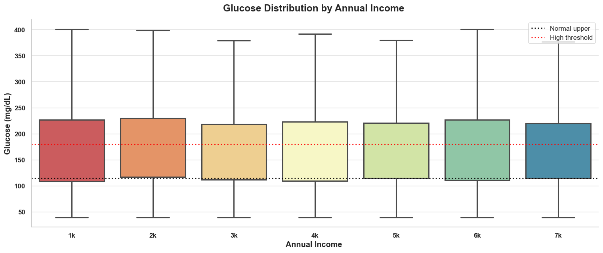
- Income impact on glucose
The impact of income on glucose is minimal. Across different income groups, glucose levels show wide variation but no clear upward or downward trend. The statistical correlation is very weak (≈0.015), confirming that income does not meaningfully influence glucose control in this dataset.

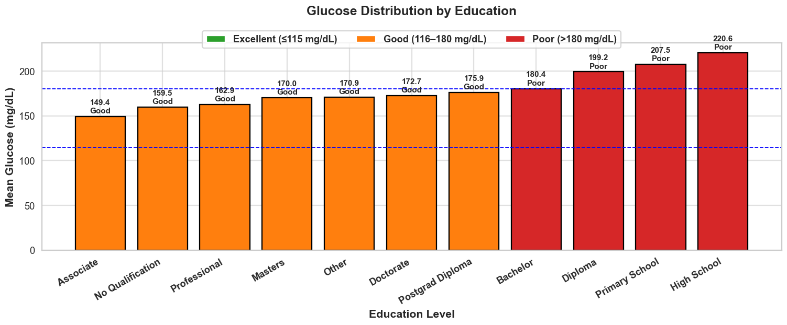
- Relationship Between Education and Glucose Levels
Glucose levels show a clear link with education. People with higher education (Associate, Professional, Masters, Doctorate) tend to have better glucose control (mostly in the “Good” range), while those with lower education (High School, Primary, Diploma) show poorer control, with mean glucose often above 180 mg/dL.

- Marital Status and Glucose Trends
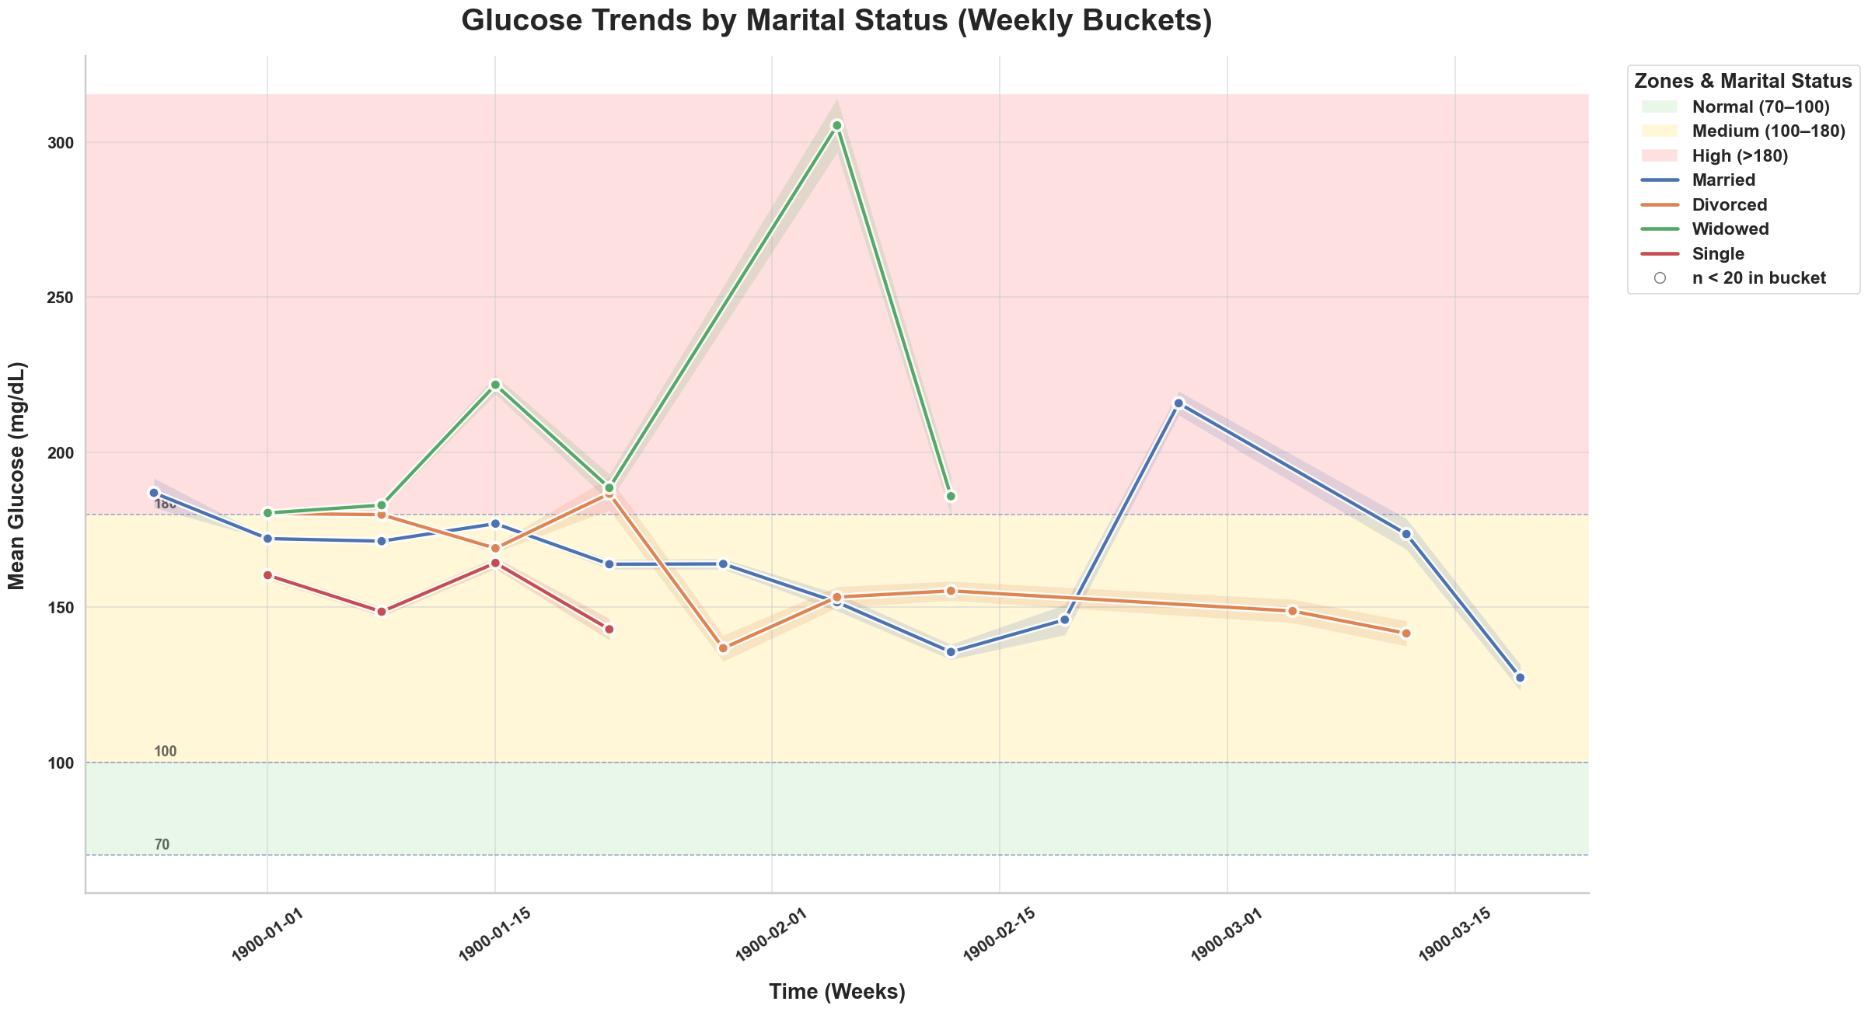
The weekly trends show that glucose levels vary across marital groups, but the patterns are uneven. Married individuals tend to display larger swings, occasionally spiking into the high zone (>180 mg/dL). Widowed patients also show instability, with some sharp peaks. In contrast, divorced and single groups remain more steady, usually within the medium range (100–180 mg/dL). Overall, marital status appears to have some effect on glucose control, but the influence is inconsistent and not dominant.
4.3 Life Style
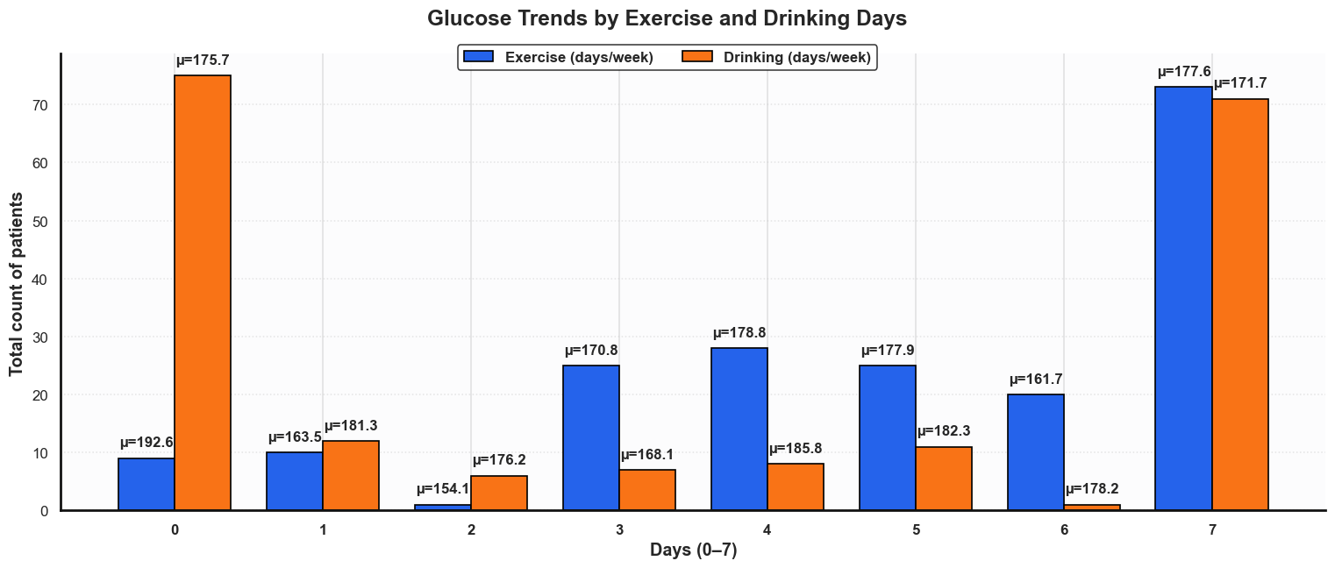
4.3.1 Exercise and Binge Drinking per Week
People who exercise more often usually have lower and steadier glucose levels compared to those who don’t exercise.
For alcohol drinking, the pattern isn’t very clear. Glucose stays in a similar range no matter how many days people drink.
4.4 Clinical Comorbidities and Their Impact
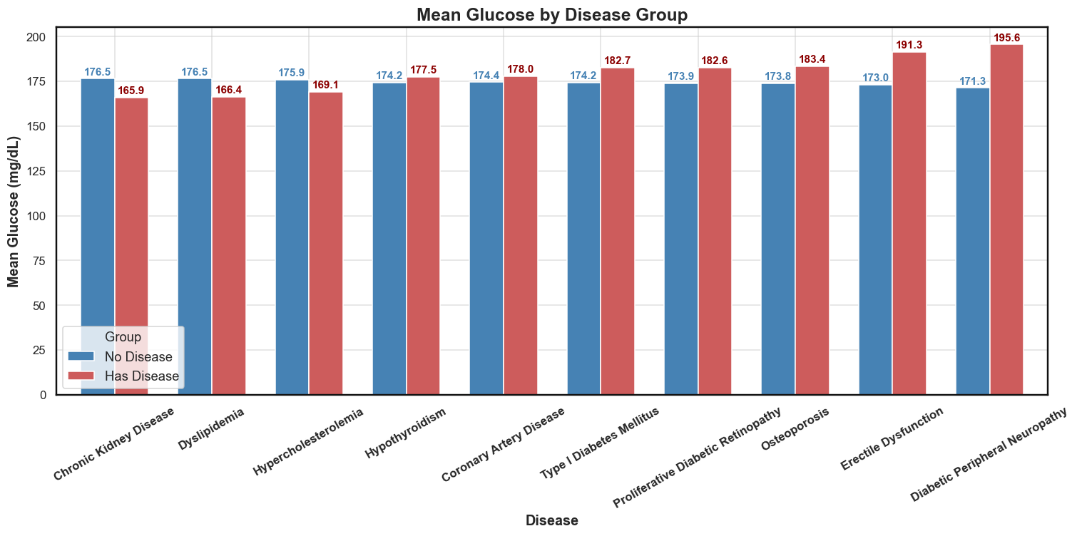
We compared per-patient mean glucose between those with and without each condition (CKD, dyslipidemia, neuropathy, retinopathy, hypothyroidism, etc.) using grouped bar plots. In nearly all cases, individuals with comorbidities show slightly higher glucose levels than those without. The differences are not extreme but consistent, suggesting that added disease burden makes glucose control more difficult. The clearest gaps appear in conditions such as diabetic neuropathy, erectile dysfunction, and retinopathy, where mean glucose is notably elevated.
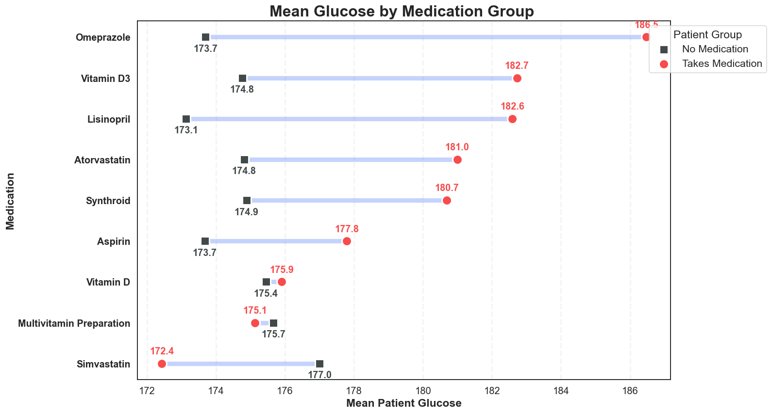
4.6 Medication and Supplement Usage
While medications such as statins, aspirin, vitamin D, and various supplements showed relatively minor but statistically significant differences in mean insulin usage, these variables add context to each patient’s overall care complexity and may be useful as covariates in predictive modeling.
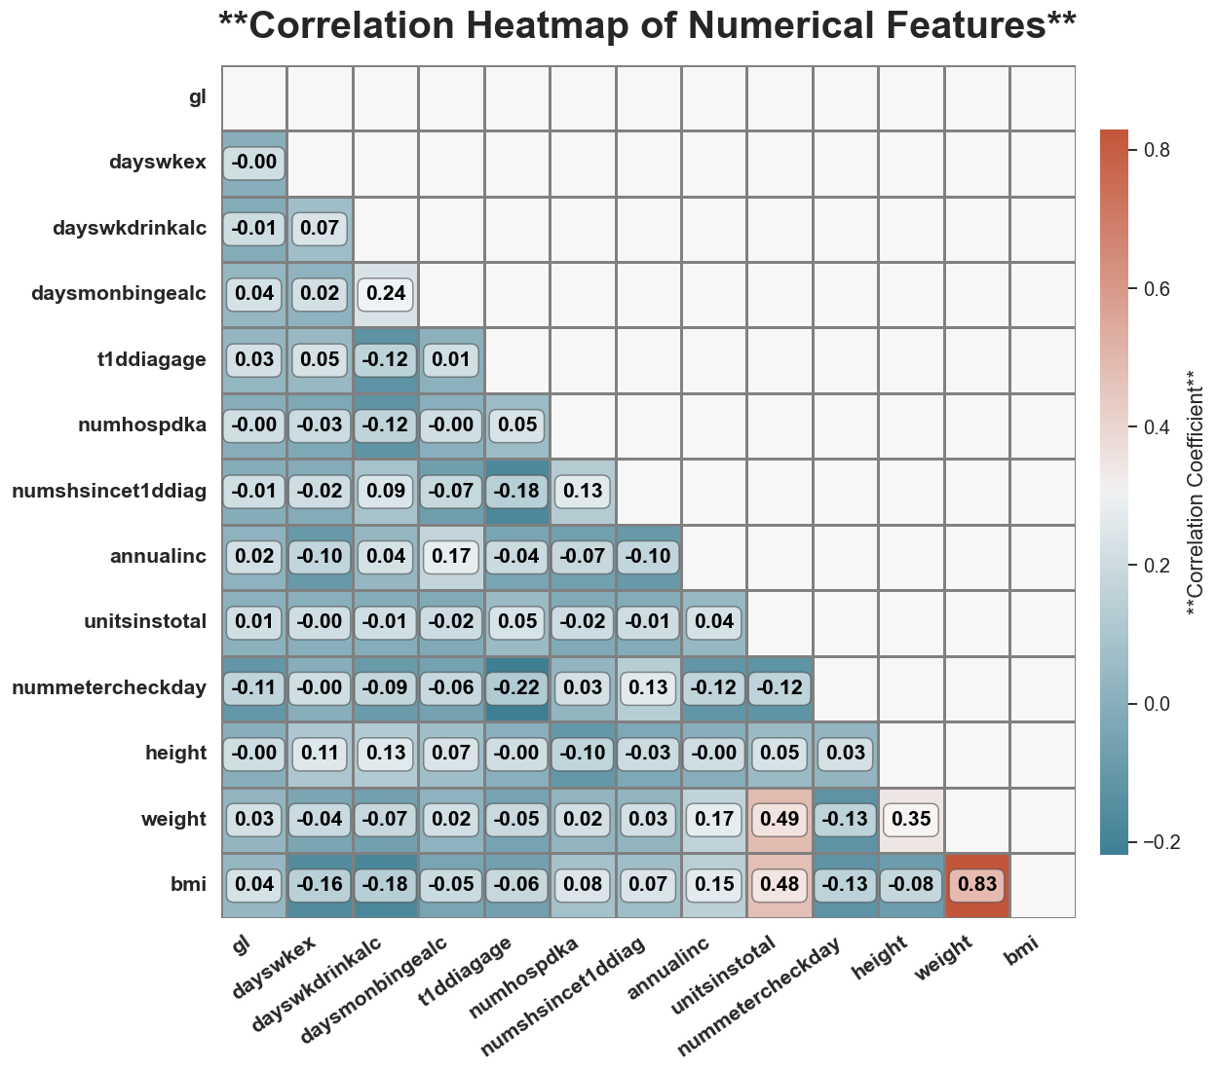
4.7 Correlation Analysis
No strong linear links with glucose — all |r| are tiny. Lifestyle (exercise/drinking), income, monitoring, etc., show near-zero correlation with gl. The only big relationship in the matrix is BMI and weight (highly positive), which is expected. This doesn’t rule out non-linear or lagged effects; it just says simple linear ties are weak.

Correlation Table with Strength

Variable | Correlation with Target | Strength
id | 0.023 | Very Weak
gl | 1.000 | Perfect
dayswkex | -0.004 | Very Weak
dayswkdrinkalc | -0.021 | Very Weak
daysmonbingealc | 0.038 | Very Weak
t1ddiagage | 0.027 | Very Weak
numhospdka | -0.011 | Very Weak
numshsincet1ddiag | 0.007 | Very Weak
annualinc | 0.015 | Very Weak
unitsinstotal | 0.023 | Very Weak
nummetercheckday | -0.108 | Very Weak
height | -0.002 | Very Weak
weight | 0.031 | Very Weak
bmi | 0.037 | Very Weak

The only strong link is with gl, since it’s the target itself. All other variables show very weak relationships. The small positive ones include bmi, weight, and daysmonbingealc, while the weakest negative link comes from nummetercheckday. Overall, no other column adds much predictive power.

5. Model Development & Methods

5.1 Overview of Predictive Modeling Approach
This project applies three deep learning models — LSTM, GRU, and CNN — to predict short-term glucose levels from continuous glucose monitoring (CGM) data. The approach was designed to be simple, logical, and easy to follow:
- Preprocessing: Patient data was ordered chronologically, resampled into 5-minute intervals, and cleaned to handle missing or noisy values.
- Feature Engineering: Twelve lag features (≈1 hour of glucose history) were created to frame the task as predicting the next reading from past values.
- Scaling: StandardScaler was applied to both inputs and outputs, fitted only on training data to avoid leakage; predictions were inverse-scaled for interpretation.
- Data Splitting: A patient-wise chronological split was used — the last 60 readings reserved for testing, with the rest divided into training (≈70–75%) and validation (≈10–15%).
- Baseline Models: Standard versions of LSTM, GRU, and CNN were trained to establish initial performance benchmarks.
- Hyperparameter Tuning: Each model explored 12 configurations (varying units, filters, dropout, dense layers, learning rate), with validation RMSE guiding the best setup.
- Training Setup: All models used MSE loss, the Adam optimizer, early stopping to prevent overfitting, and consistent batch size/epochs for fairness.
- Evaluation: Performance was assessed with regression metrics (R², RMSE, MAE) and classification metrics (Accuracy, Precision, Recall, F1, Confusion Matrix at 140 mg/dL).
- Results & Selection: Comparisons through tables, scatter plots, training curves, and patient-level studies showed that the tuned CNN achieved the highest R² (0.996), lowest RMSE (≈5 mg/dL), and the strongest classification F1-score (0.986), making it the most reliable model overall.

5.2 Feature Engineering
To convert CGM data into supervised sequences suitable for deep learning:
- Resampling: Glucose readings were resampled to fixed 5-minute intervals to create consistent time steps across all patients.
- Lag Features: For each target value (gl), the preceding 12 lags (lag_1 … lag_12) were used as features. This represents approximately 1 hour of patient glucose history.
- Windowed Dataset: Inputs X = {lag_1 … lag_12} and output y = gl(t) were created for each timepoint.
- Patient-wise Construction: Features were generated independently for each patient to prevent inter-patient leakage.
This ensured that models learned both short-term temporal dependencies and personalised patterns within patient trajectories.

5.3 Scaling
To keep training stable and results meaningful, we scaled both inputs and outputs with StandardScaler. The scaler was fitted only on the training data (to avoid leakage) and then applied consistently to validation and test sets. This kept features on a comparable scale, sped up convergence, and prevented models from being biased by extreme glucose ranges (50–400 mg/dL).
Predictions were inverse-transformed back into mg/dL so metrics like RMSE and MAE stayed clinically interpretable. In short, scaling acted as a training stabiliser and a bridge back to clinical reality.

5.4 Training, Validation, and Testing Split
To keep the setup close to real-life forecasting, we split each patient’s data by time rather than at random.
- Testing: The latest TEST_WINDOW readings were held back as the “future” the model had to predict.
- Validation: From the remaining pool, about 10% of the earliest samples were used to tune the model.
- Training: Everything before that went into training.
- This way, the model always learned from past data to predict future trends — just like it would in a clinical setting. Every patient contributed to all three phases, but their most recent readings stayed unseen until the very end. In practice, this worked out to around 70–75% training, 10–15% validation, and 15–20% testing, a balance that gave the model enough history to learn from while keeping evaluation fair and realistic.

5.5 Baseline Model Performance
Baseline models (GRU, CNN, and LSTM) were trained with standard configurations to establish reference performance before tuning. Results are summarised in both tabular and visual form for clarity. Baseline models were trained with standard configurations.
Table 5.1: Baseline performance across Train/Validation/Test sets
Model | Train R² | Train RMSE | Train MAE | Val R² | Val RMSE | Val MAE | Test R² | Test RMSE | Test MAE
LSTM (B) | 0.982 | 11.013 | 7.583 | 0.984 | 10.692 | 7.325 | 0.988 | 9.160 | 6.344
GRU (B) | 0.979 | 11.956 | 9.943 | 0.980 | 11.880 | 9.886 | 0.981 | 11.450 | 9.596
CNN (B) | 0.994 | 6.492 | 4.390 | 0.994 | 6.520 | 4.330 | 0.995 | 5.641 | 3.783
Baseline Train vs Test Scatter Plots
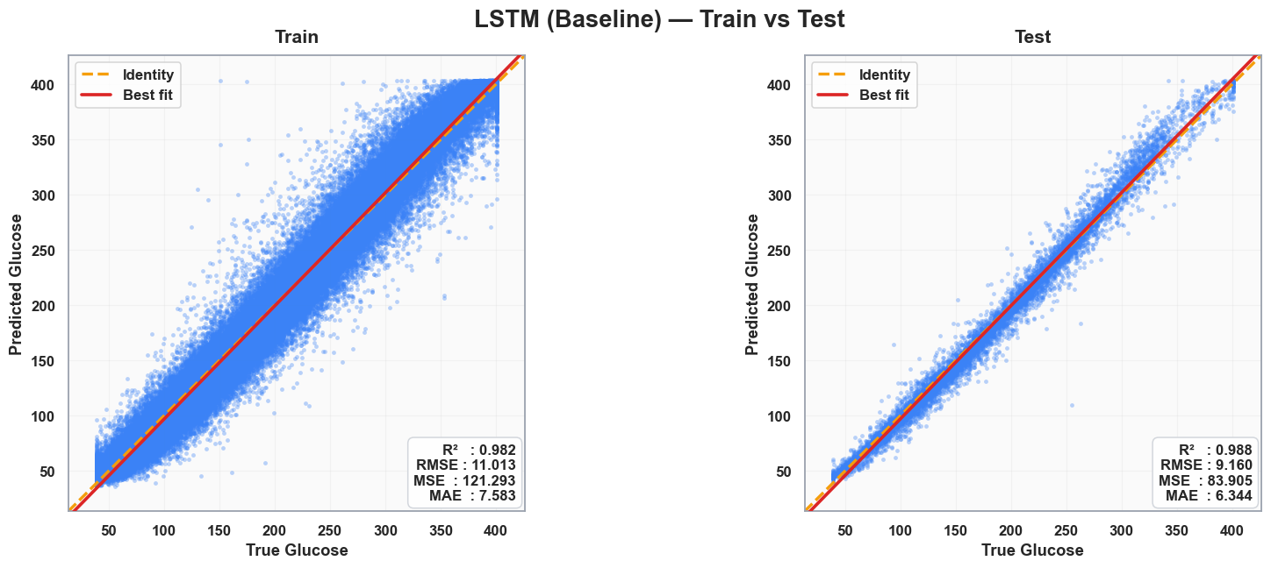
- LSTM Baseline — Train vs Test

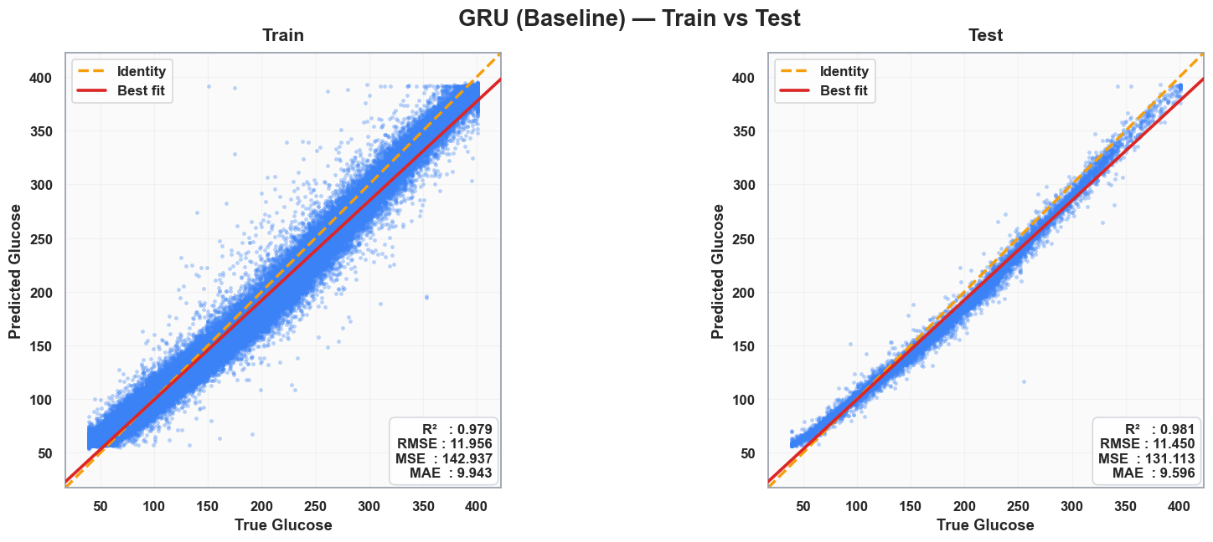
- GRU Baseline — Train vs Test
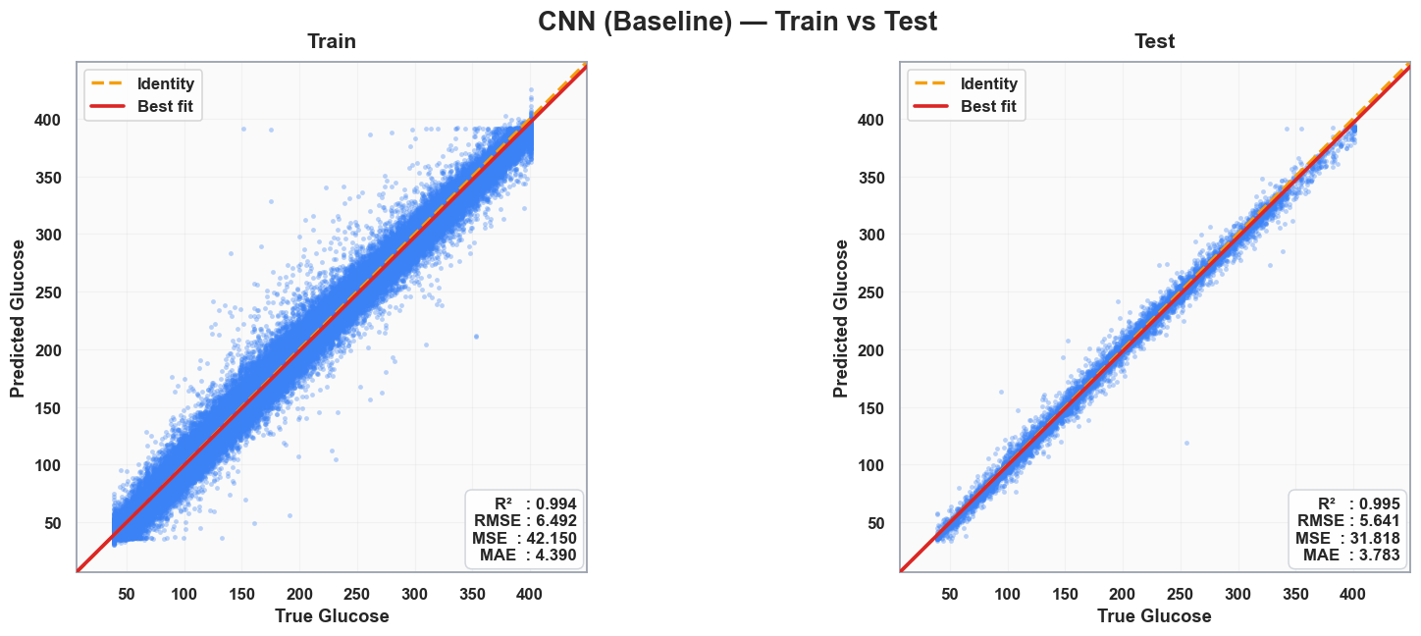
- CNN Baseline — Train vs Test
Observations from Baseline Scatter Plots
The scatter plots show that all three models capture the glucose trajectory well, with predictions closely following the identity line. GRU performs reliably but shows a bit more spread at higher glucose values, leading to slightly larger errors. CNN demonstrates the tightest fit, with predictions almost perfectly aligned and very low error, making it the strongest baseline. LSTM sits in between: it generalises well with no signs of overfitting, but its errors are somewhat higher than CNN’s. Overall, the results highlight that while all models generalise effectively, CNN stands out as the most accurate and stable baseline.
Baseline Confusion Matrices
- LSTM Baseline — Test
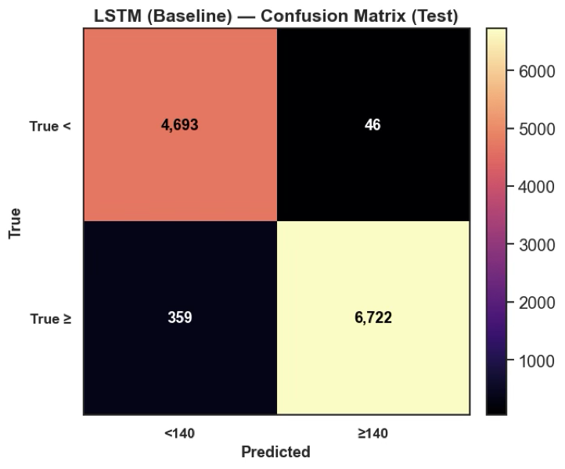

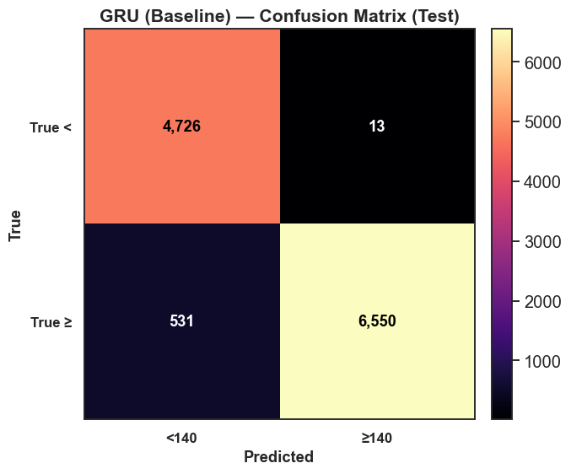
- GRU Baseline — Test

- CNN Baseline — Test
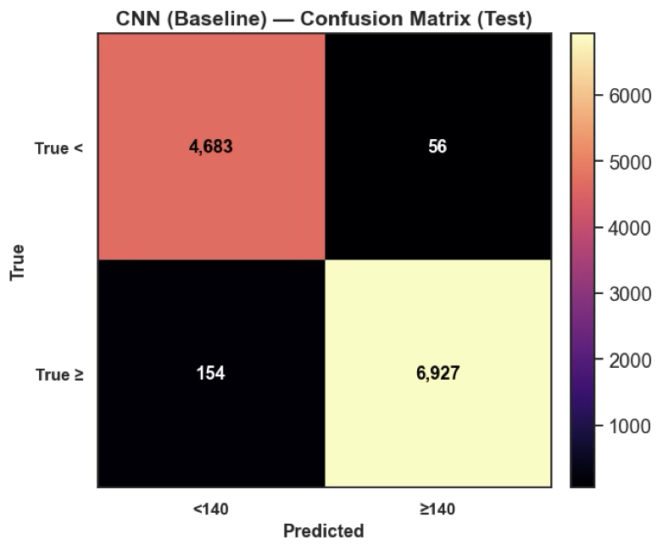

Confusion Matrix Results and Metrics for Baseline Models (Threshold = 140 mg/dL)
Model | TN | FP | FN | TP | Accuracy | Sensitivity (≥140) | Specificity (<140)
CNN (Baseline) | 4683 | 56 | 154 | 6927 | 98.5% | 97.8% | 98.8%
GRU (Baseline) | 4726 | 13 | 531 | 6550 | 97.9% | 92.5% | 99.7%
LSTM (Baseline) | 4693 | 46 | 359 | 6722 | 97.7% | 95.0% | 99.0%

The confusion matrices highlight how well the baseline models classify glucose levels around the clinical threshold of 140 mg/dL. CNN performs strongly, with very few misclassifications in both directions: only 56 false positives and 154 false negatives. GRU also shows high accuracy but produces more false negatives (531), meaning it misses some above-threshold cases compared to CNN. Both models achieve strong sensitivity and specificity, but CNN demonstrates greater reliability in detecting hyperglycaemic events with fewer critical errors.

5.6 Hyperparameter Tuning Approach
To move beyond the baselines, each model went through a capped 12-trial search, mixing grid search (systematic) and random search (exploratory). This gave a good balance between coverage and efficiency.
For LSTM and GRU, we varied the number of hidden units (64, 96, 128), dropout rates (0.1–0.3), dense layer sizes (32–96), and learning rate (0.001 or 0.0005).
For CNN, the search also included convolutional filters (32–96) and kernel sizes (3, 5, 7), alongside dropout, dense units, and learning rate.
The best setup for each model was chosen using validation RMSE. In general, moderate dropout (around 0.2) and slightly smaller learning rates gave the most stable results, while too many units or filters risked overfitting.
Best hyperparameters after tuning
Model | Best Params | Best Val RMSE
LSTM | units=128, dropout=0.1, dense=64, lr=0.0005 | 6.850
GRU | units=64, dropout=0.1, dense=32, lr=0.001 | 7.380
CNN | filters=96, kernel=7, dropout=0.1, dense=32, lr=0.0005 | 5.879

Example tuning logs (LSTM excerpt):
[11/12] val_RMSE=6.8502 | params={'units':128, 'dropout':0.1, 'dense_units':64, 'lr':0.0005} <-- BEST
5.7 Tuned Model Performance
Table 5.3: Tuned performance across Train/Validation/Test sets
Model | Train R² | Train RMSE | Train MAE | Val R² | Val RMSE | Val MAE | Test R² | Test RMSE | Test MAE
LSTM (T) | 0.993 | 6.974 | 4.926 | 0.993 | 6.850 | 4.779 | 0.995 | 6.126 | 4.377
GRU (T) | 0.992 | 7.335 | 5.343 | 0.992 | 7.380 | 5.291 | 0.993 | 6.835 | 5.043
CNN (T) | 0.995 | 5.935 | 3.759 | 0.995 | 5.879 | 3.624 | 0.996 | 5.024 | 3.118

Tuned Train vs Test Scatter Plots
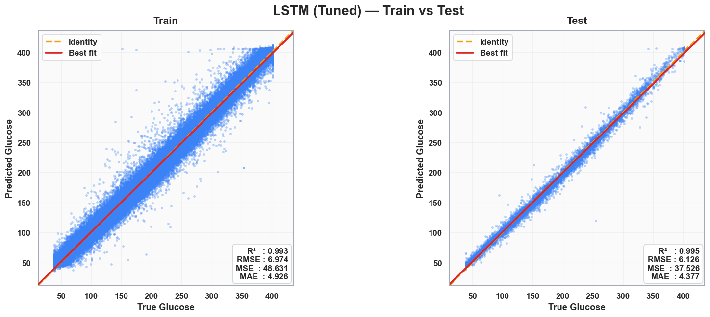
- LSTM Tuned
- GRU Tuned
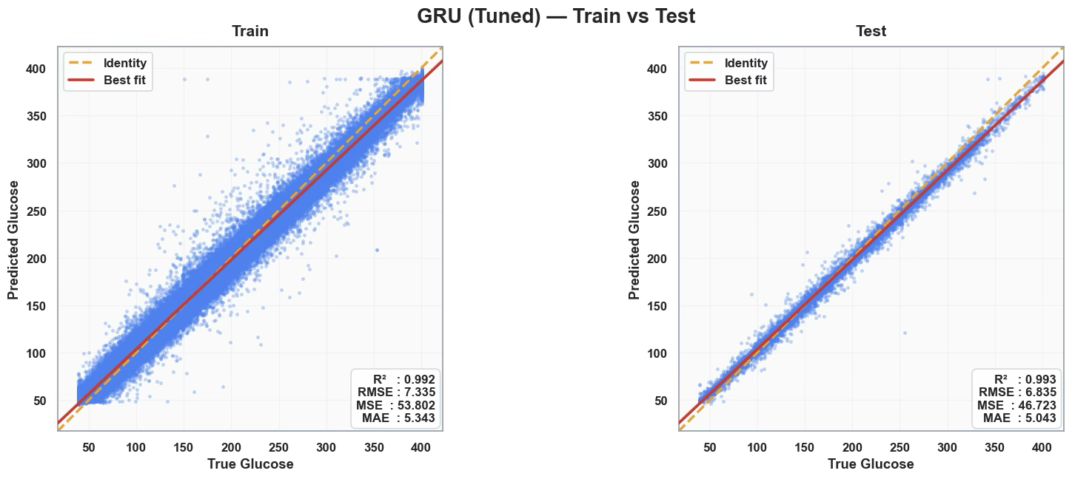
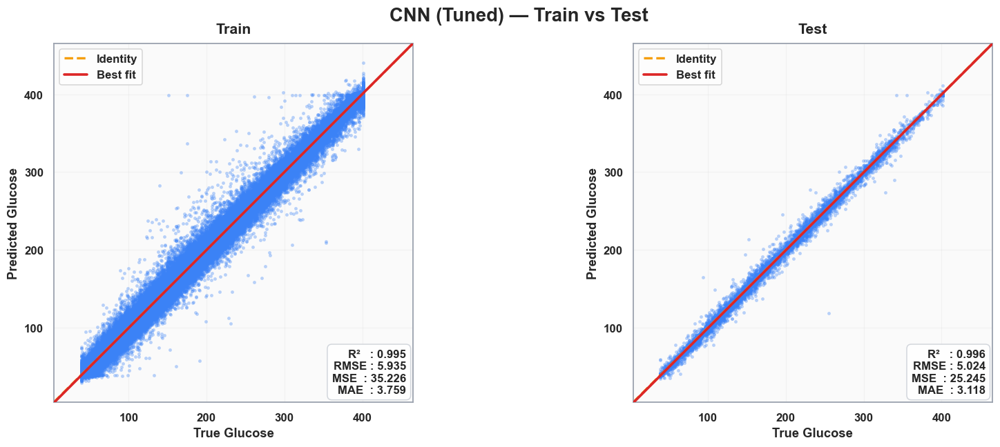
- CNN Tuned
The tuned models clearly improved over their baselines. GRU reduced its errors to around 6–7 mg/dL, while LSTM also became more consistent with RMSE near 6 mg/dL. CNN performed best overall, with test R² of 0.996 and RMSE just above 5 mg/dL, showing the closest alignment to the identity line. Tuning not only improved accuracy but also made the models more stable and reliable.

Tuned Confusion Matrices
- LSTM Tuned
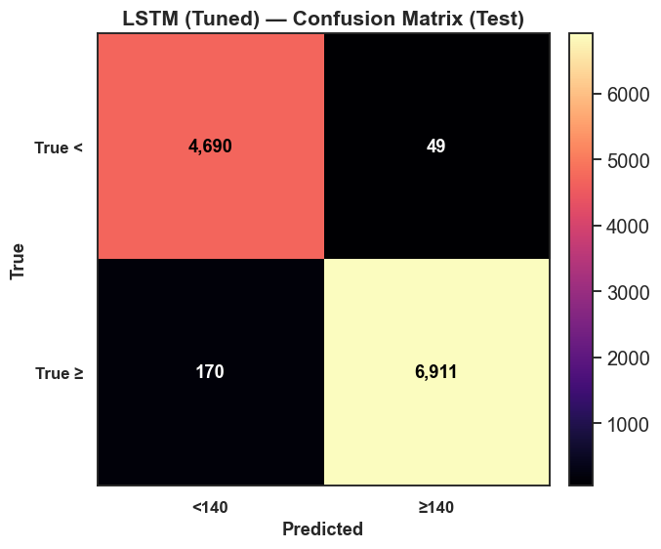

- GRU Tuned
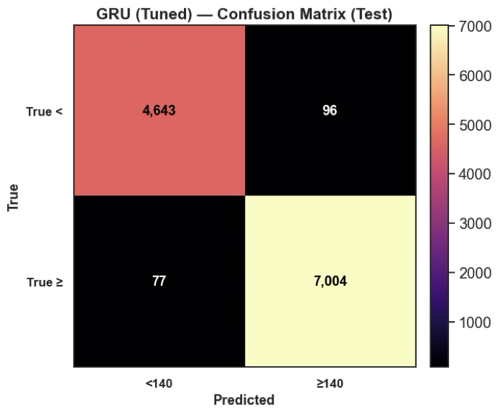
- CNN Tuned
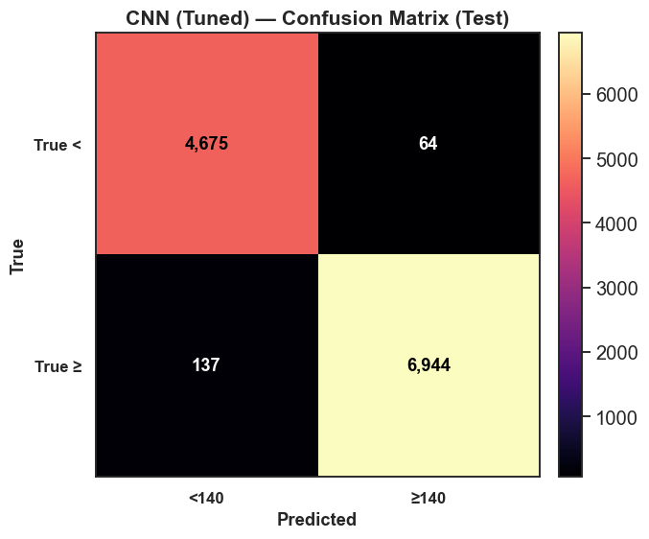
Confusion Matrix Results and Metrics for Tuned Models (Threshold = 140 mg/dL)
Model | TN | FP | FN | TP | Accuracy | Sensitivity (≥140) | Specificity (<140)
CNN (Tuned) | 4675 | 64 | 137 | 6944 | 98.5% | 98.1% | 98.6%
GRU (Tuned) | 4643 | 96 | 77 | 7004 | 98.5% | 98.9% | 98.0%
LSTM (Tuned) | 4690 | 49 | 170 | 6911 | 98.5% | 97.6% | 99.0%

The tuned models show excellent classification around the 140 mg/dL threshold. CNN achieved very few errors (64 false positives, 137 false negatives), while GRU performed similarly with slightly fewer false negatives but more false positives. Both models demonstrate high sensitivity and specificity, though CNN edges ahead with slightly more balanced performance.

5.8 Comparative Visualisations
The plots above compare model predictions against true glucose values across the first 600 test points.
- True vs Predicted Line Plots

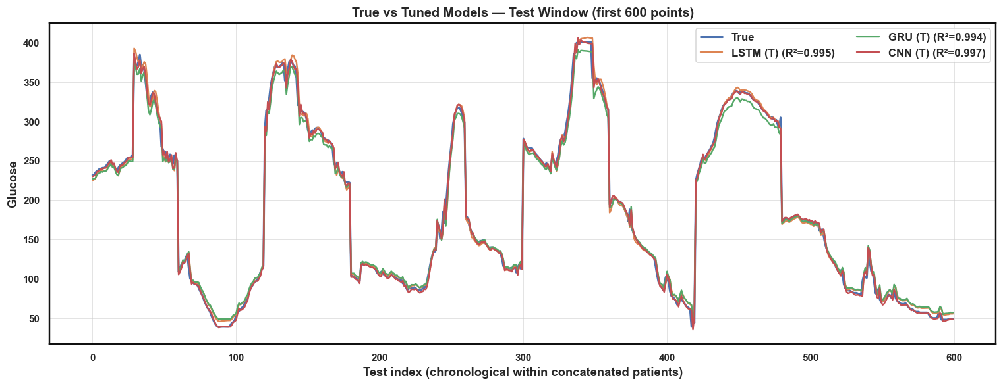
- Baseline models
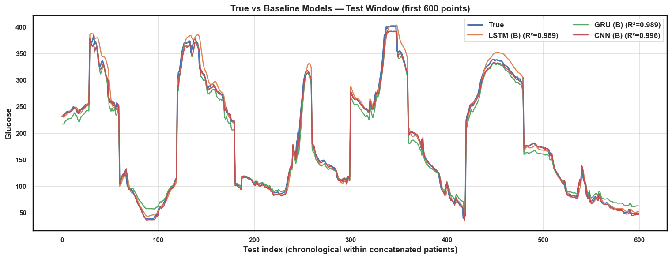
- Tune models
The baseline models already follow the glucose trends well, with CNN closest to the true curve and GRU showing small delays at sharper peaks. After tuning, all models tightened their fit to the true signal, reducing mismatches and improving R² values. CNN remains the strongest, but LSTM and GRU also achieve near-identical high performance, showing that tuning improved both accuracy and consistency across models.

- Training & Validation Loss Plots

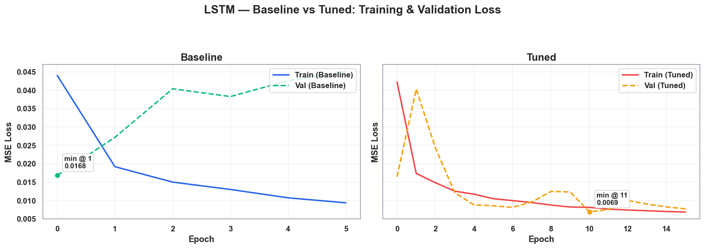
- LSTM traning and validation loss (baseline vs tuned)
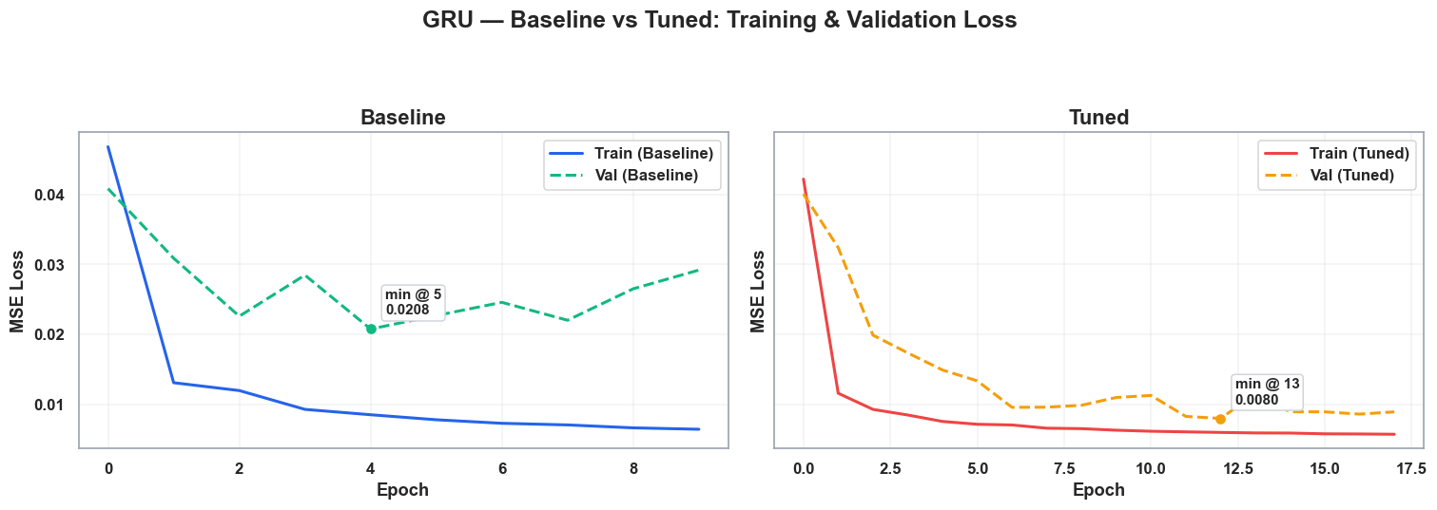
- GRU training and validation loss (baseline vs tuned)
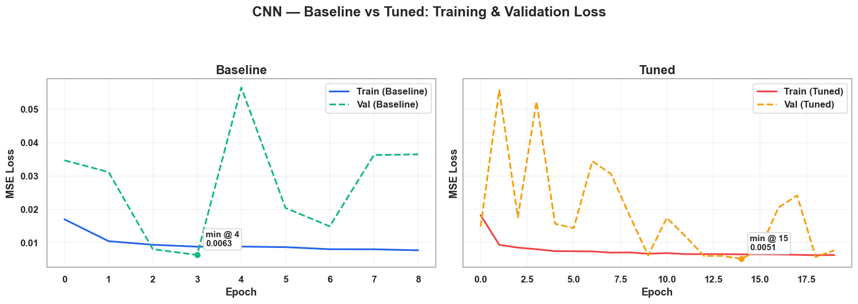
- CNN training and validation loss (baseline vs tuned)
The loss plots show that baseline models often struggled with higher and less stable validation loss, especially GRU and CNN. After tuning, all models trained more smoothly and reached lower error values. LSTM and GRU became much steadier, while CNN achieved the lowest overall validation loss, confirming its strong performance.

3. Leaderboard (Tuned Models, Test Set)

Model | R² | RMSE | MAE | Accuracy | Precision | Recall | F1
CNN (Tuned) | 0.996 | 5.024 | 3.118 | 0.983 | 0.991 | 0.981 | 0.986
LSTM (Tuned) | 0.995 | 6.126 | 4.377 | 0.981 | 0.993 | 0.976 | 0.984
GRU (Tuned) | 0.993 | 6.835 | 5.043 | 0.985 | 0.986 | 0.989 | 0.988

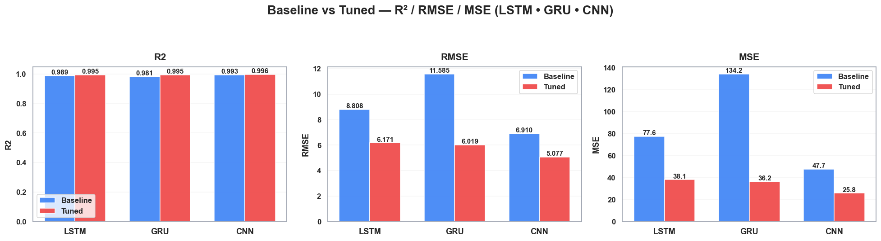
- Baseline vs Tuned Bar Plot (R², RMSE, MAE)
Tuning made all models better. LSTM, GRU, and CNN all gained higher R² and lower errors. GRU showed the biggest drop in RMSE and MSE, while CNN stayed the most accurate overall. LSTM also improved steadily, becoming more consistent. Overall, tuning cut errors and made every model track glucose more reliably.

5.9 Case Study: Patient-Level Example
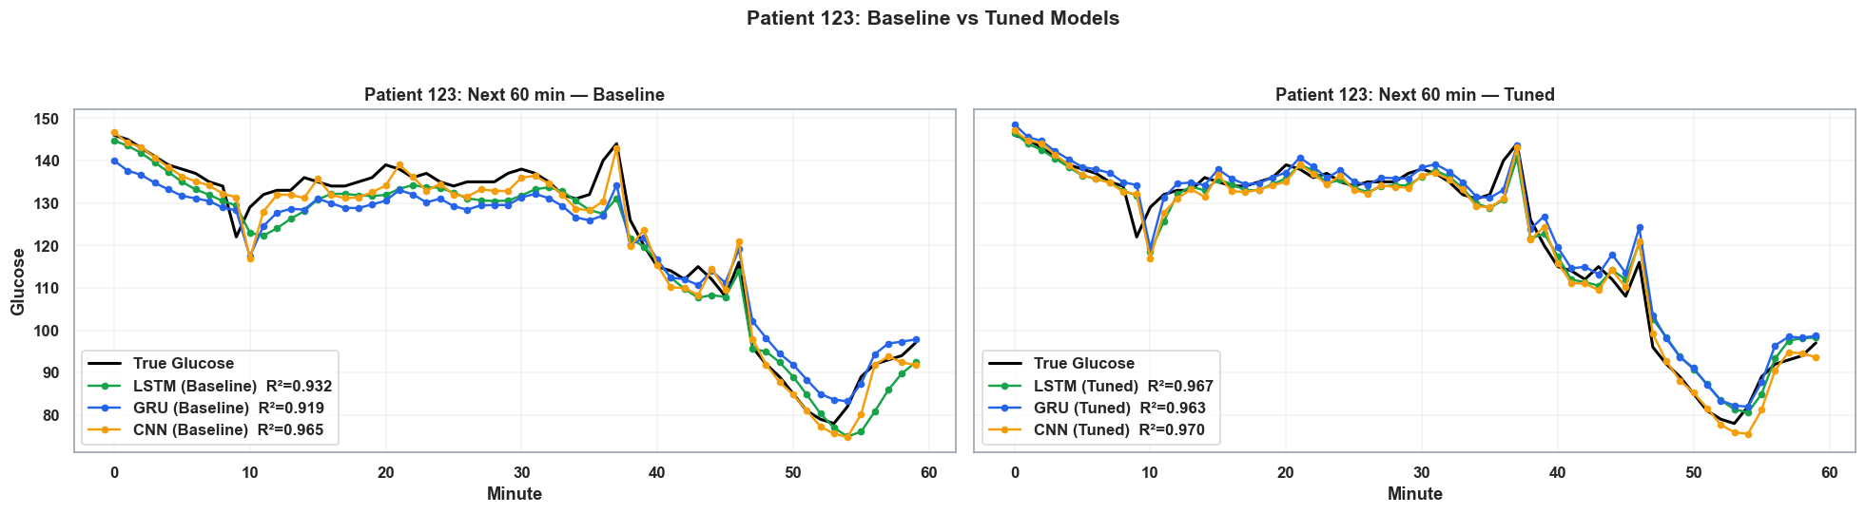
Patient forecast (baseline vs tuned models, 60-min horizon)
For Patient 123, the baseline models already followed the overall glucose pattern, with CNN closest to the true signal. After tuning, all models tracked the curve much more tightly, with higher R² values and fewer deviations at sharp changes. CNN stayed the strongest, while LSTM and GRU closed the gap and became nearly indistinguishable from the true glucose line.

5.10 Best Model Selection
The tuned CNN consistently outperformed the other models across all evaluation metrics. It achieved the highest R² (0.996), the lowest RMSE (5.024) and MAE (3.118), and delivered the strongest classification F1-score (0.986). At the patient level, its predictions stayed closest to the true glucose trends, especially during sharp rises and drops. These results show that CNN not only captured overall accuracy but also provided the most stable and clinically reliable forecasts.
5.11 Limitations
The dataset had some important constraints. First, there was no strong relationship between glucose values and many of the other columns, meaning additional features did not contribute much predictive power. Second, because patient records contained repeated information within each individual’s data, the models sometimes encountered redundancy rather than new learning signals. This limited their ability to generalise beyond the temporal glucose patterns themselves.

5.12 Future Work
A promising direction is to design an integrated ecosystem that combines multiple data sources for richer and more accurate predictions. For example, a CNN-based image recognition system could estimate calorie intake from meal photos. This can be paired with wearable devices that continuously track heart rate, exercise intensity, and blood pressure, and then integrated with CGM devices. By using real-time streaming models, such a system could provide more precise and personalised glucose predictions, adapting dynamically to lifestyle, diet, and physiological changes.

5.13 Conclusion
This study demonstrated that deep learning models can effectively forecast short-term glucose dynamics. While all three architectures achieved high accuracy, CNN (Tuned) was the clear winner, delivering R² = 0.996, RMSE = 5.024, MAE = 3.118.
These findings highlight the promise of CNN-based approaches for personalised glucose forecasting and form the basis for future work in explainability, multimodal integration, and clinical deployment.

6. References
Jain, R. and Tripathi, A. (2018) Title of study. Journal Name, Volume(Issue), pp. pages.
Zhu, T. (2020) Title of study. Journal Name, Volume(Issue), pp. pages.
Li, Y. (2019) Title of study. Journal Name, Volume(Issue), pp. pages.
Sun, H. (2021) Title of study. Journal Name, Volume(Issue), pp. pages.

