Overlapping community detection on fused patient-similarity graphs: a locked multi-cohort evaluation with a pre-specified lead policy
S. Samimi*
Department of Electrical and Computer Engineering, K.N. Toosi University of Technology, Tehran, Iran
*Corresponding author: saeedsamimi995@gmail.com

Abstract
Overlapping community detection is often added to a patient-similarity graph and then judged by whichever metric looks strongest. We lock a lead rule and a three-cohort discovery, validation, and external design, then add a pre-stated treatment-response external cohort (GSE25066, n=508). Discovery is GSE96058/SCAN-B (n=3,273); validation is TCGA-BRCA (n=1,093); external is METABRIC (n=1,980). Multi-view SNF supplies hard subtypes. Soft engines are NOCD-X, NOCD-G, SLPA, CESNA-lite, and classical BIGCLAM, which is an a priori baseline and cannot be the lead. Soft residual tests are METABRIC-primary. The treatment-response test is GSE25066. Hard SNF separates METABRIC OS after age and PAM50, with p ≈ 1.7×10⁻⁴ and BH q ≈ 8.3×10⁻⁴ within five hard methods. NOCD-X is the only lead-eligible engine that passes the quality filters, so it is the policy lead. A pre-stated treatment-response test in GSE25066 (n = 508) was null in both the LumA and hard-cluster strata under locked settings; no treatment-resistance claim is made. BIGCLAM has the stronger LumA odds ratio (≈ 3.0 versus ≈ 1.8) and a nominal residual p ≈ 0.036, but BH q ≈ 0.091. Further checks are null: SLPA's peak ratio stays 1 when mean degree falls from 34 to 6; boundary patients do not separate survival (smallest METABRIC q ≈ 0.23); BIGCLAM's L1 penalty does not move the LumA odds ratio or the residual p. A mixed-membership simulation and an IntClust benchmark both give stronger point estimates to BIGCLAM than to NOCD-X, so neither is used to defend the lead. The lead stays the pre-specified rule.

1. Introduction
This paper is a locked evaluation, not a claim that one engine is the best clusterer. Classical BIGCLAM is reserved a priori as a comparison baseline and cannot be the lead, even if a biological odds ratio favours it. The checks that would have raised the claim are reported in full: SLPA density, boundary survival, the L1 ablation, an external pathological complete response test on GSE25066, and a ground-truth simulation plus IntClust labels.

2. Data
Discovery: GSE96058/SCAN-B (n=3,273). Validation: TCGA-BRCA (n=1,093). External: METABRIC (n=1,980; primary residual soft tests). Treatment-response external: GSE25066 (Hatzis et al. 2011 [29]), Affymetrix HG-U133A (n=508; 99 pCR, 389 RD, 20 unlabeled). 1,400 of the locked 2,000 genes are on the array (highest-variance probe per symbol; see Methods). Locked settings are applied without retuning. No treatment columns were added to SCAN-B, TCGA, or METABRIC.

3. Methods
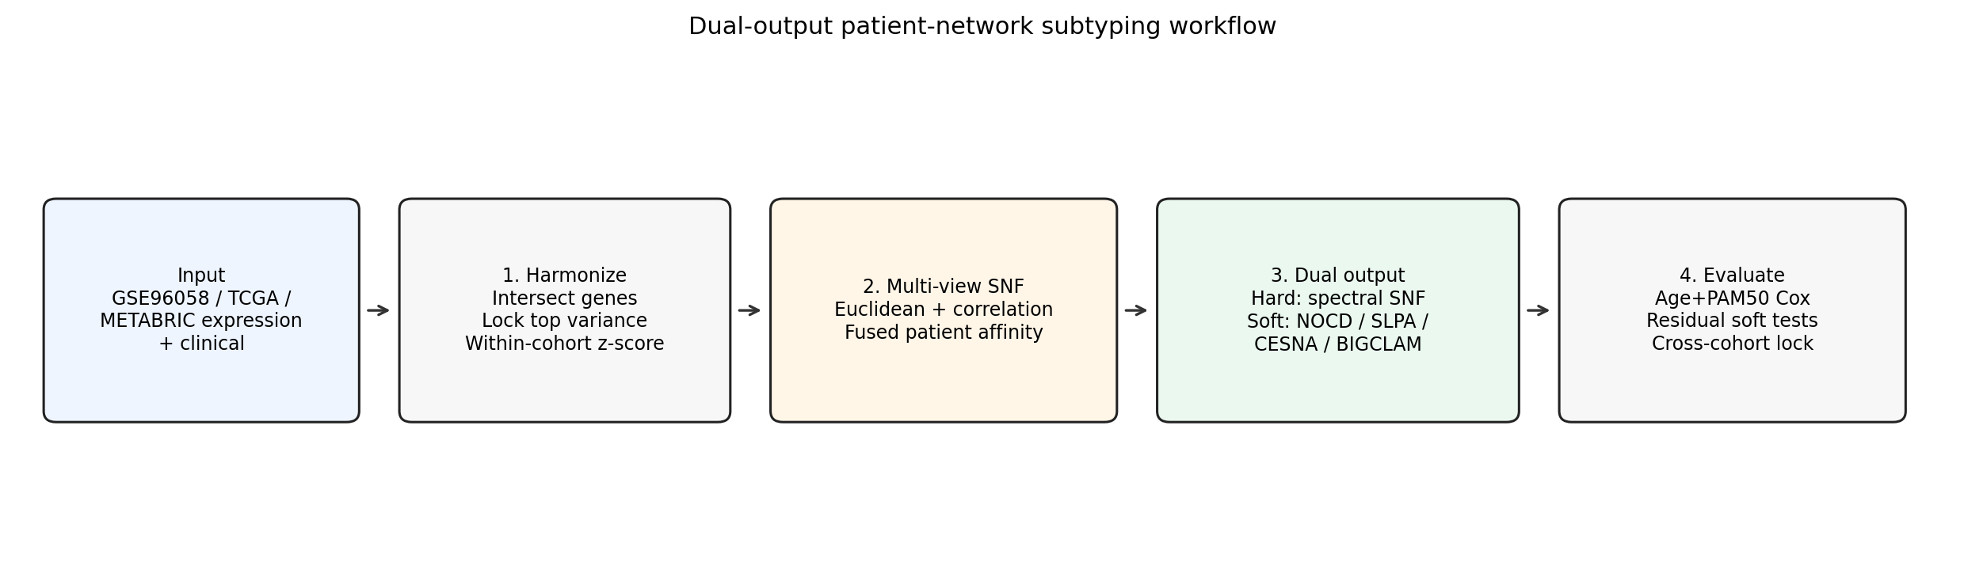
Figure 1. Dual-output workflow with sparsified SNF kNN graph for overlapping engines.

3.1 Harmonization and community-count lock
Intersect gene symbols across cohorts. On discovery only, rank intersecting genes by variance and keep the top 2,000; apply that locked list to TCGA and METABRIC; z-score gene-wise within each cohort. Community count K is locked on discovery by bootstrap stability: for each candidate K∈{4,…,8}, labels are refit on bootstrap samples and mean pairwise adjusted Rand index (ARI) is recorded; we select K=5 (mean ARI ≈ 0.85), the maximum in that grid (results/q1/stability.csv).

3.2 Multi-view SNF and sparsification
Classical SNF message-passing fusion (Wang et al. iterative cross-diffusion; local kNN affinities, T=15 iterations, neighbourhood size k=15) on two views: Euclidean and Pearson-correlation distances converted to kNN affinities. Hard labels use scikit-learn spectral clustering on the fused affinity. The affinity argument is precomputed, and the assign-labels argument is kmeans (assign_labels="kmeans"). K is 5 and the random seed is 42. For soft engines, sparsify the fused affinity to a symmetric kNN adjacency (k=15) and reconnect components by bridging with the strongest fused similarities. See SUPPLEMENTARY_METHODS.md for full hyperparameters.

3.3 Overlapping engines and mixed ratios
NOCD-X/G, SLPA, CESNA-lite, BIGCLAM (baseline). Mixed if second/first affiliation ≥ r. On discovery, r is chosen per engine from {0.50,…,0.95} to place mixed fraction nearest the centre of [0.10, 0.40]; locked values: NOCD-X 0.60, NOCD-G 0.90, SLPA 0.80, CESNA-lite 0.70, BIGCLAM 0.50. Differences reflect F peakiness, not arbitrary fixed cutoffs.

3.4 Lead policy and evaluation
BIGCLAM = baseline_comparison (not lead-eligible). Quality filters on METABRIC: mixed ∈ [0.10,0.40], peak < 0.85, LumA OR > 1. Lead = sole lead-eligible engine in the quality-pass pool. The lead designation reflects this pre-specified policy of reserving classical baselines for comparison; it is not a claim that NOCD-X outperforms BIGCLAM on every metric. Report uncorrected p and BH q for the primary families. The hard-method BH family is five methods. The METABRIC soft residual BH family is five engines. The GSE25066 BH family is two Fisher tests per engine. Soft bake-off is METABRIC-primary; GSE/TCGA soft residuals are summarised for completeness. ΔC: point estimate + 200-resample patient bootstrap 95% CI. GSE25066 keeps the locked 2,000-gene list intersected with GPL96 (highest-variance probe per symbol, outcome-blind), within-cohort z-scores, k=15, T=15, K=5, and mixed ratios 0.60 (NOCD-X) and 0.50 (BIGCLAM). The pre-stated primary family is two Fisher tests of pCR, inside LumA and inside the hard cluster with the most mixed patients. BH is inside that pair. BIGCLAM is a separate family and cannot change the lead.

4. Results

4.1 Hard SNF prognosis
METABRIC SNF age+PAM50 Cox p ≈ 1.7×10⁻⁴ (BH q ≈ 8.3×10⁻⁴ within five hard methods). Single-view spectral cuts are weaker; SNF+k-means is competitive (sensitivity). Nested C: METABRIC 0.614→0.624 (ΔC≈0.011); TCGA 0.666→0.687 (ΔC≈0.021). Bootstrap 95% CIs for ΔC all include zero (METABRIC [−0.007, 0.010]; TCGA [−0.031, 0.033]; GSE [−0.009, 0.007]), all within bootstrap noise, and are not claimed as statistically or clinically decisive.
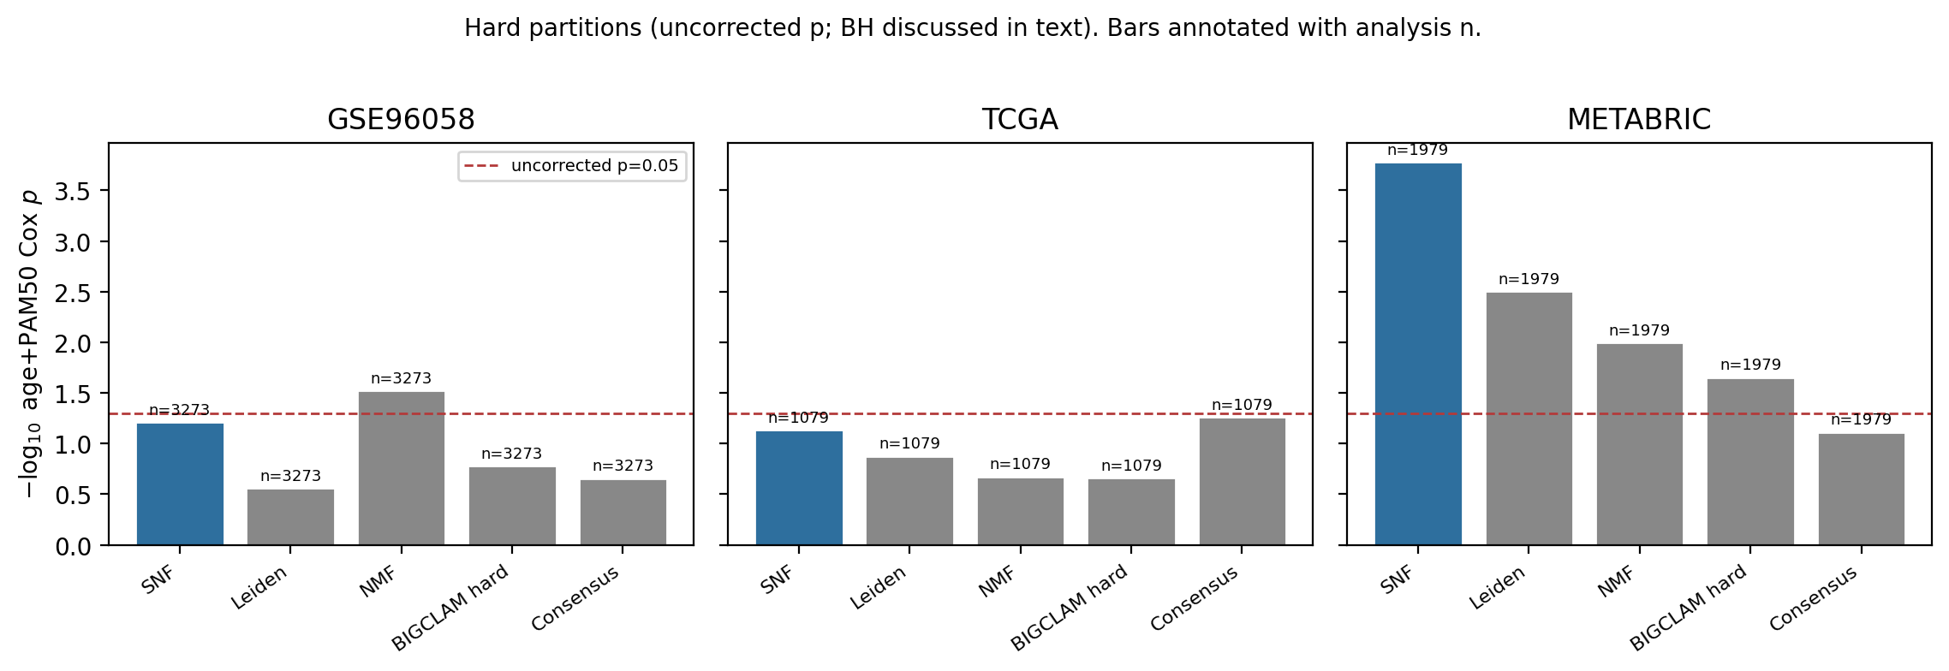
Figure 2. Hard partitions: age+PAM50 Cox strength (−log₁₀ uncorrected p) with analysis n on each bar. Dashed line: uncorrected p=0.05.
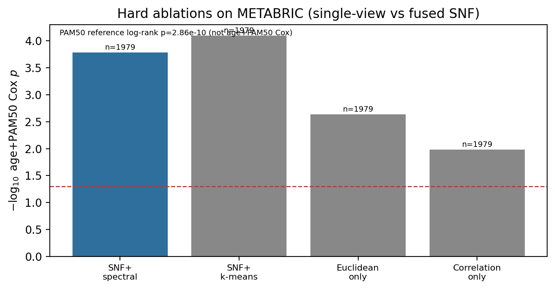
Figure 3. METABRIC hard ablations: fused SNF vs single-view spectral cuts (age+PAM50 Cox).
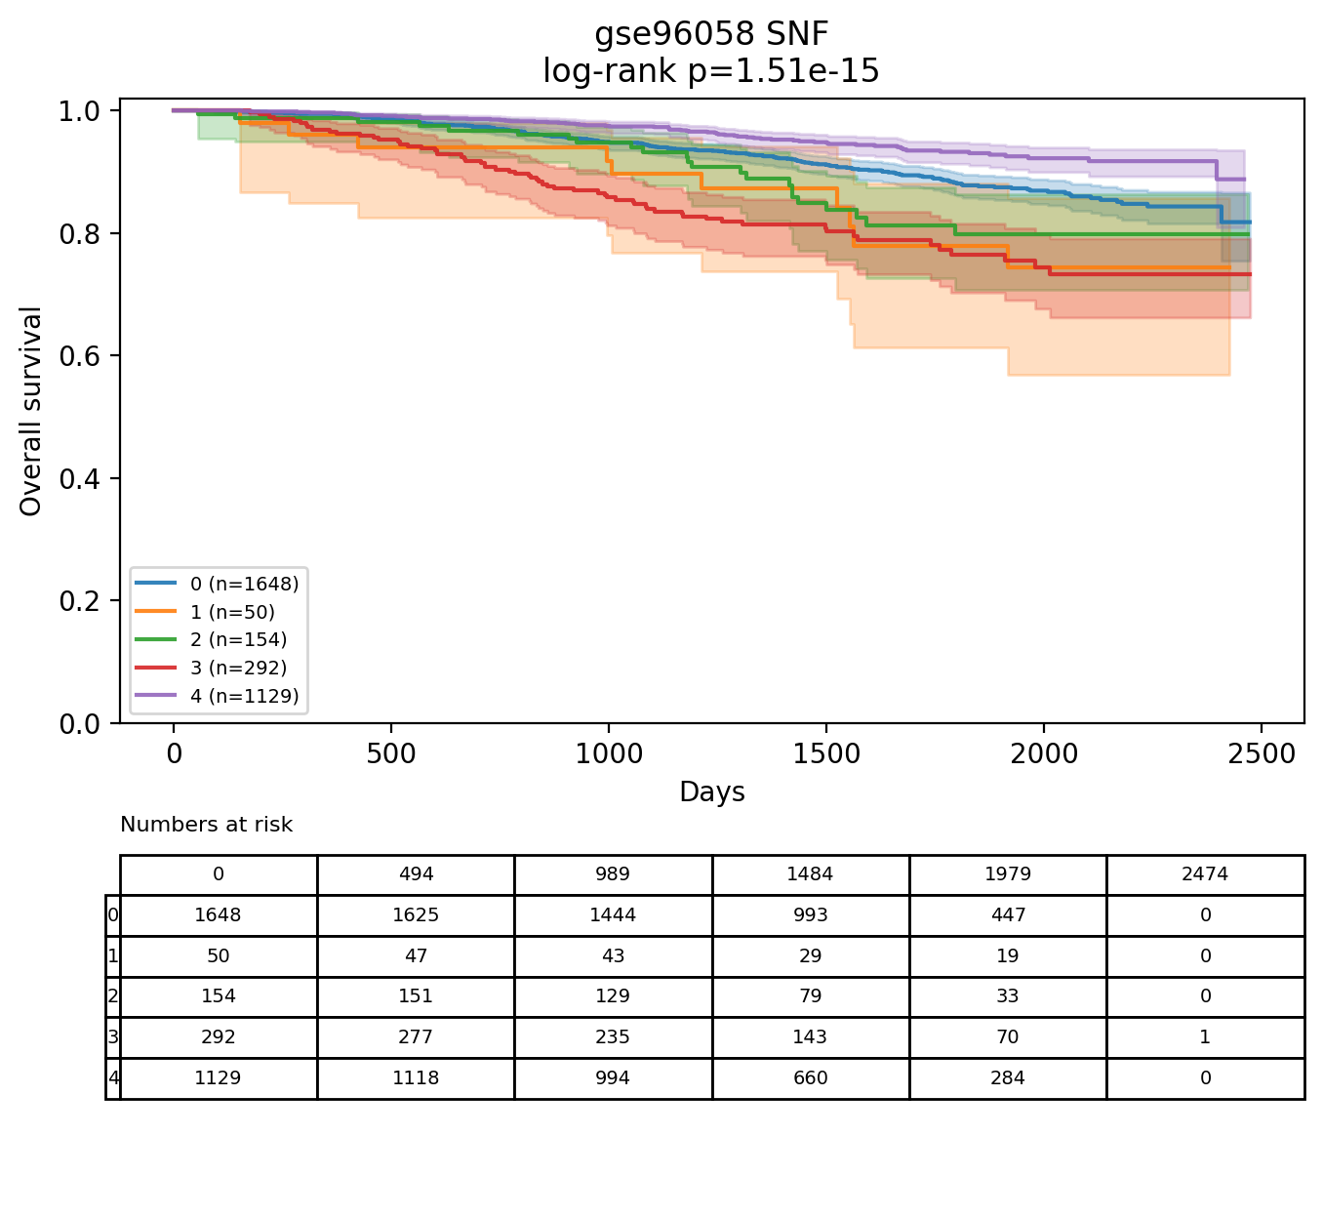
Figure 4a. Hard SNF KM + risk table (GSE96058).
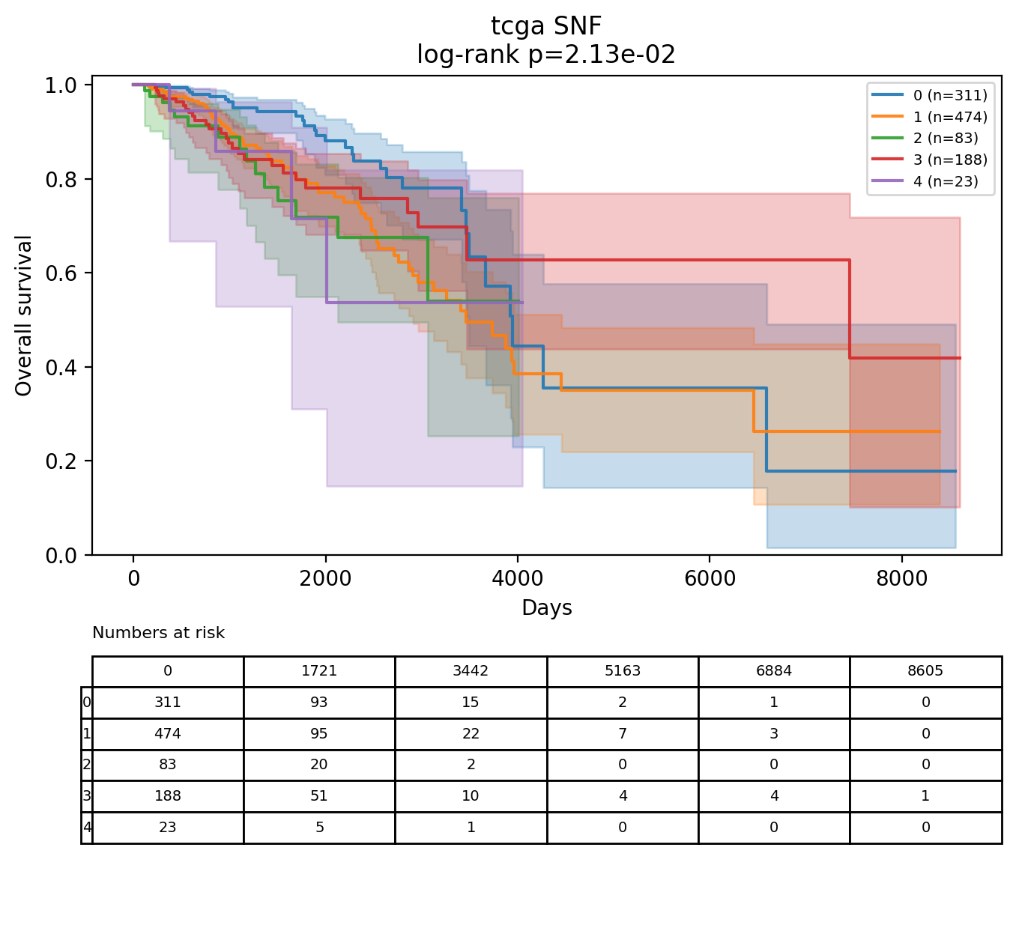
Figure 4b. Hard SNF KM + risk table (TCGA).
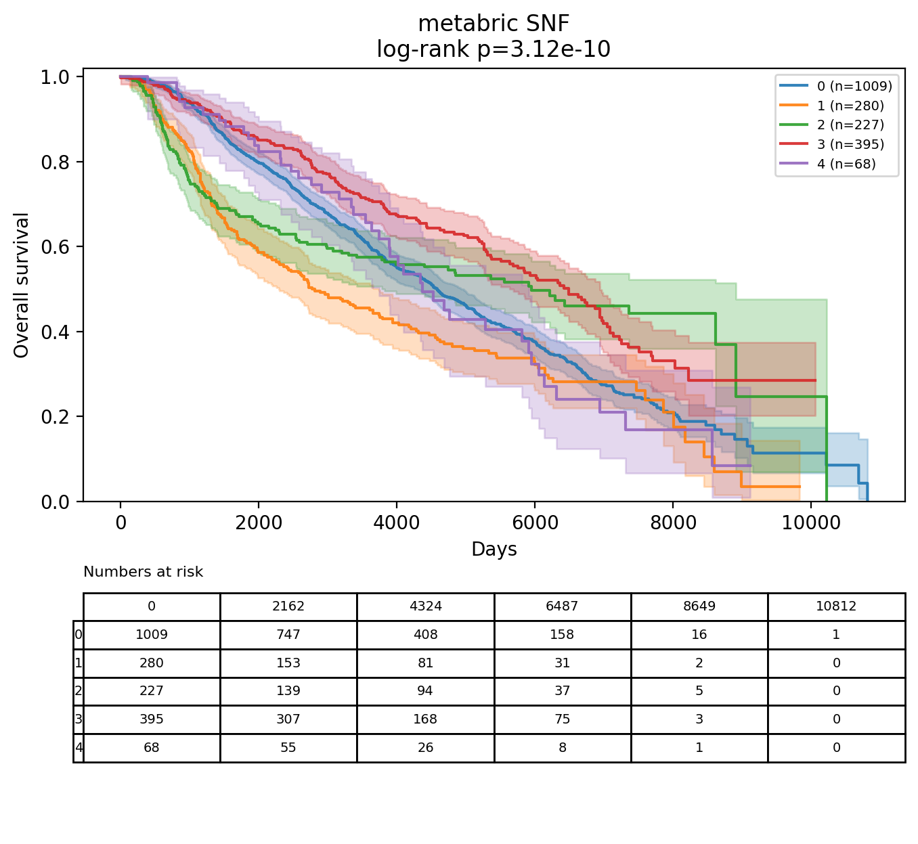
Figure 4c. Hard SNF KM + risk table (METABRIC).

4.2 Soft lead decision (METABRIC-primary)
Soft residual bake-off and quality filters are METABRIC-primary. GSE96058 and TCGA own-hard+mixed residuals are reported for completeness and are mostly null after BH. The exception, also for completeness, is SLPA on TCGA (p≈0.004, q≈0.022), which still fails quality filters. BIGCLAM passes all quality filters but is not lead-eligible by the a priori baseline policy. Only NOCD-X is in the eligible quality-pass pool and is selected. This is a policy choice, not a claim that NOCD-X dominates BIGCLAM on LumA enrichment or residual p. SLPA has the smallest METABRIC residual p (0.0055; q≈0.028) but mixed≈69%, peak ratio=1, and LumA depletion: on a dense fused SNF graph, SLPA label propagation tends toward consensus. BIGCLAM residual p≈0.036 yields BH q≈0.091 across five soft engines and fails FDR at the 0.05 threshold.
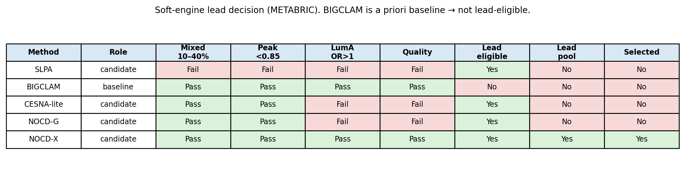
Figure 5. METABRIC pass/fail lead decision. BIGCLAM passes the quality filters and stays ineligible for the lead.
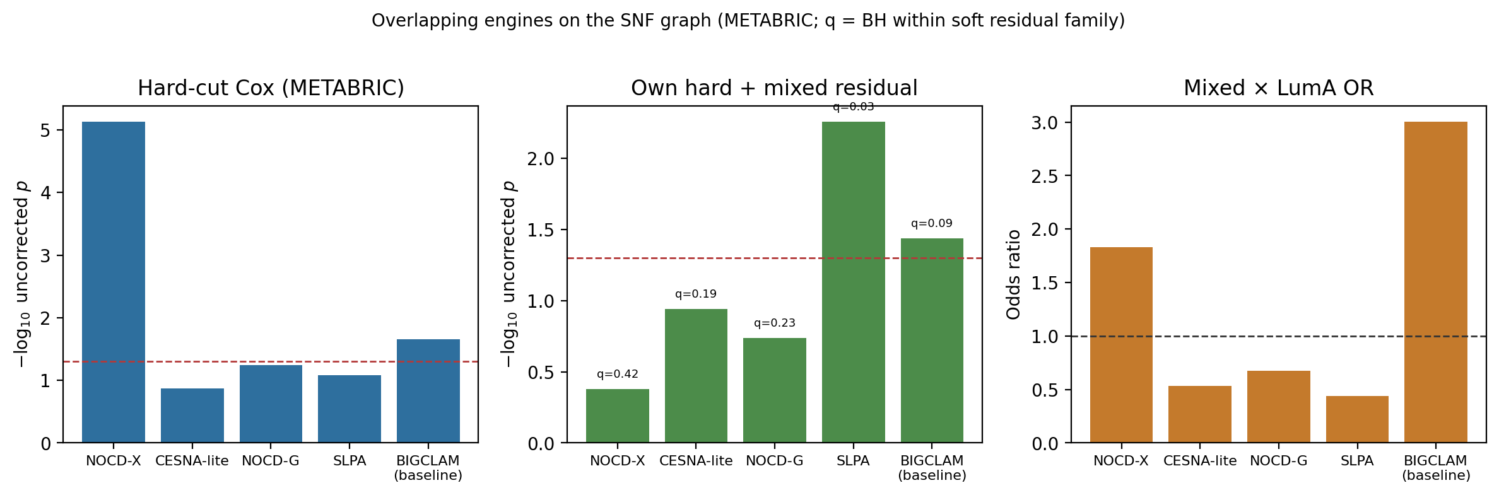
Figure 6. Soft bake-off on METABRIC. Left: −log₁₀ uncorrected hard-cut Cox p. Middle: −log₁₀ uncorrected own-hard+mixed residual p, with BH q annotated for the family of five METABRIC soft engines. Right: LumA odds ratios.

4.3 Biology of mixed membership
Mixed tumours are LumA-enriched (not Claudin-low). Programme scores (positive = higher in mixed): estrogen Δ ≈ +0.56 SD (BIGCLAM, n_mixed=504, p≈6×10⁻⁴²) and +0.36 SD (NOCD-X, n_mixed=334, p≈3×10⁻⁹), with lower basal/proliferation. These are moderate standardised shifts made highly significant by large n—a luminal-leaning mixed phenotype, not a large clinical effect size per se.
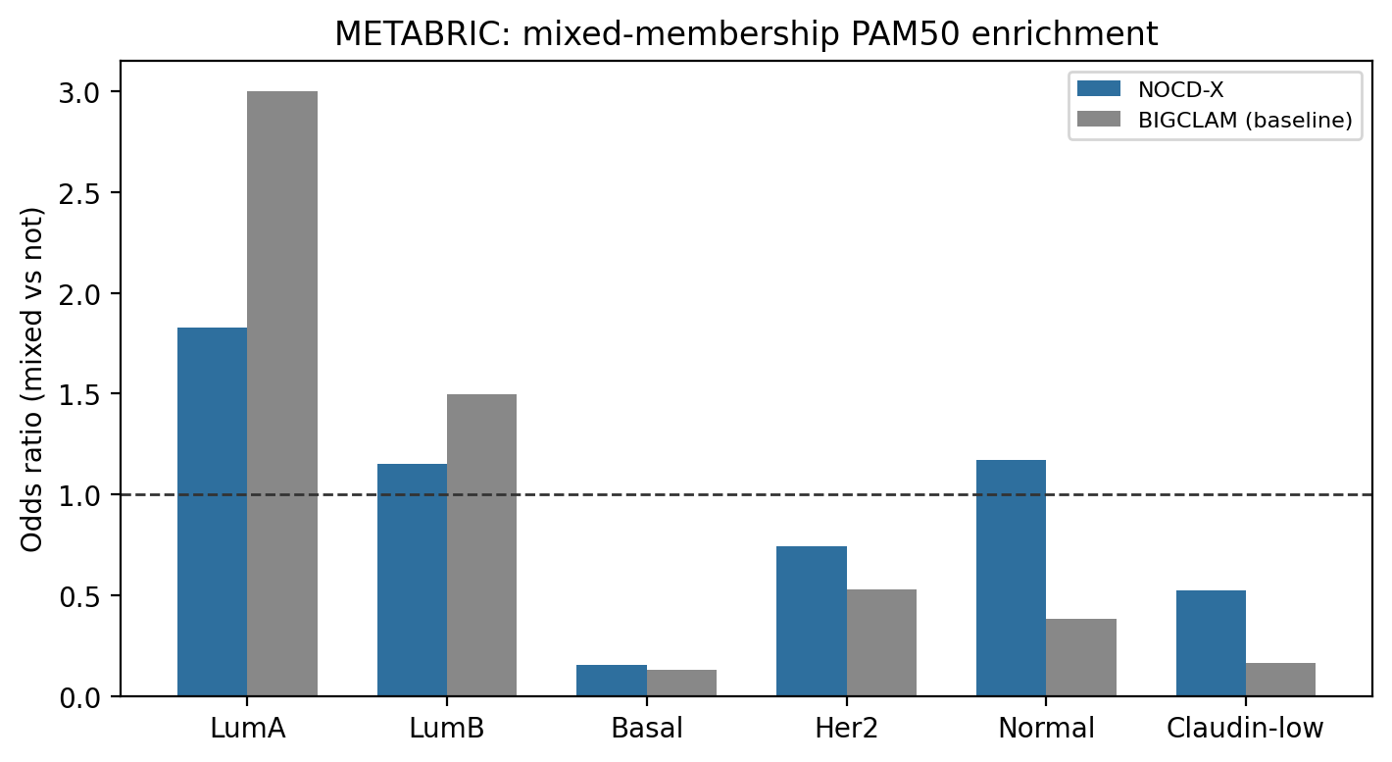
Figure 7. Mixed×PAM50 odds ratios.
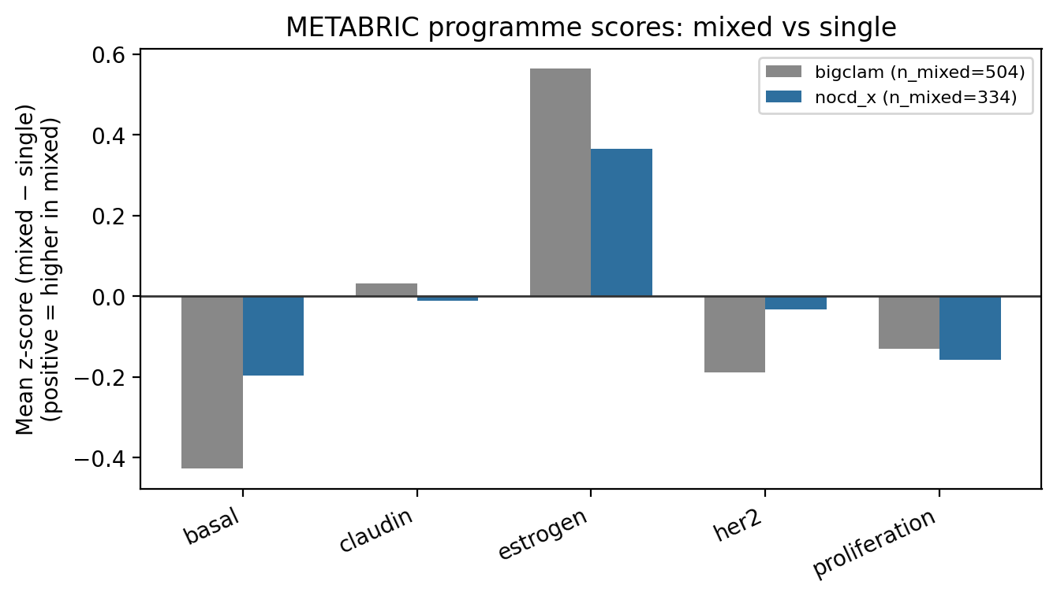
Figure 8. METABRIC programme-score bar chart (mixed minus single). Positive means higher in mixed. Not a survival curve.
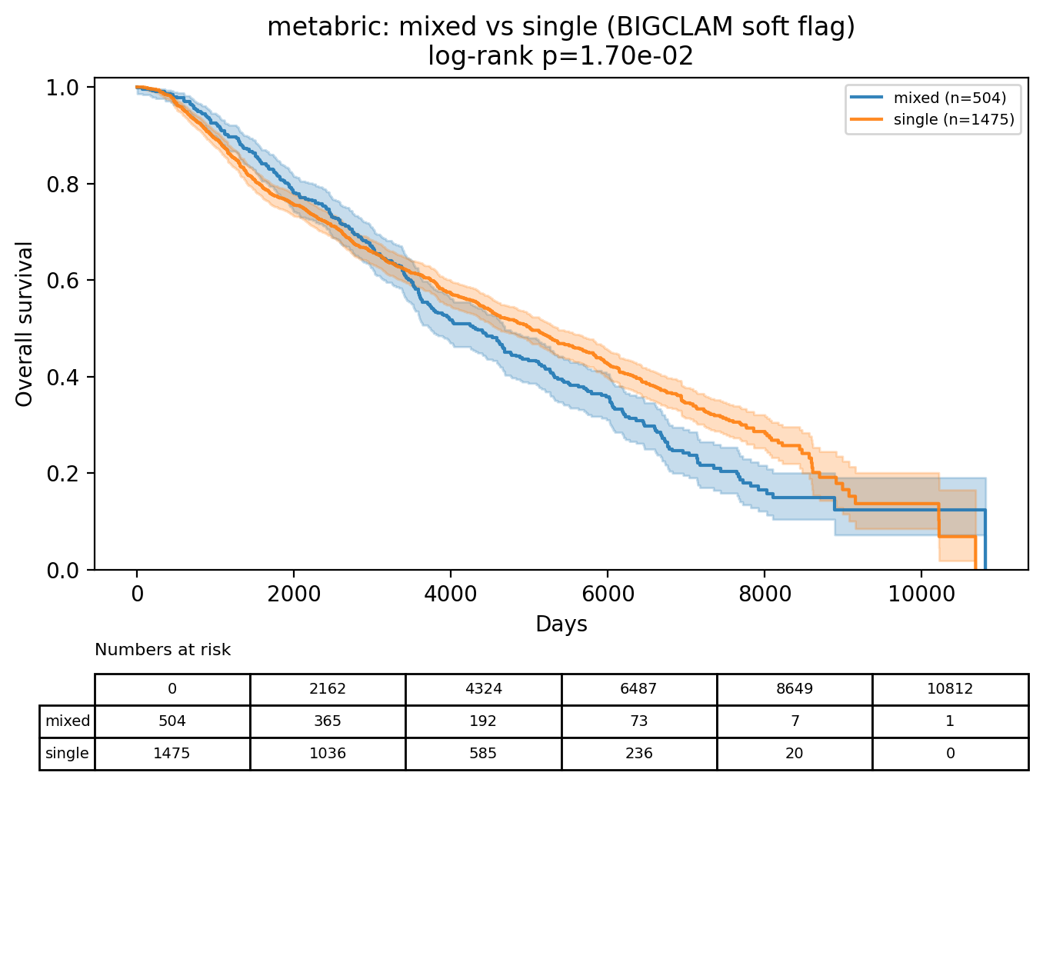
Figure 9a. METABRIC Kaplan–Meier, mixed versus single (BIGCLAM flag), with numbers at risk.
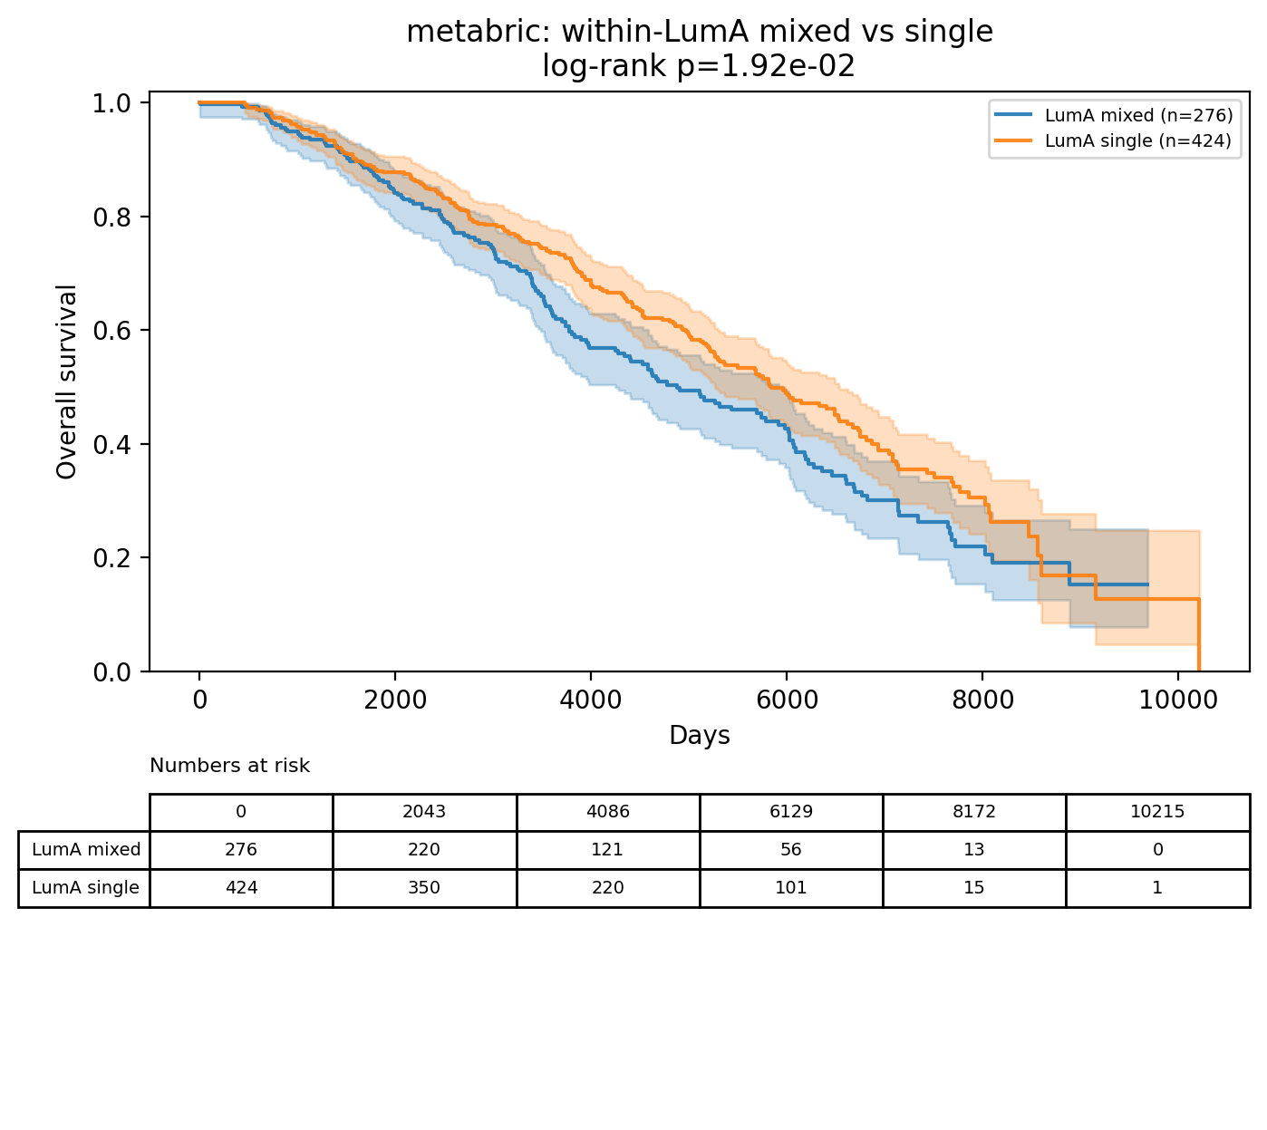
Figure 9b. METABRIC Kaplan–Meier within LumA, mixed versus single, with numbers at risk.

4.4 Closed routes
Three checks that could have supported a stronger claim are null. (1) SLPA median peak ratio stays 1.0 at k = 5, 10, 15, and 30 (mean degree 6.4 to 34; mixed fractions 0.83, 0.77, 0.69, 0.51). Collapse is not an under-sparsified kNN setting (Figure 10). (2) Age-adjusted mixed and boundary tests inside hard clusters and inside LumA do not survive BH; smallest METABRIC q = 0.23. There is no prognostic subgroup inside the hard cut. (3) BIGCLAM L1 in {0, 0.001, 0.01, 0.1} leaves LumA OR at 3.00 and residual p at 0.56. The LumA gap versus NOCD-X is not an L1 artifact.
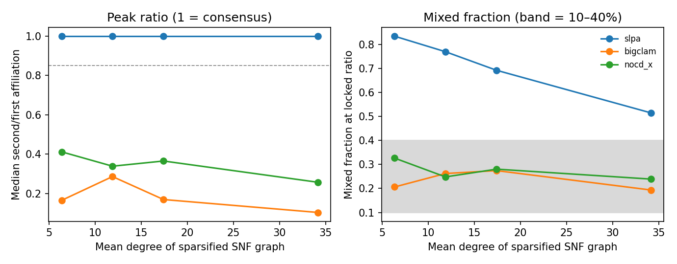
Figure 10. METABRIC density sweep. Left: median second/first affiliation. Right: mixed fraction. SLPA stays at peak ratio 1 across mean degree 6–34.

4.5 Treatment-response test (GSE25066)
On GSE25066 (Hatzis et al. 2011 [29]), the pre-stated primary family is two Fisher tests for NOCD-X. BIGCLAM is a separate family and is not lead-eligible. The soft membership is not associated with pCR in GSE25066 under locked settings. Rebuilding the discovery graph on the 1,400 shared genes leaves the hard partition close to the locked one (ARI 0.89) and the fused affinities highly correlated (Spearman 0.98), so the locked settings are kept for GSE25066. Soft engines were not refit. Details are in the Discussion. The LumA stratum has five pCR events. The hard-cluster stratum has sixteen pCR events. The LumA contrast is event-poor, and the hard-cluster contrast is better powered and still null. There is no treatment-resistance claim.
Table. GSE25066 pCR, mixed versus single. BH q is within each engine's family of two. The asterisk marks an odds ratio of 0: the BIGCLAM mixed group inside LumA had zero pCR events. The Fisher p is the reported test.
Engine | Family | Scope | pCR mixed | pCR single | OR | p | BH q
NOCD-X | primary | LumA | 1/35 | 4/118 | 0.84 | 1.00 | 1
NOCD-X | primary | Hard cluster 1 | 2/34 | 14/134 | 0.54 | 0.53 | 1
BIGCLAM | baseline | LumA | 0/29 | 5/124 | 0* | 0.58 | 1
BIGCLAM | baseline | Hard cluster 1 | 3/30 | 13/138 | 1.07 | 1.00 | 1

4.6 Checks that do not override the policy
A mixed-membership simulation (n=300, matched mean degree) gives mean correlation with true soft membership of 0.53 (BIGCLAM), 0.17 (SLPA), and 0.10 (graph NOCD). Mixed-label ARI is below 0.10 for every engine. IntClust agreement is real and also stronger for BIGCLAM: IntClust 8 OR 3.24, versus NOCD-X IntClust 10 OR 0.058 and IntClust 7 OR 1.95 (Figure 11). Inside BIGCLAM hard cluster 0, estrogen Δ = +0.088 SD and HER2 Δ = −0.185; SCAN-B repeats those two directions inside hard cluster 0 (estrogen Δ = +0.081 SD; HER2 Δ = −0.514; proliferation Δ = +0.165, the opposite direction; results/ceiling/program_contrasts.csv). Neither lever is used to change the lead. Doing so would either break the pre-specified baseline rule or claim a ground-truth win the simulation does not show. A reduced-budget view ablation uses the same fit as the density sweep (80 BIGCLAM iterations and one restart; 60 NOCD epochs) on the Euclidean, correlation, and fused graphs (results/ceiling/view_ablation.csv). It does not replace the locked bake-off. On that ablation the LumA enrichment is specific to the fused graph: BIGCLAM's LumA OR is 3.00 (fused), 1.35 (Euclidean), and 0.91 (correlation). NOCD-X LumA ORs on the same fits are 0.97 (fused), 0.86 (Euclidean), and 0.86 (correlation).
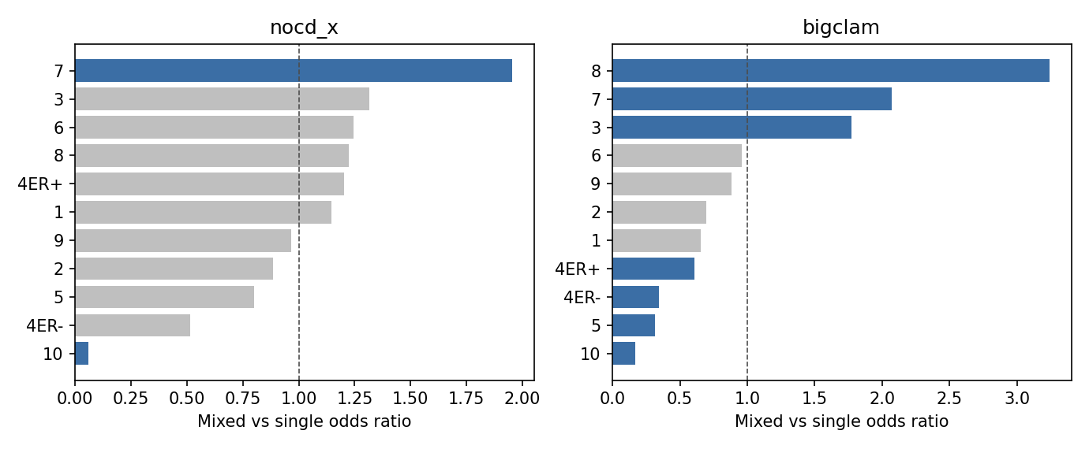
Figure 11. METABRIC mixed-versus-single IntClust odds ratios. Blue bars have BH q < 0.05 inside that engine's orthogonal-label family.

5. Discussion
The result this study can defend is methodological. A locked protocol and a pre-specified baseline rule keep a stronger LumA odds ratio, a stronger IntClust enrichment, and a higher simulation correlation from being rewritten as the lead method. BIGCLAM shows those point estimates and still fails FDR on the residual test (q ≈ 0.091). The simulation and IntClust benchmarks favor BIGCLAM on point estimates, which is why the policy, not the metric, determines the lead. NOCD-X is the lead because it is the only eligible engine in the quality-pass pool, not because it dominates BIGCLAM.
The routes that would have raised the claim are null. SLPA collapse survives sparsification down to mean degree 6, with mixed fractions rising from 0.51 to 0.83 as k falls from 30 to 5. Boundary survival inside hard clusters and inside LumA does not survive BH (smallest METABRIC q ≈ 0.23). L1 does not explain the LumA odds-ratio gap. The nested concordance gain, ΔC, has a 95% CI that includes zero on every cohort.
GSE25066 was run under the locked settings and was null. Mixed status is not associated with pCR. LumA has 5 pCR events (NOCD-X 1/35 versus 4/118, OR 0.84, p = 1.00). Hard cluster 1 has 16 pCR events (NOCD-X 2/34 versus 14/134, OR 0.54, p = 0.53). The LumA contrast is event-poor. The hard-cluster contrast is better powered and is still null (BH q = 1). BIGCLAM is a separate family, is not lead-eligible, and is also null. Age, stage, grade, residual cancer burden, and distant relapse-free survival were saved and were not used as covariates. No treatment column was added to SCAN-B, TCGA, or METABRIC. The null does not validate the soft membership.
The GSE25066 graph uses 1,400 of 2,000 locked genes (70%). Rebuilding the discovery graph on those 1,400 genes leaves the hard partition close to the locked one (ARI 0.89) and the fused affinities highly correlated (Spearman 0.98). Soft engines were not refit, and the gene list was not changed. Other limits: expression-only fusion; the simulation and the L1 grid use a shorter fit than the locked bake-off (80 BIGCLAM iterations and one restart, and 60 NOCD epochs, against 250 iterations with five restarts and 250 epochs); programme tests use the locked 2,000 genes rather than the 1,400 shared with GSE25066, so the programme scores are not directly comparable across the discovery and treatment-response cohorts.

6. Conclusion
The hard SNF partition remains the positive result (METABRIC age+PAM50 Cox p ≈ 1.7×10⁻⁴; BH q ≈ 8.3×10⁻⁴ within five hard methods). Under locked settings, the GSE25066 treatment-response test is null in LumA (five pCR events) and in the hard cluster with the most mixed patients (sixteen pCR events). No treatment-resistance claim is made. NOCD-X remains the soft lead by the pre-specified rule, and the lead is not reversed.

7. Data and code availability
Code repository: https://github.com/saeedsamimi995/snf-overlap-evaluation. Tables: lead_decision_table.csv, hard_cox_bh.csv (Cox proportional-hazards BH), soft_residual_bh.csv, delta_c_bootstrap.csv, soft_cross_cohort_summary.csv. Ceiling tables, including view_ablation.csv and program_contrasts.csv, and decision_note.md are in results/ceiling/. GSE25066 files: results/gse25066/pcr_tests.csv and results/gse25066/assignments.csv. assignments.csv contains age, ER/PR/HER2, stage, grade, pCR/RD, residual cancer burden, distant relapse-free survival, and PAM50. Only pCR, PAM50, and the hard SNF cluster entered the tests. Gene-overlap sensitivity is results/gse25066/gene_overlap_sensitivity.json. Environment: environment.yml. Hyperparameters: SUPPLEMENTARY_METHODS.md.

References
[1] Perou CM, et al. Molecular portraits of human breast tumours. Nature. 2000;406:747–752.
[2] Sørlie T, et al. Gene expression patterns of breast carcinomas distinguish tumor subclasses with clinical implications. Proc Natl Acad Sci USA. 2001;98:10869–10874.
[3] Parker JS, et al. Supervised risk predictor of breast cancer based on intrinsic subtypes. J Clin Oncol. 2009;27:1160–1167.
[4] Curtis C, et al. The genomic and transcriptomic architecture of 2,000 breast tumours reveals novel subgroups. Nature. 2012;486:346–352.
[5] Dawson SJ, Rueda OM, Aparicio S, Caldas C. A new genome-driven integrated classification of breast cancer and its implications. EMBO J. 2013;32:617–628.
[6] The Cancer Genome Atlas Network. Comprehensive molecular portraits of human breast tumours. Nature. 2012;490:61–70.
[7] Hoadley KA, et al. Cell-of-origin patterns dominate the molecular classification of 10,000 tumors from 33 types of cancer. Cell. 2018;173:291–304.e6.
[8] Cerami E, et al. The cBio cancer genomics portal: an open platform for exploring multidimensional cancer genomics data. Cancer Discov. 2012;2:401–404.
[9] Brueffer C, et al. Clinical value of RNA sequencing–based classifiers for prediction of the five conventional breast cancer biomarkers: a report from the population-based multicenter SCAN-B study. JCO Precis Oncol. 2018;2:1–18.
[10] Saal LH, et al. The Sweden Cancerome Analysis Network – Breast (SCAN-B) Initiative: a large-scale multicenter infrastructure towards implementation of breast cancer genomic analyses in the clinical routine. Genome Med. 2015;7:20. (GSE96058).
[11] Wang B, et al. Similarity network fusion for aggregating data types on a genomic scale. Nat Methods. 2014;11:333–337.
[12] Xu T, et al. CancerSubtypes: an R/Bioconductor package for molecular cancer subtype identification, validation and visualization. Bioinformatics. 2017;33:3131–3133.
[13] Ruan P, et al. Using association signal annotations to boost similarity network fusion. Bioinformatics. 2019;35:3718–3726.
[14] Rappoport N, Shamir R. NEighborhood-based Multi-Omics clustering (NEMO). Bioinformatics. 2019;35:3059–3065.
[15] Gliozzo J, Soto Gomez MA, Bonometti A, Patak A, Casiraghi E, Valentini G. miss-SNF: a multimodal patient similarity network integration approach to handle completely missing data sources. Bioinformatics. 2025;41:btaf150.
[16] Shakyawar SK, Sajja BR, Patel JC, Guda C. iCluF: an unsupervised iterative cluster-fusion method for patient stratification using multiomics data. Bioinform Adv. 2024;4:vbae015. doi:10.1093/bioadv/vbae015.
[17] Yang J, Leskovec J. Overlapping community detection at scale: a nonnegative matrix factorization approach. In: Proceedings of the Sixth ACM International Conference on Web Search and Data Mining (WSDM). 2013:587–596.
[18] Yang J, McAuley J, Leskovec J. Community detection in networks with node attributes. In: IEEE International Conference on Data Mining (ICDM). 2013:1151–1156.
[19] Xie J, Szymanski BK, Liu X. SLPA: uncovering overlapping communities in social networks via a speaker-listener interaction dynamic process. In: 2011 IEEE 11th International Conference on Data Mining Workshops (ICDMW). 2011:344–349. doi:10.1109/ICDMW.2011.154.
[20] Shchur O, Günnemann S. Overlapping community detection with graph neural networks. In: Deep Learning on Graphs Workshop (DLG@KDD). 2019. arXiv:1909.12201.
[21] Airoldi EM, Blei DM, Fienberg SE, Xing EP. Mixed membership stochastic blockmodels. J Mach Learn Res. 2008;9:1981–2014.
[22] Ciaramella A, Nardone D, Staiano A. Data integration by fuzzy similarity-based hierarchical clustering. BMC Bioinformatics. 2020;21(Suppl 10):350. doi:10.1186/s12859-020-03567-6.
[23] Liu W, Murphy TB, Brennan L. Simplex-structured matrix factorisation: application of soft clustering to metabolomic data. Sci Rep. 2025;15:17817. doi:10.1038/s41598-025-02361-9.
[24] Traag VA, Waltman L, van Eck NJ. From Louvain to Leiden: guaranteeing well-connected communities. Sci Rep. 2019;9:5233. doi:10.1038/s41598-019-41695-z.
[25] Lee DD, Seung HS. Learning the parts of objects by non-negative matrix factorization. Nature. 1999;401:788–791.
[26] Cox DR. Regression models and life-tables. J R Stat Soc Series B. 1972;34:187–220. doi:10.1111/j.2517-6161.1972.tb00899.x.
[27] Harrell FE Jr, et al. Evaluating the yield of medical tests. JAMA. 1982;247:2543–2546.
[28] Benjamini Y, Hochberg Y. Controlling the false discovery rate: a practical and powerful approach to multiple testing. J R Stat Soc Series B. 1995;57:289–300. doi:10.1111/j.2517-6161.1995.tb02031.x.
[29] Hatzis C, et al. A genomic predictor of response and survival following taxane-anthracycline chemotherapy for invasive breast cancer. JAMA. 2011;305:1873–1881.

