TITLE OF PAPER SHOULD BE A BRIEF PHRASE DESCRIBING THE CONTENTS OF PAPER, MAXIMUM 16 WORDS
Name and surname of First author  Affiliation of first author  Email address of first author | Name and surname of second author  Affiliation of second author  Email address of second author
Name and surname of third author
Affiliation of third author
Email address of third author

Abstract
The abstract should be informative and completely self-explanatory, briefly present the topic, state the scope of the experiments, indicate significant data, and point out major findings and conclusions. The Abstract should be 150 to 200 words in length. Complete sentences, active verbs, and the third person should be used, and the abstract should be written in the past tense. Standard nomenclature should be used and abbreviations should be avoided. No literature should be cited.

Key words: Following the abstract, about 3 to 8 key words that will provide indexing references should be listed.

Nomenclature
If needed, a list of non-standard abbreviations should be added. In general, non-standard abbreviations should be used only when the full term is very long and used often. Each abbreviation should be spelled out and introduced in parentheses the first time it is used in the text. Only recommended SI units should be used.

1. Introduction
The Introduction should provide a clear statement of the problem, the relevant literature on the subject, and the proposed approach or solution. It should be understandable to colleagues from a broad range of scientific disciplines.
.

2. Main Text
Materials and methods should be complete enough to allow experiments to be reproduced. However, only truly new procedures should be described in detail; previously published procedures should be cited, and important modifications of published procedures should be mentioned briefly. Capitalize trade names and include the manufacturer's name and address. Subheadings should be used. Methods in general use need not be described in detail.

2.1. General Specifications
The paper must not exceed 4 pages.
The proceedings will be edited in a CD-ROM, including the texts and figures, using Portable Document Format (PDF). The word file of paper has to be translated to PDF before submission through the conference webpage. Authors should submit the word and PDF files of their paper electronically through the web page of the conference before the official deadline. The organizers do not commit themselves to include in the proceedings any paper received later than the official deadline.
Generally, use a 12pt line between each two sections or subsections. The title should be written centered, in 14pt, boldface Roman, all capital letters. It should be 1.5 lines spaced if the title is more than one line long. The author’s name should include first name, middle initial and surname. It should be written centered, in 12pt boldface Roman. Author’s affiliation and email address should be written centered, in 11pt Italic Roman.
Use 12pt Italic Roman for the abstract. The word Abstract must be set in boldface, not italicized, at the beginning of the first line. The abstract text should be justified as shown in the first page of these instructions. Please, write no more than 8 key words, which will be used to compile the CD-ROM index. They should be written left aligned, in 12pt Roman and the line must begin with the words Key words: boldfaced.

2.2. Governing Equations
A displayed equation is numbered from right, using numbers in parentheses. It should be left aligned and leaving a 6pt space above and below to separate it from the surrounding text. The following example is a single line equation:
(1) | 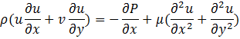
(2) | 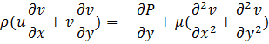

2.3. Tables, Figures, Pictures
All Tables, Figures and Pictures should be numbered consecutively and captioned. The caption title should be written centered, in 10pt Roman letters. A 6pt space should separate the figure from the caption, and a 12pt space should separate the upper part of the figure and the bottom of the caption from the surrounding text. Figures should be included within the text, see figure 1, rather than added at the end of the paper.

Table 1: A typical table
Variables Names | First Condition | Second Condition
Variable 1 | 80 | -80
Variable 2 | 20.5 | -20.5
Variable 3 | 0.001 | -0.001

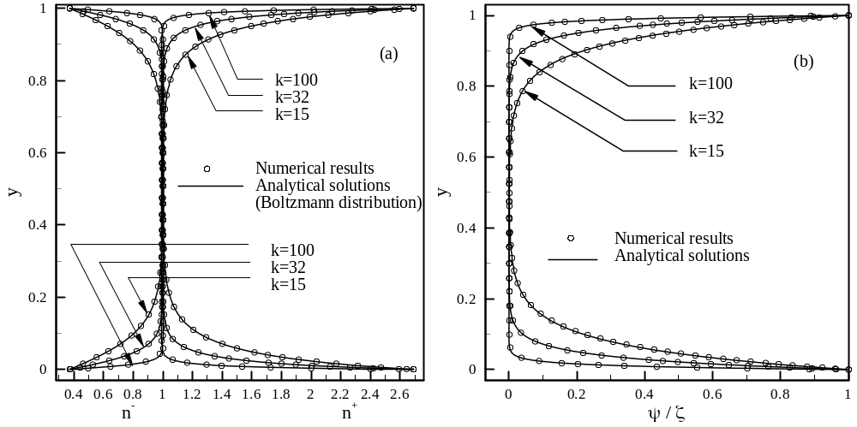
Figure 1: A typical figure, a) the distribution of ionic concentrations 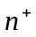 and 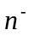 b) Electric potential distribution in Electric Double Layer, Re = 0.02 ، ζ = -25mV، k = 15، k = 32 and k = 100

2.4. Results and Discussion
Results should be presented with clarity and precision. The results should be written in the past tense when describing findings in the authors' experiments. Previously published findings should be written in the present tense. Results should be explained, but largely without referring to the literature. Discussion, speculation and detailed interpretation of data should not be included in the Results but should be put into the Discussion section.
The Discussion should interpret the findings in view of the results obtained in this and in past studies on this topic. State the conclusions in a few sentences at the end of the paper. The Results and Discussion sections can include subheadings, and when appropriate, both sections can be combined.

3. Conclusions
- Papers should be submitted electronically via the webpage of the Conference.
- Papers should be written following the format of the Word macros for submission that can be found in the Conference webpage.
- They must be translated to Portable Document Format (PDF) before submission through the Conference webpage.
- Deadline for the submission of the paper posted in the webpage must be respected.
- The organizers do not commit themselves to include in the Proceedings any paper received later than the deadline.
- At least one of the authors should register and pay his/her registration fee before the first registration deadline for their paper to be included in the final program of the Conference.

Acknowledgements
If needed.

