CMG-6TD CALIBRATION

WORKS ORDER: | 2021 | DATE: | 27 January 2003
SERIAL NUMBER: | T6226 | TESTED BY: | CJP

 |  | Velocity |  |  | Digitiser |  | Digital
 |  | Response |  |  | Output |  | Output
 |  | V/m/s |  |  | uV/count |  | m/s/count
VERTICAL |  | 1097.04 |  |  | 0.2702 |  | 2.463E-10
NORTH/SOUTH |  | 1149.07 |  |  | 0.1677 |  | 1.459E-10
EAST/WEST |  | 1164.90 |  |  | 0.2642 |  | 2.268E-10
 |  |  | Mass Position |  |  | Mass Position |  | Mass Position
 | Coil Constant |  | Response |  |  | Digital Output |  | Digital Output
 | A/m/s² |  | V/m/s² |  |  | uV/count |  | m/s²/count
VERTICAL | 0.0027 |  | 16.46 |  |  | 0.5848 |  | 9.623E-06
NORTH/SOUTH | 0.0029 |  | 17.24 |  |  | 0.5851 |  | 1.008E-05
EAST/WEST | 0.0029 |  | 17.47 |  |  | 0.5841 |  | 1.021E-05
Current Consumption: @12V ( ±10 mA) |  |  |  | 165mA
This sensor operates from 10 to 36 Volts only.

POLES AND ZERO TABLE

WORKS ORDER NUMBER:

SENSOR SERIAL NO:

Velocity response output:

POLES (HZ) | ZEROS HZ
-70.7e-3 + 70.7e-3j | -5.03207
-70.7e-3 - 70.7e-3j | 0
-393.011 | 0
-7.4904
-53.5979 - 21.7494j
-53.5979 + 21.7494j
Normalizing factor at 1 Hz: A =1.983*10^6

Sensor Sensitivity: See Calibration Sheet.

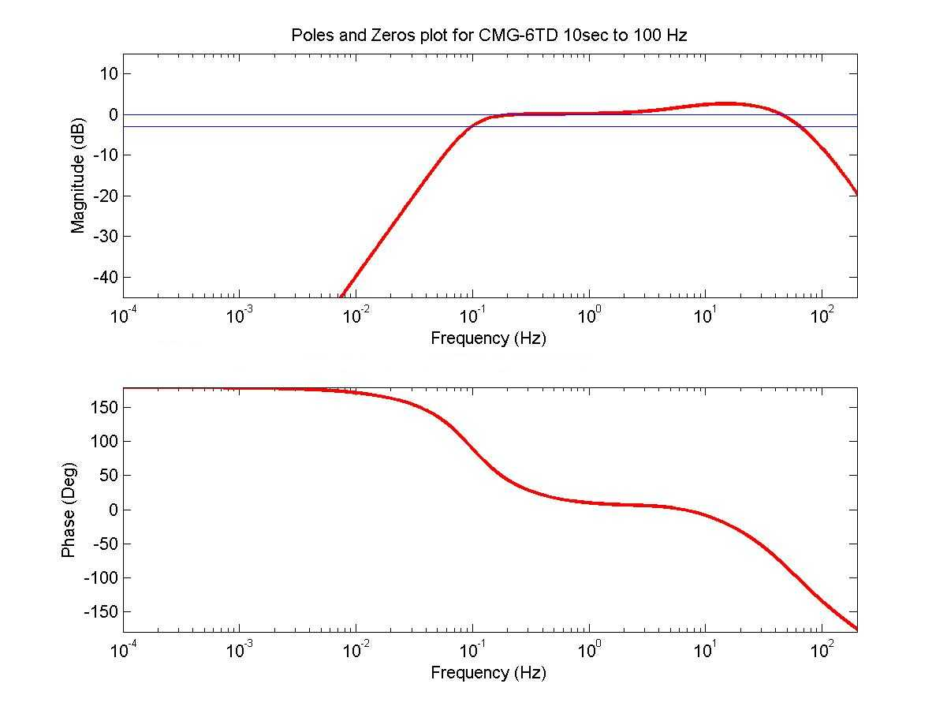

NOTE: The above poles and zeros apply to the vertical and the horizontal sensors and are given in units of Hz. To convert to Radian/sec multiply each pole or zero with 2π. The normalizing factor A should also be recalculated.

