CMG-6TD CALIBRATION

WORKS ORDER: | 2021 | DATE: | 27 January 2003
SERIAL NUMBER: | T6259 | TESTED BY: | CJP

 |  | Velocity |  |  | Digitiser |  | Digital
 |  | Response |  |  | Output |  | Output
 |  | V/m/s |  |  | uV/count |  | m/s/count
VERTICAL |  | 1041.25 |  |  | 0.2680 |  | 2.573E-10
NORTH/SOUTH |  | 1121.98 |  |  | 0.2645 |  | 2.358E-10
EAST/WEST |  | 1022.41 |  |  | 0.2554 |  | 2.498E-10
 |  |  | Mass Position |  |  | Mass Position |  | Mass Position
 | Coil Constant |  | Response |  |  | Digital Output |  | Digital Output
 | A/m/s² |  | V/m/s² |  |  | uV/count |  | m/s²/count
VERTICAL | 0.0026 |  | 15.62 |  |  | 0.5849 |  | 9.135E-06
NORTH/SOUTH | 0.0028 |  | 16.83 |  |  | 0.5835 |  | 9.820E-06
EAST/WEST | 0.0026 |  | 15.34 |  |  | 0.5840 |  | 8.957E-06
Current Consumption: @12V ( ±10 mA) |  |  |  | 165mA
This sensor operates from 10 to 36 Volts only.

POLES AND ZERO TABLE

WORKS ORDER NUMBER:

SENSOR SERIAL NO:

Velocity response output:

POLES (HZ) | ZEROS HZ
-70.7e-3 + 70.7e-3j | -5.03207
-70.7e-3 - 70.7e-3j | 0
-393.011 | 0
-7.4904
-53.5979 - 21.7494j
-53.5979 + 21.7494j
Normalizing factor at 1 Hz: A =1.983*10^6

Sensor Sensitivity: See Calibration Sheet.

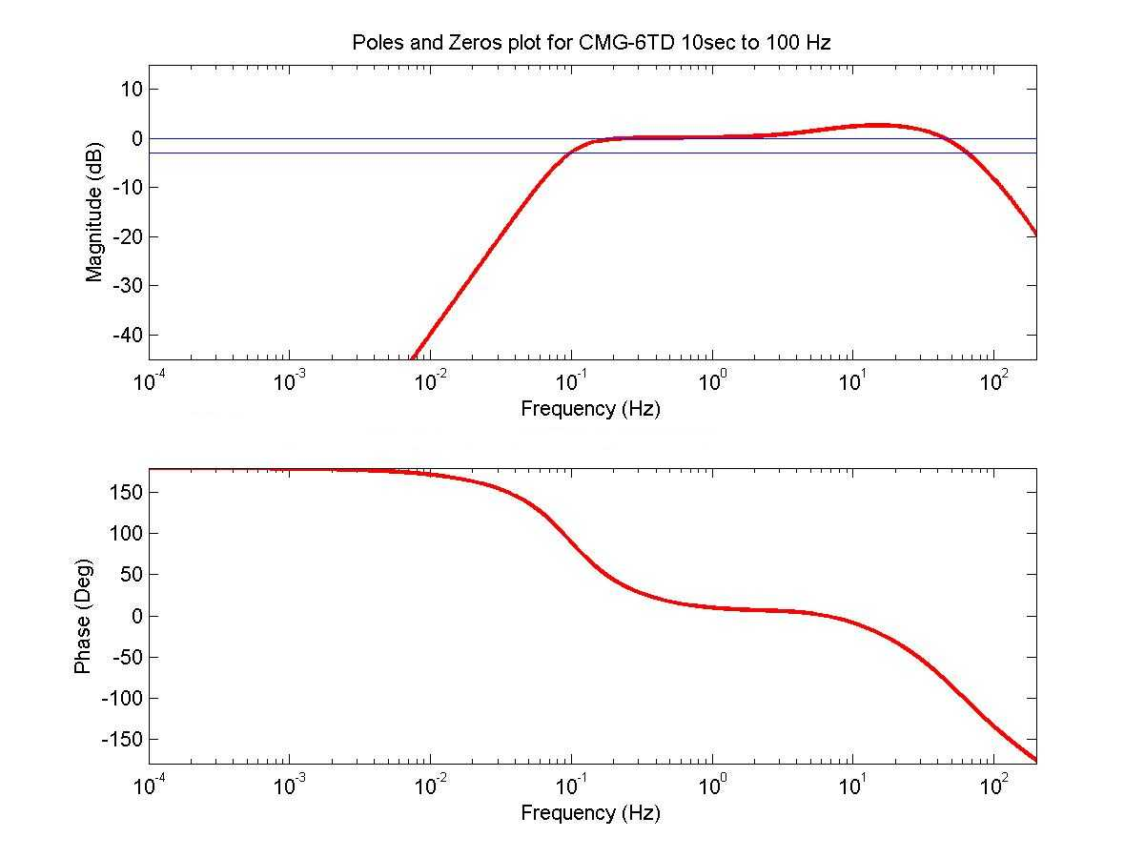

NOTE: The above poles and zeros apply to the vertical and the horizontal sensors and are given in units of Hz. To convert to Radian/sec multiply each pole or zero with 2π. The normalizing factor A should also be recalculated.

