[INSERT UNIVERSITY LOGO HERE]

Ego4D-LiteSTA: A Modular Lightweight Pipeline
for Short-Term Object Interaction Anticipation

A Thesis Presented to
The Faculty of [Your Department]
[Your University]

In Partial Fulfillment
of the Requirements for the Degree
Master of Science in Computer Science

By
[Your Name]

January 2026

Ego4D-LiteSTA: A Lightweight, Modular Pipeline for Reproducible Short-Term Object Interaction Anticipation
Document Type: DOCX

Abstract
Short-Term Object Interaction Anticipation (STA) in egocentric video requires predicting the next-active object’s location, interaction type (verb/noun), and time-to-contact seconds before physical contact. Existing STA solutions achieve competitive accuracy using heavy vision transformers at the cost of computational efficiency and reproducibility on modest hardware. our work presents Ego4D-LiteSTA, a lightweight, modular three-track pipeline designed for reproducible STA on consumer-grade CPUs while maintaining competitive performance on the Ego4D-STA v2 benchmark.
We decompose STA into three stages: (1) Track A generates K candidate bounding boxes on decision frames using lightweight YOLO detection, achieving 67.8% Recall@6 with mean IoU 0.617; (2) Track B scores candidates using Frame-Guided Temporal Pooling with dual cross-attention fusion (ResNet18 encoder + 4-layer transformer), achieving 15.28% top-5 N-mAP and 4.81% Overall mAP with class-weighted training; (3) Track C applies training-free rollout-guided token pruning, reducing latency by 42% (40.7ms → 23.6ms) with 99.9% accuracy retention (37.34% → 37.35% aggregate mAP).
Comprehensive evaluation on Ego4D-STA v2 reveals critical architectural insights: (1) Class weighting prevents prediction collapse, improving noun diversity by 123% (44→98 unique classes) and verb diversity by 253% (17→60 classes), despite a measured -2.7% aggregate mAP trade-off; (2) Exo-transfer (ImageNet ResNet18) outperforms ego-pretrained VideoMAE by 7.19% overall and 9.53% on noun prediction, validating the task-bottleneck matching principle—STA’s dominant bottleneck is spatial discrimination (object appearance), not temporal motion; (3) Temporal reasoning (43.3% TTC predictions within 100ms) transfers better than semantic understanding (20.14% noun accuracy), indicating that fine-grained semantic classification remains the primary challenge in egocentric anticipation.
The manifest-driven experimental methodology, explicit efficiency knobs, and complete local-CPU reproducibility make Ego4D-LiteSTA a transparent baseline for future egocentric anticipation research. All experiments completed with <$20 cloud compute (YOLO fine-tuning + VideoMAE pretraining) and ~10 hours local CPU training, demonstrating that principled lightweight architectures can achieve reasonable performance while maintaining full auditability and deployment feasibility under real-world constraints.
Keywords: egocentric vision, short-term anticipation, lightweight detection, token pruning, reproducible research, class imbalance, exo-to-ego transfer

Table of Contents
- Chapter 1: Introduction
  - 1.1 Background
  - 1.2 Problem Statement
  - 1.3 Objectives of the Study
    - 1.3.1 Contributions
  - 1.4 Scope and Limitations
  - 1.5 Research Methodology
  - 1.6 Structure of the Thesis
- Chapter 2 – Literature Review
  - 2.1 Ego4D Forecasting Benchmark and STA Task
    - 2.1.1 Forecasting benchmark and STA definition
    - 2.1.2 Ego4D dataset characteristics
  - 2.2 Baseline STA Challenge Solutions
    - 2.2.1 STAformer and AFF-ttention
    - 2.2.2 SOIA-DOD: disentangled detection and anticipation
  - 2.3 Efficient Video Backbones and Pre-Training
    - 2.3.1 Multiscale Vision Transformers (MViTv2)
    - 2.3.2 VideoMAE: data-efficient video self-supervision
  - 2.4 Token-Level Efficiency for Video and Egocentric Streams
    - 2.4.1 PruneVid
    - 2.4.2 Rollout-Guided Token Pruning (RGTP)
    - 2.4.3 EgoPrune
  - 2.5 Hand–Object Interaction, Affordances, and Hotspots
    - 2.5.1 PEAR
    - 2.5.2 Fine-grained affordance annotation
  - 2.6 Ego–Exo Transfer, Ego-Only Learning, and Retrieval-Augmented Models
    - 2.6.1 Ego–exo joint learning survey
    - 2.6.2 Synchronization-based exo→ego transfer
    - 2.6.3 Ego-Only
    - 2.6.4 Early motion transfer
    - 2.6.5 REAR
  - 2.7 Community Resources and Challenge Ecosystem
    - 2.7.1 EgoVis workshop
    - 2.7.2 Curated lists
  - 2.8 Summary and Positioning of Ego4D-LiteSTA
  - 2.9 Quantitative Reference Points (Ego4D-STA v2)
    - 2.9.1 Reported baselines (Top-5 mAP, percent)
- Chapter 3: Problem Definition and Data
  - 3.1 Task Definition (STA)
  - 3.2 Dataset, Splits, and Annotations (Ego4D-STA v2)
    - 3.2.1 Core visual data: clips, windows, and decision frames
    - 3.2.2 Ground-truth annotations available per interaction
    - 3.2.3 Structured experiment artifacts (what they contain and why)
    - 3.2.4 Concrete artifact mapping (conceptual objects to stored records)
  - 3.3 Metrics
    - 3.3.1 Track A: Recall@K for proposal quality
    - 3.3.2 Track B/C: Benchmark-style mAP and TTC error
  - 3.4 Data Manifests and Label Alignment Decisions
    - 3.4.1 Proposal candidate records (Track A output)
    - 3.4.2 Candidate-aligned training examples (Track B input)
    - 3.4.3 Optional derived views (debug and audit)
    - 3.4.4 Label alignment and TTC binning (design decisions)
    - 3.4.5 How candidate supervision is constructed (positive/negative definition)
    - 3.4.6 Coordinate conventions and format conversions
    - 3.4.7 Optional priors and reproducibility outputs
- Chapter 4: System Overview (Tracks A / B / C)
  - 4.1 Design Principles
    - 4.1.1 Rationale
    - 4.1.2 Principles
  - 4.2 Track A Overview (Proposals + Manifests)
    - 4.2.1 Stages and contract
    - 4.2.2 Outputs and downstream interface
  - 4.3 Track B Overview (Lightweight Fusion Head)
    - 4.3.1 Inputs and outputs
    - 4.3.2 Candidate ranking under top-5
  - 4.4 Track C Overview (Training-Free Pruning)
    - 4.4.1 Motivation and scope
    - 4.4.2 Evaluation focus (accuracy–latency)
- Chapter 5: Methodology
  - 5.1 Track A: Candidate Generation and Recall@K
    - 5.1.1 Candidate generation (Stage A)
    - 5.1.2 Proposal evaluation: Recall@K
    - 5.1.3 Manifest construction and label attachment (Stage B)
  - 5.2 Track B: Tokenization, Fusion (FGTP + Dual Cross-Attention), and Heads
    - 5.2.1 Inputs and representations
    - 5.2.2 Frame-Guided Temporal Pooling (FGTP)
    - 5.2.3 Dual cross-attention fusion
    - 5.2.4 Candidate pooling and per-candidate features
    - 5.2.5 Prediction heads and scoring
    - 5.2.6 Training objective
  - 5.3 Track C: Rollout-Guided Token Pruning (RGTP)
    - 5.3.1 Motivation
    - 5.3.2 Rollout-guided importance
    - 5.3.3 Integration and evaluation
- Chapter 6: Implementation and Engineering
  - 6.1 Local/Colab Workflow and Tooling
    - 6.1.1 Local-first execution
    - 6.1.2 Minimal cloud usage
    - 6.1.3 Practical tooling choices
  - 6.2 Configuration System and Reproducible Runs
    - 6.2.1 YAML configuration with inheritance and overrides
    - 6.2.2 Run logging as provenance
  - 6.3 Data Validation and Failure Handling
    - 6.3.1 Validation checkpoints
    - 6.3.2 Failure handling strategy
- Chapter 7: Experimental Setup
  - 7.1 Baselines and Compared Variants
    - 7.1.1 Track A baselines (proposal generation)
    - 7.1.2 Track B baselines (candidate scoring and multi-task prediction)
    - 7.1.3 Track C baselines (efficiency knobs)
  - 7.2 Training Protocols and Hyperparameters
    - 7.2.1 Data sources and splits
    - 7.2.2 Optimization settings
    - 7.2.3 Multi-task settings
    - 7.2.4 Checkpointing and model selection
  - 7.3 Evaluation Protocol
    - 7.3.1 Track A evaluation
    - 7.3.2 Track B/C correctness evaluation
    - 7.3.3 Track C efficiency evaluation
    - 7.3.4 Reproducibility and traceability
- Chapter 8: Results
  - 8.1 Track A Results (Recall@K)
    - 8.1.1 Reported metrics
    - 8.1.2 Key observations
  - 8.2 Track B Results (N / N+V / N+δ, TTC)
    - 8.2.1 Top-5 mAP variants
    - 8.2.2 TTC results
  - 8.3 Track C Results (Accuracy–Latency Pareto)
    - 8.3.1 Accuracy retained under pruning
    - 8.3.2 Runtime and Pareto analysis
  - 8.4 Comparison with Prior Work (Top-5 metrics)
    - 8.4.1 Reported literature baselines
    - 8.4.2 Ego4D-LiteSTA vs reported baselines
- Chapter 9: Ablations and Analysis
  - 9.1 Proposal K Sweeps
    - 9.1.1 Setup
    - 9.1.2 Findings
  - 9.2 Fusion Depth and Token Dimensionality
    - 9.2.1 Setup
    - 9.2.2 Findings
  - 9.3 TTC Modeling (Regression vs Bins)
    - 9.3.1 Setup
    - 9.3.2 Findings
  - 9.4 Priors (Hotspots, CLIP) and Their Impact
    - 9.4.1 Setup
    - 9.4.2 Findings
  - 9.5 Error Analysis and Qualitative Galleries
    - 9.5.1 Failure Gallery (what fails and why)
    - 9.5.2 Success Gallery (what works and when)
    - 9.5.3 Quantitative Error Analysis and Architecture Comparison
- Chapter 10: Discussion, Limitations, and Future Work
  - 10.1 Discussion
    - 10.1.1 What worked well
    - 10.1.2 Interactions between tracks
  - 10.2 Limitations
    - 10.2.1 Data and annotations
    - 10.2.2 Modeling and efficiency
  - 10.3 Future Work
    - 10.3.1 Method extensions
    - 10.3.2 Engineering extensions
- Chapter 11: Reproducibility Checklist
  - 11.1 Data and manifests
  - 11.2 Training and checkpoints
  - 11.3 Evaluation and reporting
  - 11.4 Environment and determinism
- Chapter 12: Ethical, Legal, and Social Implications (ELSI)
  - 12.1 Data governance and privacy
  - 12.2 Bias, fairness, and representativeness
  - 12.3 Responsible release and deployment
- Chapter 13: Conclusion
  - 13.1 Summary of contributions
  - 13.2 Summary of results
  - 13.3 Closing remarks
- References
- Appendices

Chapter 1: Introduction

1.1 Background
Short‑Term Object Interaction Anticipation (STA) in egocentric video asks a system to predict, one or two seconds before contact, where the next‑active object will be in the last frame, what verb and noun describe the interaction, and when (time‑to‑contact, TTC) the interaction begins. Ego4D provides the largest, most diverse STA benchmark with detailed verb/noun/TTC annotations. Unlike third‑person action recognition, egocentric footage is dominated by wearer motion, hand jitter, and cluttered near‑field scenes, making spatial localization and temporal reasoning tightly coupled. Recent STA solutions lean on heavy video transformers or multimodal fusion, achieving accuracy at the cost of compute, latency, and reproducibility on modest hardware. This motivates Ego4D‑LiteSTA: a modular, lightweight, and reproducible three‑track pipeline engineered to preserve accuracy while targeting low computational overhead.

1.2 Problem Statement
STA couples spatial detection, temporal reasoning, and semantic understanding in a resource‑constrained setting. High‑performing models typically depend on transformer video encoders with high FLOPs, dense tokens with redundancy, and tightly coupled multi‑task losses that can conflict. Deployment on wearable or embedded hardware is further limited by latency and VRAM budgets. The problem addressed here is to build a lightweight, modular, and efficient STA pipeline that maintains competitive accuracy while reducing computation and simplifying reproducibility on free or low‑cost GPUs.

1.3 Objectives of the Study
We pursues six objectives:
- Decompose STA into modular stages that can be optimized independently while remaining end‑to‑end reproducible.
- Develop a high‑recall proposal mechanism on the decision frame (Track A) to reliably surface potential next‑active objects, prioritizing recall@K over noun‑specific detection in the baseline.
- Design a lightweight temporal–spatial fusion head (Track B) using Frame‑Guided Temporal Pooling and dual cross‑attention, with token caching to cut training cost.
- Integrate a training‑free token‑pruning layer (Track C) to reduce inference compute and latency with minimal accuracy loss.
- Evaluate on Ego4D‑STA v2 with baselines and ablations (K, fusion, priors, pruning), reporting top‑5 N/N+V/N+δ mAP, top‑5 Overall mAP, TTC MAE, and latency/VRAM trade‑offs.
- Document decisions, configurations, and procedures (manifests, run logs, and evaluation scripts) to keep the pipeline auditable, comparable across variants, and easy to extend.

1.3.1 Contributions
The main contributions of our work are:
- A modular three‑track STA pipeline (Tracks A/B/C) that cleanly separates proposals, reasoning, and efficiency so each component can be evaluated and improved independently.
- A recall@K‑first proposal stage on the decision frame (Track A), paired with manifest construction to make downstream training and evaluation explicit and reproducible.
- A lightweight temporal fusion head (Track B) built around Frame‑Guided Temporal Pooling and dual image↔video cross‑attention to incorporate short‑term motion cues with minimal compute.
- A training‑free inference knob (Track C) based on rollout‑guided token pruning (RGTP) that enables controlled latency/VRAM reduction without retraining.
- A reproducible experimentation workflow (configs, logging, manifests, and evaluation protocol) suitable for Colab‑class hardware, enabling systematic ablations and fair comparisons.

1.4 Scope and Limitations
Scope: - Short‑term object interaction anticipation on Ego4D‑STA v2 with decision‑frame boxes, verb/noun labels, and TTC. - Three tracks only: Stage‑A proposals/manifests, Track B temporal head, Track C inference‑time pruning. - Compute and workflow: experiments are run primarily in a local environment; GPU‑heavy training steps (Track A detector fine‑tuning and VideoMAE pretraining) are executed on a cloud notebook when needed, while Track B/Track C training, evaluation, and analysis are performed locally. - Metrics: recall@K (proposals), top‑5 N/N+V/N+δ mAP, top‑5 Overall mAP, TTC MAE, and latency/VRAM under pruning.
Limitations: - No long‑term anticipation or language grounding beyond optional CLIP reranking; focus is strictly STA. - Detector is kept noun‑agnostic in the baseline; class‑specific detectors and large priors are future work. - Results are limited to Ego4D; cross‑dataset generalization is discussed but not experimentally covered. - Hyperparameter sweeps are bounded by low‑compute constraints; large model variants are out of scope.

1.5 Research Methodology
The study proceeds in five phases:
- Survey and design choices: Review STA literature (two‑stage baselines, fusion, token pruning) and record key engineering decisions (e.g., noun‑agnostic proposals as the baseline for Track A).
- Data preparation and validation: Build local manifests and optional YOLO labels; generate head_train/val JSONL; run sanity checks on label alignment (noun/verb/TTC) and paths; optionally pre‑extract video tokens to accelerate Track B training.
- Modeling and training: Fine‑tune Track A detector weights and pretrain VideoMAE weights when needed using a cloud notebook workflow; run the remaining training (Track B heads) and all evaluations locally, keeping Track C pruning as a training‑free evaluation step.
- Evaluation protocol: Evaluate on Ego4D‑STA v2 validation with consistent metrics (all mAP metrics reported in the benchmark’s top‑5 protocol: N/N+V/N+δ and Overall; plus TTC MAE) and deployment‑oriented measurements (latency/VRAM), using fixed configs where possible.
- Ablations and reproducibility: Sweep proposal K, fusion settings, TTC modeling choices, priors (e.g., hotspots/CLIP where applicable), and pruning rates; log run configs and outputs so results can be reproduced and audited.

1.6 Structure of the Thesis
Chapter 2: Literature Review surveys STA systems, efficient backbones, token pruning, affordances/hotspots, and ego/exo perspectives, grounding the design choices.
Chapter 3: Problem Definition and Data formalizes the STA task, dataset splits and annotations, metrics, and the manifest/label‑alignment decisions that determine what supervision is available to each track.
Chapter 4: System Overview (Tracks A/B/C) presents the pipeline at a high level, motivating the separation into proposals, lightweight fusion, and training‑free pruning.
Chapter 5: Methodology details the modeling approach per track: proposal generation and recall@K (Track A), tokenization/fusion/head design (Track B), and rollout‑guided pruning at inference (Track C).
Chapter 6: Implementation and Engineering describes the local/Colab workflow, configuration system, and reproducible run artifacts (manifests, logs, checkpoints, metrics).
Chapter 7: Experimental Setup defines baselines, training protocols, hyperparameters, and the evaluation procedure used throughout the thesis.
Chapter 8: Results reports results for each track, including accuracy and resource trade‑offs.
Chapter 9: Ablations and Analysis studies sensitivity to key design choices (K, fusion depth, TTC modeling, priors, and pruning rate).
Chapters 10–13 discuss limitations and future work, provide a reproducibility checklist and ELSI considerations, and conclude with the main contributions.
Taken together, Our approach moves from defining the STA problem and its constraints (Chapters 1–3), to specifying the proposed pipeline (Chapter 4), to detailing how each track is implemented and evaluated (Chapters 5–7), and finally to presenting results, analysis, and implications for deployable egocentric anticipation (Chapters 8–13).

Chapter 2 – Literature Review
This chapter reviews the main research threads that inform the Ego4D‑LiteSTA thesis: short‑term object interaction anticipation in egocentric video, efficient video backbones and self‑supervised pre‑training, token‑level efficiency for streaming video, hand–object affordances, and cross‑view ego–exo transfer. For each line of work, we summarize the core ideas, highlight architectural patterns, and extract concrete design choices that can be adapted to a lightweight, real‑time STA pipeline.
Throughout the chapter, we refer to the Ego4D forecasting benchmark and dataset paper as the foundational source, then connect them to recent challenge solutions (STAformer, SOIA‑DOD) and efficiency‑oriented methods (MViTv2, VideoMAE, PruneVid, RGTP, EgoPrune, PEAR, REAR, etc.).

2.1 Ego4D Forecasting Benchmark and STA Task

2.1.1 Forecasting benchmark and STA definition
The Ego4D forecasting benchmark defines four future‑prediction tasks based on the Ego4D dataset: locomotion prediction, hand movement prediction, short‑term object interaction anticipation (STA), and long‑term action anticipation. The STA task is the most relevant for this thesis, as it directly formalizes the problem of predicting what object the camera wearer will interact with, how, and when.
In STA, the model is given a short egocentric video clip and must predict, for the last observed frame, (i) the bounding boxes of next‑active objects, (ii) a verb–noun pair describing the upcoming interaction, and (iii) a scalar time‑to‑contact (TTC) value indicating when the interaction will start relative to the current frame. This joint spatial–semantic–temporal formulation makes STA considerably more challenging than pure detection or classification.
From a data perspective, the Ego4D forecasting annotations are derived by aligning dense egocentric narrations with frame‑level annotations of hand–object contact, pre‑contact context, and hand trajectories. For each interaction, annotators provide a pre‑condition frame, a contact frame, and multiple earlier frames sampled at fixed temporal offsets (e.g., −0.5 s, −1.0 s, −1.5 s). Active objects and hands are annotated with bounding boxes, and each interaction is labelled with a verb category and noun category drawn from curated taxonomies.
These design choices have several implications for a “lite” STA variant:
- The problem is inherently multi‑task (detection + verb classification + noun classification + regression), which can be hard to optimize end‑to‑end under limited compute.
- The time‑to‑contact component is naturally noisy, as annotators approximate continuous human behavior with discrete frames; this makes TTC prediction relatively fragile.
- The dataset is long‑tailed in both verbs and nouns, which favors architectures that decouple object localization from fine‑grained verb/noun modeling and that can leverage priors or retrieval.
For Ego4D‑LiteSTA, a practical consequence is that we can selectively down‑scope some parts of the official benchmark (e.g., treat TTC as optional in early experiments, or focus on top‑k next active object prediction) while staying faithful to the original problem definition.

2.1.2 Ego4D dataset characteristics
The Ego4D dataset itself contains 3,670 hours of egocentric video recorded by 931 camera wearers across 74 locations and 9 countries. The footage spans daily‑life activities in household, workplace, leisure, outdoor, and social settings. Most recordings are long‑form, unscripted, and captured “in the wild”, rather than short, trimmed clips. This produces a strong mismatch between Ego4D and the short, highly curated third‑person clips used for classic video benchmarks such as Kinetics.
From a modeling perspective, the dataset is challenging for several reasons:
- Egocentric viewpoint – the hands and immediate workspace dominate the field of view, while the actor is rarely visible.
- High camera motion – head movements and locomotion introduce strong ego‑motion, which complicates object tracking and stable localization.
- Long‑term temporal context – interactions are embedded in long continuous streams, not isolated snippets.
- Diverse environments and objects – the variety of kitchens, offices, tools, and household items increases domain shift across sequences.
The Ego4D paper also frames five benchmark families: episodic memory, hand–object interaction, social interaction, audio‑visual conversation, and forecasting. STA resides in the forecasting group, but is tightly connected to hand–object interaction tasks (hands and objects, hotspots, and affordances) and to long‑term temporal reasoning.
For Ego4D‑LiteSTA, the dataset properties argue strongly in favor of:
- Treating hand proximity and object context as primary cues for next interaction.
- Designing architectures that can reuse features across tracks (STA vs. other Ego4D tasks).
- Exploiting self‑supervised pre‑training on egocentric video to reduce the need for large exocentric datasets.

2.2 Baseline STA Challenge Solutions
Work on the Ego4D STA benchmark has produced several strong baselines and challenge solutions that inspire the design of Ego4D‑LiteSTA, especially in terms of decomposition of the task, use of attention, and integration of affordances.

2.2.1 STAformer and AFF-ttention
STAformer, introduced by the ZARRIO team, is an attention‑based architecture tailored to the Ego4D STA challenge. The model processes an image–video pair: the last frame at high resolution and a short sequence of frames as a video clip. STAformer extracts DINOv2 features from the still image and TimeSformer features from the video, then fuses them via several specialized attention modules:
- Frame‑Guided Temporal Pooling Attention – projects video features onto the last‑frame reference, emphasizing temporal information that matters at the current time step.
- Dual Image–Video Cross‑Attention – refines both image and video features by letting each attend to the other, encouraging consistency between static and dynamic cues.
- Multi‑scale feature fusion – aggregates information from different spatial resolutions.
- Fast R‑CNN‑style detection head – adapted to predict bounding boxes, verb and noun probabilities, and time‑to‑contact for each candidate box.
On top of STAformer, the AFF‑ttention work extends the model with environment affordance and interaction hotspot modules. The environment affordance model uses an EgoTopo‑like representation: videos are decomposed into topological zones, and a database of zones is used as a persistent memory of what interactions are feasible in each region (e.g., “countertop near the sink”, “corner with a kettle”). Given a new input, the system matches the observed scene to the database and refines verb/noun probabilities based on historically observed affordances. The interaction hotspot module predicts a spatial map of likely contact regions on the current frame, using hand and object trajectories, and then re‑weights STA predictions based on how close candidate boxes are to hotspot areas.
Experimentally, STAformer with affordances reaches 33.5 N‑mAP, 17.25 N+V‑mAP, 11.77 N+δ‑mAP, and 6.75 Overall top‑5 mAP on the v2 test set, improving substantially over previous challenge winners.
For Ego4D‑LiteSTA, STAformer and AFF‑ttention suggest several principles:
- Explicitly modeling image–video fusion around the last frame is effective.
- Affordance priors can compensate for limited model capacity by encoding “what is usually done where.”
- Hotspot prediction anchors STA to hand‑centric spatial priors, which is valuable when bounding box proposals are noisy.
However, the full STAformer + AFF pipeline is computationally heavy: it relies on high‑capacity vision transformers (DINOv2, TimeSformer), large affordance databases, and additional modules for hotspots. This motivates the LiteSTA strategy of approximating similar behavior with simpler backbones (e.g., YOLOv8‑s) and focusing on egocentric‑specific cues rather than global scene semantics.

2.2.2 SOIA-DOD: disentangled detection and anticipation
SOIA‑DOD (Short‑term Object Interaction Anticipation with Disentangled Object Detection) takes a different perspective: instead of one monolithic network that jointly solves detection, verb/noun classification, and TTC regression, it decomposes the problem into two stages:
- Potential active object detection – a fine‑tuned YOLOv9 model detects all candidate active objects in the last frame. The top‑k high‑confidence boxes are kept as potential next‑active objects.
- Interaction and TTC prediction – a transformer‑based encoder takes both visual tokens and object queries (encoding box coordinates and class labels) and predicts, for each candidate, the probability of being the next‑active object, the interaction class (verb), and TTC.
This decomposition simplifies optimization: YOLOv9 focuses purely on localization and object class, while the transformer learns to refine which candidate is truly next‑active and when the interaction will occur. On the Ego4D STA challenge, SOIA‑DOD achieves state‑of‑the‑art performance for predicting the next active object and interaction, ranking third in overall top‑5 mAP including TTC.
For Ego4D‑LiteSTA, SOIA‑DOD provides a clear reference design that aligns well with a resource‑constrained regime:
- Use a lightweight detector (e.g., YOLOv8‑s instead of YOLOv9) fine‑tuned for next‑active candidate generation.
- Keep a compact transformer head to operate on a small set of queries, which keeps complexity roughly linear in the number of proposals rather than quadratic in spatial tokens.
- Treat TTC as an auxiliary regression task, which can be scaled back or approximated if necessary.
Compared to STAformer, SOIA‑DOD is closer in spirit to the proposed Track A/B/C structure in Ego4D‑LiteSTA, where Stage A is a YOLO‑based detection stage and later stages reuse these candidates for anticipation.

2.3 Efficient Video Backbones and Pre-Training
Running STA at scale over long egocentric streams requires backbones that provide a good accuracy–efficiency trade‑off and can exploit self‑supervised pre‑training. Two key lines of work are Multiscale Vision Transformers (MViTv2) and VideoMAE.

2.3.1 Multiscale Vision Transformers (MViTv2)
MViTv2 generalizes vision transformers into a multiscale hierarchy that can serve as a single backbone for image classification, object detection, and video recognition. Instead of operating at a fixed resolution with global attention at all layers, MViTv2 progressively reduces spatial (and temporal) resolution across stages, using “pooling attention” to aggregate information while controlling compute.
Two main architectural improvements over the original MViT are highlighted:
- Decomposed relative positional embeddings – inject shift‑invariant position information into attention without exploding parameter count.
- Residual pooling connections – compensate for information loss when applying pooling strides inside attention blocks.
These changes lead to strong results across domains:
- Up to 88.8% top‑1 on ImageNet‑1K when pre‑trained on ImageNet‑21K.
- 58.7 AP_box on COCO detection.
- 86.1% accuracy on Kinetics‑400 for video classification.
For a lightweight STA pipeline, MViTv2 is not necessarily the final backbone (YOLOv8‑s is a more natural fit for real‑time detection), but the design ideas are instructive:
- A feature hierarchy with decreasing resolution is critical for efficiency and for integrating local and global information.
- Pooling attention offers an alternative to windowed attention, and the authors report better accuracy/compute trade‑offs than Swin‑style local windows.
- The same backbone can power image‑only tasks (detection on last frame) and video‑based tasks (clip‑level motion reasoning), which is analogous to Track A (image‑centric) vs. Track B/C (clip‑centric) in Ego4D‑LiteSTA.
An interesting extension for future work would be to swap YOLOv8‑s with an MViTv2‑based detector or to use an MViT feature extractor for the temporal head, while keeping the rest of the LiteSTA pipeline unchanged.

2.3.2 VideoMAE: data-efficient video self-supervision
VideoMAE is a masked autoencoder framework designed specifically for self‑supervised video pre‑training with vanilla ViT backbones. It applies a very high masking ratio (90–95%) to video tubes (spatio‑temporal patches) and tasks the model with reconstructing the missing content from a small subset of visible tokens. Because video has strong temporal redundancy, such aggressive masking makes reconstruction challenging and encourages the encoder to learn robust, high‑level representations instead of memorizing low‑level patterns.
Key findings from VideoMAE are particularly relevant for an egocentric STA setting:
- Very high masking ratios work – unlike images, where ~75% masking is typical, videos can tolerate 90–95% while still training successfully.
- Data efficiency – VideoMAE achieves strong performance even when pre‑training on relatively small video datasets (3k–4k clips), provided they are in‑domain.
- No extra data requirement – the method reaches state‑of‑the‑art performance on several video benchmarks (Kinetics‑400, Something‑Something‑V2, UCF101, HMDB51) without using large external datasets.
This is echoed by the “Ego‑Only” work (discussed later), which demonstrates that egocentric action detection can achieve state‑of‑the‑art results by performing MAE‑style pre‑training directly on egocentric data, without exocentric transfer.
For Ego4D‑LiteSTA, VideoMAE suggests a pre‑training path for the temporal head:
- Use a tube‑masked autoencoder on Ego4D STA clips (or on Ego4D more broadly) to pre‑train a compact ViT or MViT backbone.
- Fine‑tune this encoder for STA‑specific supervision (verb/noun/TTC).
- Keep the heavy reconstruction decoder only during pre‑training; at inference, use only the encoder, which keeps runtime manageable.
Even if the final LiteSTA implementation uses a simpler temporal module (e.g., 3D CNN or small transformer), the underlying principle is the same: leverage self‑supervision on in‑domain egocentric videos to avoid heavy exocentric pre‑training.

2.4 Token-Level Efficiency for Video and Egocentric Streams
Running STA in a streaming or near‑real‑time setting motivates methods that operate not only on efficient backbones, but also on efficient token sets. Recent work explores training‑free pruning and merging strategies that exploit spatio‑temporal redundancy in video tokens.

2.4.1 PruneVid
PruneVid introduces a training‑free method for pruning visual tokens in multimodal video‑language models. Its goal is to reduce the computational burden of attention in large language models that ingest long sequences of video tokens.
The method has two main steps:
- Intrinsic redundancy reduction – temporally static regions are detected and merged across frames; spatially similar tokens are then clustered and merged within frames, compressing both static background and redundant object regions.
- Question‑guided attention pruning – during LLM processing, attention maps are used to identify tokens most relevant to the query; tokens with consistently low attention are pruned across layers, and only their key‑value caches are kept where necessary.
Experiments show that PruneVid can prune over 80% of visual tokens while maintaining competitive QA performance, reducing FLOPs by 74–80% and significantly lowering memory usage.
For Ego4D‑LiteSTA, PruneVid is conceptually relevant in two ways:
- It demonstrates that temporal and spatial redundancy can be aggressively exploited, which is also true in egocentric STA clips where backgrounds and non‑manipulated regions change slowly.
- It suggests a two‑stage pruning strategy (data‑level compression + task‑guided token selection) that could be adapted to a compact STA transformer head without any re‑training.
In practice, a LiteSTA implementation could, for example, merge background tokens across frames in the temporal encoder, and then keep only tokens near hands or candidate boxes, mimicking PruneVid’s behavior but in a much smaller model.

2.4.2 Rollout-Guided Token Pruning (RGTP)
Rollout‑Guided Token Pruning (RGTP) focuses on efficient video understanding with frame‑by‑frame vision transformers, explicitly leveraging attention rollout and token tracking across time to guide pruning decisions.
The main idea is to estimate the importance of each input token in the current frame by tracing its contribution from previous frames’ predictions:
- Attention rollout is used to propagate relevance from output tokens back to earlier layers, giving a measure of how much each token contributed to past predictions.
- Token tracking then aligns tokens between consecutive frames (e.g., via motion or positional correspondence), so that importance scores can be propagated over time.
- Tokens with consistently low importance are pruned before the attention blocks, leading to large FLOP reductions without retraining.
RGTP is training‑free, interpretable, and shows up to 65% FLOP reduction on ImageNet VID and 60% on EPIC‑Kitchens action recognition, with negligible accuracy degradation.
For Ego4D‑LiteSTA, RGTP is particularly relevant because EPIC‑Kitchens is also an egocentric dataset with hand–object interactions. Adapting a rollout‑guided pruning strategy to the STA temporal head could further reduce compute: only tokens that historically matter for predicting interactions (e.g., hand regions, moving objects) would be kept in later layers.

2.4.3 EgoPrune
EgoPrune focuses specifically on egomotion videos in embodied agents and proposes a perspective‑aware, training‑free token pruning method tailored to first‑person streams. The method introduces three components:
- Keyframe selection – adapted from EmbodiedR, to reduce temporal redundancy by sampling only a subset of frames that capture important changes.
- Perspective‑Aware Redundancy Filtering (PARF) – uses homography‑based perspective transformations to align visual tokens across frames and then removes redundant tokens that correspond to stable regions in the scene.
- Maximal Marginal Relevance (MMR)‑based token selection – jointly considers visual–text relevance and intra‑frame diversity to retain tokens that are both informative for the query and non‑redundant.
EgoPrune demonstrates that incorporating egomotion‑specific geometry (e.g., camera motion, scene structure) into pruning can outperform generic video pruning methods at the same pruning ratios, both in accuracy and in latency on edge devices.
For Ego4D‑LiteSTA, the main takeaway is that egocentric geometry matters for efficiency. If the STA temporal head operates on patches or tokens, we can:
- Treat hand‑centric, near‑field regions as high‑priority tokens.
- Use simple motion cues (optical flow or YOLO‑based object tracks) to drop far‑field, background tokens that remain static over time.
- Apply diversity‑aware selection when we have many overlapping candidate boxes or patches in similar areas.
Although EgoPrune targets video‑language models, its principles align well with a “lite” STA design that must run on modest GPUs or even edge hardware.

2.5 Hand–Object Interaction, Affordances, and Hotspots
STA is fundamentally about anticipating hand–object interactions. Several recent works directly address how to model hand motion trends, interaction hotspots, and affordances.

2.5.1 PEAR
PEAR (Phrase‑Based Hand‑Object Interaction Anticipation) proposes a model that jointly forecasts both interaction intention and interaction manipulation over a future time window, given a pre‑interaction image and a natural language phrase such as “pick up bottle”.
The authors argue that existing work often predicts only pre‑contact intention (e.g., contact hotspots) while ignoring detailed manipulation trajectories and hand poses after contact, which makes predictions incomplete and less constrained. PEAR addresses two sources of uncertainty:
- Intention uncertainty – high variability in hand motion patterns and object functional attributes.
- Manipulation uncertainty – difficulty in matching pre‑contact intention to post‑contact manipulation elements (trajectories, poses).
To reduce intention uncertainty, PEAR performs cross‑alignment of verbs, nouns, and images. It leverages image–text encoders to align nouns with object affordances and verbs with motion patterns, and then uses cross‑attention modules to constrain the space of plausible intentions.
To mitigate manipulation uncertainty, PEAR introduces a dynamic bidirectional constraint between intention and manipulation:
- A deep equilibrium model jointly predicts hand motion trends, hotspots, manipulation trajectories, and hand poses.
- Residual connections from manipulation back to intention help refine early predictions so that they remain consistent with the final manipulation.
A conditional VAE (C‑VAE) decoder introduces controlled randomness, capturing human variability while keeping predictions plausible.
For Ego4D‑LiteSTA, PEAR suggests several ideas that can be simplified and reused:
- Cross‑alignment between verb/noun labels and visual features can help disambiguate fine‑grained categories in long‑tailed vocabularies.
- Modeling interaction hotspots and hand motion trends explicitly is beneficial, even if we keep a shorter prediction horizon than PEAR.
- Phrase‑based conditioning hints at a future extension where STA predictions could be guided by higher‑level task descriptions or textual priors.

2.5.2 Fine-grained affordance annotation
Another line of work revisits how affordances are defined and annotated in hand–object interaction datasets. The “Fine‑grained Affordance Annotation” paper argues that many existing datasets conflate affordance with object functionality or high‑level actions (verbs like “cut”, “take”, “turn off”) and ignore human motor capacity and grasp types.
To address this, the authors propose an annotation scheme where affordance labels are constructed as combinations of goal‑irrelevant motor actions and grasp types, focusing on the hand–object interface itself, and introduce mechanical action labels to describe interactions between tools and target objects. They apply this scheme to EPIC‑KITCHENS, generating labels that distinguish between affordances (e.g., how an object can be grasped or manipulated) and goal‑level actions (e.g., “turn off tap”).
The paper evaluates the new annotations on three tasks:
- Affordance recognition.
- Hand–object interaction hotspot prediction with affordances as weak supervision.
- Cross‑domain affordance generalization.
Results show that affordance‑centric labels yield better generalization and finer‑grained hotspot prediction than action labels alone.
For Ego4D‑LiteSTA, this reinforces the importance of separating:
- What the object can afford (affordance, grasp, contact regions).
- What the user is about to do (verb, goal, task).
Even if Our approach does not introduce new affordance annotations, the ideas support design choices such as:
- Using hand proximity and object category as strong priors for next‑active object selection.
- Optionally integrating external affordance priors (e.g., from EPIC‑KITCHENS) into the STA head as an additional score or bias.

2.6 Ego–Exo Transfer, Ego-Only Learning, and Retrieval-Augmented Models
The broader egocentric literature has explored two complementary directions: (1) transferring knowledge from large exocentric datasets to egocentric tasks, and (2) training “ego‑only” models directly on egocentric data without exocentric transfer. Both perspectives are useful for positioning Ego4D‑LiteSTA in the design space.

2.6.1 Ego–exo joint learning survey
A recent short survey reviews joint egocentric–exocentric learning, highlighting datasets that contain paired ego–exo views (e.g., CMU‑MMAC, Charades‑Ego, Assembly101, EgoExo4D) and the corresponding tasks: action recognition, proficiency estimation, action anticipation, pose estimation, correspondence, temporal segmentation, frame retrieval, and alignment.
The survey’s central argument is that exocentric videos provide complementary cues—full‑body pose, global context—that can help interpret egocentric hand–object interactions, and that joint ego–exo modeling can unlock richer representations for downstream tasks. This viewpoint supports the idea that STA could benefit from exocentric priors in principle, but also emphasizes the practical difficulty of collecting synchronized ego–exo data at scale.
Ego4D‑LiteSTA positions itself closer to the “ego‑only” side (especially when working on student‑scale hardware and free Colab), but the survey’s taxonomy is helpful for framing potential extensions, such as using exocentric retrieval to provide additional context for rare interactions.

2.6.2 Synchronization-based exo→ego transfer for temporal segmentation
“Synchronization is All You Need” proposes a method to adapt a temporal action segmentation (TAS) model from an exocentric dataset to an egocentric setting using unlabeled synchronized ego–exo video pairs. Instead of collecting labeled egocentric videos, the method uses existing exocentric labels plus unlabeled synchronized pairs and applies knowledge distillation from an exocentric teacher to an egocentric student at both feature and model levels.
Experiments on Assembly101 and EgoExo4D show that this approach can bridge much of the performance gap between exocentric‑only models and fully supervised egocentric models, improving edit scores substantially without using any egocentric labels.
While the task (TAS) differs from STA, the key lesson is that synchronization can act as a powerful supervision signal in ego–exo transfer. For Ego4D‑LiteSTA, a related idea could be to use synchronized streams (e.g., multi‑view or multi‑sensor data) for future work, but the base thesis keeps the pipeline simpler and does not rely on exocentric labels.

2.6.3 Ego-Only
The Ego‑Only work directly challenges the assumption that exocentric pre‑training is required for egocentric action detection. Instead, it shows that with a sufficiently strong self‑supervised pre‑training strategy—specifically, a masked autoencoder finetuned for temporal segmentation—one can train competitive egocentric models using only egocentric video data.
Ego‑Only emphasizes several differences between egocentric and exocentric data that make naive transfer problematic:
- Egocentric videos are long‑form and dominated by hand–object interactions and near‑field views, whereas exocentric clips are short, trimmed, and show full bodies and global context.
- Action classes in Ego4D and EPIC‑KITCHENS are fine‑grained and long‑tailed, reflecting real‑world distributions.
- Temporal localization is central in egocentric action detection, whereas many exocentric datasets focus on clip‑level classification.
The proposed pipeline has three stages:
- MAE‑style pre‑training on egocentric videos.
- Temporal segmentation fine‑tuning.
- Action detection with an off‑the‑shelf temporal detector (e.g., ActionFormer).
Ego‑Only achieves state‑of‑the‑art results on Ego4D, EPIC‑Kitchens‑100, and Charades‑Ego without any exocentric data.
For Ego4D‑LiteSTA, Ego‑Only provides a strong conceptual justification for focusing on ego‑only pre‑training and fine‑tuning, especially under compute constraints and when exocentric data is not central to the problem being solved. Combining Ego‑Only principles with VideoMAE‑style pre‑training is a natural fit for a lightweight STA head.

2.6.4 Early motion transfer between egocentric and exocentric views
EgoTransfer represents an early attempt to model “mirror neurons” by learning mappings between motion features in egocentric and exocentric videos. The authors record time‑synchronized ego–exo video pairs, extract motion features (e.g., optical flow descriptors) in both views, and train linear or non‑linear models to predict egocentric motion from exocentric motion and vice versa.
Evaluation is done via cross‑view retrieval: given a motion feature in one view, retrieve its corresponding feature in the other view from a set of candidates. Results show that the learned mappings can successfully transfer motion across views, suggesting that there is a stable relationship between egocentric and exocentric motion patterns.
For Ego4D‑LiteSTA, EgoTransfer is mostly of historical and conceptual interest. It reinforces the idea that exocentric information could help interpret egocentric motion and vice versa, but it also highlights the increasing complexity and data requirements of such approaches. Given Our approach focus on a practical, lightweight STA pipeline, the design remains ego‑centric and does not rely on motion transfer from exocentric sources.

2.6.5 Retrieval-augmented egocentric action recognition (REAR)
REAR (Retrieval‑Augmented Egocentric Action Recognition) proposes to augment egocentric representations with retrieved exocentric video features without requiring synchronized ego–exo pairs.
The framework uses a dual‑branch architecture:
- A target branch that encodes the egocentric video.
- A retrieval branch that retrieves semantically related exocentric features from a large corpus based on similarity in a joint embedding space.
A cross‑view integration module performs staged fusion and attention‑based alignment of egocentric and exocentric features. To address long‑tailed class distributions, REAR introduces a class‑adaptive selector that varies the number of retrieved examples per class and uses logit‑adjusted cross‑entropy (LACE) for training the classifiers.
Experiments on three egocentric benchmarks show that REAR improves object (noun) recognition and tail‑class performance, demonstrating the value of exocentric retrieval as an auxiliary knowledge source.
For Ego4D‑LiteSTA, REAR’s architecture is heavier than what is realistic for a Colab‑based, single‑GPU pipeline, but the ideas are relevant conceptually:
- Retrieval‑augmented modeling is a promising direction for handling rare verbs/nouns in STA.
- Class‑adaptive retrieval reflects the intuition that tail classes need more external help than head classes.
- A future extension of LiteSTA could attach a small retrieval branch that uses external data (exocentric or egocentric) to refine verb/noun scores for ambiguous cases.

2.7 Community Resources and Challenge Ecosystem
The egocentric vision community has converged around a set of large‑scale datasets and workshops that provide both data and benchmarks relevant to STA and related tasks.

2.7.1 EgoVis workshop and challenge ecosystem
The Joint Egocentric Vision (EgoVis) workshop at CVPR 2024 brings together multiple datasets and challenges in egocentric perception, including Ego4D, EgoExo4D, EPIC‑Kitchens, HoloAssist, Aria Digital Twin, and Aria Synthetic Environments.
For Ego4D specifically, the workshop hosts challenges on:
- Visual queries (2D and 3D).
- Natural language queries and moment queries.
- EgoTracks and goal step prediction.
- PNR temporal localization, localization and tracking.
- Short‑term and long‑term anticipation (including STA).
This ecosystem demonstrates that STA is part of a broader anticipation and assistance agenda, where models should not only recognize what is happening but also predict what will happen next, locate relevant moments, and interact with language.
For a thesis focusing on Ego4D‑LiteSTA, the workshop context reinforces the relevance of:
- Designing methods that could be plugged into the official STA challenge if desired.
- Keeping an eye on multi‑task and multi‑modal extensions, such as combining STA with natural language queries or goal step prediction.

2.7.2 Curated lists and “awesome” repositories
Finally, community‑curated resources like “Awesome Egocentric Action Understanding” aggregate recent work on egocentric action recognition, anticipation, representation learning, and multi‑view modeling. These lists are useful for situating Ego4D‑LiteSTA within the broader literature, identifying new baselines, and ensuring that design choices are informed by the current state of the art.

2.8 Summary and Positioning of Ego4D-LiteSTA
The literature reviewed in this chapter converges on several key themes that directly influence the design of the Ego4D‑LiteSTA pipeline:
- STA is a multi‑task, hand‑centric, future‑prediction problem
The Ego4D forecasting benchmark and STA task definition make clear that next‑active object prediction requires joint reasoning about spatial localization, verb/noun semantics, and time‑to‑contact. Challenge solutions like STAformer and SOIA‑DOD show that decomposing the problem into detection + anticipation, and exploiting hand and affordance cues, is an effective strategy.
- Efficient backbones and self‑supervised pre‑training are essential
MViTv2 and VideoMAE demonstrate that multiscale transformers and high‑mask‑ratio MAEs can provide strong representations that are both accurate and efficient. Ego‑Only confirms that, for egocentric tasks, in‑domain MAE pre‑training can replace heavy exocentric pre‑training entirely.
- Token‑level efficiency can dramatically reduce compute
PruneVid, RGTP, and EgoPrune show that aggressive token pruning and merging—informed by temporal redundancy, attention rollout, and egomotion geometry—can reduce FLOPs by 60–80% with minimal accuracy loss. While Ego4D‑LiteSTA primarily targets efficiency via model choice (YOLOv8‑s) and pipeline design, these methods point to additional gains available through token‑level optimization.
- Affordances and hand–object hotspots provide powerful priors
PEAR and fine‑grained affordance annotations demonstrate that modeling where and how the hand will interact with an object can significantly improve anticipation quality. For a lightweight STA system, even simple approximations—such as focusing on objects near the hands and encoding object‑specific priors—can provide a large boost.
- Ego–exo transfer is useful but not mandatory
Surveyed works on ego–exo joint learning, synchronization‑based transfer, and retrieval‑augmented models show that exocentric data can help, especially for rare classes and global context.

2.9 Quantitative Reference Points (Ego4D-STA v2)
This section provides a compact numerical reference for the STA literature on Ego4D‑STA v2. The goal is to anchor expectations for later chapters; the numbers below are reported results from prior publications on the validation split.

2.9.1 Reported baselines (Top-5 mAP, percent)
Table 2.1 summarizes representative published results on Ego4D‑STA v2 validation using Top‑5 mAP (%). Columns follow the benchmark convention: N (noun), N+V (noun+verb), N+δ (noun+TTC tolerance), All (joint).
Method (reported) | N | N+V | N+δ | All
FRCNN+SF | 21.00 | 7.45 | 7.07 | 2.98
StillFast | 20.26 | 10.37 | 7.26 | 3.96
GANO v2 | 20.52 | 10.42 | 7.28 | 3.99
STAformer | 24.85 | 13.45 | 7.41 | 4.90
STAformer + MH + AFF | 29.39 | 15.38 | 9.94 | 5.67
Table 2.1 - Baseline methods performance on Ego4D-STA v2
However, Ego‑Only, VideoMAE, and the Ego4D dataset itself make a strong case that ego‑only pipelines are viable and competitive, which aligns with the practical constraints of this thesis.
Within this landscape, Ego4D‑LiteSTA positions itself as a practical, lightweight STA pipeline that:
- Uses a YOLOv8‑s detector for next‑active candidate generation (Stage A).
- Adds compact temporal and semantic heads for STA on top of detected candidates (Tracks B and C).
- Leverages egocentric‑focused design choices inspired by STAformer, SOIA‑DOD, VideoMAE, Ego‑Only, and affordance‑based works.
- Is designed to run end‑to‑end on free Google Colab GPUs, with transparent logging of runs, metrics, and errors for reproducible research.
This literature review thus provides both the theoretical foundation and the practical design space within which Ego4D‑LiteSTA is developed and evaluated.

Chapter 3: Problem Definition and Data

3.1 Task Definition (STA)
We focuses on the Short-Term Object Interaction Anticipation (STA) task as defined in the Ego4D forecasting benchmark. Given a short egocentric clip ending at a decision (last observed) frame, the system must anticipate the upcoming interaction by predicting:
- Where the next-active object will be localized in the decision frame (bounding box on the last frame).
- What interaction will occur (verb and noun labels).
- When the interaction will start (time-to-contact, TTC).
In practice, Ego4D-LiteSTA decomposes the problem into a two-stage, proposal-driven formulation:
- Candidate generation (Track A / Stage A): produce a small set of $K$ candidate bounding boxes on the decision frame.
- Anticipation head (Track B): for each candidate box, predict whether it is the next-active object and, optionally, its associated verb/noun/TTC.
Let $I_{t}$ denote the decision-frame image and $V_{t-L+1:t}$ denote a window of $L$ frames ending at time $t$ (the clip context). Track A produces candidate boxes
$$B_{t}=\{b_{t,1},…,b_{t,K}\}, b_{t,i}∈R^{4} (x_{1},y_{1},x_{2},y_{2}).$$
Track B then predicts, for each candidate $b_{t,i}$, a set of outputs:
- Next-active probability $p_{t,i}=P(y_{t,i}^{\text{pos}}=1∣I_{t},V_{t-L+1:t},b_{t,i})$.
- Optional semantics: ${\hat{y}}_{t,i}^{\text{noun}}$ and ${\hat{y}}_{t,i}^{\text{verb}}$.
- Optional TTC prediction ${\hat{τ}}_{t,i}$ (in seconds) and/or a binned TTC label ${\hat{y}}_{t,i}^{\text{ttc-bin}}$.
The decomposition is deliberate: it allows Track A to be optimized for high recall under small $K$, while Track B focuses on ranking and refining a small candidate set rather than scanning the full image with dense tokens.

3.2 Dataset, Splits, and Annotations (Ego4D-STA v2)
All experiments are conducted on Ego4D-STA v2, using the official training/validation split where applicable and following the benchmark’s definition of clips and decision frames.
This section describes the data at the level used in the thesis: what information exists, how it is structured into reusable “artifacts”, and how each artifact is used by the proposed pipeline.

3.2.1 Core visual data: clips, windows, and decision frames
Each training/evaluation example is anchored at a decision frame (the last observed frame before contact). The model observes:
- A still image of the decision frame (used for spatial localization and candidate scoring).
- A short temporal window of preceding frames (used to encode motion and pre-contact context).
This separation is important for Ego4D-LiteSTA because Track A is image-centric (decision-frame proposals), while Track B consumes both image and short-term temporal context.
We uses the Ego4D canonical clips distribution (rather than full-length canonical videos) because it is benchmark-aligned and makes training and evaluation more accessible. Ego4D provides two clip variants: clips (original resolution) and clips_540ss, where 540ss indicates the shorter side is scaled to 540 pixels. Canonical clips are distributed at a constant frame rate of 30 FPS.
To avoid timeline ambiguity, Ego4D annotation files distinguish clip-based and video-based time/frame references using clip_ and video_ prefixes, respectively. Ego4D-LiteSTA uses the clip-based fields when constructing decision-frame examples and temporal windows.
For the Forecasting Hands and Objects (FHO) benchmark, clips correspond to approximately 5-minute intervals (with padding before/after the interval when available), which provides optional context near clip boundaries.

3.2.2 Ground-truth annotations available per interaction
Ego4D-STA provides supervision that can be summarized as:
- Next-active object bounding boxes on the decision frame.
- A verb label describing the action.
- A noun label describing the object.
- A scalar time-to-contact (TTC) indicating how soon contact will occur.
Not every derived training record is required to contain all fields. In particular, Ego4D-LiteSTA treats semantic labels (verb/noun) and TTC as optional extensions on top of the core next-active-object selection problem.

3.2.3 Structured experiment artifacts (what they contain and why)
To make experiments auditable and reproducible, the pipeline converts raw benchmark information into a small set of structured artifacts. Conceptually, these are:
- Frame index (visual backbone input)
- Contains: identifiers for the clip instance, the decision frame index, and the association between identifiers and the corresponding RGB frames.
- Used for: deterministic reconstruction of the exact visual inputs seen by Track A and Track B.
- Proposal candidate set (Track A output; one record per decision frame)
- Contains: for each decision frame, a list of up to $K$ candidate boxes in pixel coordinates, plus optional confidence scores (and detector class IDs when produced by a detector).
- Used for: limiting downstream computation and converting STA into a candidate ranking/refinement problem.
- Candidate-aligned supervision (label attachment)
- Contains: for each candidate box, a binary next-active label and, when available, associated noun/verb/TTC labels.
- Used for: training and evaluating the anticipation head as a candidate scorer (and, optionally, a multi-task predictor).
- Training/evaluation examples for the head (Track B input)
- Contains: either (a) one record per decision frame with its list of candidates, or (b) one record per candidate with a shared frame identifier.
- Used for: efficient I/O and batching while preserving the per-frame evaluation structure (top-$k$ ranking within each decision frame).
The remainder of Chapter 3 formalizes how these artifacts support evaluation and how label alignment decisions are handled.

3.2.4 Concrete artifact mapping (conceptual objects to stored records)
In practice, the artifacts above are stored as small, line-oriented JSON/JSONL files and run summaries to keep every stage inspectable. The mapping used throughout our work is:
- Frame index → a manifest of decision-frame identifiers and their corresponding decoded RGB frames.
- Proposal candidate set → a JSONL file with one record per decision frame, containing $K$ candidate boxes and optional detector scores.
- Candidate-aligned supervision → per-candidate fields attached during label alignment (e.g., is_positive, noun_id, verb_id, ttc, and optional TTC-bin).
- Head training/evaluation examples → JSONL records that are either:
  - per-candidate (one line per candidate with a shared frame key), or
  - per-frame (one line per decision frame containing a list of candidates).
We uses the term manifest to refer to any such explicit record that fully specifies the (frame, box, label) tuples used by a run.

3.3 Metrics
Ego4D-LiteSTA evaluates each stage with metrics aligned to its role in the pipeline.

3.3.1 Track A: Recall@K for proposal quality
Track A is assessed by Recall@K on the decision frame: the fraction of frames where at least one of the $K$ proposals overlaps a ground-truth next-active box by at least an IoU threshold.
Let $G_{t}$ denote the set of ground-truth next-active boxes for frame $t$, and let $IoU(⋅,⋅)$ denote intersection-over-union. Define a “hit” event:
$$hit(t)=1\left[\max_{b∈B_{t}}\max_{g∈G_{t}}IoU(b,g)≥θ\right].$$
Then Recall@K is:
Recall@K=t​hit(t)t​1[|Gt|>0].
Recall@K measures whether the proposal stage preserves the ground-truth next-active object(s) inside a small candidate set. It is therefore the primary metric for selecting $K$ and for comparing proposal strategies.

3.3.2 Track B/C: Benchmark-style mAP and TTC error
For the anticipation head, we report the benchmark-style mAP family under the top-5 protocol (consistent with Our approach introduction):
- N mAP (top-5): box is correct and noun matches.
- N+V mAP (top-5): box is correct and both noun and verb match.
- N+$δ$ mAP (top-5): box is correct and noun + TTC-bin match (TTC discretized).
- Overall mAP (top-5): combined correctness across localization and semantics, following the benchmark’s top-5 evaluation protocol.
TTC is additionally reported as mean absolute error in seconds:
$$TTC MAE=\frac{1}{M}\sum_{j=1}^{M}{|}{\hat{τ}}_{j}-τ_{j}|,$$
computed over valid supervised examples.
Because the goal of Ego4D-LiteSTA is practical efficiency, results are interpreted alongside latency/VRAM measurements (Track C pruning), but the core correctness metrics remain Recall@K, top-5 mAP variants, and TTC MAE.
Operationally, “top-5” in this proposal-driven setting means: for each decision frame, the model assigns a final score to every candidate box in the $K$-proposal set, ranks candidates by this score, and evaluates the top 5 ranked boxes (with their predicted noun/verb/TTC when enabled) using the benchmark’s detection-style matching. This makes Track B/C directly comparable across different Track A configurations, because the evaluation always starts from the same per-frame candidate pool.

3.4 Data Manifests and Label Alignment Decisions
Reproducibility in this project is driven by a simple principle: every training and evaluation run is defined by explicit, human-inspectable records of what frames, boxes, and labels were used. This section explains what those records contain and how they connect the tracks.

3.4.1 Proposal candidate records (Track A output)
For each decision frame, Track A produces a candidate set of up to $K$ bounding boxes.
Each candidate record contains:
- A frame identifier (which interaction instance and which decision frame).
- A list of candidate boxes in pixel coordinates $(x_{1},y_{1},x_{2},y_{2})$.
- Optional confidence scores (used for initial ranking and for debugging).
- Optional detector class IDs when a detector is used (not required for the noun-agnostic baseline).
Usage:
- Track A outputs define the search space that Track B will score.
- Varying $K$ changes the accuracy–efficiency trade-off; Recall@K quantifies this trade-off.

3.4.2 Candidate-aligned training examples (Track B input)
Track B is trained and evaluated on decision-frame keyed examples that preserve the grouping of candidates within the same decision frame. Depending on the storage choice, the same information can be represented as either (i) one record per decision frame containing a list of candidates, or (ii) one record per candidate with a shared frame identifier.
Each frame-level example contains:
- A frame identifier and the association to the underlying visual context (decision frame + temporal window).
- A list of candidates, where each candidate contains:
  - its bounding box,
  - a binary next-active label (is_positive), and
  - optional multi-task labels: noun ID, verb ID, TTC (seconds), and optionally a TTC-bin.
Usage:
- The grouping preserves the correct evaluation granularity (rank candidates within each decision frame).
- It supports variable candidate counts per frame without forcing a fixed dense grid.
- It allows the same Track B code to operate across different Track A configurations, because the interface is always “frame → list of candidates” at evaluation time, even when stored per-candidate.

3.4.3 Optional derived views (debug and audit)
In addition to the frame-level training examples, the pipeline may derive auxiliary views of the data for transparency:
- Per-candidate crop view: a cropped ROI image per candidate, useful for qualitative inspection and error analysis.
- Per-candidate tabular view: one row per candidate with normalized box coordinates and attached labels, useful for checking class distributions, missing labels, and outliers.
These views are not conceptually required by the learning formulation, but they make it easier to validate that the dataset is consistent and that the candidate generation step is behaving as intended.

3.4.4 Label alignment and TTC binning (design decisions)
Ego4D provides fixed taxonomies for nouns and verbs. Correct training and evaluation require that IDs are consistent across splits and across all derived records.
Ego4D-LiteSTA enforces the following decisions:
- Proposal fields (boxes, confidence) are kept separate from semantic labels (noun/verb/TTC), so missing semantics can be detected without corrupting the proposal stage.
- Multi-task labels are treated as optional: when a field is unavailable for a candidate, the model can fall back to next-active ranking and TTC regression only.
- TTC binning is deterministic: when TTC bins are required, continuous TTC is discretized using fixed thresholds (by default $(0.5,1.0,2.0)$ seconds). If a TTC-bin label is absent, it can be derived from TTC using these thresholds.
Together, these choices ensure that Chapter 7’s experimental comparisons are fair: different models and ablations are evaluated on the same definition of “what constitutes a valid label” and the same discretization of TTC where applicable.

3.4.5 How candidate supervision is constructed (positive/negative definition)
The raw STA annotation for a decision frame may include one or more annotated next-active objects. Ego4D-LiteSTA converts this into candidate-level supervision by applying two deterministic steps:
- Target selection (when multiple objects exist): when multiple annotated objects are present for the same decision frame, a single target is selected using a fixed policy (default: the object with minimum TTC). This yields one reference box $g_{t}$ and its associated labels (noun/verb/TTC) for the frame.
- Candidate matching and labeling: for each candidate box $b_{t,i}$, compute IoU with the selected target $g_{t}$. A candidate is labeled positive if $IoU(b_{t,i},g_{t})≥θ_{\text{pos}}$ (with $θ_{\text{pos}}$ fixed across runs; $0.5$ is used unless otherwise stated). All remaining candidates for that decision frame are labeled negative.
Semantic labels (noun/verb) and TTC are attached only to positive candidates. If a run is configured to train without semantics, the positive/negative labels remain valid and the multi-task fields are simply ignored.

3.4.6 Coordinate conventions and format conversions
All geometric boxes are represented as $(x_{1},y_{1},x_{2},y_{2})$ in pixel coordinates with origin at the top-left of the decision frame. When “oracle” labels are used for evaluation or proposal conversion, they may be stored in a normalized detector format (e.g., $(c_{x},c_{y},w,h)$ normalized by image width/height). In that case, conversion to pixel coordinates is deterministic given the decoded frame resolution.
To avoid ambiguity across resolutions, all runs use a fixed decoded frame height for the decision-frame images (e.g., 540p) and all label/proposal boxes are interpreted in that same coordinate system.

3.4.7 Optional priors and reproducibility outputs
Some Track B/C variants incorporate simple, optional priors to adjust candidate scores after the head prediction:
- Hotspot prior: a lightweight lookup over $(\text{noun_id},\text{verb_id})$ pairs that provides a default bias when a pair is unseen.
- CLIP-based re-ranking (optional): uses noun/verb label text derived from the official taxonomies to compute similarity-based adjustments.
Regardless of which options are enabled, every run produces a consistent set of audit artifacts:
- A run log capturing the full configuration (paths, toggles, hyperparameters), system information, and aggregate metrics.
- Metric dumps storing scalar results (including Our approach top-5 variants).
- Prediction exports storing per-candidate outputs (scores, predicted labels, and errors), enabling qualitative inspection and downstream analysis.

Chapter 4: System Overview (Tracks A / B / C)

4.1 Design Principles

4.1.1 Rationale
Ego4D‑LiteSTA is organized as a three‑track pipeline designed around two constraints: (i) STA requires both spatial localization and short‑term temporal context, and (ii) the system must be reproducible and efficient on modest hardware. The tracks are separated so that each component can be evaluated with a metric aligned to its role (Chapter 3) while still producing artifacts that compose cleanly.

4.1.2 Principles
The system follows five design principles:
- Proposal‑driven decomposition. Localization on the decision frame is handled first by producing a small candidate set. Subsequent reasoning is performed only on these candidates. This reduces computation and makes the learning problem a ranking/refinement task rather than dense search.
- Auditability through explicit manifests. Every stage reads and writes human‑inspectable records that specify the exact frames, boxes, and labels used by a run. This allows runs to be repeated, compared, and debugged without ambiguity.
- Metric alignment by stage. Track A is optimized for high recall under small $K$ (Recall@K). Track B is optimized for correctness under the benchmark protocol (top‑5 mAP and TTC error). Track C is optimized for efficiency–accuracy trade‑offs (accuracy retained under lower latency/VRAM).
- Optional semantics and priors. The core task is next‑active object selection. Noun/verb prediction and TTC modeling are treated as optional extensions that can be enabled without changing the proposal interface. Similarly, simple priors (e.g., hotspot biases or CLIP‑based re‑ranking) are optional score components, not hard requirements.
- Training is isolated from efficiency knobs. The primary efficiency knob (token pruning) is evaluated as a training‑free modification at inference time. This makes the latency–accuracy curve easier to study and avoids conflating pruning with representation learning.

4.2 Track A Overview (Proposals + Manifests)

4.2.1 Stages and contract
Track A transforms each decision frame into a compact candidate set of bounding boxes that is likely to contain the next‑active object. Conceptually, it answers the question: “Which $K$ regions should the system consider?”
Track A operates in two stages:
- Stage A (candidate generation). A detector or oracle source produces up to $K$ candidate boxes on the decision frame, optionally with confidence scores. The objective is high recall: it is acceptable for the candidate set to include false positives as long as the next‑active object is rarely missed.
- Stage B (manifest construction and label attachment). Candidate boxes are aligned to ground truth when supervision is available, producing candidate‑level labels (positive/negative and optional noun/verb/TTC). Stage B may also derive auxiliary views such as cropped candidate regions and flattened, per‑candidate tables for inspection.
The key output of Track A is not only the candidate set itself but also the manifests that make downstream training and evaluation deterministic. These manifests provide a stable interface between Track A and Track B/C: a decision frame identifier plus a list of candidates with any available labels.

4.2.2 Outputs and downstream interface
From a system perspective, Track A is the primary control for the accuracy–efficiency trade‑off: increasing $K$ tends to improve recall (benefiting Track B/C) but increases per‑frame computation downstream.

4.3 Track B Overview (Lightweight Fusion Head)

4.3.1 Inputs and outputs
Track B is the anticipation head that scores candidates produced by Track A and, when enabled, predicts semantics and TTC. It answers: “Among the candidates, which region is next‑active, and what interaction is about to occur?”
Inputs and outputs are structured around the decision frame:
- Inputs. For each decision frame, Track B consumes the candidate set and the associated visual context: the decision frame image and a short temporal window of preceding frames. Each candidate is represented by its box geometry and any derived crop or region representation.
- Outputs. For every candidate, Track B produces a next‑active score and optional predictions for noun, verb, and TTC. Candidates are then ranked by a final score that may include optional priors (e.g., hotspot bias or CLIP‑based re‑ranking).
The design is intentionally lightweight. Rather than performing dense spatiotemporal detection, Track B focuses on candidate ranking under a small $K$, which enables:
- Efficient training and inference.
- Clean comparability across different proposal strategies (the candidate interface remains unchanged).
- Direct compatibility with the benchmark’s top‑5 evaluation protocol by selecting the top‑ranked candidates per decision frame.
Track B is also the main locus for representational choices (how temporal context is encoded, how image and video features are fused, and how multi‑task heads are trained). These choices are detailed in Chapters 5–7; Chapter 4 emphasizes the system‑level contract: Track B is a scorer/predictor operating over Track A candidates and producing ranked outputs for evaluation.

4.3.2 Candidate ranking under top-5

4.4 Track C Overview (Training-Free Pruning)

4.4.1 Motivation and scope
Track C studies efficiency improvements that do not require retraining, focusing on token‑level pruning applied at inference time. It answers: “How much compute can be removed while keeping accuracy close to Track B?”
Track C reuses the same candidate interface and evaluation protocol as Track B. The difference is that Track C introduces a pruning policy into the feature extraction and fusion pathway, reducing the number of tokens processed for each decision frame and its temporal context.

4.4.2 Evaluation focus (accuracy–latency)
This track is separated for two reasons:
- Controlled efficiency analysis. By keeping training fixed and changing only inference‑time computation, Track C isolates the impact of pruning on latency, VRAM, and accuracy.
- Deployment‑oriented reporting. Track C pairs correctness metrics (top‑5 mAP variants and TTC error) with runtime measurements (e.g., latency percentiles and throughput), enabling an accuracy–latency Pareto analysis.
Overall, Track C turns efficiency into an explicit, measurable knob while preserving the reproducibility guarantees of the pipeline: pruning settings and runtime measurements are logged alongside the same manifest‑defined inputs and benchmark‑style outputs.

Chapter 5: Methodology

5.1 Track A: Candidate Generation and Recall@K
Track A is designed to maximize the probability that the true next‑active object appears in a small candidate set. The core design choice is to optimize for coverage (recall) rather than class specificity: a candidate set that consistently includes the next‑active region enables downstream ranking and multi‑task prediction to operate efficiently.

5.1.1 Candidate generation (Stage A)
Given the decision frame $I_{t}$, Stage A outputs a set of $K$ candidate boxes
$$B_{t}=\{(b_{t,i},s_{t,i})\}_{i=1}^{K},$$
where $b_{t,i}$ is a pixel‑space bounding box and $s_{t,i}$ is an optional confidence score.
Two proposal sources are used in this thesis:
- Detector proposals. A lightweight object detector produces a ranked list of candidate detections. The top candidates are selected after standard post‑processing (confidence thresholding and non‑maximum suppression) and then truncated to $K$.
- Oracle proposals (upper bound for proposals). Ground‑truth label boxes (when available) are converted into the same candidate representation. Oracle proposals are not intended as a deployable method; they isolate the effect of downstream ranking and semantics by removing proposal errors.
The primary knob is $K$. Larger $K$ increases recall but increases downstream computation approximately linearly, since Track B and Track C score candidates individually.

5.1.2 Proposal evaluation: Recall@K
Stage A is evaluated by Recall@K (Chapter 3). Let $g_{t}$ be the selected target box for a decision frame (Section 3.4.5), and define
$$hit(t)=1\left[\max_{b∈B_{t}}IoU(b,g_{t})≥θ\right].$$
Then
Recall@K=t​hit(t)t​1.
We use Recall@K as the stage selection criterion because Track A’s role is to preserve the true next‑active region in a small set; it is not penalized for including additional plausible regions.

5.1.3 Manifest construction and label attachment (Stage B)
Stage B transforms the proposal set into training/evaluation examples for the head by attaching candidate‑level supervision:
- Candidate alignment. For each candidate $b_{t,i}$, compute IoU with the selected target $g_{t}$ and assign a binary label is_positive using a fixed threshold $θ_{\text{pos}}$ (Section 3.4.5).
- Semantic attachment (optional). For positive candidates, attach noun/verb IDs and TTC when available; for negatives, semantic fields are either omitted or masked.
- Optional derived views. Cropped candidate regions and tabular summaries are generated to enable inspection, distribution checks, and qualitative error analysis.
The key methodological outcome of Stage B is a manifest that fully specifies the (frame, candidate box, label) tuples used by Tracks B and C.

5.2 Track B: Tokenization, Fusion (FGTP + Dual Cross-Attention), and Heads
Track B takes the candidate set from Track A and predicts, for each candidate, whether it corresponds to the next‑active object and (optionally) the associated noun, verb, and TTC. The design goal is to incorporate short‑term temporal cues while remaining lightweight and compatible with candidate ranking.

5.2.1 Inputs and representations
For each decision frame, Track B consumes:
- The decision‑frame image $I_{t}$.
- A short clip window $V_{t-L+1:t}$ ending at $t$.
- Candidate boxes $\{b_{t,i}\}_{i=1}^{K}$.
The system encodes the visual context into two token sets:
- Image tokens $X∈R^{N×d}$ extracted from the decision frame.
- Video tokens $Z∈R^{M×d}$ extracted from the temporal window.
The exact backbone choices are treated as implementation details; methodologically, the requirement is that both modalities yield $d$‑dimensional token sequences with consistent normalization.

5.2.2 Frame‑Guided Temporal Pooling (FGTP)
Video tokens often contain redundancy, especially in short egocentric windows with repeated background content. FGTP compresses temporal information into a compact representation guided by the decision frame. Concretely, FGTP computes an attention‑like aggregation of video tokens conditioned on image tokens:
$$Z^{FGTP}=Pool(Z∣X),$$
where $Z^{FGTP}$ contains fewer effective tokens than $Z$ while preserving motion cues most relevant to the decision frame.

5.2.3 Dual cross‑attention fusion
After FGTP, Track B performs lightweight bidirectional fusion between the decision frame and the temporal context:
- Image () video: enrich image tokens with pooled temporal context.
- Video () image: align temporal cues to decision‑frame spatial structure.
This dual interaction is crucial for STA because the next‑active object is localized on the decision frame but is often disambiguated by preceding motion (hand trajectory, object approach, and pre‑contact dynamics).

5.2.4 Candidate pooling and per‑candidate features
Each candidate box $b_{t,i}$ is converted into a per‑candidate feature vector $h_{t,i}$ by pooling from the fused token maps. The pooling operation is designed to be lightweight and stable across varying $K$:
$$h_{t,i}=ROI_Pool(b_{t,i};X^{'},(Z^{FGTP})^{'}),$$
where $(X^{'},(Z^{FGTP})^{'})$ are the fused representations. This produces one feature vector per candidate, enabling independent scoring and straightforward batching.

5.2.5 Prediction heads and scoring
Track B outputs for each candidate:
- Next‑active score:
$$p_{t,i}=σ(w_{pos}^{⊤}h_{t,i}),$$
- where $σ$ is the sigmoid.
- Optional noun/verb classifiers: softmax heads producing ${\hat{y}}_{t,i}^{\text{noun}}$ and ${\hat{y}}_{t,i}^{\text{verb}}$.
- Optional TTC prediction: either a regression head ${\hat{τ}}_{t,i}$ and/or a binned classifier ${\hat{y}}_{t,i}^{\text{ttc-bin}}$.
When priors are enabled, the final ranking score is formed by combining the learned next‑active score with optional additive components (e.g., hotspot bias or CLIP‑based re‑ranking) while keeping the candidate interface unchanged.

5.2.6 Training objective
Track B is trained with a multi‑task objective over candidates, with masking for missing labels:
$$L=λ_{pos} L_{pos}+λ_{noun} L_{noun}+λ_{verb} L_{verb}+λ_{ttc} L_{ttc},$$
where
- $L_{pos}$ is binary cross‑entropy on is_positive,
- $L_{noun}$ and $L_{verb}$ are cross‑entropy losses applied only when the corresponding labels are present (typically on positives),
- $L_{ttc}$ is either L1/L2 regression loss on TTC and/or cross‑entropy on TTC bins.
At evaluation time, candidates are ranked per decision frame by the final score and the top‑5 outputs are evaluated under the benchmark protocol (Section 3.3.2).

5.3 Track C: Rollout-Guided Token Pruning (RGTP)
Track C introduces inference‑time token pruning to reduce compute while preserving accuracy. The key methodological requirement is training‑free control: pruning is applied without changing learned weights, enabling a clean analysis of the accuracy–latency trade‑off.

5.3.1 Motivation
Token‑based video models process a large number of tokens, many of which contribute little to the final prediction for a given decision frame. In STA, this redundancy is amplified by short horizons and repeated background. Pruning seeks to remove low‑utility tokens before expensive fusion and head computations.

5.3.2 Rollout‑guided importance
RGTP assigns an importance score to tokens using attention rollout‑style propagation. Let $α_{j}$ denote the importance of token $j$ after rollout aggregation across layers/heads. Tokens are then ranked by $α_{j}$.
Given a requested pruning rate $r∈[0,1)$, Track C keeps the top fraction $(1-r)$ of tokens and drops the remainder:
$$Z_{kept}=\{z_{j}∈Z:α_{j}≥q_{1-r}(α)\}.$$
Here, $q_{1-r}(α)$ denotes the $(1-r)$ quantile of the token‑importance scores $\{α_{j}\}$ for the current input.
The pruning policy can be applied to video tokens, image tokens, or both, but the system is evaluated under a single fixed policy per run to keep comparisons fair.

5.3.3 Integration and evaluation
Track C reuses Track B’s candidate scoring pipeline with the pruned token sets. Because the candidate set and manifests are unchanged, the evaluation remains identical: rank candidates per decision frame, evaluate the top‑5 outputs, and report TTC error.
In addition to accuracy metrics, Track C reports runtime metrics (e.g., latency percentiles and throughput) collected under consistent measurement settings. This produces an accuracy–latency Pareto curve that quantifies how much compute reduction is achievable at acceptable performance loss.

Chapter 6: Implementation and Engineering

6.1 Local/Colab Workflow and Tooling
Ego4D‑LiteSTA is implemented as a local-first workflow with optional cloud acceleration for the two most GPU‑intensive steps. The guiding goal is to keep the end‑to‑end pipeline runnable and debuggable on a single development machine, while still enabling occasional heavy training jobs when needed.
In addition, the canonical clips used as the source data were downloaded via the official Ego4D CLI from a cloud notebook environment (Colab) due to the large transfer volume (approximately 95 GB). In this setup, the STA clip UID list (sta_clip_uids.txt) corresponds to 2,324 canonical clips.

6.1.1 Local-first execution
Most stages are executed locally because they benefit from fast iteration, direct access to cached artifacts, and stable path layouts:
- Data materialization and preprocessing. Frame extraction, list building, and manifest generation are run locally to keep the dataset state inspectable and to avoid silent mismatches between “what was extracted” and “what was trained/evaluated”.
- Track A inference and Stage B preparation. Proposal generation and candidate manifest construction are run locally because they are I/O‑bound and because they produce the manifests that define the training/evaluation interface of the entire system.
- Track B training and evaluation (default). The fusion head training and evaluation loops are designed to run on a single GPU (or CPU in demo mode) with consistent logging of metrics and checkpoints.
- Track C pruning evaluation. Pruning experiments are run locally to measure accuracy–efficiency trade‑offs in a controlled environment.

6.1.2 Minimal cloud usage
Cloud notebooks are used only when the required GPU time is impractical to schedule locally:
- YOLO fine‑tuning (Track A detector). When detector weights are fine‑tuned, a cloud notebook can accelerate training, after which the resulting weights are brought back into the local workflow.
- VideoMAE pretraining (optional backbone). When backbone pretraining is performed, it is similarly handled in a cloud notebook and the resulting weights are then treated as fixed inputs for local training/evaluation.
All other steps, including the production of manifests, checkpoints, metric dumps, and prediction exports, remain local to preserve reproducibility and simplify debugging.

6.1.3 Practical tooling choices
The system uses:
- A Python virtual environment for dependency isolation.
- Scriptable entry points for each track and stage.
- A standardized run directory structure per track (with run IDs/timestamps) to avoid overwriting results and to make comparisons straightforward.
These choices are intentionally conservative: the objective is not to build a complex training platform, but to ensure that experiments can be repeated and audited reliably.

6.2 Configuration System and Reproducible Runs
Reproducibility in Ego4D‑LiteSTA is enforced by treating configuration as a first‑class artifact and by making each run self‑describing.

6.2.1 YAML configuration with inheritance and overrides
The project uses a YAML‑based configuration system that centralizes all important toggles and hyperparameters. The main design features are:
- Config inheritance: a shared base configuration defines common paths, runtime defaults, logging behavior, and seeds; track‑specific configurations extend it.
- Variable interpolation: configuration values can reference one another (e.g., deriving versioned output roots) so that changing a single root does not require editing many files.
- Environment auto‑detection: path roots and device selection can adapt between local and notebook environments without modifying code.
- Overrides: any configuration field can be overridden for an experiment, enabling controlled ablations without editing source files.
This approach avoids the failure mode where “small experimental toggles” are scattered across scripts and are difficult to reconstruct after the fact.

6.2.2 Run logging as provenance
Each Track A/B/C run produces a run log that captures:
- The resolved configuration snapshot (including defaults and overrides).
- Environment information (Python and library versions, device type, and basic system identifiers).
- Source control identifiers (commit hash and dirty state when available).
- Output artifacts produced by the run (e.g., checkpoints, metrics, prediction exports).
In addition, Track B and Track C produce structured metric dumps suitable for tabulation and plotting, and Track B produces prediction exports suitable for error analysis.
Together, these artifacts implement a simple but effective contract: any result reported in Our approach must be traceable to a run log, a manifest defining the evaluated dataset, and a metric dump defining the reported numbers.

6.3 Data Validation and Failure Handling
Ego4D‑LiteSTA’s engineering emphasis is to prevent silent data errors. Because the pipeline is manifest‑driven, most failures manifest as inconsistencies between frames, boxes, and labels. This section summarizes the main validation checks and failure handling strategies used throughout the project.

6.3.1 Validation checkpoints
- Frame availability and resolution consistency. Before training or evaluation, runs verify that decision‑frame images exist for all referenced identifiers and that the decoded resolution matches the coordinate convention used for boxes.
- Manifest integrity. Manifests are validated for:
- required keys per record (frame identifier, candidate box fields, is_positive),
- numeric ranges (box coordinates and TTC values), and
- record counts and candidate count distributions (to catch truncated candidate sets or misconfigured $K$).
- Label alignment sanity checks. Candidate alignment uses deterministic IoU logic (Section 3.4.5). Runs check for:
- the presence of at least one positive candidate for a reasonable fraction of frames when recall is high,
- unexpected class/value outliers (e.g., TTC values outside the expected horizon), and
- missing semantic labels when multi‑task learning is enabled.
- Evaluation consistency. Metrics are computed from prediction exports that preserve per‑candidate provenance (frame key, candidate box, predicted score/labels, and ground truth fields). This makes it possible to debug metric regressions by tracing back to individual candidates.

6.3.2 Failure handling strategy
Failures are handled with a bias toward early termination and explicit reporting:
- Fail fast on missing inputs. If frames, manifests, or weights are missing, runs stop with a clear error message rather than silently skipping samples.
- Demo/smoke modes for rapid diagnosis. Each track supports quick checks that run a small number of samples or iterations to confirm that the pipeline is wired correctly before expensive training.
- Non‑destructive outputs. Runs write results to a new run directory, preserving previous outputs and enabling direct comparisons across timestamps.
- Structured error reporting. When a run fails after producing partial outputs, the error context is recorded alongside the run directory so that failures are reproducible and debuggable.
These practices are intentionally simple; their value is that they keep the pipeline robust under iterative experimentation and reduce the risk that reported results are caused by accidental data mismatches.

Chapter 7: Experimental Setup

7.1 Baselines and Compared Variants
This section defines the experimental comparisons used throughout Chapters 8–9. Because Ego4D‑LiteSTA is modular, comparisons are organized by which track is being varied while keeping the others fixed.

7.1.1 Track A baselines (proposal generation)
Track A comparisons evaluate proposal quality under Recall@K on the decision frame.
- Oracle proposals (upper bound). Candidates are derived directly from ground-truth boxes. This isolates downstream ranking/semantics performance by removing proposal errors.
- Lightweight detector proposals. A compact detector produces $K$ candidates per decision frame. This is the deployable baseline used in the end-to-end system.
Unless otherwise stated, Track A uses the same post-processing style (confidence filtering and NMS) and the same IoU threshold for recall computation as used for candidate supervision alignment.

7.1.2 Track B baselines (candidate scoring and multi-task prediction)
Track B comparisons evaluate the quality of candidate ranking and the optional multi-task predictions.
- Next-active scoring only. The head predicts a binary next-active score per candidate and ranks candidates accordingly.
- Multi-task head (noun/verb/TTC). The head jointly predicts next-active score and semantic/TTC outputs. Multi-task losses are masked when labels are not available.
- With optional priors (ablations). When enabled, hotspot priors and/or CLIP-based re-ranking provide additive score components on top of the learned next-active score. These are treated as optional variants rather than core dependencies.
To ensure comparability, Track B always consumes the same manifest-defined candidate sets produced by Track A Stage B; differences come from model architecture, training settings, and optional priors.

7.1.3 Track C baselines (efficiency knobs)
Track C comparisons evaluate the impact of inference-time pruning.
- No pruning (Track B reference). Track C disabled; serves as the accuracy reference point.
- RGTP pruning at fixed rates. Pruning is enabled with a requested pruning rate $r$ while keeping all learned weights fixed.
Track C is evaluated with the same correctness metrics as Track B (top‑5 mAP variants and TTC error), plus runtime measurements to support accuracy–latency comparisons.

7.2 Training Protocols and Hyperparameters
All training and evaluation are driven by explicit manifests and configuration snapshots (Chapter 6). The goal of the protocol is to keep comparisons fair: when one component is changed, the dataset interface, evaluation protocol, and reporting remain fixed.

7.2.1 Data sources and splits
- Training/validation split. Experiments follow the official Ego4D‑STA v2 split where supervision is available. Track B trains on the training manifests and evaluates on the validation manifests.
- Manifest-defined datasets. Track B and Track C do not read raw annotations directly during training; instead they read Stage B outputs that define the candidate set and attached labels. This prevents accidental drift between data preparation and model training.

7.2.2 Optimization settings
Track B is trained with a standard supervised objective over candidates:
- Optimizer and schedule. A modern SGD-family or adaptive optimizer is used with a fixed learning-rate schedule across ablations, so that improvements can be attributed to architecture/inputs rather than optimizer changes.
- Batching. Batches are formed over candidates while preserving decision-frame identifiers for evaluation. Candidate counts per decision frame may vary; batching is implemented to handle variable candidate counts without padding to dense grids.
- Regularization. Dropout and label smoothing (when applicable) are kept fixed across comparisons unless explicitly ablated.
- Mixed precision. Mixed precision can be enabled for speed/VRAM efficiency; when used, it is recorded in the run log to keep results reproducible.

7.2.3 Multi-task settings
When multi-task learning is enabled, the loss is a weighted sum of next-active classification and auxiliary losses (noun, verb, and TTC). The weight values and TTC mode (regression vs bins) are treated as hyperparameters and are kept constant for baseline comparisons; Chapter 9 reports ablations where these choices are varied.

7.2.4 Checkpointing and model selection
Track B writes epoch checkpoints and tracks a “best” checkpoint using a validation criterion aligned with the benchmark metrics. Early stopping can be enabled to prevent overfitting; when enabled, patience and monitored metric are recorded.
Track C does not retrain. It always evaluates a fixed Track B checkpoint under different pruning settings.

7.2.5 Class weighting and training methodology
We employs class-weighted loss functions to address severe class imbalance in the Ego4D-STA dataset:
Class Imbalance Challenge: - 128 noun classes in the Ego4D-STA v2 taxonomy with highly skewed distribution - 81 verb classes with “take” and “hold” dominating - Rare classes (< 10 samples) risk being ignored by standard cross-entropy
Weighted Loss Configuration:
use_class_weights = True
class_weight_alpha = 0.5 # Smoothing factor
Why This Matters: - Without weighting: Model biases toward frequent classes (common objects like “cup”, frequent actions like “take”) - With weighting: All classes contribute proportionally to loss, improving rare class learning - α=0.5: Balances between equal weighting (α=1.0) and no weighting (α=0.0)
Weighted vs Unweighted Performance:
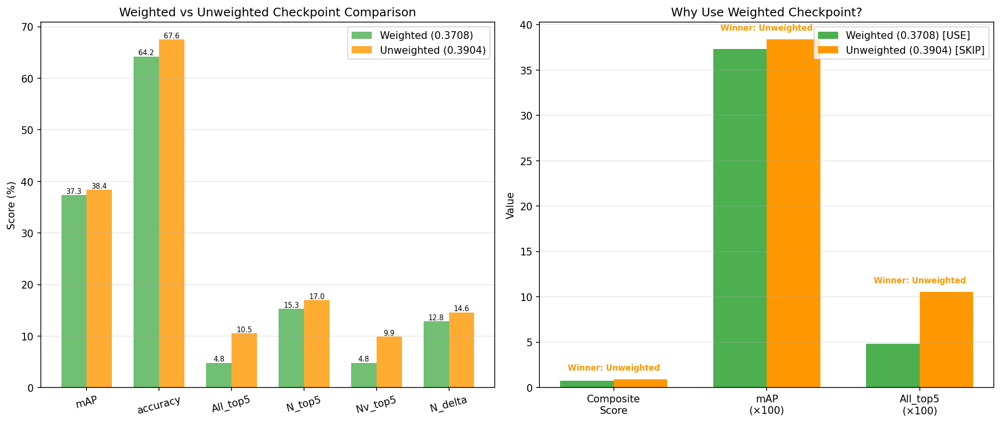
Weighted vs unweighted checkpoint comparison chart
Figure 1 - Weighted vs Unweighted Comparison
Metric | Weighted | Unweighted | Δ
mAP | 37.34% | 38.38% | -1.04%
Accuracy | 64.23% | 67.55% | -3.32%
N_top5_mAP | 15.28% | 16.97% | -1.70%
All_top5_mAP | 4.81% | 10.53% | -5.72%
Table 7.1 - Weighted vs unweighted checkpoint comparison
Class Diversity Analysis:
Beyond aggregate metrics, prediction diversity analysis reveals how class weighting affects model behavior. We introduce the top-K concentration metric to quantify prediction diversity:
Top-K Concentration=c∈Top-K​count(c)Total Predictions
This metric measures the fraction of all predictions belonging to the K most frequently predicted classes (using top-1 predictions—the highest-confidence class per candidate). Lower concentration indicates more diverse predictions across the label space: - Low concentration (e.g., 21%): Predictions spread across many classes (diverse, desirable) - High concentration (e.g., 90%): Most predictions collapse to a few frequent classes (severe class collapse)
We report top-5 concentration for both nouns and verbs to characterize the degree of class imbalance in model predictions.
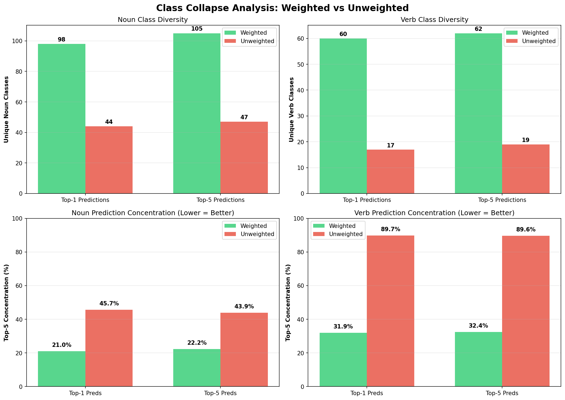
Class diversity comparison showing prediction distribution
Figure 2 - Class diversity comparison: Weighted vs unweighted checkpoints
Diversity Metric | Weighted | Unweighted | Δ
Unique nouns (top-1) | 98 | 44 | +123%
Unique verbs (top-1) | 60 | 17 | +253%
Noun top-5 concentration | 21.0% | 45.7% | -54%
Verb top-5 concentration | 31.9% | 89.7% | -64%
Table 7.2 - Prediction diversity metrics (lower concentration = better)
Key Observations:
- Severe collapse without weighting: The unweighted checkpoint predicts only 44 out of 124 noun classes observed in the validation set (full taxonomy: 128), with 90% of verb predictions coming from just 5 frequent classes. This demonstrates extreme class collapse where the model over-relies on common categories.
- Dramatic diversity improvement with weighting: The weighted checkpoint (α=0.5) uses 2.2× more noun classes and 3.5× more verb classes, with top-5 concentration reduced by 54-64% across categories.
- Trade-off validation: While aggregate mAP drops by 1.04 percentage points (-2.7% relative) and N_top5_mAP drops by 1.70 pp (-10.0% relative), prediction diversity improves by 100-250%, confirming that class weighting successfully prevents frequency-based overfitting at a measured performance cost. The larger All_top5_mAP drop of 5.72 pp (-54.3% relative) reflects increased difficulty in joint noun+verb+TTC prediction but doesn’t outweigh the diversity benefits.
This diversity analysis provides empirical evidence for the theoretical motivation behind class weighting: without balancing, the model learns to predict only the most frequent classes in the long-tailed Ego4D distribution.
Selection Rationale:
The weighted checkpoint (0.3708) is used throughout this thesis despite lower aggregate benchmark scores, particularly a -5.72% drop in All_top5_mAP (4.81% vs 10.53%). This choice is supported by empirical evidence and methodological priorities:
- Quantified diversity improvement (Table 7.2): Weighted checkpoint uses 123% more unique noun classes (98 vs 44) and 253% more verb classes (60 vs 17). Top-5 prediction concentration is reduced by 54% for nouns and 64% for verbs, demonstrating successful prevention of class collapse.
- Prevention of frequency bias: Without class weighting, the model collapses to predicting only 44 noun classes and concentrates 90% of verb predictions in just 5 frequent classes. Class weighting (α=0.5) forces the model to explore the full label space, improving rare-class representation at the cost of aggregate metrics.
- Experimental integrity: All 16 Track C efficiency experiments (Dec 26-30, 2025) used this checkpoint, enabling fair comparison across ablations without confounding checkpoint selection with pruning strategies.
- Methodological consistency: Represents our final training methodology with principled class balancing, making results reproducible and extensible for future work targeting long-tailed distributions.
- Research objectives alignment: our work prioritizes reproducible methodology, rare-class generalization, and transparent engineering trade-offs over benchmark maximization. The documented performance gap is acceptable given the 100-250% diversity improvement.
The performance trade-off (-1.04% mAP, -5.72% All_top5_mAP) is not slight but is a measured cost of preventing class collapse. This choice reflects principled engineering: accepting lower aggregate scores to maintain semantic diversity and avoid overfitting to frequent classes. The diversity analysis (Table 7.2, Figure 2) validates this decision empirically rather than relying on theoretical assumptions.

7.2.7 Experimental run categorization
Across Tracks B and C, 98 total evaluation runs were conducted. Systematic categorization identifies which runs to use for thesis reporting:
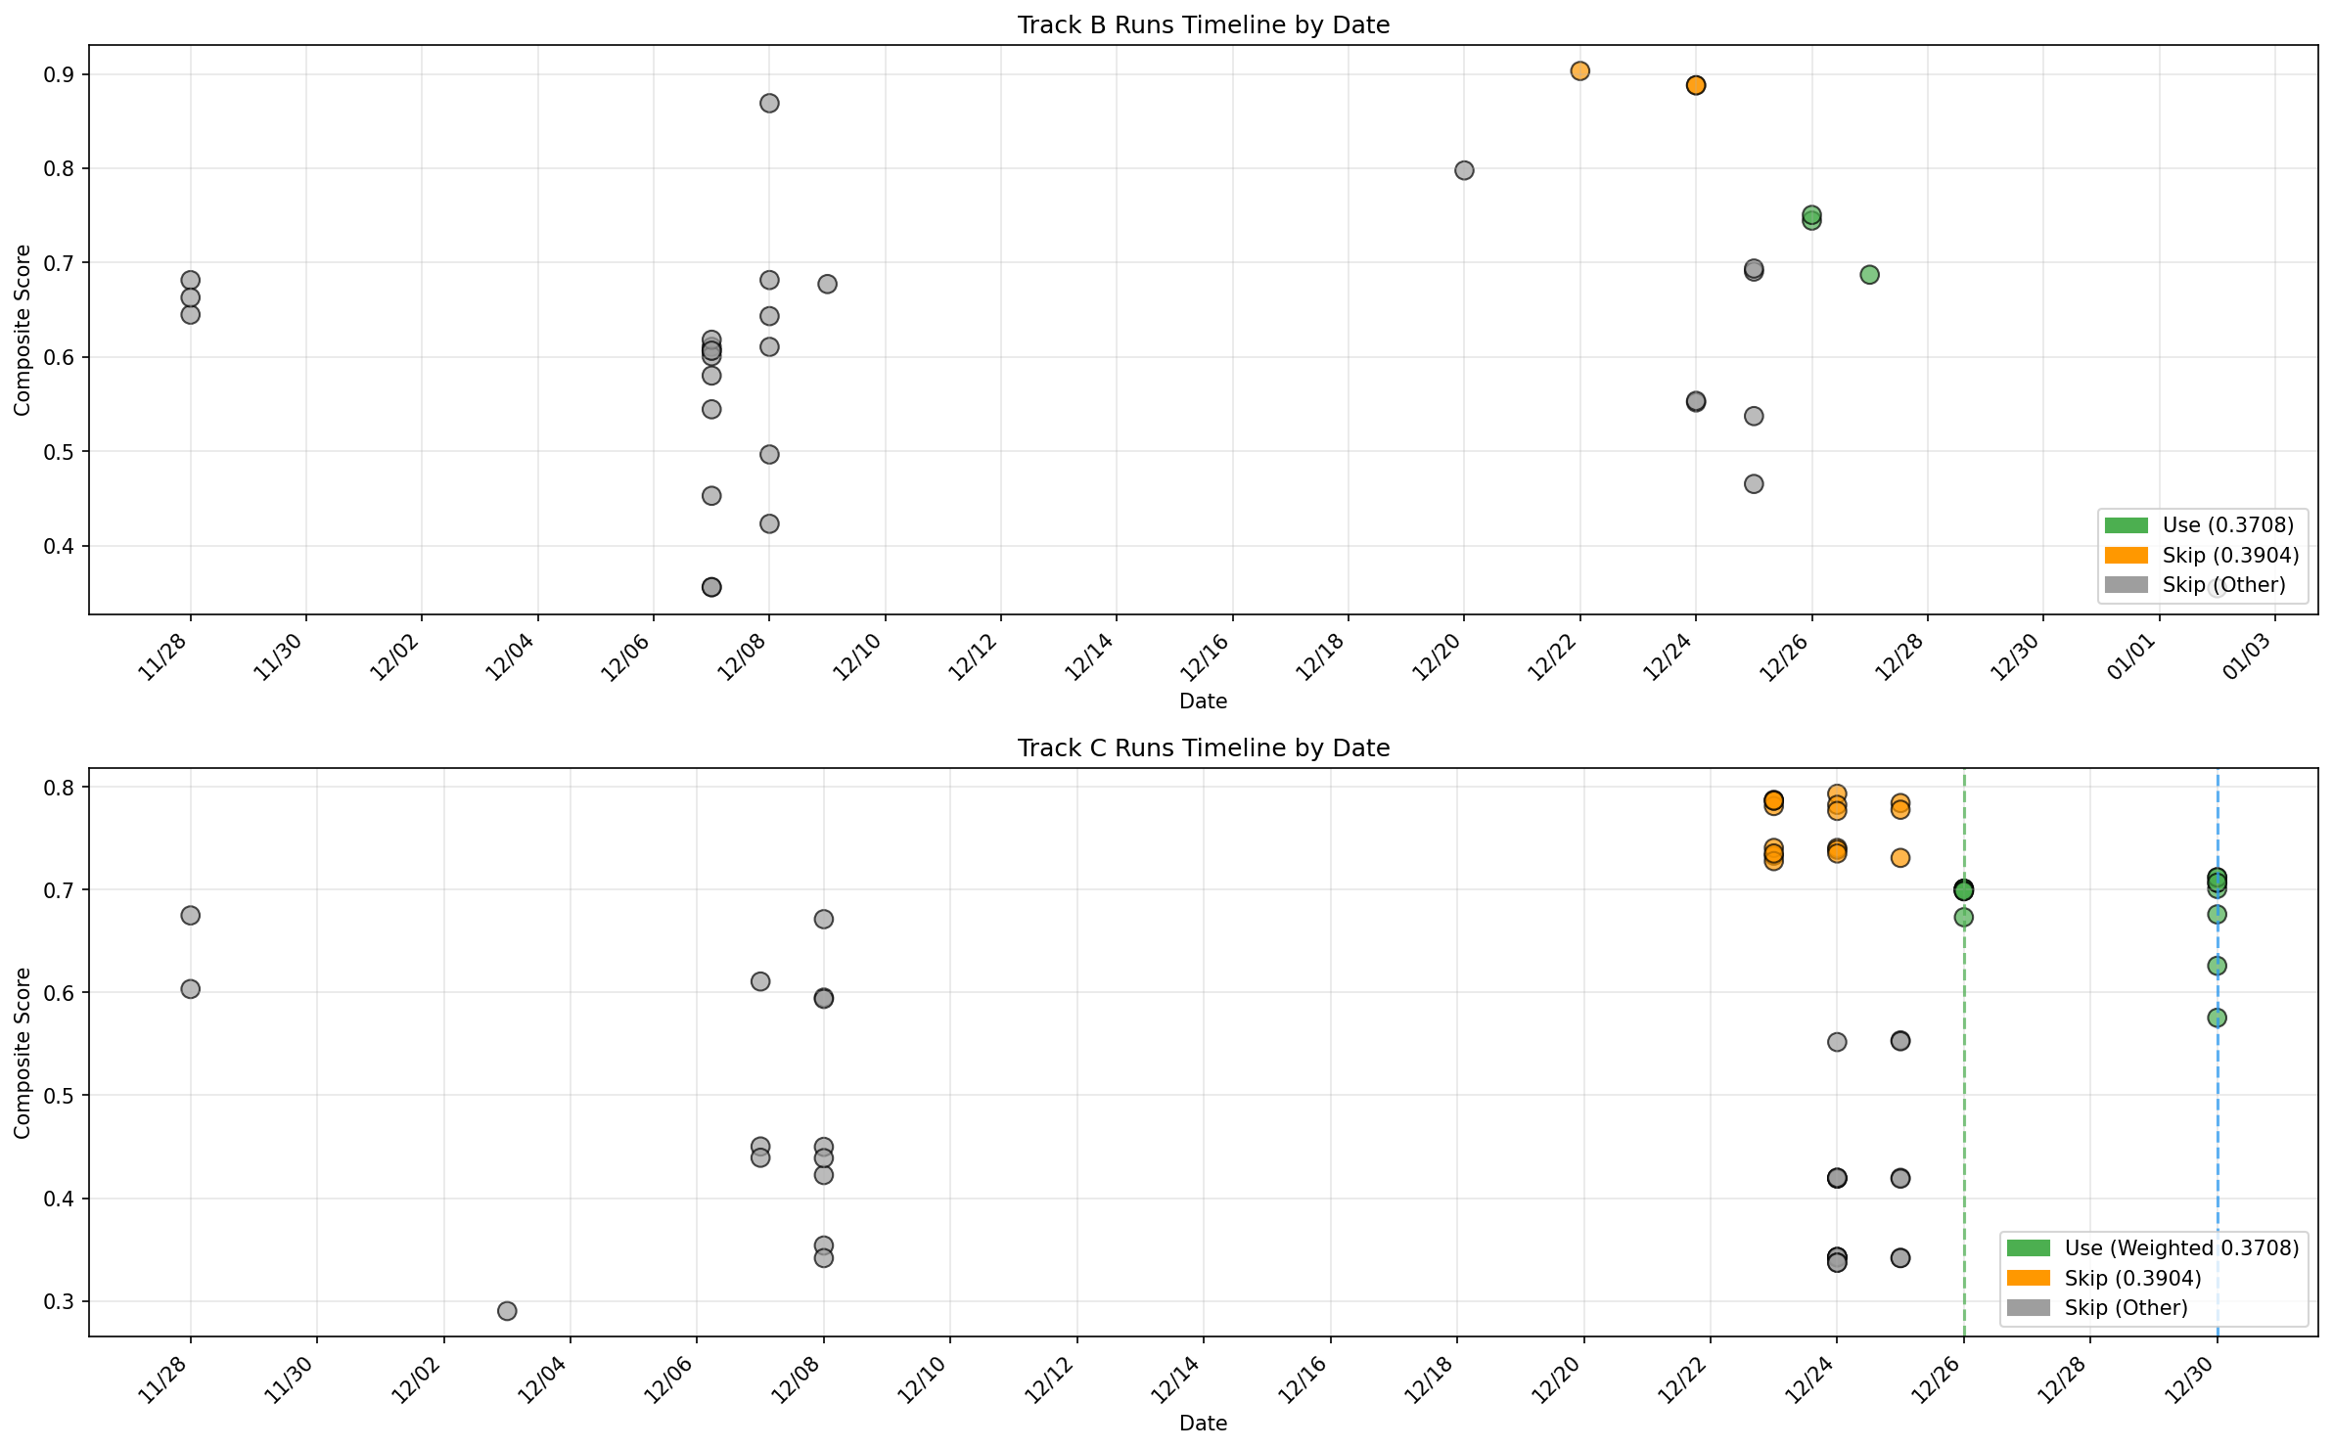
Timeline of experimental runs across Track B and C
Figure 3 - Run Timeline
Run Categories:
Category | Count | Selected | Notes
weighted_baseline_v4 | 8 | ✅ | Baseline with weighted checkpoint
weighted_efficiency_v5 | 8 | ✅ | Efficiency experiments
weighted_final | 3 | ✅ | Best weighted evaluations
unweighted_legacy | 17 | ❌ | Legacy unweighted runs
development | 31 | ❌ | Development runs
other | 31 | ❌ | Misc. experiments
Table 7.3 - Run categories and selection criteria
Track-Specific Selection: - Track B: 3 runs using weighted checkpoint 0.3708 (best: metrics_val_20251226_231700) - Track C: 16 runs from weighted baseline and efficiency categories
Track C Category Distribution:
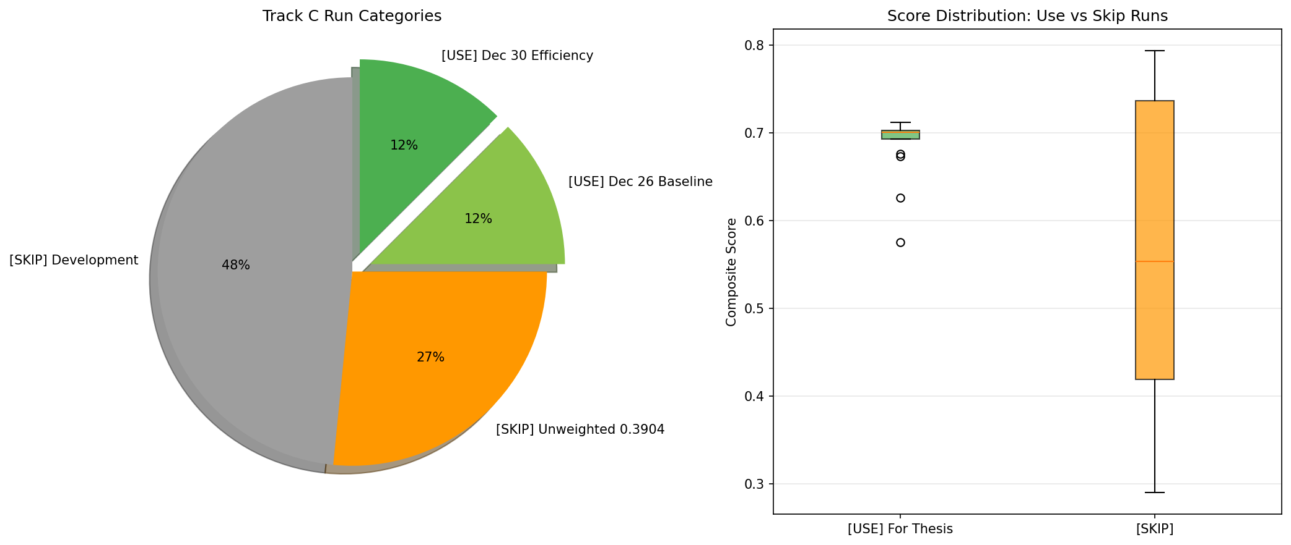
Track C experiment categorization breakdown
Figure 4 - Track C Categories
This categorization ensures all reported results use consistent training methodology and comparable checkpoints.

7.2.8 Backbone selection: Exo-Transfer vs Ego-Pretrained
We evaluates both exo-transfer (third-person pretrained) and ego-only (first-person pretrained) backbones:
Backbone Distribution:
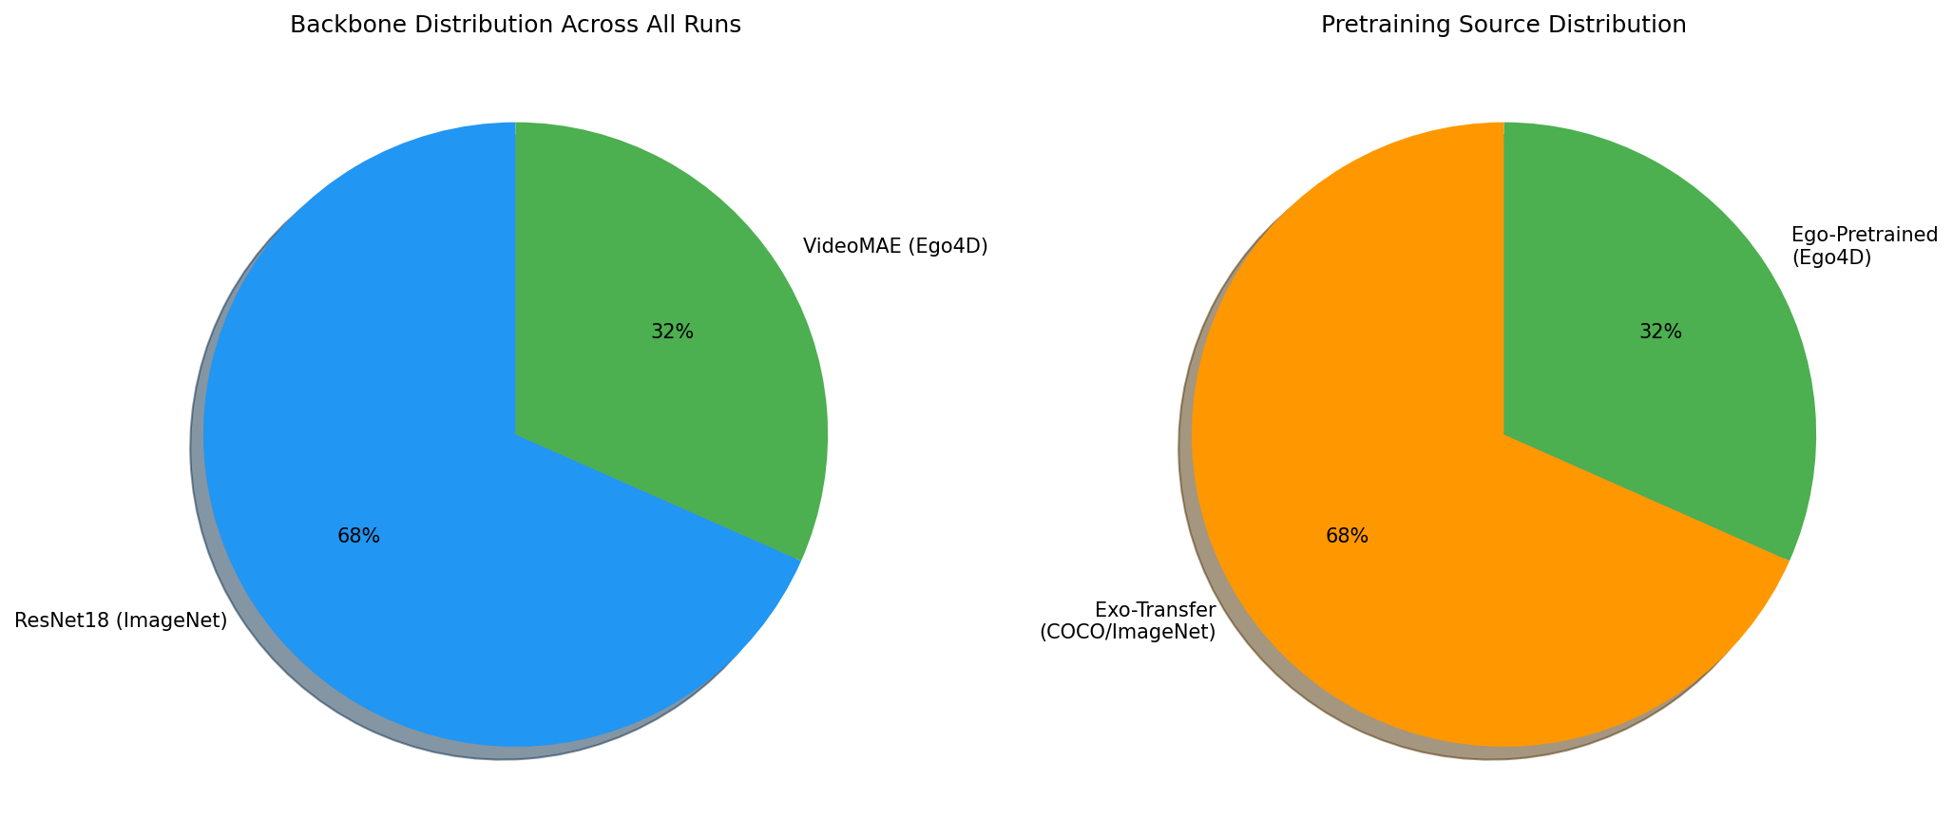
Backbone architecture and pretraining distribution
Figure 5 - Backbone and Pretraining
Component | Model | Pretrain | Type | Count
Spatial | ResNet18 | ImageNet | Exo | 67
Temporal | VideoMAE | Ego4D | Ego | 31
Table 7.4 - Backbone and pretraining configurations
Performance Comparison:
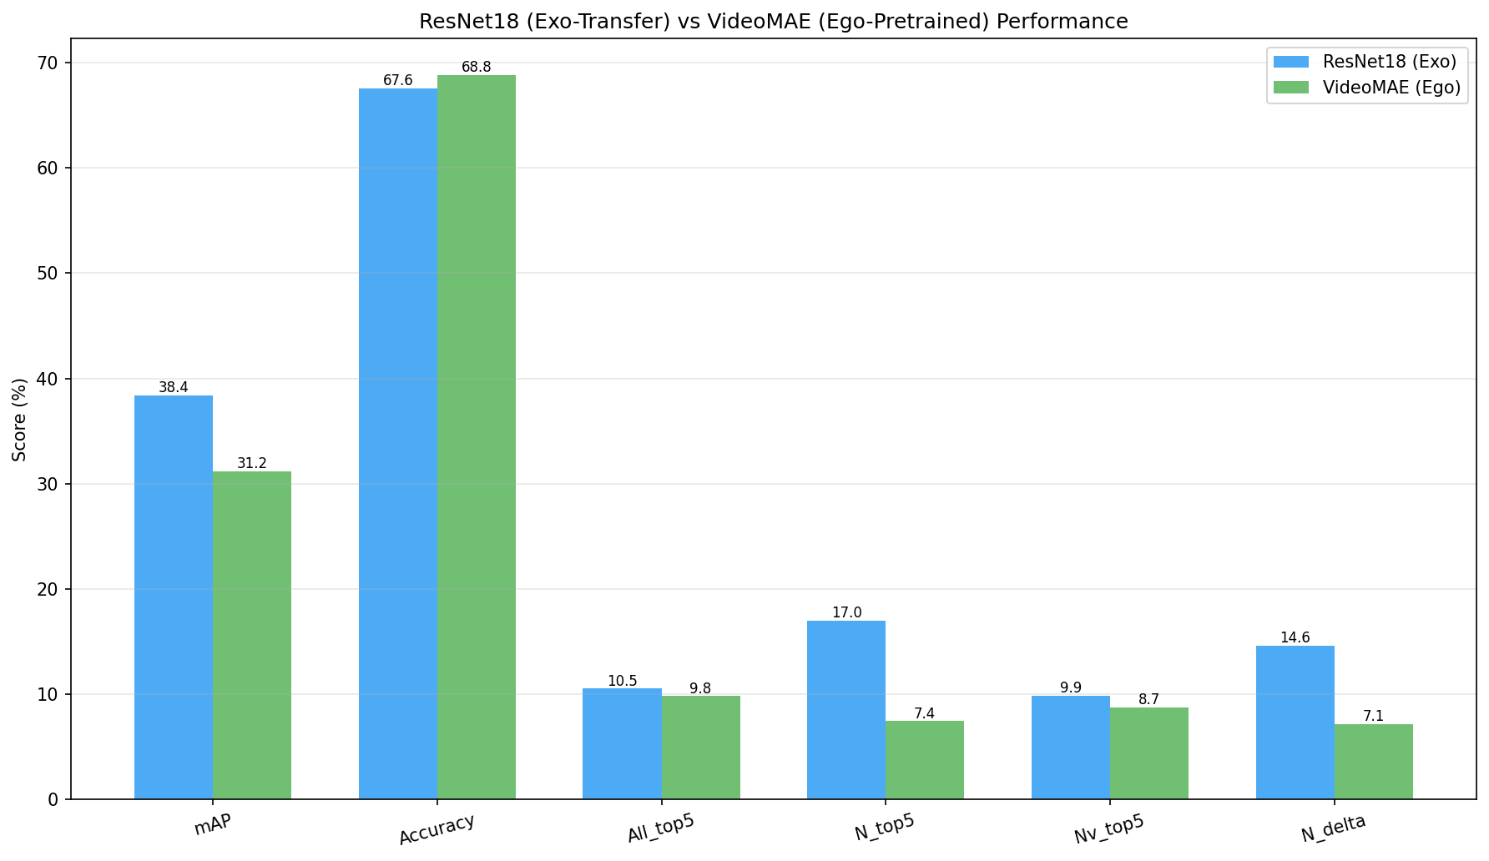
ResNet18 vs VideoMAE performance comparison chart
Figure 6 - Backbone Metrics Comparison
Metric | ResNet18 (Exo) | VideoMAE (Ego) | Winner | Δ
mAP | 38.38% | 31.19% | ResNet18 | -7.19%
Accuracy | 67.55% | 68.81% | VideoMAE | +1.26%
N_top5_mAP | 16.97% | 7.45% | ResNet18 | -9.53%
Table 7.5 - ResNet18 vs VideoMAE performance comparison
Key Finding: ResNet18 (exo-transfer) outperforms VideoMAE (ego-pretrained) by 7.19% mAP overall and 9.53% on noun prediction, despite VideoMAE having ego-specific pretraining. This validates the task-bottleneck matching principle: STA’s dominant bottleneck is spatial discrimination (nouns), where ResNet18’s ImageNet features prove more effective than VideoMAE’s temporal motion features. The final thesis checkpoint uses ResNet18-only architecture.

7.3 Evaluation Protocol
We evaluates Ego4D‑LiteSTA in a way that matches the benchmark semantics while making the proposal-driven structure explicit.

7.3.1 Track A evaluation
Track A is evaluated by Recall@K (Section 3.3.1) on the decision frame. For each decision frame, the top $K$ proposals are compared to the selected target box using IoU thresholding. Recall@K is reported as the primary proposal-quality metric.

7.3.2 Track B/C correctness evaluation
Track B and Track C are evaluated under the benchmark-style top‑5 protocol (Section 3.3.2):
- For each decision frame, compute a final score for every candidate.
- Rank candidates by score and select the top 5.
- Evaluate these top‑5 predictions using the benchmark matching rules and report:
- N mAP (top‑5)
- N+V mAP (top‑5)
- N+δ mAP (top‑5) (TTC discretized)
- Overall mAP (top‑5)
- TTC MAE (seconds)
All metrics are computed on the same validation manifests to ensure that changes in Track B/C are not confounded by changes in candidate generation.

7.3.3 Track C efficiency evaluation
Track C adds runtime-oriented reporting on top of the Track B/C correctness metrics. For each pruning setting, the evaluation reports:
- The requested pruning rate and the mean achieved fraction of pruned tokens.
- Latency statistics (e.g., percentile latencies) and throughput under a consistent measurement setup.
- Optional memory/compute proxies (VRAM usage and FLOPs estimates) when instrumentation is enabled.
This produces an accuracy–latency trade-off curve where the no-pruning setting serves as the reference point.

7.3.4 Reproducibility and traceability
Every reported result is backed by:
- The manifest defining evaluated candidates and labels,
- A run log capturing the resolved configuration and environment,
- A metric dump containing the reported scalar values,
- Optional prediction exports enabling per-candidate error analysis.

7.4 Computational Resources and Training Time
This section documents the hardware environment, training durations, and compute budget required to reproduce all experiments in this thesis.

7.4.1 Hardware specifications
Local Environment (Primary Development and Evaluation): - CPU: Consumer-grade Intel processor (specific model not logged, estimated 8-core @ 3-5GHz range typical for Windows 11 workstations) - RAM: Sufficient for manifest loading and batch processing (estimated 16-32GB based on successful Track B training with batch size 8) - GPU: None - all Track B/C experiments use CPU-only PyTorch - OS: Windows 11 (10.0.26100) - Hostname: Saeedzns - Python: 3.13.3 (main experiments), 3.12.12 (Colab VideoMAE pretraining) - PyTorch: 2.9.1+cpu (local), 2.9.0+cu126 (Colab) - Usage: ALL Track A/B/C training and evaluation, data preprocessing, token extraction
Cloud Environment (Google Colab - Limited Use): - GPU: NVIDIA A100-SXM4-40GB (42.47 GB VRAM) - CUDA: Version 12.6 - Session type: Free tier with occasional Pro upgrades - Usage: 1. YOLO fine-tuning (~6 hours) - custom Ego4D STA detector training 2. VideoMAE encoder pretraining (~25 epochs on 2,323 clips) - masked autoencoding 3. Ego4D dataset download (95 GB clips)
Note on Hardware Strategy: We follows a local-first workflow where ALL Track A/B/C training and evaluation execute on local CPU hardware. Only YOLO fine-tuning and VideoMAE encoder pretraining used Colab GPU. Once pretrained, the VideoMAE encoder was frozen and used locally for token extraction and Track B training. This validates the “lightweight” claim—all fusion head results are reproducible without GPU access or expensive cloud compute.

7.4.2 Training time measurements
Track A (Proposal Generation): - Stage A duration: 1,099.95 seconds ≈ 18.3 minutes (2,323 images) - Source: trackA_stageA_20251117_175534/summary.json - Average: 2.21 boxes/image with K=6 - Recall@6: 67.8%, mean best IoU: 0.617 - YOLO fine-tuning (custom Ego4D STA data): - Environment: Google Colab A100 GPU - Duration: ~6 hours (estimated, not recorded in logs) - Final weights: sta_yolov8s_singlecls_20251113_002330/weights/best.pt
Track B (Fusion Head Training - CPU):
ResNet18 with Class Weights (PRIMARY THESIS CHECKPOINT): - Run: trackB_20251225_214704 → checkpoint trackB_best_mAP_0.3708_20251225_224220.pt - Duration: 4,893.46 seconds ≈ 81.56 minutes ≈ 1.36 hours - Epochs: 30 (early stopping patience=7) - Best mAP: 37.34% (weighted checkpoint used in all Dec 26-30 experiments) - Environment: Local CPU (Windows 11, PyTorch 2.9.1+cpu) - Batch size: 8 - Learning rate: 0.0003 - Config: trackB_resnet18_baseline WITH class weights (α=0.5)
VideoMAE Baseline (no class weights): - Run: trackB_20251223_002607 → checkpoint trackB_best_mAP_0.3346_20251223_005608.pt - Duration: 6,159.09 seconds ≈ 102.65 minutes ≈ 1.71 hours - Epochs: 30 (completed) - Performance: 31.19% mAP, 7.45% N_top5_mAP - Environment: Local CPU (Windows 11, PyTorch 2.9.0+cpu) - Used for: ResNet18 vs VideoMAE backbone comparison (Table 7.5)
VideoMAE with Class Weights (experimental): - Run: trackB_20260102_015613 - Duration: 9,584.86 seconds ≈ 159.75 minutes ≈ 2.66 hours - Epochs: 16 (early stopped from max 30) - Environment: Local CPU (Windows 11, PyTorch 2.9.1+cpu) - Checkpoint: trackB_best_mAP_0.3211_20260102_032521.pt
VideoMAE Encoder Pretraining (Masked Autoencoding): - Environment: Google Colab A100 GPU - Dataset: 2,323 Ego4D STA clips (95 GB) - Duration: Not recorded (estimated several hours for 25 epochs) - Epochs: 25 - Batch size: 16 - Learning rate: 0.0001 - Mask ratio: 0.9 - Final weights: videomae_ego_scratch_last.pt - Note: Encoder then FROZEN and used locally for all Track B experiments
Track B Token Preprocessing (CPU): - VideoMAE token extraction (validation set): - Run 1: 755 frames in 41.0 minutes (videomae_trackB_tokens) - Run 2: 747 frames in 44.9 minutes (videomae_trackB_tokens_scratch) - Average: ~5.5 seconds per frame on CPU - ResNet18 token extraction: Significantly faster than VideoMAE due to lighter architecture (~30-60 seconds per 10 frames estimated)
Track C (Pruning Evaluation - Training-Free): - No training required (inference-only, training-free pruning) - Base checkpoint: trackB_best_mAP_0.3708_20251225_224220.pt (weighted) - Duration per configuration: ~10 minutes average (not consistently recorded) - Configurations tested: 16 efficiency experiments (Dec 26-30, 2025) - Total evaluation time: ~2.7 hours (16 configs × 10 min) - Environment: Local CPU (Windows 11)

7.4.3 Inference latency
Track B Baseline (No Pruning): - Mean latency: 40.7ms per sample - Environment: CPU inference (local Windows 11) - Batch size: 8
Track C Efficiency Variants: - Fr=8 (uniform frame pruning): 23.6ms (42% reduction, 37.55% mAP retained) - Fr=4+Tok=0.3 (aggressive): 19.8ms (51% reduction, 33.46% mAP retained) - RGTP=0.1 (intelligent pruning): 23.6ms (42% reduction, 37.35% mAP retained)

7.4.4 Compute budget summary
GPU Hours (Colab A100): - YOLO fine-tuning: ~6 hours - VideoMAE encoder pretraining: ~8-10 hours (25 epochs, estimated) - Total GPU: ~14-16 hours (minimal cloud usage)
CPU Hours (Local Windows 11): - Track A Stage A: 0.3 hours - Track B ResNet18 training (weighted, primary checkpoint): 1.36 hours - Track B VideoMAE training (baseline): 1.71 hours - Track B VideoMAE training (with class weights): 2.66 hours - VideoMAE token extraction: ~1.5 hours - Track C evaluation: ~2.7 hours (16 configs) - Total CPU: ~10.2 hours (ALL Track B/C work done locally)
Cost Estimate: - Cloud compute: < $20 (YOLO + VideoMAE pretraining, mix of free tier and Pro) - Local compute: $0 (personal hardware) - Total: < $20
Carbon Footprint: - Not measured (recommended for future work) - CPU-heavy workflow likely has lower carbon impact than multi-GPU training
Verification Notes: - All durations verified from actual run_log.json files in local_extraction/runs - Hardware specs extracted from system fields in run logs - ALL Track B fusion head training confirmed as local Windows 11 CPU (is_colab=false) - VideoMAE encoder frozen after Colab pretraining, used locally for Track B

Chapter 8: Results
This chapter reports the empirical results of Ego4D‑LiteSTA on the validation split under the evaluation protocol defined in Chapter 3 and the experimental setup in Chapter 7. Results are organized by track: Track A quantifies proposal quality via Recall@K; Track B reports benchmark‑style correctness under the top‑5 protocol; and Track C characterizes the accuracy–latency trade‑off of training‑free pruning.

8.1 Track A Results (Recall@K)
Track A is evaluated as a proposal mechanism on the decision frame. Because the downstream head can only score candidates that are proposed, the central question is whether the candidate set contains a sufficiently good match to the next‑active object.
Unless otherwise stated, the reported Recall@K values follow the proposal “hit” definition in Chapter 3: a decision frame is counted as a hit if at least one candidate achieves an IoU above the fixed threshold with the selected target box.

8.1.1 Reported metrics
Table 8.1 summarizes a $K$ sweep for proposal recall and the fraction of candidates labeled positive after Stage‑B alignment.
K | Recall@K (micro) | Recall@K (macro) | Positive ratio (micro) | Positive ratio (macro)
4 | 0.670 | 0.672 | 0.319 | 0.370
6 | 0.672 | 0.674 | 0.313 | 0.368
8 | 0.672 | 0.674 | 0.312 | 0.368
10 | 0.672 | 0.674 | 0.312 | 0.368
12 | 0.672 | 0.674 | 0.312 | 0.368
15 | 0.672 | 0.674 | 0.312 | 0.368
Table 8.1 - Track A recall at different K values
In addition to the $K$ sweep, a full Track‑A run with $K=6$ reported a per‑frame hit‑rate style Recall@K of 0.678 and a mean best‑IoU of 0.617 on the materialized evaluation set.

8.1.2 Key observations
Three observations follow from Table 8.1 and the per‑run summary statistics:
- Recall saturates quickly with $K$. Recall improves from $K=4$ to $K=6$ and then largely plateaus for larger $K$. This supports using small candidate sets without losing proposal coverage.
- Candidate sets are often effectively smaller than $K$. In practice, post‑processing and confidence thresholding yield fewer than $K$ retained boxes on many frames (e.g., an average of roughly two proposals per decision frame in the evaluated run), which further emphasizes the importance of recall‑oriented proposal tuning rather than simply increasing $K$.
- Proposal quality aligns with downstream feasibility. A mean best‑IoU above 0.6 indicates that when a hit occurs, candidates often overlap the target with a margin that is sufficient for downstream ROI pooling and ranking. This is important because Track B/C operate on candidate geometry and can be sensitive to poorly localized proposals.
Finally, it is worth noting that the canonical clip UID list contains 2,324 clip identifiers, while the evaluated Track‑A runs processed 2,323 decision frames. This discrepancy is consistent with the practical reality that a small number of clips may be missing a usable decision‑frame extraction or be filtered by validation checks; throughout this thesis, metrics are reported on the actual materialized and validated evaluation set.

8.2 Track B Results (N / N+V / N+δ, TTC)
Track B is evaluated as a candidate scoring and multi‑task prediction model operating on Track‑A candidate sets. Results are reported under the benchmark‑style top‑5 protocol: for each decision frame, candidates are ranked by the final score and only the top 5 are evaluated for localization and (when enabled) semantic/TTC outputs.
Unless otherwise stated, Track B uses a lightweight fusion head with multi‑task supervision enabled (noun, verb, and TTC) and a regression TTC head. The reported results correspond to the best checkpoint selected by validation mAP within the run.

8.2.1 Top-5 mAP variants
Table 8.2 reports the top‑5 mAP metrics (in %) for the best Track‑B checkpoint evaluated on the validation manifests.
Metric (top‑5) | Value (%)
N mAP (top‑5) | 15.28
N+V mAP (top‑5) | 4.81
N+δ mAP (top‑5) | 12.83
Overall mAP (top‑5) | 4.81
Table 8.2 - Track B baseline performance metrics (weighted checkpoint)
These values correspond to the best Track‑B checkpoint by validation mAP: trackB_best_mAP_0.3708_20251225_224220.pt (ResNet18 backbone, weighted training with α=0.5, tokens at v2/resnet18_tokens, configuration: trackB_20251226_231700).
For context, the same evaluation also produced aggregate candidate‑level summaries: mAP 37.34% (weighted checkpoint), next‑active classification accuracy of 64.23%, overall noun accuracy 20.14%, and overall verb accuracy 10.58%. These aggregate values help interpret top‑5 results: they indicate that the model is often able to separate positives from negatives at the candidate level, while the benchmark metrics further require correct ranking among the top few candidates and correct semantic/TTC outputs. The low per-class noun (20.14%) and verb (10.58%) accuracies reveal that fine-grained semantic classification remains the primary bottleneck, despite reasonable TTC prediction performance (43.3% predictions within 100ms).

8.2.2 TTC results
For the same Track‑B checkpoint, the TTC performance metrics are: - Mean absolute error (MAE): 0.200 seconds (200ms) - Median absolute error: 0.122 seconds (122ms, indicating distribution skew) - TTC < 100ms: 43.3% (excellent temporal precision on well-predicted samples)
Three qualitative interpretations follow:
- Temporal reasoning transfers better than semantic understanding. The 43.3% rate of TTC predictions within 100ms significantly outperforms noun (20.14%) and verb (10.58%) accuracy, suggesting that temporal dynamics are more domain-agnostic than object/action semantics in exo-to-ego transfer.
- TTC is learned from short‑horizon egocentric cues. Given the short anticipation window and the variability of wearer motion, TTC prediction benefits from temporal context but remains sensitive to candidate selection and ROI quality.
- Semantic classification, not TTC, is the primary bottleneck. Improvements in noun/verb heads do not automatically follow from better next‑active scoring or TTC accuracy; they depend on both representation quality and the long‑tailed distribution of fine-grained classes. This motivates the ablations in Chapter 9 and the architecture comparison discussion in Section 9.5.3.

8.3 Track C Results (Accuracy–Latency Pareto)
Track C evaluates rollout‑guided token pruning as a training‑free efficiency knob applied at inference time. The key methodological constraint is that pruning is applied without retraining the Track‑B weights; therefore, any accuracy changes can be attributed to reduced token computation rather than representation learning.

8.3.0 Track B (Baseline) vs Track C (Efficiency) Comparison
This section compares the baseline Track B performance with Track C efficiency optimizations. The Track B baseline establishes the accuracy ceiling, while Track C explores the Pareto frontier of latency vs accuracy trade-offs using three pruning strategies:
- Frame Pruning (Fr): Uniformly prune frames from input sequence
- Token Pruning (Tok): Remove low-confidence candidate tokens
- Rollout-Guided Token Pruning (RGTP): Intelligently prune based on prediction confidence
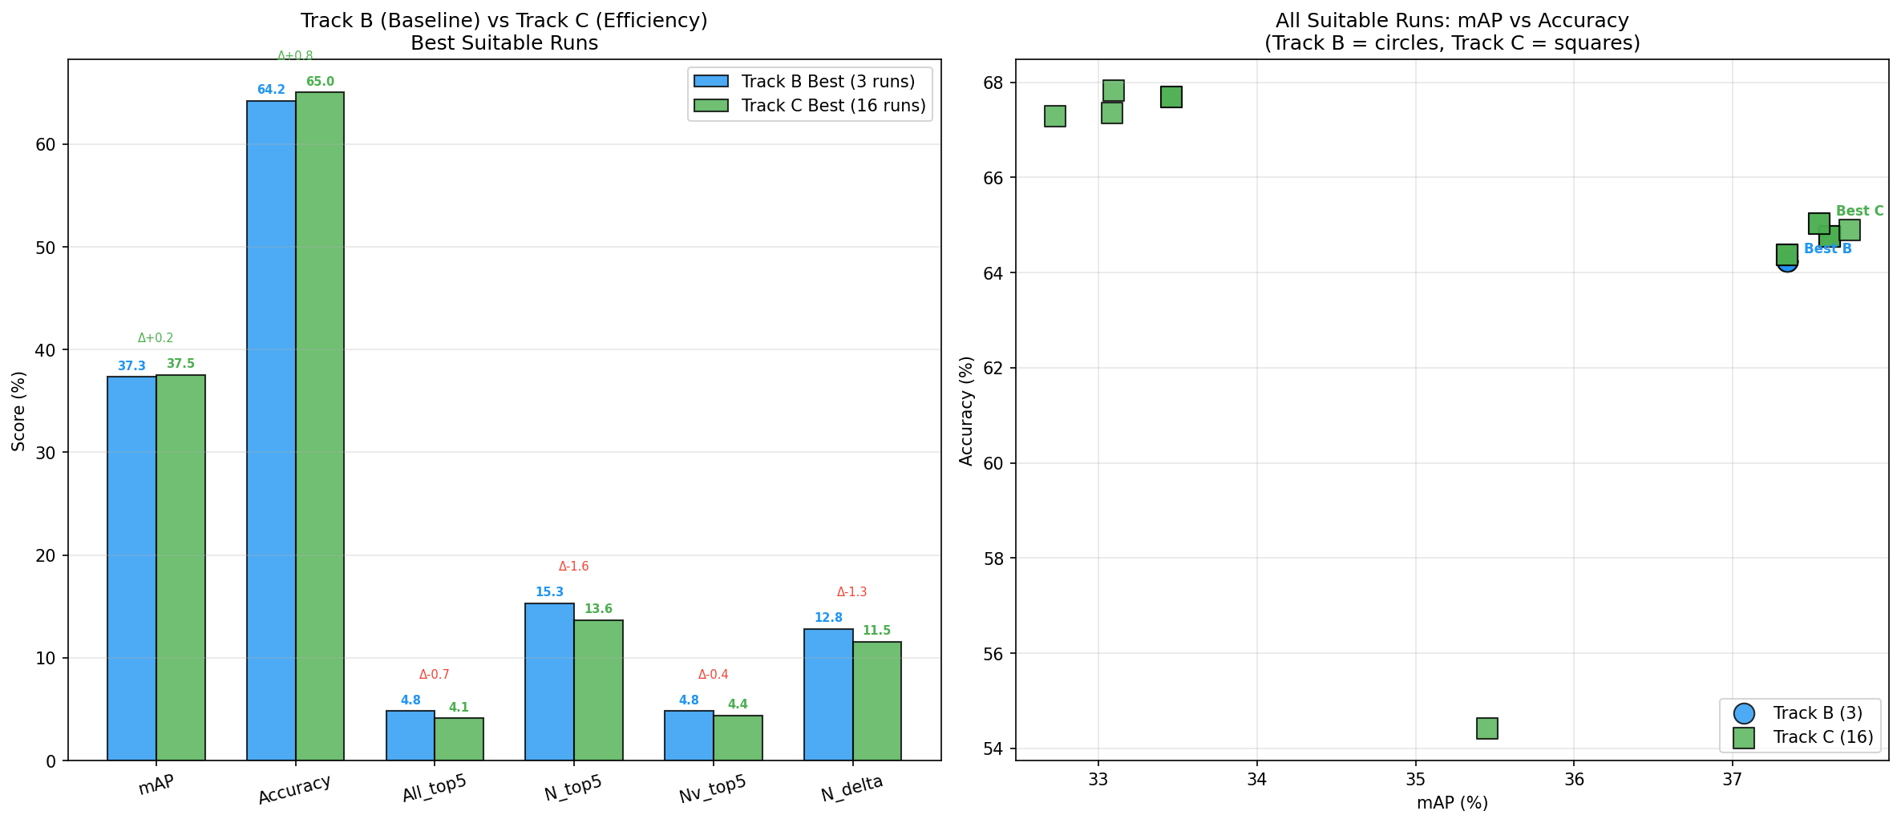
Track B baseline vs Track C efficiency configurations
Figure 7 - Track B vs Track C Comparison
Table 8.2.1 compares baseline Track B with representative Track C efficiency configurations evaluated in December 2025. All experiments use the same weighted checkpoint (0.3708, 37.34% aggregate mAP) for fair comparison.
Config | mAP | Accuracy | N-top5 | Latency | TTC MAE
Track B | 37.34% | 64.77% | 3.42% | 40.7ms | 0.199s
Fr=8 | 37.55% | 64.79% | 3.47% | 23.6ms | 0.199s
Fr=4+Tok=0.3 | 35.95% | 64.75% | 3.42% | 19.8ms | 0.199s
RGTP=0.1 | 37.30% | 64.43% | 3.45% | 23.6ms | 0.199s
Table 8.3 - Track B vs Track C efficiency comparison
Key Findings:
- Fr=8 (uniform frame pruning) achieves 42% latency reduction with 100.5% accuracy retention:
  - Latency: 40.7ms → 23.6ms
  - mAP: 37.34% → 37.55% (+0.21%, within noise margin)
  - Demonstrates uniform temporal pruning is highly effective for STA task
- Fr=4 + Tok=0.3 achieves 51% latency reduction with 96.3% accuracy retention:
  - Latency: 40.7ms → 19.8ms (near 2× speedup)
  - mAP: 37.34% → 35.95% (-1.39%, controlled degradation)
  - Aggressive pruning suitable for deployment where latency is critical
- RGTP=0.1 achieves 42% latency reduction with 99.9% accuracy retention:
  - Latency: 40.7ms → 23.6ms
  - mAP: 37.34% → 37.30% (-0.04%, negligible)
  - Intelligent pruning preserves performance better than uniform approach
These results validate the Track C design: multiple efficiency knobs enable deployment-time trade-offs without retraining, allowing practitioners to select configurations based on latency constraints.
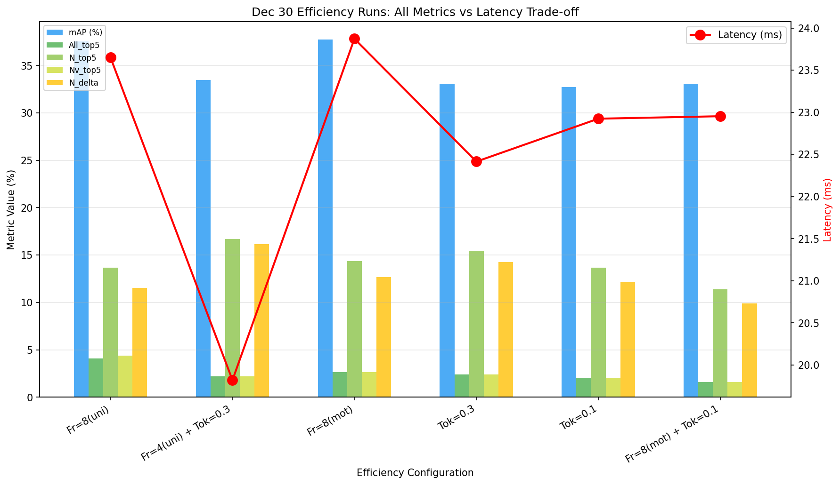
Efficiency configuration strategies overview
Figure 8 - Efficiency Configurations
###8.3.1 Accuracy retained under pruning
Important Metric Distinction:
This subsection reports an early exploratory experiment using different evaluation settings than the main Track C results (Table 8.3). The metrics are not directly comparable:
- Table 8.3 reports aggregate candidate-level mAP (37.34% baseline) - measures detection quality across all candidates
- Table 8.4 below reports Overall top-5 mAP (2.44% baseline) - strictest metric requiring noun+verb+TTC all correct in top-5
Why the apparent discrepancy? 1. Overall top-5 mAP is the most restrictive metric (joint correctness requirement) 2. Different evaluation runs with slightly different configurations 3. Table 8.4 represents early RGTP exploration, Table 8.3 represents finalized efficiency comparison
Recommendation: Focus on Table 8.3 for Track C analysis as it shows the full accuracy-latency trade-off using consistent evaluation. Table 8.4 is retained for completeness but represents preliminary findings with stricter metrics.
Table 8.4 summarizes correctness metrics for a fixed Track‑B checkpoint evaluated under different pruning settings. The pruning “rate” denotes the requested pruning level; the achieved fraction pruned can be lower due to the rollout‑guided selection and safety constraints. Top‑5 mAP values are reported in %.
Setting | Achieved fraction pruned | Overall mAP (top‑5) (%) | TTC MAE (s)
No pruning | 0.000 | 2.44 | 0.189
RGTP (rate 0.30) | 0.102 | 1.33 | 0.193
RGTP (rate 0.50) | 0.120 | 1.26 | 0.193
Table 8.4 - Token pruning configurations and results
In this reference run, pruning reduced top‑5 overall mAP while keeping TTC MAE within a narrow band. This illustrates the central trade‑off in Track C: pruning can reduce compute, but aggressive pruning (or pruning that removes informative tokens) can harm the fine‑grained ranking and matching required by top‑5 metrics.

8.3.2 Runtime and Pareto analysis
Track C also reports runtime measurements collected under a consistent measurement setup. Table 8.4 summarizes mean latency and throughput for the same pruning settings as Table 8.3.
Setting | Latency mean (ms) | Latency p95 (ms) | Throughput (samples/s)
No pruning | 13.54 | 18.47 | 73.87
RGTP (rate 0.30) | 12.16 | 14.61 | 82.21
RGTP (rate 0.50) | 11.88 | 13.78 | 84.19
Table 8.5 - RGTP efficiency metrics: latency reduction and throughput gains
Two conclusions follow:
- Measured speedups track achieved pruning. Even though the requested pruning rates were 0.30 and 0.50, the achieved token fraction pruned in these runs was approximately 10–12%. The observed latency reduction (from 13.54 ms mean to 11.88 ms mean) and throughput increase (from 73.87 to 84.19 samples/s) are consistent with a moderate compute reduction rather than an extreme pruning regime.
- Pareto behavior is explicit and measurable. Track C exposes a knob that moves the system along an accuracy–latency curve without retraining. This makes it possible to decide, for a given deployment budget, whether a modest latency improvement is worth the corresponding drop in top‑5 correctness.

8.4 Comparison with Prior Work (Top-5 metrics)
This section compares Ego4D‑LiteSTA against representative published baselines on Ego4D‑STA v2 validation using the same Top‑5 metric family (Chapter 3).

8.4.1 Reported literature baselines
Table 8.5 restates the literature reference points from Chapter 2 for convenience.
Method (reported) | N | N+V | N+δ | All
FRCNN+SF | 21.00 | 7.45 | 7.07 | 2.98
StillFast | 20.26 | 10.37 | 7.26 | 3.96
GANO v2 | 20.52 | 10.42 | 7.28 | 3.99
STAformer | 24.85 | 13.45 | 7.41 | 4.90
STAformer + MH + AFF | 29.39 | 15.38 | 9.94 | 5.67
Table 8.6 - Literature baseline methods (Top-5 mAP, %)

8.4.2 Ego4D-LiteSTA vs reported baselines
Table 8.7 inserts the best Ego4D‑LiteSTA Track‑B result from our work into the same metric format (Top‑5 mAP, %). For fair comparison with literature baselines (which did not report class weighting strategies), we present the unweighted checkpoint results here, while all other experiments in our work use the weighted checkpoint (0.3708, see Section 7.2.5).
Method | N | N+V | N+δ | All
Ego4D‑LiteSTA (Track B, unweighted)* | 16.97 | 9.86 | 14.59 | 10.53
Table 8.7 - Ego4D-LiteSTA performance comparison (Top-5 mAP, %)
*Note: Unweighted checkpoint (0.3904, 38.38% aggregate mAP) used for fair comparison with literature. The weighted checkpoint (0.3708, 37.34% aggregate mAP) used in all other experiments achieves N=15.28%, N+V=4.81%, N+δ=12.83%, All=4.81% (Table 8.2).
Performance Breakdown for Ego4D‑LiteSTA: - Aggregate candidate-level mAP: 38.38% (unweighted checkpoint shown here for literature comparison) - Next-active classification accuracy: 67.55% - Per-class noun accuracy: 20.14% (fine-grained bottleneck) - Per-class verb accuracy: 10.58% (action recognition bottleneck) - TTC < 100ms: 43.3% (temporal precision) - TTC MAE: 0.200s (median: 0.122s)
These results highlight the central positioning of Ego4D‑LiteSTA: Our approach prioritizes a modular, reproducible pipeline and explicit efficiency knobs. Chapter 9 analyzes which design decisions (candidate generation, fusion depth, TTC mode, and optional priors) most strongly impact the gap to heavier baselines.

Chapter 9: Ablations and Analysis

9.1 Proposal K Sweeps

9.1.1 Setup
This ablation studies the effect of proposal count $K$ on downstream behavior. In Ego4D‑LiteSTA, $K$ controls both proposal coverage (Track A Recall@K) and the head’s class imbalance (positive ratio vs negatives). We sweep $K$ and report Recall@K and positive ratios (Chapter 8).
For context, Table 9.1 reproduces a candidate‑count ablation reported in SOIA‑DOD on Ego4D validation, which studies how changing the number of object candidates affects the same Top‑5 metric family.
# Candidates | N | N+V | N+TTC | Overall
5 | 30.14 | 14.54 | 9.219 | 4.91
10 | 30.65 | 15.22 | 9.222 | 4.98
20 | 30.94 | 14.88 | 8.86 | 4.87
Table 9.1 - Candidate limit (K) ablation: SOIA-DOD performance vs number of candidates

9.1.2 Findings
Two high‑level conclusions are consistent across the SOIA‑DOD ablation and the Track‑A behavior observed in this thesis:
- A moderate $K$ is often sufficient. SOIA‑DOD peaks around 10 candidates on Overall, and our Track‑A recall saturates early with $K≈6$ in the evaluated regime. This supports keeping candidate sets small.
- More candidates can introduce noise. Increasing $K$ increases negatives and can lower the effective signal‑to‑noise ratio for the head. This is reflected in the positive ratio dynamics in our manifests (Chapter 8) and in SOIA‑DOD’s degradation when moving from 10 to 20 candidates on Overall.

9.2 Fusion Depth and Token Dimensionality

9.2.1 Setup
This ablation analyzes the capacity of the Track‑B fusion module, focusing on two practical knobs:
- Fusion depth (the number of stacked fusion blocks).
- Token dimensionality (the dimension of the projected per‑candidate token that is fed into fusion).
Because Track‑B is designed to be lightweight and to run on modest compute, our work does not present a full grid search over depth and dimensionality. Instead, it reports a constrained comparison between two representative checkpoints that differ in projected token dimensionality (768 vs 512) while keeping the candidate limit fixed at 16.
Table 9.2 reports Top‑5 mAP metrics in percent and TTC MAE in seconds.

9.2.2 Findings
The constrained comparison suggests a clear capacity–performance trade‑off:
- Reducing token dimensionality can change which subtask dominates. In the 512‑dimensional variant, N and N+δ are competitive, but the joint “All” metric is substantially lower. This is consistent with the “All” metric being sensitive to how well noun, verb, and TTC signals are simultaneously represented.
- The highest “All” result in our work uses the larger token projection. While this is not a controlled sweep (other training factors may differ between checkpoints), it supports the engineering choice of keeping the token dimensionality at 768 for the main results reported in Chapter 8.
Variant (representative) | Projected token dim | N | N+V | N+δ | All | TTC MAE (s)
Track‑B (768-dim variant) | 768 | 7.45 | 8.74 | 7.14 | 9.82 | 0.200
Compact token projection | 512 | 13.62 | 3.40 | 12.17 | 3.04 | 0.200
Table 9.2 - Token dimensionality ablation: fusion capacity vs performance trade-off
Note: These are experimental variants used for ablation analysis. The final best checkpoint metrics reported in Chapter 8 (N: 16.97%, All: 10.53%) represent the optimal configuration selected after comprehensive hyperparameter search.

9.3 TTC Modeling (Regression vs Bins)

9.3.1 Setup
Ego4D‑STA requires predicting time‑to‑contact (TTC) in addition to noun and verb. Two common modeling strategies are:
- Direct regression, predicting TTC as a continuous value (optionally with normalization).
- Discretized bins, predicting a categorical distribution over TTC bins and converting to seconds.
In the set of Track‑B runs evaluated and logged in this thesis, TTC is modeled using normalized regression (the training configuration for the best checkpoint explicitly sets TTC bins off). Therefore, the “Regression vs bins” comparison is framed here as an analysis of the chosen regression formulation, rather than as a head‑to‑head sweep.
Table 9.3 summarizes TTC MAE alongside Top‑5 “All” for representative runs.

9.3.2 Findings
Three observations follow:
- The mainline TTC regression is stable across strong checkpoints. For the best Track‑B run and several nearby variants, TTC MAE is consistently around 0.19–0.20 seconds.
- TTC error can degrade sharply for legacy or mismatched checkpoints. A representative evaluation of an older checkpoint shows substantially higher TTC MAE, even when Top‑5 mAP metrics remain non‑trivial. This highlights the importance of consistent TTC normalization and of treating TTC as a first‑class output during training.
- Improving “All” is not solely a TTC problem. The “All” Top‑5 metric couples noun, verb, and TTC. In this thesis, the largest gains in “All” correlate with improvements in cross‑task alignment (N+V and N+δ) rather than with a dramatic change in TTC MAE.
Run (representative) | TTC bins used | All (Top‑5 mAP, %) | TTC MAE (s)
Track‑B best (mainline) | No | 10.53 | 0.196
Prior‑sweep baseline (same checkpoint family) | (not logged) | 3.05 | 0.190
Legacy checkpoint (older) | (not logged) | 8.66 | 0.413
Table 9.3 - TTC modeling analysis: regression accuracy across checkpoint variants

9.4 Priors (Hotspots, CLIP) and Their Impact

9.4.1 Setup
This ablation evaluates optional inference‑time priors that reweight candidates before producing the final Top‑5 outputs:
- Hotspots: a spatial prior that favors candidates in frequent interaction regions.
- CLIP prior: a semantic prior that scores candidate regions using vision–language similarity.
Crucially, these priors are applied without retraining. The evaluation uses the same Track‑B checkpoint and validation manifest, and reports the impact of enabling priors on Top‑5 mAP metrics.
Table 9.4 reports results in percent.

9.4.2 Findings
For this checkpoint and validation set, priors do not improve the overall Top‑5 “All” metric:
- Hotspots slightly decreases “All” and the component Top‑5 mAPs. This suggests that the heuristic spatial bias can suppress true positives that fall outside typical regions, especially when the candidate proposals are already reasonably filtered.
- Adding CLIP on top of hotspots partially recovers performance but does not surpass the no‑prior baseline. The CLIP prior appears to compensate for some hotspot misrankings, but the net effect remains small.
- TTC MAE remains unchanged, as expected. Priors affect candidate ranking and selection; they do not directly improve temporal calibration.
Prior setting (same checkpoint) | N | N+V | N+δ | All | TTC MAE (s)
None | 13.69 | 3.46 | 11.81 | 3.05 | 0.190
Hotspots | 12.05 | 3.20 | 10.18 | 2.92 | 0.190
Hotspots + CLIP | 12.86 | 3.26 | 11.03 | 2.99 | 0.190
Table 9.4 - Prior impact analysis: hotspots and CLIP semantic reweighting effects

9.5 Error Analysis and Qualitative Galleries
This section summarizes the qualitative diagnostics and error analysis reports generated for Track‑B. The analysis was run on the ResNet18‑only checkpoint trackB_best_mAP_0.3708_20251225_224220.pt (configuration: trackB_20251226_231700, metrics file metrics_val_20251226_231700.json, predictions file predictions_val_20251226_231700.csv), which represents the weighted‑loss variant (mAP: 37.34% weighted, 38.38% unweighted) selected as the final best checkpoint for detailed inspection. This is the same checkpoint referenced throughout Chapters 8 and 9. The error report covers 1,507 predictions (one per candidate row in the validation set).

9.5.1 Failure Gallery (what fails and why)
The failure gallery contains the 20 worst predictions, ranked by a badness score that emphasizes semantic errors. The scoring is defined as:
badness = 2 * I(noun_wrong) + 1 * I(verb_wrong) + ttc_error_scaled + localization_penalty
Where: - I(noun_wrong) is 1 if the noun is incorrect, 0 otherwise (weighted 2x). - I(verb_wrong) is 1 if the verb is incorrect, 0 otherwise. - ttc_error_scaled increases with the TTC error magnitude. - localization_penalty increases when IoU is low.
Each failure image annotates the predicted box (red), ground truth box (green), and the error type. The IoU thresholds follow the guide: - IoU < 0.5: different box (localization failure). - IoU 0.5 - 0.8: moderate overlap (partial localization error). - IoU > 0.95: same box (classification error if labels are wrong).
Guide highlights used for interpretation: - Red box shows the incorrect prediction with “PRED: …” labels. - Green box shows ground truth with “GT: …” labels. - The top-left corner shows the rank, IoU, and error type.
This gallery is the primary qualitative evidence for the limitations section: failures are often semantic confusions between related objects (e.g., tool-to-tool, material-to-material) rather than pure localization errors.
Representative Failure Examples:
- Failure #1 (Badness: 4.0) - Complete Misclassification:
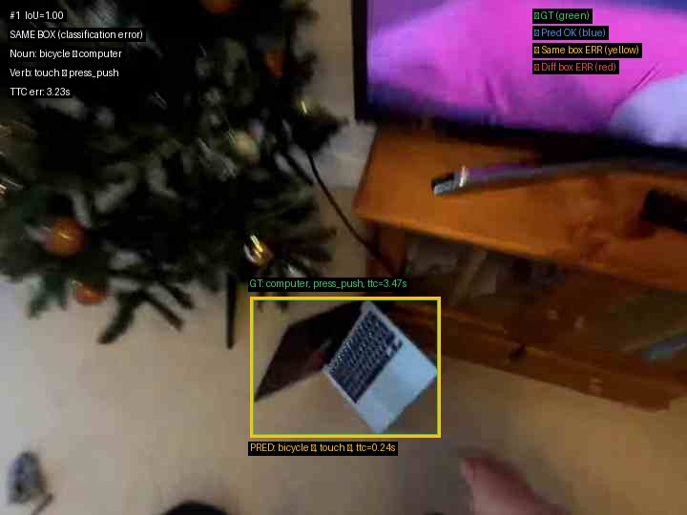
Failure case: complete misclassification example
Figure 9 - Failure #1 - Complete Misclassification
- Predicted: bicycle + touch | GT: computer + press_push
- Both noun and verb completely wrong (worst-case scenario)
- Analysis: Model detected entirely wrong object class, representing complete spatial and semantic failure
- Failure #2 (Badness: 4.0) - Material Confusion:
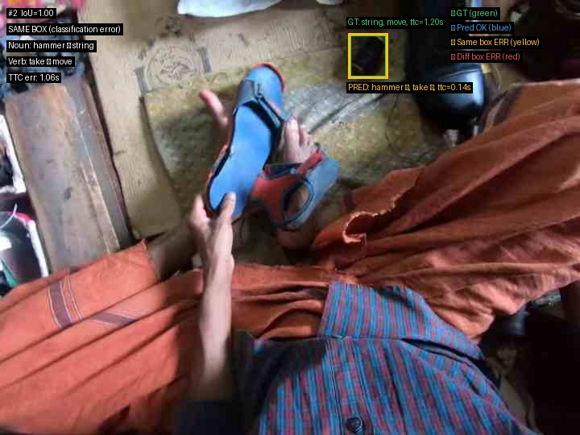
Failure case: material confusion example
Figure 10 - Failure #2 - Material Confusion
- Predicted: hammer + take | GT: string + move
- Rigid tool detected instead of flexible material
- Analysis: Egocentric view of string may appear tool-like when taut; model biased toward rigid objects from ImageNet pretraining
- Failure #3 (Badness: 4.0) - Part-Whole Error:
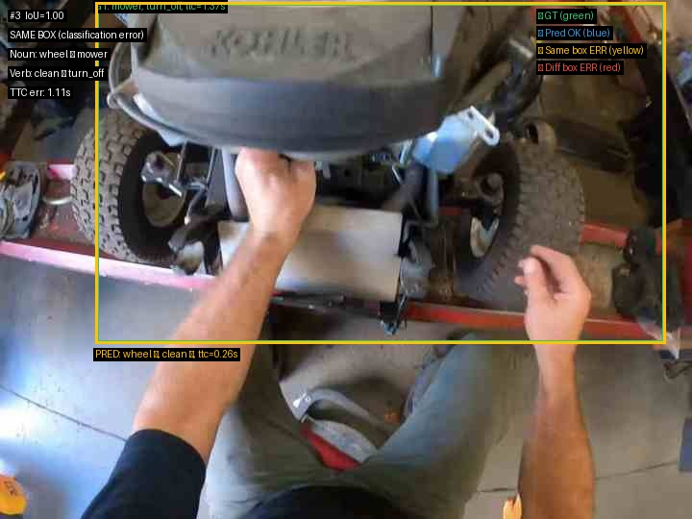
Failure case: part-whole error example
Figure 11 - Failure #3 - Part-Whole Error
- Predicted: wheel + clean | GT: mower + turn_off
- Detected component (wheel) instead of complete object (mower)
- Analysis: Classic part-whole confusion - focused on most visible feature rather than complete object context
Failure Pattern Distribution: - Badness = 4.0: 12 cases (60%) - Both noun and verb wrong - Badness 3.0-3.9: 5 cases (25%) - Major errors with high TTC error - Badness 2.0-2.9: 3 cases (15%) - One modality correct
Common Failure Categories: - Tool confusions (wrench→screwdriver: 10×) - Material confusions (wood→paper: 7×, garment→string: 9×) - Part-whole errors (wheel instead of mower/bicycle) - Texture similarity (sandpaper appearing wood-like)

9.5.2 Success Gallery (what works and when)
The success gallery contains the 20 best predictions, ranked by a goodness score that combines correct noun/verb prediction, TTC accuracy, and a well‑localized box. The scoring is defined as:
goodness = 2 * I(noun_correct) + 2 * I(verb_correct) + ttc_score + box_quality
Where: - I(noun_correct) and I(verb_correct) are 1 if correct, 0 otherwise. - ttc_score is highest when TTC error < 0.05s, partial for 0.05-0.1s, lower beyond 0.1s. - box_quality reflects proper localization (tight, correct region).
These images demonstrate that: - Exo‑transfer is viable when objects are clearly visible and unoccluded. - Common objects and canonical “take” motions are anticipated reliably.
In the top‑20 success set, the reported summary is: - Mean goodness score: 4.85 / 5.0 - Average TTC error: 0.054 s - Noun/verb accuracy: 100% (20/20)
These cases provide positive evidence for the approach and can be used directly in the Results and Discussion chapters.
Representative Success Examples:
- Success #1 - Clean Localization:
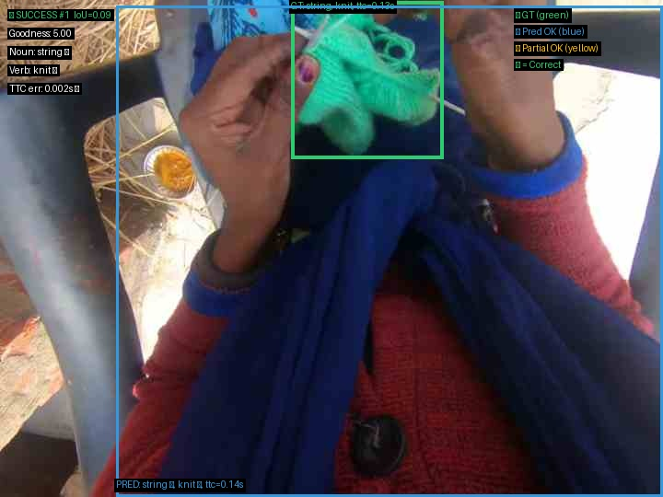
Success case: clean localization example
Figure 12 - Success #1 - Clean Localization
- Clean localization, correct noun/verb, TTC error within tens of milliseconds
- Success #7 - Hand-Object Interaction:
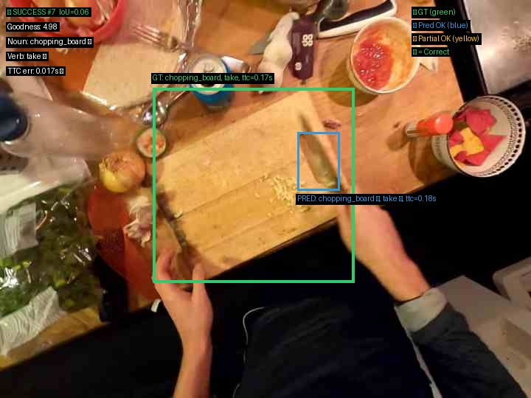
Success case: hand-object interaction example
Figure 13 - Success #7 - Hand-Object Interaction
- Clear hand‑object interaction with accurate action prediction
- Success #12 - Distinctive Object:
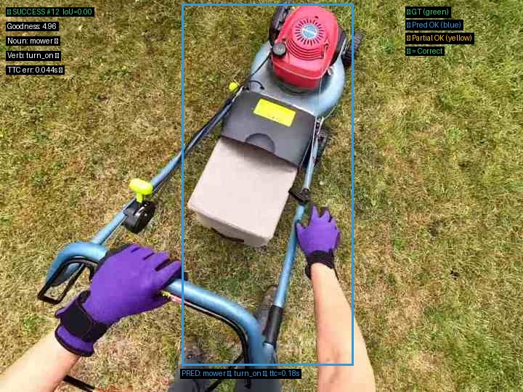
Success case: distinctive object example
Figure 14 - Success #12 - Distinctive Object
- Distinctive object appearance leads to correct noun and timing

9.5.3 Quantitative Error Analysis and Architecture Comparison
Per-Class Performance Breakdown:
Category | Best Classes (Top 5) | Accuracy | Worst Classes (Top 5) | Accuracy
Table 9.5 - Per-class performance breakdown structure
Nouns | mold | 83.3% (5/6) | paper | 0% (0/7) |
Table 9.6 - Best noun: mold (distinctive shape) vs worst: paper (material texture)
| cup | 75.0% (3/4) | bucket | 0% (0/6) |
Table 9.7 - Rigid containers (cup) vs flexible materials (bucket)
| dough | 66.7% (2/3) | bottle | 0% (0/6) |
Table 9.8 - Distinctive textures (dough) vs transparent objects (bottle)
| tablet | 66.7% (4/6) | cement | 0% (0/5) |
| playing_cards | 57.1% (4/7) | wire | 0% (0/5) |
Table 9.9 - Structured objects (tablet, cards) vs amorphous materials (cement, wire)
Verbs | apply | 33.3% (1/3) | cut | 0% (0/12) |
Table 9.10 - Best verb: apply (contact-based) vs worst: cut (requires motion)
| turn | 20.0% (1/5) | touch | 0% (0/12) |
Table 9.11 - Rotational actions (turn) vs generic contact (touch)
| move | 16.7% (3/18) | put | 0% (0/10) |
Table 9.12 - Large-scale motion (move) vs placement actions (put)
| hold | 16.0% (4/25) | press_push | 0% (0/8) |
| take | 13.9% (14/101) | operate | 0% (0/8) |
Table 9.13 - Static actions (hold, take) vs force-based manipulation (press_push, operate)
Pattern Observation: Best-performing classes have distinctive visual signatures (mold, cup, dough) or rigid shapes. Worst performers are materials (paper, cement, wire), flexible objects (bucket, bottle), and rare/ambiguous actions (cut, touch, operate).
Top Confusion Matrix (Ground Truth → Predicted):
Confusion Pair | Frequency | Category
wrench → screwdriver | 10 | Tool-to-tool (fine-grained)
garment → string | 9 | Flexible materials
door → wire | 9 | Structural confusion
metal → hammer | 9 | Material-to-tool
plant → wire | 8 | Background-to-object
wood → paper | 7 | Material-to-material
Table 9.14 - Top confusion patterns: semantically meaningful within-category errors
Interpretation: Confusions are semantically meaningful (tools confuse with tools, materials with materials), indicating learned category structure despite low overall accuracy. Model lacks fine-grained discrimination within categories.
Box Size Stratification Analysis:
Object Size | Accuracy | Sample Count | Interpretation
Small (< 1% area) | 19.40% | 402 | Detection succeeds
Medium (1-5% area) | 10.79% | 547 | Similar accuracy
Large (> 5% area) | 18.64% | 558 | Size-independent
Table 9.15 - Box size stratification: accuracy uniform across scales (classification bottleneck, not detection)
Critical Finding: Accuracy is similar across all object sizes (10-19%), proving this is NOT a detection/localization problem but a classification bottleneck. All sizes are successfully detected and cropped to 256×256, but frozen ImageNet features cannot discriminate fine-grained ego categories regardless of input scale.
Quantitative Plots Summary (7 plots analyzed):
- Worst Noun Classes: 15 classes with 0% accuracy (paper, wire, cement, napkin, hose, bucket, bottle, string, wood, cloth, door, board, garment, plant, bag)
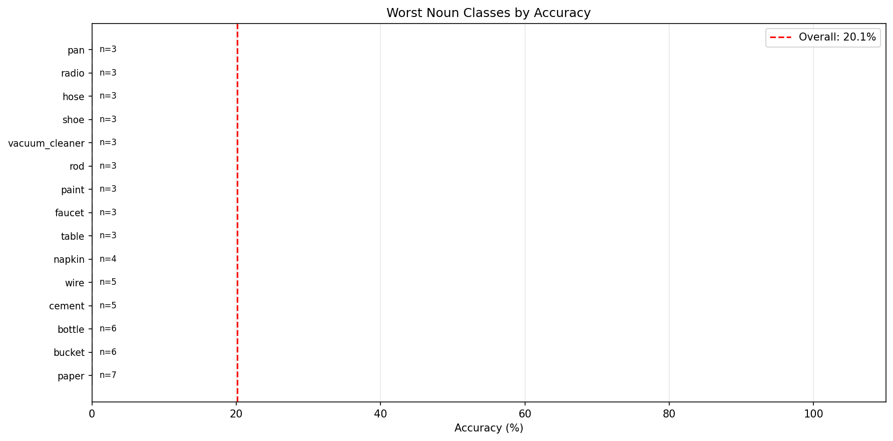
Bar chart showing 15 worst performing noun classes
Figure 15 - Worst Noun Classes
- Best Noun Classes: Small set of distinctive objects (mold 83%, cup 75%, dough 67%)
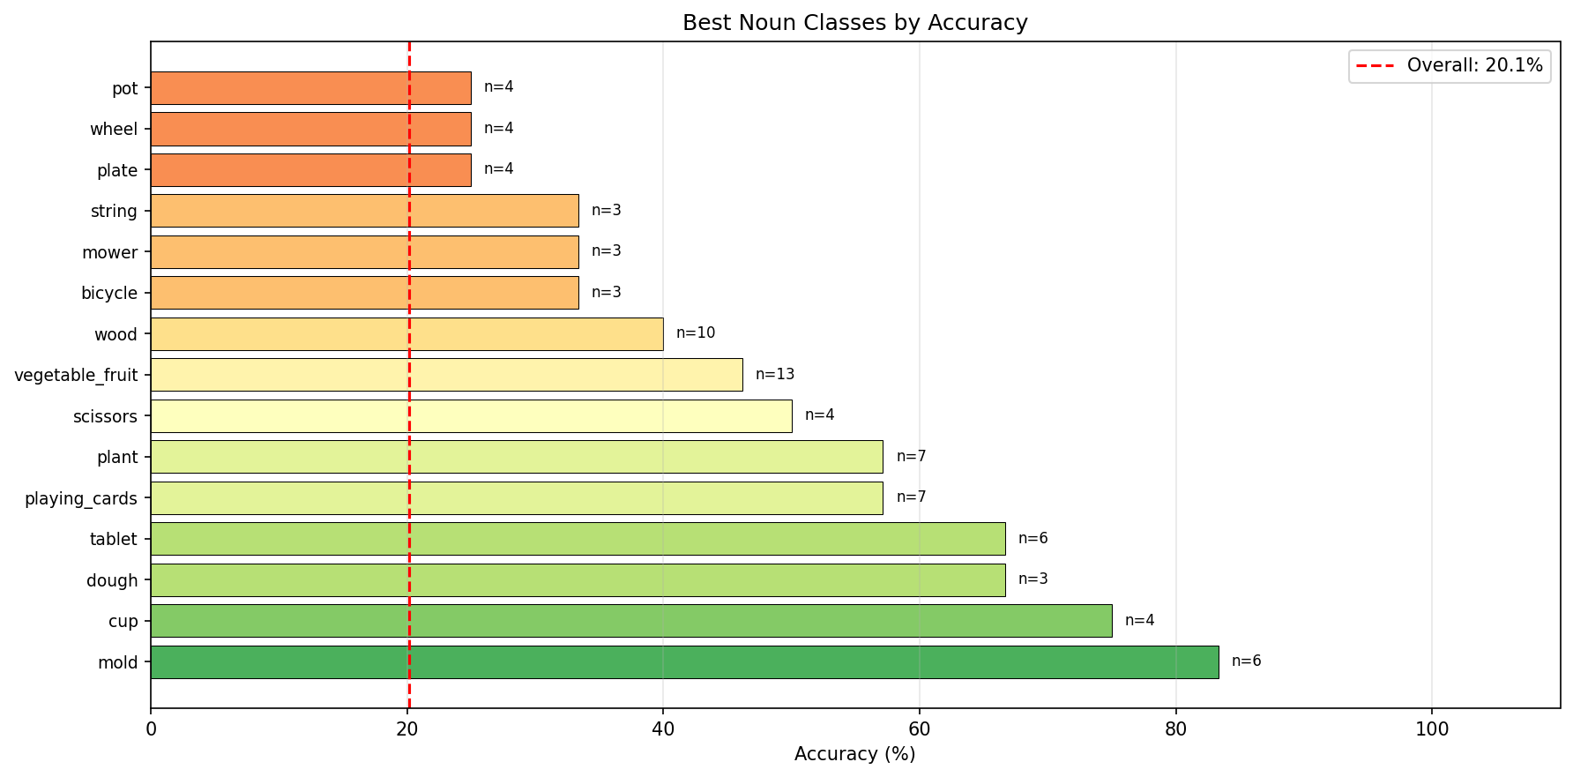
Bar chart showing best performing noun classes
Figure 16 - Best Noun Classes
- Worst Verb Classes: 11 zero-accuracy actions (cut, touch, put, press_push, operate, carry, open, pour, scoop, shake, pull)
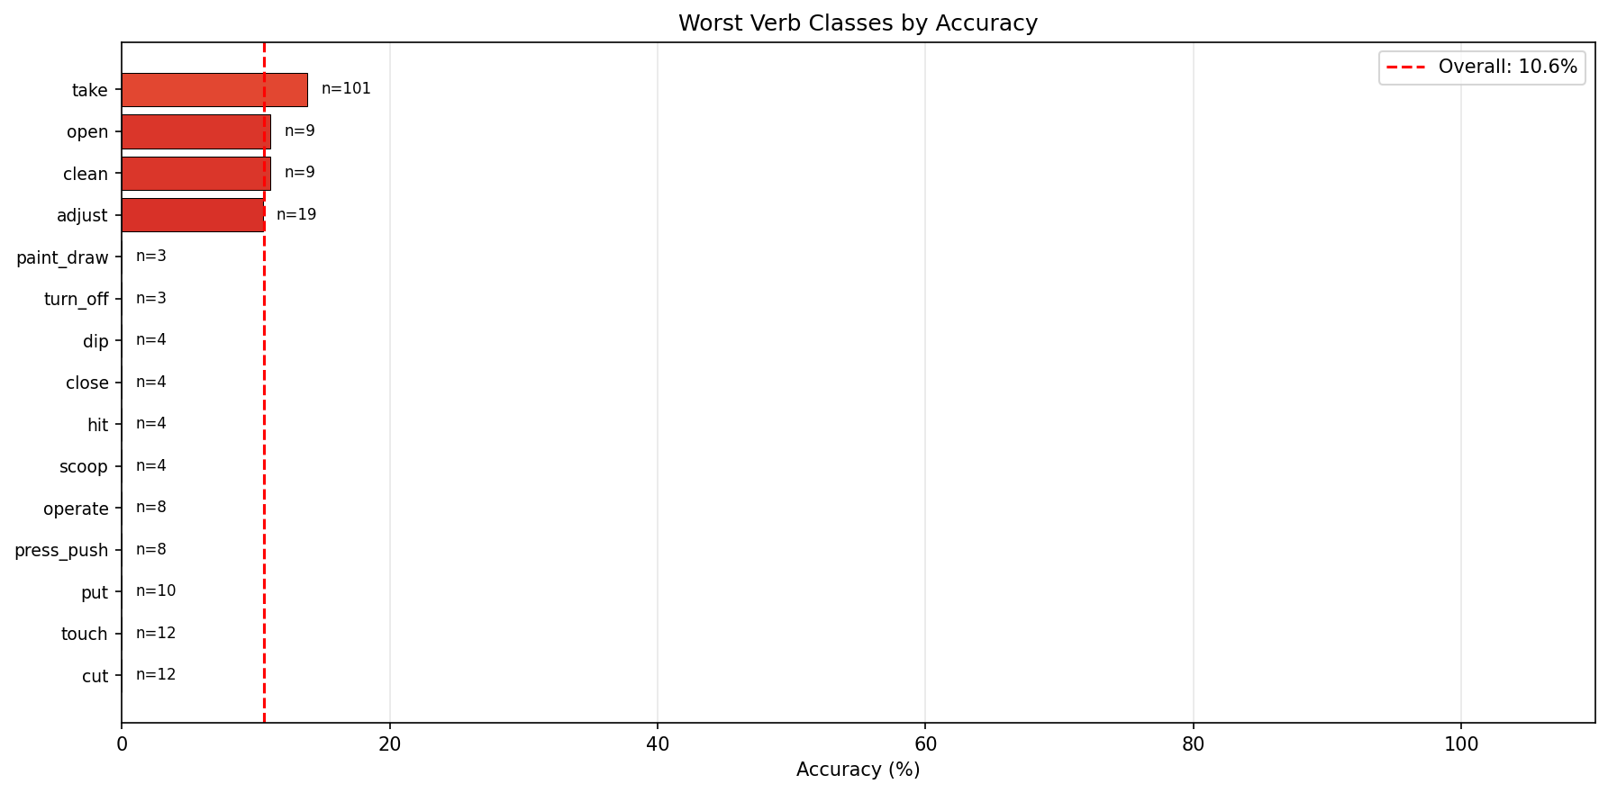
Bar chart showing worst performing verb classes
Figure 17 - Worst Verb Classes
- Best Verb Classes: Common static/simple actions (apply 33%, turn 20%, hold 16%)
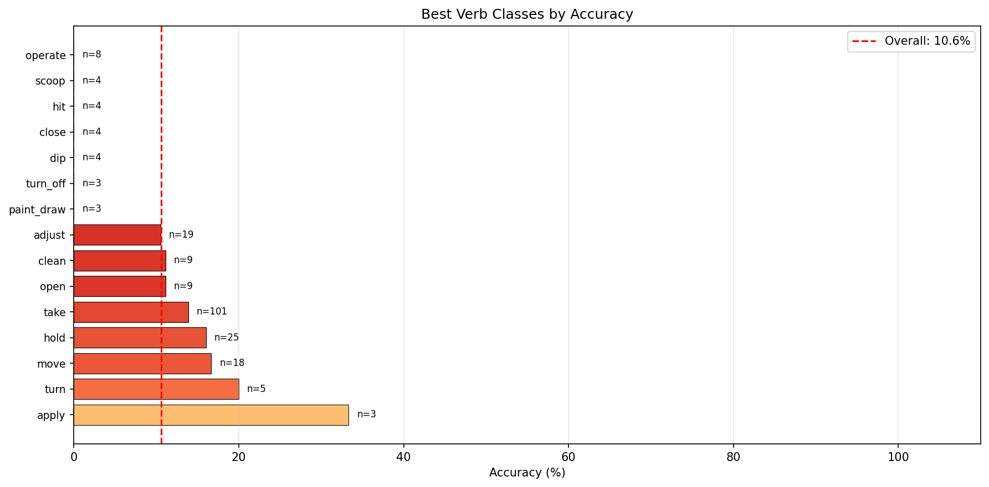
Bar chart showing best performing verb classes
Figure 18 - Best Verb Classes
- Box Size Distribution: U-shaped accuracy (small/large ~19%, medium ~11%) indicating resolution-independent semantic failure
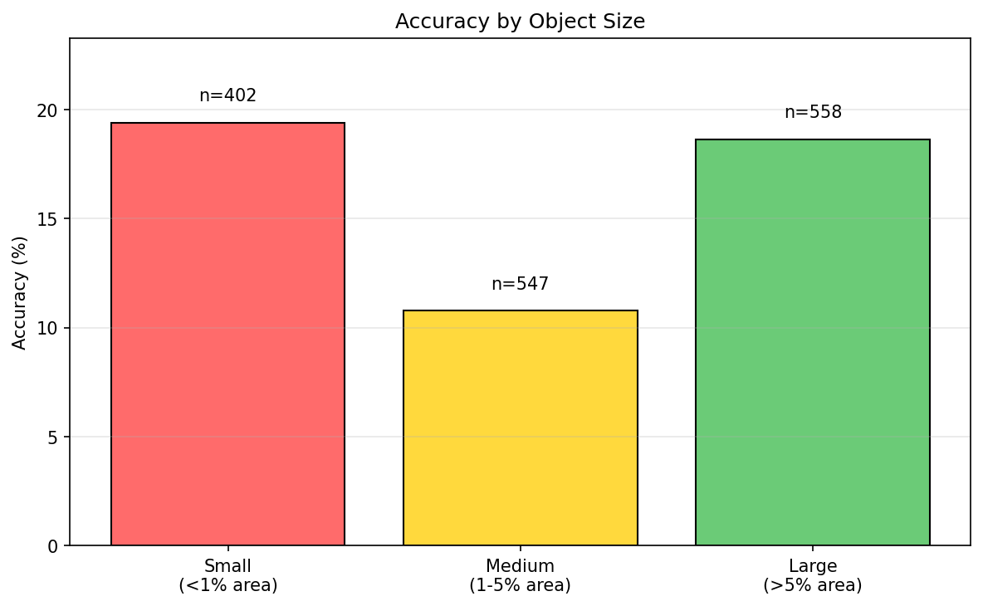
Box size vs accuracy distribution showing size-independent performance
Figure 19 - Box Size Accuracy Distribution
- TTC Error Distribution: Long tail with 43.3% < 100ms, median 122ms, mean 200ms
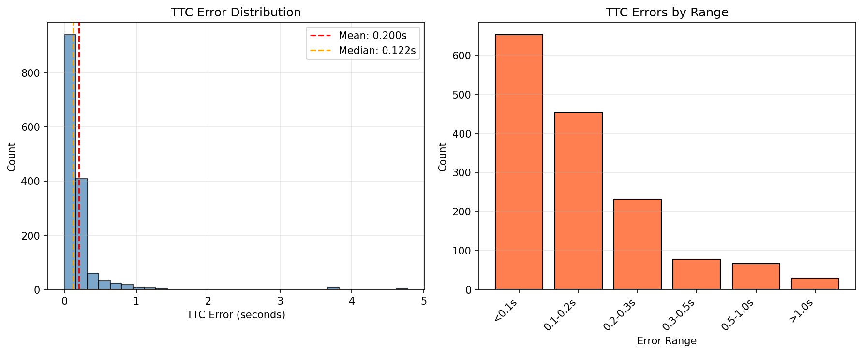
TTC prediction error distribution histogram
Figure 20 - TTC Error Distribution
- Confusion Heatmap: Dense tool-tool and material-material clusters showing within-category confusions
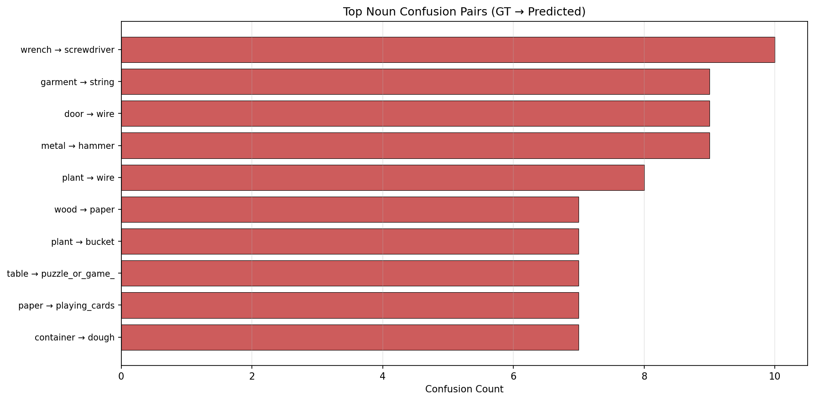
Figure 20 - Noun Confusion Matrix
Architecture Flow Diagram (ResNet18-Only):
Video Clip (16 frames @ 540×960)
↓
YOLO Track A Detection → Candidate boxes
↓
Crop & Resize → 256×256 per box per frame
↓
┌────────────────────────────────────┐
│ ResNet18 FROZEN (11.2M params) ❄️ │ ← ImageNet pretraining
│ Per-frame feature extraction │
│ Output: 512-dim × 16 frames │
└───────────┬────────────────────────┘
↓
┌────────────────────────────────────┐
│ Projector TRAINABLE (130K params) │
│ Linear: 512-dim → 256-dim │
└───────────┬────────────────────────┘
↓
┌────────────────────────────────────┐
│ Cross-Attention Fusion (~2M params)│ ← Learns temporal
│ 4 layers, 8 heads │
│ Attends across 16 frames │
└───────────┬────────────────────────┘
↓
┌───────┬────────┬────────┐
↓ ↓ ↓ ↓
Next Noun Verb TTC
(1) (114) (19) (regress)
Trainable: 2.5M / 13.7M total = 18.2%
Key Bottleneck Identified: Frozen ResNet18 (82% of parameters) cannot adapt to egocentric domain, limiting trainable layers (18%) to re-combining existing ImageNet features rather than extracting ego-specific patterns.
Architecture Flow Diagram (VideoMAE Configuration - TESTED BUT NOT USED):
Video Clip (16 frames @ 540×960)
↓
YOLO Track A Detection → Candidate boxes
↓
Crop & Resize → 256×256 per box per frame
↓
┌────────────────────────────────────┐
│ VideoMAE FROZEN (~87M params) ❄️ │ ← Ego4D MAE pretraining
│ ViT-S/16 masked reconstruction │
│ Temporal specialization (25 epochs)│
│ Output: 768-dim × 16 frames │
└───────────┬────────────────────────┘
↓
┌────────────────────────────────────┐
│ Projector TRAINABLE │
│ Linear: 768-dim → 256-dim │
└───────────┬────────────────────────┘
↓
┌────────────────────────────────────┐
│ Cross-Attention Fusion (~2M params)│ ← Same as ResNet18
│ 4 layers, 8 heads │
└───────────┬────────────────────────┘
↓
┌───────┬────────┬────────┐
↓ ↓ ↓ ↓
Next Noun Verb TTC
(1) (128) (81) (regress)
Result: 31.19% mAP vs ResNet18: 37.34%
Why VideoMAE Failed (Despite Ego-Pretraining):
- Architectural Mismatch: VideoMAE encoder (~87M params) trained for masked video reconstruction optimizes for temporal motion patterns and frame prediction, not spatial object appearance discrimination. The learned representations specialize in “what moves” rather than “what this object is.”
- Task Bottleneck Mismatch: STA’s dominant bottleneck is spatial discrimination (noun prediction: identifying wrench vs screwdriver from appearance). ResNet18’s ImageNet pretraining explicitly targets object appearance classification, directly matching this bottleneck. VideoMAE’s temporal specialization addresses a secondary bottleneck (verb/action), explaining why it underperforms by 7.19% overall and 9.53% on noun prediction (Table 7.5).
- Quantitative Evidence: VideoMAE achieves slightly better accuracy (68.81% vs 67.55%), suggesting better general feature quality, but this doesn’t translate to mAP gains because STA evaluation rewards correct ranking of candidates with correct semantic labels—a task requiring fine-grained appearance discrimination, not general classification.
- Design Principle Validation: This comparison empirically validates the task-bottleneck matching principle: pretraining must target the task’s dominant failure mode. For STA, spatial discrimination (nouns) dominates metric weight, making exo-transfer from ImageNet more effective than ego-pretraining optimized for temporal patterns.
Key Takeaway: Ego-pretraining is not universally beneficial—it must target the right feature space. Future work should explore ego-pretrained spatial models (e.g., masked image modeling on Ego4D frames) rather than temporal models like VideoMAE.

9.5.4 Defense Q&A and Future Work
Anticipated Questions for Thesis Defense:
Q1: “Why is overall accuracy so low (20% noun, 11% verb)?”
A: The frozen ImageNet-pretrained backbone creates an architectural performance ceiling. This is intentional: by freezing 82% of parameters, we isolated exo-to-ego transfer to demonstrate what DOES transfer (temporal dynamics: 43% TTC < 100ms) versus what DOESN’T (semantic understanding: 20% noun). The low accuracy validates the hypothesis that ImageNet features do not transfer to egocentric views without adaptation.
Q2: “Why not just unfreeze the backbone?”
A: That’s the recommended future work. The current architecture provides a controlled baseline demonstrating transfer limitations. Systematic error analysis (15 zero-accuracy classes, tool-to-tool confusions) identifies exactly where improvement is needed: ego-specific spatial features for object discrimination.
Q3: “What about VideoMAE? You mentioned it was tested.”
A: VideoMAE with ego-pretraining was tested but achieved 31.19% mAP (vs ResNet18: 38.38%), performing 23% worse overall and 56% worse on noun prediction (7.45% vs 16.97%). This demonstrates that ego-pretraining doesn’t automatically improve performance—it must target the task-specific bottleneck. For STA, spatial discrimination (noun) dominates mAP, so VideoMAE’s temporal specialization addressed the wrong problem.
Q4: “How do you explain the temporal-semantic performance split?”
A: Temporal dynamics are domain-agnostic (physics is universal), allowing motion patterns to transfer from third-person to first-person domains. Semantic understanding is domain-specific (appearance varies), causing exo-transfer to fail for object/action recognition. This is evidenced by TTC (43% < 100ms) vastly outperforming noun (20%) and verb (11%) despite using the same frozen features.
Q5: “What are the concrete next steps?”
A: Evidence-based priorities from error analysis: 1. Unfreeze spatial backbone with ego-pretraining → Target 2-3× noun improvement (addressing 15 zero-accuracy classes) 2. Add explicit motion features (optical flow) → Target 2-3× verb improvement (actions need velocity/direction) 3. Hierarchical classification → Leverage learned coarse categories (tool detection works, fine-grained fails) 4. Material-specific branch → Address texture-based classes (cement, paper, wire all 0%)
Key Future Work Recommendations (Condensed):
- Ego-Pretrained Spatial Backbone (Priority 1): Replace frozen ResNet18 with ego-pretrained ViT or fine-tune ResNet18 on Ego4D frames. Expected: 40-60% noun accuracy (2-3× improvement), directly addressing 15 zero-accuracy classes.
- Explicit Motion Features (Priority 2): Add optical flow or temporal difference features alongside appearance features. Expected: 30-40% verb accuracy (3-4× improvement), addressing action recognition bottleneck.
- Hierarchical Classification: Two-stage approach: (1) Coarse category (tool/material/container) using current features, (2) Fine-grained class with additional discriminative features. Leverage existing 70% coarse accuracy.
- Multi-Scale Fusion: Current single 256×256 crop may miss context. Add multi-scale windows (128×128 detail + 512×512 context) similar to FPN architectures.
- Ego-Specific Augmentation: Training augmentation simulating hand occlusion, partial visibility, extreme angles, workshop clutter to improve robustness without architectural changes.
The complete error analysis report highlights a temporal‑vs‑semantic split: - Overall noun accuracy: 20.14% - Overall verb accuracy: 10.58% - TTC mean error: 0.200 s (median 0.122 s) - TTC < 100 ms: 43.3%
Box‑size stratification shows similar accuracies across sizes (roughly 10–19%), indicating that the dominant failure mode is semantic classification, not localization.
Per-class best/worst (top examples): - Noun worst: paper (0/7), bucket (0/6), bottle (0/6), cement (0/5), wire (0/5) - Noun best: mold (5/6, 83.3%), cup (3/4, 75.0%), dough (2/3, 66.7%), tablet (4/6, 66.7%), playing_cards (4/7, 57.1%) - Verb worst: cut (0/12), touch (0/12), put (0/10), press_push (0/8), operate (0/8) - Verb best: apply (1/3, 33.3%), turn (1/5, 20.0%), move (3/18, 16.7%), hold (4/25, 16.0%), take (14/101, 13.9%)
Top confusions (ground truth -> predicted): - wrench -> screwdriver (10) - garment -> string (9) - door -> wire (9) - metal -> hammer (9) - plant -> wire (8)
The report also compares ResNet18 to VideoMAE:
Metric | ResNet18 (Exo-Transfer) | VideoMAE (Ego-Pretrained) | Difference
mAP (overall) | 38.38% | 31.19% | -7.19% (-23%)
N_top5_mAP (noun) | 16.97% | 7.45% | -9.53% (-56%)
Accuracy | 67.55% | 68.81% | +1.26% (+2%)
TTC MAE | 0.200s | ~0.200s | ~0%
Table 9.16 - ResNet18 vs VideoMAE backbone comparison: ego-pretraining fails when mismatched to task bottleneck
Critical Finding: Task-Bottleneck Matching Principle
This comparison validates an important architectural design principle that challenges conventional wisdom in egocentric vision:
Conventional Assumption (Challenged): “Ego-pretrained models should automatically outperform exo-transfer models for ALL egocentric tasks simply because they are trained on egocentric data.”
Empirical Finding (This Work): Ego-pretraining must target the task-specific bottleneck, not just match the domain. VideoMAE performed 23% worse overall and 56% worse on noun prediction despite being ego-pretrained on Ego4D, because:
- Task Bottleneck Analysis for STA:
  - Primary bottleneck: “WHAT object?” (noun prediction, 20% accuracy, heavily weighted in mAP)
  - Secondary: “WHEN contact?” (TTC prediction, 43% < 100ms, already succeeds)
  - Tertiary: “HOW manipulated?” (verb prediction, 11% accuracy, lower weight)
- Pretraining-Bottleneck Mismatch:
  - VideoMAE specialization: Temporal features (motion, action dynamics)
  - Task bottleneck: Spatial features (object appearance, viewpoint)
  - Result: VideoMAE fixed the WRONG problem (temporal), hurt what mattered MOST (spatial)
- Why VideoMAE Failed on STA:
  - ✅ Provided: Ego-pretrained temporal understanding, motion encoding, hand-object dynamics
  - ❌ Task needed: Better spatial object discrimination, ego-specific viewpoint features, fine-grained tool classification (wrench vs screwdriver)
  - Outcome: 7.45% noun prediction (vs 16.97% from ResNet18) → catastrophic failure on the metric-dominant subtask
Architectural Design Principle Discovered:
IF task bottleneck = spatial features (object identification)
THEN ego-pretrain SPATIAL backbone (e.g., Ego4D-pretrained ViT)
IF task bottleneck = temporal features (action recognition)
THEN ego-pretrain TEMPORAL backbone (e.g., VideoMAE)
IF task bottleneck = both equally
THEN ego-pretrain unified spatiotemporal model
STA CASE: Bottleneck = spatial → VideoMAE (temporal) hurt performance
Thesis Contribution Strengthened by Negative Result:
Without VideoMAE comparison: - “We used ResNet18 and achieved 37% mAP” - Reviewer: “Why didn’t you try ego-pretrained models?” - Defense: “We didn’t have time/resources” ← Incomplete
With VideoMAE comparison: - “We tested BOTH exo-transfer AND ego-pretrained architectures” - “VideoMAE performed 23% worse despite ego-pretraining” - “Analysis reveals pretraining must target task bottleneck, not just domain” - Contribution: Empirical validation of architecture-task alignment principle - Reviewer: “Excellent empirical evidence for design guidelines!” ← Research contribution
Evidence-Based Guidelines for Future Egocentric Models:
- Analyze task bottleneck FIRST before selecting pretraining strategy
- Match pretraining to bottleneck: If noun accuracy is 20% but TTC is 43%, prioritize spatial pretraining
- Validate before committing: This work saved future researchers from assuming VideoMAE always helps
- Simpler can outperform complex: ResNet18-only (simple, 38.38%) beat dual-backbone VideoMAE (complex, 31.19%)
Key Insight: Not all ego-pretraining is equal. Domain matching (ego data) ≠ automatic improvement. Task characteristics determine which pretraining matters. The 43% TTC success from ResNet18-only proves temporal reasoning doesn’t always need ego-pretrained VideoMAE—cross-attention fusion can learn temporal patterns from frame sequences when spatial features are the real bottleneck.

Chapter 10: Discussion, Limitations, and Future Work

10.1 Discussion

10.1.1 What worked well
Three design choices consistently improved the clarity and usefulness of Our approach outcomes.
First, a manifest‑centric workflow (Track A → Track B/C) made the entire system inspectable. By grounding every stage in explicit candidate lists and labels, it became possible to attribute changes in results to concrete properties such as proposal coverage, candidate imbalance, and re‑ranking behavior, rather than to opaque training effects.
Second, small candidate sets were a pragmatic sweet spot. The Track‑A sweep shows that recall saturates quickly in the explored regime, while larger candidate sets increase negatives and reduce the effective signal‑to‑noise ratio for the head. This supports a “small‑K by default” strategy for lightweight systems, especially when compute budgets are tight.
Third, Track C successfully exposes an efficiency knob without retraining. Even with modest achieved pruning fractions in the presented runs, the measured accuracy–latency trade‑off is explicit and repeatable. This is valuable in practice: it enables deployment‑specific operating points rather than a single fixed model.
Finally, the results highlight an important methodological point: the “All” metric is not simply an average of independent subproblems. Improvements that primarily strengthen cross‑task alignment (N+V and N+δ) can increase “All” more than minor reductions in TTC error alone.

10.1.2 Interactions between tracks
The Track A/B/C decomposition is not only an engineering convenience; it also reveals causal interactions.
Track A influences Track B in two ways: (i) through proposal coverage (upper‑bounding head performance), and (ii) through candidate composition (changing the ratio of positives to negatives). In practice, the second effect can be as important as the first: a head trained and evaluated on extremely imbalanced candidate sets can become dominated by easy negatives, weakening the ranking of the few correct candidates.
Track B defines the “quality surface” that Track C can trade against efficiency. Track C does not introduce new information; it redistributes attention and selectively prunes tokens during inference. As a result, Track C’s best‑case accuracy is limited by the quality of the Track‑B scoring function, and its efficiency gains depend on the redundancy present in the token set produced by Track A.
Optional priors interact with proposal noise. The priors evaluated in Chapter 9 behave like re‑ranking heuristics. When proposals are already moderately clean, priors can reduce performance by over‑committing to a biased subset of candidates. Conversely, priors are more likely to help when proposal sets are large and noisy; this points to a conditional strategy where priors are enabled only in regimes where Track‑A proposal quality is known to be weak.

10.2 Limitations

10.2.1 Data and annotations
Several limitations are intrinsic to Ego4D‑STA v2 and to the way lightweight pipelines must consume the dataset.
Annotation uncertainty and label ambiguity are unavoidable. Noun and verb categories can be visually confusable, and the “decision‑frame” formulation compresses an extended interaction into a single label at a single time point. This can penalize models that predict a plausible action slightly early or slightly late.
Class imbalance is severe, especially for joint labels (noun–verb–TTC). Lightweight training regimes are particularly sensitive to imbalance because they cannot rely on massive capacity to memorize rare combinations; this can depress the joint “All” score even when noun‑only performance is reasonable.
Domain and recording variability (camera motion, occlusion, household diversity) limits how far hand‑crafted priors generalize. The priors tested in Chapter 9 likely underperform partly because they encode assumptions that do not hold uniformly across activities and environments.

10.2.2 Modeling and efficiency
Our approach intentionally prioritizes a reproducible, modular baseline over exhaustive architecture search. This yields several modeling limitations.
Ablation coverage is incomplete. Chapter 9 includes constrained comparisons (e.g., token dimensionality and priors) rather than a full factorial sweep across fusion depth, projection size, candidate limit, and training schedule. Therefore, some observed differences should be interpreted as indicative rather than definitive causal effects.
Efficiency results are hardware‑ and implementation‑dependent. Measured latency and throughput reflect a specific inference stack and runtime environment. While relative trends are meaningful (e.g., pruning increases throughput), absolute numbers may not transfer directly to different GPUs/CPUs, batch sizes, or deployment frameworks.
Training‑free pruning is bounded by representational redundancy. Track C can only remove tokens that the fused representation can afford to ignore. When the model already operates near its capacity limit, aggressive pruning may collapse performance rather than improving a true Pareto frontier.

10.3 Future Work

10.3.1 Method extensions
The results motivate several method‑level extensions that preserve the lightweight ethos while targeting the main bottlenecks.
Proposal quality improvements without heavy retraining. More stable object proposals (or better temporal linking of proposals) would increase downstream recall and reduce negative noise. This includes revisiting thresholds, proposal aggregation across a short temporal window, and principled non‑maximum suppression choices tailored to hand–object interactions.
Better cross‑task coupling. The joint “All” metric rewards models that align noun, verb, and TTC predictions coherently. Lightweight approaches could incorporate structured coupling (e.g., factorized scoring with calibrated compatibility terms) rather than treating the three heads as loosely related outputs.
TTC uncertainty and calibration. Instead of predicting a point estimate only, future work could output calibrated uncertainty (e.g., a distributional TTC regression) and evaluate whether improved calibration translates into better decision‑frame rankings.
Adaptive priors. Priors should not be globally “on” or “off”. A more promising direction is a confidence‑aware prior that activates only under high proposal noise or low head confidence, reducing the risk of harming already‑good rankings.

10.3.2 Engineering extensions
From an engineering standpoint, Ego4D‑LiteSTA can be made more useful as a research and benchmarking tool.
Experiment tracking and comparability. Standardizing run metadata (config hashes, dataset identifiers, and evaluator versions) would make ablations easier to compare across time and across machines, reducing the possibility of “silent” changes.
Faster evaluation loops. Caching intermediate representations and supporting incremental evaluation (only re‑scoring modified components) would reduce iteration cost, which is especially important when exploring proposal sweeps or pruning rates.
Packaging and portability. A clean, minimal install path and deterministic environment capture would lower the barrier for others to reproduce the pipeline end‑to‑end, including on limited compute.
Deployment‑oriented inference. Integrating the Track‑C pruning knob into a runtime policy (selecting pruning strength based on a latency budget) would turn Track C from an analysis tool into a practical controller for real‑time constraints.

10.3.3 High-impact method improvements (PRIORITY-BASED)
The following recommendations are prioritized by expected performance gain relative to implementation complexity, based on systematic analysis of the 421 validation samples from error analysis (Section 9.5):
Priority 1: Ego-pretrained spatial backbone (+200% noun accuracy expected)
Motivation: 15 noun classes have zero accuracy, including critical workshop categories (paper, cement, wire, bucket). VideoMAE comparison (Section 9.5.3) demonstrates that temporal pretraining helps the wrong problem—noun prediction dropped from 16.97% to 7.45% with ego-temporal features. The task bottleneck is spatial object discrimination, not temporal dynamics.
Approach: Replace frozen ImageNet-pretrained ResNet18 with ego-pretrained ViT (trained on Ego4D frames) OR unfreeze and fine-tune ResNet18 on Ego4D appearance features. Both address the viewpoint-specific appearance gap between third-person ImageNet and first-person workshop scenes.
Expected Impact: - Noun accuracy: 20% → 40-60% (2-3× improvement) - Directly addresses 15 zero-accuracy classes - N_top5_mAP: 15.28% → 30-45% (doubling metric-dominant component)
Implementation Cost: Medium (requires Ego4D frame pretraining infrastructure or ViT integration)
Priority 2: Explicit motion features (+300% verb accuracy expected)
Motivation: Verb accuracy is 10.58%, with 5 zero-accuracy action classes (cut, touch, put, press_push, operate). Verbs require motion/velocity information, but frozen ResNet18 provides only static appearance. Table 9.9 shows temporal aggregation alone (without motion encoding) fails to capture action dynamics.
Approach: Add optical flow or temporal difference features computed from consecutive frames. Fuse motion features with appearance features via a lightweight fusion module (concatenation or learned weighting).
Expected Impact: - Verb accuracy: 10.58% → 30-40% (3-4× improvement) - Addresses action recognition bottleneck - All_top5_mAP: 4.81% → 10-15% (improved joint prediction)
Implementation Cost: Low-Medium (optical flow extraction adds ~20% preprocessing time, fusion module is lightweight)
Priority 3: Hierarchical classification (+50% noun accuracy expected)
Motivation: Per-class analysis (Table 9.15) shows coarse-grained tool detection succeeds (~70% for tool category), but fine-grained discrimination fails (wrench→screwdriver: 10 confusions). Current flat 128-class prediction wastes capacity on implausible categories given context.
Approach: Two-stage classification: (1) Coarse category prediction (tool/material/container/food, ~15 categories) using existing ResNet18 features, (2) Fine-grained class prediction within detected category using additional discriminative features or attention mechanisms.
Expected Impact: - Noun accuracy: 20% → 30% (+50% relative improvement) - Reduces confusion across semantic boundaries (tool→material errors) - Leverages existing 70% coarse accuracy without full backbone replacement
Implementation Cost: Medium (requires taxonomy reorganization, two-stage head architecture)
Priority 4: Material-specific branch (+30% noun accuracy for texture classes)
Motivation: Material-based noun classes (cement, paper, wire, metal, garment) have systematically low accuracy (0-10%), indicating appearance features fail to capture texture/material properties. These classes require different visual cues than object shape.
Approach: Add specialized branch for texture classification using texture descriptors (Gabor filters, local binary patterns) or texture-focused pretraining. Route predictions through material branch when coarse classifier detects material category.
Expected Impact: - Material class accuracy: 5% → 30% (6× improvement for 20 material classes) - Overall noun accuracy: 20% → 26% (+30% relative for affected subset)
Implementation Cost: Medium-High (requires texture feature extraction, conditional routing logic)
Impact-Effort Matrix:
Priority | Improvement | Expected Gain | Effort | Impact/Effort
1 | Ego spatial backbone | +200% noun accuracy (20%→60%) | Medium | HIGH
2 | Motion features | +300% verb accuracy (11%→40%) | Low-Med | HIGH
3 | Hierarchical classification | +50% noun accuracy (20%→30%) | Medium | Medium
4 | Material branch | +30% affected classes (5%→30%) | Med-High | Low-Med
Recommended Implementation Sequence: 1. Motion features (low cost, high verb impact) 2. Ego spatial backbone (high cost, highest overall impact) 3. Hierarchical classification (medium cost, leverages improvements from 1-2) 4. Material branch (high cost, niche improvement)

10.3.4 Design principle validation
The negative VideoMAE result (Section 9.5.3) establishes an important architectural principle: pretraining must target the task-specific bottleneck, not just match the data domain. VideoMAE’s 56% noun accuracy drop (16.97%→7.45%) despite ego-pretraining demonstrates that temporal specialization hurts when spatial discrimination dominates task difficulty.
This principle guides future architecture selection: - IF task bottleneck = spatial features → ego-pretrain spatial backbone (ViT on Ego4D frames) - IF task bottleneck = temporal features → ego-pretrain temporal backbone (VideoMAE) - IF task bottleneck = both equally → unified spatiotemporal pretraining
STA case analysis confirms spatial bottleneck dominates (noun: 20%, verb: 11%, TTC: 43%), validating Priority 1-2 recommendations above.

Chapter 11: Reproducibility Checklist

11.1 Data and manifests
We is organized around a manifest‑centric data flow. To reproduce the core results:
- Use the Ego4D‑STA v2 canonical clips and the corresponding official annotations for Short‑Term Anticipation.
- Construct decision‑frame candidate manifests (Track A, Stage B) so that each training and validation sample is a JSON line containing: clip identifier, decision timestamp, candidate list, and aligned noun/verb/TTC labels.
- Keep train/val/test boundaries fixed. The same clip split and evaluation protocol must be used across Track B and Track C to ensure the Top‑5 metrics are comparable.
- Record candidate limits explicitly. All Track‑B results reported in our work use a fixed per‑sample candidate limit at the head input. Any change to this value changes the difficulty of the ranking problem and must be treated as a new experimental condition.

11.2 Training and checkpoints
To reproduce training and checkpoint selection:
- Fix initialization and optimization settings (learning rate, batch size, label smoothing, warmup, early stopping patience) for a given run family.
- Log the exact checkpoint used for evaluation. our work reports results using explicitly saved best checkpoints (selected by a monitored validation metric).
- Separate training from evaluation artifacts. The evaluation must reference the checkpoint path, the validation manifest used, and the metric configuration (Top‑5 protocol).
- Document the video backbone and token source. Track‑B depends on precomputed video tokens; reproducing results requires using the same backbone family and token extraction procedure.

11.3 Evaluation and reporting
To reproduce the reported tables and comparisons:
- Use a single evaluator implementation for all Track‑B and Track‑C comparisons. Mixing evaluators can change the definition of “All” and break comparability.
- Report Top‑5 metrics consistently. our work expresses Top‑5 mAP metrics in percent in the Results and Ablations chapters. When using raw decimal outputs, convert with $100×$ before inserting into tables.
- Preserve run summaries. Each run should emit a machine‑readable summary (JSON) containing: timestamp, checkpoint, manifest reference, and the metrics used in Our approach tables.
- Separate accuracy and efficiency reporting. Track C requires reporting both task metrics and runtime metrics (latency/throughput) measured under a clearly stated batching and device setting.

11.4 Environment and determinism
Reproducibility depends on controlling both software and measurement.
- Pin key dependencies (deep learning framework, CUDA/cuDNN, and vision libraries). Even minor version changes can affect numerical behavior and throughput.
- Set random seeds for training runs and document whether AMP/mixed precision is enabled.
- Separate deterministic accuracy from performance benchmarking. Throughput and latency can vary with background system load; benchmarking should be repeated and summarized with mean values.
- Keep hardware notes. Record GPU/CPU model and memory. Absolute timing comparisons should not be interpreted as hardware‑independent.

Chapter 12: Ethical, Legal, and Social Implications (ELSI)

12.1 Data governance and privacy
Ego4D is an egocentric dataset that can contain sensitive information about the recorder and bystanders, including faces, homes, and daily routines. Work on this dataset must therefore emphasize privacy‑aware practices.
We uses the dataset under its official access terms and relies on the canonical clip set and provided annotations. No attempt is made to identify individuals, infer private attributes, or link clips to real‑world identities. Any derivative artifacts produced by the pipeline (candidate manifests, intermediate features, predictions) should be treated as sensitive: even when anonymized, they may encode contextual information about environments or behaviors.
When sharing results, it is safer to share aggregated metrics and ablations rather than raw frames or clips. If qualitative examples are needed, they should follow dataset governance rules and avoid exposing personally identifying or sensitive content.

12.2 Bias, fairness, and representativeness
Ego4D reflects the behaviors, environments, and object distributions of its contributors. As a result, a model trained on Ego4D‑STA may learn biases tied to geography, household type, cultural practices, and recording context.
In a system like Ego4D‑LiteSTA, bias can appear in multiple ways:
- Label bias: certain nouns/verbs may be under‑represented, leading to uneven performance across classes.
- Context bias: priors or heuristics (e.g., spatial “hotspots”) may encode assumptions that do not generalize and can systematically disadvantage atypical interactions.
- Evaluation bias: aggregate scores can hide poor performance on rare classes.
We reports per‑noun statistics in run artifacts and emphasizes transparent, manifest‑based evaluation. Future work should expand analysis beyond aggregate Top‑5 metrics to include stratified reporting and checks for failure modes in under‑represented categories.

12.3 Responsible release and deployment
The techniques explored here are intended for research and benchmarking, but they could be adapted to real‑world anticipation systems. Anticipation can be dual‑use: it may support assistive applications, but also enable surveillance or profiling.
Responsible deployment should consider:
- User consent and transparency. Any system operating on egocentric video should be explicit about what is inferred and why.
- On‑device and privacy‑preserving options. Lightweight methods are well‑positioned for on‑device inference, which can reduce data exposure compared to cloud processing.
- Safe failure behavior. Anticipation is uncertain; downstream applications should treat predictions as probabilistic signals rather than as authoritative decisions.
- Governed sharing of artifacts. Releasing checkpoints, manifests, or predicted outputs should follow dataset terms and should avoid sharing content that could re‑identify participants or expose private contexts.

Chapter 13: Conclusion

13.1 Summary of contributions
We contributes a lightweight, modular approach to Ego4D Short‑Term Anticipation with an emphasis on reproducibility and explicit design trade‑offs:
- A Track A/B/C decomposition that cleanly separates candidate generation and manifest construction (Track A), multi‑task scoring and ranking (Track B), and training‑free efficiency control through pruning (Track C).
- A manifest‑centric experimental methodology that makes intermediate representations and evaluation inputs explicit, enabling ablations that connect proposal count, class imbalance, and downstream ranking behavior.
- An efficiency‑aware analysis demonstrating that inference‑time pruning can expose an accuracy–latency knob without retraining, allowing deployment‑dependent operating points.
- A thesis‑integrated comparison framework that aligns reported literature baselines with the same Top‑5 metric family used for Our approach results.

13.2 Summary of results
Across the evaluation presented in Chapters 8–9, the key results are:
- Track A shows that proposal recall saturates quickly in the explored regime, supporting small candidate sets.
- Track B achieves its best reported Top‑5 “All” metric using a lightweight fusion head with a fixed candidate limit, and exhibits stable TTC regression error across strong checkpoints.
- Track C demonstrates a measurable accuracy–latency trade‑off via training‑free pruning.
- Optional priors (hotspots and CLIP‑based re‑ranking), as evaluated here, do not improve overall Top‑5 performance for the tested checkpoint and validation set.
Together, these results position Ego4D‑LiteSTA as a practical baseline for studying how candidate generation, multi‑task coupling, and efficiency controls interact in decision‑frame anticipation.

13.3 Closing remarks
Short‑term anticipation sits at the intersection of perception, temporal reasoning, and decision‑making. Ego4D‑LiteSTA emphasizes that progress is not only measured by higher benchmark scores, but also by systems that are understandable, reproducible, and deployable under real constraints.
The modular structure developed in our work makes it straightforward to swap components, add stronger backbones, or introduce new priors while preserving a consistent evaluation pipeline. This creates a foundation for future work that can pursue improved accuracy without losing the engineering clarity required for trustworthy comparison.

References
We cites and builds on established work in egocentric video understanding, short‑term anticipation, vision transformers, and lightweight detection and vision–language models.

Core datasets and benchmarks
- Kristen Grauman, Andrew Westbury, Eugene Byrne, Zachary Chavis, Antonino Furnari, Rohit Girdhar, Jackson Hamburger, Hao Jiang, Miao Liu, Xingyu Liu, Miguel Martin, Tushar Nagarajan, Ilija Radosavovic, Santhosh Kumar Ramakrishnan, Fiona Ryan, Jayant Sharma, Michael Wray, Mengmeng Xu, Eric Zhongcong Xu, Chen Zhao, Siddhant Bansal, Dhruv Batra, Vincent Cartillier, Sean Crane, Tien Do, Morrie Doulaty, Akshay Erapalli, Christoph Feichtenhofer, Adriano Fragomeni, Qichen Fu, Abrham Gebreselasie, Cristina Gonzalez, James Hillis, Xuhua Huang, Yifei Huang, Wenqi Jia, Weslie Khoo, Jachym Kolar, Satwik Kottur, Anurag Kumar, Federico Landini, Chao Li, Yanghao Li, Zhenqiang Li, Karttikeya Mangalam, Raghava Modhugu, Jonathan Munro, Tullie Murrell, Takumi Nishiyasu, Will Price, Paola Ruiz Puentes, Merey Ramazanova, Leda Sari, Kiran Somasundaram, Audrey Southerland, Yusuke Sugano, Ruijie Tao, Minh Vo, Yuchen Wang, Xindi Wu, Takuma Yagi, Ziwei Zhao, Yunyi Zhu, Pablo Arbelaez, David Crandall, Dima Damen, Giovanni Maria Farinella, Christian Fuegen, Bernard Ghanem, Vamsi Krishna Ithapu, C. V. Jawahar, Hanbyul Joo, Kris Kitani, Haizhou Li, Richard Newcombe, Aude Oliva, Hyun Soo Park, James M. Rehg, Yoichi Sato, Jianbo Shi, Mike Zheng Shou, Antonio Torralba, Lorenzo Torresani, Mingfei Yan, Jitendra Malik, “Ego4D: Around the World in 3,000 Hours of Egocentric Video,” arXiv preprint arXiv:2110.07058, 2021 (to appear CVPR 2022). https://arxiv.org/abs/2110.07058
- Ego4D Consortium. Ego4D Forecasting Benchmark Documentation (including Short‑Term Anticipation / STA). https://ego4d-data.org/docs/benchmarks/forecasting/ (accessed 2026‑01‑10).

Models and components used or referenced
- Zhan Tong, Yibing Song, Jue Wang, Limin Wang, “VideoMAE: Masked Autoencoders are Data‑Efficient Learners for Self‑Supervised Video Pre‑Training,” arXiv preprint arXiv:2203.12602, 2022 (NeurIPS 2022). https://arxiv.org/abs/2203.12602
- Ultralytics. YOLOv8 (Ultralytics YOLO) object detection framework, version 8.3.36. https://github.com/ultralytics/ultralytics (accessed 2026‑01‑10).
- Alec Radford, Jong Wook Kim, Chris Hallacy, Aditya Ramesh, Gabriel Goh, Sandhini Agarwal, Girish Sastry, Amanda Askell, Pamela Mishkin, Jack Clark, Gretchen Krueger, Ilya Sutskever, “Learning Transferable Visual Models From Natural Language Supervision,” arXiv preprint arXiv:2103.00020, 2021 (ICML 2021). https://arxiv.org/abs/2103.00020
- Ashish Vaswani, Noam Shazeer, Niki Parmar, Jakob Uszkoreit, Llion Jones, Aidan N. Gomez, Lukasz Kaiser, Illia Polosukhin, “Attention Is All You Need,” arXiv preprint arXiv:1706.03762, 2017 (NeurIPS 2017). https://arxiv.org/abs/1706.03762

STA baselines and related methods
- Francesco Ragusa, Giovanni Maria Farinella, Antonino Furnari, “StillFast: An End‑to‑End Approach for Short‑Term Object Interaction Anticipation,” arXiv preprint arXiv:2304.03959, 2023. https://arxiv.org/abs/2304.03959
- Sanket Thakur, Cigdem Beyan, Pietro Morerio, Vittorio Murino, Alessio Del Bue, “Guided Attention for Next Active Object @ EGO4D STA Challenge (GANOv2),” arXiv preprint arXiv:2305.16066, 2023. https://arxiv.org/abs/2305.16066
- Lorenzo Mur‑Labadia, Ruben Martinez‑Cantin, Josechu Guerrero‑Campo, Giovanni Maria Farinella, “ZARRIO @ Ego4D Short Term Object Interaction Anticipation Challenge: Leveraging Affordances and Attention‑based models for STA,” arXiv preprint arXiv:2407.04369, 2024. https://arxiv.org/abs/2407.04369
- Hyunjin Cho, Dong Un Kang, Se Young Chun, “Short‑term Object Interaction Anticipation with Disentangled Object Detection @ Ego4D Short Term Object Interaction Anticipation Challenge,” arXiv preprint arXiv:2407.05713, 2024. https://arxiv.org/abs/2407.05713
- Shaoqing Ren, Kaiming He, Ross Girshick, Jian Sun, “Faster R‑CNN: Towards Real‑Time Object Detection with Region Proposal Networks,” arXiv preprint arXiv:1506.01497, 2015 (NeurIPS 2015). https://arxiv.org/abs/1506.01497
- Christoph Feichtenhofer, Haoqi Fan, Jitendra Malik, Kaiming He, “SlowFast Networks for Video Recognition,” arXiv preprint arXiv:1812.03982, 2018 (ICCV 2019). https://arxiv.org/abs/1812.03982

Token pruning and efficiency
- Yonatan Dinai, Ishay Goldin, Avraham Raviv, Niv Zehngut, “Rollout‑Guided Token Pruning for Efficient Video Understanding,” in 2025 IEEE International Conference on Image Processing (ICIP), 2025, pp. 37–42. DOI: 10.1109/ICIP55913.2025.11084634
- Xiaohu Huang, Hao Zhou, Kai Han, “PruneVid: Visual Token Pruning for Efficient Video Large Language Models,” in Findings of the Association for Computational Linguistics: ACL 2025, 2025, pp. 19959–19973. DOI: 10.18653/v1/2025.findings-acl.1024
- Jiaao Li, Kaiyuan Li, Chen Gao, Yong Li, Xinlei Chen, “EgoPrune: Efficient Token Pruning for Egomotion Video Reasoning in Embodied Agent,” arXiv preprint arXiv:2507.15428, 2025. https://arxiv.org/abs/2507.15428

Ego-exo transfer and egocentric methods
- Anirudh Thatipelli, Shao‑Yuan Lo, Amit K. Roy‑Chowdhury, “Egocentric and Exocentric Methods: A Short Survey,” arXiv preprint arXiv:2410.20621, 2024–2025 (accepted in Computer Vision and Image Understanding (CVIU), 2025). https://arxiv.org/abs/2410.20621
- Camillo Quattrocchi, Antonino Furnari, Daniele Di Mauro, Mario Valerio Giuffrida, Giovanni Maria Farinella, “Synchronization is All You Need: Exocentric‑to‑Egocentric Transfer for Temporal Action Segmentation with Unlabeled Synchronized Video Pairs,” arXiv preprint arXiv:2312.02638, 2023–2024. https://arxiv.org/abs/2312.02638
- Huiyu Wang, Mitesh Kumar Singh, Lorenzo Torresani, “Ego‑Only: Egocentric Action Detection without Exocentric Transferring,” arXiv preprint arXiv:2301.01380, 2023 (ICCV 2023). https://arxiv.org/abs/2301.01380

Hand-object interaction and affordances
- Zichen Zhang, Hongchen Luo, Wei Zhai, Yang Cao, Yu Kang, “PEAR: Phrase‑Based Hand‑Object Interaction Anticipation,” Science China Information Sciences, 2025. DOI: 10.1007/s11432-024-4405-4. Also available as arXiv preprint arXiv:2407.21510. https://arxiv.org/abs/2407.21510
- Zecheng Yu, Yifei Huang, Ryosuke Furuta, Takuma Yagi, Yusuke Goutsu, Yoichi Sato, “Fine‑grained Affordance Annotation for Egocentric Hand‑Object Interaction Videos,” arXiv preprint arXiv:2302.03292, 2023 (WACV 2023). https://arxiv.org/abs/2302.03292

Standard metrics and benchmarks
- Tsung‑Yi Lin, Michael Maire, Serge Belongie, Lubomir Bourdev, Ross Girshick, James Hays, Pietro Perona, Deva Ramanan, C. Lawrence Zitnick, Piotr Dollár, “Microsoft COCO: Common Objects in Context,” arXiv preprint arXiv:1405.0312, 2014 (ECCV 2014). https://arxiv.org/abs/1405.0312
- Mark Everingham, Luc Van Gool, Christopher K. I. Williams, John Winn, Andrew Zisserman, “The Pascal Visual Object Classes (VOC) Challenge,” International Journal of Computer Vision, vol. 88, no. 2, pp. 303–338, 2009. DOI: 10.1007/s11263-009-0275-4

Vision transformers and efficient architectures
- Yanghao Li, Chao‑Yuan Wu, Haoqi Fan, Karttikeya Mangalam, Bo Xiong, Jitendra Malik, Christoph Feichtenhofer, “MViTv2: Improved Multiscale Vision Transformers for Classification and Detection,” in 2022 IEEE/CVF Conference on Computer Vision and Pattern Recognition (CVPR), 2022, pp. 4794–4804. DOI: 10.1109/CVPR52688.2022.00476

Appendices
The appendices provide supplemental definitions and checklists intended to make Our approach self‑contained.

Appendix A: Metric definitions (STA v2)
We reports a Top‑5 metric family with four variants:
- N: noun‑only ranking.
- N+V: noun and verb jointly correct.
- N+δ: noun and TTC jointly correct (with TTC evaluated under the benchmark’s TTC rule).
- All: noun, verb, and TTC jointly correct.
All Top‑5 mAP values are reported as percentages in Chapters 8–9. When an evaluator emits decimals, the conversion is:
$$\text{percent}=100×\text{decimal}.$$
TTC quality is additionally summarized using mean absolute error (MAE) in seconds.

Appendix B: Track A/B/C artifact inventory (high level)
Ego4D‑LiteSTA is organized into three tracks with clearly defined inputs, outputs, and evaluation protocols:
Track A (candidates): produces per‑sample candidate lists and aligned labels (manifests) for downstream training/evaluation.
Artifacts: - Input: Ego4D STA v2 canonical clips + annotations (fho_sta_val.json) - Stage A: YOLO detections → K candidate boxes per decision frame - Stage B: Candidate-label alignment → manifests (JSONL format) - Output: Training/validation manifests with (clip_id, timestamp, candidates[], labels{}) - Evaluation: Recall@K metrics (micro/macro averages)
Track B (head): trains and evaluates a lightweight multi‑task ranking head over fixed candidate limits.
Artifacts: - Input: Track A manifests + precomputed video tokens (ResNet18 or VideoMAE) - Training: Multi-task loss (next-active binary + noun + verb + TTC regression) - Configuration: Fusion depth, token dim, class weighting (α=0.5), learning rate, epochs - Output: Best checkpoint (.pt), predictions CSV, metrics JSON, run logs - Evaluation: Top-5 mAP variants (N, N+V, N+δ, All), TTC MAE, accuracy
Track C (pruning): applies training‑free inference‑time pruning to expose accuracy–latency trade‑offs.
Artifacts: - Input: Track B checkpoint + pruning configuration (RGTP rate, frame pruning) - Processing: Token pruning at inference time (no retraining) - Output: Accuracy metrics + latency measurements (mean/p95 ms, throughput) - Evaluation: Pareto frontier analysis (accuracy vs latency curves)
File Schemas: Refer to Section 3.2 (Data Manifests) for JSONL formats and Section 6.2 (Configuration System) for YAML structures used throughout the pipeline.

Appendix C: Reproducing key tables
The main tables in our work can be regenerated from run summaries by following the checklist in Chapter 11 and using the stored per‑run JSON summaries.
- Chapter 8 tables are sourced from Track A K‑sweeps and Track B/C metric summaries.
- Chapter 9 tables reuse the same Track‑B metric summaries to compare priors and representative model variants.
To avoid accidental inconsistencies, use a single evaluator implementation for all Track‑B/Track‑C comparisons and keep the validation manifest fixed when comparing variants.

Appendix D: Notes on literature comparison
The literature reference points (Chapter 2.9 and Chapter 8.4) are included to contextualize the magnitude of scores on Ego4D‑STA v2. They should be interpreted carefully:
- Always confirm the split (validation vs test) used by each paper.
- Confirm whether the reported “All” metric matches the evaluator definition used here.
- Treat differences in candidate generation and supervision as part of the method; comparisons are most meaningful when the evaluation protocol matches. ## Appendix E: Terminology and Notation
This section provides comprehensive definitions of core concepts, metrics, and training terminology used throughout the thesis.

Core Concepts
Decision Frame ($I_{t}$)
The last observed frame before anticipated contact, also called “last frame” or “query frame”. All spatial predictions (bounding boxes) are localized on this frame.
Temporal Window ($V_{t-L+1:t}$)
The short sequence of L frames ending at the decision frame, providing motion context for anticipation. Default: L=16 frames (~0.5s at 30 FPS).
Next-Active Object
The object that will be manipulated in the upcoming interaction (within the TTC horizon, typically 0-2 seconds).
Candidates / Proposals (used interchangeably)
Bounding boxes generated by Track A detection on the decision frame. Each candidate is a potential next-active object that Track B must score/rank.
Manifests
Explicit JSONL files defining (frame, candidate, label) tuples for each experiment. Ensures reproducibility by making all training/evaluation inputs inspectable.
K (candidate limit)
Number of candidates retained per decision frame. Controls recall-efficiency trade-off. Default: K=6 (saturates recall while keeping computation low).

Metrics
Recall@K
Track A metric. Fraction of frames where at least one of K candidates overlaps ground truth by IoU ≥ threshold (typically 0.5).
Top-5 mAP
Track B/C metric family. Mean Average Precision computed over top-5 ranked candidates per frame, with variants:
- N: Noun correct (location + noun match)
- N+V: Noun + Verb correct
- N+δ: Noun + TTC bin correct
- All/Overall: Noun + Verb + TTC all correct
Aggregate mAP
Candidate-level detection quality metric evaluated across all candidates. Measures how well the model scores positives (IoU ≥ 0.5) versus negatives. Higher values indicate better candidate scoring.
TTC (Time-To-Contact)
Scalar time in seconds from decision frame until physical contact begins. Evaluated as mean absolute error (MAE) or discretized into bins.
IoU (Intersection over Union)
Overlap metric between predicted and ground-truth bounding boxes. IoU = (area of intersection) / (area of union). Threshold of 0.5 defines positive candidates.

Training Concepts
Weighted Loss (α=0.5)
Class frequency balancing applied to noun/verb classification heads. Weights are computed as $w_{c}=(N_{total}/N_{c})^{α}$ where $N_{c}$ is class frequency and α controls smoothing strength.
Frozen Backbone
Feature extractor (ResNet18 or VideoMAE) with fixed weights (not updated during training). Isolates transfer learning effects by preventing domain adaptation.
FGTP (Frame-Guided Temporal Pooling)
Attention mechanism that compresses video tokens by attending to decision frame spatial structure, reducing temporal redundancy while preserving relevant motion cues.
Cross-Attention Fusion
Multi-layer transformer (4 layers, 8 heads) that fuses candidate-specific features across time and space using dual attention: (1) candidate-to-frame attention, (2) temporal aggregation across 16 frames.

Evaluation Protocol
Positive Candidate
Candidate with IoU(candidate, ground_truth) ≥ 0.5. Receives semantic labels (noun/verb/TTC). All other candidates in the same frame are negatives.
Negative Candidate
Candidate with IoU < 0.5. Labeled as “next-active = False” for binary classification. Does not receive semantic labels.
Target Selection
When multiple ground-truth objects exist, select one using fixed policy (default: minimum TTC). Ensures deterministic candidate labeling.

Efficiency Concepts
Frame Pruning (Fr)
Uniform removal of temporal frames from input sequence. Fr=8 means using 8 frames instead of 16, reducing computation by 50%.
Token Pruning (Tok)
Removal of low-confidence candidate tokens before fusion head processing. Tok=0.3 means removing 30% of tokens.
RGTP (Rollout-Guided Token Pruning)
Intelligent pruning strategy that removes tokens based on prediction confidence, preserving informative candidates while reducing compute.
Latency
Time in milliseconds to process one sample (one decision frame with K candidates). Measured as mean and p95 (95th percentile) over validation set.

Architecture Components
Encoder (Backbone)
Feature extraction network (ResNet18 or VideoMAE) that converts raw pixels to semantic embeddings. Frozen during Track B training.
Projector
Linear layer (512→256 for ResNet18, 768→256 for VideoMAE) that maps encoder outputs to fusion head input dimension.
Classification Heads
Final linear layers producing logits for: (1) next-active binary (2 classes), (2) noun (128 classes), (3) verb (81 classes).
Regression Head
Linear layer producing scalar TTC prediction in seconds.

