Operations Management - Course Project Proposal
Streamlining HiLegal's Lawyer Promotion
Content Production Process
Augustin 2601214242 | Dedi 2601214239 | Joel 2602010046 | Saeed 2601214247 October 2026

1. Executive Summary
HiLegal sells lawyer promotion as a paid service, yet produces each promotional video through a twelve-step manual process requiring roughly ten hours of labour spread over two to four weeks. This proposal maps the process, identifies waiting and overprocessing as the dominant wastes, and traces them to a root cause: the workflow cannot scale with the current team and manual effort. We propose a direction based on standardization at intake and selective automation of production, with an indicative impact of a one-to-two-day lead time, under one hour of labour per video, and roughly a tenfold capacity increase with the existing team.

2. Company Background and Project Scope
HiLegal is a cross-border legal-tech platform operated by FaDaDa, a leading Shenzhen-based electronic-signature provider, connecting Chinese companies expanding abroad with international lawyers. The platform currently offers a promotional video service for the lawyers listed on it, which has become a core paid service and a stated differentiator, as no major competitor offers AI-video promotion for lawyers in the cross-border space. However, the company now aims to scale this service up and requires external support to do so. This project is scoped strictly to the end-to-end Content Production process, from the initial video request through to the completion of the final video. The project applies lean methods: as-is mapping with TIMWOODS waste identification, root-cause analysis (Five Whys, Theory of Constraints), future-state design, and implementation and evaluation planning.

3. Current State Analysis (As-Is) & Root-Cause Diagnosis
The current workflow consists of twelve sequential steps, integrating AI tools such as Seedance for video generation and ChatGPT for text and image processing. The green-highlighted boxes denote the core transformational activities: Content Brief, Script Drafting, AI Refinement, Video Generation, Audio Generation, and Audio Visual Sync. Meanwhile, the white boxes represent coordination and decision-making stages, including Intake Queue, Clarification, Approval, Final Script, Final Approval, and Video Sent for Publishing. Iterative feedback loops — particularly the rejection paths from the three approval gates — ensure quality control and ultimately lead to the final approved video ready for publishing.
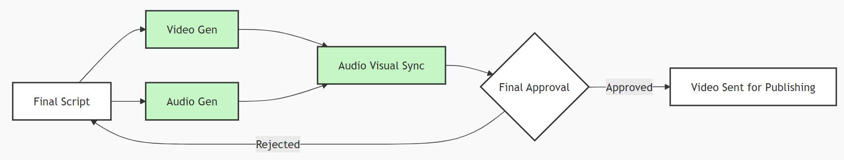
Figure 1: Process flowchart confirmed with HiLegal in September 2026
TIMWOODS analysis identifies three dominant wastes. Waiting: multiple queues across the process, including the intake queue and three approval gates (Clarification, Approval, and Final Approval), each capable of looping. Overprocessing: scripts are drafted manually with AI used only for refinement, while audio and video are generated separately and synchronized manually. Defects: every approval gate can loop — Clarification returns to the intake queue, Approval returns to script drafting, and Final Approval returns to the final script — and the clarification gate may loop multiple times. By Little's Law, the process is queue-gated: waiting, not work, drives the lead time.

Viewed through the four Vs of operations, the service is high-variety, high-visibility, moderate-variation, and low-volume. We have also identified that variety is absorbed manually at many steps instead of being standardized at the front end. From a Theory of Constraints perspective, manual audio–video synchronization is a potential capacity bottleneck due to its high labour requirements, while intake queues and approval loops are the main contributors to extended lead time.

Baseline metric | Value
Content production lead time | 2-4 weeks (14-28 days waiting, ~10 h work)
Intake queue before work starts | 3-7 days, workload-dependent
Brief approval loop | At least 4 iterations
Largest manual steps | Audio-video synchronization 2-3 h;  platform adaptation ~2 h
Monthly output | ~15-20 videos (ceiling 35-40)
Table 1: As-is baseline of the content production process

4. Proposed Improvements (To-Be Direction)
Three changes carry most of the improvement: standardizing the front of the process and automating its most laborious steps. First, structured self-serve intake: a structured brief form with template previews replaces the free-form request and the 3–7-day intake queue, and because lawyers choose the output format before anything is produced, the clarification approval loop is attacked at its source. Second, template-driven AI scripting: the language model drafts the script from the brief and the lawyer's profile against a fixed set of content formats, so employees edit rather than write — reversing today's manual-draft, AI-refine order. Third, single-render avatar video: one render produces voice, lip-sync and video together, eliminating the separate audio track and the 2–3 hours of manual synchronization that today form the largest labour block.
In the enhanced process, these changes link into a single pipeline of eight steps: (1) the lawyer submits a self-serve structured brief with format previews; (2) the pipeline automatically checks completeness and routes the request without a queue; (3) the AI drafts the script from templates and the lawyer's profile; (4) an employee edits and quality-checks the draft; (5) the lawyer approves through a mobile, structured approval link with a 48-hour service-level agreement and automatic reminders; (6) the approved script renders as a single avatar video with voice and lip-sync together in a batch queue; (7) the video is finalized and delivered to the lawyer; and (8) engagement is monitored from a unified dashboard while the cycle time of every step is logged automatically — installing the Plan-Do-Check-Act measurement habit the current process lacks. Where the current process needs twelve steps and roughly ten hours of labour per video, the enhanced process compresses this to eight steps and targets under one hour, with a target lead time of one to two business days, depending on lawyer approval times.
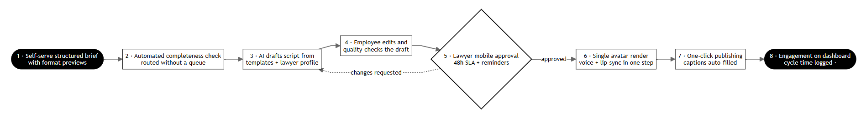
Figure 2: Process flowchart to-be

5. Implementation Roadmap, Risks and Evaluation
We recommend a phased implementation so that standardization, which requires no new technology, delivers value first: Phase 1 (weeks 1-4) introduces brief templates with format previews and structured approval links; Phase 2 (weeks 5-10) automates scripting and video rendering; Phase 3 (ongoing) establishes weekly PDCA reviews using a per-step cycle-time dashboard to monitor performance and support continuous improvement – consistent with HiLegal's requirement to become self-sufficient within months.
The expected operational improvements will be evaluated by comparing the As-Is and proposed To-Be processes using the following KPIs:
KPI | Purpose
Lead Time per Video | Measure end-to-end process speed, including waiting
Human Processing Time per Video | Measure labor efficiency
Cost per Video | Measure economic efficiency
Throughput (Videos/Month) | Measure overall process capacity and scalability
Rework Rate | Measure repeated work and process quality
Table 2: Key Performance Indicators for Process Evaluation
Key risks and mitigations: lawyers may still iterate heavily (format previews, structured change requests); AI-generated content may require additional corrections (human quality control); third-party AI vendors carry pricing and lock-in risk (dual-vendor evaluation, interchangeable components); avatar video requires written consent for each lawyer's likeness and voice; and part of the baseline is estimated, so the proposed design considers a worst-case scenario in which all three approval gates require four iterations.
The analysis is limited to a single-company study based partly on self-reported data, with flagged estimates and no controlled comparison.

6. Conclusion
Our initial assessment shows that the Content Production process has significant room for improvement, and we have prioritized these areas using the Theory of Constraints and Little's Law. The current process requires twelve steps and roughly ten hours of labour per video, spread over two to four weeks, with three approval gates (Clarification, Approval, and Final Approval) that can each loop and extend lead time. The root cause is clear: the workflow cannot scale with the current team and manual effort.
Standardizing intake, automating the deterministic middle, and instrumenting every step turn the same two employees and largely the same technology into a scalable, measurable service. The proposed redesign aims to reduce the process to eight steps and under one hour of labour per video, with a target lead time of one to two business days and a roughly tenfold capacity increase with the existing team. The solution is intended to be implemented in stages so that we can maintain a feedback loop throughout the rollout.

The dashboard mentioned is an internal tool for evaluating staff efficiency and client engagement. By “publishing”, we mean delivering the videos to clients, not posting them on social media platforms.

