**Exp No 07: Questions:**

Name:-Saeel Sakhalkar   
Roll No: 2439   
**Basic JOIN Queries (1-5)**   
 1.**Retrieve all student details along with their course names using an INNER JOIN.**  o *Hint:* Use INNER JOIN on course_id.

**SELECT * FROM STUDENTS S INNER JOIN COURSES C ON S.COURSE_ID=C.COURSE_ID**

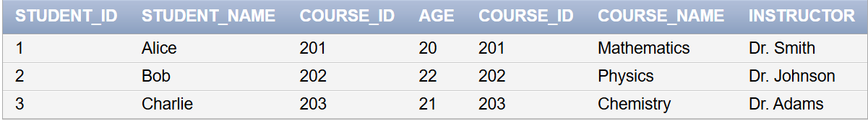

2.**Get a list of students and their assigned courses, ensuring that even students with no assigned**  **course appear in the result (use LEFT JOIN).**

o *Hint:* Use LEFT JOIN.

**SELECT * FROM STUDENTS S LEFT JOIN COURSES C ON S.COURSE_ID=C.COURSE_ID**

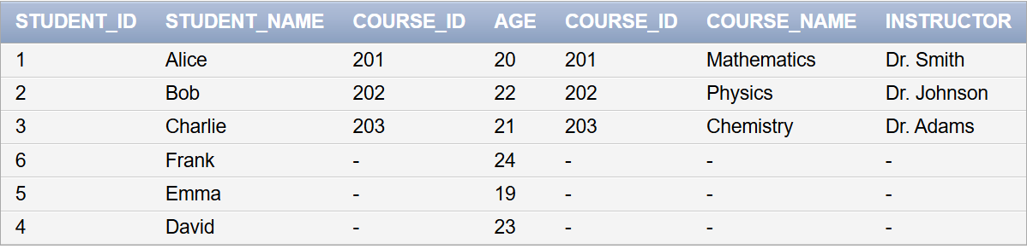

3.**Retrieve all courses and the students enrolled in them, ensuring that even courses with no**  **students appear in the result (use RIGHT JOIN).**

o *Hint:* Use RIGHT JOIN.

**SELECT * FROM STUDENTS S RIGHT JOIN COURSES C ON S.COURSE_ID=C.COURSE_ID**

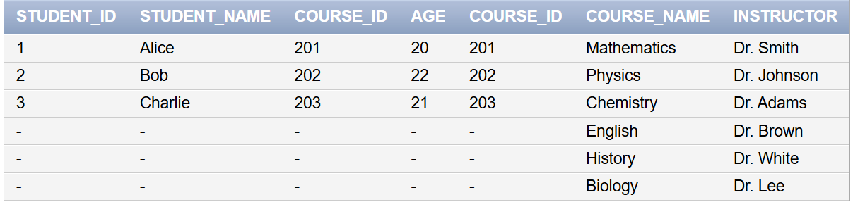

4.**List all students and courses, including those without a match in both tables (use FULL OUTER**  **JOIN).**

o *Hint:* Use FULL OUTER JOIN.

**SELECT * FROM STUDENTS S FULL JOIN COURSES C ON S.COURSE_ID=C.COURSE_ID**

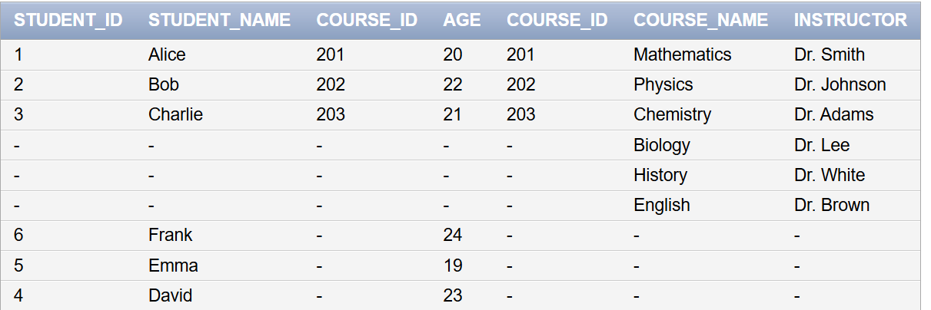

5.**Find all possible student-course combinations using a CROSS JOIN.**

o *Hint:* Use CROSS JOIN without an ON condition.

**SELECT * FROM STUDENTS S CROSS JOIN COURSES C**

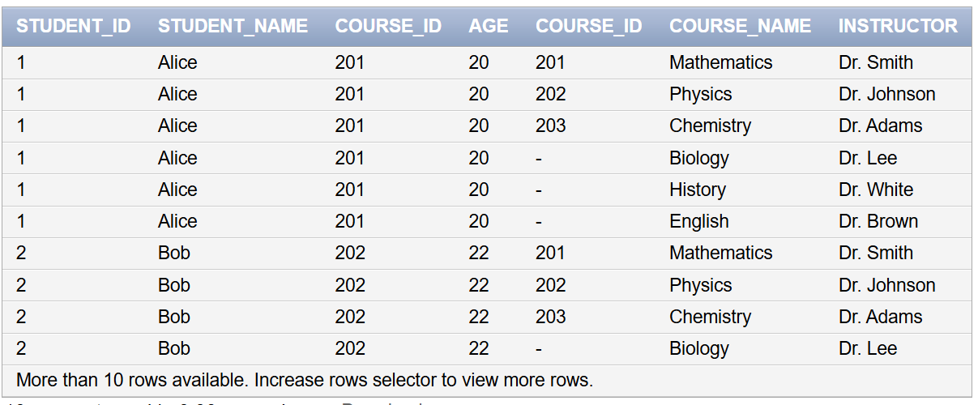

**JOINs with WHERE Condition (6-10)**   
 6.**Retrieve students enrolled in 'Physics'.**

o *Hint:* Use INNER JOIN and WHERE course_name = 'Physics'.

**SELECT STUDENT_NAME FROM STUDENTS S INNER JOIN COURSES C ON S.COURSE_ID=C.COURSE_ID WHERE COURSE_NAME='Physics';**

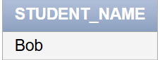

7.**List students who have not been assigned a course (use LEFT JOIN and check NULL values).**  o *Hint:* Use LEFT JOIN and WHERE course_id IS NULL.

**SELECT STUDENT_NAME FROM STUDENTS S LEFT JOIN COURSES C ON S.COURSE_ID=C.COURSE_ID WHERE S.COURSE_ID IS NULL;**

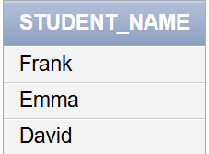

8.**Retrieve courses that have at least one student enrolled (use INNER JOIN).**

o *Hint:* Use INNER JOIN and check non-null student names.

**SELECT * FROM STUDENTS S INNER JOIN COURSES C ON S.COURSE_ID=C.COURSE_ID WHERE S.STUDENT_NAME IS NOT NULL;**

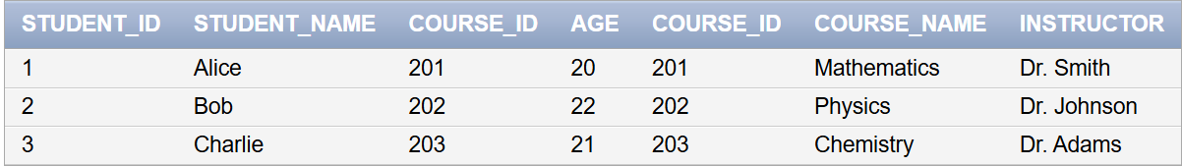

9.**Find all students enrolled in a course taught by 'Dr. Smith'.**

o *Hint:* Use INNER JOIN and filter with WHERE instructor = 'Dr. Smith'. **SELECT STUDENT_NAME FROM STUDENTS S INNER JOIN COURSES C ON S.COURSE_ID=C.COURSE_ID WHERE C.INSTRUCTOR='Dr. Smith';**

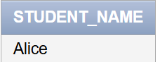

10.**Find students who are 21 years or older and have been assigned a course.**

● *Hint:* Use INNER JOIN with WHERE age >= 21.

**SELECT * FROM STUDENTS S INNER JOIN COURSES C ON S.COURSE_ID=C.COURSE_ID WHERE**

**S.AGE>=21;**

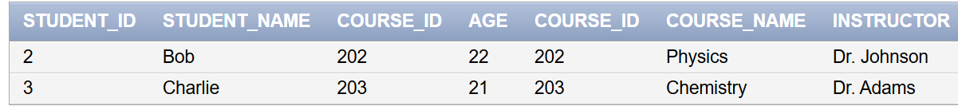

**JOINs with ORDER BY Clause (11-15)**

11.**List students and their courses, sorted by student name in ascending order.**

● *Hint:* Use ORDER BY student_name ASC.

**SELECT STUDENT_NAME,COURSE_NAME FROM STUDENTS S INNER JOIN COURSES C ON**

**S.COURSE_ID=C.COURSE_ID ORDER BY S.STUDENT_NAME ASC;**

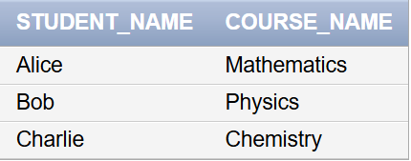

12.**List courses with their assigned students, sorted by course name in descending**

**order.**● *Hint:* Use ORDER BY course_name DESC.

**SELECT STUDENT_NAME,COURSE_NAME FROM STUDENTS S INNER JOIN COURSES C ON**

**S.COURSE_ID=C.COURSE_ID ORDER BY COURSE_NAME DESC;**

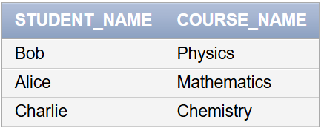

13.**Retrieve students along with their assigned courses, ordered by student age (oldest to**

**youngest).**

● *Hint:* Use ORDER BY age DESC.

**SELECT STUDENT_NAME,COURSE_NAME FROM STUDENTS S INNER JOIN COURSES C ON**

**S.COURSE_ID=C.COURSE_ID ORDER BY AGE DESC;**

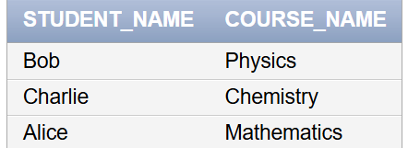

14.**List students who have a course assigned, ordered by the course instructor name.**●

*Hint:* Use ORDER BY instructor ASC.

**SELECT STUDENT_NAME,COURSE_NAME FROM STUDENTS S INNER JOIN COURSES C ON**

**S.COURSE_ID=C.COURSE_ID ORDER BY INSTRUCTOR ASC;**

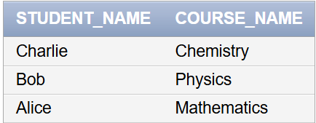

15.**Find all student-course combinations from the CROSS JOIN, sorted by student name first and**

**then by course name.**

● *Hint:* Use ORDER BY student_name, course_name.

**SELECT * FROM STUDENTS S CROSS JOIN COURSES C ORDER BY**

**S.STUDENT_NAME,C.COURSE_NAME;**

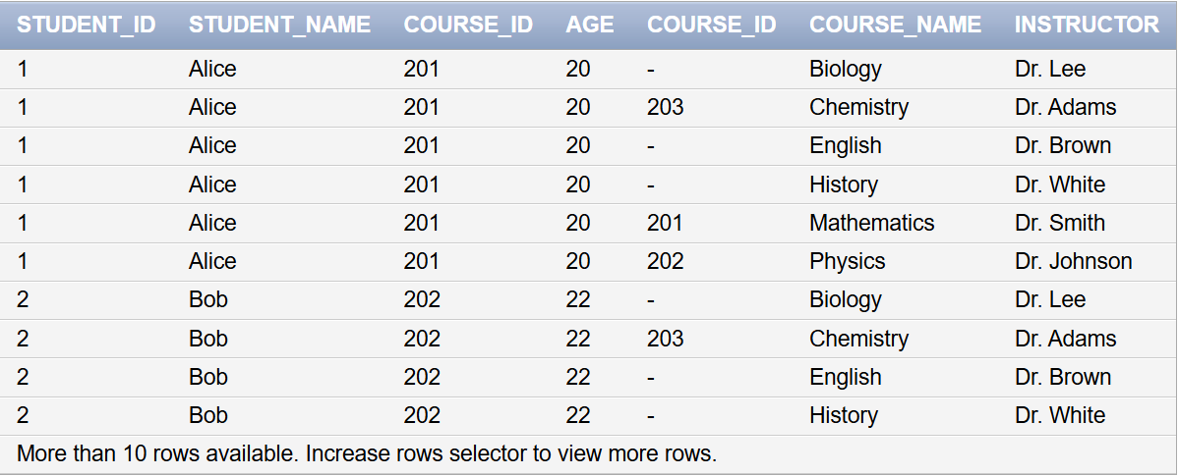

**JOINs with GROUP BY and HAVING (16-20)**

16.**Find the total number of students enrolled in each course (use GROUP BY).**

● *Hint:* Use COUNT(student_id) GROUP BY course_id.

**SELECT COUNT(student_id) AS TOTAL_NO_sTUDENTS,COURSE_NAME FROM STUDENTS S RIGHT JOIN COURSES C ON S.COURSE_ID=C.COURSE_ID GROUP BY COURSE_NAME**

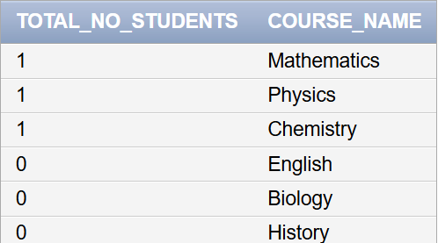

17.**Find the average age of students enrolled in each course (use GROUP BY).**

● *Hint:* Use AVG(age) GROUP BY course_id.

**SELECT AVG(AGE) AS AVERAGE_AGE,COURSE_NAME FROM STUDENTS S RIGHT JOIN COURSES C ON S.COURSE_ID=C.COURSE_ID GROUP BY COURSE_NAME**

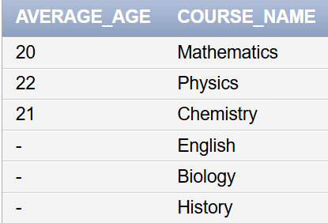

18.**Show only those courses where more than one student is enrolled.**

● *Hint:* Use HAVING COUNT(student_id) > 1.

**SELECT COUNT(STUDENT_ID) AS TOTAL_COUNT,COURSE_NAME FROM STUDENTS S INNER JOIN COURSES C ON S.COURSE_ID=C.COURSE_ID GROUP BY COURSE_NAME HAVING COUNT(STUDENT_ID) > 1**



19.**Find the course with the highest number of students enrolled.**

● *Hint:* Use GROUP BY and ORDER BY COUNT(student_id) DESC LIMIT 1.

**SELECT TOTAL_COUNT, COURSE_NAME FROM (SELECT COUNT(S.STUDENT_ID) AS**   
**TOTAL_COUNT, C.COURSE_NAME FROM STUDENTS S INNER JOIN COURSES C ON S.COURSE_ID = C.COURSE_ID GROUP BY C.COURSE_NAME ORDER BY TOTAL_COUNT DESC) WHERE**   
**ROWNUM = 1;**

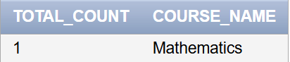

20.**Find the average age of students per course, but only for courses where the average age is**  **greater than 21.**

● *Hint:* Use HAVING AVG(age) > 21.

**SELECT AVG(AGE) AS AVG_AGE,COURSE_NAME FROM STUDENTS S INNER JOIN COURSES C ON S.COURSE_ID=C.COURSE_ID GROUP BY COURSE_NAME HAVING AVG(AGE)> 21**

