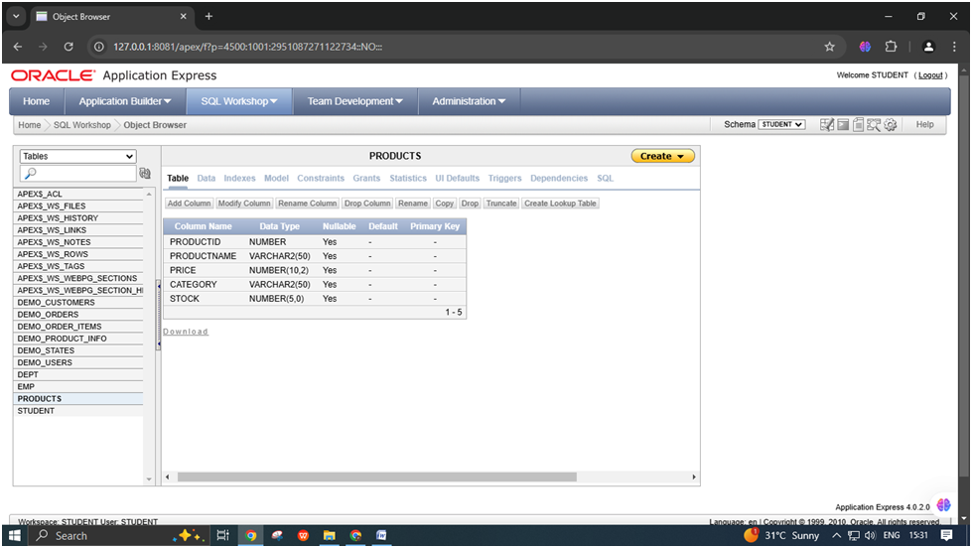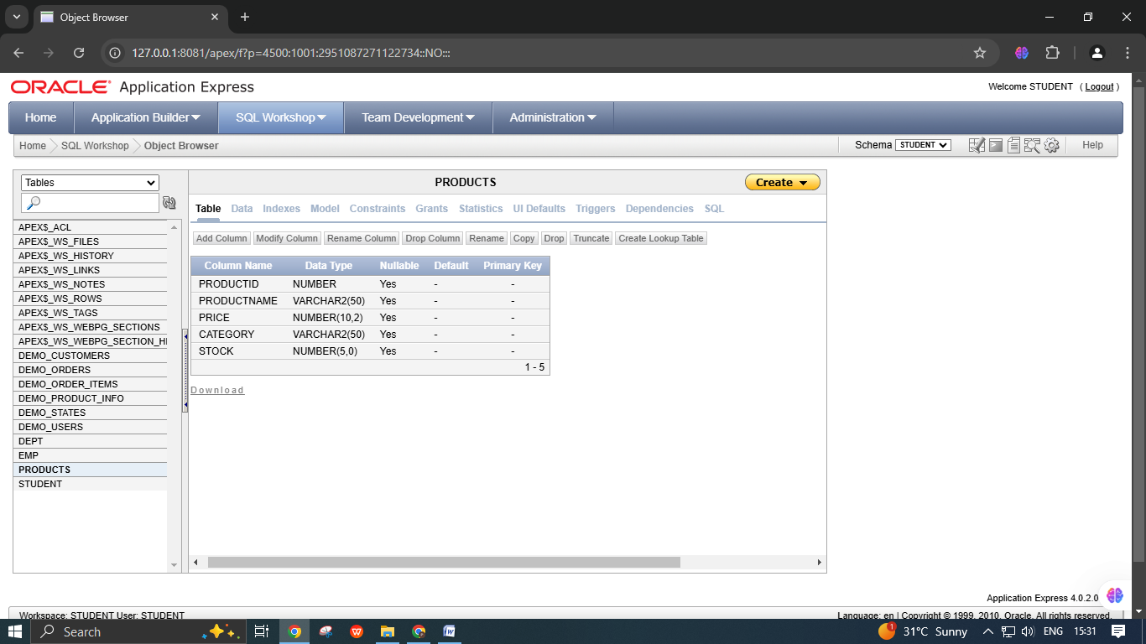

1. Create the Products Table   
Create a table named Products with the following columns:

ProductID: NUMBER

ProductName: VARCHAR2(50)

Price: NUMBER(10, 2)

Category: VARCHAR2(30)

Stock: NUMBER(5)

CREATE TABLE Products (

ProductID NUMBER,

ProductName VARCHAR(50),

Price NUMBER(10,2),

Category VARCHAR(30),

Stock NUMBER(5)

);

2. Modify the Table Structure   
Perform the following modifications on the Products table: 1. Change the data type of Category from VARCHAR2(30) to VARCHAR2(50).

ALTER TABLE Products MODIFY Category VARCHAR(50);

2) Add a new column SupplierEmail of type VARCHAR2(40).

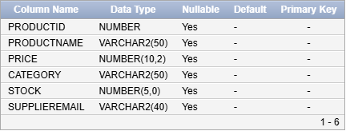

ALTER TABLE Products ADD SupplierEmail VARCHAR2(40);

3) Drop the Stock column from the table.

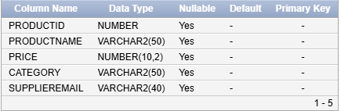

ALTER TABLE Products DROP COLUMN Stock;   
4) Add a new column AddedDate with the data type DATE.

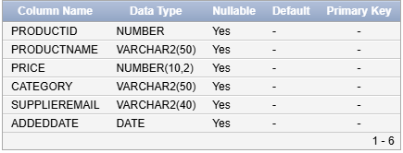

ALTER TABLE Products ADD AddedDate DATE;   
3. Add Constraints   
Add constraints to ensure data integrity:   
1. Add a primary key constraint on the ProductID column (if not already added).

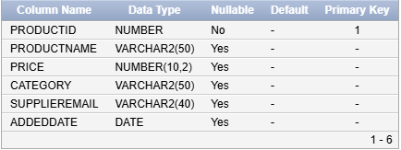

ALTER TABLE Products ADD CONSTRAINT PK_Products PRIMARY KEY (ProductID);

2. Add a unique constraint to the SupplierEmail column.



ALTER TABLE Products ADD CONSTRAINT UQ_SupplierEmail UNIQUE (SupplierEmail);

4. Populate and Explore Deleting/Truncating Tables   
Perform the following actions and observe the differences:   
1. Insert a few rows into the Products table to test the table structure and constraints.

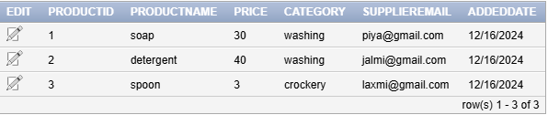

2. Use the TRUNCATE command to remove all rows from the table without deleting its structure.

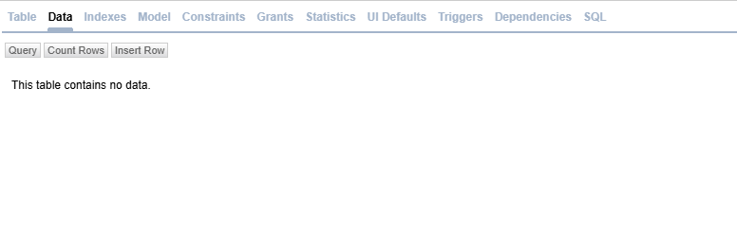

TRUNCATE TABLE Products;   
3. Use the DROP command to delete the Products table completely.

DROP TABLE Products;

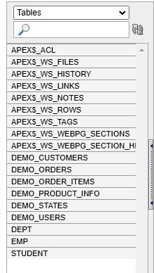

5. Insert 10 Rows into the Products Table

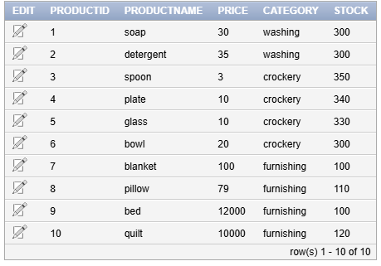

6. Perform Basic DML Commands   
1. SELECT Command (Retrieve Data):   
SELECT * FROM Products;

