Full Project Guide
In anaconda prompt after typing code . in that specific folder, it will open a VS Code instance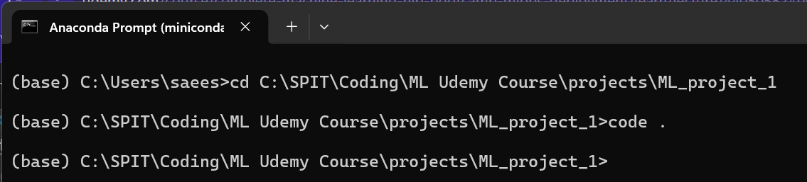
Create environment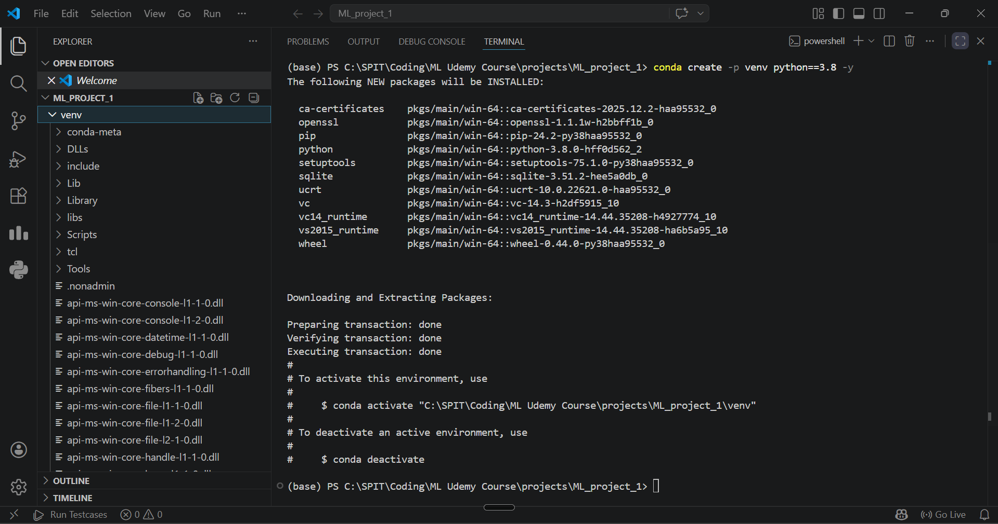
Activate the environment
Clone repo and sync with github
Initialize an empty git repo in the project folder
Create README.md file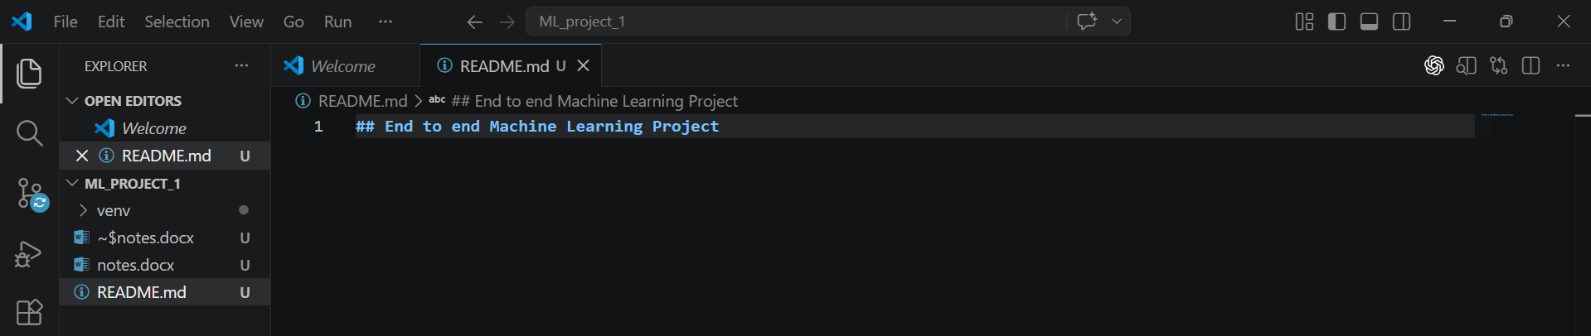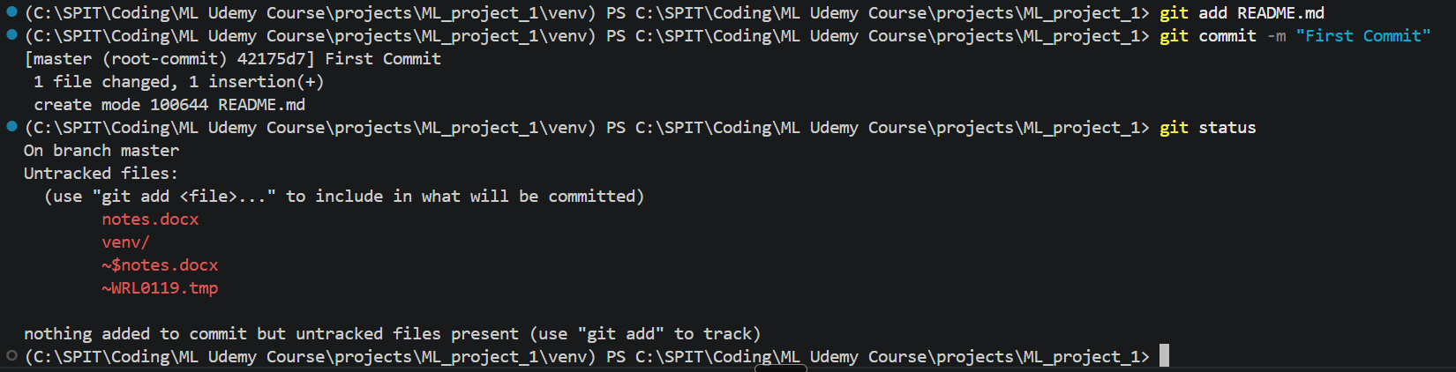

NOTE: (if your doing push for the first time you need to do the global login) 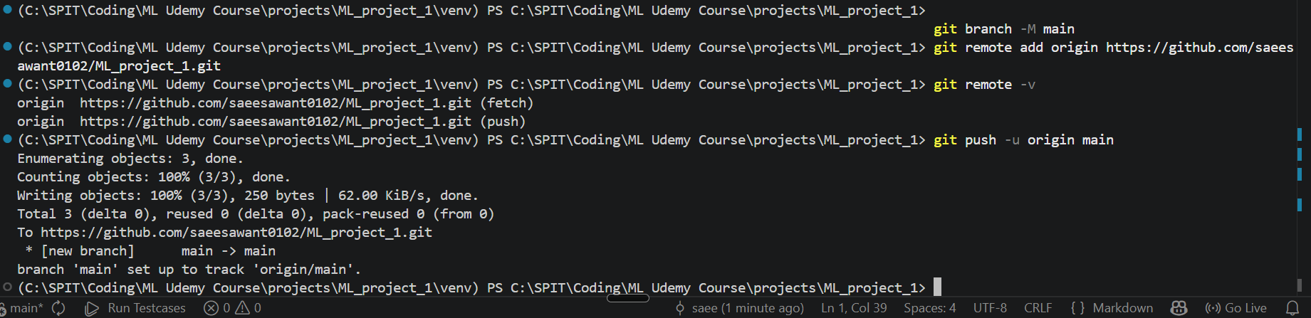
Create .gitignore file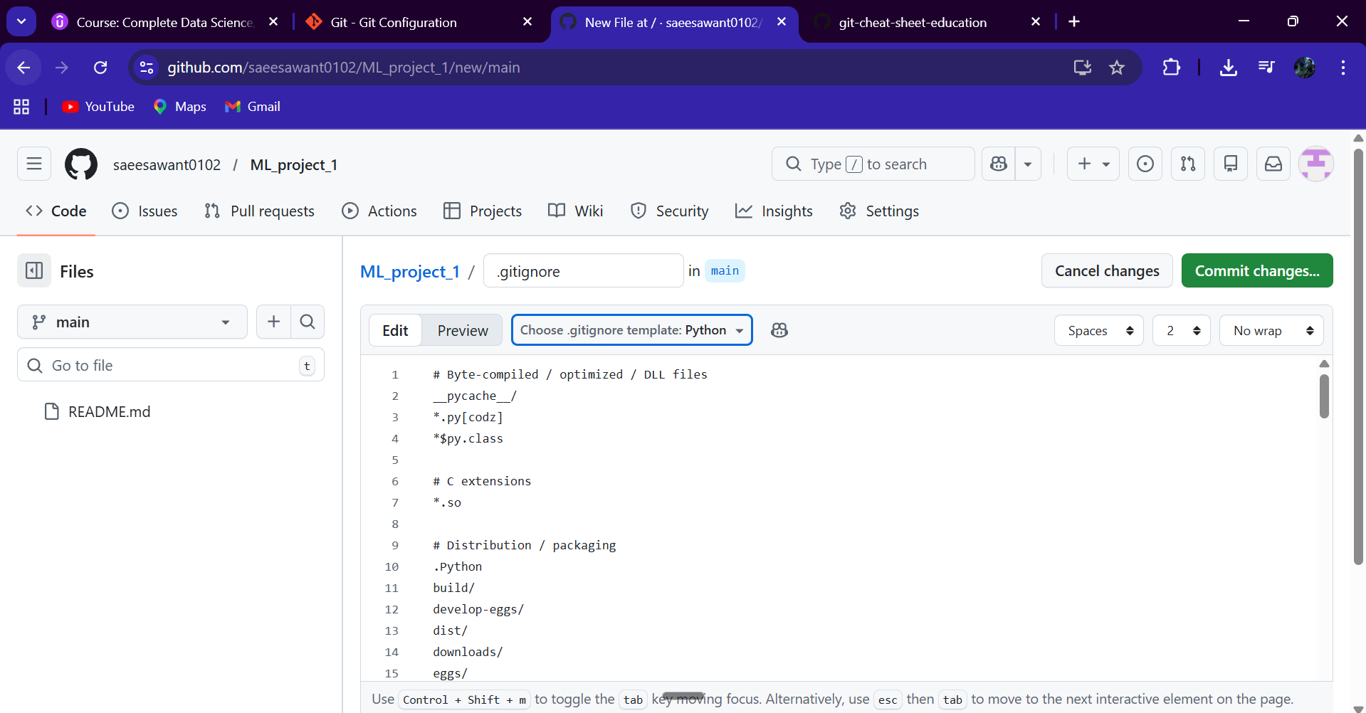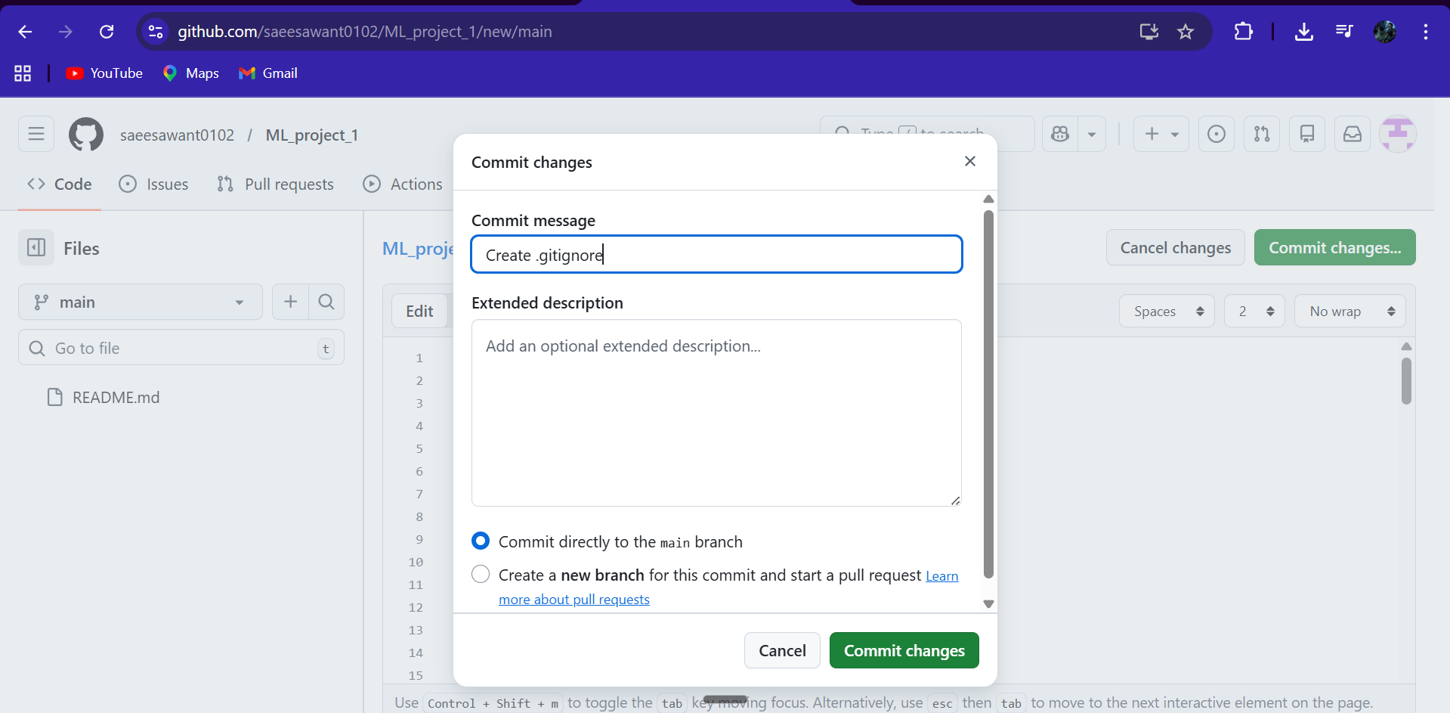
For all updations to happen on your side (ie in vsc) use git pull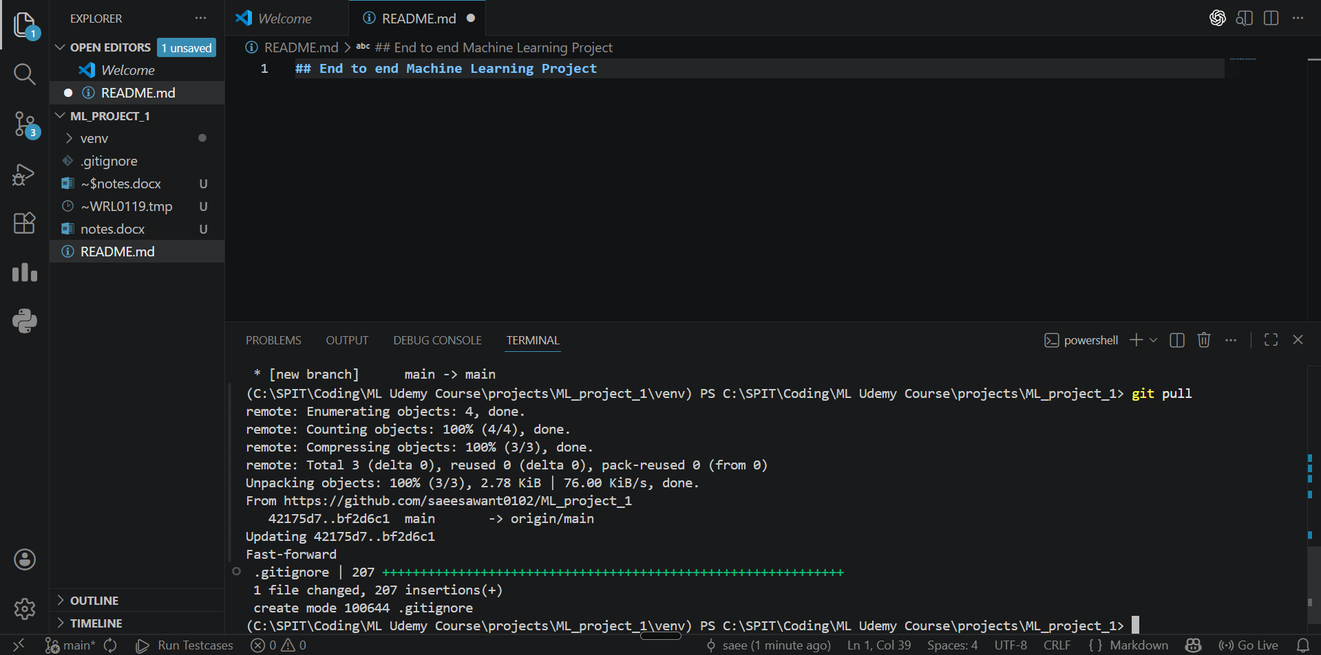

Make setup.py(its responsible for building the machine learning application as a package and this package can be uploaded to PyPi)

